Pupil Premium Strategy Statement

BENTLEY NEW VILLAGE PRIMARY SCHOOL
HEADTEACHER: VICTORIA SIMMONS
2025

Pupil premium strategy statement

This statement details our school’s use of pupil premium (and recovery premium for the 2022 to 2025 academic year) funding to help improve the attainment of our disadvantaged pupils.

It outlines our pupil premium strategy, how we intend to spend the funding in this academic year and the effect that last year’s spending of pupil premium had within our school.

School overview
Detail | Data
School name | Bentley New Village Primary School
Number of pupils in school | 250
Proportion (%) of pupil premium eligible pupils | 49%
Academic year/years that our current pupil premium strategy plan covers | 2025/2026  2026/2027  2027/2028
Date this statement was published | 15.10.25
Date on which it will be reviewed | 15.10.26
Statement authorised by | Victoria Simmons
Pupil premium lead | Abigail Smith
Governor / Trustee lead | Martin Lamb
Funding overview
Detail | Amount
Pupil premium funding allocation this academic year | £157,970
Pupil premium funding carried forward from previous years | £0
Total budget for this academic year | £157,970

Part A: Pupil premium strategy plan

Statement of intent
Our school is founded on the values of determination, creativity, tolerance, cooperation, curiosity and resilience, which underpin every aspect of our learning community. We are committed to providing an inclusive and ambitious education for all pupils, with a strong focus on supporting disadvantaged learners to achieve their full potential.
We recognise that effective support must benefit the whole school community. Therefore, key interventions are implemented at a whole-school level, ensuring that all pupils can access high-quality provision. While some initiatives are made possible through pupil premium and catch-up funding, our approach remains inclusive and not limited solely to those eligible for funding.
By working closely and collaboratively with pupils and their families, we use our detailed knowledge of individual needs to provide targeted support. Our aim is to ensure that disadvantaged pupils achieve outcomes in line with their peers and are empowered to succeed both academically and personally.
Our curriculum is broad, rich and carefully designed, rooted in a deep understanding of our local context. This enables us to deliver a bespoke educational experience that engages pupils, supports strong outcomes and nurtures a lifelong love of learning.
School leaders are dedicated to ensuring that all disadvantaged pupils—including those with the potential to achieve greater depth—receive consistently high-quality teaching. Where pupils may have fallen behind, timely intervention and daily support are prioritised to help them regain confidence and make sustained progress.
Ultimately, we strive for every child to leave our school with the confidence, ambition and skills required to become successful learners in their future education and beyond.

Challenges

This details the key challenges to achievement that we have identified among our disadvantaged pupils.
Challenge number | Detail of challenge
1  SIP -6a, 3a, 3b, | Lower starting points, especially on-entry and therefore pupils achieving less than national at GLD and being Year 1 ready.  This means that more disadvantaged pupils do not achieve GLD. They need greater support to become Year 1 ready.  This is most pronounced in foundational knowledge such as: speech and language, early reading, early writing, PSED.  The majority of pupils receiving intervention support are pupil premium.  On entry into F2 in 2025, 3% of pupils were expected in Literacy, 8% were expected in Speech, Language and Communication and 12% were expected in PSED.  At the end of EYFS 2025, 49% of pupils achieved GLD; of which was 50% pupil premium.  In Speech, Language and Communication, national was 82.7% and school pupil premium achieved 67%.  In Self regulation, national was 84% and school pupil premium achieved 73%.  In writing, national was 71.8% and school pupil premium achieved 60%.  In reading, national was 76.5% and school pupil premium achieved 53%.
2  SIP – 3a, | Pupil premium pupils are slower to learn phonics and less achieve the standard by the end of Year 1. In addition, in-year assessments and observations suggest that disadvantaged pupils have greater difficulty learning to read.  There is less engagement from some families in terms of how they can support their child.  In 2025, 68% passed the PSC; disadvantaged pupils achieved 63% and non-disadvantage achieved 75%. This is typical for Year 1 attainment.
3  SIP – 3a, 3b, | Attainment Gaps  Pupils are achieving lower outcomes in reading and writing across the school with a notable gap between pupil premium pupils and non-pupil premium pupils.
4  SIP – 1a, 2b, 6a, | Communication and language  Children starting school have low starting points in communication and language and older children find it difficult to communicate effectively and purposefully. This includes speech and language difficulties and a lack of exposure to a range of vocabulary. Children do not understand how to talk differently for different audiences and purposes.
5 | Wider experiences  Pupils have limited opportunity for wider experiences, education at home and in their community. 41% of disadvantaged children attended after school clubs either provided by school or external providers.
6  SIP – 4a, | Attendance gaps  Attendance for disadvantaged pupils is lower than their peers, including those children who are persistent absentees.  All pupil’s attendance exceeds national at 95.5%.  Disadvantage data is above national at 93.68%.  Disadvantaged pupils' attendance is below all pupils at 95.3%.  All PA is 16.47%; however, FSM PA is 45.43% greater.
7  SIP – 1a, 4b, | Thrive assessments, observations and discussions with pupils and families have identified social and emotional issues for many pupils, notably due to difficulties with emotional regulation. These challenges particularly affect disadvantaged pupils, including their attainment. 63% of children that access reparative thrive sessions are pupil premium pupils.

Intended outcomes
This explains the outcomes we are aiming for by the end of our current strategy plan, and how we will measure whether they have been achieved.
Intended outcome | Success criteria
Improved GLD attainment for disadvantage pupils. | At the end of reception, the gap for all children towards national reduces.  - Speech and language interventions, such as WELCOMM, show evidence of improvement over-time.  - Writing diagnostics and pupil’s work shows that disadvantage pupils are making sustained progress.  - More disadvantage pupils are achieving milestones which indicate Year 1 readiness.  - Thrive assessments show children are making progress towards their right time thrive emotional readiness.
Improved phonics outcomes for disadvantage pupils | Phonics data at the end of Year 1 shows a reduced gap between disadvantage and non-disadvantage pupils.  - There is evidence of improved reading practices at home for disadvantage pupils.  - Disadvantage pupils engage with specific reading initiatives at activities in school.
Reduced attainment gaps | Attainment gaps between disadvantaged and non-disadvantaged pupils are significantly narrowed in Reading and Writing across all year groups.  - There is a demonstrable narrowing of attainment gap between disadvantaged and non-disadvantaged pupils.
Children are confident and able to speak well to a range of audiences and for different purposes. | - Review of the oracy curriculum is embedded and observed practise is strong  - Pupil premium pupils are a focus during discussions during the Vertical learning afternoons.  - All pupils, are exposed to tier 1, 2 and 3 vocabulary throughout the curriculum.  - Targeted pupils receive additional speech and language intervention  - Parents are engaged in the development of their child’s speech and language.  - Teacher assessment shows that children are gaining knowledge of the vocabulary expected of them across the curriculum.  - Whole school curriculum conversations with parents take place to show case the learning taking place whilst developing oracy skills
All pupils are exposed to a breadth of experiences that allow them to build upon their social and academic skills. All children have the opportunity to access experiences beyond the curriculum. | - Teachers plan a range of visits and visitors  - Whole school curriculum conversations with parents take place to show case the learning taking place whilst developing oracy skills  - Children will be exposed to a range of social, cultural, enrichment and sporting activities within and outside of the school day.
Reduced attendance gaps between overall attendance and PA. | - Disadvantaged pupils will match or exceed national averages for non-disadvantaged pupils (96+%)  - Monitoring of attendance by Attendance officer, and SLT brings about increase in PP attendance and decrease in being persistently absent.
Children are supported to develop emotional resilience, positive relationships, improved self-regulation and increased confidence, enabling them to engage with learning more successfully. | - Children will have access to a trained THRIVE practitioner for support either 1:1 or small group depending on need.  - Safe spaces available for children to be able to access during times when they may feel dysregulated.  - All children have access to Right Time Thrive sessions which develop skills and emotional readiness for their right time age.

Activity in this academic year
This details how we intend to spend our pupil premium (and recovery premium funding) this academic year to address the challenges listed above.

Teaching (for example, CPD, recruitment and retention)
Budgeted cost: £72,318+ (NB The school pays in excess of this figure which represents a portion of the PPG and is subsidized from the school budget)
Activity | Evidence that supports this approach | Challenge number(s) addressed
Thrive Training CPD  Thrive courses/subsc = £1,475  Inclusion Manager Salary 50% = £17,589  SEMH Practitioners x2 50%  £20,816  Total = £39,880 | Whole-staff training on attachment-aware and trauma-informed practises, drawing on the EEF's guidance on 'Improving Social and Emotional Learning in Primary Schools' (EEF, 2019). This will help teachers better understand the impact of adverse childhood experiences and develop strategies to create a nurturing, emotionally supportive classroom environment.  Whole-school approach to social and emotional learning (SEL), incorporating evidence-based programmes such as Thrive, as recommended in the EEF's 'Improving Social and Emotional Learning in Primary Schools' guidance (EEF, 2019).  The school's curriculum and teaching practises promote the development of self-regulation, resilience, and emotional intelligence, as outlined in the EEF's 'Improving Social and Emotional Learning in Primary Schools' guidance (EEF, 2019).  A dedicated team of trained mental health and well-being practitioners (e.g., school counsellors, mental health first aiders) to provide targeted, evidence-based interventions for pupils identified as needing additional support, drawing on the EEF's 'Improving Social and Emotional Learning in Primary Schools' guidance (EEF, 2019).  A structured, evidence-based mentoring programme, such as the EEF-recommended 'Mentoring' intervention, to provide one-to-one or small-group support for disadvantaged pupils, focusing on building positive relationships, goal-setting, and emotional regulation. Provided through reparative thrive, group thrive and RTT.  Collaboration with external agencies and partners (e.g., local mental health services, social services, youth organisations) to provide wraparound support for pupils and their families, as recommended in the EEF's 'Working with Parents to Support Children's Learning' guidance (EEF, 2018).  A robust system for early identification of social, emotional, and mental health needs, using screening tools and regular check-ins, as suggested in the EEF's 'Improving Social and Emotional Learning in Primary Schools' guidance (EEF, 2019).  Social and Emotional Learning – interventions which target social and emotional learning seek to improve pupil’s interaction with others and self management of emotions, rather than focusing directly on the academic or cognitive elements of learning. SEL interventions might focus on the ways in which students work with (and alongside) their peers, teachers, family and community. | 1,7
Reducing the attainment gap; Quality First Teaching.  Provide ongoing high quality professional development and training to support subject knowledge and pedagogy  Each lesson ppt to clearly display which lesson we are in, links with prior learning. Continuous referral to learning behaviours.  Review curriculum design to ensure that we teach fewer things in greater depth, that it is cumulative across all subjects and that at each stage we ensure the transfer of knowledge into long term memory  Key language is discussed each lesson and oracy opportunities are built into learning  HLTA Cover 0.5 x 3weekly = £9006  Walk thru = £1340  Jigsaw = £300  WR / TTRS / Number Sense = £1150  Total = £11,796 | EEF indicates that the quality of teaching is one of the biggest drivers of pupil attainment, particularly for those from disadvantaged backgrounds.  The evidence suggests that quality Professional Development shows that PD does indeed improve teaching and pupil learning (Fletcher-Wood & Zuccollo, 2019; Kennedy, 2016a; Lynch et al., 2019). Senior leaders to carry out learning walks, monitor and evaluate teaching and learning.  Provide high-quality professional development for all teaching staff, focusing on evidence-based teaching strategies that have a proven impact on disadvantaged pupils' learning (EEF, 2021).  Implement a structured programme of peer-to-peer coaching and lesson study to enable teachers to observe, reflect on, and improve their practice (EEF, 2018).  Ensure all teachers have a deep understanding of the school's curriculum and how to deliver it effectively, with a focus on building pupils' vocabulary, language, and oracy skills (EEF, 2021).  Develop a whole-school approach to feedback, with a focus on providing high-quality, actionable feedback to pupils to help them progress in their learning (EEF, 2021).  Implement a structured programme of assessment, including diagnostic assessments, to identify and address gaps in pupils' knowledge and understanding (EEF, 2021).  Provide training and support for teaching assistants to ensure they are deployed effectively to support learning, particularly for disadvantaged pupils (EEF, 2021). | 2, 3,4
Subject Leader release time to ensure outstanding curriculum for all pupils.  English policy and sequences rewritten to address outcomes  Reading curriculum and teaching sequence revised to address outcomes. | To continually evolve and improve our school curriculum, leaders need to regularly evaluate their subject, provide support to those that need it and continuously innovate based on the evidence they gather.  The school uses termly vertical learning days whereby subject leaders work with a selection of pupils, including disadvantaged pupils, to review the learning and gain pupil voice. Leaders are involved in pupil progress meetings, discussing progress, identifying barriers and ensuring that progress of all learners is achieved.  Ofsted Research Reviews. | 3,4
Provide ongoing coaching and professional Development for teachers and teaching assistants in EYFS and KS1 on Little Wandle and interventions.  10% English/Phonics Lead TLR = £6527  10% Salary for release = £3002  Total = £9529 | Reflective and well-trained teaching assistants will strive to improve their practice to enable them to make further impact on pupil progress. Training is provided by English subject lead and supported by the English Hub. Teachers are released to observe strong teaching of Little Wandle phonics in other settings.  Reading is crucial to success in school and life. It is essential that children develop a good level of phonics and decoding from leaving Early Years. Early reading is linked to reading for pleasure.  EEF Early Literacy and Phonics – high impact for very low cost based on very extensive evidence + 5 months | 1,2,3
Whole school oracy and staff training / CPD  Oracy leadership release 10% = £7532  HLTA cover 10% = £3581  Total = £ 11,113 | The EEF's 'Improving Literacy in Key Stage 1' and 'Improving Literacy in Key Stage 2' guidance;  Professional development for all staff on effective strategies for teaching vocabulary, such as explicit instruction, word-rich environments, and morphology teaching.  Vocabulary instruction across the curriculum, ensuring key subject-specific terms are explicitly taught and reinforced.  Purposeful, exploratory talk in lessons through techniques like 'talk partners' and structured discussions.  Reading for pleasure and access to a wide range of high-quality texts to expose pupils to rich language.  The EEF's 'Preparing for Literacy' guidance;  Intensive training for EYFS staff on evidence-based strategies for developing children's language and communication skills.  The EYFS curriculum and environment are language-rich, with a focus on developing vocabulary, narrative skills, and active listening.  Targeted interventions, such as 'Nuffield Early Language Intervention', to support the lowest-attaining pupils.  The EEF's 'Improving Literacy in Key Stage 1' and 'Improving Literacy in Key Stage 2' guidance;  High-quality phonics instruction, using a systematic, synthetic phonics programme.  Teaching of comprehension strategies, such as prediction, questioning, and summarization. | 3, 4

Targeted academic support (for example, tutoring, one-to-one support structured interventions)
Budgeted cost: £37,092
Activity | Evidence that supports this approach | Challenge number(s) addressed
One to one or one to three tuition  (including Phonics)  Regular diagnostic assessment of phonics  Regular diagnostic assessment of reading – YARC  3 x LSA Salary (0.3)  = £16755 | EEF – Teaching and Learning Toolkit – One to One tuition – High impact for moderate cost based on moderate evidence + 5 Months  EEF – Teaching and Learning Toolkit – Individualised instruction – Moderate impact for very low cost based on limited evidence + 4 months  One to one tuition might be an effective strategy for providing targeted support for pupils that are identified as having low prior attainment or are struggling in particular areas. Research which focuses on teaching assistants who provide one to one or small group targeted interventions shows a stronger positive benefit of between four and six additional months on average. In some cases one to one tuition has led to greater improvement, while in others tuition in groups of two or three has been equally or even more effective. (EEF Teaching and Learning Toolkit – Teaching Assistant Interventions)  Interventions from the class teachers are provided for pupils who need this additional support in order to progress and engage effectively with their learning. Interventions for some are planned on a regular basis and for others it is managed by the class teacher according to needs as they arise. | 1,2,3
To develop the teaching of vocabulary and comprehension in EYFS and KS1 (based on research and working with external agencies to improve provision).  Tier 3 concept and disciplinary vocabulary is covered in wider curriculum  10% English/Phonics Lead TLR = £6527  10% Salary for release = £3002  Total = £9529 | EEF – Teaching and Learning Toolkit - Oral language interventions - Very high impact for very low cost based on extensive evidence +6 months  EEF – Teaching and Learning Toolkit – Reading Comprehension strategies - Very high impact for very low cost based on extensive evidence +6 months  There is evidence to suggest that pupils from lower socioeconomic backgrounds are more likely to be behind their more advantaged counterparts in developing early language and speech skills, which may affect their school experience and learning later in their school lives. There is a strong evidence base that suggests oral language interventions, including dialogic activities such as high-quality classroom discussion, are inexpensive to implement with high impacts on reading.  Training can support adults to ensure they model and develop pupils’ oral language skills and vocabulary development. | 1,2.3
Identify and support the needs of PP pupils in EYFS & KS1 with speech and language difficulties.  Speech and language interventions with trained member of staff  EYFS 80% LSA delivering WELLCOMM = £6993  WELCOMM = £865  Lexia = £2950  Total = £10,808 | EEF – Teaching and Learning Toolkit - Oral language interventions - Very high impact for very low cost based on extensive evidence +6 months  Continue using Wellcomm communication and language toolkit throughout school to provide specific target intervention for each identified pupil  Children start school with weak language and communication skills. All pupils in Nursery are assessed using WELCOMM at baseline, resulting in a significant proportion of pupils being identified as needing speech and language support. Most children are unlikely to have the breadth of vocabulary that reflects their experiences on entry to Reception. In KS1 and KS2, children are unlikely to use talk to connect ideas and explain what is happening coherently. The use of the Wellcomm programme aims to increase the attainment and progress in phonics, reading and writing for the identified cohort, including pupil premium children. See attached report for evidence of small group intervention support for S&L in primary settings:  https://www.rcslt.org/speech-and-language-therapy/where-slts-work/education/  Best Start in Speech, Language and Communication: Guidance to support local commissioners and service leads. Department of Health and Social Care/Department for Education 2020  Parsons, S. & Schoon, I. (2011) Long-term Outcomes for Children with Early Language Problems: Beating the Odds. Children & Society Vol. 25  EEF – Teaching and Learning Toolkit – One to One tuition – High impact for moderate cost based on moderate evidence + 5 Months | 2

Wider strategies (for example, related to attendance, behaviour, wellbeing)
Budgeted cost: £ 44,988
Activity | Evidence that supports this approach | Challenge number(s) addressed
Social and Emotional/Pastoral Support  - SEMH Team  - Senior mental health training  - Continued development of Jigsaw PSHE scheme  - Wellbeing Leads  Inclusion Lead/AHT Salary 20% = £13273 | Positive communication with parents and carers to develop their own skills in supporting their children's social, emotional, and mental well-being, as outlined in the EEF's 'Working with Parents to Support Children's Learning' guidance (EEF, 2018).  The Thrive base within the school, provides a safe and nurturing space for pupils to access support, engage in therapeutic activities, and develop self-regulation strategies, in line with the EEF's 'Improving Social and Emotional Learning in Primary Schools' guidance (EEF, 2019).  Collaboration with the local authority and community partners to develop a comprehensive support network for families, including access to mental health services, parenting programmes, and community-based activities, as recommended in the EEF's 'Working with Parents to Support Children's Learning' guidance (EEF, 2018).  Regular review and refinement of the school's behaviour policy and practises to ensure a trauma-informed, restorative approach that promotes positive relationships and supports pupils' social and emotional development, as suggested in the EEF's ‘Improving behaviour in Schools' guidance (EEF, 2019). | 1, 7
To ensure that disadvantaged pupils have access to an experience rich curriculum  £3000 (£20/pp) | Children who are rich in experiences have a more secure understanding of the world around them and a better mastery of vocabulary linked to such experiences. Their ability to write, read and reason about a variety of experiences is increased. Children from families who cannot afford educational trips are disadvantaged and experiences are limited. Staff understand the importance of ensuring that all children have the right to an experience rich education. | 5
To partially fund the Attendance officer role in school.  Attendance officer salary 60%  £20,532 | All staff, including teachers and support staff, understand the importance of good attendance and their role in promoting it (EEF Improving Attendance in Schools report)  Training for staff on effective strategies for engaging with parents and carers to understand and address barriers to attendance (EEF Improving Attendance in Schools report)  A whole-school approach to attendance, with clear policies, procedures, and communication to pupils and families (EEF Improving Attendance in Schools report)  Utilisation the school's existing data tracking systems to closely monitor attendance patterns and identify pupils at risk of poor attendance (EEF Improving Attendance in Schools report)  Attendance as a key priority within the school's improvement plan and performance management system for all staff (EEF Improving Attendance in Schools report)  Implementation early intervention programmes, such as 'Attendance Matters', to identify and support pupils with emerging attendance issues (EEF Improving Attendance in Schools report)  One-to-one or small group mentoring for pupils with persistent absence, addressing the underlying causes and barriers to attendance (EEF Improving Attendance in Schools report)  Collaboration with external agencies, such as the local authority's attendance team, to access additional support and resources for families struggling with attendance (EEF Improving Attendance in Schools report)  Incentives and rewards for improved attendance, tailored to the needs and interests of individual pupils (EEF Improving Attendance in Schools report)  Effective communication and coordination between the school, families, and any external agencies involved in supporting attendance (EEF Improving Attendance in Schools report) | 6
Breakfast/Snacks for identified Pupil Premium children  Staffing £8,183 | Provision access to wraparound care, such as breakfast and after-school clubs, to support families and encourage regular attendance (EEF Improving Attendance in Schools report)

Total budgeted cost: £157,970+

Part B: Review of outcomes in the previous academic year

Pupil premium strategy outcomes
This details the impact that our pupil premium activity had on pupils in the 2024 to 2025 academic year.
Post Covid staff have identified many gaps in PP academic skills and also in social skills. Academic Data still shows that the children in receipt of Pupil Premium funding are still behind their peers in school and nationally. We are now adapting approaches, looking at more individual to each child and to try and support with the families more with Family Thrive and family learning events.
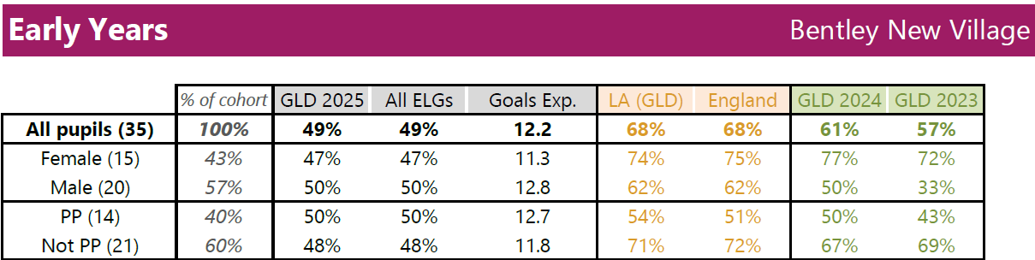
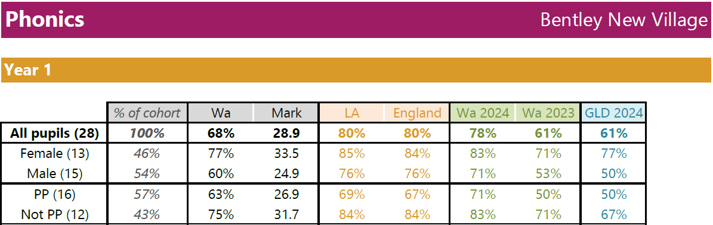

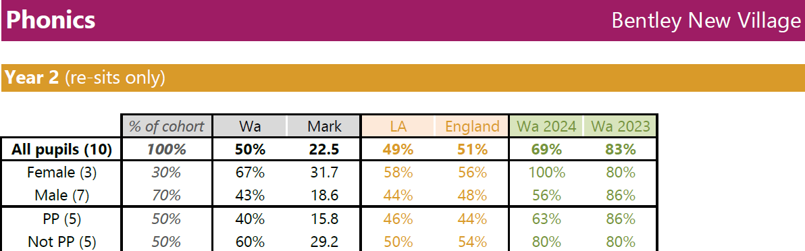

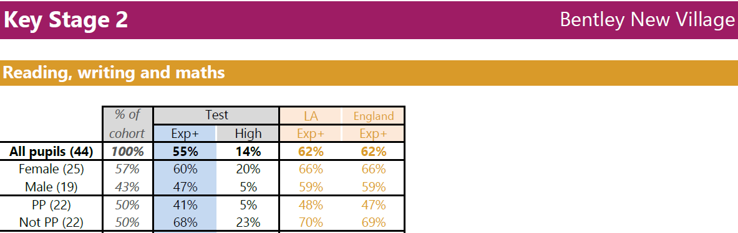

Externally provided programmes
Please include the names of any non-DfE programmes that you purchased in the previous academic year. This will help the Department for Education identify which ones are popular in England
Programme | Provider
Little Wandle | Letters and Sounds
Times Table Rock Stars | Maths Circle Ltd
Number Sense | Number Sense
WELLCOMM | GL Assessment

