

Non-Compliance With School Uniform Policy
To promote equality, readiness for learning, and a strong sense of belonging, all pupils are expected to wear the correct school uniform every day, including their PE kit on designated PE days. When a pupil is not in the correct uniform, the following procedures will be followed:
Step 1 – Notification to Parents/Carers - If a child arrives at school without the correct uniform, a message will be sent to parents/carers via Class Dojo. Parents/carers will be asked to bring the correct uniform or PE kit to school so their child can change as soon as possible.
Step 2 – Use of the Uniform Bank - If the correct uniform or PE kit is not provided, the school will loan items from the Uniform Bank for the child to wear for the day. Loaned items must be returned at the end of the school day.
Repeated Non-Compliance
Where a pupil is repeatedly not wearing the correct school uniform and no valid explanation has been provided, the following actions may be taken:
1. Monitoring and Record Keeping
2. Parent/Carer Meeting
3. Pastoral and Safeguarding Support Intervention

For more details see the schools uniform policy available on the school website


School Uniform
Information Leaflet

What Challenges Us, Changes us
Determination – Resilience – Tolerance – Cooperation – Creativity - Curiosity

School Uniform Purchasing
Branded School uniforms can be ordered online at http://www.schooltrends.co.uk/

For more details see the schools uniform policy available on the school website

School uniform

All children at New Village Primary School wear their school uniform with pride. It contributes to a sense of belonging, collaboration and teamwork. Therefore, when your child joins, or is already part of the New Village Primary School, we are all in a shared agreement that:

It is the responsibility of children, parents and carers to ensure that the correct New Village uniform is worn at all times and is clean and appropriate to the child.

It is the responsibility of New Village Primary School staff to promote high expectations with the school uniform.

Wearing a school uniform is part of our home school agreement and will be consistently monitored. Parents will be contacted if any child is not wearing the appropriate uniform.

Non-uniform will only be agreed under exceptional circumstances, and the Headteacher would need to be informed of this reason in writing or by verbal discussion.

Thank you so much for supporting us in this matter.

School Uniform:
All pupils are required to wear:
- Plain navy blue, grey or black trousers, pinafore or knee-length skirt or knee length dress-shorts (not sports shorts)
- Plain white shirt with a collar or plain white polo t-shirt,
- Plain navy blue sweater may have the school logo on the front.
- No jeans and no tracksuit bottoms
- Shoes: navy blue, grey or black shoes flat or with a heel less than 2cm. No flip flops or toe-post sandals
- Blue gingham summer dress – knee length

All of the above generic uniform items are available to be purchased from a range of high street retailers or supermarkets.

Optional branded items which are available for purchase from http://www.schooltrends.co.uk/
- Fleeces
- Sweatshirts
- Cardigans
- Polo shirts
- Woolly hats
- Caps
- Book Bags
- PE Bags
- Storm dry jacket

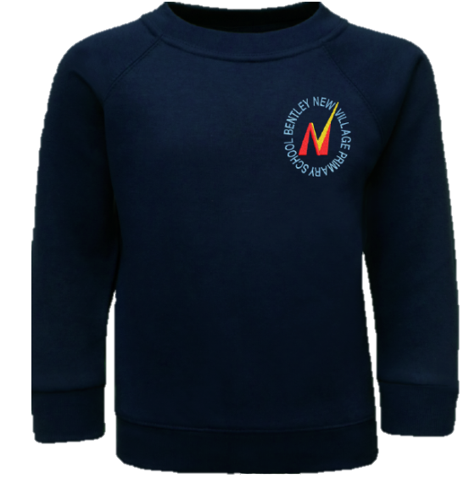

Jewellery:
- Small-faced watch - to be analogue or digital. No smart watches. Fitbits are allowed.
- Stud earrings
- All jewellery must be removed for PE or outdoor physical activities

NB - If a child needs to wear a piece of jewellery for medical or religious reasons, it must be agreed with the Headteacher and removed, or covered up, during physical activity.

Make-up

Make-up may not be worn to school, unless for themed activity days and a function out of school hours, e.g. a school disco.

Nail Varnish

Nail varnish on children is not permitted. False nails are also not permitted as these form a Health and Safety risk.

P.E Kit
All pupils are required to wear:
- Plain navy blue, grey or black sports shorts, jogging trousers/tracksuit bottoms
- Plain white t-shirt (plain or school logo allowed)
- Jumpers- hoodies or jumpers (with or without a zip) either plain, navy blue, or school branded
- Footwear: trainers or plimsolls

All of the above generic uniform items are available to be purchased from a range of high street retailers or supermarkets. Optional branded items for PE which are available for purchase from http://www.schooltrends.co.uk/
- PE Shirt
- Hoodies
- Shorts

Swimming Kit:
Pupils will go swimming as a statutory part of the National Curriculum in Key Stage 2, usually in Year 5.
- swimming trunks (and not shorts)
- hair tied back if required
- wear a one-piece swimming suit and not a bikini
- a towel
- Swimming goggles are suggested, however they are optional.

