
BENTLEY NEW VILLAGE PRIMARY SCHOOL
Computing Policy
COMPUTING LEADER: G HUGHES
HEADTEACHER: V Simmons
2025-2026

PERSON RESPONSIBLE FOR POLICY: APPROVED: SLT | Gareth Hughes
PERSON RESPONSIBLE FOR POLICY: APPROVED: SLT | DATE: September 2025
SIGNED: | ROLE: CO-ORDINATOR
TO BE REVIEWED: | DATE: September 2026
School vision
Together, we will create a calm and welcoming learning environment and work together to secure success for all. We will strive to create a safe, caring, supportive and inclusive school. Our school will equip pupils with the skills that society and the local community demand. We will value the knowledge and learning that children need to look after themselves, their families and their mental and physical wellbeing. We will teach the whole child to create lifelong learners and proactive citizens.
Ethos
1. All children can learn; all staff and pupils recognise the value of learning.
2. Staff at Bentley New Village have consistently high expectations of children’s learning potential, attitudes and behaviour and take shared responsibility for this across school.
3. Learning happens across the school day — inside and outside the classroom.
4. Children will be taught how to learn and to become outstanding learners.
5. Consistently challenging, engaging and empowering teaching supports excellent learning and helps every child to fulfil their potential.
6. Staff will value every child’s contribution and create a learning environment that brings out their full potential.
7. Rigorous monitoring, evaluation and accurate analysis of teaching are essential to improving practice.
8. Learning at Bentley New Village will develop skills that last a lifetime.
9. We are committed to continuous professional development for all staff.
10. All children will be encouraged to develop as individuals, with their creativity, talents and uniqueness celebrated.
School values
Determination — Resilience — Tolerance — Cooperation — Creativity — Curiosity
Curriculum mandate
Our curriculum offers equitable opportunities for all pupils to access a curriculum rich in knowledge, experience and language. We prioritise vocabulary development, oracy and reading across subjects. Through our curriculum children are exposed to diversity and learn how to take responsibility for their physical and mental wellbeing. Our mission statement: 'What challenges us, changes us.'
Rationale
Bentley New Village serves a community with a high proportion of families in areas of economic disadvantage. Many children have limited experience of home access to computing equipment. The school therefore prioritises ensuring pupils gain the basic computing skills and knowledge they need to access future opportunities. We focus on three complementary strands: digital literacy, computer science and information technology. Computing lessons build skills, knowledge and confidence so pupils can safely
and creatively use technology.

Purpose of the policy
This policy:
- Explains how computing links with our values, British values, SMSC and safeguarding.
- Defines key vocabulary and progression expectations for each year group.
- Explains roles and responsibilities.
- Summarises the topics and approaches to be delivered across the school.

Aims
Our aims are that pupils will:
- Understand online safety and be responsible for their own wellbeing online.
- Experience a stimulating computing curriculum that builds procedural and declarative knowledge progressively.
- Develop learning behaviours: creativity, curiosity, resilience, determination, tolerance and cooperation.
- Apply English and maths basic skills within computing contexts.
- Learn and use technical vocabulary appropriately.
- Have opportunities to plan and complete projects using equipment correctly and evaluate their work.

Intent / Implementation / Impact
Intent: all children will understand the importance of online safety, build technical vocabulary and develop computational thinking skills.
Implementation: we use the Teach Computing (NCCE) scheme of work to deliver a progressive sequence of units and lessons. Teachers use knowledge organisers, low-stakes quizzes for retrieval practice, challenge questions, and opportunities to record pupils’ comments and examples of their work (for instance in a floorbook or class portfolio).
Impact: pupils will be critical thinkers, confident users of technology, aware of online safety, and will meet national expectations for the end of each key stage.

Responsibilities
Senior leadership team:
- Appoint a subject coordinator and ensure computing provision is resourced and monitored.
- Ensure budget and capital replacement for equipment.

Subject coordinator:
- Ensure the curriculum is progressive and that units prepare pupils for secondary school.
- Manage the technician (if available) and prioritise technical issues.
- Oversee the budget and update school website and staff when necessary.
- Provide or direct staff CPD and share updates from Teach Computing and NCCE.

Teachers:
- Deliver the computing curriculum accurately and plan lessons that link to school drivers and values.
- Use knowledge organisers, include a 'Do Now' starter and record pupil voice/examples of work.
- Use formative assessment and low-stakes quizzes to inform planning.
- Model technical vocabulary and provide opportunities for pupils to present their work.

Support staff:
- Support pupils and help maintain equipment.

Pupils:
- Show cooperation, resilience and respect for equipment.
- Demonstrate creativity and curiosity when using hardware and software.

Parents:
- Reinforce online safety at home and encourage responsible use of devices.
- Support children to respect school equipment and to use email and social media responsibly.

Pedagogy and timetable
Computing is taught for 1 hour per week in KS1 and KS2 (foundation stage provision is planned to match the early years framework). Sessions are timetabled and additional equipment can be booked when required. Teachers plan short-term sequences delivered as blocks or series of lessons across a half-term. Lessons model skills explicitly and provide practice and application across the curriculum.

Long-term planning and curriculum strands
Long-term planning ensures each strand (computer science, information technology, digital literacy) is taught on balance and revisited. The curriculum includes: computing systems and networks, programming, creating media, data handling and online safety. Knowledge organisers and progression maps are used for each year group.

Adaptive teaching and inclusion
We use adaptive teaching to make the curriculum accessible for all pupils. The scheme is referenced to National Curriculum attainment targets to ensure progression and coverage. Support includes additional adult help, adapted resources, specialist equipment for sensory needs and peer support.

Vocabulary and oracy
Pupils are expected to learn and use technical vocabulary linked to each topic. Oracy is prioritised in computing lessons through practical tasks, paired talk and presentations.

Marking and feedback
Most computing work is electronic and stored in individual folders; some work will be printed where appropriate. Feedback is mainly verbal and linked to lesson objectives and basic English and maths skills. Pupils should be able to explain their development points.

Themes and unit overview
Each half-term follows a broad theme which loosely ties the computing work across the school. Example themes:
- Autumn 1: Using technology safely
- Autumn 2: Communication
- Spring 1: Algorithms / Programming
- Spring 2: Using software on a range of digital devices
- Summer 1: Collect, analyse and present data
- Summer 2: Detecting and correcting errors

Assessment
Formative and summative assessment are used to monitor progress. Lessons include formative checks (questioning, success criteria, practical tasks). End-of-unit quizzes and knowledge checks record pupils’ understanding and inform subsequent planning. Termly records of progress are submitted to the assessment leader.

British values and SMSC
Computing contributes to British values and SMSC: democracy (collaborative projects and decision-making), rule of law (understanding laws such as copyright and data protection), individual liberty (making safe online choices), mutual respect (peer feedback) and cultural awareness (how technology connects communities).
Safeguarding and online safety
Online safety is taught explicitly and referred to in the school's Online Safety policy. Staff follow safeguarding procedures for reporting concerns. Pupils are taught secure password practice, privacy, recognising risks and reporting concerns.

SMSC
SMSC
Spiritual Development | Moral Development | Social Development | Cultural Development
Students are continually reflecting on their own lives and the lives of others as they look at various ICT/Computing case studies. Students debate and formulate their own set of values and beliefs through case studies as they share their own experiences.  Computing provides opportunities for reflection of awe and wonder about the achievements in ICT today and the possibilities for the future. ICT lets students have the opportunity to reflect on how computers can sometimes perform better in certain activities than people. To promote students’ spiritual development, their sense of self and their will to achieve, the computing department continually takes the opportunity to praise students for their contribution in lessons. | Through real life case studies, students consider issues surrounding the misuse and access rights to personal data. The use of case studies in computing encourages students to draw conclusions through evidence rather than their preconceptions whilst allowing the students the time to reflect on the origins of their own personal perceptions of a topic.  Students consider the effects of social networking and the consequences of cyber bullying; they also consider the legal aspects of ICT including the Data Protection Act, Computer Misuse Act and Copyright legislation. They consider the implications of file sharing and downloading illegally and the penalties for engaging in this type of activity. Students also consider the moral aspects of developments in technology including the use of CCTV cameras, Speed Cameras and Loyalty Cards to balance up people’s rights and responsibilities.  Computing helps students to explore aspects of real and imaginary situations and enables them to reflect on the possible consequences of different actions and situations. It can raise issues such as whether it is morally right to have computer games whose aim is killing and violence, and whether it is fair that some people in this country and in other countries cannot use the internet.  Other moral issues surrounding the topics of e-waste and the digital divide are also explored through case studies. The use of case studies in ICT encourages students to draw conclusions through evidence rather than their preconceptions whilst allowing the students the time to reflect on the origins of their own personal perceptions of a topic. | As part of the computing curriculum students are taught to think and produce work that reflects the needs of diverse audiences within our community and the wider community.  As students develop their skills in a range of software they are challenged to work in groups to find solutions whilst developing respect for the ideas and opinions of others in their team. This is particularly prevalent in the design phase of tasks given. In addition, students are encouraged to develop their team working skills through collaborative work and research. The students also explore the concept of teams and the roles that individuals have to play. Computing can also help all students to express themselves clearly and to communicate. As students’ progress through their learning they will consider more complex social needs and are encouraged to research and work collaboratively to find appropriate solutions to issues that may affect particular groups within society. | Computational thinking encourages students to develop and explore their problem-solving skills. Computing Empowers students to apply their ICT and computing skills and to gain knowledge of how programming links between subjects for instance maths.  Students explore how developments in technology have changed our culture, particularly the rise in social networking sites and the ability to communicate instantly across National and International borders. Computing involves the breaking through of linguistic and cultural barriers. It is possible to e-mail or chat across the world and to word process in the mother tongue.  Whilst studying various aspects of computing students are asked to reflect on how different cultures are portrayed on the internet and why or who is portraying them in this way. Students are also challenged to think about how differing cultures access and use the internet and what implications this has on the individual and the culture.

Learning Behaviours
Creativity | Curiosity | Resilience | Determination | Tolerance | Co-operation
Children explore creativity within Computing. By using iPads and laptops to draw, animate, design games and edit documents. Children are learning how to be responsible, competent, confident and creative users of information and communication technology. | Our Computing curriculum builds on our children’s natural curiosity and develops computational thinking that allows students to problem solve, by using computational language and vocabulary. | At BNV we focus on digital resilience; this involves having the ability to understand when you are at risk online, knowing what to do if anything goes wrong, learning from your experiences of being online, and being able to recover from any difficulties or upsets. Children who are digitally resilient will be equipped to handle the challenges of the modern, digital world | We want our children to relish challenges that being a computer scientist can bring: asking perceptive questions, thinking critically, weighing evidence, sifting arguments, and developing perspective and judgement. Our computing curriculum is to prepare our children for a rapidly changing world through the use of technology. Our high-quality computing curriculum is designed to enable them to use computational thinking and creativity to further understand the world. | In computing we understand that we are connected to people across the whole world. We understand that these are people from different communities, cultures, faiths and beliefs. We use the opportunities offered in computing to question, challenge and understand people with these different characteristics to support and develop our tolerance of them. | In Computing, we examine how the internet facilitates online communication and collaboration; our students complete shared projects online and evaluate different methods of communication. Additionally, children learn how to communicate responsibly by considering what should and should not be shared on the internet

Safeguarding
Please see Online Safety policy and subject overview.

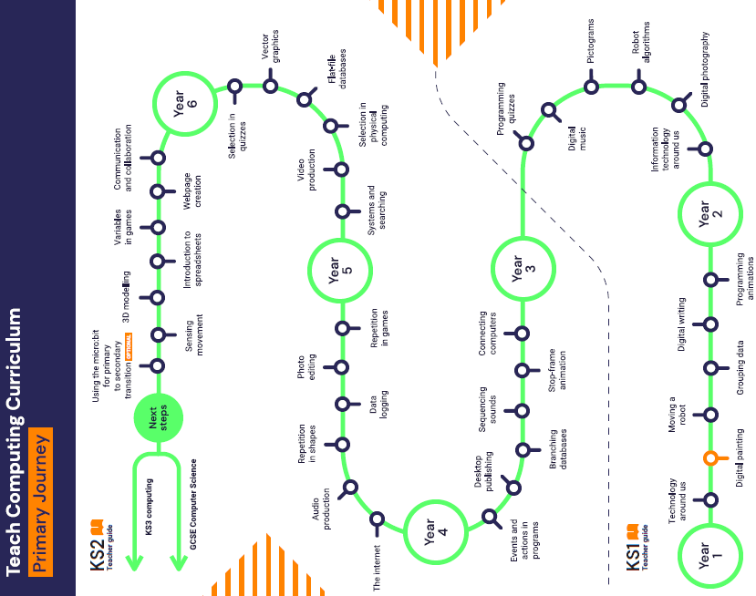
Appendices

Subject overview

Computing depends upon the development of many skills which should be evident in the learning opportunities at every key stage, across all subjects. Some of these skills are common to many areas of the curriculum such as the skills of listening, speaking, reading and writing.

There are, however, other skills which make a particular contribution to pupils’ learning in computing.
These include the skills of:
■ investigation
■ interpretation
■ improvement
■ evaluation
■ analysis
■ synthesis
■ application
■ expression
These skills will be used throughout school.

The Teaching of Computing in the Foundation Stage
At Bentley New Village, many children start in F1 with basic skills which are well below the national average.
- Computing in Foundation Stage 1 and 2 is linked to the Foundation Stage Curriculum.
- With these younger children, Computing is linked to their own lives and necessities.
- Vocabulary related to different themes is introduced
- Staff model the use of vocabulary and sentences, and where necessary paraphrase what the children say to provide good examples.
- Children are encouraged to ‘play’ and ‘discover’ with computing technologies.

The Teaching of Computing in Key Stage 1
- Children will build upon previous known skills to ensure that they are enhancing their technological skills.
- They will study:
- Digital Literacy – covering E-Safety issues.
- Computer Science – covering programming and technology in our lives.
- Information Technology – covering Multimedia and Handling Data.

The Teaching of Computing in Key Stage 2
- Children will build upon previous known skills to ensure that they are enhancing their technological skills and are working towards being ‘secondary ready’ at the end of the Key Stage.
- They will study:
- Digital Literacy – covering E-Safety issues.
- Computer Science – covering programming and technology in our lives.
- Information Technology – covering Multimedia and Handling Data.

