2025

Mathematics Policy

Maths Policy
BENTLEY NEW VILLAGE PRIMARY SCHOOL
HEADTEACHER: kirsten mckechnie

BENTLEY NEW VILLAGE PRIMARY SCHOOL
SUBJECT LEADERS; A. SMITH & G.HUGHES
MATHS POLICY
PERSON RESPONSIBLE FOR POLICY: A. Smith & G. Hughes  APPROVED: SLT | Maths Subject Leaders: A. Smith & G. Hughes
 | DATE: July 2025
SIGNED: A.Smith | TO BE REVIEWED: July 2027

OUR SCHOOL VISION
Together, we will create a calm and welcoming learning environment and work together to secure success for all. We will strive to create a safe, caring, supportive and inclusive school.
Our school will equip its pupils with the skills that society and the local community demand and so we will value the skills and learning that children need in order to look after themselves, their families, their health, their mental well-being and their bodies. We will strive to teach the whole child and create life-long learners and pro-active citizens.

ETHOS
We believe that:
- All children can learn. All staff and children are able to recognise the value of learning.
- All staff, working at New Village, will have consistently high expectations of children’s learning potential, attitudes and behaviour and take corporate responsibility for ensuring these in, and around, school.
- Learning takes place in all areas of our school and through the entire learning day - inside and outside of the classroom.
- Children should be taught how to learn; learning how to be an outstanding learner.
- Consistently challenging, dynamic, engaging and empowering teaching leads to outstanding learning, resulting in a school where every child’s potential is realised.
- All staff will value every child’s contribution to the school and strive to create a learning environment that brings out the full potential in all.
- Rigorous, continuous monitoring, thorough and informed evaluation and accurate analysis of all the elements of teaching, is essential in ensuring high-level teaching and learning.
- Learning at New Village will produce and enhance a learning skills-set that will be lifelong; we will actively promote this for every child and for all staff.
- New Village School will demonstrate its commitment to quality teaching and learning through its dedication to continuous professional development for all staff; recognising and exploiting all opportunities to enhance its workforce and the learning environment.
- All children will be encouraged to develop as individuals. Their creativity, talents, differences and uniqueness.
OUR SCHOOL VALUES
Determination – Resilience – Tolerance – Cooperation – Creativity – Curiosity

Curriculum Mandate
Our New Village curriculum will offer equitable opportunities for all pupils to access a curriculum that is rich in knowledge, experiences, understanding and language that represent the best of humankind. Whilst instilling in our learners a knowledge, understanding and appreciation of how to take responsibility for their physical and mental wellbeing. Through the curriculum, children are exposed to diversity through celebrating, studying and appreciating differences and similarities. We recognise the importance of language in school and throughout life and enrich the curriculum with opportunities to develop vocabulary, speak in different contexts, read quality texts and learn to be active listeners. Our curriculum contributes effectively to building a self-regulating, self-motivated individual who consistently demonstrates the New Village key values when faced with challenge because we know what challenges us changes us.

The Purpose and Aims of the Policy
‘Mathematics is essential to everyday life, critical to science, technology and engineering, and necessary for financial literacy and most forms of employment. A high quality mathematics education therefore provides a foundation for understanding the world, the ability to reason mathematically, an appreciation of the beauty and power of mathematics, and a sense of enjoyment and curiosity about the subject.’ Mathematics Purpose of Study – National Curriculum 2014.
This policy summarises our approach to the teaching of mathematics at Bentley New Village Primary to ensure systematic and consistent practice throughout the school and result in our pupils leaving BNVP as confident and independent learners.
Intent | Implementation | Impact
- All children can achieve in mathematics from their starting point.  - A typical Maths lesson will provide the opportunity for all children, regardless of their ability, to work through fluency, reasoning and problem-solving activities.  - Lessons use manipulatives to develop a secure base upon which to build children’s mathematical understanding.  - Maths is a journey and a long-term goal achieved through exploration, clarification, practice and application over time.  - At each stage of learning children should be able to demonstrate a deep, conceptual understanding of the topic and build on this and apply it over time.  - Ensuring that our children have access to a high quality Maths curriculum that is both challenging and enjoyable  - Providing children with a variety of mathematical opportunities, which will enable them to make the connections in learning needed to enjoy greater depth of learning and understanding  - Ensuring that children are confident mathematicians who are not afraid to ‘have a go’ and take a risk.  - Fully develop independent learners with inquisitive minds who have a secure mathematical foundations and an interest in self improvement  - Challenge children to try new concepts and teach resilience when we are unable to solve a problem first time around  - To return to concepts in Do Nows to reignite learning and embed in Long Term Memory.  - Fully follow the National Curriculum, alongside our own bespoke curriculum structure and Unit Plans.  - To provide children with mathematical language and communication skills to enable clear and accurate explanations.  - Majority of children progress through maths curriculum content at the same pace. Adaptive teaching is in place and interventions support children to close the gap in their learning.  - Emphasis on early and thorough coverage of core knowledge to enable pupils to progress through the curriculum at increasing rates later on. | - Curriculum structure delivers the strands in blocks of learning to promote depth learning and a teaching for mastery approach.  - Use of accurate and diagnostic questioning, mini quizzes, Do Nows, maths meetings to recap and reinforce their understanding; and to test conceptual and procedural knowledge and identify children who may need intervention  - Teachers will use the concrete, pictorial and abstract approach (CPA) to ensure that procedural and conceptual understanding are developed simultaneously.  - Challenge for pupils grasping concepts quickly is provided through depth tasks and breadth of experience.  - Use of Power Maths, White Rose, NCETM, Maths Mastery, Planpanion, I See Maths resources across school  - Introduction of new vocabulary is made daily and displayed on the classroom Working Wall. Teachers clearly define and model the use of the vocabulary introduced and sentence stems  - Talk Tasks are evident in all mathematics lessons and specifically planned for. This allows all children to orally rehearse their explanations and justify their reasoning.  - Full sentence responses are expected in class lessons. Teachers model and rehearse clear explanations.  - Following of the Calculation Policy, which enables staff to teach standard methods systematically and progressively across all age groups.  - All children from Year 2 to 6 are taught Multiplication and Division Facts following Number Sense - a Timetable scheme  - Children from F2 through to KS1 have Mastering Number sessions to support number development and basic number fact  - All F2 and Year 1 children and children working at that curriculum age have access to Numbots to allow for regular and focused practice of basic skills and to support their number development  - All children from Year 2 have access to Rockstars, which is a web-based ability- appropriate times tables programme, which children access at home and school.  - Children in 5 & 6 have Math Meetings to reignite previous learning | - Children will have a confident ‘can do’ attitude towards mathematics. They will use arithmetic and times tables fluently and make connections in order to solve real life problems.  - They will recognise that Mathematics is essential for everyday life and make at least good progress in Mathematics from their last point of statutory assessment or from their starting point in Nursery.  - Children will be able to use and understand the various mathematical terms and thus make good progress against National Expectations.  - Children will be able to explain and justify in all areas of the curriculum in the same way as in maths lessons.  - Children will be able to move between different representations to support their understanding  - Children will have the ability to recognise relationships and patterns  - Children will be able to apply their knowledge to different scenarios and to choosing the most efficient way to solve a problem.  - Children will make at least good progress in Mathematics from their last point of statutory assessment or from their starting point in Nursery.  - Children will use their Mathematics knowledge and skills, in all curriculum areas, to enable them to know more, remember more and understand more.  - Children will recognise the importance of Mathematics as a facilitating subject to enable them to access other areas of learning and operate successfully is everyday life both now and in the future.

RESPONSIBILITIES
- SLT will ensure that all children have access to a high quality Maths curriculum that is both challenging and enjoyable. They will ensure that the majority of children progress through the maths curriculum content at the same pace and that adaptive teaching is in place.

- Subject Leaders will ensure that all children can achieve in mathematics from their starting point and that a Maths lesson will provide the opportunity for all children, regardless of their ability, to work through fluency, reasoning and problem-solving activities They will ensure that teaching fully follows the National Curriculum, alongside our own bespoke curriculum structure and Unit Plans. They will ensure that teaching provides children with mathematical language and communication skills to enable clear and accurate explanations.

- Teachers will provide children with mathematical language and communication skills to enable clear and accurate explanations. They will challenge children to try new concepts and teach resilience when they are unable to solve a problem first time around. They will ensure that children are confident mathematicians who are not afraid to ‘have a go’ and take a risk as well as providing children with a variety of mathematical opportunities, which will enable them to make the connections in learning needed to enjoy greater depth of learning and understanding.

- Support Staff will ensure that children are confident mathematicians who are not afraid to ‘have a go’ and take a risk. They will support children in using mathematical language and communication skills to enable clear and accurate explanations.

- Pupils will try new things, be resilient to problem solving and develop an enjoyment of math.

- Parents will support their child to try new things and be resilient to problems. They will support their child in accessing TTRS at home.

PEDAGOGY
The Ofsted Research review series on mathematics have classified mathematical curriculum content into 3 ways:
- Declarative knowledge – consists of facts, formulae, concepts, principles and rules. It can be prefaced with the sentence stem ‘I know that’
- Procedural knowledge – is recalled as a sequence of steps, it consists of methods, algorithms and procedures. It can be prefaced with the sentence stem ‘I know how’
- Conditional knowledge – gives the ability to reason and solve problems. Useful combinations of declarative and procedural knowledge are transformed into strategies to support solving relevant problems. It can be prefaced with the sentence stem ‘I know when’.
In Mathematics, like all other subjects, we recognise the importance of the methods and practice of teaching (the pedagogy) we choose to use in enabling pupils to know more, understand more and remember more. In Mathematics, the following approaches will be used, and be evident in pupil discussion, observations and work in books, in order to ensure that the learning opportunities and skill development are as effective as possible and that pupils progress throughout the year and across year groups during their maths experiences in school:

Teaching Sequence in Mathematics | Dependant on Year group;  Daily Maths Meeting – fast-paced, revisiting concepts previously taught, no written evidence needed or multiplication session dependant on year group  Number Sense Multiplication and Division Program  Mastering Number
Teaching Sequence in Mathematics | Do Now – to revise prior learning
Teaching Sequence in Mathematics | ‘The Big Picture’ – setting the mathematics learning that is about to take place within the chronology of pupil’s maths learning and skill development to date. Starting with what the children know, understand, are able to do and able to say.  Sharing of the WALT/WILF
Teaching Sequence in Mathematics | Specify key vocabulary to be used and its meaning.
Teaching Sequence in Mathematics | Specify mathematical skills to be used and clearly model the expectations; I do, We do, You do
Teaching Sequence in Mathematics | ‘Talk Task’ - Provide opportunities for the children to develop their Oracy and mathematical understanding whilst working interactively
Teaching Sequence in Mathematics | Response to assessments – children are to be secure in their knowledge before moved on to new concepts
Teaching Sequence in Mathematics | Elements of fluency, reasoning and problem solving – variation should be embedded, access for all
Teaching Sequence in Mathematics | Provide opportunities for children to critically review their own work and that of others. Individual reflection on the learning and mathematical skill development that has taken place.

OUR CURRICULUM PLANNING – F2 to Year 6
Curriculum Structure – The Curriculum structure delivers mathematical strands in blocks of learning to promote depth learning and a teaching for mastery approach. There is an estimated number of weeks teaching time but this is flexible to allow children to gain that deeper understanding.

Unit Plans – These plans give the NC objectives, vocabulary, ready to progress criteria and links to resources to allow a teacher to plan the relevant unit of work. Teachers assess the pupils' starting points prior to adapting the learning in any given unit. The Unit plans also give the teacher an overview of:
- The pre-requisite skills and knowledge that pupils should bring from prior learning (from the previous academic year);
- The potential gaps in learning of the cohort, based on AfL, transition information from the previous teacher or if pupils have come from another school;
- What common difficulties and misconceptions are associated with the learning within the unit.

Short term plans – Short term planning are the teachers own. It was agreed, to support staff wellbeing and reduce workload, that planning should take the form of slides used to teach. There are some basic elements to these plans;
- Do Now activity – either rehearsal of previous coverage or application of knowledge. Frequent low stakes testing of taught content can help prepare pupils for summative tests and providing memory enhancing opportunities to recall and apply taught content.
- Clear reference to the WALT – these should be directly linked to the small steps for that mathematical strand
- Dedicated slide for vocabulary – this should be defined and children encouraged to use
- Clear procedural modelling using worked examples; I do, We do, You do – Fluency moving onto reasoning and problem solving where all children have access to depth learning
- Opportunity for a talk task and use of specific sentence stems – this SHOULD be modelled clearly to the children
- Depth Task Modelled
- An opportunity to independently rehearse content
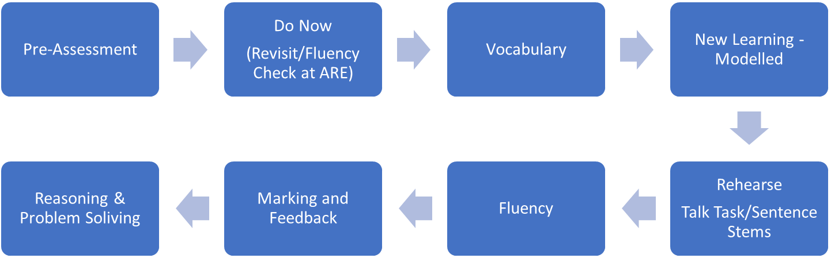

These plans should ensure that the maths lessons are:
- well structured, lively and delivered at a good pace
- structured to embed mathematical understanding through concrete, pictorial and abstract representation.
- Encourage the use of specific mathematical vocabulary
- Encourage the use of talk partners and feature discussions and explanation as children are encouraged to explore their own and others’ ideas, as an essential part of the learning process. Pupils will be encouraged to ask, as well as answer, mathematical questions.
- Provide the mathematical challenge through tasks and questioning which provides depth for all pupils
- Provide variation to broaden the children’s exposure to the learning objectives in a wide range of context to ensure deeper understanding of concepts.
- Adapt the teaching, questioning and level of support so that the children are all working towards the same learning objective appropriate to their age group.
- Ensure that all the maths equipment that could and might be used is available for the pupils. The pupils will decide what equipment they might use to tackle the challenge and will collect these resources as needed. This will encourage the pupils to think through the process of solving the challenge or problem and minimise wasted learning time.
- Provide an emphasis on pupil's learning beginning with practical examples leading onto informal jottings and mental strategies, and finally to formal representations as laid out for year groups in the calculation policy.

Class teachers are responsible for the content of the maths sessions although they may be delivered by a different teacher, HLTA or TA. Should a teacher not teach a maths lesson (perhaps due to PPA or professional development opportunities), the class teacher remains responsible for the effective delivery of the learning outcomes and must ensure sufficient time for the person covering to become familiar with the planning and expectations for the lesson.

Similarly, the class teacher is responsible for ensuring that those pupils who display a particular gift for mathematics or/and achieve at a level higher than expected for their age are appropriately challenged and supported to maximise their progress. This will include the provision of different, more appropriate work rather than ‘differentiation by exhaustion’ whereby pupils are simply expected to do more of the same.

TEACHING SEQUENCE
Classes complete three lessons of teaching a strand, one lesson weekly will have a problem solving focus and one will be an arithmetic / purple pen reflection opportunity. Year 1 will gradually build in the teaching of arithmetic as the year progresses.

ADDITIONAL TO THE MAIN TEACHING SESSION

In addition to the main teaching session, pupils will access an additional Number Sense or Math Meeting depending on Year group and the focus for that year group.

F1 – Daily Math Meeting
F2 - Daily Math Meeting, Mastering Number, use of Numbots
Year 1 – x 4 Mastering Number, use of Numbots
Year 2 – x 4 Number Sense, use of Numbots
Year 3&4 – Daily Number Sense
Year 5&6 – x 2 Number Sense, x 2 Math Meetings

NUMBER SENSE
From October 2023, teachers from Year 2- 6 will be using the Number Sense scheme to teach Multiplication and Division, either daily or twice weekly depending on year group. Please see the ‘Times table’ section below and our Times table progression document for further information.
Mastering Number
From September 2025, children in F2 and KS1 will be using the Mastering Number program to support their number development and basic numerical skills.

MATHS MEETINGS
Years 5 & 6 will provide the recall of key fluency facts within a Maths meeting twice weekly. It is a fifteen-minute whole class session, used to consolidate key areas of mathematics, which also gives the teachers an opportunity to check pupil’s general maths knowledge. It includes singing, whole class response and questioning to ensure that every child is involved, fully participating and enjoying maths, Maths Meetings help the teacher to fill in any gaps in understanding from previously taught lessons, but may also cover other content that may not be explicitly taught during a unit during that given week e.g. time.

During Maths Meetings, teachers use a mixture of open and closed questions. Closed questions are used to ensure pace and elicit a demonstration of knowledge, whilst open-ended questions allow for deeper thought, explanation and discussion.

Successful Maths Meetings should always:
- Be pacey and snappy
- Have 100% pupil participation
- Cover a number of areas
- Be fun with songs, chants and rhymes
- Include both open and closed questions
- Use a variety of resources and manipulatives
- Follow the same daily structure

PROBLEM SOLVING
As a school, we recognise the importance and need to teach problem solving and reasoning skills to our pupils. Therefore, each session will have a modelled depth question that all pupils have the opportunity to access. To support the development of problem solving and reasoning, we have introduced an explicit session into the weekly teaching sequence where talk and collaborative learning are central to teaching. Staff use a range of resources to deliver these sessions.

TIMES TABLES – refer to the Times Table progression document
Each Year group has a particular times table that they focus on each half term. By the end of Year 4, all children would have been exposed to all the times tables. Year 4 children now have to take a multiplication check. The purpose of the MTC is to determine whether pupils can recall their times tables fluently, which is essential for future success in mathematics.
Children are taught multiplication facts through Number sense; a multiplication and division program. The program develops recall of 36 core multiplication facts. Fluency in these facts provides the focus for all written and mental multiplication and division. New facts are introduced and taught visually through the conceptual lessons and orally through chanting of verbal sound patterns. Facts are learned to fluency through daily practise and target support where needed. Children’s progress in learning of these facts are assessed at the end of the half term using TTRS. TTRS is used for additional practise and to consolidate learning at home. Their learning of facts is further supported through; games, counting-stick work, step counting using manipulatives, chanting and technology-based, quick-reaction exercises.
The process follows the sequence Learn → rehearse → recall → play/apply/assess
There are 7 key steps that teachers should consider when introducing a new times table (these will be covered in more detail after this introduction):
Step 1 | Order of introduction
Step 2 | Making conceptual links to the real world - display
Step 3 | Use of the concrete, pictorial, abstract approach – use of arrays to model
Step 4 | Building fluency in multiplication and division facts and understanding multiplicative relationships using Number Sense
Step 5 | Explore patterns in times tables. Reasoning. Investigation. Deeper learning. Making links
Step 6 | Consistency of language
Step 7 | Time-tabled opportunities to practise times tables facts

MULTIPLE REPRESENTATIONS & MANIPULATIVES
An important part of ‘deep understanding’ in mathematics is being able to represent ideas in many different ways. Representing mathematics using different objects and pictures to represent abstract concepts is essential. At Bentley New Village Primary the children use manipulatives to represent mathematical concepts. Representing ideas in multiple ways ensures support and understanding for lower attaining pupils by giving a sense of meaning to more abstract problems, whilst it challenges the higher attaining pupils to see a concept differently and to build up their communication and reasoning skills.
All classes have some basic maths equipment appropriate for the age group. Children will have the opportunity to use a wide range of resources consistently throughout school (FSU – Y6). Manipulatives such as Numicon, 10’s frames, 2 coloured counters, base 10 materials, bead strings, pattern blocks, bar modelling resources, number lines, number tracks and number squares will support conceptual understanding for all pupils. Pupils can be helped with manipulatives but the aim should be that pupils move to working with symbols and abstract representations (Ofsted – research review series mathematics)

ADAPTIVE TEACHING
The mastery approach follows a cumulative, age related curriculum for depth. Deep understanding is promoted by fewer topics. The skills studied by a child are determined by their school year, with every child in a year group studying the same concept and skills. The highest attaining pupils study the same mathematical content as the lowest attaining – what is different is the way in which they are being taught and the level of support they are given. Challenge is provided through increased depth, rather than acceleration of content. Different learners have different needs, but they do not need different content. The questioning and scaffolding individual pupils receive in class, as they work through problems, will differ and pupils who grasp concepts rapidly are challenged through more demanding problems which deepen their knowledge further.
Formative assessment should be used through the lesson to identify children who need support or challenge. Pupils’ difficulties and misconceptions are identified and addressed with rapid intervention – commonly through individual or small group support later the same day: there are very few “closing the gap” strategies, because there are very few gaps to close.
Interventions and Closing the Gap
The Ready to Progress criteria is used in pre-assessments prior to a unit being taught to address any existing gaps in knowledge. For children working below their year group, the RTP criteria along with any QLA are used to assess a child’s gap in knowledge. Where possible, a one-to-one conferencing approach is taken when working with children to allow for discussion around misconceptions to allow for precision teaching. Following assessment, RTP intervention materials are used to close the gap in learning.
Children may also be placed on a times table intervention based on gap analysis. Subject leads regularly monitor interventions.

VOCABULARY AND ORACY
Good spoken language skills are important for all pupils to achieve their very best. At Bentley New Village Primary School, we focus on the importance of language, understanding and spoken word to ensure that communication for our children is as easy, effective and enjoyable as possible. All children will be provided with opportunities to learn new words, to understand their meanings and use them in context through written and spoken activities. Language development is a key focus for our children in ALL AREAS of the curriculum and the focus is to provide language to equip them for their future.
Language is vital to mathematics. Mathematical modelling (consideration of a real-life situation and using mathematics to solve it) is a crucial part of the subject. It is essential that the pupils are able to articulate their methods, findings and answers and to do so successfully they need explicit help which can only be given by extended discussion. It is often through discussion and listening to others that a pupil’s thought is modelled and expanded, acting as a scaffold for their own thinking. In order to deepen children’s mathematical understanding, every Maths lesson involving pupil talk either in pairs or small groups. The pupils are always encouraged to give full sentence answers, use provided sentence stems and use the mathematical vocabulary they have learned.

INCLUSION
Within most class groupings, there may be children who are working significantly above or below the level of their peers. The learning objective will take into account their bespoke BNVP APP targets ensuring challenge so that individual progress is made. Reasonable adjustments can be made to their tasks or level of support. Advice can be sought from the school’s SENCO where applicable.

Children with SEN are be supported to access maths through focused provision mapping and appropriate targets on Support Plans.

EARLY YEARS FOUNDATION STAGE (EYFS)
Mathematics teaching in EYFS begins with a focused adult-led session with direct teacher input and has high language expectations. The teacher and TA model the Talk Task for pupils. Adults then plan the indoor / outdoor continuous provision to enable pupils to explore the key learning from the unit through child-initiated play throughout the indoor and outdoor provision.

LEARNING ENVIRONMENT
The environment should be balanced with both Literacy and Numeracy resources being both eye catching and appropriate to the age of the children. In each class there is a working wall which is added to for the purposes of modelling teaching. The board displays modelling, mathematical vocabulary and appropriate mathematical challenges. This wall is used by children to support their learning. Displays may include concrete and pictorial apparatus to help support children to grasp concepts and mathematical vocabulary. To support the teaching of multiplication and division facts, a multiplication display reflects the facts being taught for that half term as well as a timetable strip. All classrooms have access to an interactive whiteboard. This should be incorporated into most Maths lessons.

ASSESSMENT
Children are set individual targets at the beginning of each year and progress towards them is regularly reviewed, each term, throughout the year.

Pre-Assessment | Formative Assessment (AfL) - (monitoring children’s learning) | Summative Assessment – (evaluating children’s learning)
Before embarking on a unit of learning the teachers should present a short pre-assessment to best analyse the starting points for the children and any gaps.  These pre-assessments should be:  - No more than 6 questions  - Use the RTP criteria where appropriate  - Questions covering expectations from the previous at least 2 years, then 2 questions from current year e.g. Fraction in Y4 – pre-assessment cover linked content from Y2, Y3 and then 2 or 3 questions from the Y4 content.  - Pre assessments are put into books  The analysis of this should inform the starting point of the unit of lessons. | Assessment is an integral and continuous part of the teaching and learning process at New Village and much of it is done informally as part of each teacher’s day-to-day work.  Teachers integrate the use of formative assessment strategies such as:  - effective questioning  - clear learning objectives  - the use of success criteria  - effective feedback and response in their teaching  - observing children participating in activities.  - Frequent low stakes quizzes  - Pre-assessment activities prior to units of work  Findings from these types of assessment are used to inform same day interventions, challenge and future planning. Planning should be annotated and those who need more support, must be identified on plans through use of AfL This plan, assess, review cycle ensures that misconceptions are identified and steps are put in place to support these learners.  From this information, staff plan the next steps to learning. Staff must ensure children have a solid basis of that aspect of learning before moving onto new concepts. Do not move on until most children do. For those who do not have this solid basis, then interventions in small groups should be used to ensure they do. For those who securely understand the concepts, ensure children can use and demonstrate the skills in a wide variety of contexts and problems (greater depth). | More formal methods are used to determine the levels of achievement of children at various times during the school year. Summative tests are used termly. A scaled score is recorded. They allow the school to measure each child’s attainment in all areas of mathematics, and compare this with an “average” for children of that age. The results are used to monitor individual’s progress in year and year-on-year. These termly assessments are used throughout the year to aid planning. In addition, the children of Yr2 and Yr6 complete the Statutory End of Key Stage Assessment.  We use termly assessments as a way of recording children’s progress in objectives covered across that specific term. This information is then submitted to the Assessment Leader.  Any summative assessments must be followed by an analysis of the results. The QLA should inform next steps in teaching and identify any gaps which should be addressed through keep-up, catch-up sessions.

MARKING AND FEEDBACK
Pupils’ work will be marked in line with the Marking Policy and will model how corrections should be made, giving pupils a chance to learn from their misconceptions or incorrect methods.

- Marking should always be focused on the Learning Objective
- Children to self-assess their work when appropriate
- Peer assessment should be used where appropriate using the Marking Symbols
- Children should always be given chance to read and respond to comments made
- Wherever possible, the checking or marking of work will be done with the child who will be given the opportunity to ask questions and self-correct (purple pen.)
- Corrections requested should be followed up by pupils and then checked by staff
- All work to be marked/acknowledged by class teacher or teaching assistant in a timely manner (before next lesson)
- Number formations issues ALWAYS to be picked up in marking and feedback for corrections.
- If verbal feedback is given during the lesson, the initials VF will be noted in the child’s book.

BRITISH VALUES
Math at BNVP promotes tolerance, individual liberty and democracy through the children’s collaborative work together and oracy opportunities. We endeavour to teach our children the skills for effective talk; how to listen to others’ opinions and to build on another’s view point whilst deepening their mathematical understanding of the concept being discussed.
PRESENTATION & RECORDING WORK
It is important that pupil progress is recorded. Some of the best learning does not happen on paper and may well have been achieved through the used of paired discussion and using manipulatives. It is paramount that these moments are captured photographically or via note taking, annotations to planning, to provide a record for staff, pupils and parents.
- The numerical date will be placed on the top line of the top left-hand corner of the page with the day, month and year e.g. 19.01.21 (Key Stage 1 / 2) and underlined
- A line will be left after the date before the learning objective (WALT) will be written underneath and underlined. (Key Stage 2)
- Maths work to be written as one number per square
- When necessary the page should be folded in half, questions and answers on the left of the page and jottings on the right.

LEARNING BEHAVIOURS

The pupils are encouraged to continually develop their BNVP key Learning Behaviours throughout the curriculum. Although we have a focus learning behaviour each half term, this does not mean that we do not continuously encourage the children to practise them all.

Determination | Resilience | Tolerance | Cooperation | Creativity | Curiosity
The pupils are encouraged to take risks and experiment with mathematical concepts and take leadership of their own learning | The pupils are taught to be patient, determined and resilient when faced with new problems or concepts. We foster a can-do attitude and belief. The pupils are encouraged to become reflective by listening and taking on board feedback to help them improve their work | The pupils are encouraged to become independent learners and to try first before asking for help or support. We encourage the children to work collaboratively and sensitively towards their peers. | The pupils are taught to share, ‘turn-take’ and show the skills needed to be a good talk partner. | The pupils are encouraged to make connections between different areas of mathematics when solving problems. They are also given the opportunity to understand the connections between mathematics and other subject areas and contexts: this in turn helps the children to develop a level of ‘mastery’ | The pupils are encouraged to use their curiosity and to explore ideas then applying their knowledge and skills to different contexts.

SMSC
Through various projects, mini investigations and activities built into lessons, SMSC, (Spiritual, Moral, Social and Cultural) is being delivered through maths lessons.

Spiritual development | Moral development | Social development | Cultural development
- Understanding how Mathematics relates to the world around them  - The skill of analysing data enables children to make sense of the vast amounts of data available in the modern world and around them  - Develop a fascination about how currency can be used in everyday lives  - Learning life skills such as telling the time, reading measurements and scales are taught in exciting contextual lessons  - Explore shapes in the world around them and talk creatively using mathematical language  - Understanding of patterns and sequences in everyday life. | - Recognise how logical reasoning can be used to consider the consequences of particular decisions and choices  - Explore a range of mathematical investigations where they are challenged and made aware that there may be more than one solution  - Proving or explaining whether an answer is right or wrong. This helps them learn the value of mathematical truth  - Mathematical reasoning can be developed by group work where the children are encouraged to talk about their learning and listen to others’ viewpoints  - Look at moral issues raised from a question and will investigate, often using statistics to find an answer | - Problem solving skills and teamwork through creative thinking, discussion, explaining and presenting ideas  - Work together productively on mathematical tasks  - Experimental and investigation work where children are encouraged to work collaboratively  - Work collaboratively when completing outdoor learning tasks  - Self and peer reviewing are very important to enable pupils to have an accurate grasp of where they are and how they need to improve. | - Begin to get a sense of number systems around the world  - Recognise that mathematicians from many cultures have contributed to the development of modern day mathematics  - Counting and explore early counting ideas from other countries such as tallies  - Explore more developed number systems such as Roman numerals, imperial and metric measurements  - Realise how the counting system has developed through the ages and shaped the decimal system we use today  - Exploring Mathematics applied in different cultures such as Rangoli patterns, symmetry, tessellations and Islamic geometric patterns.  - Application of math skills to exchange rates for foreign travel.

LEADERSHIP AND MANAGEMENT
Subject Leaders Role: | How this will be achieved:
- to empower colleagues to teach maths to a high standard and to support staff in the following ways  - to keep up-to-date on current issues through appropriate CPD; disseminating relevant information and providing training for staff members (either directly or through other professionals)  - to have a knowledge of the quality of mathematics provision across the school  - to identify and act on development needs of staff members  - to monitor expectations, provision and attainment across the school and providing feedback to develop practice further in order to raise standards.  - To provide necessary equipment and maintaining it to a high standard.  - To have a clear picture of the attainment and progress of pupils in maths  - To have an honest understanding of the pupil’s response and attitude to Maths and the quality of work produced. | - Classroom observation of Maths, including learning walks, with written feedback  - Questioning of children during these observations  - Discussions with pupils  - Carrying out regular scrutiny of work, and feeding this scrutiny back to teachers through termly health check and TOAP.  - Looking at Maths displays in classrooms and corridors.  - Monitoring each teacher’s Maths planning every term, as appropriate, and providing written feedback.  - Keeping all staff informed on changes that effect Maths in school.  - Attending any Maths Subject Leader meetings arranged by the pyramid schools or LA.

SAFEGUARDING
At BNVP, Safeguarding is everyone’s responsibility and is paramount to all that we do. Great importance is placed on identifying opportunities in the taught curriculum for children to learn about safeguarding. We are sensitive in our teaching and consider our children’s lived experiences. Please refer to BNV’s Safeguarding Policy for further information.

BENTLEY NEW VILLAGE MATHS NON-NEGOTIABLE EXPECTATIONS
- All work to be dated with the small number date.
- Learning Objectives taken from the National Curriculum and White Rose Small steps
- Learning Objective / WALT and Success Criteria/WILF to be discussed and shared with children
- WALT to be clear on all work (perhaps glued in for younger or less able pupils)
- Good presentation to be insisted upon. When squared paper is used, 1 number per square for all calculations. Writing as per writing expectations.
- Times tables practise – see separate times table document
- Marking to follow school marking policy
- Maths working wall to be evident in every classroom in order to support maths learning in accordance with the school learning environment policy. This should reflect the teaching sequence at the time of delivery.
- Times table display reflecting the facts being taught that half term
- Layout to be modelled and appear on Working wall
- Maths should be taught through ‘topic’ where possible.
- Maths calculation strategies to be taught as per the school calculation policy
- Language and vocabulary should be age-appropriate in discussions and used by adults and children.
- Correct use of basic skills to be maintained when recording work
- Wherever possible Teaching Assistants support individuals, pairs or groups of children in all aspects of the lesson
- Individual whiteboards are to be used as a tool for rehearsal only; evidence of work should be in books.
- Use of photographs to evidence other learning.
- Maths Meetings in Years F2, 5 & 6
- At least one Do Now to be evidenced in books weekly
- At least 3 to 5 pieces of work or evidence recorder per week.

APPENDIX A – Curriculum Overview for 2024/25
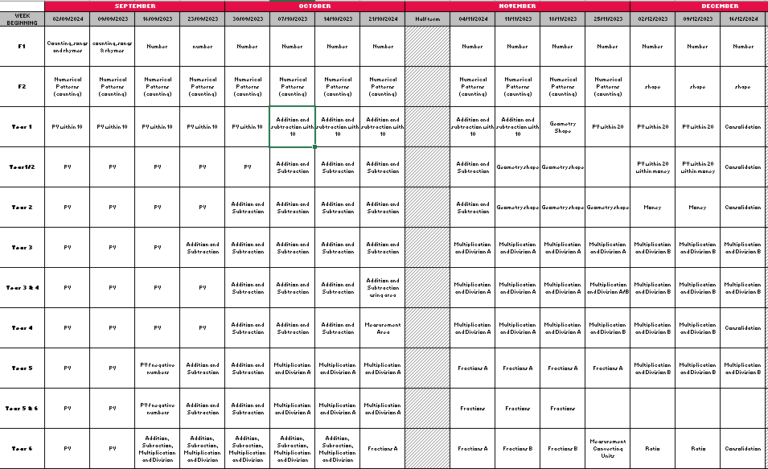

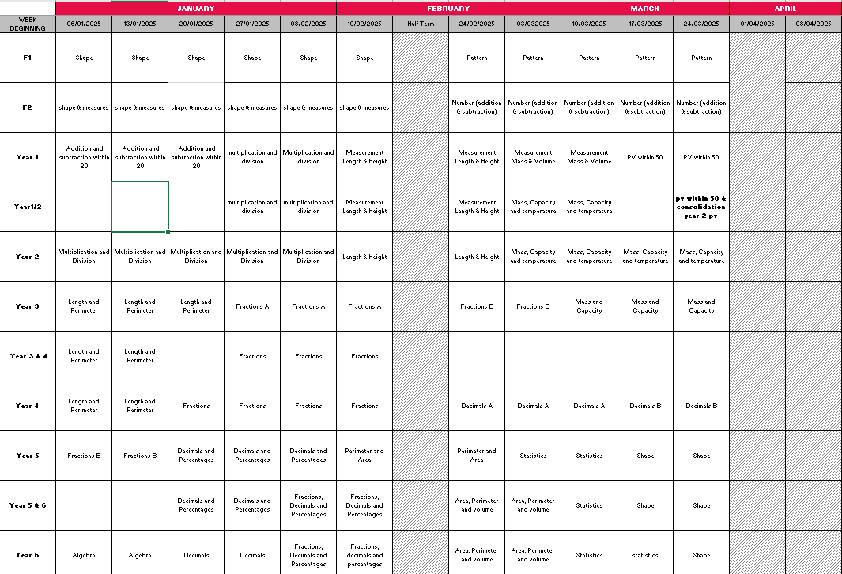
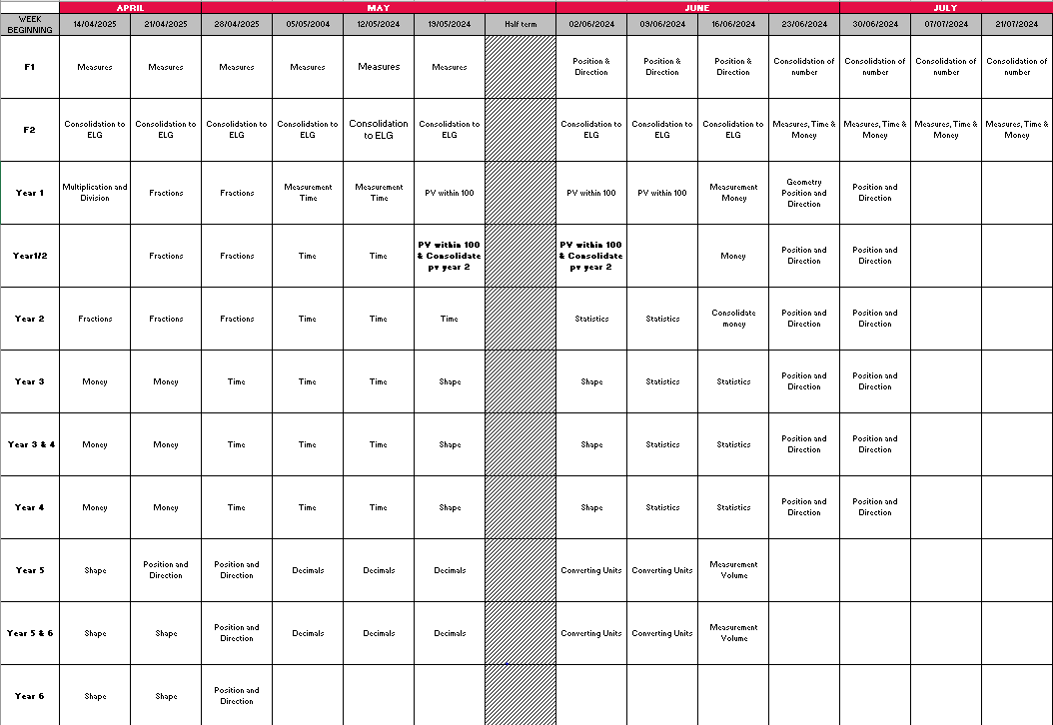

APPENDIX B – Ready to Progress Criteria

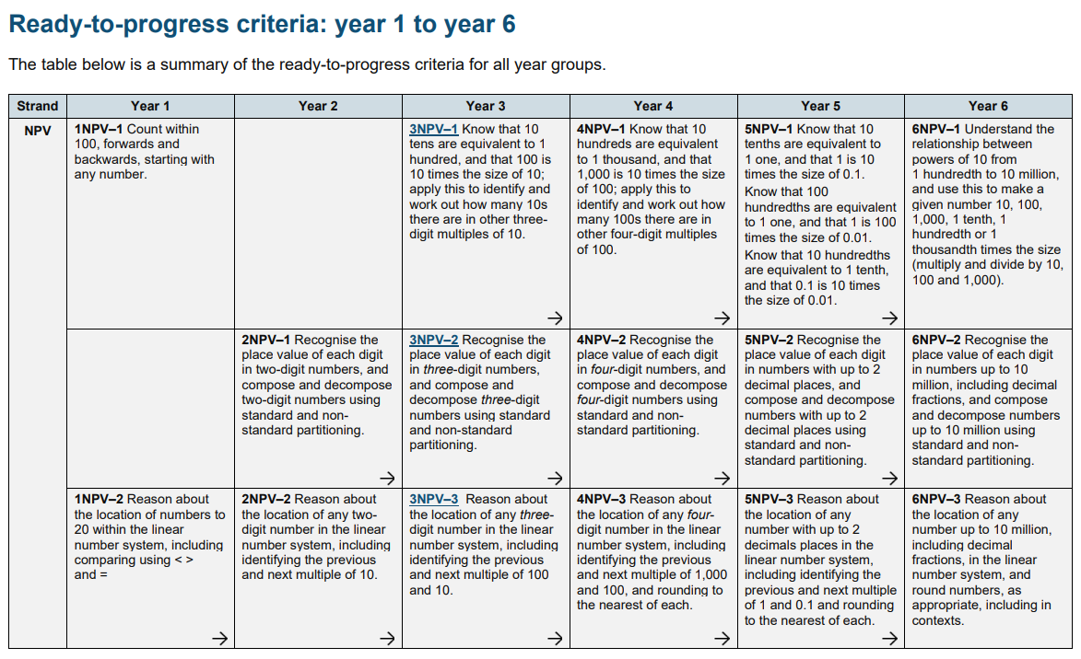
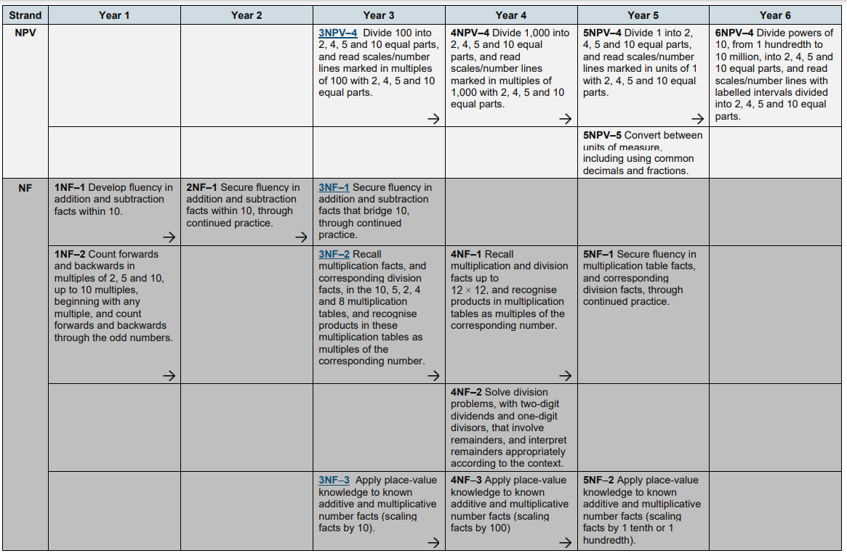
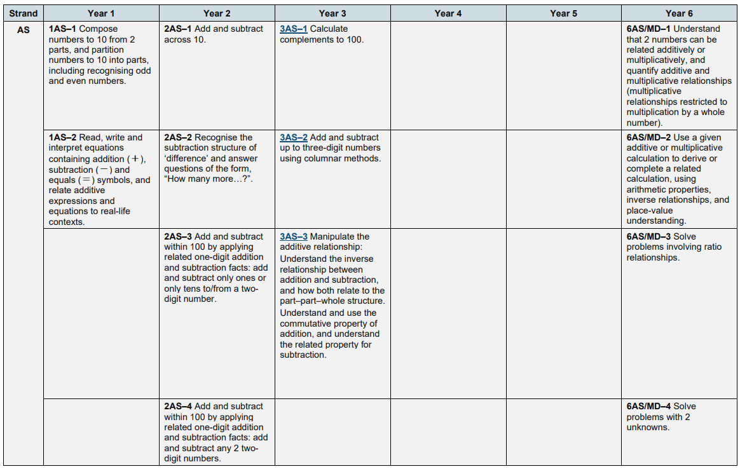

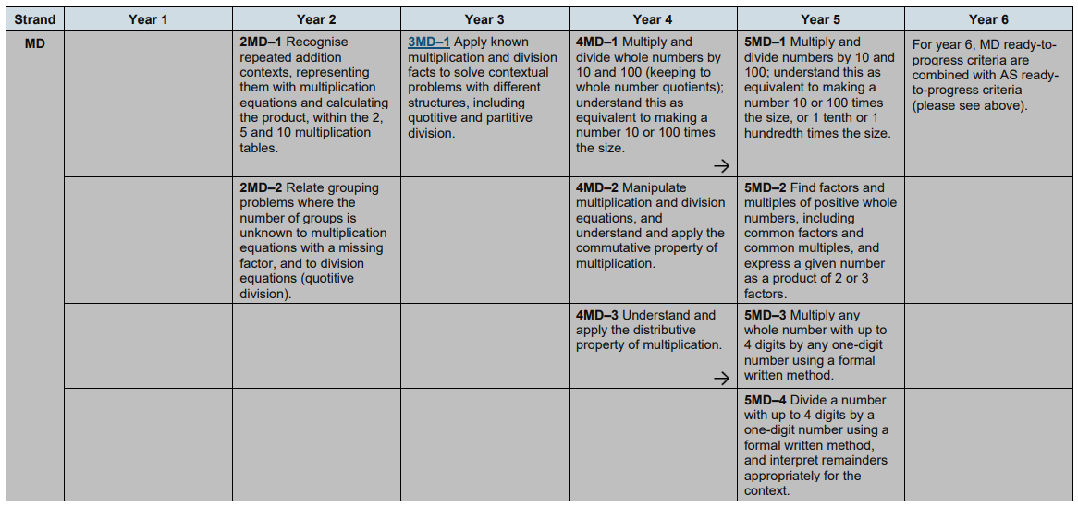

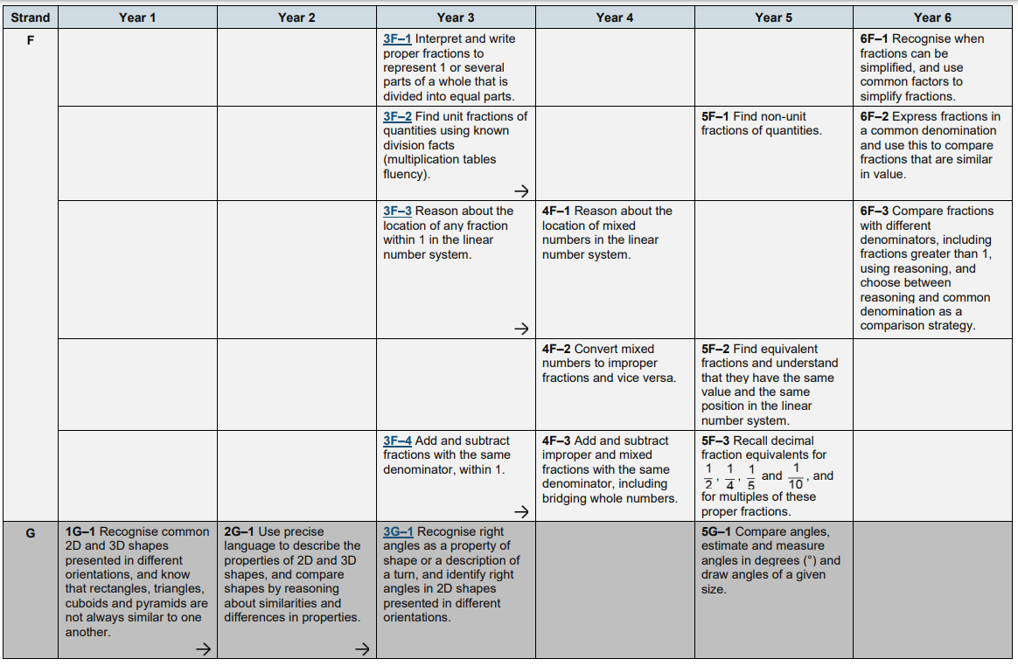

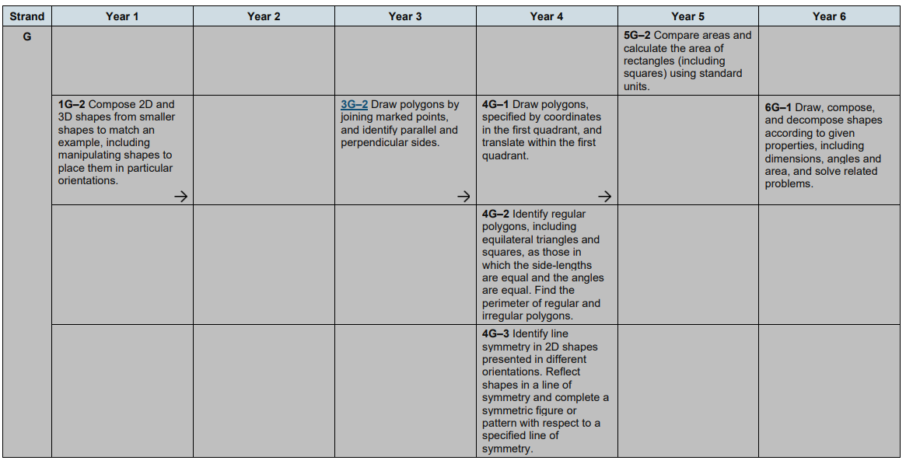

APPENDIX C – Progression Map

NPV
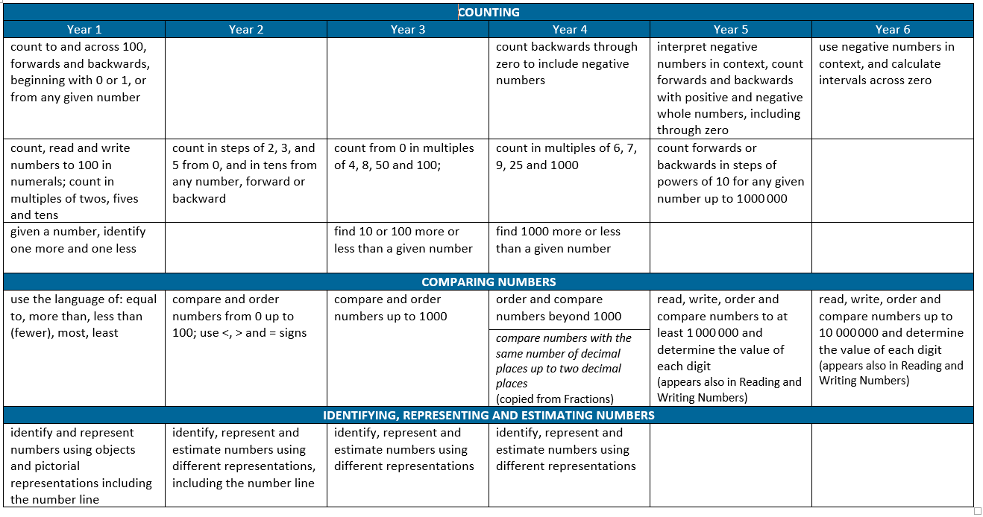

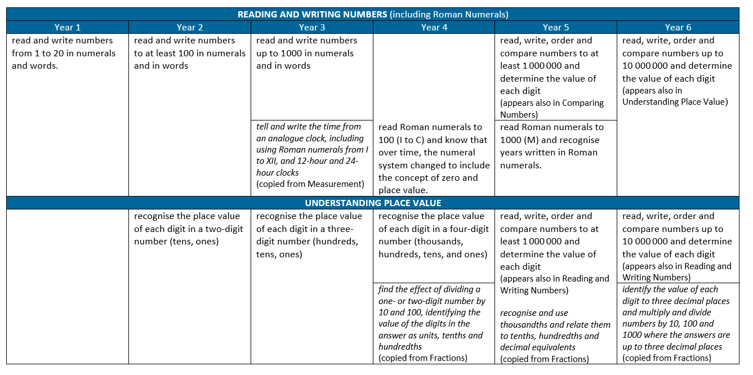

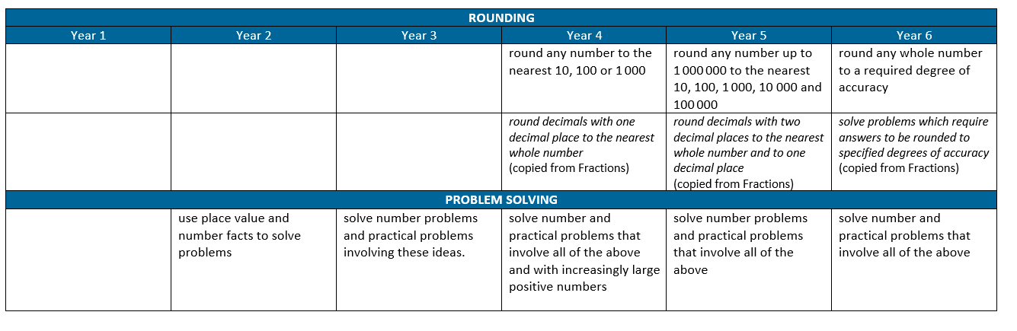

ADDITION & SUBTRACTION

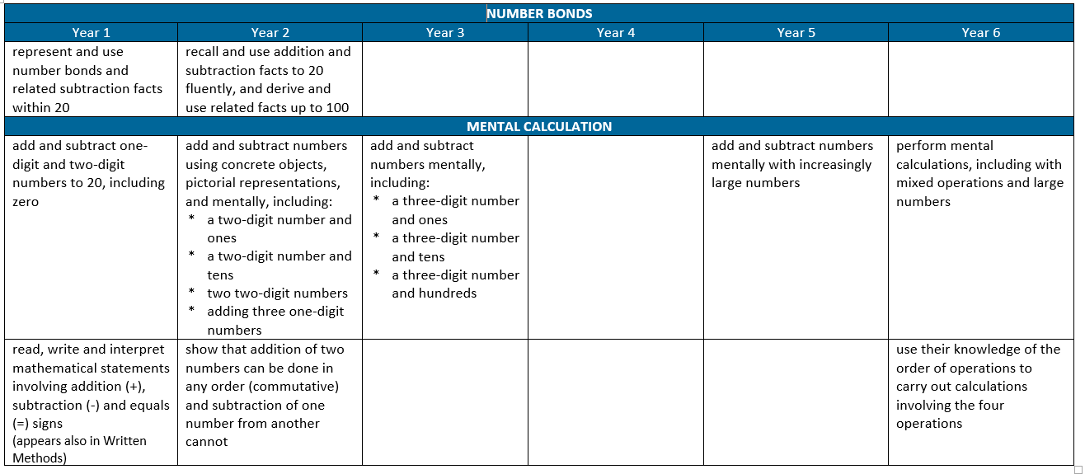

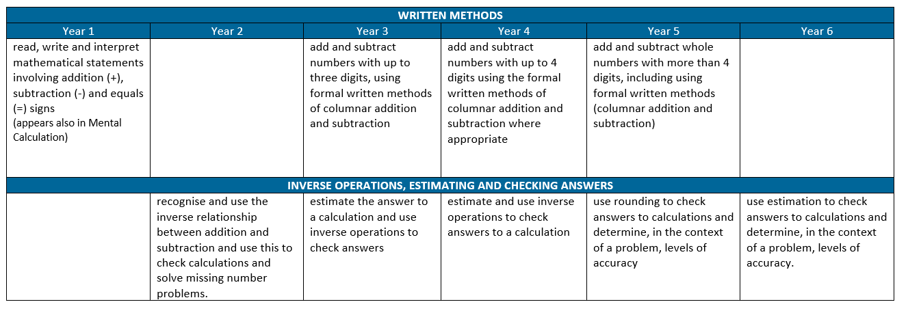
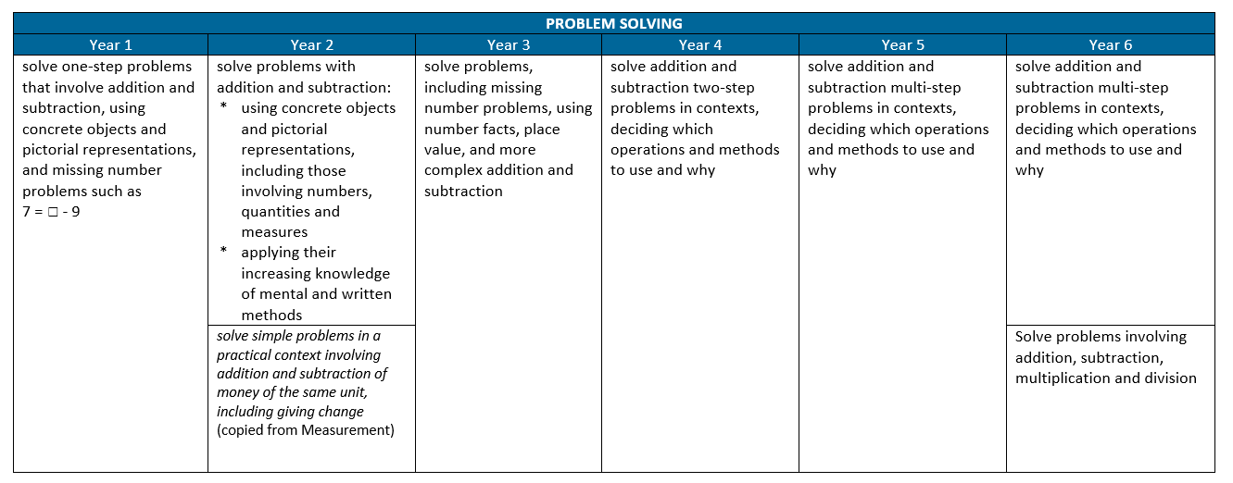

MULTIPLICATION & DIVISION
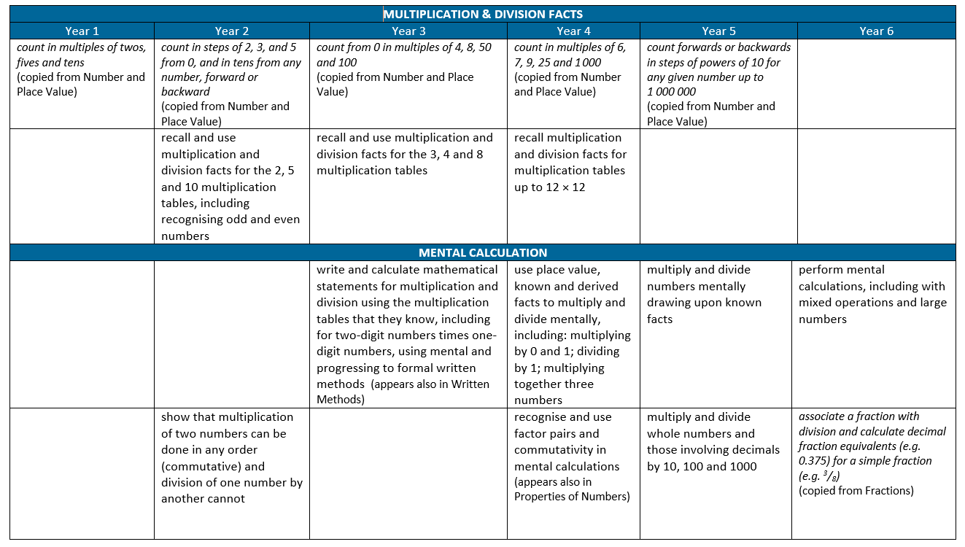
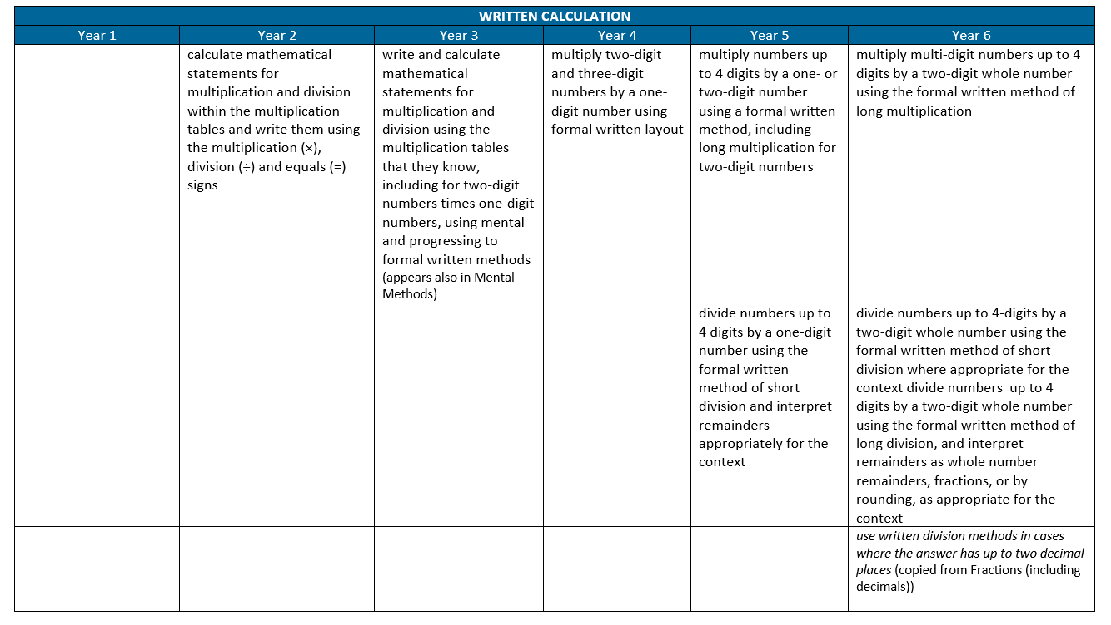
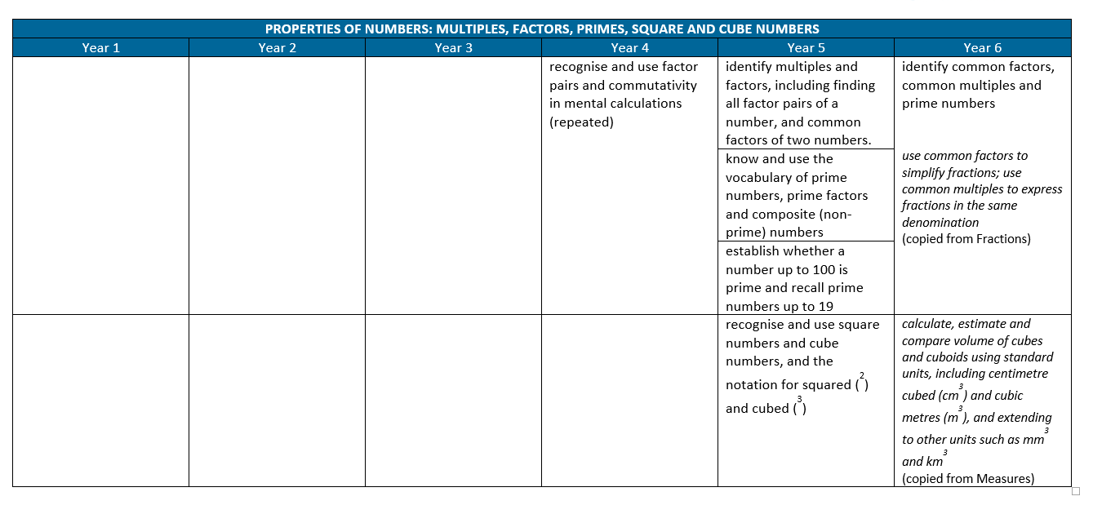

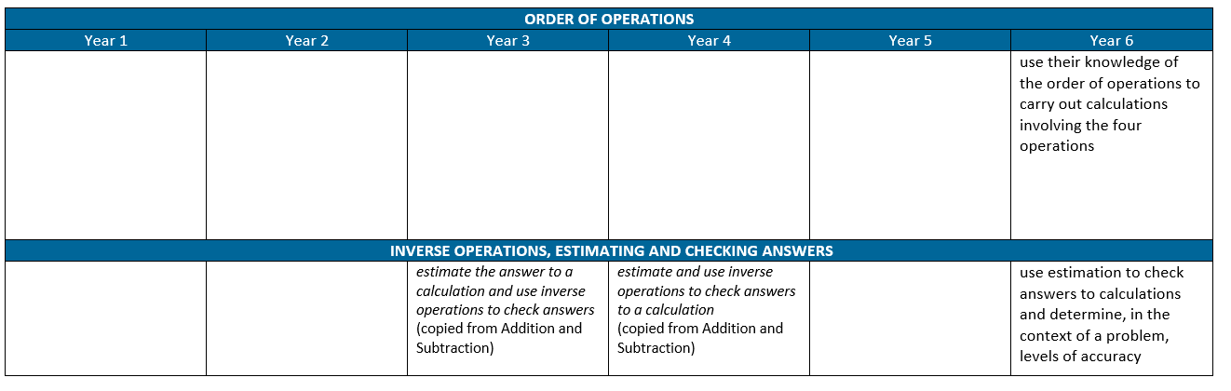

Fractions, including percentages and decimals

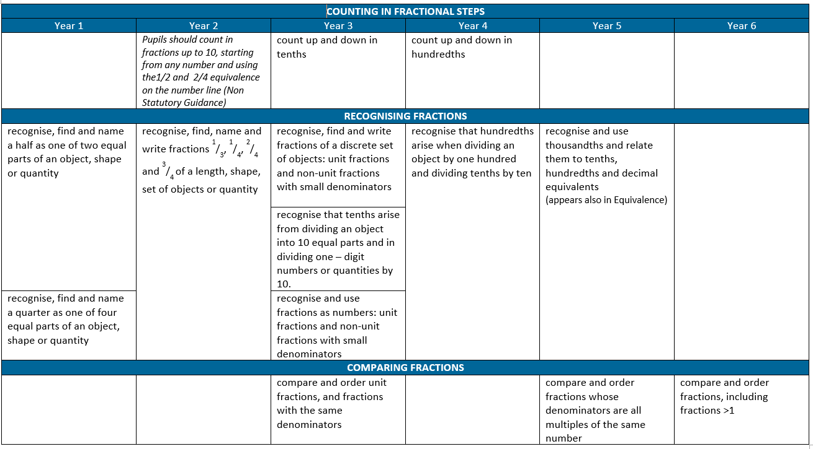

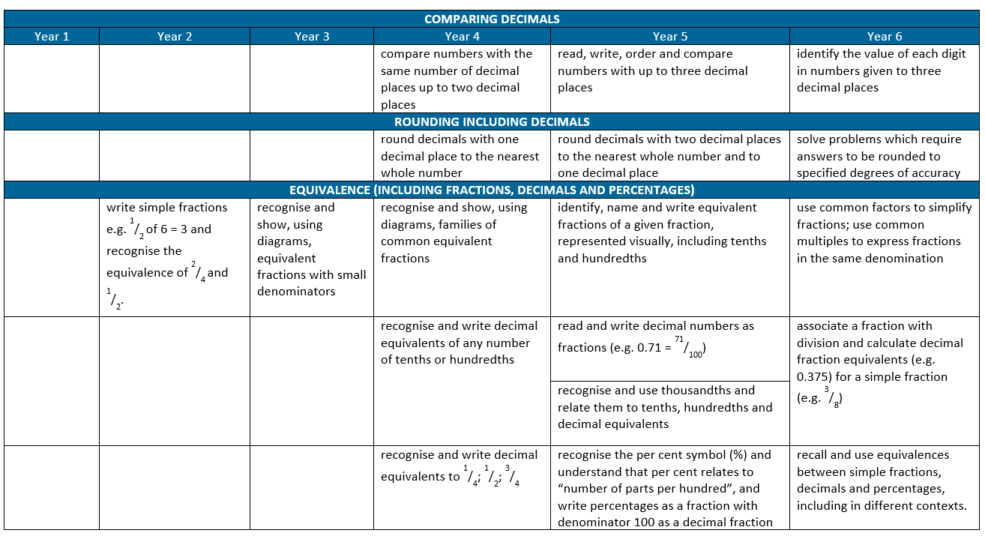

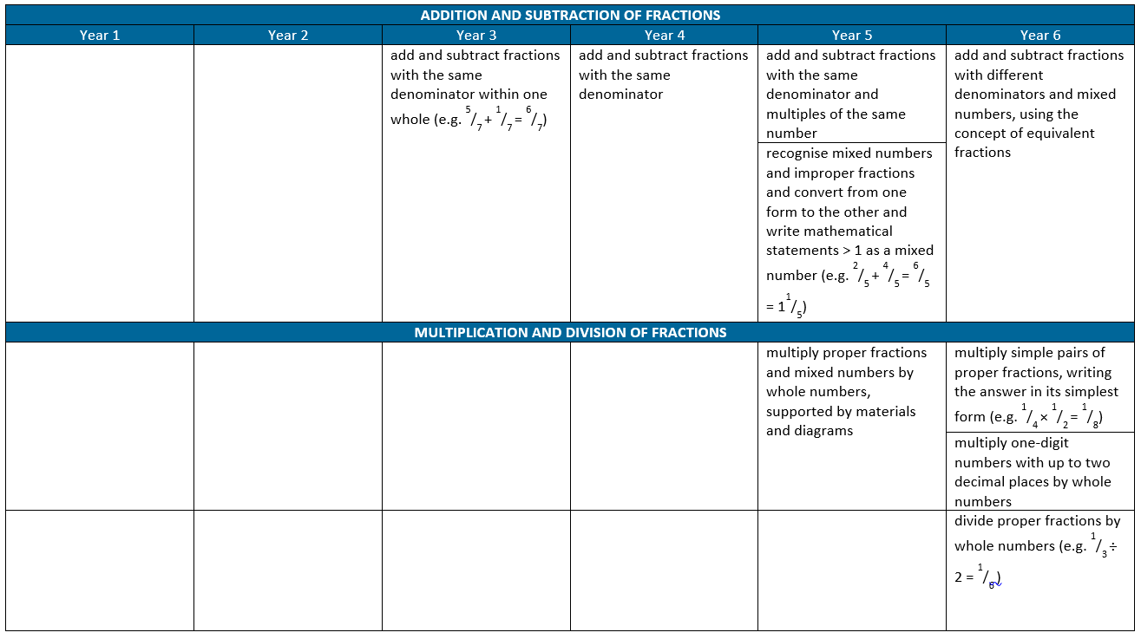4
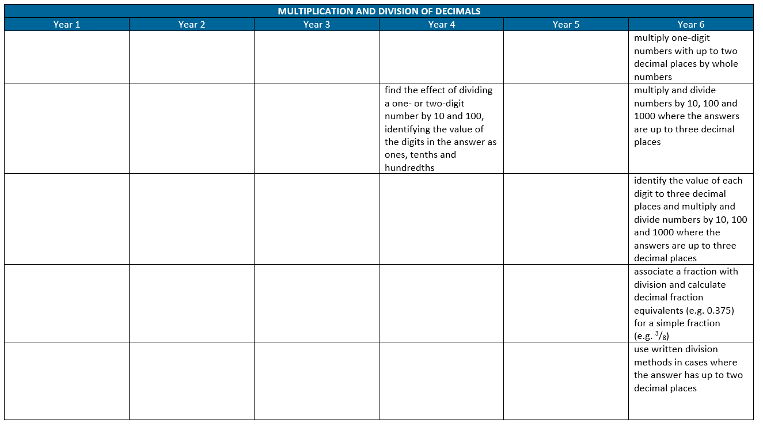

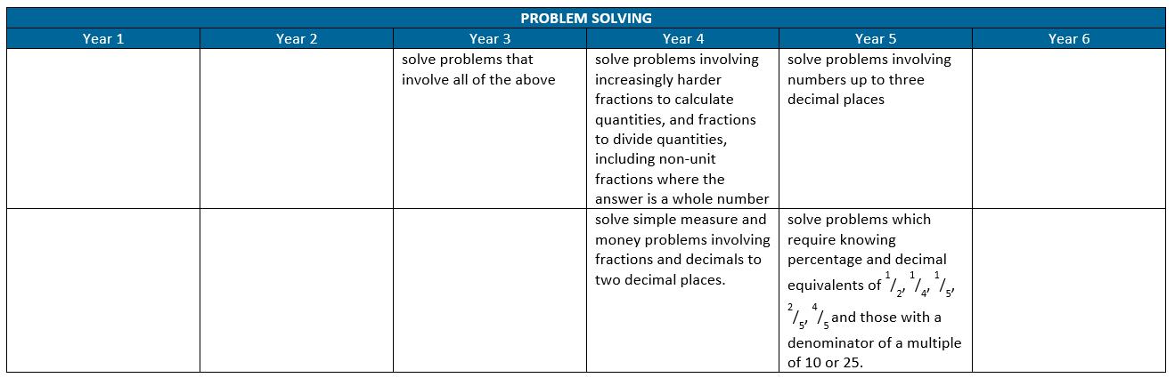

RATIO & PROPORTION

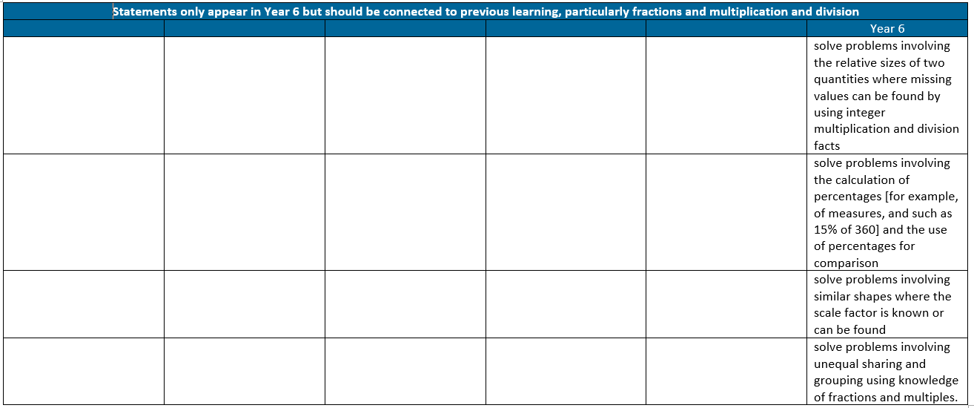

ALGEBRA

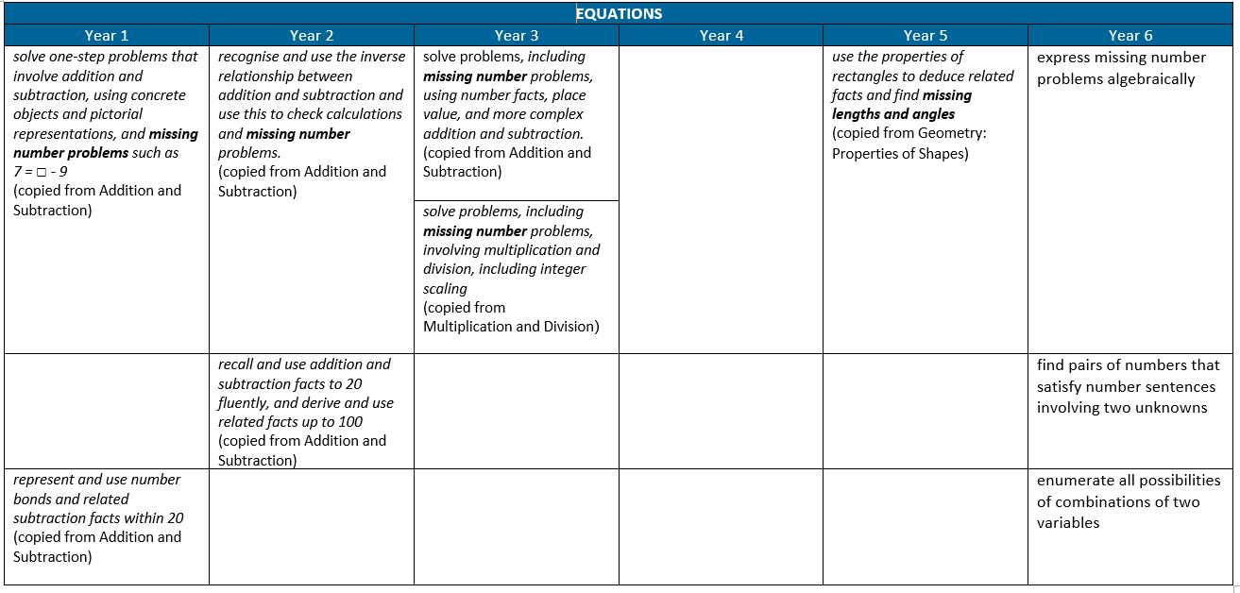

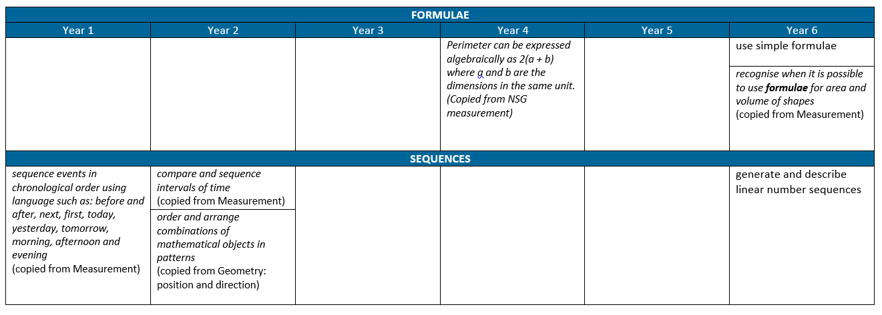

MEASUREMENT
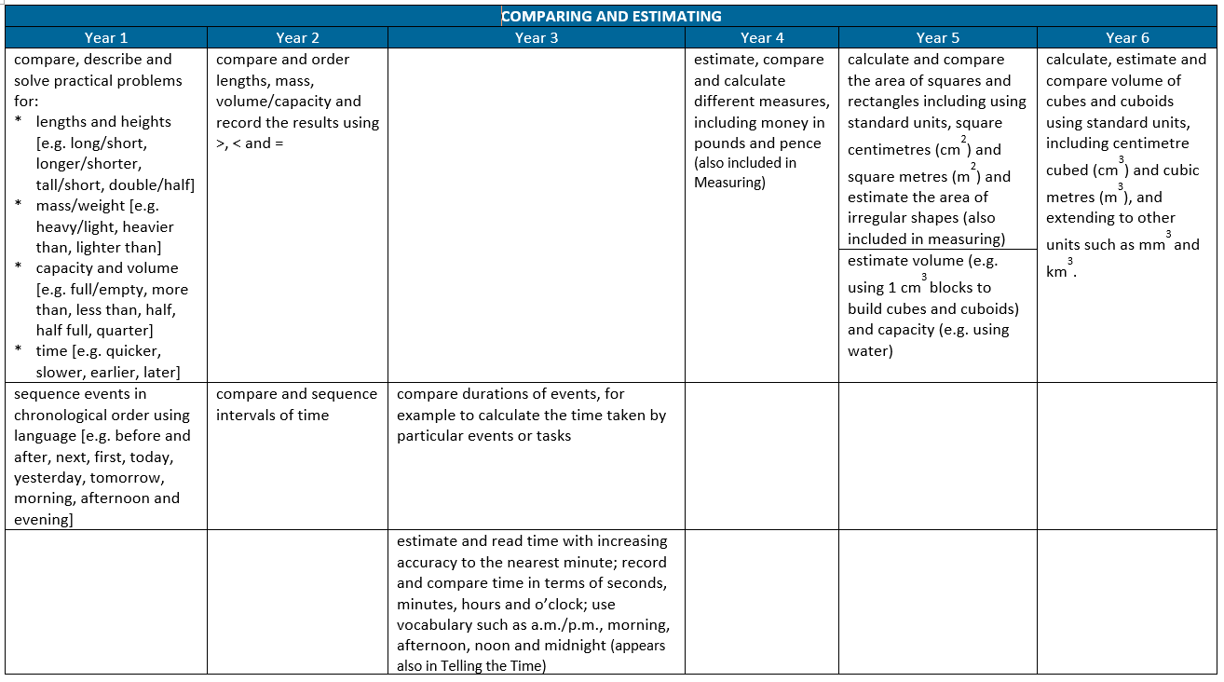
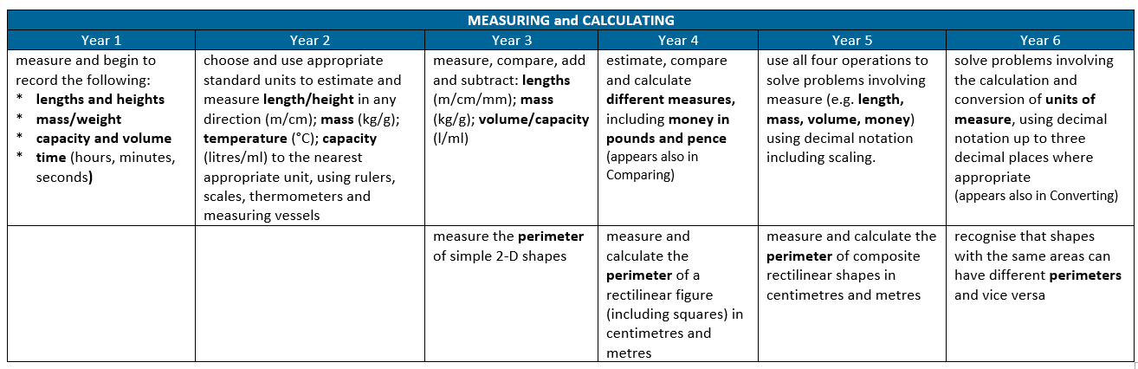

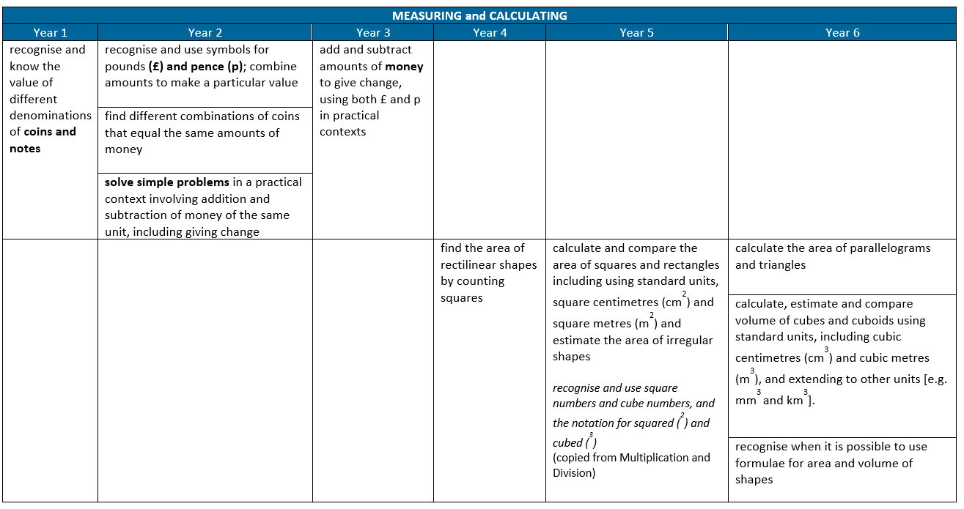

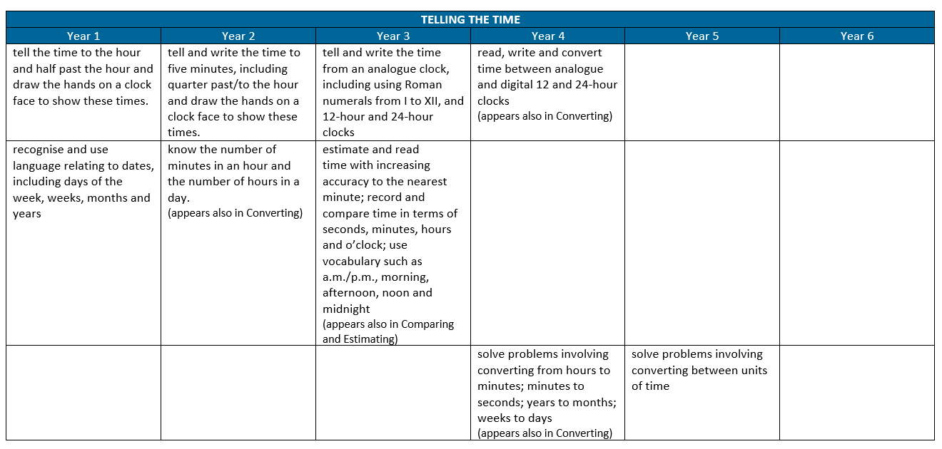

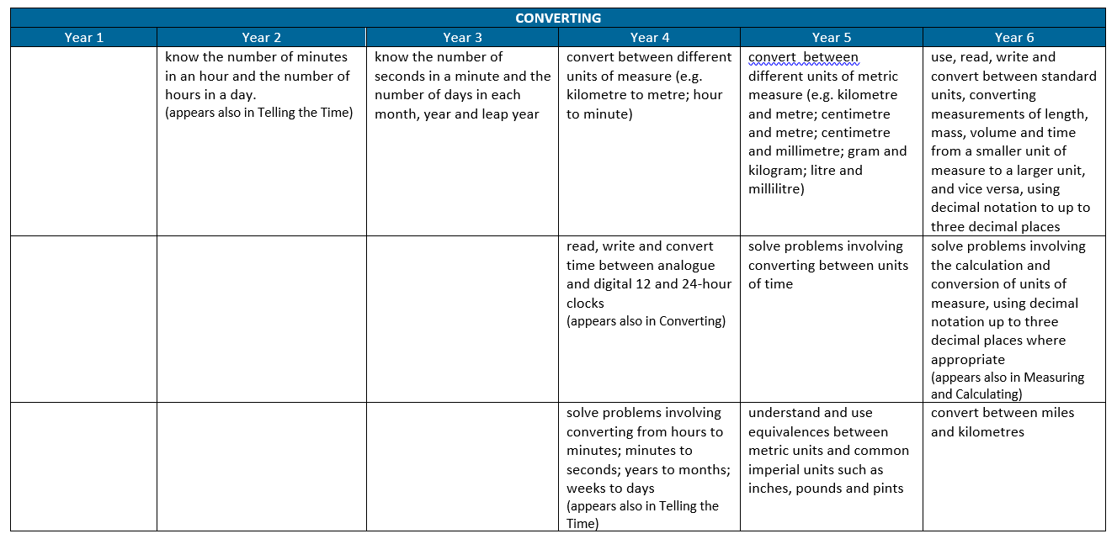

GEOMETRY PROPERTY OF SHAPE
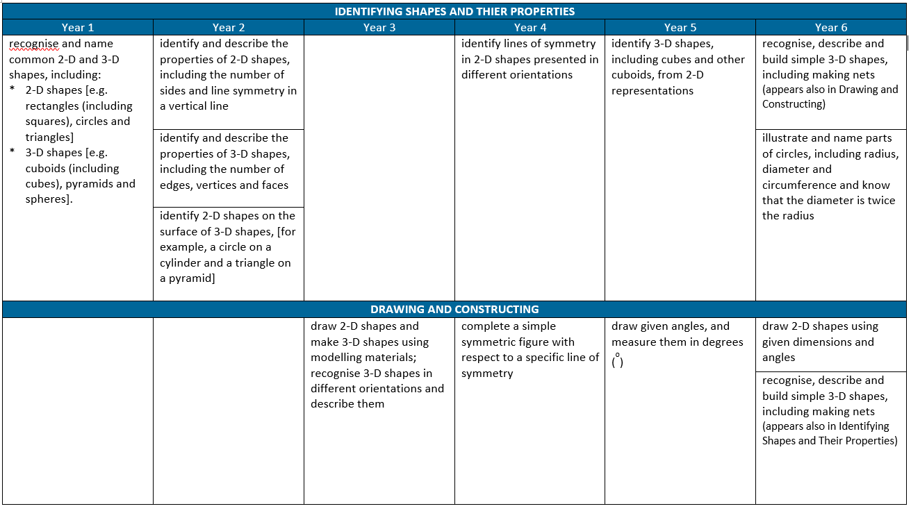
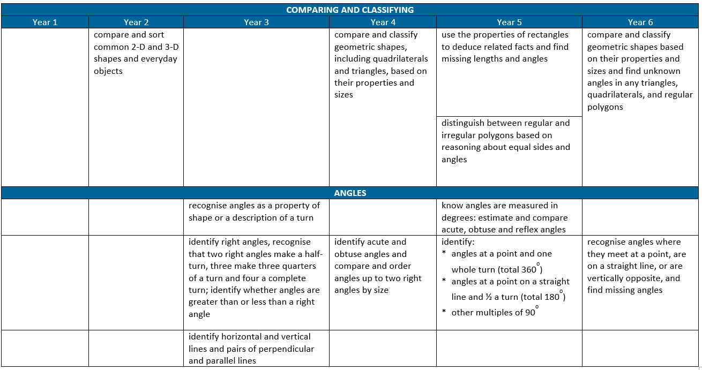

GEOMETRY; POSITION AND DIRECTION
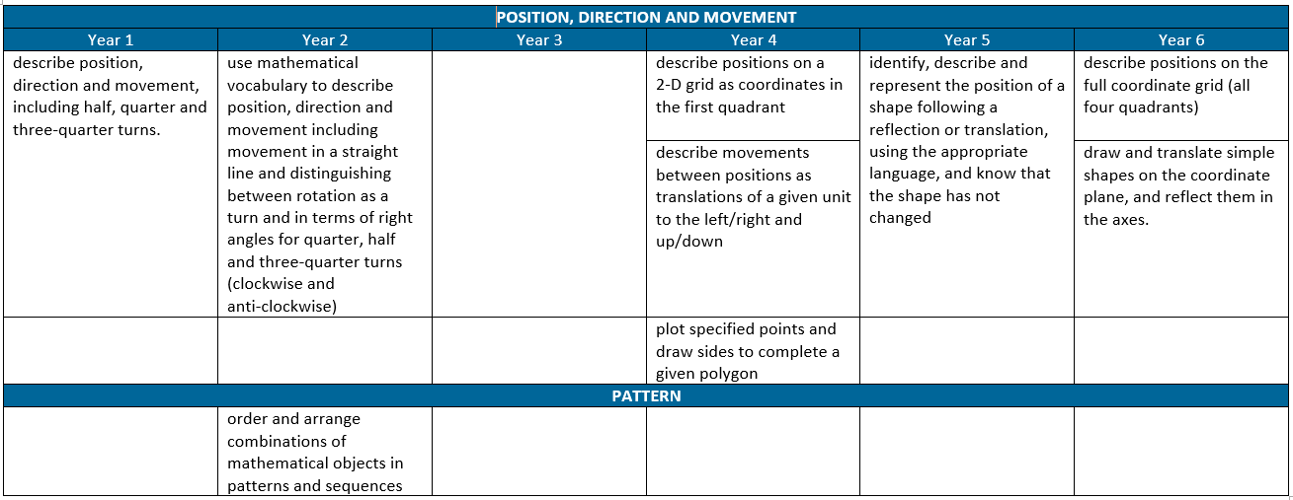

STATISTICS
