Computing Policy
2023 2024
BENTLEY NEW VILLAGE PRIMARY SCHOOL
HEADTEACHER: VICTORIA SIMMONS
SUBJECT LEADER: GARETH HUGHES

Computing POLICY
PERSON RESPONSIBLE FOR POLICY: APPROVED: SLT | Gareth Hughes
PERSON RESPONSIBLE FOR POLICY: APPROVED: SLT | DATE: January 2024
SIGNED: | ROLE: CO-ORDINATOR
TO BE REVIEWED: | DATE: September 2024
OUR SCHOOL VISION
Together, we will create a calm and welcoming learning environment and work together to secure success for all. We will strive to create a safe, caring, supportive and inclusive school.
Our school will equip its pupils with the skills that society and the local community demand and so we will value the skills and learning that children need in order to look after themselves, their families, their health, their mental well-being and their bodies. We will strive to teach the whole child and create life-long learners and pro-active citizens.

ETHOS
We believe that:
- All children can learn. All staff and children are able to recognise the value of learning.
- All staff, working at New Village, will have consistently high expectations of children’s learning potential, attitudes and behaviour and take corporate responsibility for ensuring these in, and around, school.
- Learning takes place in all areas of our school and through the entire learning day - inside and outside of the classroom.
- Children should be taught how to learn; learning how to be an outstanding learner.
- Consistently challenging, dynamic, engaging and empowering teaching leads to outstanding learning, resulting in a school where every child’s potential is realised.
- All staff will value every child’s contribution to the school and strive to create a learning environment that brings out the full potential in all.
- Rigorous, continuous monitoring, thorough and informed evaluation and accurate analysis of all the elements of teaching, is essential in ensuring high-level teaching and learning.
- Learning at New Village will produce and enhance a learning skills-set that will be lifelong; we will actively promote this for every child and for all staff.
- New Village School will demonstrate its commitment to quality teaching and learning through its dedication to continuous professional development for all staff; recognising and exploiting all opportunities to enhance its workforce and the learning environment.
- All children will be encouraged to develop as individuals. Their creativity, talents, differences and uniqueness.
OUR SCHOOL VALUES
Determination – Resilience – Tolerance – Cooperation – Creativity – Curiosity
Curriculum Mandate
Our New Village curriculum will offer equitable opportunities for all pupils to access a curriculum that is rich in knowledge, experiences, understanding and language that represent the best of humankind. Whilst instilling in our learners a knowledge, understanding and appreciation of how to take responsibility for their physical and mental wellbeing. Through the curriculum, children are exposed to diversity through celebrating, studying and appreciating differences and similarities. We recognise the importance of language in school and throughout life and enrich the curriculum with opportunities to develop vocabulary, speak in different contexts, read quality texts and learn to be active listeners. Our curriculum contributes effectively to building a self-regulating, self-motivated individual who consistently demonstrates the New Village key values when faced with challenge because we know what challenges us changes us
Our mission statement, “What challenges us, changes us.”

Rationale
At Bentley New Village, we believe that children deserve a stimulating, enriched experience of Computing which will allow them to show:
- Determination to learn new skills
- Resilience to continue, even when the skills are difficult
- Curiosity to ask questions and apply what we see in public
- Creativity to search for and problem solve issues with technology
- Tolerance to help and support others
- Cooperation to work with and alongside others and keep one another safe
- Knowledge and understanding of, and empathy with, a diverse range of groups within their community and beyond

The Purpose of the Policy
The purpose of this policy is to:
- Outline how computing links closely with our key values
- Outline how computing links closely with British Values
- Outline how computing links closely with SMSC
- Outline how computing links closely with Safeguarding
- Outline key vocabulary for each year group (BNV 9)
- Explain roles and responsibilities
- Outline the topics to be delivered in each year group

Aims of this Policy:
Bentley New Village is a school in an area of Doncaster with a high proportion of families living in the 30% most deprived areas in the country. The key issues from local intelligence data highlight that many of our children are living in workless families and are eligible for free school meals. Educational attainment is lower than surrounding areas and high school attendance is lower than the Doncaster average. Due to the workless families of our community, capital is not available to expose our children to computing equipment, meaning that we as a school, need to equip our children with the necessary skills and understanding to allow them to live in the technological world and access the same opportunities as their peers.

Bentley New Village wishes to provide our children with the best opportunities in future life and as they will be facing careers that currently do not exist, due to technological advances, it is only fair we provide them with the very best start with regards to the basic skills in computing – digital literacy, computer science and IT.

As a school our drivers are English and Maths, which will be commented upon and basic skills a focus. Then to coincide with the community needs, our foundation drivers are science, PE and PSHE. Where possible all our topics, in all year groups, have been linked to these drivers to address the school’s needs.

Intent: | Implementation: | Impact:
At Bentley New Village, all children will:  - Understand the importance of Online Safety and be responsible for their own physical and mental wellbeing online  - Receive a stimulating, enriched experience of Computing which will allow them to ask questions, use practical skills and be reflective about the world around them, as well as equipping them with an array of skills which they can use to further their curiosity of the world around them.  - Have the chance to both show and develop the learning behaviours of creativity, curiosity, resilience, determination, tolerance and co-operation through the Computing curriculum  - Be given opportunities to develop the basic skills acquired in English (speaking and listening, reading and writing) and Mathematics and apply to the same standards as in English and Maths lessons  - Be given the opportunity to learn, understand and use a range of technical vocabulary as appropriate  - Tinkering’ with software and programs to develop pupils’ confidence when encountering new technology in our evolving and changing landscape.  - Experience diversity through celebrating, studying and appreciating differences and similarities  - Build a self-regulating, self-motivated individual  - Be provided with the opportunity to acquire specific skills and knowledge to help them to think digitally and technologically  - Embed digital and technological enquiry skills in each topic  - Receive a progressive sequence of Computing lessons which will build upon their prior knowledge whilst embedding the procedural knowledge into the long-term memory  - Receive Computing lessons which develop a deep understanding of the body of knowledge of Computing in each of the key areas – digital literacy, computer science and information technology – and also the skills built up through the experimental testing of ideas  - Gain an understanding of the uses and implications of Computing today and for the future  - Be given the opportunity to plan and carry out projects, using equipment correctly  - Be taught to evaluate a plan and make appropriate, effective changes  - Be able to investigate, where appropriate, in and about their: homes, school, gardens, playground, local community and wider environment within our Computing lessons | As part of this planning process, teachers need to plan the following:  - A safe, secure space for children to learn about Computing, including; lessons about Online Safety, opportunities for children to show their ability to stay safe online and the promotion of Online Safety resources and skills  - A knowledge organiser which outlines knowledge (including vocabulary) that all children must master  - A low-stakes quiz which is tested regularly to support learners’ ability to block learning and increase space in the working memory  - Challenge questions for pupils to apply their learning in a philosophical/open manner  - Opportunities to apply skills and learning developed in Computing lessons to other parts of the curriculum  - Progress and develop skills year on year to ensure targets are met. | Our Computing curriculum is high-quality, well-thought out and is planned to demonstrate progression. If children are keeping up with the curriculum, they are deemed to be making good or better progress.  The expected impact of the Computing curriculum is that children will:  - Be critical thinkers and able to understand how to make informed and appropriate digital choices in the future.  - Understand the importance that computing will have going forward in both their educational and working life and in their social and personal futures.  - Understand how to balance time spent on technology and time spent away from it in a healthy and appropriate manner.  - Understand that technology helps to showcase their ideas and creativity. They will know that different types of software and hardware can help them achieve a broad variety of artistic and practical aims.  - Show a clear progression of technical skills across all areas of the National curriculum - computer science, information technology and digital literacy.  - Be able to use technology both individually and as part of a collaborative team.  - Be aware of online safety issues and protocols and be able to deal with any problems in a responsible and appropriate manner.  - Have an awareness of developments in technology and have an idea of how current technologies work and relate to one another.  - Meet the end of key stage expectations outlined in the National curriculum for Computing

Responsibilities
Senior Leadership Team will:
- Select the co-ordinator who is most likely to drive computing forward.
- Ensure that current practices and educational developments are being addressed.
- Ensure that computing is being taught throughout school and that the schemes of work are progressive.
- Ensure that there is capital to replace broken equipment and update to current technologies.

Subject Coordinator will:
- Ensure the curriculum is progressive through the skills being taught.
- Ensure the children have access to a wide range of software and hardware over their time at BNV.
- Ensure that all units taught are allowing the children to be ‘Secondary ready.’
- Ensure that the Technician in school is directed and issues are prioritised.
- Ensure that the budget is managed to address priorities.
- Aim to ensure that the equipment is updated and well kept.
- Update the website when necessary.
- Ensure that updates in computing are disseminated to all staff.
- Ensure that staff feel supported with the teaching of computing.

Teachers will:
- Ensure they possess the necessary skills to teach the children with accuracy.
- Ensure the units of study link to the key drivers and key values of BNV.
- Demonstrate high-expectations to the children of basic skills throughout
- Model the curiosity and determination/resilience that is needed to complete tasks.
- Provide children with exciting opportunities to use newly introduced technologies to the children in their class.
- Assess their children and ensure that work is at an ability matched to each group of pupils.
- Ensure that the children are developing their technological language.
- Provide every child with the chance to progress.
- Allow children to display their computing work alongside their English and maths.

Support Staff will:
- Aid pupils to complete all their responsibilities.
- Ensure that the equipment is cared for and respected.

Pupils will:
- Demonstrate co-operation by completing activities that they find difficult
- Demonstrate co-operation by helping one another and tolerating when others find skills difficult.
- Show determination and resilience when they are finding new skills difficult.
- Show respect and care for the equipment they have access to.
- Show creativity by creating documentation, reports, presentations and books in different programmes available to them.
- Display curiosity to want to learn more about the hardware, software and skills being taught.
- Work with curiosity on the internet, whilst knowing how to remain safe.

Parents will:
- Ensure that their children understand the importance of staying safe on the internet.
- Ensure that their children know that technological equipment is expensive and needs to be respected.
- Allow their children to access the internet and programmes available to develop their skills.
- Ensure that their children are using emails and social media responsibly.

PEDAGOGY
Computing will be taught for 1 hour per week in all year groups. Foundation will teach it according to their programme of study and Y1-6 will teach from the BNV programme of study for KS1 and 2. All classes will teach on different days (depending on computer availability), but sessions will be timetabled and further computing equipment can be booked according to need.

Planning

Short-term planning
The short-term planning is either taught as a block or in a series of sessions over a half-term or term. In computing, pupils show enthusiasm and very good attitudes to their learning. They are proud of their outcomes and are able to discuss the relevance of their learning, both across the curriculum and within their lives outside of school. Well planned units mean pupils are shown clear models and they make good progress learning and using skills.

Long-term planning
Long term curriculum planning for computing is created so that each Programme of Study (POS) strand is taught on balance and revisited throughout the course of the academic year.
The strands of computing are:
Computer Science (CS) Information Technology (IT) Digital Literacy (DL)
Our computing curriculum is organised so that pupils have the opportunity to develop skills using a wide range of software.

Computing systems and networks: Identifying hardware and using software, while exploring how computers communicate and connect to one another.
Programming: Understanding that a computer operates on algorithms, and learning how to write, adapt and debug code to instruct a computer to perform set tasks.
Creating Media: Learning how to use various devices — record, capture and edit content such as videos, music, pictures and photographs.
Data Handling: Ensuring that information is collected, recorded, stored, presented and analysed in a manner that is useful and can help to solve problems.
Online Safety: Understanding the benefits and risks of being online — how to remain safe, keep personal information secure and recognise when to seek help in difficult situations.

Adaptive teaching & SEND Inclusion
We use adaptive teaching to ensure that the curriculum can be accessed by all students. Our scheme has been closely referenced against the National Curriculum attainment targets in order to ensure progression and coverage. Having discreet lessons means that the children are able to develop depth in their knowledge and skills over the duration of each of their computing topics. Where appropriate, meaningful links will be made between the computing curriculum and the wider curriculum. In computing lessons, the children will use either iPads or laptops in order to access a range of apps and software.
We use adaptive teaching to ensure all students meet the same goals. For example, students who struggle with keyboard skills are given extra support from a teaching assistant. We also encourage teamwork so that students can be supported by their peers. We cater for the need of children with special educational needs. For example, using specialist equipment for students with visual impairment.

Vocabulary and Oracy
All children will be expected to know the meaning of and use confidently the technical vocabulary linked to the topics they are learning.
Children will be expected to know the language of the New Village Nine linked to computing and its curriculum. It is expected that teachers will bring about a broad curriculum with rich language and oracy. Many opportunities will be created for all children to speak and listen during computing lessons, which for our school is priority, as on entry to the school their speaking and listening skills and vocabulary knowledge is significantly below average.

Marking and Feedback
While most of the computing work will be done on the computer and work will be stored in the children’s individual folders, some work will be expected to be printed and marked when appropriate. The marking and feedback is expected to be mainly verbal and children are expected to be able to explain their development points according to this feedback. The feedback will link to the main objective of the computing lesson, but it will also reflect the basic skills in English and Maths too. Correct, technical vocabulary will be used at all times.

Themes

During each half-term a theme will be followed. The work will be loosely tied to this theme and each term the children will build a foundation of knowledge in this area. The Themes are as follows:

AUTUMN 1 - Using technology safely
AUTUMN 2 - Communication
SPRING 1 – Algorithms / Programming
SPRING 2 – Using software on a range of digital devices
SUMMER 1 - Collect, Analyse, Evaluate and Present Data
SUMMER 2 - Detecting and correcting errors

Assessment
Within computing lessons, both formative and summative assessment approaches are used to determine pupil progress and adapt teaching as necessary. Formative assessment activities are vital to enable teachers to adapt their lessons appropriately. Using short formative assessment activities during lessons identifies the need to revisit a concept from a previous unit or changing the expected time to complete a task, whilst activities towards the end of a lesson, such as gauging pupils’ confidence against the learning objectives are used to adapt content in upcoming lessons. End-of-unit quizzes enable the knowledge and skills within a unit of work to be examined and recorded. The outcomes of these assessment activities are subsequently used to inform future teaching or changes to the school’s curriculum content.

Formative Assessment (AfL) - (monitoring children’s learning) | Summative Assessment – (evaluating children’s learning)
Assessment is an integral and continuous part of the teaching and learning process at New Village and much of it is done informally as part of each teacher’s day-to-day work.  Teachers integrate the use of formative assessment strategies such as:  - effective questioning  - clear learning objectives  - the use of success criteria  - effective feedback and response in their teaching  - observing children participating in activities.  Findings from these types of assessment are used to inform same day interventions, challenge and future planning. Planning should be annotated and those who need more support, must be identified on plans through use of AfL This plan, assess, review cycle ensures that misconceptions are identified and steps are put in place to support these learners.  From this information, staff plan the next steps to learning. Staff must ensure children have a solid basis of that aspect of learning before moving onto new concepts. Do not move on until most children do. For those who do not have this solid basis, then interventions in small groups should be used to ensure they do. For those who securely understand the concepts, ensure children can use and demonstrate the skills in a wide variety of contexts and problems (greater depth). | More formal methods are used to determine the levels of achievement of children at various times during the school year. They allow the school to measure each child’s attainment in all areas of PE, and compare this with an “average” for children of that age. The results are used to monitor individual’s progress in year and year-on-year. These termly assessments are used throughout the year to aid planning.  We use termly assessments as a way of recording children’s progress in objectives covered across that specific term. This information is then submitted to the Assessment Leader and class teacher.

British Values

British Values in ICT/Computer Science.

Democracy - All pupils within Computing are encouraged to promote British Values; to work as a team when asked; and individually respecting others when producing coursework. Resilience is a must when programming code and the key skill of computational thinking is developed when problem solving.

The rule of law - Within the Computer Science programme of study, we look at a variety of laws to ensure that pupils are healthy, safe and that their data is safe. The Copyright and GDPR acts are all studied, as well as discussing criminal laws within e-safety. These help our pupils understand the values and reasons behind these laws; what we must follow to protect each other, to respect others work and to ensure that people work here in the UK, under satisfactory conditions. Debates are held to discuss the moral issues of piracy and copyright, and all pupils are taught the need for secure passwords, the right to privacy, and the impact of plagiarism.

Individual liberty - Students are encouraged to use both primary and secondary research to explore their hypotheses made in our spreadsheet unit and make presentations of their findings to help within coursework. They are required to gain feedback from other pupils to help support improvement of their work, offering an honest appraisal judging against success criteria. In both key stages, the freedom to explore issues of E-Safety are carried out, identifying the positives and downsides to social media.

Mutual respect - Within the Computing Department we allow pupils to demonstrate their work, through our classroom monitoring software. Pupils discuss and demonstrate the skills used and address issues of difficulties to allow others to offer their opinions on how to solve problems. All work done, is in a safe, secure environment, where we ensure positive peer pressure and that all pupils strive to better their target grades.

SMSC

SMSC
Spiritual Development | Moral Development | Social Development | Cultural Development
Students are continually reflecting on their own lives and the lives of others as they look at various ICT/Computing case studies. Students debate and formulate their own set of values and beliefs through case studies as they share their own experiences.  Computing provides opportunities for reflection of awe and wonder about the achievements in ICT today and the possibilities for the future. ICT lets students have the opportunity to reflect on how computers can sometimes perform better in certain activities than people. To promote students’ spiritual development, their sense of self and their will to achieve, the computing department continually takes the opportunity to praise students for their contribution in lessons. | Through real life case studies, students consider issues surrounding the misuse and access rights to personal data. The use of case studies in computing encourages students to draw conclusions through evidence rather than their preconceptions whilst allowing the students the time to reflect on the origins of their own personal perceptions of a topic.  Students consider the effects of social networking and the consequences of cyber bullying; they also consider the legal aspects of ICT including the Data Protection Act, Computer Misuse Act and Copyright legislation. They consider the implications of file sharing and downloading illegally and the penalties for engaging in this type of activity. Students also consider the moral aspects of developments in technology including the use of CCTV cameras, Speed Cameras and Loyalty Cards to balance up people’s rights and responsibilities.  Computing helps students to explore aspects of real and imaginary situations and enables them to reflect on the possible consequences of different actions and situations. It can raise issues such as whether it is morally right to have computer games whose aim is killing and violence, and whether it is fair that some people in this country and in other countries cannot use the internet.  Other moral issues surrounding the topics of e-waste and the digital divide are also explored through case studies. The use of case studies in ICT encourages students to draw conclusions through evidence rather than their preconceptions whilst allowing the students the time to reflect on the origins of their own personal perceptions of a topic. | As part of the computing curriculum students are taught to think and produce work that reflects the needs of diverse audiences within our community and the wider community.  As students develop their skills in a range of software they are challenged to work in groups to find solutions whilst developing respect for the ideas and opinions of others in their team. This is particularly prevalent in the design phase of tasks given. In addition students are encouraged to develop their team working skills through collaborative work and research. The students also explore the concept of teams and the roles that individuals have to play. Computing can also help all students to express themselves clearly and to communicate. As students’ progress through their learning they will consider more complex social needs and are encouraged to research and work collaboratively to find appropriate solutions to issues that may affect particular groups within society. | Computational thinking encourages students to develop and explore their problem solving skills. Computing Empowers students to apply their ICT and computing skills and to gain knowledge of how programming links between subjects for instance maths.  Students explore how developments in technology have changed our culture, particularly the rise in social networking sites and the ability to communicate instantly across National and International borders. Computing involves the breaking through of linguistic and cultural barriers. It is possible to e-mail or chat across the world and to word process in the mother tongue.  Whilst studying various aspects of computing students are asked to reflect on how different cultures are portrayed on the internet and why or who is portraying them in this way. Students are also challenged to think about how differing cultures access and use the internet and what implications this has on the individual and the culture.

Learning Behaviours
Creativity | Curiosity | Resilience | Determination | Tolerance | Co-operation
Children explore creativity within Computing. By using iPads and laptops to draw, animate, design games and edit documents. Children are learning how to be responsible, competent, confident and creative users of information and communication technology. | Our Computing curriculum builds on our children’s natural curiosity and develops computational thinking that allows students to problem solve, by using computational language and vocabulary. | At BNV we focus on digital resilience; this involves having the ability to understand when you are at risk online, knowing what to do if anything goes wrong, learning from your experiences of being online, and being able to recover from any difficulties or upsets. Children who are digitally resilient will be equipped to handle the challenges of the modern, digital world | We want our children to relish challenges that being a computer scientist can bring: asking perceptive questions, thinking critically, weighing evidence, sifting arguments, and developing perspective and judgement. Our computing curriculum is to prepare our children for a rapidly changing world through the use of technology. Our high-quality computing curriculum is designed to enable them to use computational thinking and creativity to further understand the world. | In computing we understand that we are connected to people across the whole world. We understand that these are people from different communities, cultures, faiths and beliefs. We use the opportunities offered in computing to question, challenge and understand people with these different characteristics to support and develop our tolerance of them. | In Computing, we examine how the internet facilitates online communication and collaboration; our students complete shared projects online and evaluate different methods of communication. Additionally, children learn how to communicate responsibly by considering what should and should not be shared on the internet

Safeguarding
Please see Online Safety policy and subject overview.

Appendices

Subject overview

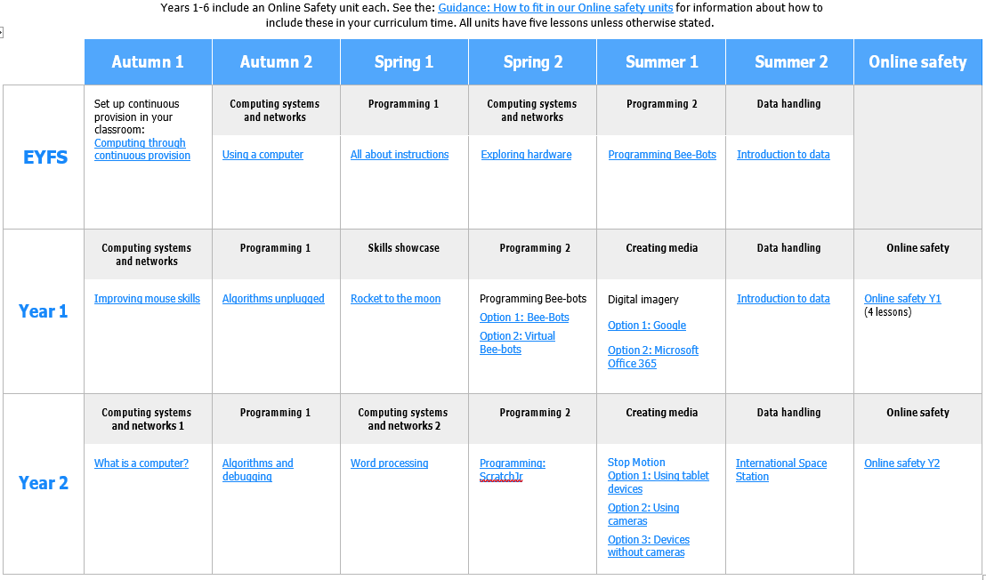

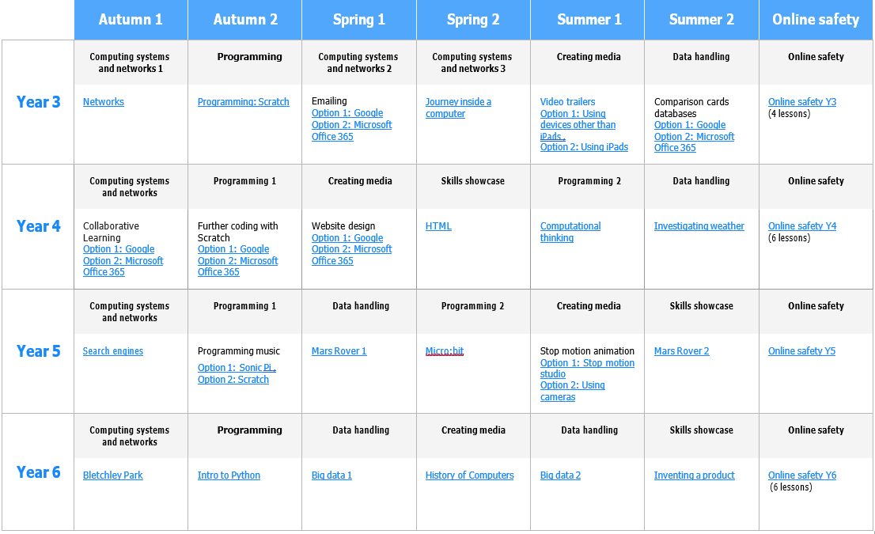

Computing depends upon the development of many skills which should be evident in the learning opportunities at every key stage, across all subjects. Some of these skills are common to many areas of the curriculum such as the skills of listening, speaking, reading and writing.

There are, however, other skills which make a particular contribution to pupils’ learning in computing.
These include the skills of:
■ investigation
■ interpretation
■ improvement
■ evaluation
■ analysis
■ synthesis
■ application
■ expression
These skills will be used throughout school.

The Teaching of Computing in the Foundation Stage
At Bentley New Village, many children start in F1 with basic skills which are well below the national average.
- Computing in Foundation Stage 1 and 2 is linked to the Foundation Stage Curriculum.
- With these younger children, Computing is linked to their own lives and necessities.
- Vocabulary related to different themes is introduced
- Staff model the use of vocabulary and sentences, and where necessary paraphrase what the children say to provide good examples.
- Children are encouraged to ‘play’ and ‘discover’ with computing technologies.

The Teaching of Computing in Key Stage 1
- Children will build upon previous known skills to ensure that they are enhancing their technological skills.
- They will study:
- Digital Literacy – covering E-Safety issues.
- Computer Science – covering programming and technology in our lives.
- Information Technology – covering Multimedia and Handling Data.

The Teaching of Computing in Key Stage 2
- Children will build upon previous known skills to ensure that they are enhancing their technological skills and are working towards being ‘secondary ready’ at the end of the Key Stage.
- They will study:
- Digital Literacy – covering E-Safety issues.
- Computer Science – covering programming and technology in our lives.
- Information Technology – covering Multimedia and Handling Data.

