

**NON-COMPLIANCE WITH SCHOOL UNIFORM POLICY**

**As a pupil or a parent/carer of a pupil attending New Village Primary School, you therefore agree to the school uniform policy; school sanctions will be put in place if this is not adhered to.**

**Sanctions:**

* If children come to school and are not wearing the agreed school uniform, New Village staff will provide a temporary school uniform for that day; parents will be contacted and asked to send their child in uniform the next day
* Pupils wearing inappropriate footwear will be offered a temporary alternative when/if possible, and a phone call home will be made asking for alternative footwear to be brought in. Please note: *flip-flops, crocs or toe-post sandals are never acceptable in school.*
* Hooded sweaters or jumpers/sweaters that carry a logo/lettering are not permitted although they may be worn at break-times when outdoors
* If children persistently fail to come to school in the agreed uniform, or fail to have a PE/swimming kit, then the parent/carer will be contacted and asked to provide the uniform on that day. A meeting with the Headteacher may follow to discuss the matter

**BNVP Parent & Carer   
School Uniform**

**Information Leaflet**



***What Challenges Us, Changes us***

**Determination – Resilience – Tolerance – Cooperation – Creativity - Curiosity**

**School Uniform Purchasing**

School uniforms can be ordered online at Nationwide School Uniforms

<https://www.nationwideschooluniforms.co.uk/school-uniform/primary-school/bentley-new-village-primary-school.html>

**School uniform**

All children at New Village Primary School wear their school uniform with pride. It contributes to a sense of belonging, collaboration and teamwork. Therefore, when your child joins, or is already part of the New Village Primary School, we are all in a shared agreement that:

It is the responsibility of children, parents and carers to ensure that the correct New Village uniform is worn at all times and is clean and appropriate to the child.

It is the responsibility of New Village Primary School staff to promote high expectations with the school uniform.

Wearing a school uniform is part of our home school agreement and will be consistently monitored. Parents will be contacted if any child is not wearing the appropriate uniform.

Non-uniform will only be agreed under exceptional circumstances, and the Headteacher would need to be informed of this reason in writing or by verbal discussion.

Thank you so much for supporting us in this matter.



**School uniform for Winter:**

* Plain navy blue, grey or black trousers, pinafore or knee-length skirt,
* plain white shirt with a collar or plain white polo t-shirt,
* plain navy blue sweater may have the school logo on the front.
* No jeans and no tracksuit bottoms
* navy blue, grey or black shoes flat or with a heel less than 2cm

**School uniform for Summer:**

* Plain navy blue, grey or black trousers or smart shorts, pinafore or knee-length skirt or knee length dress-shorts (not sports shorts),
* plain white shirt with a collar or plain white polo t-shirt,
* plain navy blue sweater may have the school logo on the front
* Blue gingham summer dress – knee length
* Shoes: navy blue, grey or black shoes flat or with a heel less than 2cm. No flip flops, crocs or toe-post sandals

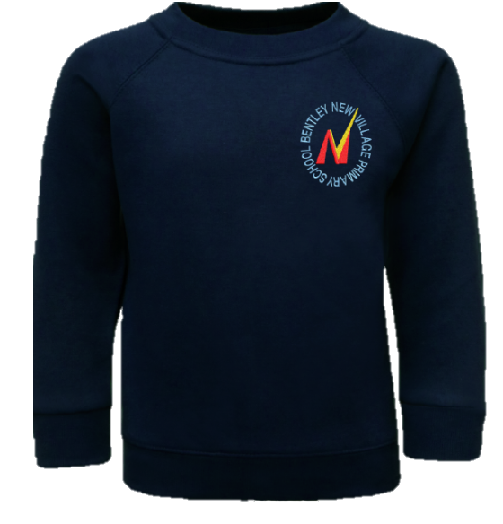

Jewellery & Accessories

No jewellery except one pair of plain studs should be worn in school.  They must be removed or covered for P.E and swimming. Acrylic nails are not permitted due to the risk they pose in school. Children can wear a small faced watch.

NB - If a child needs to wear a piece of jewellery for medical or religious reasons, it must be agreed with the Headteacher and removed, or covered up, during physical activity.

**Sanctions:**

Pupils wearing jewellery for school, that is not part of the agreed uniform policy, will be asked to remove the jewellery. Jewellery will be stored in a safe place although school does not accept responsibility for jewellery that becomes lost or is stolen

**P.E Kit**

**PE and Games**

* Plain navy blue, grey or black sports shorts, plain white t-shirt (school logo allowed)
* Plain navy blue, grey or black jogging trousers/tracksuit bottom can be worn during the winter months.
* Footwear: trainers or plimsolls

**Swimming**

* swimming trunks (and not shorts)
* hair tied back if required
* wear a one-piece swimming suit and not a bikini

It is the responsibility of children, **parents and carers** to ensure that the correct New Village PE uniform is worn for *all* PE lessons and that the correct swimming kit is provided each week along with a clean, dry towel.

**Sanctions:**

If children do not have the correct PE kit, New Village staff will provide a temporary PE kit for that day; parents will be contacted and asked to send their child with a suitable PE kit in time for the next PE session