Pupil premium strategy statement

BENTLEY NEW VILLAGE PRIMARY SCHOOL
HEADTEACHER: VICTORIA SIMMONS
2022

Pupil premium strategy statement

This statement details our school’s use of pupil premium (and recovery premium for the 2022 to 2025 academic year) funding to help improve the attainment of our disadvantaged pupils.

It outlines our pupil premium strategy, how we intend to spend the funding in this academic year and the effect that last year’s spending of pupil premium had within our school.

School overview
Detail | Data
School name | Bentley New Village Primary School
Number of pupils in school | 279
Proportion (%) of pupil premium eligible pupils | 146/279 = 52%
Academic year/years that our current pupil premium strategy plan covers | 2022-25
Date this statement was published | 01.11.23
Date on which it will be reviewed | 01.07.24
Statement authorised by | Victoria Simmons
Pupil premium lead | Victoria Simmons
Governor / Trustee lead | Ruth Precious
Funding overview
Detail | Amount
Pupil premium funding allocation this academic year | PPG 23-24 = £193485  EYFS PPG 23-24 = £2055.30  PPG+ = £1250
Recovery premium funding allocation this academic year | £20590  (NTP = £8708 – will not be spent)
Pupil premium funding carried forward from previous years | £0
Total budget for this academic year | £217380.30

Part A: Pupil premium strategy plan

Statement of intent
New Village serves a disadvantaged and highly-challenged community with consistently around 50% of its pupils being in receipt of PPG and, as such, places great importance on the impact that the PPG spending can have on the life chances of disadvantaged children who often have more complex needs that their peers in more affluent areas. As such, all spending is based on school data, the school’s own accurate knowledge and understanding of the needs of its pupils and the surrounding community and in research evidence which takes into account a range of research and informed recommendations. Spending follows a three tier system (EEF; June 2019) which identifies barriers, and challenges, to success and those factors that disadvantage our pupils.

What does ‘disadvantaged’ mean at New Village? When the key drivers of a disadvantaged life chances are considered (Crenna-Jennings; 2018), the complexities of the issues and challenges that our pupils face become clearer. As such, at New Village we define the term ‘disadvantaged’ as any pupil in a position where they may NOT meet their full potential, in any key developmental area, due to controlling and/or influencing factors. Any disadvantaged child finding themselves negatively influenced and at risk of not achieving is deemed to be ‘disadvantaged’. This means that pupils, beyond those identified as being in receipt of free school meals are considered disadvantaged; this group of children makes up a significant percentage of the school. The key drivers of disadvantage identified by the school (Key Drivers of the Disadvantage Gap Literature Reivew 2018) - that are the predominant causes of inequalities for our pupils - are:
- Emotional/Mental/Psychological
- Speech Language & Communication
- Behaviour
- Community & Environment
- Family
- Income
- Physiological/Physical
- Locality
- Culture
- Social

Our ethos encompasses and individualised approach that enables every child and their family to feel valued. We recognise that though attainment is necessary it is not always sufficient. We have ambition for all pupils and understand what barriers to learning some children face. Our PPG spend will strive to address the barriers to learning, and to learners, through accurate and astute identification of such barriers, and through skilled and committed approaches to removing said barriers and creating social justice and equitable life chances for the pupils of Bentley New Village. The school’s development plan is dedicated to this focus and in providing access to quality teaching and learning opportunities which offer equitable opportunities for all pupils to access a curriculum that is rich in experiences, knowledge, understanding and language that represent the best of humankind. The curriculum achieves this by encouraging in our pupils a local identity and generating pride in our locality. Whilst instilling in our learners a knowledge, understanding and appreciation of how to take responsibility for their physical and mental wellbeing. Through the curriculum children are exposed to diversity through celebrating, studying and appreciating differences and similarities. We recognise the importance of language in school and throughout life and enrich the curriculum with opportunities to develop vocabulary, speak in different contexts, read quality texts and learn to be active listeners. Our curriculum contributes effectively to building a self- regulating, self-motivated individual who consistently demonstrates the New Village key values when faced with challenge….
…because we know what challenges us changes us.

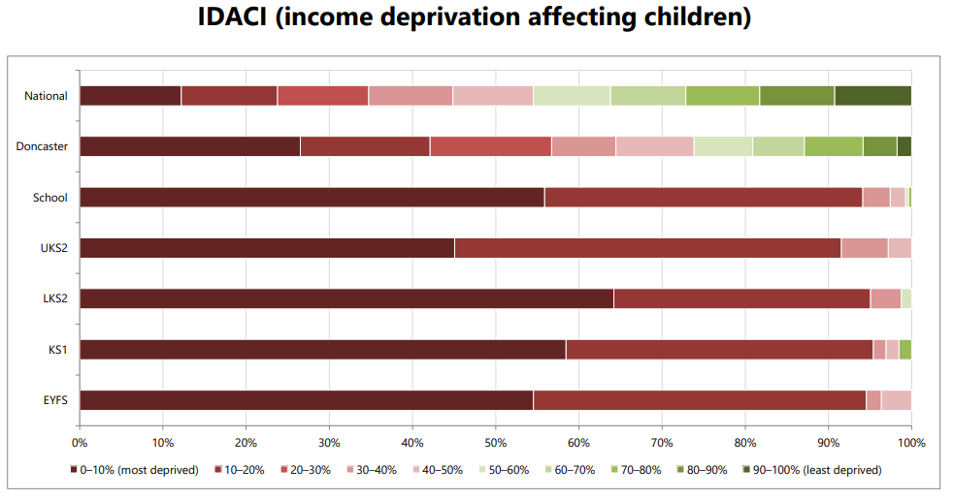
We aim to do this by:
- Recognising that not all pupils who are socially disadvantaged are registered or qualify for FSM. As a school and Governing Body we reserve the right to allocate the funding to support any pupils or groups of pupils the school has identified as being disadvantaged
- Ensuring that teaching and learning opportunities meet the needs of all pupils and tat teaching is good or better in every year group, across school.
- Ensuring that appropriate provision is made for pupils who belong to vulnerable groups, this includes ensuring that the needs of disadvantage pupils are adequately assessed and addressed
- Baselining new children on role, to quickly assess possible subject and behavioural interventions that may be required. Ensuring that data and children’s social-emotional needs are shared with appropriate adults in school.
- Making provision for socially disadvantaged pupils within and outside of the school day.

Challenges

This details the key challenges to achievement that we have identified among our disadvantaged pupils.
Challenge number | Detail of challenge
1 | Social, Emotional and Mental Health development  - At BNVP, we support children’s emotional and behavioural development. We have staff trained in Thrive, Trauma Informed practise and with a strong knowledge of attachment behaviours. Behaviour is recognised as a form of communication and our aim is to understand that communication and to support the child with their needs, referring to outer agencies and specialised support where necessary. The Inclusion team is skilled and expert and supports the whole school in this aim but is larger than for some other primary schools – maintaining quality, training and expertise along with sufficient staff capacity and appropriate supervision is a challenge  - The primary SEND need in our school is linked to SEMH. Addressing this need takes expertise in staff, time investment and capacity to liaise and work with a range of other agencies  - We use FTEX and PTEX only in extreme circumstances. In the academic year 2021-2022(to July 2022), we have had 13 FTEX. All 13 FTEX are limited to 4 children – 100% boys, 100% SEMH identified needs, 75% SEN Register. The school expertly uses data linked to potential or actual FTEx to ensure that we are accessing relevant services, outreach support or alternative provisions but wishes to develop the next level of support and understanding for these children. There will need to be an investment initially in staff training and the implementing of systems to support changes  - All of the pupils receiving reparatory SEMH support are vulnerable and most have complex needs. 62% of those children receiving 1:1 SEMH support are in receipt of pupil premium; all are disadvantaged and at risk of not meeting their potential due to the negative influence of their SEMH. This high-level of input and support requires expertise, ongoing training, staff supervision, time allocations to deliver the programme, liaise with other agencies where needed and with parents/carers, in most cases specific resources are also needed.  - Many pupils have low resilience, confidence, self esteem and have limited support from home which can negatively effect their readiness to learn.
2 | Speech, language and communication  - Assessments, observations, and discussions with pupils indicate underdeveloped oral language skills and vocabulary gaps among many disadvantaged pupils. These are evident from Reception through to KS2 and in general, are more prevalent among our disadvantaged pupils than their peers.  - There is much documented evidence to show the link between good speech and language skills and the impact this has on developing reading and writing skills; poor speech and language skills development directly impacts, negatively, on reading and writing skills.  - Children at New Village enter the school with speech and language skills development significantly below those of their peers in other schools. Referrals to SALTherapy have a poor parental take-up resulting in non-attendance and therefore no expert input or reparatory support. The school does not have the staffing capacity to train individuals in speech therapy nor does it have access to public services easily as there is a backlog and a significant wait. The school would like to employ its own speech therapist; cost, QA and venue are to be considered potential challenges  - Poor or slower language development directly impacts on children’s decoding and understanding in reading (fluency and accuracy) along with impeding the developing of skills such as inference and deduction. A phonics leader/champion with time to review the quality of teaching and learning maintains good impact but there is a cost to non-contact time, training and support and the time capacity to facilitate high-quality feedback to other staff  - Writing is not enriched with a range of vocabulary to add depth and detail to written work. Spellings are impacted upon negatively when children are unable to accurately verbalise, blend and segment words to spell them phonetically because they are unable to accurate form and say words and phrases. The school does not have the staffing capacity to train individuals in speech therapy nor does it have access to public services easily as there is a backlog and a significant wait. The school would like to employ its own speech therapist; cost, QA and venue are to be considered potential challenges  - The secondary SEND need in our school is linked to Communication, Language and Literacy skills development. Addressing this need takes expertise in staff, time investment and capacity to liaise and work with a range of other agencies
3 | Attendance:  - Our attendance data over the last X years indicates that attendance among disadvantaged pupils has been between X - Y% lower than for non-disadvantaged pupils  - X - Y% of disadvantaged pupils have been ‘persistently absent’ compared to X - Y% of their peers during that period. Our assessments and observations indicate that absenteeism is negatively impacting disadvantaged pupils’ progress.  - Disadvantaged (PPG) children do not attend as well as their peer (Gov.UK Pupils Absence in schools in England – 21/20 & 20/21). Whole school data (including EYFS) for New Village showed an improvement (2017-18 =93.63%; 2018-19 =94.71%; =+1.09) which is above national data but still demonstrates an in-school gap. Attendance for disadvantaged is currently lower than previous years, however, this figure does not accurate represent the situation as there are still children who have left and remain on roll. Mobility at the school is high and this adversely impacts upon the stability of school data. (BNVPS SEF2021). In order to maintain progress to-date, a designated Attendance Officer is now in roll who has the capacity, time, expertise along with ongoing CPD to keep this important element of school improvement pertinent and improving  - Children on the SEND register do not attend as well as their peers (Gov.UK Pupils Absence in schools in England – 21/20 & 20/21) Whole school data (including EYFS) for New Village showed an improvement (2017-18 = 91.44%; 2018-19 =93.56%: =+2.12) but the recent Covid disruptions have disproportionately impacted on this group of children, negatively; this group of children are a focus for analysis and resulting support. Attendance for SEND is currently lower than previous years, however, this figure does not accurate represent the situation as there are still children who have left and remain on roll. Mobility at the school is high and this adversely impacts upon school data.
4 | Quality First Teaching  - Supporting high quality teaching is pivotal in improving children’s outcomes. Indeed, research tells us that high quality teaching can narrow the disadvantage gap. (EEF Characteristics of Effective Teachers Professional Development 21)  - The school continues to develop its new wider curriculum after interruptions related to Covid closures and disruptions. Subject leaders are being supported to operate as high-performing middle leaders with time to manage their subjects, deliver training and guidance to colleagues and to monitoring the quality of teaching and learning in their subject in order to amend, refine and improve. This requires non-contact time, cover, training and opportunities to share findings and directives with wider staff team  - Established senior leaders have key areas of responsibility where they monitor the quality and impact of learning and take actions when and where needed. The continued development of this high-impactful team of senior leaders continues to be a key driver to the continued success of our pupils but requires external input in order to make it impactful and offer necessary expertise. Currently this cannot be accesses through the LA and must be sources directly through the school.

Intended outcomes
This explains the outcomes we are aiming for by the end of our current strategy plan, and how we will measure whether they have been achieved.
Intended outcome | Success criteria
Skilled and expert support and intervention in place to address SEMH needs within school including our most disadvantaged pupils.  To achieve and sustain improved wellbeing for all pupils in our school, particularly our disadvantaged pupils.  To further improve collaboration with parents  (SIP – Behaviour and Attitudes – 4b, 4c, 4d) | - Students have access to in-school support for emotional and mental health concerns ensuring there are no learning barriers to their progress or attainment.  - Quality training, expertise in place to increase capacity to support children with complex needs.  - Positive engagement in Thrive.  - Reduction in incidents disruptive behaviour.  - Emotional readiness and enthusiasm for learning.  - Children feel supported and positive within the school context.  - Children given opportunity to explore their emotions and build and strengthen social relationships with their peers
Improved oral language skills and vocabulary among disadvantaged pupils.  (SIP – Quality of Education – 1d) | - Assessments and observations indicate significantly improved oral language among disadvantaged pupils. This is evident when triangulated with other sources of evidence, including engagement in lessons, book scrutiny and ongoing formative assessment.  - Lessons show focus on discussion and language progression.  - Opportunities are made to maximise, develop oracy and language skills across EYFS  - Impact reports from external therapists show positive improvements
Attendance is high across all student groups, and students with persistent absence are supported to improve their attendance  (SIP – Behaviour& Attitudes – 4a) | - Attendance data reports will show that pupils in receipt of PP have attendance in line with national averages and of 97% in line with school targets.  - Both attendance and persistent absence rates for PP students are consistent and in line with non PP students.  - Attendance of disadvantaged pupils will be closely monitored.  - Attendance officer will work closely with parents to support improved attendance
Reduce the attainment gaps between non PP and PP pupils ensuring students make progress in line with non PP students in school  Children to achieve national expectations in progress and attainment  To ensure all gaps in Reading, Writing and Maths are closed for all our pupils, particularly our disadvantaged pupils.  (SIP – Quality of Education – 1a, 1b, 1c, 1e) | - Data analysis will show any gaps reducing between PP and non PP students. Where there are gaps, evidence of increased progress will be noted for PP students to ensure acceleration.  - Children will attain in line with non disadvantaged pupils/national averages RWM % (EXS/GDS) in KS1 & KS2  - Children will achieve national average GLD %  - Children will achieve national average phonics %  - Children are in line with or exceeding their expected attainment in maths.  - Teachers attended mastering number training sessions and successfully delivering these in school.  - Vocabulary teaching is consistent throughout the school and curriculum subjects.  - Children are in line with or exceeding their expected attainment in writing.  - Parents are informed by half termly newsletter if their child/ren’s intended topics.  - Knowledge organisers shared  - Learning is contextualised ensuring cultural capital for our pupils  - Maths Leads work with South Yorkshire Maths Hub on the 4th Year of the Mastery in Schools Programme

Activity in this academic year
This details how we intend to spend our pupil premium (and recovery premium funding) this academic year to address the challenges listed above.

Teaching (for example, CPD, recruitment and retention)
Budgeted cost: £202,304 + (NB The school pays in excess of this figure which represents a portion of the PPG and is subsidized from the school budget)
Activity | Evidence that supports this approach | Challenge number(s) addressed
Thrive Training CPD  Thrive courses/subsc = £3460.05  Inclusion Manager Salary 100% = £38178  SEMH Practitioners  £13419, £13419, £26089, £16053  = £ | EEF - Social and Emotional Learning– Moderate impact for very low cost based on very limited evidence + 4 months  Social and Emotional Learning – interventions which target social and emotional learning seek to improve pupil’s interaction with others and self management of emotions, rather than focusing directly on the academic or cognitive elements of learning. SEL interventions might focus on the ways in which students work with (and alongside) their peers, teachers, family and community. | 1
Quality First Teaching.  Provide ongoing high quality professional development and training to support subject knowledge and pedagogy  Each lesson ppt to clearly display which lesson we are in, which part of the lesson we are up to and which learning behaviour we need to use.  Review curriculum design to ensure that we teach fewer things in greater depth, that it is cumulative across all subjects and that at each stage we ensure the transfer of knowledge into long term memory | EEF indicates that the quality of teaching is one of the biggest drivers of pupil attainment, particularly for those from disadvantaged backgrounds.  The evidence suggests that quality Professional Development shows that PD does indeed improve teaching and pupil learning (Fletcher-Wood & Zuccollo, 2019; Kennedy, 2016a; Lynch et al., 2019). Senior leaders to carry out learning walks, monitor and evaluate teaching and learning. | 2, 4
Subject Leader release time to ensure outstanding curriculum for all pupils.  English policy and sequences rewritten to address outcomes  0.5 day HLTA cover weekly  £5850 | To continually evolve and improve our school curriculum, leaders need to regularly evaluate their subject, provide support to those that need it and continuously innovate based on the evidence they gather  Ofsted Research Reviews | 4
Provide ongoing coaching and professional Development for teachers and teaching assistants in EYFS and KS1 on Read Write Inc Phonics and interventions.  £2430  10% English/Phonics Lead TLR = £3982  10% Salary for release = £6765 = £12,401 | EEF Phonics – high impact for very low cost based on very extensive evidence + 5 months  Reflective and well-trained teaching assistants will strive to improve their practice to enable them to make further impact on pupil progress. Training provided by English subject lead  Reading is crucial to success in school and life. It is essential that children master decoding and blending before they move to Year 2  Early reading is linked to reading for pleasure | 2, 4
Targeted academic support (for example, tutoring, one-to-one support structured interventions)
Budgeted cost: £76308
Activity | Evidence that supports this approach | Challenge number(s) addressed
One to one or one to three tuition  (including Phonics)  Regular diagnostic assessment of what sounds children know and what sounds they need to learn next  2 x LSA Salary (0.3)  = £6286.50 | EEF – Teaching and Learning Toolkit – One to One tuition – High impact for moderate cost based on moderate evidence + 5 Months  EEF – Teaching and Learning Toolkit – Individualised instruction – Moderate impact for very low cost based on limited evidence + 4 months  One to one tuition might be an effective strategy for providing targeted support for pupils that are identified as having low prior attainment or are struggling in particular areas. Research which focuses on teaching assistants who provide one to one or small group targeted interventions shows a stronger positive benefit of between four and six additional months on average. In some cases one to one tuition has led to greater improvement, while in others tuition in groups of two or three has been equally or even more effective. (EEF Teaching and Learning Toolkit – Teaching Assistant Interventions)  Interventions from the class teachers are provided for pupils who need this additional support in order to progress and engage effectively with their learning. Interventions for some are planned on a regular basis and for others it is managed by the class teacher according to needs as they arise. | 2, 4
To develop the teaching of vocabulary and comprehension in EYFS and KS1 (based on research and working with external agencies to improve provision).  Tier 3 concept and disciplinary vocabulary is covered in wider curriculum  10% Salary for release for English Lead = £5989 = £12,401  10% Salary for release = £6765 | EEF – Teaching and Learning Toolkit - Oral language interventions - Very high impact for very low cost based on extensive evidence +6 months  EEF – Teaching and Learning Toolkit – Reading Comprehension strategies - Very high impact for very low cost based on extensive evidence +6 months  There is evidence to suggest that pupils from lower socioeconomic backgrounds are more likely to be behind their more advantaged counterparts in developing early language and speech skills, which may affect their school experience and learning later in their school lives. There is a strong evidence base that suggests oral language interventions, including dialogic activities such as high-quality classroom discussion, are inexpensive to implement with high impacts on reading.  Training can support adults to ensure they model and develop pupils’ oral language skills and vocabulary development. | 2, 4
Identify and support the needs of PP pupils in EYFS & KS1 with speech and language difficulties.  Speech and language interventions with trained member of staff  LINGO = £9,880  EYFS 30% LSA delivering WELLCOMM = £6069.33  WELCOMM = £865.25  = £16814.58 | EEF – Teaching and Learning Toolkit - Oral language interventions - Very high impact for very low cost based on extensive evidence +6 months  Continue using Wellcomm communication and language toolkit in Reception to provide specific target intervention for each identified pupil  Children start school with weak language and communication skills. All pupils in Nursery are assessed using WELCOMM at baseline, resulting in a significant proportion of pupils being identified as needing speech and language support. Most children are unlikely to have the breadth of vocabulary that reflects their experiences on entry to Reception. In KS1 and KS2, children are unlikely to use talk to connect ideas and explain what is happening coherently To increase the attainment and progress in phonics reading and writing and the identified for the identified cohort, including pupil premium children. See attached report for evidence of small group intervention support for S&L in primary settings:  https://www.rcslt.org/speech-and-language-therapy/where-slts-work/education/  Best Start in Speech, Language and Communication: Guidance to support local commissioners and service leads. Department of Health and Social Care/Department for Education 2020  Parsons, S. & Schoon, I. (2011) Long-term Outcomes for Children with Early Language Problems: Beating the Odds. Children & Society Vol. 25  EEF – Teaching and Learning Toolkit – One to One tuition – High impact for moderate cost based on moderate evidence + 5 Months | 2

Wider strategies (for example, related to attendance, behaviour, wellbeing)
Budgeted cost: £ 31312
Activity | Evidence that supports this approach | Challenge number(s) addressed
Social and Emotional/Pastoral Support  - SEMH Team  - Senior mental health training  - Family Thrive  - Continued development of Jigsaw PSHE scheme  Inclusion Lead/AHT Salary 20% = £10,872.20  HLTA 20% Salary = £5,527.96 | EEF - Social and Emotional Learning– Moderate impact for very low cost based on very limited evidence + 4 months.  There is extensive evidence associating childhood social and emotional skills with improved outcomes at school and in later life (e.g., improved academic performance, attitudes, behaviour and relationships with peers):  Parental Engagement has a positive impact on average of 4 months additional progress. It is crucial to consider how to engage with all parents to avoid widening attainment gaps  DFE Recovery Curriculum: Teaching a broad and balanced curriculum (published 2nd July 212) states: ‘ Schools will want to consider adjusting the curriculum to prioritise topics that will best support pupils to reengage with their peers in school. These include: mental wellbeing, physical health and fitness, respectful relationships and being safe.’ | 1
To partially fund the Attendance officer role in school.  Attendance officer salary  £14,911.50 | This member of staff regularly supports our most vulnerable families (large proportion are of PP pupils). The role includes • Pastoral evidence based interventions and support for children with SEMH needs and for those dealing with trauma. • Embedding our behaviour systems in school – the Granger Code is evidence based (written based on EEF Improving Behaviour in schools 2016).  Embedding principles of good practice set out in the DfE’s Improving School Attendance advice. This will involve training and release time for staff to develop and implement new procedures and appointing attendance/support officers to improve attendance  ‘Explore Education statistics: The link between absence and attainment at KS2 and KS4’ states ‘ The higher the percentage of sessions missed across KS2, the lower the level of attainment at the end of KS4  Securing good attendance and tackling persistent absence (OFSTED 2022) | 3
Breakfast/Snacks for identified Pupil Premium children | Food deprivation is occurring more in PP families. Research shows hungry children do not perform as well

Total budgeted cost: £ 225,669+

Part B: Review of outcomes in the previous academic year

Pupil premium strategy outcomes
This details the impact that our pupil premium activity had on pupils in the 2022 to 2023 academic year.
Post Covid staff have identified many gaps in PP academic skills and also in social skills. Academic Data still shows that the children in receipt of Pupil Premium funding are still behind their peers in school and nationally. We are now adapting approaches, looking at more individual to each child and to try and support with the families more with Family Thrive and family learning events.
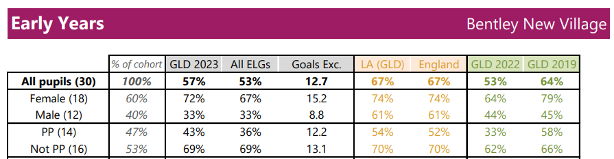

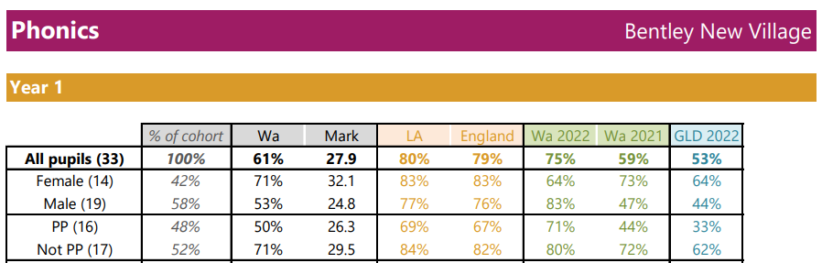

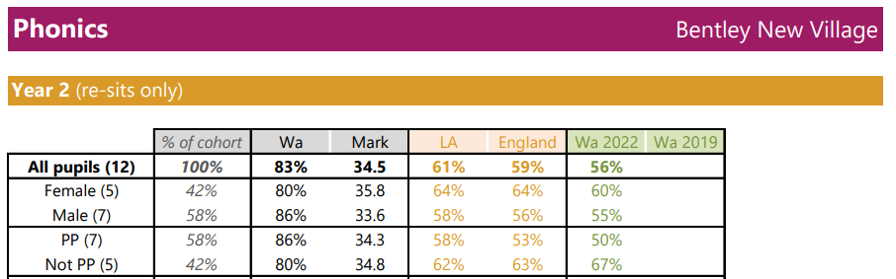
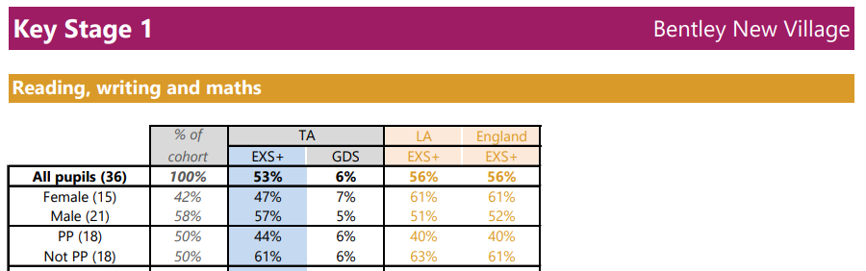
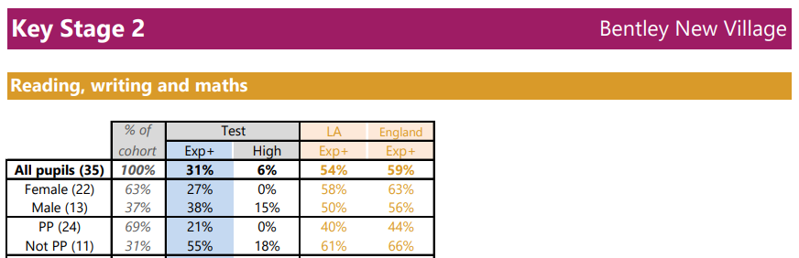

Externally provided programmes
Please include the names of any non-DfE programmes that you purchased in the previous academic year. This will help the Department for Education identify which ones are popular in England
Programme | Provider
Read, Write Inc Phonics | Ruth Miskin
Times Table Rock Stars | Maths Circle Ltd
Number Sense | Number Sense
Speech and Language Therapists | LINGO
WELLCOMM | GL Assessment

