Newsletter
October 2022

www.bentleynewvillage.com
https://www.facebook.com/BentleyNewVillagePrimarySchool

Thank you for everyone’s continued support and hard work to make our first half term back a happy and successful one! The children have all begun to settle back into school routines well and are looking

Family Talk Time:
One of our school priorities this year is centred around Oracy and meaningful talk. To support we have launched a new initiative called family talk time. It’s easy to think that children’s speech, language and communication develops no matter what. But this isn’t true. Children don’t learn to talk by accident. Adults play a really important role in nurturing and supporting these skills. We can do this by listening to what children say and building on their ideas. Hopefully by now you should have received the focus for last half term which was based around a favourite photograph. Children will be asked in school to talk about the chosen photograph.

Our topic for next half term will be family. The children will be asked to talk about their family with you and then report back to class.

Payments to School:
Payments to school for dinner money, trips and extended school clubs continue to be paid using the ParentPay website. If you have not set up an account with ParentPay, or have lost your login details, please speak to staff in the school office.
Class Dojo:
By now you should be up and running on class dojo. If not please see your child’s class teacher to be invited. Thank you to all the parents already on there. You can see the dojo’s awarded in class and also keep up to date with events in school. Please use dojo to contact parents where possible.

Open Evenings:
The week beginning 14th November will be our first parents evening of this school year. I hope you all find them very useful to discuss your child’s return to school and how they have settled in. We are aiming for 100% contact, please contact your child’s class teacher as soon as possible to make an appointment.
School Council:
We are pleased to announce the names of our children elected onto our school council. These children have already had an important role to play in the interviews for our new headteacher:

Key Stage 1:
Daisy and Isaac (Mr McGregors Garden)
Jay and Lucy (Neverland)
Jorgi and Kaya (100 Acre wood)

Lower Key Stage 2: Upper Key Stage 2:
Gabriel and Maria (Magic Faraway Tree) Rose and Jack (Narnia)
Milly and Faith (Secret Garden) Lewis and Trudy (New York)
Cayson and Imogen (Hogsmeade) Riley and Miley (Wonderland)

Focus Learning Behaviour:
In school we promote 6 different learning behaviours. This year we have decided to focus on developing one each half term. This would be started on the first day of term and continued throughout the half term including playtimes. Our focus for last half term was encouraging cooperation and up until Christmas we will be working on determination. Please support us by looking at what this means at home.

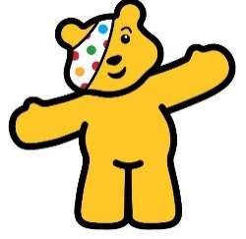
Children in Need:
We would like to support BBC Children in Need on Friday 18th November. This year, the BBC theme is ‘Together we can change young lives’ – It is intended to be ‘spotacular’. We will be asking children to wear spots for the day.

Contact Details:
To support us in being able to contact you in an emergency and remain GDPR compliant, please inform the school office of any change in address and/or contact numbers asap.

School Improvement Priorities:
School priorities are determined with regard to the following: outcomes of the school’s self-evaluation systems, government/LA initiatives, data analysis, consulting with children and parents, both formally and informally and embedding successful school initiatives which warrant further development. Our key priorities identified for improvement over this coming school year are:
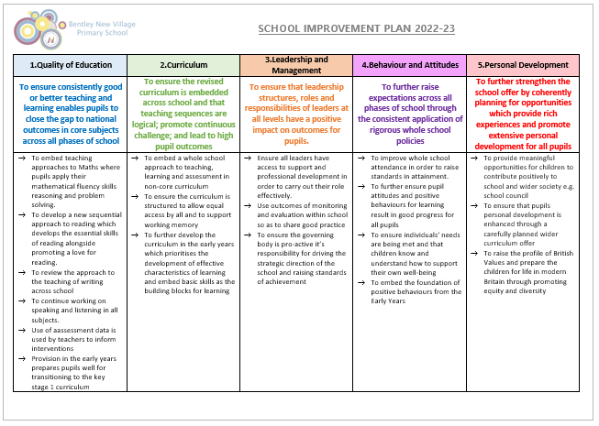
Attendance:
This year we are continuing to aim for our target of 97% and this is reflecting in attendance being one of our target priorities. As a Local Authority maintained school, we follow Doncaster LA Attendance policies and guidelines. As part of these processes, we are required to send a letter to parents if their child’s attendance falls below 95%. If your child is absent for 10% or more of school sessions, and their attendance falls below 90%, they are defined by the government as a ‘Persistent Absentee’ and information regarding your child’s attendance is reported to the Local Education Authority and Department for Education.

Wherever possible, medical and dental appointments should be arranged out of school hours; where this is not possible we need to see either an appointment card or receive a letter containing the appropriate details. Our aim is to have no children absent without authorisation and we rely on your help and co-operation to achieve this. Also, please note that children in all year groups are assessed during May/June and therefore any absences should be avoided during this month. In addition to the end of Key Stage assessments (Years 2 & 6), there is a compulsory phonics assessment for every child in Year 1 and a multiplication tables test for every child in Year 4 which will both take place during June 2023.

The table below shows the weekly average attendance figures for each class so for this half-term. The school target is 97% so we have no classes above that figure, this is obviously a concern.
Class | Average Attendance (%) | Number of Late Marks
Ducklings | 89.3 | 6
Robins | 95.4 | 8
Mr McGregors Garden | 91.9 | 27
Neverland | 96 | 8
100 Acre Wood | 94.8 | 4
Hogsmeade | 93.1 | 14
Secret Garden | 91.5 | 23
Magic Faraway Tree | 96.4 | 27
Narnia | 92.1 | 10
New York | 94 | 13
Wonderland | 86.4 | 9
TOTAL | 93 | 149

Diary Dates:
Where a * * appears these could be days where the children are asked to dress in a costume.
Date | Year Group | Event
31.10.22 | All Years | School opens (start of school day)
11.11.22 | All Years | Remembrance Day
w/b 14.11.22 | All Years | Parents Consultation Evening
18.11.22 | All Years | *Children in Need*
01.12.22 | All Years | Christmas Tree Dressing/Carols
05.12.22 | Y1 & 2 | 2pm Christmas Concert
06.12.22 | F1 (Duckings) | 11am/2pm Christmas Concert
07.12.22 | Y5 & 6 | 2pm Christmas Concert
08.12.22 | Y3 & 4 | 2pm Christmas Concert
09.12.22 | F2 (Robins) | 2pm Christmas Concert
 | All Years | *Christmas Jumper Day*
16.12.22 | All Years | am – Christmas Party and activities  School closes at 1.30pm
03.01.23 | All Years | School opens (start of school day)
w/b 16.01.23 | Y2 & 6 | SATS parents information meetings
w/b 23.01.23 | Y4 | Multiplication Tables Check (MTC) parent information meeting
 | Y1 | Phonics information meeting
06.02.23 | All Years | Children’s Mental Health Week
10.02.23 | All Years | School closes (end of school day)
20.02.23 | All Years | Training Day
21.02.23 | All Years | School opens (start of school day)
23.02.23 | All Years | Safer Internet Day
02.03.23 | All Years | *World Book Day*
13.03.23 | All Years | Science Week
17.03.23 | All Years | *Comic Relief*
24.03.23 | All Years | Reports Out
31.03.23 | All Years | School closes (end of school day)
17.04.23 | All Years | School opens (start of school day)
01.05.23 | All Years | School Closed
02.05.23 | All Years | School opens (start of school day)
 | Y2 | Y2 SATs begin
w/b 08.05.23 | Y6 | SATs week
25.05.23 | All Years | School closes (end of school day)
26.05.23 | All Years | Training Day
05.06.23 | All Years | School opens (start of school day)
05.06.23 | Y4 | MTC check begins
09.06.23-11.06.23 | Y5 & 6 | PGL
w/b 12.06.23 | Y1 | Phonics Screening week
21.06.23 | All Years | *World Music Day*
26.06.23 | All Years | School Diversity Week
03.07.23 | All Years | Arts Week
w/b 03.07.23 | All Years | Parents Consultation Evenings
w/b 10.07.23 | All Years | Sports Week (Sports day within this week date tbc)
w/b 17.07.23 | Y6 | Leavers Performances & Party
18.07.23 | All Years | New Village Citizen of the Year Awards
21.07.23 | All Years | School closes

And Finally…
We welcome back Mrs Smith following her maternity leave.

Some more of our staff have welcomed new additions recently. Many congratulations to Miss Greaves, Mr Stallard, Miss Oldham and Mrs Fogg.

It is with sadness that we say our farewells to Mrs Brown this week, as she moves on to a new exciting role outside of the classroom – we wish her all our best wishes.

Mrs Simmons

