Newsletter
January 2023

www.bentleynewvillage.com
https://www.facebook.com/BentleyNewVillagePrimarySchool

Happy New Year!

New School Day Consultation:
We have been holding consultations about returning the children to having a school day that is no longer staggered. This will make it easier for parents who have children in more than one area and stop the waiting about in the cold. I will be sharing a google form with the 2 options on via dojo. We would ask that if you wish to respond to this consultation, even if you support the arrangements, by completing your feedback on the following link
https://forms.gle/4yhgJBqLQRg3GAu76
I appreciate that these changes may affect a small minority in terms of childcare or working arrangements. Responses to the consultation will be collated and discussed. The consultation runs for a 4-week period, from 2nd January 2023 – 3rd February 2023. The result outcome will be shared by 10.02.23 and changes starting on 21st February.

Cultural Passport:
At Bentley New Village Primary School, we believe that cultural activities are a vital part of life and play a very important role in children’s social development. The pupils will participate in a range of cultural activities organised by the school, to enrich their lives and create great memories. Some cultural activities may also be completed in the children’s own time outside the school, with family and friends.

We are launching six Cultural Passports to complete during the children’s time at Bentley New Village Primary School; One for each year in Key Stage 1 and 2. Within each passport there are a range of cultural activities to complete and they are split into the following four categories:
- Outdoor and nature
- Community
- Creative
- Global

They must complete 6 or more activities each term, completing at least 1 activity from each of the 4 sections.

Family Talk Time:
As discussed in the previous newsletter we are continuing to develop our school priority centred around Oracy and meaningful talk. This half term the focus is on holidays. This could be around a holiday you have been on as a family or around the Christmas Holiday. The children will be asked to share their favourite thing about the holiday. You can send props or photos to share.

School Library:
As a school, we want to continue to promote and support children’s reading in school and at home. Reading continues to be one of our key priorities as a school and to continue to encourage and promote a love of reading we are very lucky to announce our New School Library is open.

We were very fortunate to be offered funding for the library from the “Love our Libraries scheme”. Therefore, our library has many new books, furniture, e –readers and much more. We are so excited to be ready to finally allow our school community to be enjoying the space and borrowing books. In the new year we are looking forward to opening our library after school for families to use the library together.

School Reports and Open Evenings:
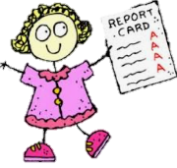
As you may remember from the letter sent out in September the annual report will now be shared with you during the Spring Term. Any targets set by the class teacher can then be worked on through the remainder of the year. There will be another Parent’s Evening during the Summer term to review progress and attainment.

During the Parent’s evening and in November parents completed the Parental Questionnaire. The overall consensus was to offer this both on paper and online. I will therefore ensure this is offered in the future.

Some of the results were:

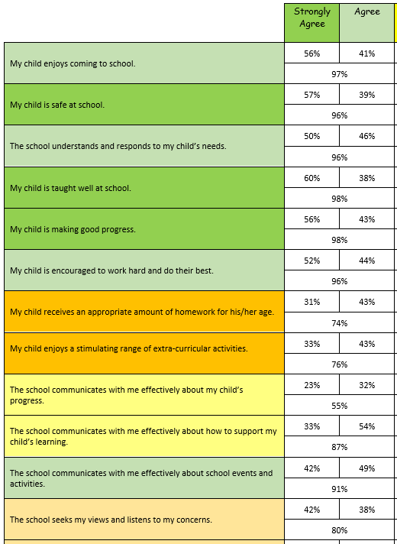

School Council:
In the first half of the Autumn term, the school council took part in the interviews to help our board of governors select the new headteacher. They came up with their own questions for the candidates about the things that they would do should they become our new headteacher. School council also decided that teachers should have their own Class Dojo so that the children in school can decide when the teachers are showing our school's key values and reward them with Dojos!

In the second half of the Autumn term, school council discussed what is and isn't going well around school so that we have some things to work on going forward. The representatives took ideas from each of their classes and then brought them to the meeting in order to help to plan our upcoming Curiosity day and Mental Health week and they have also begun to think of ideas for other themed days that we might have over the rest of the year.

Child Questionnaire
We have also conducted our annual student questionnaire. Some of the results were:
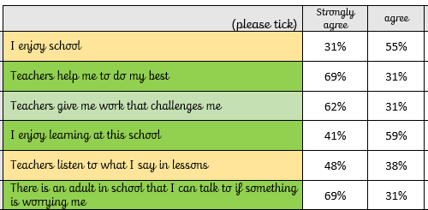
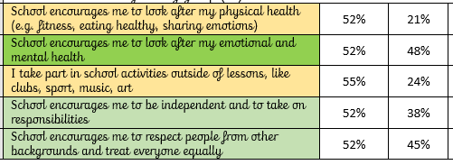

Focus Learning Behaviour:
In school we promote 6 different learning behaviours. This year we have decided to focus on developing one each half term. This would be started on the first day of term and continued throughout the half term including playtimes. Our focus for last half term was encouraging determination and after Christmas we will be working on curiosity. Please support us by looking at what this means at home.

Contact Details:
To support us in being able to contact you in an emergency and remain GDPR compliant, please inform the school office of any change in address and/or contact numbers asap.

Attendance:
The table below shows the weekly average attendance figures for each class for this half-term. The school target is 97% so we have no classes above that figure, this is obviously a concern.
Class | Average Attendance (%) | Number of Late Marks
Ducklings | 89.4 | 21
Robins | 94.7 | 35
Mr McGregors Garden | 92 | 70
Neverland | 94.9 | 29
100 Acre Wood | 94.5 | 13
Hogsmeade | 92.3 | 40
Secret Garden | 93.3 | 56
Magic Faraway Tree | 96.6 | 70
Narnia | 92.5 | 55
New York | 93.9 | 39
Wonderland | 90.2 | 26
TOTAL | 93.3 | 454

After School Clubs and Extra Curricular:
Here is the Spring Term Overview for the available afterschool clubs this term. If your child is interested contact the school office to see if there are any places available.
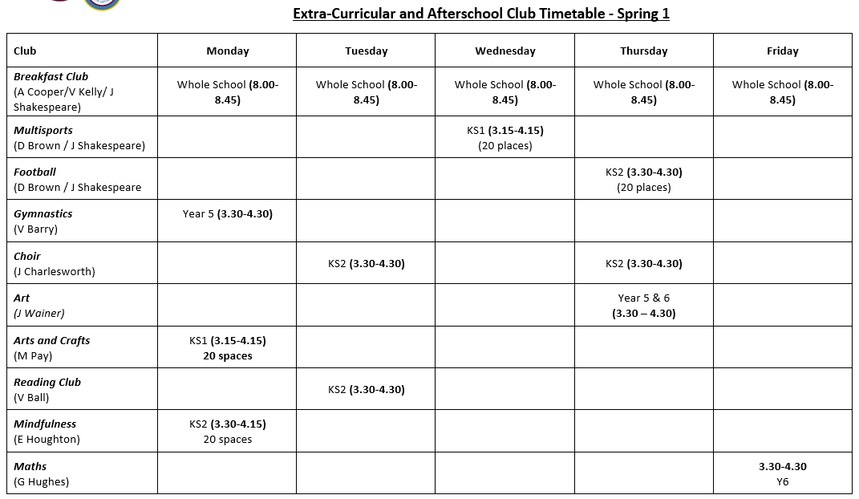

Diary Dates:
Where a * * appears these could be days where the children are asked to dress in a costume.
Date | Year Group | Event
03.01.23 | All Years | School opens (start of school day)
w/b 16.01.23 | Y2 & 6 | SATS parents information meetings
w/b 23.01.23 | Y4 | Multiplication Tables Check (MTC) parent information meeting
 | Y1 | Phonics information meeting
06.02.23 | All Years | Children’s Mental Health Week
08.02.23 | KS2 (School Choir) | Young Voices Concert
10.02.23 | All Years | School closes (end of school day)
20.02.23 | All Years | Training Day
21.02.23 | All Years | School opens (start of school day)
23.02.23 | All Years | Safer Internet Day
02.03.23 | All Years | *World Book Day*
13.03.23 | All Years | Science Week
17.03.23 | All Years | *Comic Relief*
24.03.23 | All Years | Reports Out
31.03.23 | All Years | School closes (end of school day)
17.04.23 | All Years | School opens (start of school day)
01.05.23 | All Years | School Closed
02.05.23 | All Years | School opens (start of school day)
 | Y2 | Y2 SATs begin
w/b 08.05.23 | Y6 | SATs week
25.05.23 | All Years | School closes (end of school day)
26.05.23 | All Years | Training Day
05.06.23 | All Years | School opens (start of school day)
05.06.23 | Y4 | MTC check begins
09.06.23-11.06.23 | Y5 & 6 | PGL
w/b 12.06.23 | Y1 | Phonics Screening week
21.06.23 | All Years | *World Music Day*
26.06.23 | All Years | School Diversity Week
03.07.23 | All Years | Arts Week
w/b 03.07.23 | All Years | Parents Consultation Evenings
w/b 10.07.23 | All Years | Sports Week (Sports day within this week date tbc)
w/b 17.07.23 | Y6 | Leavers Performances & Party
18.07.23 | All Years | New Village Citizen of the Year Awards
21.07.23 | All Years | School closes

And Finally…
I would like to express my gratitude to the staff and pupils during the Autumn Term. The performances they developed were fabulous!

In particular I would like to thank Mr Lund for planning the Winter Day and creating links with the wider community in Bentley. Items created (decorations, cards etc) on the winter day were shared with residents of local care homes as a present from us.
I would also like to give a special mention to Mrs Charlesworth for her fabulous work with the choir. They have sung at the Frenchgate raising an amazing £181 for school and visited some of the residents of a local care home to sing carols for them.

I would also like to thank our fabulous Lunchtime Supervisors, cleaners and staff who sold raffle tickets during our Christmas performances – a total of £306.20 was rasied.
Mrs Simmons

