Safeguarding and Child Protection Policy
children and young people

Including managing allegations against staff working in a public capacity (LADO) and Mandatory reporting duties under Prevent and FGM

named Governor responsible for policy:  Named Head Teacher / Principal: | Sharon Golze  KIRSTEn MCKECHNIE
Approved: Yes | Date; October 2020
Signed: 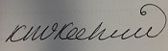 S.Golze
Reviewed/ Revised on:  Next review date (at least Annually ) | September 2020  September 2021

This policy was updated on 1ST September 2020 in line with KCSIE
https://assets.publishing.service.gov.uk/government/uploads/system/uploads/attachment_data/file/912592/Keeping_children_safe_in_education_Sep_2020.pdf
Local Authority Statement

Academy / School / Education Provider Responsibility

The LA only offers this model policy for all educational settings. The Governing Body must ensure this is adapted/adopted and implemented/reviewed within the establishment context. The LA only offers this as a guide – establishments must ensure they are responsible for their own policies and ensure this is demonstrated and owned by the school community in practice. Schools and Academies are responsible for reviewing and updating the school/academy safeguarding policy in line with legislative changes.

Schools and local authorities must have regard to it when carrying out their duties to safeguard and promote the welfare of children under section 175, of the Education Act 2002, paragraph 7(b) of Schedule 1 to the Education (Independent School Standards) Regulations 2014 and paragraph 3 of the Schedule to the Education (Non-Maintained Special Schools)(England) Regulations 2011.

The school/setting Bentley New Village recognises the responsibility it has under Section 175 of the Education and Inspections Act 2002, to have arrangements for safeguarding and promoting the welfare of children. The Governing Body approve the S175 or 157 and return to the Local Authority (LA) on a yearly basis. This policy demonstrates the school’s commitment and compliance with safeguarding legislation.

Through their day-to-day contact with pupils and direct work with families, staff at the school/setting have a crucial role to play in noticing indicators of possible abuse or neglect and referring them to The Doncaster Children’s Trust MAAP team. This also involves understanding serious case reviews and how to improve practice to prevent children from falling through the gaps.

Local Safeguarding and Chid Protection

This model LA safeguarding policy does not replace the agreed DSCP Multi Agency Child Protection Tri-x procedures http://doncasterscb.proceduresonline.com/

Staff must ensure they refer to the DSCP procedures on a regular basis.

It is the responsibility of Governors to review the new Ofsted Education Inspection Framework (EIS) alongside Senior Leaders Schools -schools must review this policy in accordance with the new and publish their intent for safeguarding with information on how they will implement safeguarding and monitor impact.

It is the Local Authority intent that ALL educational establishments will be effective (outstanding) for safeguarding.

It is the responsibility of the setting to ensure they maintain an effective safeguarding policy and keep in tune with the changing Government advice during Covid19 and attach amendments to this policy when statutory guidance is issued. For example https://www.gov.uk/government/publications/face-coverings-in-education/face-coverings-in-education
26 August 2020

The way schools and colleges are currently operating in response to coronavirus (COVID-19) is fundamentally different to business as usual, however, a number of important safeguarding principles remain the same:

- with regard to safeguarding, the best interests of children must always continue to come first

- if anyone in a school or college has a safeguarding concern about any child they should continue to act and act immediately

- a DSL or deputy should be available

- it is essential that unsuitable people are not allowed to enter the children’s workforce and/or gain access to children

- children should continue to be protected when they are online

Schools and colleges should, as far as is reasonably possible, take a whole institution approach to safeguarding. This will allow them to satisfy themselves that any new policies and processes in response to COVID-19 are not weakening their approach to safeguarding or undermining their child protection policy.

governors statement

- The Governing Body and staff of Bentley New Village (hereinafter referred to as ‘the school’) take as our first priority the responsibility to safeguard and promote the welfare of our pupils, to minimise risk and to work together with other agencies to ensure rigorous arrangements are in place within our school to identify, assess, and support those children who are suffering harm or who are likely to suffer harm and to keep them safe and secure whilst in our care.

- The Governing Body will ensure the Designated Safeguarding Lead and Deputy Designated Lead (s) have a job description in line with Keeping Children Safe in Education 2020 with dedicated time and support in place for the DSL to fulfill this duty.

- The responsibilities set out in this policy apply (as appropriate) to all members of the school community including pupils, staff, governors, visitors/contractors, volunteers and trainees working within the school. It is fully incorporated into the whole school ethos and is under pinned throughout effective leadership; the teaching of the curriculum and within PHRSCE and within the safety of the physical environment provided for the pupils.

- The governors will ensure safeguarding self-evaluation takes place on a regular basis, a safeguarding audit has taken place and statutory S175/157 action plans are measured. The governors ask for a regular safeguarding impact report and ensure all statutory requirements under KCSIE Sept 2020 are fulfilled.

- The Ofsted Inspection Handbook is benchmarked to ensure safeguarding is `outstanding` in this setting.

- Governors and senior leaders/DSL will continually review all polices required by law https://www.gov.uk/government/publications/statutory-policies-for-schools

Signed; R. Precious

Chair of Governors and Designated Safeguarding Governor

Date; 19.10.2020

Safeguarding Children and young people POLICY

Rationale:

This policy has been developed in accordance with the principles established by the Children Act 1989 and 2004, The Education Act 2002 and Working Together to Safeguard Children 2018. This policy reflects the statutory requirements within Keeping Children Safe in Education September 2020 and DSCP local policy and procedures. Including local lessons learned to ensure all children young people and families in Doncaster are supported,
Supporting the vision for Doncaster to be the most child friendly Borough.

Safeguarding Definitions:

Safeguarding and promoting the welfare of children are defined for the purposes of this policy as:

- Protecting children from maltreatment
- Preventing impairment of children’s health or development
- Ensuring that children grow up in circumstances consistent with the provision of safe and effective care, and
- Taking action to enable all children to have the best outcomes

(Working Together to Safeguard Children 2018 HM Government)

Safeguarding is not just about protecting children from deliberate harm. It relates to aspects of school life including:

- Pupil’s health and safety
- The use of reasonable force
- Meeting the needs of pupils with medical conditions
- Providing first aid
- Educational visits
- Intimate care
- Internet or e-safety
- Appropriate arrangements to ensure school security, taking into account the local context.
- Mental health and well-being

It can involve a range of potential issues such as:

- Bullying, including cyber bullying (by text message, on social networking sites, and so on) and prejudice based bullying
- Racist, disability, and homophobic or transphobic abuse
- Radicalisation and extremist behaviour
- Child sexual exploitation
- Child criminal exploitation
- Sexting
- Substance misuse
- Issues that may be specific to local area or population, for example gang activity and youth violence
- Particular issues affecting children including domestic violence, sexual exploitation, female genital mutilation and forced marriage
- Educating children and young people to stay safe on line during Covid19

KCSIE 2020 and DSCP-tri-ax Safeguarding Policy and Procedures manual both include wider safeguarding categories. This setting applies all to practice. In addition
Informed Trauma and Adverse Child Experiences are demonstrated in safeguarding practice and “thinking the unthinkable” and “it could happen here” is paramount.

PURPOSE:

The purpose of the policy is to ensure that safeguarding is everyone’s responsibility.

- The welfare of the child is paramount.
- All children regardless of age, gender, ability, culture, race, language, religion or sexual identity have equal rights to protection.
- Everyone who works with children has a professional responsibility to keep them safe (Working Together 2018).
- All staff have an equal responsibility to act on suspicion or disclosure that may suggest a child is at risk of harm, any professional with concerns about a child’s welfare should make a referral to the Doncaster Children’s Trust, and professionals should follow up their concerns if they are not satisfied with the response. (Working Together 2018).
- Pupils and staff involved in safeguarding issues receive appropriate support and training outlined in the DSCP workforce development strategy and Doncaster Children and Young Peoples Plan.
- Staff to adhere to a Code of Conduct and understand what to do if a child discloses any allegations against teaching staff, Head teachers or the Governing Body.
- To develop and promote effective working relationships with other agencies, especially the police and social care.
- To ensure all staff have been recruited in accordance with safer recruitment principles and a single central record is kept to monitor that all required vetting checks have been carried out before appointments are made. These include satisfactory (enhanced) DBS (incorporating a barred list check), prohibition from teaching, prohibition from leadership and management, satisfactory references which have been validated, medical declaration, right to work in the UK, full identity information are made in accordance with guidance. Any gaps in personnel files are noted and reasonable steps are taken to rectify with on-going supervision (see DMBC update – Annex 1).
- We have a safe school with confident staff, confident parent/carers and confident pupils who know how to recognise and report safeguarding concerns.
- All staff understand the categories of abuse, indicators and know how, when, who and how to record and report all safeguarding concerns.
- Understand ward level data and local priorities linked to

Governors Responsibilities:

- The Governing Body fully recognises its responsibilities with regard to Safeguarding and promoting the welfare of children and has ensured at least part 1 of DfE Keeping Children Safe in Education 2020 has been implemented and understood by all staff.

- This states that the Governing Body should ensure that:
- The school/setting has Child Protection procedures in place
- The school/setting operates safe recruitment procedures and appropriate checks are carried out on new staff and adults working on the school site
- The school/setting has procedures for dealing with allegations of abuse against any member of staff or adult on site
- The school/setting has a member of the Leadership Team who is designated to take lead responsibility for dealing with Child Protection issues with a job description and time allocated to attend meetings and training.
- The Governing Body should remedy any deficiencies or weaknesses with regard to Child Protection arrangements.
- The Governing Body has nominated a member responsible for liaising with the LA and/or partner agencies in the event of allegations of abuse against the Head Teacher. This should be the Chair of Governors.
- The Governing Body reviews its Safeguarding policy and procedures annually.
- The Governing Body approves the LA/DSCP annual Safeguarding Audit.
- It undertakes a review of behaviour and safety (safeguarding) as part of the Governing Body self-evaluation on a regular basis.
- All members of the governing body understand and fulfil their responsibilities and discharge KCSIE 2020 requirements. They support the role of the designated safeguarding lead in managing referrals, training and raising awareness (KCSIE 2020).
- Ensuring the school/academy is compliant with Part 2: The Management of Safeguarding KCSIE 2020.
- The governing body has ensured all staff have read at least part 1 of the new KCSIE 2020 statutory guidance and this is now included in all staff induction and whole school training.
- The procedures contained in this policy apply to all staff, volunteers, sessional workers, agency staff, contractors or anyone working on behalf of the Doncaster school/setting. They are consistent with South Yorkshire Child Protection procedures/Doncaster Safeguarding Children Board (DSCP) child protection procedures.
- We fully embrace the KCSIE quotation “It could happen here” and “thinking the unthinkable”

- The Governing Body are responsible for liaising with the Head Teacher/Designated Staff over all matters regarding child protection issues. The role is strategic rather than operational – they will not be involved in concerns about individual pupils.

- The nominated Safeguarding Governor will support the designated safeguarding lead in their role from the perspective of ensuring the allocation of funding and resource is sufficient to meet the current safeguarding and child protection activity.

- The DSL and named safeguarding governor are responsible for providing an annual report to the governing body of child protection activity. The local authority annual review monitoring return for safeguarding should be sufficient as an annual report for governors.

- The DSL must ensure that the annual review child protection monitoring submission is completed and returned in a timely manner to the local authority/LSCB. The return must be signed by the Chair of Governor’s to confirm that it is an accurate reflection of the safeguarding arrangements of the school/college.

- The governing body should have child protection training on their strategic responsibilities in order to provide appropriate challenge and support for any action to progress areas of weakness or development in the school/college’s safeguarding arrangements.

- The chair is nominated to liaise with the local authority and/or partner agencies on issues of child protection and in the event of allegations of abuse made against the Head Teacher, the principal of a college or proprietor or member of governing body of an independent school.

- In the event of allegations of abuse being made against the head teacher and/or where the head teacher is also the sole proprietor of an independent school, allegations should be reported directly to the local authority designated officer (LADO) without delay and within one working day.

- Under no circumstances should the establishment’s governors or trustees be given details of individual cases. Governors may, however, be provided with a report at the end of the academic year, outlining the number of cases dealt with and other statistics which do not identify individual children.

- Governors will ensure that appropriate internet filters and appropriate web-use monitoring systems are in place. Children should not be able to access harmful or inappropriate material from the school or colleges IT system.
.

TERMINOLOGY:

Designated Safeguarding Lead (DSL) previously known as designated safeguarding officer or designated safeguarding teacher, the named person for safeguarding in education establishments.

LADO – Local Authority Designated Officer – deals with any allegation against any member of staff in a public setting.

Safeguarding and promoting the welfare of children refers to the process of protecting children from abuse or neglect, preventing the impairment of health and development, ensuring that children growing up in circumstances consistent with the provision of safe and effective care and undertaking that role so as to enable those children to have optimum life chances and to enter adulthood successfully.

Child Protection refers to the process undertaken to protect children who have been identified as suffering, or being at risk of suffering significant harm.

Staff refers to all those working for or on behalf of the school/setting in either a paid or voluntary capacity.

Child refers to all young people who have not yet reached the age of 18.

Parent refers to birth parents and other adults who are in a parenting role – step-parents, foster parents, carers and adoptive parents.

There are 4 main elements to the Policy:

- Prevention – through the curriculum and pastoral support offered to pupils and through the creation and maintenance of a whole school/setting protective ethos.

- Procedures – for identifying and reporting cases, or suspected cases of abuse.

- Support to Pupils – who may have been abused, including early preventative work.

- Preventing unsuitable people working with children – by following statutory guidance, DSCP, LADO,DBS and TSA and HR procedures.

A PREVENTION

The school/setting will establish an ethos where:

- Children feel secure.
- Ensure children know that there are adults in the school/setting who they can approach if worried or in difficulty.
- Include in the curriculum opportunities for PSHCE/SMSC/RSE to equip children with the skills needed to stay safe. This includes our PREVENT duty. http://intranet.doncaster.gov.uk/directorates/adults-health-wellbeing/preventing-people-being-drawn-into-extremism
- Include in the curriculum material, which will help children develop realistic attitudes to their responsibilities in adult life.
- It will work in accordance with ‘Working Together to Safeguard Children 2018’ and will support the ‘Doncaster Early Help Offer’ and new Localities way of working to ensure children and young people receive the most appropriate referral and access provision.
- It will deliver the approved DSCP whole school safeguarding training and ensure all designated safeguarding officers/deputy safeguarding person attend three out of four annual network meetings annually, and attend refresher Designated Safeguarding Person/Lead (DSP/L) training on a two yearly basis
- We will work collaboratively and with our Early Help Co-ordinators to improve outcomes for children and young people.
- We access the school nursing universal offer for all our children and young people.
- We keep our safeguarding training up to date, access DSCP training events on a regular basis, and understand the safeguarding requirements for Ofsted.
- Parents, carers and families, teachers, staff and young people/agencies know how to raise any safeguarding concerns and we have a named designated/deputy safeguarding lead(s) on our senior leadership team.
- We have a clear complaints policy and all staff are aware of whistleblowing procedures.

SAFEGUARDING KEY CONTACT DETAILS
The Designated Senior Member of staff /lead for Safeguarding (Child Protection) is Kirsten McKecnhie.  Designated Safeguarding Lead (DSL) are;  Abigail Smith  Louise Wales  Kelly Hemmingway  Rachel Emery  The Single Point of  Contact for Early  Help / DCS Trust Multi Agency Access Point in our setting are:  Abigail Smith  Louise Wales | Define holiday cover arrangements  The named Safeguarding Lead during holiday periods representing the school is Kirsten McKechnie or in her absence Abigail Smith or Louise Wales.  The method for contact will be via email or telephone on the School Mobile.  head@newvillage.doncaster.sch.uk  admin@newvillage.doncaster.sch.uk  School Mobile; 07526041406  Any changes will be emailed to cypssafeguardingsupport@doncaster.gov.uk  A DSL is required at all times.  Contact during C19  The optimal scenario for any school or college providing care for children is to have a trained DSL or deputy available on site. It is recognised this may not be possible, and where this is the case the setting needs to be clear on stating DSL contact

The Deputy Designated Safeguarding Lead (s) are:  Abigail Smith  Louise Wales  Contact Details:  01302 874385 | How to contact during C19  A trained DSL or deputy from the school or college can be available to be contacted via phone or for virtual meetings.  admin@newvillage.doncaster.sch.uk  Bentley New Village School; 01302 874385  School Mobile; 07526041406
The Designated Teacher for Looked After Children is:
Abigail Smith

Contact Details:

01302 874385

The Nominated Child Protection/ Safeguarding Governor is Sharon Golze

The Nominated Governor for looked after children is
Sharon Golze

The named PREVENT lead is:
Louise Wales

The named CSE lead is:
Louise Wales

The named Mental Health First Aider is:
Abigail Smith

The named on-line protection officer and e-safety leads are:
Kelly Hemmingway
Louise Wales

Anti bullying officer is:
Louise Wales

LGBTQ lead is:
Louise Wales

The named complaints handler is:
Kirsten McKechnie

The named LAC officer is:
Abigail Smith

The named Operation Encompass lead is
Kirsten McKechnie

The Headteacher is the lead officer for all allegations against staff  Contact Details:  01302 874385 | How to Contact during C19;  Bentley New Village; 01302 874385  head@newvillage.doncaster.sch.uk
Only use this email  address to contact LADO office:  LADO@dcstrust.co.uk | The Local Authority Designated Officer (LADO) is:  Monday, Tuesday & Thursday –  CAROLINE TANNER  Wednesday & Friday – HELEN COOPER  Conference Chairs will deputise where required.  Low level LADO advice to educationsafeguarding@doncaster.gov.uk
Email contact  CYPSsafeguardingsupport@doncaster.gov.uk | Your Doncaster Council: Children and Young Peoples Safeguarding Manager is:  Sarah Stokoe  Doncaster Council: Children and Young Peoples Safeguarding Officers are:  Gill Whiteman  Dana Kelly  Please direct any online protection queries to Sarah, Gill or Dana

.

B PROCEDURES

The school will:

- Ensure it has a senior Designated Safeguarding Lead (DSL) who has undertaken appropriate Safeguarding (Child Protection) training (see above).

The school/setting will ensure that every member of staff and person working on behalf of the school/setting:

- Understand part 1 of KCSIE 2020 and the proposed Working Together 2018 changes including the mandatory reporting duty.
- Knows the name of the designated person and his/her role and responsibility.
- Have an individual responsibility to refer Safeguarding (Child Protection) concerns.

- Will receive training at the point of induction so that they know:
- Their personal responsibility/code of conduct/teaching standards
- DSCP child protection procedures and know how to access them
- Understand the definitions of abuse, physical abuse, emotional abuse, sexual abuse and neglect
- The need to be vigilant in identifying cases of abuse at the earliest opportunity
- How to support and respond to a child who discloses significant harm (either actual or likely)

- Knows their duty concerning unsafe practices in regard to children by a colleague.
- The designated person will disclose any information about a pupil to other members of staff on a need to know basis.
- The school/setting will undertake appropriate discussion with parents prior to involvement with other agencies unless the circumstances preclude this.
- The school/setting will ensure that parents have an understanding of their obligations regarding Child Protection by intervention as and when appropriate.
- Understand Ofsted grade descriptors in relation to personal development, behaviour and welfare of pupils
- Monitors internet usage in accordance with PREVENT/KCSIE and knows how to recognise and respond to inappropriate internet use.
- Ensure that designated staff will take advice from a Safeguarding (Child Protection) specialist when managing complex cases.
- The school/setting/DSL will liaise with the LADO/ Children’s and Young People’s Safeguarding Team before investigating any allegation involving actual or suspected abuse of a child within 24 hours of disclosure and follow up referral in writing, using relevant contact pathways for the MAAP (Multi Agency Access Point), which is Social Care and Early Help as one front door.
- All school/setting staff will pass any observations leading to suspicion of abuse, or information received about abuse, immediately to the Designated Safeguarding Lead or deputy Designated Safeguarding Lead.
- In the case of serious injury, risk of serious injury or allegation, the DSL will contact The Doncaster Children’s Trust Multi Agency Access Point without delay.
- If the allegation of abuse is against the deputy or designated safeguarding person, the Head Teacher will speak with the Children and Young Peoples Safeguarding Team to discuss the next steps.
- If the allegation is against the Head Teacher, the Chair of Governors should be contacted immediately and advice from the Doncaster Council Children and Young Peoples Safeguarding Team sought within 24 hours. If the allegation is against both the Head Teacher and Chair of Governors the Doncaster Council Children and Young Peoples Safeguarding Team will be contacted. No member of staff will conduct their own investigation or pass on information to the alleged perpetrator.
- Where an allegation is identified as serious/high level, please see LADO information/DSCP procedures - annex (P88) re protocol/thresholds and submit a referral asap
- The emergency social services team should be contacted outside normal working hours 01302 796000. All staff will contact the LADO immediately to report any `high level’ concerns that meet the threshold for LADO and complete the DCS Trust secure referral form. With these cases, the Doncaster Council Safeguarding Service does not need to be informed.

CHILD PROTECTION PROCEDURES

  - In the case of poorly explained serious injuries or where behaviour concerns arouse suspicion, the designated teacher will consult with the DCS Trust MAAP Service (formerly R&R) on 01302 737777. If out of hours, the emergency Doncaster Children’s Trust Social Care out of Hours team - (ESST) 01302 796000 (after 5.00pm and before 8.30 am weekdays and weekends).
  - For urgent referrals or advice, the MAAP Professionals’ Line is 01302 737033 (please note this number MUST NOT be circulated to parent/carers).
  - For advice relating specifically to concerns around the mental health of a child/young person, advice can be provided by ringing the MAAP Mental Health Specialist Advice Line 01302 796191.

- All parents and carers of families can contact the general contact number on 01302 737777. All staff are aware of the new MAAP/One Front Door Social Care Referral procedures. https://dscp.org.uk/report-concern
.

CE - Child Exploitation (CCE and CSE)

The Doncaster Definition of Child Criminal Exploitation is:

- Child Criminal Exploitation relates to any activity where a child, or vulnerable young adult up to the age of 21 ( if they are also Care Leavers or accessing a service from the Children with Disabilities team), is coerced, groomed, incentivised or threatened to become involved in criminal activity where they are too fearful to refuse the activities requested of them.

- Child Criminal Exploitation may also apply to socially- isolated young people who feel a kinship to other young people, adults or groups who offer inclusion into a group in exchange for engaging in criminal activities, which they otherwise would not have done.

- Child Criminal Exploitation should also be considered in the cases of children whose parents are organised crime nominals and who are therefore exposed to criminal activity, whether they are engaged in it themselves, or observe it, as a consequence of residing in that household and the child’s emotional, mental or physical health is impacted upon as a result.

It is important to have a clear definition of what constitutes CE if we are accurately to gauge the scale of the issue locally. The following is an extract from the Doncaster Child Sexual Exploitation Strategy where it seeks to define CCE:
- Child Exploitation relates to any activity where a child, or vulnerable young adult up to the age of 21 (if they are also Care Leavers or accessing a service from the Children with Disabilities team), is coerced, groomed, incentivised or threatened to become involved in criminal activity where they are too fearful to refuse the activities requested of them.

Indicators of involvement in child criminal exploitation:

- Child withdrawn from family;
- Sudden loss of interest in school. Decline in attendance or academic achievement (although it should be noted that some gang members will maintain a good attendance record to avoid coming to notice);
- Being emotionally ‘switched off’, but also containing frustration / rage;
- Starting to use new or unknown slang words;
- Holding unexplained money or possessions;
- Staying out unusually late without reason, or breaking parental rules consistently;
- Sudden change in appearance – dressing in a particular style or ‘uniform’ similar to that of other young people they hang around with, including a particular colour;
- Dropping out of positive activities;
- New nickname
- Unexplained physical injuries, and/or refusal to seek / receive medical treatment for injuries;
- Graffiti style ‘tags’ on possessions, school books, walls;
- Constantly talking about another young person who seems to have a lot of influence over them;
- Breaking off with old friends and hanging around with one group of people;
- Associating with known or suspected gang members, closeness to siblings or adults in the family who are gang members;
- Starting to adopt certain codes of group behaviour e.g. ways of talking and hand signs;
- Going missing;
- Returning home looking dishevelled;
- Being found by Police in towns or cities many miles from home;
- Expressing aggressive or intimidating views towards other groups of young people, some of whom may have been friends in the past;
- Being scared when entering certain areas;
- Concerned by the presence of unknown youths in their neighbourhoods.
An important feature of gang involvement and child exploitation is that, the more heavily a child is involved, the less likely they are to talk about it.
If there is any concern that a child/ young person is being criminally exploited there is a duty to safeguard their well- being. Early intervention is key to prevent escalation. A referral to children’s services is necessary or if the child/ young person is thought to be at immediate danger then DCST MAAP/One Front Door and or the Police need to be informed without delay. Prompt response may prevent them or others being harmed.
Anyone with concerns about gang involvement can contact the Targeted Youth Support Service (TYS) and they will arrange to visit the child or young person and carry out an assessment at that point. The Team EPIC worker will keep the school informed of the outcome of the assessment, and any interventions that are put in place as a result. You will be part of any multi-agency meeting that arises as a result of their involvement with Team EPIC or other provision available from TYS.
In Doncaster a low level intelligence form (not a referral form) is in place. The DSL should complete this form and pass to the police should low level concerns emerge that may indicate CE.
The previous CSE team will now take on the name of CE to tackle both CSE and CE. Local procedures are still developing – all procedures, including referral pathways and services can be accessed via the DSCP procedures
http://doncasterscb.proceduresonline.com/chapters/p_gang_activity.html?zoom_highlight=CCE
http://doncasterscb.proceduresonline.com/chapters/p_child_sexual_exploit.html?zoom_highlight=CSE

Professionals to refer concerns for advice and guidance through CSE Team Direct Number 01302 737200.

Low-level intelligence forms below can be used to alert services to suspected involvement in CSE (following guidance).

The DSL will also consider CE/CSE and share information on any child, young person or family at risk to ensure correct procedures are followed.

• Where child sexual exploitation or child criminal exploitation, or the risk of it, is suspected, frontline practitioners should complete a cause for concern form and pass onto the designated member of staff for child protection or contact the Child Exploitation Team. Education contacts are Carmel Bartlett/Jayne Pezzulo.(see referral forms page 12)

• The DSL should complete the CE checklist tool (see below) for partners and refer to the table at the end of the tool to help decide how to proceed; a copy of the completed tool must be kept in the child’s child protection records for future reference.

• If the child/young person already has an allocated social worker, the DSL must contact them (or their team manager) to discuss any concerns about child exploitation.

• A copy of the CE checklist tool for partners can be obtained from:
http://www.DSCP.co.uk/sexual-exploitation

http://doncasterscb.proceduresonline.com/chapters/p_gang_activity.html?zoom_highlight=CCE

Professionals can telephone team members for advice
01302 862012 - Jayne Pezzulo
01302 736929 - Carmel Bartlett

- All parents and carers of families can contact the general MAAP contact number on 01302 737777.

UNEXPLAINED AND SUDDEN CHILD AND YOUNG PEOPLES NOTIFIED DEATH

- In the event of an unexplained/sudden child death DSCP DCDOP procedures will be followed
https://doncasterchildcare.proceduresonline.com/chapters/p_death_serious.html

- Following any serious untoward incidents (SUI) procedure or where `near miss’ situations occur the DSL / Head Teacher will contact the Doncaster Council Learning Provision Service, this covers health and safety related incidents where safeguarding is compromised. Notification of near miss situations can also be emailed to cypssafeguardingsupport@doncaster.gov.uk and paul.ruane@doncaster.gov.uk or a call to the Assistant Directors/Duty Head of Service to enable a co-ordicanted response.

- The school/academy will have an emergency plan in place to respond to unforeseen circumstances, e.g. staff/child unexpected death, site security threats, floods, storms etc and know how to notify the LA of a critical incident.

SECURITY BREACHES / THREATS

- The school will follow the Doncaster Council emergency procedures for hoax emails/threats and notify relevant officers should any significant security threats be made. Each section within the DMBC Emergency planning policy includes contact details for local services available to safeguard all.

HEALTH AND SAFETY

RIDDOR notifiable incidents and significant safeguarding breaches to be notified via the Emergency Planning contacts and this policy is cross referenced to managing fist aid, including head injuries and managing medications and reporting aggression and violence (including on staff)

Guidance around Bomb Threats
National Counter Terrorism Security Office Guidance Note:

The school/setting has a clear emergency plan in place this includes NaTSCO guidance (schools to cross reference here linked policy)

ICT security, the school applies regular searches within the ICT infrastructure to ensure all children are safeguarded and any inappropriate material accessed is blocked, or where breaches occur the setting applies procedures set out within this policy.

The annual S175/157 confirms such checks take place and toolkits are in place to enhance keeping children safe on line such as The Counter Terrorism Internet Referral Unit (CTIRU) Filtering Tool .This tool can be accessed through the UKSIC website at http://testfiltering.com/ (settings to adapt here to reflect internet secutiry)

C SUPPORT TO PUPILS

During COVID19 Local authorities have the key day-to-day responsibility for delivery of children’s social care. Social workers and Virtual School Heads will continue to work with vulnerable children in this difficult period and should support these children to access this provision. There is an expectation that children with a social worker will attend provision, unless in consultation with the child’s social worker and family it is agreed this is not in the best interests of the child.

Senior leaders, especially DSLs (and deputies) know who their most vulnerable children are and have the flexibility to offer a place to those on the edges of receiving children’s social care support.

School and college staff should continue to work with and support children’ social workers to help protect vulnerable children. This will be especially important during the COVID-19 period.

Conversations with a child who discloses abuse should follow the basic principles:

- Listen rather than directly question; remain calm.
- Never stop a child who is recalling significant events.
- Make a record of discussion to include time, place, persons present and what was said (child language – do not substitute words).
- Advise that you will have to pass the information on.
- Avoid coaching/prompting.
- Never take photographs or videos of any injury.
- Allow time and provide a safe haven/quiet area for future support meetings.
- Share all concerns no matter how trivial they may seem to the DSL, who will notify with the DCS Trust MAAP/One Front Door Referral Procedure and follow up any child protection concern immediately in writing
- For children with CP plans/named lead practitioner/named social worker (CIN) where new information is shared by the young person, the DSL will ensure information is shared with the social worker and not withheld until core/review meetings take place.
- At no time promise confidentiality.
https://doncasterscb.proceduresonline.com/chapters/p_info_sharing.html

Working Together (2018) and Keeping Children Safe in Education (2020) provides a diagram to show the expected response to raising any safeguarding concerns.

See table below:

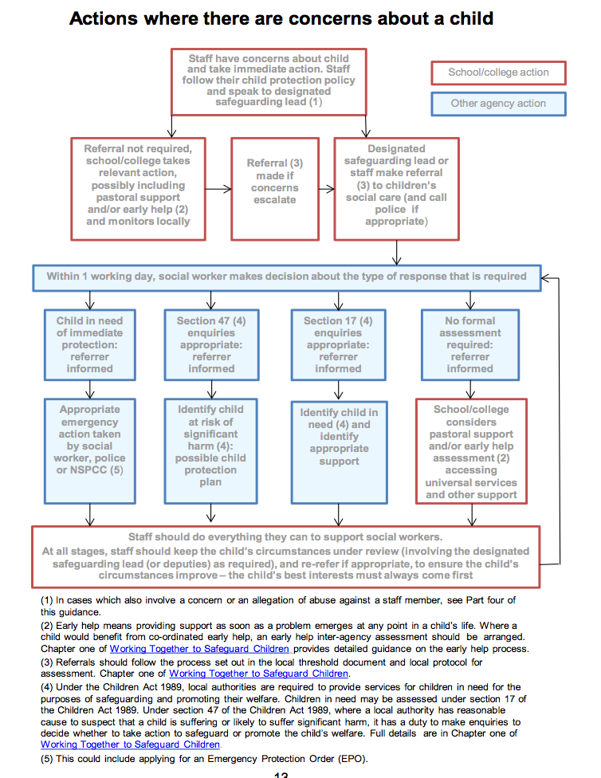

The Role of Designated Safeguarding Lead and Deputy Safeguarding Lead

In addition the example job description provided within KCSIE 2020 –

The DSL has a clear job description as outlined in Keeping Children Safe in Education 2020 and agreed safeguarding cover arrangements during school holidays for agencies to contact are in place.

- The DSL will ensure that all staff involved in direct case work of vulnerable children, where there are child protection concerns/issues; have access to regular safeguarding supervision.

- Designated staff must have a working knowledge of how local authorities conduct a child protection case conference (ICPC) and a child protection review conference (RCPC) and be able to attend and contribute to these effectively when required to do so. (See Section 9.1)

- Designated staff must be alert to the specific needs of children in need, those with special educational needs. LGBTQ, at risk of exploitation and young carers. Recognising adverse childhood experiences, family breakdown, bereavement and exam stress and the impact of domestic abuse and all abuse on childhood development.

- Designated staff must obtain access to resources and attend any relevant or refresher training courses.

- Designated staff must encourage a culture of listening to children amongst all staff.

- Designated staff must highlight the importance of demonstrating children’s wishes and feelings and voice to all staff and that these are clearly evidenced.

- Designated Staff must ensure that they are appropriately trained and supported to fulfil this role.

- Designated staff must follow GDPR policy and procedure.

- Designated staff must learn from serious case/practice reviews and lessons learned, know when to challenge consent and lack of engagement, understand case escalation and local procedures to challenge systems that may be failing, in the best interest of the young person.

Raising Awareness (see KCSIE 2020 job description)

- The DSL should ensure the school or college’s policies are known, understood and used appropriately.

- Ensure the school’s safeguarding and child protection policy is reviewed annually and the procedures and their implementation are updated and reviewed regularly, and work with governing bodies or proprietors regarding this.

- Ensure the safeguarding (child protection) policy is on the school’s website, available publicly and parents are aware of the fact that referrals about suspected abuse or neglect may be made and the role of the school in this.

Record Keeping

Once a child protection cause for concern form has been passed to the DSL they should start a separate child protection file for the child where the form is stored and any responses and outcomes will be recorded. A chronology needs to be started and CPOMS (or equivalent) updated.

• If concerns relate to more than one child from the same family at the establishment, a separate file for each child should be created and cross-referenced to the files of other family members. Common records, e.g. child protection conference notes, should be duplicated for each file.

• Child Protection records will be stored securely in a central place separate from academic records. Individual files will be kept for each child; school will not keep family files. Original files will be kept for at least the period during which the child is attending the school, and beyond that in line with current data legislation.

• Access to these files by staff other than the designated staff will be restricted, and a written record will be kept of who has had access to them and when.

https://cdn.ymaws.com/irms.org.uk/resource/collection/8BCEF755-0353-4F66-9877-CCDA4BFEEAC4/2016_IRMS_Toolkit_for_Schools_v5_Master.pdf

The school follows the record keeping guidelines taken from Sections 1 – Child Protection and Section 4 – Pupil Records.

Supplementary advice for schools buying into LA Data Protection: Safeguarding information rightly goes up to the secondary school in the pupil file. Primary schools should only keep the information they have created for 6 years, which gives the pupil and the secondary school time to request the information back from the primary school if they need it. This is also in line with the financial regulations that states that claims must be made within 6 years of the incident.

For more information contact: Nikki Minnikin, Schools’ DPO 737978 / Nikki.minnikin@doncaster.gov.uk

Records and Monitoring

• Any concerns about a child will be recorded in writing within 24 hours. All records will provide a factual and evidence based account and there will be accurate recording of any actions. Records will be signed, dated and where appropriate, witnessed.

• At no time should an individual teacher/member of staff or school be asked to or consider taking photographic evidence of any injuries or marks to a child’s person, this type of behaviour could lead to the staff member being taken into managing allegations procedures.

• A chronology will be kept on CPOMS prior to the commencement of a concern file. Staff, particularly pastoral staff, will record any minor concerns on the chronology and will take responsibility for alerting the designated person should the number of concerns rise or, in their professional judgement, become significant.

• At the point at which a concern file (see below) is commenced, it can be referenced alongside CPOMs records, ensuring that a chronology supports referral and re-referral to one front door MAAP team and EHM/Mosaic is also maintained to support TAFs/CINS/CP.

• Safeguarding, child protection and welfare concerns will be recorded and kept in a separate secure file (“concern file”); some schools still refer to this as a child protection file, which will be securely stored and away from the main pupil file on CPOMS.

• Files will be available for external scrutiny for example by a regulatory agency or because of a serious case review or audit.

• The DSL will share all safeguarding information with any transfer/receiving school without delay.

• Our staff will be encouraged to understand why it is important that recording is comprehensive and accurate and what the messages are from serious case reviews are in terms of recording and sharing information.

- Each child protection file should contain a chronological summary of significant events and the actions and involvement of the school, and recognising external / contextualised safeguarding.

- Where children leave, the school/college will ensure that the child protection file is transferred securely and separately from the main pupil file to the receiving school/educational establishment (where this is known), within 15 schools days. This is a legal requirement set out under regulation 9 (3) of ‘The Education (Pupil Information – England) Regulations 2005. A copy of the chronology must be retained for audit purposes.

- The school does keep copies of the child protection file and the chronology summary. The school sends the originals and requests a receipt of handover.

- Where the child has not attended the nominated school (the original file should be retained by the school).

- Where there is any ongoing legal action (the original file should be retained by the school and a copy sent).

- Children records should be transferred in a secure manner, for example, by hand. When hand-delivering pupil records, a list of the names of those pupils whose records are being transferred and the name of the school they are being transferred to must be made and a signature obtained from the receiving school as proof of receipt.

- If a pupil moves from our school, child protection records will be forwarded onto the named DSL at the new school, with due regard to their confidential nature. Good practice suggests that this should always be done with a face-to-face handover and a signed receipt of file transfer obtained for audit purposes by the delivering school.

- If sending by post, children records should be sent, “Special Delivery”. A note of the special delivery number should also be made to enable the records to be tracked and traced via Royal Mail.

- For audit purposes, a note of all pupil records transferred or received should be kept in either paper or electronic format. This will include the child’s name, date of birth, where and to whom the records have been sent, and the date sent and/or received. A copy of the child protection chronology sheet will also be retained for audit purposes.

- If a pupil is permanently excluded and moves to an alternative or specialist provision, child protection records will be forwarded on to the relevant organisation in accordance with the ‘The Education (Pupil Information – England) Regulations 2005, following the above procedure for delivery of the records.

- If a parent chooses to electively home educate (EHE) their child, the child protection record must be forwarded to the appropriate LA person, following the above procedure for delivery of the records

- When a DSL member of staff resigns their post or no longer has child protection responsibility, there should be a full face-to-face handover/exchange of information with the new post holder.

- In exceptional circumstances when a face-to-face handover is unfeasible, it is the responsibility of the head teacher to ensure that the new post holder is fully conversant with all procedures and case files.

- All DSLs receiving current (live) files or closed files must keep all contents enclosed and not remove any material.

- All receipts confirming file transfer must be kept in accordance with the recommended retention periods. For further information, refer to the archiving section.

Archiving

Responsibility for the pupil record once the pupil leaves the school:

- The school that the pupil attended until statutory school leaving age (or the school where the pupil completed sixth form studies) is responsible for retaining the child protection record. The recommended retention period is 35 years from closure when there has been a referral to DCST. If no referral has been made to DCST, the child protection record should be retained until the child’s 25th birthday. The decision of how and where to store these files must be made by the school via the governing body. Due to sensitivity of the information, the records should continue to be held in a secure area with limited access e.g. designated officer or head teacher.

Children’s and parents’ access to child protection files

- A pupil or their nominated representative has the legal right to request access to information relating to them. This is known as a subject access request. Therefore, it is important to remember that all information should be accurately recorded, objective in nature and expressed in a professional manner.

- The General Data Protection Regulation, which came into effect on 25th May 2018 and supersedes the Data Protection Act 1998.

- Any child who has a child protection file has a right to request access to it. In addition, the Education (Pupil Information) (England) Regulations 2005 give parents the right see their child’s school records. However, neither the child nor the parent has an automatic right to see all the information held in child protection records. Information can be withheld if disclosure:
- could cause serious harm or is likely to cause serious harm to the physical or mental health or condition of the child or another person; or
- could reveal that the child or another person has been a subject of or may be at risk of child abuse and the disclosure is not in the best interests of the child; or
- is likely to prejudice an on-going criminal investigation; or
- the information about the child also relates to another person who could be identified from it, or
- the information has been given by another person who could be identified as the source, unless the person has consented to the disclosure or the person providing the information is an employee of the establishment or the Local Authority.

- It is best practice to make reports available to the child or their parents unless the exceptions described above apply. If an application is made to see the whole record, advice should be sought

- The establishment’s report to the child protection conference should be shared with the child, if old enough and parent at least two days before the conference.

Safe destruction of the pupil record

- Where records have been identified for destruction, they should be disposed of securely at the end of the academic year (or as soon as is practical before that time). Records which have been identified for destruction should be confidentially destroyed. This is because they will either contain personal or sensitive information which is subject to the requirements of the Data Protection Act 2018/GDPR, or they will contain information which is confidential to school or the Local Education Authority. Information should be shredded prior to disposal, or other confidential disposal can be arranged through private contractors. For audit purposes, the school should maintain a list of records which have been destroyed, and who authorised their destruction. This can be kept securely in either paper or an electronic format.

INFORMATION SHARING

- When there is a concern that a child is at risk of significant harm, all information held by the establishment must be shared with Children’s Social Care, Police and Health professionals. Section 47 of the Children Act 1989 and sections 10 and 11 of the Children Act 2004 empower all agencies to share information in these circumstances. If DSLs are in doubt, they should consult the DCST MAAP/one front door Professionals Line on 01302 737033.

- On occasions when safeguarding concerns exist for a child in the context of a family situation and siblings attend other educational establishments or the children are known to other agencies, it may be appropriate for the designated safeguarding staff to consult with, on a confidential basis, their counterpart from other establishments or other agencies to share and jointly consider concerns. If in any doubt about the appropriateness of this process, advice can be sought from the MAAP Team Professionals Line on 01302 737033.

- In accordance with the Data Protection Act 2018, the Police are allowed access to school records in certain circumstances such as criminal investigations. If you have any queries regarding Police access to any school records, please contact the Safeguarding Team for advice.

- It is good practice to seek consent from the child or their parent before sharing information. Children over the age of 12 years are considered to have the capacity to give or withhold consent to share their information, unless there is evidence to the contrary; therefore, it is good practice to seek their views. If the young person is over 16, they should be involved in decision-making about information sharing, unless they do not have the capacity to give consent.

- However, consent is not always a condition for sharing and sometimes we do not inform the child or family that their information will be shared, if doing so would:
- place a person (the child, family or another person) at risk of significant harm; or
- prejudice the prevention, detection or prosecution of a crime; or
- lead to unjustified delay in making enquiries about allegations of significant harm to a child or serious harm to an adult.

- Consent should not be sought if the establishment is required to share information through a statutory duty, e.g. section 47 of the Children Act 1989 as discussed above, or court order.

THE CONCERNS FILE (FOR SCHOOLS WITHOUT ELECTRONIC RECORDING SYSTEMS (ie CPOMS)

Electronic systems are better and in all cases, EHA (DIPS/ Mosaic) is recommended and all DSLs need to maintain, share and update any concerns. CPOMS must be updated and monitored to ensure any new risk identified is followed up immediately, especially when risks have been previously identified. This should support any e-referral and the full chronology attached to the report a concern referral to MAAP.

RECORDING PRACTICE

The Senior Designated Person will have a systematic means of monitoring children known or thought to be at risk of harm (through the concern file and through an on-going dialogue with pastoral staff). They will ensure that we contribute to assessments of need and support multi-agency plans for those children.

The DSL will be part of a wider inclusion team to link attendance, behaviour, SEND needs so all plans are holistic and capture wider support for example EHCP plans and DfE Managing Long Term Medical Conditions (including mental health)

The DSL will ensure the safeguarding team records links to parental complaints to ensure there is a reference to any concerns raised with other staff members, so a full picture is available, with no one team acting in isolation.

Considering Adverse Childhood Experiences (ACES), Contextualised Safeguarding, signs of safety and the capture of the child’s voice within records.
Child voice is highlighted in records.

WORKING WITH PARENTS & OTHER AGENCIES TO PROTECT CHILDREN

- In the majority of cases (unless sharing will cause further harm to the child), the DSL will discuss concerns with parents/carers before approaching other agencies and will seek consent/to inform parents/carers when making a referral to another agency. Appropriate staff will approach parents/carers after consultation with the DSL. The exception to this rule will be in situations where a member of staff has reasonable cause to believe that informing parents/carers of a referral to another agency may increase the risk of significant harm to the child.

- Parents/carers are informed about the school’s safeguarding/child protection policy via the school prospectus, website, newsletters etc. A copy of the safeguarding/child protection policy is available on the school website.

LOCAL SOLUTIONS (NEW SEPTEMBER 2020)

Four Local Solutions groups have been established across the borough to support families who may need additional support.

The Local Solution groups are made up of a range of practitioners (further details below), who come together regularly to meet the needs of children, young people and their families. The groups are based in each of Doncaster’s locality areas, Central, North, South and East so that practitioners can be on the ‘ground’, and work with communities, building on the many strengths and assets already in place.
Details on how to make referrals and what happens next are outlined below.

How to make referrals into Local Solutions
If you feel a family you are working with would benefit from the support of the local solutions group, you can make a referral into the Local Solutions Group. You can do this by contacting your local group:
Central: LocalSolutionCentral@doncaster.gov.uk
North: LocalSolutionNorth@doncaster.gov.uk
East: LocalSolutionEast@doncaster.gov.uk
South: LocalSolutionSouth@doncaster.gov.uk
When you make contact with your Local Solution Group it is important to send the information needed to progress the referral:
Family Details: The names, dates of births of family members, address and contact phone number
What you are worried about: A summary or bullet points of the situation or needs
What is working well: A summary of the strengths and positive factors already in place
What would help: Idea’s from the family or yourself as to what would help improve things

See Annex E for FAQ, conversation forms and more information to support your community.

EARLY HELP ENQUIRY

The Early Help enquiry through MAAP (Multi Agency Access Point) has been established to improve communication, information sharing; and to support more effective delivery of services where there is a need. MAAP is composed of the Early Help Hub and Social Care team.

MAAP is a multi-disciplinary team with two main functions:

- Providing information, advice and guidance to professionals who have queries about children who made need a coordinated early help response.
- Screening all early help enquires forms to ensure an appropriate level of response for the child and family.

The team is available from 8.30am to 5.00pm, Monday to Friday, and telephone messages will be responded to within one working day. IAG Telephone: 01302 734110

Email: earlyhelphub@doncaster.gov.uk

If you believe that an early help is needed, discuss the situation with the parent/carers and gain their signed consent to make the Early Help Enquiry through MAAP. The ‘Early Help for your Family’ information and consent leaflet will help you have this conversation. Once consent is gained, complete the online form within the DSCP website https://dscp.org.uk/professionals/early-help and attach a copy of the consent form. The Early Help Hub within MAAP will screen your enquiry to establish the threshold of need and who would be the most appropriate Lead Practitioner.

The MAAP will assess the case and inform you of the action required. This could be:
- If an EHA has already been completed or there is an existing TAC/F, you will be asked to share your information and join the TAC/F
- Single agency response for a specific piece of work – Lead Practitioner identified
- EHA required – lead practitioner identified
- No further action
- Escalation to Children’s Social Care if this case is already known to them or the information gathered during screening indicates escalation is required.

The Early Help process does not replace the existing ‘front door’ arrangements for children’s social care in Doncaster. If at any stage, you have any concerns that a child is at risk of harm you must follow your agency’s safeguarding procedure and make a referral to Children’s Social Care MAAP Service on:

Telephone: 01302 737777 (available 8:30am – 5pm Monday to Friday)
Telephone: 01302 796000 (outside office hours)

EARLY HELP SUPPORT

The Early Help Coordinators will support with TAF meetings, Lead Professional roles, Stepping cases up to social care under section 17 and provide case advise / guidance.
In addition to the Early Help Enquiry ‘One Front Door’ DSLs will also liaise with Early Help Coordinators to ensure early help assessments are supported, implemented and reviewed.

• Early Help Coordinator contacts:
Tel: 01302 736250 or Email: earlyhelpcoordinator@doncaster.gov.uk

• Early Help Pathway Leads:
North & South - Cheryl Duffield Tel: 01302 735598 or email: cheryl.duffield@doncaster.gov.uk

Central & East – Emma McDonagh Tel : 01302 862682 or
email: emma.mcdonagh@doncaster.gov.uk

• Early Help Pathway Manager:
Dawn Lawrence Tel: 01302 734946 or email: dawn.lawrence@doncaster.gov.uk

Young Carers Service:

A young carer is a child or young person who provides regular and on-going care and emotional support to a family member with physical or mental health problems, has a disability, or misuses drugs or alcohol. This does not mean the everyday and occasional help around the home that many young people are often expected to give within families.
The key feature of being a 'young carer' is that the caring responsibilities continues over time and can make a young carer vulnerable, when the level of care and their responsibility to the person they look after, becomes excessive or inappropriate and risks impacting on emotional or physical wellbeing, educational achievement and life chances.
Doncaster has a team of workers who are able to support children who are identified as being Young Carers. See https://www.doncaster.gov.uk/services/schools/young-carers, tel: 01302 736099 or email young.carers@doncaster.gov.uk

CHILDREN WITH ADDITIONAL NEEDS (INCLUDING LOOKED AFTER CHILDREN)

When the school is considering excluding, either fixed term or permanently, a vulnerable pupil and/or a pupil who is either subject to a S47 Child Protection plan or there are/have previously been child protection concerns, we will call a multi-agency risk-assessment meeting prior to making the decision to exclude. In the event of a one-off serious incident resulting in an immediate decision to exclude, the risk assessment must be completed prior to convening a meeting of the Governing body.

PART TIME PROVISION / PART TIME TIMETABLES

The Local Authority has issued guidance to all schools on student entitlement to a full time education. For safeguarding reasons, we expect all students to be in receipt of a full time education. There are rare and exceptional circumstances where it may be necessary for a student to be placed on a part-time timetable for a limited period. The statutory guidance says:

“In very exceptional circumstances there may be a need for a temporary part-time timetable to meet a pupil’s individual need. For example, where a medical condition prevents a pupil from attending full-time education and a part time package is considered as part of a reintegration package. A part-time timetable must not be treated as a long-term solution. Any pastoral support programme or other agreement must have a time limit by which point the pupil is expected to attend full-time or be provided with alternative provision. (p14, School Attendance, DfE)”

Part-time timetables may be used in circumstances such as:

- Where a pupil has a short-term medical condition that prevents full-time attendance for a time limited period
- As part of a staged reintegration following an extended period of absence.
- When there are behavioural difficulties and the school is trying a part-time timetable as an intervention to avoid permanent exclusion

We expect that when any part-time arrangement is made that the school inform the local authority using the reporting form, which is included in the guidance.

LIAISON WITH OTHER AGENCIES DURING C19

Doncaster Single Point of Contact

Locally Doncaster Council LOCYP Team have developed a one point of contact email address for any enquires during this time edulog@doncaster.gov.uk * This will change mid September 2020

The following Doncaster Council LOCYP officers may be contacted for advice and support:

Health and Well Being of all Headteachers and DSLs will be supported by:

- Sameena Choudry (Primary) Sameena.Choudry@doncaster.gov.uk Mobile: 07970267827
- Sarah- Jane Smith (Primary) Sarah-Jane.Smith@doncaster.gov.uk Mobile: 07976952962
- Rebecca Rowett (Primary) Rebecca.Rowett@doncaster.gov.uk Mobile: 07929371310
- Kevin Drury (Secondary) Kevin.Drury@doncaster.gov.uk Mobile: 07971396033

In addition, colleagues from Partners in Learning may be contacted:
- Janet Foster janet.foster@Partnersinlearning.org.uk
- Helen Bellinger helen.bellinger@Partnersinlearning.org.uk
- Jonathan Sharp Jonathan.Sharp@Partnersinlearning.org.uk

Initial Child Protection Conference / Reviews

The school/setting will:

• Work to develop effective links with relevant agencies in relation to Safeguarding (Child Protection).

• Send representatives to case conferences, core groups and Child Protection review meetings.

Notify cypssafeguardingsupport@doncaster.gov.uk any changes to the DSL

Ensure cover is available during holidays and at all times (as per KCSIE)

• Notify any allocated Social Worker if:

➢ A pupil subject to a Child Protection Plan (CPP) is excluded (fixed term or permanent);

➢ if there is an unexplained absence of a pupil on a CPP of more than 2 days or 1 day following a weekend, or as agreed as part of a CPP.

• Follow the LA policy and statutory guidance on Children Missing Education (CME) and Elected Home Education (EHE)

Note next review meeting set, so that if invitations are missed, there is always a noted date set in the diary of the DSL.

Child Protection Conferences and LAC reviews during COVID19

During C19 the following procedures apply for child protection conferences are (updated 9/4/2020) :

During C19 the following procedures apply for LAC reviews are:

In the event of staff absence in our setting – a virtual report will be provided to conference. The social worker contacted, and if the social worker is unavailable to MAAP team contacted to ensure the report is forwarded to the correct conference chair.

Safeguarding and clusters (for school / academy adaptation)
during COVID19

Where schools and colleges collaborate and children and/or staff from multiple settings are clustered in one place, the principles in Keeping children safe in education (KCSIE) and this guidance continue to apply. In particular, the school or college that is acting as the hub in the cluster should continue to provide a safe environment, keep children safe and ensure staff and volunteers have been appropriately checked and risk assessments carried out as required. Additional advice on clusters and safeguarding will be provided in due course.

- The LA issued information for Doncaster schools on 27th March 2020 titled
Covid-19 – Context and Capacity Model.

- In addition, daily updates are forwarded reflecting your schools approach to free school meals, safe and well checks, keyworker support and staffing levels.

- As a school you may wish to explain and detail your offer here and add local context to cluster support available.

CHILDREN MISSING EDUCATION / MANAGING ATTENDANCE

School will follow their Attendance policy and relevant amendments made in light of
COVID 19.

School will agree with families whether children in need should be attending education provision – and the school or college should then follow up on any child that they were expecting to attend, who does not. Schools and colleges should also follow up with any parent or carer who has arranged care for their children and the children subsequently do not attend.

To support the above, schools and colleges should take the opportunity when communicating with parents and carers to confirm emergency contact numbers are correct and ask for any additional emergency contact numbers where they are available. In all circumstances where a vulnerable child does not take up their place at school or college, or discontinues, the school or college should notify their social worker.

The department has introduced a daily online attendance form to keep a record of children of critical workers and vulnerable children who are attending school. This allows for a record of attendance for safeguarding purposes and allows schools to provide accurate, up-to-date data to the department on the number of children taking up places.

A child going missing from education is a potential indicator of abuse or neglect. School and college staff members must follow the Doncaster Safeguarding Children Partnership and LA procedures for children missing education and notify the APWS team in accordance with LA procedures.

- The school will have a number of contacts that are checked on a regular basis (several contacts are advised)

- Children who are absent, abscond or go missing during the school day are vulnerable and at potential risk of abuse or neglect. School and college staff members should follow the school’s or college’s procedures for dealing with children who are absent/go missing, particularly on repeat occasions, to help identify the risk of abuse and neglect including sexual abuse or exploitation and to help prevent the risks of their going missing in future.

- We will comply with our statutory duty to inform the local authority of any pupil who falls within the reporting notification requirements outlined in Children Missing Education – Statutory guidance for local authorities 2016 https://assets.publishing.service.gov.uk/government/uploads/system/uploads/attachment_data/file/550416/Children_Missing_Education_-_statutory_guidance.pdf

- Where child sexual exploitation or child criminal exploitation, or the risk of it is suspected, frontline practitioners should complete a cause for concern form and pass onto the designated member of staff for child protection or contact the Child Exploitation Team. Education contacts are Carmel Bartlett/Jayne Pezzulo.(see referral forms page 12)

- We will ensure the school works in partnership with parents/carers and other agencies as appropriate. This includes facilitating return to home interviews as requested.

SCHOOL NURSING – ACCESS TO UNIVERSAL PROVISION

- If health needs are identified, the DSL will contact the school nursing service for information and advice. Where a new diagnosis is received and further advice and support are required school may contact the School Nursing Single Point of Contact (where all enquiries need to go) on 01302 566776 or email rdash.doncasterchildrenscaregroup@nhs.net

- The school nurse will offer guidance and support in the form of signposting to specialist practitioners; where appropriate and advice re care planning. The school nursing service can offer early identification cases where some concerns are being raised. Help with managing healthy weight/lifestyles, CSE, domestic abuse, FGM, childhood illnesses and support managing medicines and health care plans/allergies. The service also provides training for staff.

- The school nurse contact details are available below:

Secondary School Offer: SCHOOLS TO ADAPT THIS PARAGRAPH ON THE SCHOOL NURSING SERVICES OFFERED

For example : The school nursing offers health and well-being plus clinics in all secondary academies, and (academy to add name here) supports this provision and access to services. All students have access to the e-clinic and knowhow to access school nursing provision.

CAMHS /Mental Health

https://www.gov.uk/government/publications/mental-health-and-behaviour-in-schools--2

School supports the Mental Health of our pupils by working in collaboration with our CAMHS practitioner in the Me in Mind project and through our Mental First Aiders. Please refer to school’s Mental Health and Wellbeing Policy.

Negative experiences and distressing life events, such as the current circumstances, can affect the mental health of pupils and their parents. Teachers should be aware of this in setting expectations of pupils’ work where they are at home.

The school follows DfE guidance on providing education remotely and guidance on mental health and behaviour in schools (which may also be useful for colleges) sets out how mental health issues can bring about changes in a young person’s behaviour or emotional state which can be displayed in a range of different ways, and that can be an indication of an underlying problem. Support for pupils and students in the current circumstances can include existing provision in the school (although this may be delivered in different ways, for example over the phone) or from specialist staff or support services.

The school has two named Mental Health First Aiders.

All children requiring additional mental health support will have access to the CAMHS provision. All DSLs understand the Traffic Light system and referral pathway. Steps are taken to ensure staff are trained in spotting the signs of any mental health indicators and understand how to refer children and young people to services.

Fabricated Induced Illness

Fabricated or Induced Illness is a condition whereby a child suffers harm through the deliberate action of their main carer and which is attributed by the adult to another cause.

It is a relatively rare but potentially lethal form of abuse.

Concerns will be raised for a small number of children when it is considered that the health or development of a child is likely to be significantly impaired or further impaired by the actions of a carer or carers having fabricated or induced illness.

It is important that the focus is on the outcomes or impact on the child's health and development and not initially on attempts to diagnose the parent or carer.

The range of symptoms and body systems involved in the spectrum of fabricated or induced illness are extremely wide.

Investigation of Fabricated and Induced Illness and assessment of significant harm to a child falls under statutory framework provided by Working Together to Safeguard Children and Safeguarding Children in whom illness is fabricated or induced (Supplementary guidance to Working Together to Safeguard Children) The DfE have provided additional guidance for schools.

DSLs will liaise with professionals and follow DSCP agreed procedures

https://doncasterscb.proceduresonline.com/p_fab_ind_illness.html

.
THE CURRICULUM

- Safeguarding will be addressed through the PSHCE/RSE curriculum, including self-esteem, emotional literacy, assertiveness, power, sex and relationship education, online safety, online bullying, sexting, child exploitation (CE), Child criminal exploitation, child sexual exploitation (CSE), sexual harassment, female genital mutilation (FGM), preventing radicalisation, peer on peer abuse and anti- bullying.

- Safeguarding will be addressed through other areas of the curriculum. For example, circle time, English, History, Drama, PSCHE, Art and assemblies.

ON LINE SAFETY – REMOTE LEARNING

Bentley New Village take necessary action to safeguard our pupils online. The school adheres to COVID19 DfE guidance issues in March 2020.
Please refer to our E-Safety, Home Learning, Anti Bullying and Staff Code of Conduct policies.

SUICIDE PREVENTION

DSLs have had the opportunity to attend Papyrus (Prevention of Young Suicide) training. School have promoted and staff have attended online sessions delivered by Trauma Informed Schools. School continues to inform staff of the impact of Adverse Childhood Experiences and Early Life Traumas. Staff will pass concerns onto a DSL or to a Mental Health First Aider.

Information is available from the below:

https://papyrus-uk.org/shop/ http://www.childline.org.uk/Pages/Home.aspx

https://www.samaritans.org/your-community/samaritans-education/step-step

http://www.supportaftersuicide.org.uk/

The school promotes HOPELineUK (0800 068 41 41) so teachers, children/young people and parents/carers know who to contact for any support or advice for young people. https://papyrus-uk.org/hopelineuk/

GAMBLING & SOCIAL GAMING (this is the activity of playing an online game on a social media platform).

Young people need to be 18 years and over to legally gamble in casinos, high street bookmakers and in most cases on-line. However, there are certain categories of slot machines (such as the traditional ‘penny slots’ found in arcades, predominantly at seaside resort towns) which have no age restriction. Similarly, young people wanting to buy National Lottery Scratch Cards or Lottery Tickets can do so at the age of 16 years. All these type of activities are classed as gambling and with the explosion of advertising and the presence of high street bookmakers, gambling is more prevalent in society today.

In addition to the above traditional forms of gambling, social gaming is hugely popular among young people. Social gaming has no age restriction and is predominantly accessed by young people via mobile phones or tablets in the form of a downloadable app (such as Candy Crush or Game of Thrones). These apps are free to download and play, but have countless opportunities for players to purchase (often with real cash) tools or tips to advance levels in such games. Though many young people do not experience harm, for some young people such games can be highly addictive and lead to (i) isolation and time lost to playing and (ii) financial pressure due to consistently purchasing tools to advance. If you are concerned or suspect students may be vulnerable to a gambling problem, here are some of the risk factors:

- Be male and aged 13 – 18 years.
- Use gambling to cultivate status among peers.
- Family disagreements, truant from school or college.
- Low self-esteem, but irrational behaviour.
- Preoccupied on mobile, restless or irritable.
- Lies to family members, friends and college staff to conceal behaviour.
- Never has any money.

Advice or help can be accessed via:

- National Problem Gambling Helpline (0808 8020 133).
- Gamble aware website (https://www.begambleaware.org/) – generic website offering advice.
- Inviting the Young Gamblers Education Trust (YGAM) in to school to talk to students or deliver workshops on gambling & social gaming as part of PSHE or school enrichment days. https://www.ygam.org/ .
- All the materials used by YGAM are PSHE quality assured and accredited by ASDAN.

WHISTLE BLOWING

- We recognise that children cannot be expected to raise concerns in an environment where staff do not feel confident to do so.
- All staff should be aware of their duty to raise concerns, where they exist, about the management of child protection, which may include the attitude or actions of colleagues. If it becomes necessary to consult outside the school, they should speak in the first instance, to the Doncaster Council, Children and Young People Safeguarding Team or LADO following the Whistleblowing Policy.
- Whistle blowing re the Head Teacher should be made to the Chair of the Governing Body whose contact details are readily available to staff (as pertinent to setting).
- Ofsted also may wish the LA to investigate any whistleblowing concerns and the school/setting will work with the LA should this arise
- KCSIE details Ofsted and NSPCC as additional whistleblowing options.

PHYSICAL INTERVENTION

- We acknowledge that staff must only ever use physical intervention as a last resort, when a child is endangering him/herself or others, and that at all times it must be the minimal force necessary to prevent injury to another person.
- Staff who are likely to need to use physical intervention will be appropriately trained in Positive Handling.
- We understand that physical intervention of a nature which causes injury or distress to a child may be considered under child protection or disciplinary procedures.
- The school understands how to report any injuries to staff to the health and safety team.
- We recognise that touch is appropriate in the context of working with children, and all staff have been given ‘Safe Practice’ guidance to ensure they are clear about their professional boundary and a clear Code of Conduct is in place for all staff.
All staff are aware of the role of LADO and what constitutes a referral to LADO following any allegation of using force or restraint.

INTERNET SAFETY

Please refer to Bentley New Village’s policies of E-Safety, Home Learning, Anti Bullying and Staff Code of Conduct.

We ensure appropriate filters and monitoring systems are in place to protect children when they are online on the school IT systems or recommended resources.

- Recognise some young people may require additional support following any blocked content coming to light, the school has an on line safety officer who can be contacted.

- We have a named officer with the technical knowledge to maintain safe IT arrangements.

- The UK Council for Internet Safety provides information to help governing boards and proprietors assure themselves that any new arrangements continue to effectively safeguard children online. (schools may reference this)

- The UK Safer Internet Centre’s professional online safety helpline also provides support for the children’s workforce with any online safety issues they face. Local Authorities may also be able to provide support.

- The LOCYP Safeguarding team provides advice and guidance on all safeguarding on line concerns – email cypssafeguardingsupport@doncaster.gov.uk:

- If there are any immediate safeguarding concerns raised regarding significant harm, the safeguarding lead should follow safeguarding procedure as appropriate and contact MAAP team, police, and/or South Yorkshire Prevent team following the procedures contained within the sections above.

ANTI - BULLYING

- Bentley New Village adheres to DfE Statutory Guidance
https://www.gov.uk/government/uploads/system/uploads/attachment_data/file/623895/Preventing_and_tackling_bullying_advice.pdf (July 2017)
- Our school policy on anti-bullying is set out in a separate document and acknowledges that to allow or condone bullying may lead to consideration under child protection procedures. This includes all forms e.g. cyber, racist, homophobic, trans, and gender related bullying.
- We are guided by DfE documentation Teaching Online Safety in Schools https://assets.publishing.service.gov.uk/government/uploads/system/uploads/attachment_data/file/811796/Teaching_online_safety_in_school.pdf
- We record all incidents of cyber bullying in accordance with DfE Statutory Guidance
https://www.gov.uk/government/uploads/system/uploads/attachment_data/file/374850/Cyberbullying_Advice_for_Head Teachers_and_School_Staff_121114.pdf
- We keep a record of known bullying incidents. All staff are aware that children with SEND and/or differences/perceived differences are more susceptible to being bullied/victims of child abuse. We keep a record of bullying incidents.
- Internet Safety/E-Safety – The school has a separate e-safety policy in place.
- Abuse is Abuse and should never be passed off as ‘banter’ or ‘having a laugh’.
- The conduct of staff/pupils/parents/carers using social media are outlined in a separate social media policy.
- We have CEOP trained staff in school and take part in National and local activities to reduce bullying.
- Sexting/Youth Produced Imagery – we include reporting of any sexual images within our policy
- The CEOP eye is promoted in E-Safety and ICT sessions so all young people know how to report any inappropriate content received on-line.
- We have recognition of the gendered nature of peer on peer abuse (i.e. that it is more likely that girls will be victims and boys perpetrators), but that all peer on peer abuse is unacceptable and will be taken seriously.
- The different forms of peer on peer abuse is understood i.e.:
  - sexual violence and sexual harassment http://doncasterscb.proceduresonline.com/chapters/p_sexually_harm_behav.html?zoom_highlight=sexual+harmful+behaviour
  - physical abuse such as hitting, kicking, shaking, biting, hair pulling, or otherwise causing physical harm;
  - sexting/youth produced imagery: The school takes sexting very seriously and is included within our E-Safety policy. The DfE provides searching screening and confiscation advice for schools. The UK Council for Child Internet Safety (UKCCIS) Education Group has recently published sexting advice for schools and colleges https://assets.publishing.service.gov.uk/government/uploads/system/uploads/attachment_data/file/609874/6_2939_SP_NCA_Sexting_In_Schools_FINAL_Update_Jan17.pdf ; and
  - initiation/”hazing” type of violence and rituals (forcing someone to perform humiliating/dangerous actions).
  - Upskirting – “changes to the Voyeurism (Offences) Act 2019 criminalises the act of 'up skirting'. The Criminal Prosecution Service (CPS) defines 'up skirting' as a colloquial term referring to the action of placing equipment such as a camera or mobile phone beneath a person’s clothing to take a voyeuristic photograph without their permission. It is not only confined to victims wearing skirts or dresses and equally applies when men or women are wearing kilts, cassocks shorts or trousers. It is often performed in crowded public places, for example on public transport or at music festivals, which can make it difficult to notice offenders."
  - Serious Violence – ““All staff should be aware of indicators, which may signal that children are at risk from, or are involved with serious violent crime. These may include increased absence from school, a change in friendships or relationships with older individuals or groups, a significant decline in performance, signs of self-harm or a significant change in wellbeing, or signs of assault or unexplained injuries. Unexplained gifts or new possessions could also indicate that children have been approached by, or are involved with, individuals associated with criminal networks or gangs. “All staff should be aware of the associated risks and understand the measures in place to manage these.”

RACIST INCIDENTS/ HOMOPHOBIC/ BI-PHOBIC / TRANS-PHOBIC LANGUAGE /EQUALITY ACT 2010 PROTECTED CHARACTERISTICS

Hate crime

- Our policy on Equality includes racist incidents and is set out separately, and acknowledges that repeated racist incidents or a single serious incident may lead to consideration under child protection procedures. We keep a record of racist incidents and incidents reportable under the Equality Act 2010.
- We use a reporting system to record any incidents in line with the latest DfE guidance.
- The DSL understands how to report Hate Crime

LGBTQ support

- The DSL understands how to support young people and families to access LGBTQ support through family and Youth Hubs. Young people requiring additional support may access CAMHS provision or School Nursing services.
Doncaster Support Services & Referral Pathway http://buy.doncaster.gov.uk/Page/12408

For details of the Youth Group please email:
LGBTQenquiries@doncaster.gov.uk

- The school curriculum reflects opportunity to explore difference and celebrate diversity and has resources listed on the Stonewall website.

Please see our Equality Policy.

Trans Young People - An individualised approach (updated May 2020)

Bentley New Village plays a vital role in supporting LGBT children and young people
We create an inclusive environment where all learners feel welcome and valued.

Given the breadth of trans identities and experiences, it is important that any support offered to a trans child or young person starts with identifying their individual needs. The DSL is responsible ensuring the voice of the child/young person remains at the centre and is listened to. The DSL role, in line with DfE requirements, is to ensure staff are trained, referral pathways are available and the safeguarding procedures contained within this policy are followed. The DSL will share all support services available to Doncaster children, young people, families and carers and may liaise with the CAMHS practitioner and named nurse where appropriate. The DSL will consider a whole school approach and seek additional advice if required from Professionals listed within LGBTQ : Doncaster Support Services & Referral Pathways http://buy.doncaster.gov.uk/Page/12408

The DSL will consider the whole school approach and seek additional advice if required by emailing: cypssafegardingsupport@doncaster.gov.uk

Stonewall also has guidance for schools and settings on supporting LGBT children and young people, including dedicated sections on supporting trans children and young people. It can be found below. The school will continue to work in partnership with all to ensure all children and young people feel supported and our LGBTQ community feel safe
.
https://www.stonewall.org.uk/system/files/cymru_introduction_to_supporting_lgbt_young_people_english.pdf

HUMAN TRAFFICKING

The Trafficking Protocol defines human trafficking as:

(a) [...] the recruitment, transportation, transfer, harbouring or receipt of persons, by means of threat or use of force or other forms of coercion, of abduction, of fraud, of deception, of the abuse of power or of a position of vulnerability or of the giving or receiving of payments or benefits to achieve the consent of a person having control over another person, for the purpose of exploitation. Exploitation shall include, at a minimum, the exploitation of the prostitution of others or other forms of sexual exploitation, forced labour or services, slavery or practices similar to slavery, servitude or the removal, manipulation or implantation of organs;

(b) The consent of a victim of trafficking in persons to the intended exploitation set forth in sub-paragraph (a) of this article shall be irrelevant where any of the means set forth in subparagraph (a) have been used;
(c) The recruitment, transportation, transfer, harbouring or receipt of a child for the purpose of exploitation shall be considered "trafficking in persons" even if this does not involve any of the means set forth in sub-paragraph (a) of this article;
(d) "Child" shall mean any person less than eighteen years of age. [14]

Staff are aware of potential signs, especially and will immediately report any concerns to the DSL lead. This may involve contacting 101, and the MAAP Service or CSE team for advice.
http://doncasterscb.proceduresonline.com/
http://hopeforjustice.org/

PREVENTING RADICALISATION

Radicalisation is defined as the process by which people come to support terrorism and violent extremism and, in some cases, to then participate in terrorist groups. The process of radicalisation is different for every individual and is a process, not a one off event; it can take place over an extended period or within a very short time frame. It is important that staff are able to recognise possible signs and indicators of radicalisation.

Our setting knows how to recognise and respond to any behaviour that could link to radicalisation/extremism. Our Children and Young Persons Police Officer (CYPO) is the first point of contact and any behaviour from staff or pupils that may point to concerns relating to radicalisation/extremism will be discussed with the CYPO immediately, or if unavailable to call 101. If travel abroad is a suspected/immediate threat, staff are aware to call 999/MAAP one front door service and they also have access to the confidential anti-terrorist hotline 0800789321. The South Yorkshire Police PREVENT team will also provide a response to any PREVENT related concerns - Prevent Inbox: Prevent_Inbox@southyorks.pnn.police.uk . or complete the referral form below:

PREVENT

PREVENT is part of the UK’s counter terrorism strategy. It focusses on supporting and protecting vulnerable individuals who may be at risk of being exploited by radicalisers and subsequently drawn into terrorist related activity. PREVENT is not about race, religion or ethnicity, the programme is to prevent the exploitation of susceptible people.

Responding to PREVENT concerns during C19
Any partner who identifies a person they consider is ‘vulnerable to being drawn in to terrorism’ should be referred for Prevent assessment via Prevent_Inbox@southyorks.pnn.police.uk – this remains unaffected and will continue to be monitored Monday – Friday 8am – 4pm. Outside these hours please contact 101 or 999 in the case of an emergency.

Schools and colleges are expected to assess the risk of children being drawn into terrorism, including support for extremist ideas that are part of terrorist ideology. This means being able to demonstrate both a general understanding of the risks affecting children and young people in the area and a specific understanding of how to identify individual children who may be at risk of radicalisation and what to do to support them. The CYPOs and LA Prevent leads can advise and identify local referral pathways and Doncaster Channel Panel/Process.

Effective early help relies on all staff to be vigilant and aware of the nature of the risk for children and young people and what support may be available. Our school will ensure as a minimum that the Designated Safeguarding Lead undertakes Prevent awareness training and is able to provide advice and support to other members of staff on protecting children from the risk of radicalisation.

How to report on-line extremist material is available and visible in our school/setting. https://www.gov.uk/report-terrorism and we will share information with South Yorkshire Prevent Team

The Doncaster CYPOS listed above may also support low level advice:

CYPO realignment

EAST
PC 3362 RACHEL ELY-HISCOCK
Hungerhill Academy
Armthorpe Academy
Ash Hill Academy
Trinity Academy
Campsmount

WEST
PC 1585 LEE DODDS
Don Valley Academy*
Outwood Academy - Adwick
De Warenne Academy
Ridgewood School
Sir Thomas Wharton Academy
Laurel Academy – Mexborough
OpenCast Bentley*
Pennine Way Community School*
Stonehill Community School*

CENTRAL
PC 2119 LOU GREEN
Danum Outwood Academy
Astrea Academy Balby Carr
The Levett Schools (Upper and Lower)
NBEC
Hill House
Hayfield Academy
New College*
The Hub*
Heatherwood School
Mapel Medical PRU

CENTRAL
Vacant
Rossington All Saints
Hall Cross Academy
McAuley School
St Wilfreds Academy
Doncaster Community Specialist College (deaf school)
XP School
Engage
Enhancement

Staff are aware of the PREVENT agenda and understand the Doncaster Channel Process

The school/ setting has undertaken a prevent self-assessment and all staff are aware of spotting the signs.

- The school SMSC curriculum explores shared values and beliefs.
- The school includes Educate Against Hate http://www.educateagainsthate.com/
- School leaders have completed a PREVENT self-assessment (see Buy Doncaster – Children’s Safeguarding Team PREVENT resources)
- The designated safeguarding lead will access/has accessed Home Office approved WRAP training – workshop to raise awareness of prevent.
- The LA trained trainer is sarah.stokoe@doncaster.gov.uk
- All staff access basic Prevent Awareness Training
- Young people and parents/carers understand how to report terrorist and/or extremist, illegal or harmful information

FGM (FEMALE GENITAL MUTILATION)

Female Genital Mutilation: The Mandatory Reporting Duty

Section 5B of the Female Genital Mutilation Act 2003 (as inserted by section 74 of the Serious Crime Act 2015) places a statutory duty upon teachers, along with social workers and healthcare professionals, to report to the police where they discover FGM appears to have been carried out on a girl under 18.

It will be rare for teachers to see visual evidence, and they should not be examining pupils, but the same definition of what is meant by “to discover that an act of FGM appears to have been carried out” is used for all professionals to whom this mandatory reporting duty applies.

Under the mandatory reporting requirements, teachers must personally report to the police cases where they discover that an act of FGM appears to have been carried out (either through disclosure by the victim or visual evidence) on a girl under 18. Those failing to report such cases will face disciplinary sanctions. Unless the teacher has a good reason not to, they should still consider and discuss any such case with the school’s designated safeguarding lead and involve children’s social care as appropriate (KCSiE, September 2020).

The school recognises the areas where FGM is prevalent and works in partnership with agencies to safeguard any chid at risk of FGM. The designated safeguarding lead understands this is classed as child abuse in the UK and will report any risk to 101 immediately. The school have access to DSCP training on FGM and the designated safeguarding teacher includes FGM in whole school safeguarding training. Any children attending/starting school from one of the most prevalent areas where this is practiced will seek advice from school nursing / DCST MAAP service. A Department for Health risk assessment is available on engage Doncaster website.

All staff have read and understand the mandatory reporting included in keeping Children Safe in Education September 2020 – Part 1.

Designated safeguarding leads understand local DSCP procedures for reporting suspected FGM. http://doncasterscb.proceduresonline.com/chapters/p_female_gen_mutilat.html

DSLS are aware of breast ironing/flattening practiced in some societies and will make appropriate referrals to safeguard children and young people.

Online training is available for all staff https://www.fgmelearning.co.uk/

HONOUR BASED VIOLENCE

The police definition of Honour Based Violence is:

- ‘A crime or incident which has or may have been committed to protect or defend the honour of the family and or community’

- Honour Based Violence is where a person is being punished by their family or community for actually or allegedly undermining what they believe to be the correct code of behaviour. By not conforming it may be perceived that the person may have brought shame or dishonour on the family.

- This type of violence can be distinguished from other forms of violence, as it is often committed with some degree of approval and/or collusion from the family and/or community.

Staff are fully aware of risks and how to report a concern.

FORCED MARRIAGE

- Forced Marriage is defined as ‘a marriage conducted without the valid consent of one or both parties, where duress is a factor’.

- Duress involves emotional pressure as well as criminal actions such as an assault or abduction.

- Forced marriage is domestic and/or child abuse. It may include physical or sexual violence, threatening behaviour, stalking/harassment, imprisonment, abduction, financial control any other form of demeaning or humiliating behaviour or control.

- A Forced Marriage is distinct from an Arranged Marriage, which is arranged by families but the choice remains with the individuals who give full and free consent.

- Other provisions include making the use of a deception in order to entice someone abroad so that they can be married against their will an offence and giving protection to those lacking mental capacity to make an informed decision about whether to marry or not.

Staff will report any concerns immediately to the DSL lead.

PRIVATE FOSTERING

Private Fostering – A Definition

A private fostering arrangement is essentially one that is made privately (that is to say without the involvement of the Authority) for the care of a child or young person under the age of 16 (under 18 if disabled) by someone other than a parent or close relative with the intention that is should last for 28 days or more. The period for which the child is cared for or accommodated by the private foster carer should be continuous, but that continuity is not broken by the occasional short break.

(National Minimum Standard for Private Fostering DFES 2005)

All staff are aware of the Think Private Fostering flowchart and how to refer any cases to the DSL lead or the Private Fostering Team.

More information is on the website:
http://www.doncasterchildrenstrust.co.uk/private-fostering

To notify the DCST of a private fostering arrangement or proposed arrangement, or for general information relating to private fostering please contact:
Katie Fisher – Fostering Team Manager 01302 735060 Katie.Fisher@dcstrust.co.uk

DOMESTIC ABUSE

Domestic Abuse is a priority and the setting follows DSCP safeguarding procedures.

http://doncasterscb.proceduresonline.com/chapters/p_dom_viol_abuse.html

All staff recognise the signs of domestic abuse and understand domestic violence abuse is child abuse. All staff know how to refer concerns to the DSL lead. The one front door provides professional advice, and the DSL will liaise with the MAAP service. Schools also have knowledge of the Domestic Abuse Hub and can signpost anyone to this service. Training is also provided by Andrea Hamshaw and details are available at www.doncaster.gov.uk/domesticabuse
or by contacting Andrea.hamshaw@doncaster.gov.uk

We recognise partnership work is required to support children living in households where domestic abuse is present (or DV) and recognise young people to adult and peer on peer abuse.
DASH risk assessment and knowledge of MARAC enhance staff understanding.

Information on the DASH (Domestic Abuser Stalking and Harrassment) Risk Assessment and MARAC (Multi Agency Risk Assessment Conference) processes are also available through contacting the DA Hub or training via Andrea Hamshaw.

School partakes in Operation Encompass which helps us to identify and support children and families who are suffering from Domestic Abuse.
The setting recognises that for some young people they may not talk or seem less communicative, and Informed Trauma is recognised.
We recognise adverse child experiences and how trauma may display itself. Staff are trained on professional curiosity, healthy scepticism, start again syndrome and disguised compliance.

Family centres and links to early help and localities is promoted within the setting and guidance available for parents on how to access support services.
Professional curiosity and understanding families and contextualised safeguarding enables a greater shared understanding of possible risks. When in doubt the setting will always share concerns and consider adults who pose a risk in the interest of safeguarding, and ensure monitoring and catching moments to offer support is considered.
The setting learns from serious case reviews (Daniel Pelka) and attends regular training, and reviews practice against DSCP procedures to ensure all children young people and families are safeguarded.

Information is also available from the DMBC website in relation to Domestic Homicide Reviews (DHRs) where death’s in relationships have occurred and support lessons to be learned by all staff. The Domestic Abuse Protocol is also available on the DMBC website to support all settings in recognising signs, support available and signposting.

Operation Encompass

Designated staff have an understanding of Operation Encompass and have attended a briefing. This school is committed to the initiative and signed the appropriate agreement. https://www.operationencompass.org/

SUBSTANCE MISUSE

The possession and or use of drugs or alcohol in school, during the school day or while travelling to/from school is inappropriate. Drugs/ illegal substances are not to be bought, sold or otherwise exchanged or brought onto school premises during the school day, or while pupils are on school visits. Individual exceptions may be made for pupils who require prescription medicines where appropriate. Refer to the school’s Medicine Policy.

Schools is a ‘Smoke Free Environment’ that includes banning smoking (including use of e-cigarettes) on school premises and grounds for all school events and activities before and after school.

A spiral programme of PSHE should be delivered by staff who are trained to deliver the subject and have the knowledge, confidence and skills to deal with subject matter that can be sensitive and personal. Drugs, alcohol and tobacco education is a requirement as part of Health Education (Statutory from September 2020). Schools should include evidenced based and quality marked content and resources. The Doncaster Public Health team collate quality assured resources for use in schools, links are available through the Doncaster Healthy Learning, Healthy Lives programme; www.healthylearningdoncaster.co.uk

The school keeps in tune with local issues relating to substance misuse, through participation and use of Pupil Lifestyle Survey data and any local campaigns such as “Nitrous Oxide gas canisters” August 2020. To disseminate messages to pupils, staff, parents/carers schools should have clear awareness raising / communication strategy in place.

Further support including guidance on developing or reviewing health and wellbeing policies is available from the public team by contacting PUBLIC HEALTH: publichealthenquiries@doncaster.gov.uk | Tel: 01302 734581 or healthylearning@doncaster.gov.uk

Appropriate referrals will be made to Project 3 https://www.rdash.nhs.uk/services/our-services/children-young-people-and-families-doncaster-community-integrated-services/project-3/ / school nursing and additional agencies, if required.

HIDDEN HARM

The Governments ‘Hidden Harm’ reports (ACMD 2003, 2007) revealed the large numbers of children across the UK living with parents who misuse drugs – an estimated 200,000.

For some of these vulnerable children, attendance at school provides a respite from difficult home circumstances. For others, the consequences of family substance misuse include poor attendance, lack of progress with their education and failure to develop the necessary social and behavioural skills. This can be particularly difficult for children if they are also taking on a carer role for parents or siblings. Children can "act out", through challenging behaviour, or "act in", through withdrawal or self-harming behaviours, the distress that they are experiencing due to difficulties at home.

The DSL will refer any concerns to the Early Help Hub/MAAP service and work with partner agencies and Project 3 so children in these circumstances can be responded to appropriately.

Families where parents/carers drink problematically, use illicit drugs or misuse prescribed medication can still provide a safe, secure and supportive family environment for children. However, for some families drug and/or alcohol misuse can become the central focus of the adults’ lives, feelings and social behaviour, and has the potential to impact on a child at every age from conception to adulthood. It is therefore essential that the implications for each child in the family are carefully assessed and guidance followed as detailed in the Doncaster Hidden Harm Strategy:

D - PROCEDURE FOR MANAGING ALLEGATIONS AGAINST STAFF, CARERS AND VOLUNTEERS

- The school follows the agreed DSCP local procedures for Procedure for Allegations Against Staff, Carers and Volunteers:
https://dscp.org.uk/professionals/allegations-against-people-who-work-children
- Procedures in the event of an allegation against a member of staff or person in school. Please also refer to the DCSP LADO page as above.
- These procedures must be followed in any case in which it is alleged that a member of staff, governor, visiting professional or volunteer has:-

- behaved in a way that has harmed a child or may have harmed a child
- possibly committed a criminal offence against or related to a child
- behaved in a way that indicates s/he is unsuitable to work with children

Inappropriate behaviour by staff/volunteers could take the following forms:

- Physical includes, for example, intentional use of force as a punishment, slapping, use of objects to hit with, throwing objects or rough physical handling.

- Emotional includes, for example, intimidation, belittling, scapegoating, sarcasm, lack of respect for children’s rights, and attitudes which discriminate on the grounds of race, gender, disability or sexuality.

- Sexual includes, for example, sexualised behaviour towards pupils, sexual harassment, sexual assault and rape.

- Neglect: may include failing to act to protect a child or children, failing to seek medical attention or failure to carry out appropriate/proper risk assessment etc.

The role and function of the Local Authority Designated Officer (LADO) is set out in statutory guidance (Working Together to Safeguard Children 2018 and Keeping Children Safe in Education September 2020) and included within the wider framework for inter-agency cooperation as set out in Section 11 Children Act 2004.

Doncaster Safeguarding Children Partnership reviews procedures on a regular basis – All procedures are available on-line. Section 3.2 (on-line procedures) refers to the procedure for responding to allegations against staff, carers and volunteers, provides guidance on how to deal with allegations against staff
https://dscp.org.uk/professionals/allegations-against-people-who-work-children
The objective of the LADO role and function is to ensure that there is a coordinated and timely response to concerns that an adult has:
- Behaved in a way that has harmed a child(ren) in a way that indicates he/she would pose a risk of harm to children;
- Where he/she possibly has committed a criminal offence against or related to a child(ren) or;
- Behaved towards a child (ren) in a way that indicates he/she would pose a risk of harm to children.
- These are the criteria for a direct referral to the LADO.

The LADO role is also established to provide advice and guidance to schools, colleges and academies to help them decide whether a referral is necessary in accordance with the criteria above, or whether other action is more appropriate given initial findings.
Where referral criteria are met, the LADO role facilitates a monitoring and tracking process, arranges strategy meetings and liaises with the police and other agencies in accordance with individual circumstances.

The focus of activity is on the adults who are the subjects of concerns and ensuring that investigation processes are applied in continuous and consistent ways. Where concerns exist that a child or young person is suffering or likely to suffer significant harm the matter must be referred immediately and as a matter of priority, to the Children’s Services Trust Multi Agency Access Point (MAAP) and not the LADO.

LADO arrangements in Doncaster

The local authority has commissioned the Children’s Trust to provide the LADO service in accordance with the criteria for referral set out above.

Direct referrals to the LADO must be made by the Head Teacher in schools or academies, and the Principal in colleges, usually in consultation with the designated safeguarding lead, where there is reasonable cause to believe that one or more of the criteria set out above are met. It is important that referrals are made by the Head Teacher or Principal to ensure that accountability requirements are maintained in accordance with current statutory guidance. Referrals must be made without undue delay.

The LADO referral form can be accessed from the on-line DSCP procedure manual
https://dscp.org.uk/professionals/allegations-against-people-who-work-children

The Doncaster Council Children and Young People Safeguarding Inbox details are
EducationSafeguarding@doncaster.gov.uk (please note this will show up as “EduSafe@.......

All staff understand the new procedures outlined in the leaflet (Appendix A)
Head Teachers and Principals or other education staff should not investigate the matter by interviewing the person against whom an allegation has been made, the child or potential witnesses, but should only gather sufficient information to establish whether there is enough credible information to determine whether the criteria for referral have been met (this is known as a ‘fact find’). Where there is a concern a child may be at risk of harm, referrals must not be delayed in order to gather information:
- Obtain written details of the allegation, signed and dated by the person receiving the complaint, or allegation and any other relevant person at the point the allegation has been made;
- Countersign and date the written details;
- Record discussions about the child and/or member of staff, any decisions made, and the reasons for those decisions;
- Decide whether any immediate action needs to be taken to safeguard any child or whether an urgent referral needs to be made to either the Children’s Services Trust and/or the Police;
- The adult against whom an allegation has been made must not be informed of the allegations before joint consideration has been given to the implications this may have on any subsequent investigation by the police and/or LADO.

School/college referrals

Where a concern is identified in a school regarding the conduct of an adult towards a child or children, it is for the Head Teacher to determine whether a referral to the LADO is required. If one or more of the criteria set out above are met a referral must be made within one working day using the referral form (Annex A).

If advice is required at the initial stage the Doncaster Council Children and Young People Safeguarding service can be contacted. EducationSafeguarding@doncaster.gov.uk
or to speak to team staff directly:

Sarah Stokoe – Safeguarding Manager on 01302 736743.
Gill Whiteman on 01302 862115 / Mobile: 07866 032788
Dana Kelly on 01302 736179

If the criteria set out above are met to make a direct LADO referral the LADO will also be able to provide advice on any further actions or steps that may need to be considered before a strategy meeting is convened.

It is the responsibility of the Head Teacher or Principal (or in their absence the Deputy Head or Deputy Principal) to make the referral.

Where the concern relates to the Head Teacher or Principal it will be the responsibility of the chair of governors, board or committee to make the referral or to seek further advice from the LADO.

The LADO will not be able to respond to referrals made by designated school staff as it will always be expected that referrals will be made either by the Head Teacher, Principal, Deputy Head or Deputy Principal or Chair of Governors, Board or Committee. This is in line with current statutory guidance and will ensure that accountabilities are maintained. Where schools have identified other issues, but there is doubt that the criteria set out above for direct referral to the LADO have not been met, further advice can also be obtained from the Doncaster Council Children and Young People Safeguarding Service. It should be noted that this is not the LADO service (as this is commissioned by the council from the Trust in accordance with the arrangements set out above). However, the Children and Young People Safeguarding service is available to provide advice and guidance on matters of concern where it is not felt they meet the criteria for direct LADO referral. This service is not established to provide immediate feedback to schools and this should be borne in mind when contacts are made. Staff within the Doncaster Council: Children and Young People Safeguarding service will maintain a rota of availability in order to respond to contacts within a reasonable time.

Where contacts are made and it is felt that the information provided indicates that the criteria for LADO referral are met, the matter will be referred by the school / academy direct to LADO.

Where referrals to the LADO service are made it is expected that agencies will act in accordance with the advice, guidance and direction provided by the LADO service.

Referral and contact process

Contacts
LADO, Mary Woollett Centre, Danum Road, Doncaster, DN4 5HF
Tel: 01302 737748 or 01302 737332 Email: LADO@dcstrust.co.uk

Recording, monitoring and tracking

The LADO service will maintain a confidential system to monitor and track the progress of referrals in line with Data Protection requirements. Referral information relating to schools, colleges and academies will be routinely shared with the Head of Service for LOCYP.
Schools, colleges and academies must ensure that the records they keep meet confidentiality standards which respect the confidentiality of the alleged victim(s) and/or the alleged adult perpetrator of harm to a child(ren). Records should only contain factual information about the alleged perpetrator and care must be taken not to incorporate information about the alleged victim(s) into this record (which should be kept separate).

Procedure for Allegations Against Staff, Carers and Volunteers

This procedure deals with allegations against staff, volunteers and foster carers, it is for employers and organisations responsible for providing services to children and young people, and to adults who are parents or carers.

The aim of the procedure is to:

- Ensure that allegations are dealt with expeditiously and in a fair manner;
- Ensure that where staff are not suitable to work with children that they are prevented from doing so by notification to relevant bodies.

Each local authority has to appoint a designated officer (Local Authority Designated Officer - LADO) to oversee the investigation of all allegations and to maintain detailed records of their conduct and the outcomes. The Local Authority Designated Officer (LADO) is responsible for this work and can be contacted to answer general enquiries about these procedures and their implementation.

Advice and guidance, in respect of individual cases, can be accessed by contacting the Local Authority Designated Officer (See Annex A)

- The school/setting will operate safe recruitment practices including appropriate Disclosure and Barring Service (DBS) and reference checks according to DBS and DfE procedures. The single central record meets Ofsted recommended practice contained within the KCSIE September 2020.
- The named person to manage all allegations is the Head teacher (unless the allegation is against the Head) the LADO advice is sought.
- The school/setting will ensure that staff adhere to a published code of conduct and other professional standards at all times, including after school activities. Staff are aware of social media/on-line conduct.
- The school/setting will ensure any disciplinary proceedings against staff related to Child Protection matters are concluded in full in accordance with Government guidance “Working Together to Safeguard Children 2018” and “Keeping Children Safe in Education 2020”. We follow DSCP, LADO and HR Policy and Procedures.
- The school/setting will ensure that all staff and other adults on site are aware of the need for maintaining appropriate and professional boundaries in their relationship with pupils and parents following the model LA Code of Conduct. Adequate risk assessments are in place for extended school, volunteer and holiday activities.
- Staff are confident to report any misconduct.
- All staff are aware of their Duty of Care and know how to respond to medical/first aid needs.

- In the event of allegations of abuse being made against the head teacher and/or where the head teacher is also the sole proprietor of an independent school, allegations should be reported directly to the local authority designated officer (LADO) without delay and within one working day.

Safer Recruitment, selection and pre-employment vetting – COVID19

Refer to school’s Safer Recruitment Policy.

It remains essential that people who are unsuitable are not allowed to enter the children’s workforce or gain access to children. If schools and colleges are recruiting new staff, they should continue to follow the relevant safer recruitment processes for their setting, including, as appropriate, relevant sections in part 3 of KCSIE. In response to COVID-19, the Disclosure and Barring Service (DBS) has made changes to its guidance on standard and enhanced DBS ID checking to minimise the need for face-to-face contact.

Where schools and colleges are utilising volunteers, they should continue to follow the checking and risk assessment process as set out in paragraphs 167 to 172 of KCSIE. Under no circumstances should a volunteer who has not been checked be left unsupervised or allowed to work in regulated activity.

Regarding members of the school or college workforce already engaging in regulated activity and who already have the appropriate DBS check, there is no expectation that a new DBS check should be obtained where that member of the workforce temporarily moves to another school or college to support the care of children. The type of setting on the DBS check, for example a specific category of school, is not a barrier. The same principle applies if childcare workers move to work temporarily in a school setting. The receiving institution should risk assess as they would for a volunteer (see above). Whilst the onus remains on schools and colleges to satisfy themselves that someone in their setting has had the required checks, including as required those set out in part 3 of KCSIE, in the above scenario this can be achieved, if the receiving institution chooses to, via seeking assurance from the current employer rather than requiring new checks.

Schools and colleges must continue to follow their legal duty to refer to the DBS anyone who has harmed or poses a risk of harm to a child or vulnerable adult. Full details can be found at paragraph 163 of KCSIE.

Schools and colleges should continue to consider and make referrals to the Teaching Regulation Agency (TRA) as per paragraph 166 of KCSIE and the TRA’s ‘Teacher misconduct advice for making a referral. During the COVID-19 period all referrals should be made by emailing Misconduct.Teacher@education.gov.uk. All referrals received by the TRA will continue to be considered. Where referrals on serious safeguarding matters are received and it is deemed that there is a public interest in doing so consideration will be given as to whether an interim prohibition order (IPO) should be put in place. The TRA will continue to progress all cases but will not schedule any hearings at the current time.

Whilst acknowledging the challenge of the current environment, it is essential from a safeguarding perspective that any school or college is aware, on any given day, which staff/volunteers will be in the school or college, and that appropriate checks have been carried out, especially for anyone engaging in regulated activity. As such, schools and colleges must continue to keep the single central record (SCR) up to date as outlined in paragraphs 148 to 156 in KCSIE. The SCR can, if a school or college chooses, provide the means to log everyone that will be working or volunteering in a school or college on any given day, including any staff who may be on loan from other institutions. The SCR can also, if a school or college chooses, be used to log details of any risk assessments carried out on volunteers and staff on loan from elsewhere

- The school pays full regard and commitment to following the safer recruitment, selection and pre-employment vetting procedures as outlined in part three of KCSiE (2020), including the recommendation of Section 128 checks for Governors and/or those responsible for the management of a school setting.

- The school will maintain a single central record which demonstrates the relevant vetting checks required including: a barred list check, DBS check at the correct level, identity, qualifications, prohibition order and right to work in the UK. Governors check the SCR against personnel files on a regular basis.

- All recruitment materials will include reference to the school’s commitment to safeguarding and promoting the wellbeing of pupils.

- The school will ensure that all recruitment panels include at least one person that has undertaken safer recruitment training as recommended by the Local Authority

- The school will ensure that a person who is prohibited from teaching will not be appointed to work as a teacher in the school.

- The school will ensure that appropriate DBS risk assessments will be undertaken as required. Advice and support for carrying out risk assessments can be accessed through the schools HR Advisor/Provider/Contact.

- A change in the law means that Disqualification by Association will only apply on domestic premises. However, Disqualification under the Childcare Act 2006, still applies to staff themselves. Schools must no longer ask about the cautions or convictions of someone living or working in their household. Disqualification under the Child Care Act still applies to staff themselves who work in a child care capacity, whether paid, volunteer or are on work placements. Relevant staff are those working in child care, or in a management role because they are: working with reception age children at any time; or working with children older than reception until age eight, outside school hours. Keeping Children Safe in Education (DfE, 2020) paragraph 136 also refers to disqualification: “For staff who work in childcare provision or who are directly concerned with the management of such provision, the school needs to ensure that appropriate checks are carried out to ensure that individuals are not disqualified under the Childcare (Disqualification) Regulations 2009.

SAFEGUARDING TRAINING & SUPPORT – for staff during COVID 19

All existing school and college staff will already have had safeguarding training and have read part 1 of KCSIE. The important thing for these staff will be awareness of any new local arrangements so they know what to do if they are worried about a child.

Where new staff are recruited, or new volunteers enter the school or college, they should continue to be provided with a safeguarding induction. An up to date child protection policy (described above) will support this process as will part 1 of KCSIE.

The existing school and college workforce may move between schools and colleges on a temporary basis in response to COVID-19. The receiving school or college should judge, on a case-by-case basis, the level of safeguarding induction required. In most cases, the existing workforce will already have received appropriate safeguarding training and all they will require is a copy of the receiving setting’s child protection policy, confirmation of local processes and confirmation of DSL arrangements

Any safeguarding training requests can be emailed to cypssafeguardingsupport@doncaster,gov.uk

All staff members should be aware of systems within our school that support safeguarding and these will be explained to them as part of our staff induction. This includes: the school’s child protection policy; the school’s safer working practice document, the school’s whistleblowing procedures and the DSL and their cover or nominated deputy.

We recognise the stressful and traumatic nature of child protection work. Support is available for any member of staff from Mrs McKechnie, Mrs A Smith, Miss Wales. Staff may access union support and health and well-being advice.

Annex B provides DSCP guidance “Guidance on Supporting Adults who disclose non recent (historical) child/young person sexual abuse support for staff”.
- Designated Safeguarding staff must have attended the mandatory DSCP modules and 8 hours learning over 2 years. They will attend DSL network meetings to ensure they meet the KCSIE `regular refresh` requirement. Buy Doncaster contains all training for schools. The DSL will undertake Prevent Awareness Training to enable them to provide advice and support to other members of staff on protecting children from the risk of radicalisation.

- The school will ensure all staff including temporary and volunteers receive induction and updated INSET appropriate to their roles and responsibilities, especially staff new to the school. All staff will access refresher training at least every three years and regular safeguarding and child protection updates (for example, via email, e-bulletins, staff meetings), as required, but at least annually, to provide them with relevant skills and knowledge to safeguard children effectively. Access to training can be via the DSCP Training page or Buy Doncaster.

- The Head teacher will attend appropriate safeguarding training on a regular basis (if designated) or termly attend the recommended training sessions/network meetings.

- Governors, including the nominated Governor will attend specific training for their role to maintain DSCP Level 3 Safeguarding status. Designated Safeguarding Lead Network Meetings can be part of this training.

- A print out of the school’s training history can be obtained from the school.

- Any training accessed through third party/independent providers must reflect the DSCP protocols and the DSCP minimum standards checklist. This training should be recorded by the school on a separate database and maybe cross referenced to the single central register SCR.

HEALTH & SAFETY

Our Health & Safety Policy set out in a separate document, reflects the consideration we give to the protection of our children both physically within the school environment, and for example in relation to internet use, and when away from the school and when undertaking school trips and visits. There is an adequate first aid risk assessment in place. This includes how to access the Emergency Care Practitioner (ECP) Service or 999 and when to contact parents/carers.

The ECP Service contact number is 0300 123 1221 (minor injuries & minor-moderate illness & falls etc.)

In line with HSE & DfE guidance for schools on first aid provision and reporting and recording accidents including RIDDOR, staff understand the reporting mechanisms in place i.e. If they Buy Back Corporate Safety Services when to complete a record on the SHE ASSURE SYSTEM and will contact robin.dales@doncaster.gov.uk if in any doubt, or to report serious notifiable injuries (RIDDOR).

Alternatively, if you are a school that does not Buy Back Corporate Safety Services you will need to ensure suitable arrangements are in place for first aid provision and reporting and recording accidents including RIDDOR with your competent Health and Safety Advisor.

Managing medicines

- Managing Long Term Illness / Managing Medicines - The procedures are outlined in the school’s Managing Medicines Policy. All children with an identified illness have a detailed healthcare plan in line with the DfE requirements.

MONITORING AND EVALUATION

- Safeguarding ‘Keeping Children Safe in Education 2020 procedures will be monitored and evaluated by: Kirsten McKechnie, Abigail Smith & Louise Wales
- S175/157 action plan
- SEF/Governors toolkit linked to personal development, behaviour and safeguarding
- Prevent risk assessment
- Training and development (section 3 s175)
- Complaints linked to safeguarding concerns
- CP case file auditing
- Ofsted `quantifiable complaints` Ofsted parental complaints received via the LA
- Using the new Ofsted Inspection Handbook to review what constitutes `outstanding in safeguarding`
- Ofsted parental dashboard
- Governing Body visits to the school
- Safeguarding audit tools
- Anti-Bullying audit tools (ABA website)
- CPOMS data (if applicable)
- SLT ‘drop ins’ and discussions with children and staff:
- Pupil surveys and questionnaires
- Scrutiny of Attendance data
- Scrutiny of range of risk assessments
- Scrutiny of GB minutes
- Logs of bullying (including homophobic)/racist/behaviour incidents for SLT and GB to monitor
- Review of parental concerns and parent questionnaires.
- Reviewing risk assessments for holiday club activities run on school sites
- First aid procedures and health care plans

This safeguarding policy also links to our policies on:

- Complaints policy
- Staff Recruitment and retention – safer recruitment
- Managing Medicines Policy
- Managing Emotional Development and Behaviours Policy
- Mental Health Policy
- Staff Code of Conduct
- Code of Conduct for Working with Children
- E-Safety Policy – on line protection
- Whistleblowing
- Anti-bullying
- Health & Safety
- Allegations against staff
- Parental concerns/Complaints
- Attendance & Children Missing in Education Policy
- Safeguarding Curriculum
- PSHCE
- SMSC – Including Fundamental British Values
- Teaching and Learning
- Positive Handling
- Part time Timetables
- Inclusion
- Emergency Plans

Safeguarding Children Policy

Name of Setting: Bentley New Village Primary School
Academic year: 2020-2021

We all have a statutory duty to “safeguard and promote the welfare of children”.
If you have any concerns about the health and safety of a child at this educational setting or feel that something may be troubling them, you should share this information with an appropriate member of staff straight away.
Some issues e.g. a child’s appearance, hygiene, general behaviour, can be shared with any teacher or member of support staff in this setting. Do not worry that you may be reporting small matters – we would rather that you tell us things which turn out to be small than miss a worrying situation.
However, if you think the matter is very serious and may be related to a child protection concern, e.g. physical, sexual, emotional abuse or neglect, you must talk to one of the people below immediately. If you are unable to contact them you can ask the school office staff to find them and ask them to speak to you straight away about a confidential and urgent matter.

The people you should talk to in this setting are:

Designated Safeguarding Lead
Name: Mrs K McKechnie

Office location; Key Stage One Corridor
Telephone number is 01302 874385

Their office is located next to …

Their tel no / mobile no is…
Deputy Safeguarding Lead
Name: Mrs A Smith

Office Location; Assistant Heads Office
Telephone number is 01302 874385

Their tel no / mobile no is…

Designated Safeguarding Lead
Name: Mrs K Hemmingway

Office Location; Key Stage Two Corridor
Telephone number is 01302 874385

Their tel no / mobile no is…

Deputy Safeguarding Lead
Name: Miss L Wales

Office Location; The Thrive Base
Telephone number is 01302 874385

Their tel no / mobile no is…

Any allegation or disclosure involving someone who works with children in a paid or voluntary capacity must be reported directly to the Headteacher or Senior Manager, unless it involves them and then it should be reported directly to the Chair of the Governing Body or Management Committee.
If it involves them it should go direct to the Local Authority Designated Officer. If in any doubt refer to the DSCB Policies and Procedures and contact the LADO.

T PRACTICE RECORD KEEPING – DOCUMENT EX

The Safeguarding Children Team in your setting includes:
Head Teacher: responsible for implementing policies and procedures, allocating resources to the safeguarding team and addressing staff safeguarding concerns.
Name: Mrs K McKechnie Tel no: 01302 874385
Designated Safeguarding Lead / Child Protection Liaison Teacher or Officer (DSL/CPO): a senior member of the leadership team, responsible for dealing with safeguarding issues, providing advice and support to other staff, liaising with the local authority, and working with other agencies.
Name: Mrs K McKechnie Tel no: 01302 874385
Deputy Child Protection Lead / Teacher or Officer(s): a member of the teaching, support or pastoral staff, in a post which requires assessment of children, with sufficient status and authority to effectively deputise for the CPLT/O role above. Cannot be an administrative or finance worker.
Name: Miss L Wales Tel no: 01302 874385
Deputy Child Protection Lead / Teacher or Officer(s): a member of the teaching, support or pastoral staff, in a post which requires assessment of children, with sufficient status and authority to effectively deputise for the CPLT/O role above. Cannot be an administrative or finance worker.
Name: Mrs A Smith Tel no: 01302 874385
Special Educational Needs Coordinator (SENCo): staff member who provides advice, liaison and support for school staff and other agencies working with pupils with special educational needs and their parents or carers.
Name: Miss R Emery Tel no: 01302 874385
Looked After Children (LAC) Designated Teacher: promotes the educational achievement of ‘looked after’ children who are on the school roll, and helps staff understand issues that affect how they learn and achieve.
Name: Mrs A SMITH Tel no: 01302 874385

Your Safeguarding Children Team also links in with the:
Safeguarding/Child Protection Governor: ensures there are appropriate safeguarding children policies and procedures in place, monitors whether they are followed and, together with the rest of the governing body, remedies deficiencies and weaknesses that are identified.
Name: Mrs S Golze Tel no: 01302 874385
Chair of Governors: takes the lead in dealing with allegations of abuse made against the Headteacher (and other members of staff when the Headteacher is not available), in liaison with the Local Authority; and on safe recruitment practices with the Headteacher.
Name: Mrs M Eyre Tel no: 01302 874385

Body Map Guidance for Schools

Body Maps should be used to document and illustrate visible signs of harm and physical injuries.

Always use a black pen (never a pencil) and do not use correction fluid or any other eraser.

Do not remove clothing for the purpose of the examination unless the injury site is freely available because of treatment.

*At no time should an individual teacher/member of staff or school be asked to or consider taking photographic evidence of any injuries or marks to a child’s person, this type of behaviour could lead to the staff member being taken into managing allegations procedures, the body map below should be used in accordance with recording guidance. Any concerns should be reported and recorded without delay to the appropriate safeguarding services, e.g. MASH or the child’s social worker if already an open case to social care.

When you notice an injury to a child, try to record the following information in respect of each mark identified e.g. red areas, swelling, bruising, cuts, lacerations and wounds, scalds and burns:

- Exact site of injury on the body e.g. upper outer arm/left cheek.
- Size of injury - in appropriate centimetres or inches.
- Approximate shape of injury e.g. round/square or straight line.
- Colour of injury - if more than one colour, say so.
- Is the skin broken?
- Is there any swelling at the site of the injury, or elsewhere?
- Is there a scab/any blistering/any bleeding?
- Is the injury clean or is there grit/fluff etc.?
- Is mobility restricted as a result of the injury?
- Does the site of the injury feel hot?
- Does the child feel hot?
- Does the child feel pain?
- Has the child’s body shape changed/are they holding themselves differently?

Importantly the date and time of the recording must be stated as well as the name and designation of the person making the record. Add any further comments as required.

Ensure First Aid is provided where required and record

A copy of the body map should be kept on the child’s concern/confidential file.

BODYMAP
(This must be completed at time of observation)

Names for Child: |  |  | Date of Birth:
Name of Worker: |  |  | Agency:
Date and time of observation:

Name of Child: |  |  | Date of observation:
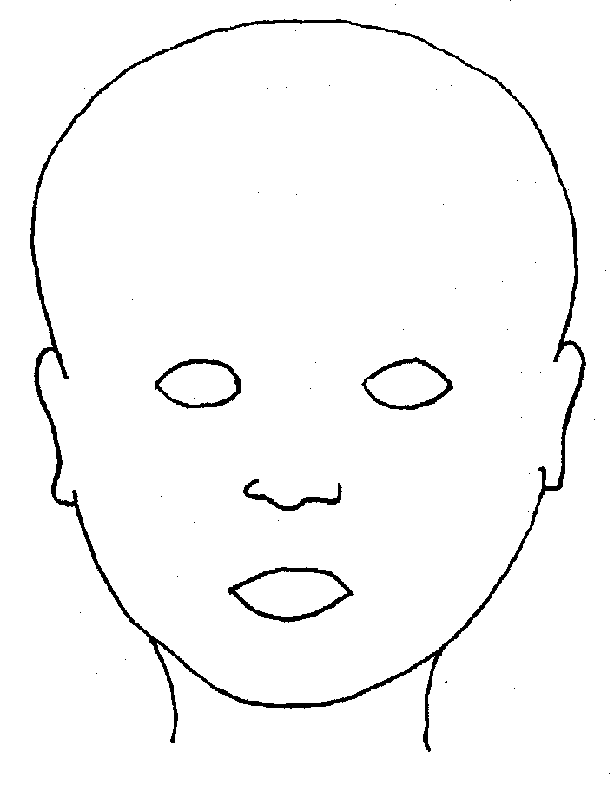
FRONT |  | BACK
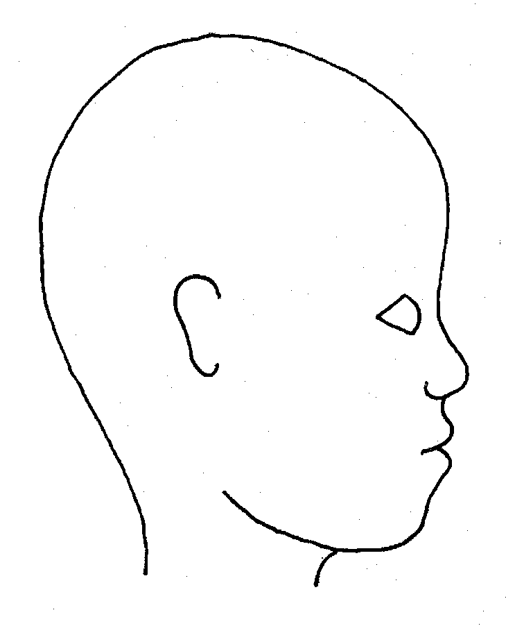 |  | 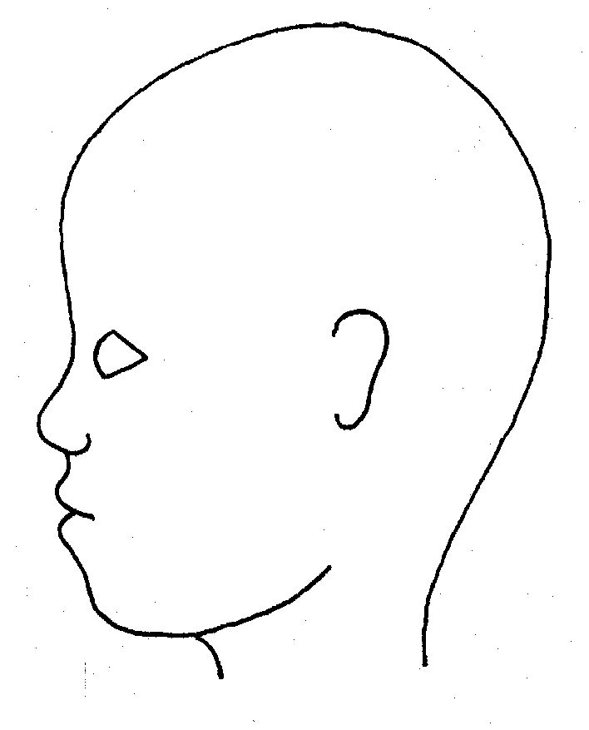
RIGHT |  | LEFT

Name of Child: |  |  | Date of observation:
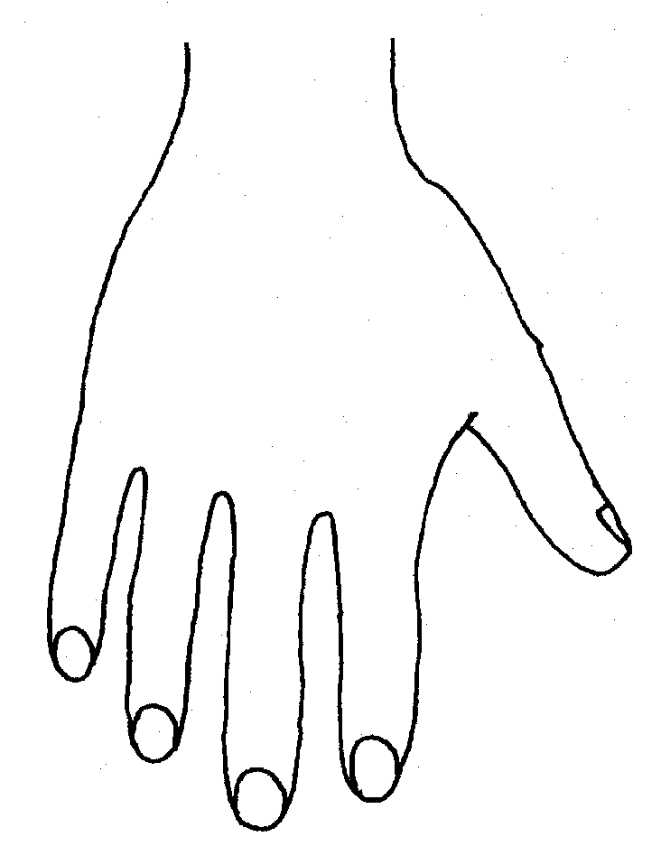 |  | 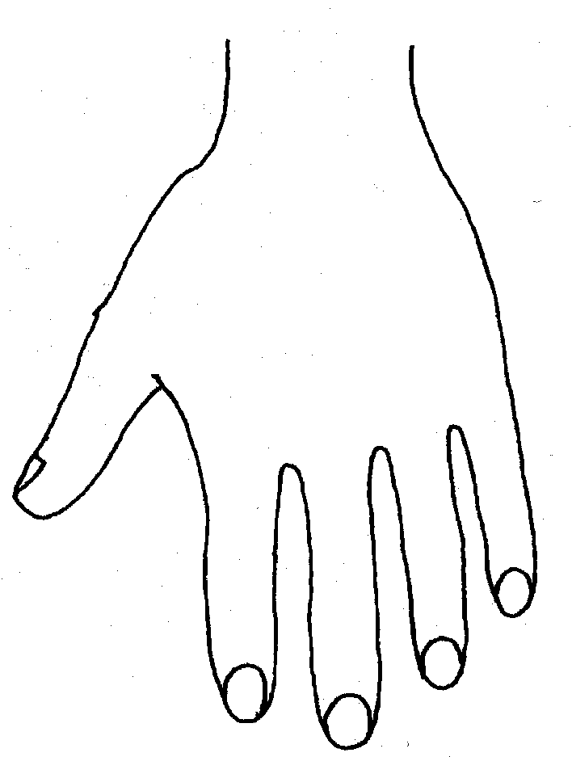
R |  | L
BACK
R |  | L
PALM

Name of Child: |  |  |  |  |  |  | Date of observation:
R | TOP |  |  |  | L | R |  | BOTTOM |  |  |  | L
R |  |  |  |  |  | L
INNER
R |  |  |  |  |  | L
OUTER
Printed Name and Signature of worker: |  |  |  |  |  |  |  |  | Date:  Time:
Role of Worker
Other information:

Allegations Against Staff, Carers and Volunteers

All organisations providing services to children (anyone under 18years old) must ensure that those who work with or on behalf of children and young people are competent, confident and safe to do so. Likewise, anyone who comes into contact with children and young people in their work has a duty of care to safeguard and promote their welfare.

The vast majority of adults who work with children act professionally and aim to provide a safe and supportive environment which secures the well-being and very best outcomes for children and young people in their care. However, it is recognised that in this area of work tensions and misunderstandings can occur. It is here that the behaviour of adults can give rise to allegations of abuse being made against them. Allegations may be misplaced or malicious. They may arise from differing perceptions of the same event, but when they occur, they are inevitably distressing and difficult for all concerned.

Equally, it must be recognised that some allegations will be genuine and there are adults who will deliberately seek out, create or exploit opportunities to abuse children. It is therefore essential that a clear process exists for the investigation and resolution of allegations made for the benefit of all concerned.

Who is covered by the allegations against staff process?
This process covers all persons working within the children’s workforce in either a paid or unpaid capacity and includes volunteers and foster carers. This includes anyone working in a health, education, social care, faith groups or voluntary sector service setting as well as any other service provided to children. An adult may have more than one role working with children and their suitability must be considered in whatever capacity they are working with children.

Who is responsible for the allegations against staff process in Doncaster?
The process is managed by Doncaster’s LADO (Local Authority Designated Officer). All local authorities must have a LADO who is responsible for

- managing individual cases
- providing advice and guidance
- liaising with police and other agencies
- Monitoring progress of cases for timeliness, thoroughness and fairness.

The LADO can be contacted as follows:

LADO
Mary Woollett Centre
Danum Road
Doncaster
DN4 5HF

LADO Tel: 01302 737748
LADO Administrator Tel: 01302 737332
email: LADO@dcstrust.co.uk

Education related enquiries may be emailed to educationsafeguarding@doncaster.gov.uk or contact Sarah Stokoe Gill Whiteman or Dana Kelly

When is it necessary to contact the LADO?
All allegations that meet the following criteria must be reported to the LADO within one working day, where it is alleged that someone has:

• behaved in a way that has harmed a child, or may have harmed a child;

• possibly committed a criminal offence against or related to a child;

• behaved towards a child or children in a way that indicates he or she would pose a risk of harm if they work regularly or closely with children.

The LADO can also be contacted for advice regarding concerns or suspicions about behaviour towards children by staff within Doncaster’s children’s workforce.

What happens when I contact the LADO?
Most referrers will be asked to complete a referral form and where necessary provide other supporting information. The LADO will then complete an initial evaluation and provide advice regarding the pathway to be followed to resolve the allegation.

The LADO will advise the employer whether or not informing the parents of the child(ren) involved will impede the disciplinary or investigative processes. Acting on this advice, if it is agreed that the information can be fully or partially shared, the employer should inform the parent/s. In some circumstances, however, the parent/s may need to be told straight away (e.g. if a child is injured and requires medical treatment).

The parent/s and the child, if sufficiently mature, should be helped to understand the processes involved and be kept informed about the progress of the case and of the outcome where there is no criminal prosecution. This will include the outcome of any disciplinary process, but not the deliberations of, or the information used in, a hearing.

The employer should seek advice from the LADO, the police and / or LA children's social care about how much information should be disclosed to the accused person.

Subject to restrictions on the information that can be shared, the employer should, as soon as possible, inform the accused person about the nature of the allegation, how enquiries will be conducted and the possible outcome

The LADO may also need to hold a LADO strategy meeting and will need to ensure that the relevant people are invited to it and any follow up meetings to ensure that the full scope of the enquiry can be effectively addressed. This will include an invitation to the employers Senior Manager unless there is good reason not to do so.

A LADO strategy discussion or initial evaluation can be conducted by way of a series of video/telephone calls with a dedicated minute taker wherever practicable.

The LADO will normally chair the LADO strategy/evaluation meeting and the participants should be sufficiently senior to contribute all relevant available information about the allegation, child and accused person and make decisions on behalf of their agencies.

The LADO should regularly monitor the progress of cases either by:
• Holding review LADO strategy discussions/meetings; or

• By liaising with the police and/or children’s social care, employers and any other relevant parties.

A final LADO strategy or evaluation discussion/meeting should be held at the end of enquiries to ensure that all tasks have been completed and where appropriate to agree an action plan for learning lessons in order to inform future practice.

There should be an identified outcome for all allegation investigations:
Substantiated: there is sufficient identifiable evidence to prove the allegation;
False: there is sufficient evidence to disprove the allegation;
Malicious: there is clear evidence to prove there has been a deliberate act to deceive and the allegation is entirely false;
Unsubstantiated: this is not the same as a false allegation. It means that there is insufficient evidence to prove or disprove the allegation; the term therefore does not imply guilt or innocence.

Will suspension be necessary?
Decisions about suspension are made on a case by case basis and depend on the nature and seriousness of the allegation. Whilst the LADO can offer advice only an employer may make a decision to suspend a staff member. Many people subject to allegations are not suspended although their working arrangements may be adjusted whilst the matter is followed up.

The possible risk of harm to children posed by an accused person needs to be evaluated and managed effectively - in respect of the children involved in the allegations, and any other children in the individual’s home, work or community life. In some cases, this requires the employer to consider suspending the person. Suspension should be considered in any case where;

• There is cause to suspect a child has suffered, or is likely to suffer significant harm; or

• The allegation warrants investigation by the police; or

• The allegation is so serious that it might be grounds for dismissal.

People must not be suspended automatically or without careful thought and it should not be considered as a default option. Employers must consider carefully whether the circumstances of a case warrant a person being suspended from contact with children until the allegation is resolved.

How long will an allegation take to investigate?
It is important that allegations are investigated as quickly as possible for all concerned. Initial evaluations by the LADO begin immediately and initial advice is given within a few days and usually concluded within a month. More complex investigations or those involving the police can take longer but the LADO is expected to monitor these for timeliness and assist in resolving delays where possible.

Key points
http://www.doncasterchildrenstrust.co.uk/

If you are worried about a child in an emergency

Contact 01302 734100 between 8:30am and 5pm, Monday to Friday

Outside of these hours call
01302 796000
or
Children’s Services
Multi Agency Access Point
01302 737777
- Regardless of the nature of allegations and who receives the allegation, it must be reported to the LADO. This must include situations where the worker resigns. Compromise agreements are not acceptable in such circumstances and may put others at risk in the future.
- Complaints procedures are separate to the allegations process and just because someone does not wish to make a complaint, this does not mean the allegation should not be considered and investigated.
- Any allegation is likely to cause anxiety and distress to all those involved. Early contact with the LADO for advice and guidance will assist with the process and ensure that support is considered at the earliest opportunity.
- It is extremely important that when an allegation is made, the organisation makes every effort to maintain confidentiality. This is important for both the adult who has been accused and for the child(ren) concerned.
- There is a legal requirement for organisations to make a referral to the DBS (Disclosure and Barring Service) where they think that an individual has engaged in conduct that harmed (or is likely to harm) a child; or if a person otherwise poses a risk of harm to a child. This applies even if that person has subsequently resigned or the organisation no longer uses their services.

LADO
01302 737748

LADO details Monday, Tuesday & Thursday – CAROLINE TANNER
Wednesday & Friday – HELEN COOPER

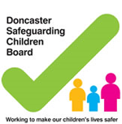
Doncaster Safeguarding Children Partnership Procedures can be found at:
http://doncasterscb.proceduresonline.com/

Doncaster Safeguarding Children Partnership website can be found at:
http://www.dscp.org.uk

