English Policy
2020 2022

BENTLEY NEW VILLAGE PRIMARY SCHOOL
HEADTEACHER: kirsten mckechnie
ENGLISH POLICY

PERSON RESPONSIBLE FOR POLICY: APPROVED: SLT | Literacy Leader
 | DATE: July 2020
SIGNED: K.Hemmingway | Kelly Hemmingway: ASSISTANT HEADTEACHER
TO BE REVIEWED: | July 2022

OUR SCHOOL VISION
Together we will create a calm and welcoming learning environment and work together to secure success for all. We will strive to create a safe, caring, supportive and inclusive school in which we will focus on excellent progress within traditional core subjects whilst providing a rich and exciting curriculum.
We believe that our school should equip its pupils with the skills that society and the local community demand and so we will value the skills and learning that children need in order to look after themselves, their families, their health, their mental well-being and their bodies. We will strive to teach the whole child and create life-long learners and pro-active citizens.
All pupils will have the opportunity to take part in a wide range of physical and sporting activity, as part of the curriculum, as an extra-curricular activity and in competition with other schools. Through sport we will promote a love of physical activity, the spirit of fair play and the ability to be a team-player, a coach and a mentor.
We will encourage the development of individual flair, creativity, talent and personality and will always embrace differences and uniqueness. Our school will value a good sense of humour and celebrate the fun that can be had in learning and within our school.

OUR SCHOOL VALUES
Determination – Resilience – Tolerance – Cooperation – Creativity – Curiosity

OUR SCHOOL AIMS
- To raise the aspirations and life-expectations of each individual within our school so everyone strives for personal excellence in everything they do
- To provide outstanding learning and teaching which enables all pupils, regardless of gender, race, background or ability, to excel
- To help pupils and staff build on their strengths and overcome their weaknesses through development, mentoring and support
- To help pupils develop respect for others so that they can form tolerant and caring relationships and be sympathetic to the needs of other people, whoever they may be
- To provide pupils with a variety of experiences and the support they need to be healthy and active, to stay safe, to enjoy and achieve, to make a positive contribution and to achieve economic well-being
- To use the skills, knowledge, experience and talents of all staff to personalise the learning for each pupil
- To develop a culture of team work that promotes continuous improvement and the highest standards of achievement and conduct
- To be committed to providing a high quality programme of professional development and training.
Our mission statement, “What Challenges us, Changes us”

English Learning Walls

ENGLISH LEARNING WALLS

Non Negotiables
- English learning walls should be backed in yellow with a blue border in KS1 and KS2. In EYFS, the English learning walls should be backed in cream with a blue border.

- Vocabulary displayed will in the format of the New Village Nine triangle.

- Audience, genre and purpose are to be displayed on the working wall and are to be known to the children, as part of the integrated lesson sequence.

- An enlarged, displayed example of the text type you are teaching will be included on the learning wall. This is a printed example, which is appropriate for the age of children you are teaching. Enlarge to a minimum of A3. Highlighted features which are labelled will be included.

- Features of the genre will be listed and may contain a concise explanation. This is a toolkit of what the text type needs to support the children when they write their own or analyse a text.

- A sample of modelled writing should be displayed. This is the shared writing activity, hand-written by the teacher, with the children. Add this to the classroom washing line.

- Spelling focus rules are to be displayed on the working wall each week.

Reading

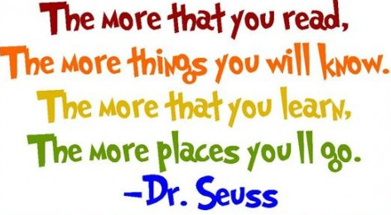

AIMS

The aims of the Reading Policy are to:
- present the reading ethos of the school which will be upheld by all stakeholders and be at the heart of all we do
- create a high-expectations culture within which reading is taught
- share a framework and common approach for teaching, learning and assessment to ensure quality teaching for all pupils
- present the expectations and responsibility for all stakeholders in order to improve pupil outcomes in reading
- allow for clear and accurate monitoring of pupil progress and attainment

NEW VILLAGE READING ETHOS

At New Village, we believe that reading is a key.

A child who can read has the key to life and to the world we live in; with all its wonders, opportunities and experiences.

At New Village, we pledge to make reading at the heart of all we do so that children are able to immerse themselves in the myriad wonders and opportunities that reading has to offer.

Our core aims when teaching children to read are to:
- Build confident readers by allowing children to develop and succeed in a supportive and celebratory learning environment
- Give children access to the pleasures and benefits of reading so that they can enjoy the excitement, imagination and exhilaration of a great fiction or marvel at the wonders and revelations that non-fiction can share
- Create fluent and accurate readers with good reading stamina and speed
- Develop children’s language skills, expand and enrich their vocabulary and encourage a love of the English language
- Create reflective, comprehending and thoughtful readers who think about the meaning, understand the purpose and consider the impact of the literature they read
- Allow access to real life and the wider world, so that they may contribute to society, study, research and continue to learn throughout their lives

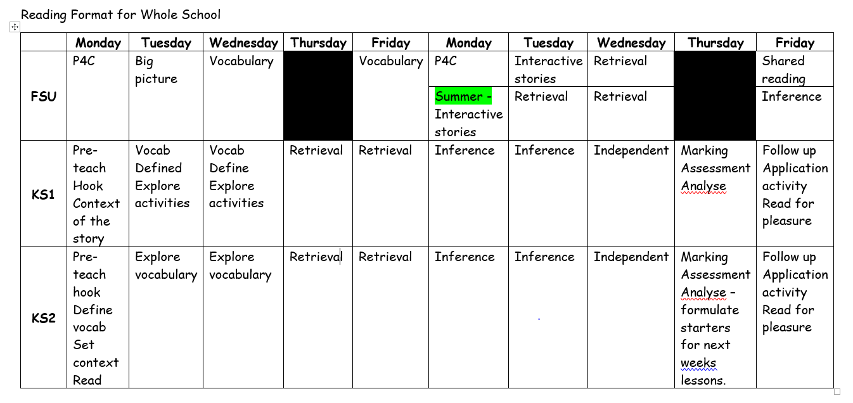
What reading looks like at Bentley New Village

NEW VILLAGE READING NON-NEGOTIABLES

These non-negotiables were agreed by the staff and the pupils as being essential components and tools needed to achieve the New Village Reading Ethos.
- All children will have a reading book and a reading record that they are able to read in school and at home. The reading book will be accessible but offer challenge at the child’s level

- Children will be read to each day by an enthusiastic, animated adult who inspires a love of reading

- Children will read every day and be exposed to, and have access to, a wide range of high-quality texts and genres from a wide variety of authors and eras

- All literature will be used as a tool to enrich and expand pupils’ vocabulary, to explain words, phrases and meanings, and to facilitate pupils’ exposure to higher-level vocabulary

- Children will be taught to read following the school’s reading framework. New Village will use a systematic and dynamic literacy programme rooted in phonics to give children the skills to read accurately and fluently and to build reading stamina.

- Through the curriculum and the school’s reading framework, children will be taught to be readers: to comprehend what they have read, to infer meaning and deduce connotations, to interpret information, make predictions and establish the meaning and impact of words and phrases.

- Children will review and edit their own work, make corrections and complete challenges: this will be done in purple pen

- Staff will mark all chilrens’ work in a timely and appropriate manner – in line with the school’s Marking and Feedback Policy. No misconception will be allow to stand.

- Pupils work will be chronologically ordered, have a date, a title, a focus, be on the agreed template and clearly show increased challenge and progress over each half term

- All literature and texts shared with children will be accessible but offer appropriate and personalised challenge

- All classrooms will be language-rich and have a range of resources to support reading including dictionaries and thesauruses to support pupils at their different levels

- Children will be taught to access reading tests and National Tests and will be supported to build their confidence in doing so. Summative reading assessments will take place half termly

- All classrooms will have a reading area that inspires children to read

- All classrooms will have a Literacy Learning Wall and VCOP Learning Wall

- Vocabulary will be displayed on the New Village Nine triangle.

PROMOTING A LOVE OF READING

TEACHING READING AT NEW VILLAGE

At New Village we not only teach children to read but to also enjoy reading and to be able to access the assessments that they will face through primary school. All children will have the opportunity to access a range of fiction and non-fiction which provide a suitable challenge for their age range.

The teaching of reading follows a program of delivery from Year 1 to Year 6 that is adhered to in all classes week on week. Teaching and learning also takes into account the information teachers take from pupil observations, marking, formative assessment, summative assessments and question level analysis

Day 1: shared reading with a focus upon language and vocabulary

Day 2: focus upon language and vocabulary

Day 3: focus upon language and vocabulary

Day 4: shared reading with a focus upon retrieval and comprehension

Day 5: shared reading with a focus upon retrieval and comprehension

Day 6: shared reading with a focus upon inference and deduction

Day 7: shared reading with a focus upon inference and deduction

Day 8: independent reading task /activity

Day 9: assess and review leading to shared edit and improve

Day 10: Reading for pleasure activity.

TALK PARTNERS

All lessons will provide opportunities for children to work with a talk partner to discuss, develop and refine their answers and to allow them to challenge and question their peers’ answers and responses. Talk partners also allow constructive review own and others’ learning and allows children to make amendments and edits to improve. The teacher will use talk partners to ascertain the quality of learning taking place. When using talk partners, children are to have a role and a goal to provide purposeful speaking and listening using the objectives from communication matters.

ESSENTIAL LANGAUGE

There is an agreed list of ‘essential’ language that all staff will use when teaching. This ensures that there is consistency in the language that all staff use across the school and allows pupils to develop and deep understanding of the essential language of reading

MARKING AND FEEDBACK

All marking and feedback will be timely and support the pupil moving their learning forwards. No misconceptions will be allowed to stand – these will be tackled and clarified by either the teacher or teaching assistant.

Teacher marking will be in black pen. Pupil or peer marking will be in purple pen.

Marking will always identify strengths and areas for further development or rehearsal

PLANNING READING AT NEW VILLAGE
Teacher Name:  Year Group: Class: |  |  | Week: |  | Term: |  | Text Title:  Chapters/Pages:
Vocabulary day | Skill & text | Teaching strategies.  Include: Whole class teaching; Direct  Instructions & Key Questions |  | Activities  (indicate on planning which groups will be Teacher Guided, TA Guided, Independent) |  |  |  | Assess & Review  Include AfL, questions for targeted groups / children
 | Text – | Shared read with a focus on language.  Read the text to the class and discuss any language they may have found tricky.  Discuss highlighted vocabulary.  Discuss ‘reading around the word’ to try and decide on the meaning.  Teach-Model-Chn rehearse with talk partner and/or independently  (List of focus vocab) |  | Secure |  | Discuss highlighted vocabulary and phrases.  Discuss the question…  CT / TA focus: |  | After sharing the text and discussing the new vocabulary present within the text, the children are to work as a group and choose one word for display.  The blue card will include a chosen word and a definition written in the group’s own words  Children to add their new chosen vocabulary to word books  - Read together / talk about words / phrases  - Groups on one word – dictionaries  - Own sentence verbally – all involved  - Writing down own definition  - Sharing the def. & put into a sentence.
Skill focus

2a - Give / explain the meaning of words in context.

2g - Identify / explain how meaning is enhanced through choice of words and phrases.

Essential language:
Text
Vocabulary/Word
Phrase
Definition/Meaning

 |  |  |  | WT Expected |  | Discuss highlighted vocabulary and phrases.  Discuss the question…  CT / TA focus:
 |  |  |  | WT Emerging |  | Discuss highlighted vocabulary and phrases.  Discuss the question…  CT / TA focus:
SPAG Focus:
Teach –
Practise –
Apply –

Retrieval day | Skill & text | Teaching strategies.  Include: Whole class teaching; Direct  Instructions & Key Questions | Activities  (indicate on planning which groups will be Teacher Guided, TA Guided, Independent) |  | Assess & Review  Include AfL, questions for targeted groups / children
 | Text: | Shared read with a focus on retrieval  Model reading the questions, then reading the text alongside to find the answers. Teach why an answer is corre ct and why an answer is an error  Model these retrieval questions and model writing the answers (place eg below)  Teach-Model-Chn rehearse with talk partner and/or independently | Secure | Children to independently answer x/amount of retrieval questions  (define question type/style)  CT / TA focus: | Shared mark and edit the independent questions.  Teach-Model-Chn rehearse with talk partner and/or independently  Children to correct, edit and improve using a purple pen
Skill focus

2b - Retrieve and record information / identify key details from fiction and non-fiction.

Essential language:
Retrieval
Evidence
Locate/Find
Highlight/Identify
Correction
Review and Edit
 |  |  | WT Expected | Children to independently answer x/amount of retrieval questions  (define question type/style)  CT / TA focus:
 |  |  | WT Emerging | Children to independently answer x/amount of retrieval questions  (define question type/style)  CT / TA focus:
SPAG Focus:
Teach –
Practise –
Apply –

Inference Day | Skill & Context | Teaching strategies.  Include: Whole class teaching; Direct  Instructions & Key Questions | Activities  (indicate on planning which groups will be Teacher Guided, TA Guided, Independent) |  | Assess & Review  Include AfL, questions for targeted groups / children
 | Text – | Shared read with a focus on inference  Model reading the questions and answering inferentiatial questions; model writing the answers in sentences.  Teach and/or discuss how they know this is an inferential question. Teach and/or discuss how they know where to find the information.  (place eg of question type/style below)  Teach-Model-Chn rehearse with talk partner and/or independently | Secure | Children to independently answer an amount of questions  (define question type/style with points allocated)  CT / TA focus: | Shared mark and edit the independent questions.  Show three answers for the explain question. Which one would the children give 1, 2 or 3 marks to? Why?  Teach-Model-Chn rehearse with talk partner and/or independently  Children to give themselves a mark out of three; then up level (if needed)  Children to correct, edit and improve using a purple pen
Skills focus –

2d - Make inferences from the text / explain and justify inferences with evidence from the text.

Essential language:
Infer/Inference
Explain/Justify
Evidence
Highlight/Identify
Correction
Review and Edit
 |  |  | WT Expected | Children to independently answer an amount of questions  (define question type/style with points allocated)  CT / TA focus:
 |  |  | WT Emerging | Children to independently answer an amount of questions  (define question type/style with points allocated)  CT / TA focus:
SPAG Focus:
Teach –
Practise –
Apply –

Independent Task | Skill & Context | Teaching strategies.  Include: Whole class teaching; Direct  Instructions & Key Questions | Activities  (indicate on planning which groups will be Teacher Guided, TA Guided, Independent) |  | Assess & Review  Include AfL, questions for targeted groups / children
 | Text – | Brief discussion about strategies to solve problems that have been discussed and taught this week. | Secure | Children to independently complete hot task.  Ensure children use all of the time and go back and check each answer correctly.  Have they got enough points to get 3 marks etc? | N/A
Skill focus –

2a, 2b, 2c, 2d, 2e, 2g

Essential language:
Text
Vocabulary/Word
Phrase
Definition/Meaning
Retrieval
Evidence
Locate/Find
Highlight/Identify
Infer/Inference
Explain/Justify

 |  |  | WT Expected
 |  |  | WT Emerging
SPAG Focus:
Teach –
Practise –
Apply –

Assessment day | Skill & Context  Steps to Success | Teaching strategies.  Include: Whole class teaching; Direct  Instructions & Key Questions | Activities  (indicate on planning which groups will be Teacher Guided, TA Guided, Independent) |  | Assess & Review  Include AfL, questions for targeted groups / children
 | Text – | Shared review with a focus on editing and improving  Teacher to model answering each question.  Teach-Model-Chn rehearse with talk partner and/or independently  Discuss what strategy the children used for each step; which were successful/which were not.  How did they know what type of question they were answering? (retrieval/inference/word etc) | Secure | Shared mark and edit the independent questions.  Discuss and model how to answer the questions and ask the children what answers they got. Take a variety of answers and focus on success – link to points  Teach-Model-Chn rehearse with talk partner and/or independently  Children to correct, edit and improve using a purple pen  Summarise question types children were strong on and the ones for further focus.
Skill focus –

2a, 2b, 2c, 2d, 2e, 2g

Essential language:
Text
Explain/Justify
Evidence
Highlight/Identify
Correction
Review and Edit

 |  |  | WT Expected
 |  |  | WT Emerging
SPAG Focus:
Teach –
Practise –
Apply –

READING AT HOME

ASSESSING READING AT NEW VILLAGE

PROGRAMMES OF STUDY

Year 1 Reading - word reading
Pupils should be taught to:
- apply phonic knowledge and skills as the route to decode words
- respond speedily with the correct sound to graphemes (letters or groups of letters) for all 40+ phonemes, including, where applicable, alternative sounds for graphemes
- read accurately by blending sounds in unfamiliar words containing GPCs that have been taught
- read common exception words, noting unusual correspondences between spelling and sound and where these occur in the word
- read words containing taught GPCs and –s, –es, –ing, –ed, –er and –est endings
- read other words of more than one syllable that contain taught GPCs
- read words with contractions [for example, I’m, I’ll, we’ll], and understand that the apostrophe represents the omitted letter(s)
- read books aloud, accurately, that are consistent with their developing phonic knowledge and that do not require them to use other strategies to work out words
- reread these books to build up their fluency and confidence in word reading
Pupils should revise and consolidate the GPCs and the common exception words taught in reception year. As soon as they can read words comprising the year 1 GPCs accurately and speedily, they should move on to the year 2 programme of study for word reading.
The number, order and choice of exception words taught will vary according to the phonics programme being used. Ensuring that pupils are aware of the GPCs they contain, however unusual these are, supports spelling later.
Young readers encounter words that they have not seen before much more frequently than experienced readers do, and they may not know the meaning of some of these. Practice at reading such words by sounding and blending can provide opportunities not only for pupils to develop confidence in their decoding skills, but also for teachers to explain the meaning and thus develop pupils’ vocabulary.
Pupils should be taught how to read words with suffixes by being helped to build on the root words that they can read already. Pupils’ reading and rereading of books that are closely matched to their developing phonic knowledge and knowledge of common exception words supports their fluency, as well as increasing their confidence in their reading skills. Fluent word reading greatly assists comprehension, especially when pupils come to read longer books.

Year 1 Reading - comprehension
Pupils should be taught to:
- develop pleasure in reading, motivation to read, vocabulary and understanding by:
  - listening to and discussing a wide range of poems, stories and non-fiction at a level beyond that at which they can read independently
  - being encouraged to link what they read or hear to their own experiences
  - becoming very familiar with key stories, fairy stories and traditional tales, retelling them and considering their particular characteristics
  - recognising and joining in with predictable phrases
  - learning to appreciate rhymes and poems, and to recite some by heart
  - discussing word meanings, linking new meanings to those already known
- understand both the books they can already read accurately and fluently and those they listen to by:
  - drawing on what they already know or on background information and vocabulary provided by the teacher
  - checking that the text makes sense to them as they read, and correcting inaccurate reading
  - discussing the significance of the title and events
  - making inferences on the basis of what is being said and done
  - predicting what might happen on the basis of what has been read so far
- participate in discussion about what is read to them, taking turns and listening to what others say
- explain clearly their understanding of what is read to them
Pupils should have extensive experience of listening to, sharing and discussing a wide range of high-quality books with the teacher, other adults and each other to engender a love of reading at the same time as they are reading independently.
Pupils’ vocabulary should be developed when they listen to books read aloud and when they discuss what they have heard. Such vocabulary can also feed into their writing. Knowing the meaning of more words increases pupils’ chances of understanding when they read by themselves. The meaning of some new words should be introduced to pupils before they start to read on their own, so that these unknown words do not hold up their comprehension.
However, once pupils have already decoded words successfully, the meaning of those that are new to them can be discussed with them, thus contributing to developing their early skills of inference. By listening frequently to stories, poems and non-fiction that they cannot yet read for themselves, pupils begin to understand how written language can be structured in order, for example, to build surprise in narratives or to present facts in non-fiction. Listening to and discussing information books and other non-fiction establishes the foundations for their learning in other subjects. Pupils should be shown some of the processes for finding out information.
Through listening, pupils also start to learn how language sounds and increase their vocabulary and awareness of grammatical structures. In due course, they will be able to draw on such grammar in their own writing.
Rules for effective discussions should be agreed with and demonstrated for pupils. They should help to develop and evaluate them, with the expectation that everyone takes part. Pupils should be helped to consider the opinions of others.
Role play can help pupils to identify with and explore characters and to try out the language they have listened to.

Year 2 Reading - word reading
Pupils should be taught to:
- continue to apply phonic knowledge and skills as the route to decode words until automatic decoding has become embedded and reading is fluent
- read accurately by blending the sounds in words that contain the graphemes taught so far, especially recognising alternative sounds for graphemes
- read accurately words of two or more syllables that contain the same graphemes as above
- read words containing common suffixes
- read further common exception words, noting unusual correspondences between spelling and sound and where these occur in the word
- read most words quickly and accurately, without overt sounding and blending, when they have been frequently encountered
- read aloud books closely matched to their improving phonic knowledge, sounding out unfamiliar words accurately, automatically and without undue hesitation
- reread these books to build up their fluency and confidence in word reading
Pupils should revise and consolidate the GPCs and the common exception words taught in year 1. The exception words taught will vary slightly, depending on the phonics programme being used. As soon as pupils can read words comprising the year 2 GPCs accurately and speedily, they should move on to the years 3 and 4 programme of study for word reading.
When pupils are taught how to read longer words, they should be shown syllable boundaries and how to read each syllable separately before they combine them to read the word.
Pupils should be taught how to read suffixes by building on the root words that they have already learnt. The whole suffix should be taught as well as the letters that make it up.
Pupils who are still at the early stages of learning to read should have ample practice in reading books that are closely matched to their developing phonic knowledge and knowledge of common exception words. As soon as the decoding of most regular words and common exception words is embedded fully, the range of books that pupils can read independently will expand rapidly. Pupils should have opportunities to exercise choice in selecting books and be taught how to do so.

Year 2 Reading - comprehension
Pupils should be taught to:
- develop pleasure in reading, motivation to read, vocabulary and understanding by:
  - listening to, discussing and expressing views about a wide range of contemporary and classic poetry, stories and non-fiction at a level beyond that at which they can read independently
  - discussing the sequence of events in books and how items of information are related
  - becoming increasingly familiar with and retelling a wider range of stories, fairy stories and traditional tales
  - being introduced to non-fiction books that are structured in different ways
  - recognising simple recurring literary language in stories and poetry
  - discussing and clarifying the meanings of words, linking new meanings to known vocabulary
  - discussing their favourite words and phrases
  - continuing to build up a repertoire of poems learnt by heart, appreciating these and reciting some, with appropriate intonation to make the meaning clear
- understand both the books that they can already read accurately and fluently and those that they listen to by:
  - drawing on what they already know or on background information and vocabulary provided by the teacher
  - checking that the text makes sense to them as they read, and correcting inaccurate reading
  - making inferences on the basis of what is being said and done
  - answering and asking questions
  - predicting what might happen on the basis of what has been read so far
- participate in discussion about books, poems and other works that are read to them and those that they can read for themselves, taking turns and listening to what others say
- explain and discuss their understanding of books, poems and other material, both those that they listen to and those that they read for themselves
Pupils should be encouraged to read all the words in a sentence and to do this accurately, so that their understanding of what they read is not hindered by imprecise decoding (for example, by reading ‘place’ instead of ‘palace’).
Pupils should monitor what they read, checking that the word they have decoded fits in with what else they have read and makes sense in the context of what they already know about the topic.
The meaning of new words should be explained to pupils within the context of what they are reading, and they should be encouraged to use morphology (such as prefixes) to work out unknown words.
Pupils should learn about cause and effect in both narrative and non-fiction (for example, what has prompted a character’s behaviour in a story; why certain dates are commemorated annually). ‘Thinking aloud’ when reading to pupils may help them to understand what skilled readers do.
Deliberate steps should be taken to increase pupils’ vocabulary and their awareness of grammar so that they continue to understand the differences between spoken and written language.
Discussion should be demonstrated to pupils. They should be guided to participate in it and they should be helped to consider the opinions of others. They should receive feedback on their discussions.
Role play and other drama techniques can help pupils to identify with and explore characters. In these ways, they extend their understanding of what they read and have opportunities to try out the language they have listened to.

Year 3 & 4 Reading - word reading
Pupils should be taught to:
- apply their growing knowledge of root words, prefixes and suffixes (etymology and morphology) as listed in - see English appendix 1 , both to read aloud and to understand the meaning of new words they meet
- read further exception words, noting the unusual correspondences between spelling and sound, and where these occur in the word

Notes and guidance (non-statutory)
At this stage, teaching comprehension should be taking precedence over teaching word reading directly. Any focus on word reading should support the development of vocabulary.
When pupils are taught to read longer words, they should be supported to test out different pronunciations. They will attempt to match what they decode to words they may have already heard but may not have seen in print (for example, in reading technical, the pronunciation /tɛtʃnɪkəl/ (‘tetchnical’) might not sound familiar, but /tɛknɪkəl/ (‘teknical’) should).

Year 3 & 4 Reading - comprehension
Pupils should be taught to:
- develop positive attitudes to reading, and an understanding of what they read, by:
  - listening to and discussing a wide range of fiction, poetry, plays, non-fiction and reference books or textbooks
  - reading books that are structured in different ways and reading for a range of purposes
  - using dictionaries to check the meaning of words that they have read
  - increasing their familiarity with a wide range of books, including fairy stories, myths and legends, and retelling some of these orally
  - identifying themes and conventions in a wide range of books
  - preparing poems and play scripts to read aloud and to perform, showing understanding through intonation, tone, volume and action
  - discussing words and phrases that capture the reader’s interest and imagination
  - recognising some different forms of poetry [for example, free verse, narrative poetry]
- understand what they read, in books they can read independently, by:
  - checking that the text makes sense to them, discussing their understanding, and explaining the meaning of words in context
  - asking questions to improve their understanding of a text
  - drawing inferences such as inferring characters’ feelings, thoughts and motives from their actions, and justifying inferences with evidence
  - predicting what might happen from details stated and implied
  - identifying main ideas drawn from more than 1 paragraph and summarising these
  - identifying how language, structure, and presentation contribute to meaning
- retrieve and record information from non-fiction
- participate in discussion about both books that are read to them and those they can read for themselves, taking turns and listening to what others say
The focus should continue to be on pupils’ comprehension as a primary element in reading. The knowledge and skills that pupils need in order to comprehend are very similar at different ages. This is why the programmes of study for comprehension in years 3 and 4 and years 5 and 6 are similar: the complexity of the writing increases the level of challenge.
Pupils should be taught to recognise themes in what they read, such as the triumph of good over evil or the use of magical devices in fairy stories and folk tales.
They should also learn the conventions of different types of writing (for example, the greeting in letters, a diary written in the first person or the use of presentational devices such as numbering and headings in instructions).
Pupils should be taught to use the skills they have learnt earlier and continue to apply these skills to read for different reasons, including for pleasure, or to find out information and the meaning of new words.
Pupils should continue to have opportunities to listen frequently to stories, poems, non-fiction and other writing, including whole books and not just extracts, so that they build on what was taught previously. In this way, they also meet books and authors that they might not choose themselves. Pupils should also have opportunities to exercise choice in selecting books and be taught how to do so, with teachers making use of any library services and expertise to support this.
Reading, re-reading, and rehearsing poems and plays for presentation and performance give pupils opportunities to discuss language, including vocabulary, extending their interest in the meaning and origin of words. Pupils should be encouraged to use drama approaches to understand how to perform plays and poems to support their understanding of the meaning. These activities also provide them with an incentive to find out what expression is required, so feeding into comprehension.
In using non-fiction, pupils should know what information they need to look for before they begin and be clear about the task. They should be shown how to use contents pages and indexes to locate information.
Pupils should have guidance about the kinds of explanations and questions that are expected from them. They should help to develop, agree on, and evaluate rules for effective discussion. The expectation should be that all pupils take part.

Years 5 & 6 Reading - word reading
Pupils should be taught to:
- apply their growing knowledge of root words, prefixes and suffixes (morphology and etymology), as listed in English appendix 1, both to read aloud and to understand the meaning of new words that they meet
At this stage, there should be no need for further direct teaching of word-reading skills for almost all pupils. If pupils are struggling or failing in this, the reasons for this should be investigated. It is imperative that pupils are taught to read during their last two years at primary school if they enter year 5 not being able to do so.
Pupils should be encouraged to work out any unfamiliar word. They should focus on all the letters in a word so that they do not, for example, read ‘invitation’ for ‘imitation’ simply because they might be more familiar with the first word. Accurate reading of individual words, which might be key to the meaning of a sentence or paragraph, improves comprehension.
When teachers are reading with or to pupils, attention should be paid to new vocabulary – both a word’s meaning(s) and its correct pronunciation.

Year 5 & 6 Reading - comprehension
Pupils should be taught to:
- maintain positive attitudes to reading and an understanding of what they read by:
  - continuing to read and discuss an increasingly wide range of fiction, poetry, plays, non-fiction and reference books or textbooks
  - reading books that are structured in different ways and reading for a range of purposes
  - increasing their familiarity with a wide range of books, including myths, legends and traditional stories, modern fiction, fiction from our literary heritage, and books from other cultures and traditions
  - recommending books that they have read to their peers, giving reasons for their choices
  - identifying and discussing themes and conventions in and across a wide range of writing
  - making comparisons within and across books
  - learning a wider range of poetry by heart
  - preparing poems and plays to read aloud and to perform, showing understanding through intonation, tone and volume so that the meaning is clear to an audience
- understand what they read by:
  - checking that the book makes sense to them, discussing their understanding and exploring the meaning of words in context
  - asking questions to improve their understanding
  - drawing inferences such as inferring characters’ feelings, thoughts and motives from their actions, and justifying inferences with evidence
  - predicting what might happen from details stated and implied
  - summarising the main ideas drawn from more than 1 paragraph, identifying key details that support the main ideas
  - identifying how language, structure and presentation contribute to meaning
- discuss and evaluate how authors use language, including figurative language, considering the impact on the reader
- distinguish between statements of fact and opinion
- retrieve, record and present information from non-fiction
- participate in discussions about books that are read to them and those they can read for themselves, building on their own and others’ ideas and challenging views courteously
- explain and discuss their understanding of what they have read, including through formal presentations and debates, maintaining a focus on the topic and using notes where necessary
- provide reasoned justifications for their views
Even though pupils can now read independently, reading aloud to them should include whole books so that they meet books and authors that they might not choose to read themselves.
The knowledge and skills that pupils need in order to comprehend are very similar at different ages. Pupils should continue to apply what they have already learnt to more complex writing.
Pupils should be taught to recognise themes in what they read, such as loss or heroism. They should have opportunities to compare characters, consider different accounts of the same event and discuss viewpoints (both of authors and of fictional characters), within a text and across more than 1 text.
They should continue to learn the conventions of different types of writing, such as the use of the first person in writing diaries and autobiographies.
Pupils should be taught the technical and other terms needed for discussing what they hear and read, such as metaphor, simile, analogy, imagery, style and effect.
In using reference books, pupils need to know what information they need to look for before they begin and need to understand the task. They should be shown how to use contents pages and indexes to locate information.
The skills of information retrieval that are taught should be applied, for example in reading history, geography and science textbooks, and in contexts where pupils are genuinely motivated to find out information [for example, reading information leaflets before a gallery or museum visit or reading a theatre programme or review]. Teachers should consider making use of any library services and expertise to support this.
Pupils should have guidance about and feedback on the quality of their explanations and contributions to discussions.
Pupils should be shown how to compare characters, settings, themes and other aspects of what they read.

Writing

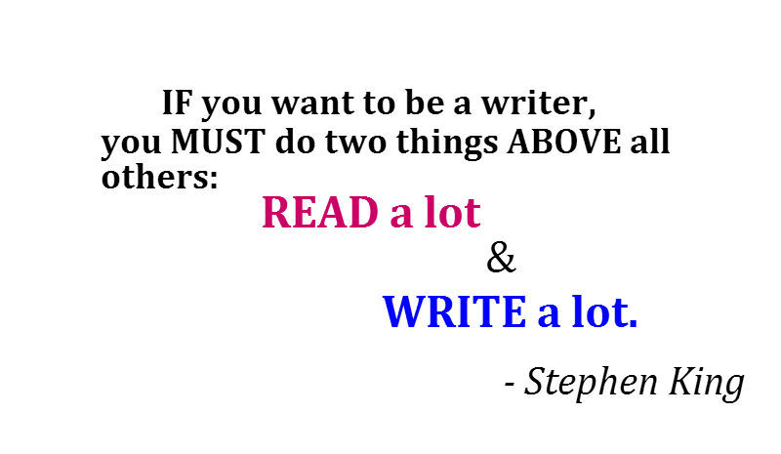

NEW VILLAGE WRITING NON-NEGOTIABLES

These non-negotiables were agreed by the staff and the pupils as being essential components and tools needed to achieve the New Village Writing Ethos.
- A hook will be used to engage and enthuse the pupils to their writing focus. A hook is essential to all writing themes and is encouraged to link to topic work

- All children will be given the opportunity to experience, text mark and write in a range of genres and text types

- Oracy will be a valued focus of the writing sequence and used to facilitate imaginative and engaging writing. Extending and developing vocabulary will remain key and this vocabulary will be displayed in the classroom New Village Nine format.

- The BNVP step teaching sequence will be followed when teaching writing and will result in an edited and reviewed piece of writing

- Writing planning will follow the BNVP agreed format

- The writing assessment grid will be used to make a judgement of strengths and areas for further development. Criteria highlighted in yellow are the KPI and are essential to the teaching and learning within that year group.

- Pink highlighter will be used by the adult to identify areas for development; a green highlighter will be used to identify strengths within the pupils’ writing based on the assessment grids

- Assessment will be moderated in a range of forms, including teacher assessed, year group moderated, phase, whole school and pyramid

- All classrooms will have a Literacy Learning Wall and VCOP Learning Wall

- A ‘Writer of the month’ will be chosen by each class teacher and their work will be celebrated in a central area in school.

TEACHING WRITING AT NEW VILLAGE

At New Village, we teach children to write using a range of fiction and non-fictional pieces and different genre. All children will have the opportunity to access a range of fiction and non-fiction in reading and we wish to apply their knowledge from reading to their written pieces. Children will be challenged according to their individual ability.

The teaching of writing follows a program of delivery from Year 1 to Year 6 that is adhered to in all classes week on week. Teaching and learning also takes into account the information teachers take from pupil observations, marking, formative assessment, summative assessments and question level analysis.

Prior to teaching the unit of writing, the audience, purpose, genre and speaking focus must be decided and documented on the planning document.

Step 1: Read an example of the genre being studied. Then use text mark to find the language and layout features. Language features will be highlighted in yellow and layout features in orange. The children will then annotate the text to explain what it is that they found. This lesson will end with a WILF being generated to use throughout the unit so that the children know the features.

Step 2 & 3: Focus on oracy. Children are to complete drama activities, such as: freeze frame, decorate the room and enter, being reporters, conscience tunnel, talk for writing text map, hotseating, counters for discussion. The purpose of this lesson, is to develop vocabulary skills and aid children with more understanding into the genre.

Step 4: Research - some genres require some research to be completed but the children to allow for their writing to be individual and unique. This lesson will be used for this. This lesson is the only one in the sequence that may not follow chronology and it will be left to teacher discretion if they choose to move it or if it is required.

Step 5: Modelled Writing session – the teacher will show the children how to write and will speak out the process to the children to demonstrate clearly the process of writing for the specified genre. Planning the document will also be discussed within this lesson – either teacher will have a plan to show or the plan with be planned respectively afterwards.

Step 6: Shared Writing session – together the class will work with the teacher to compose the next paragraph of writing. Planning notes will be provided and children will be steered to use the grammatical features asked of them within the assessment document.

Step 7: Shared or Paired Writing session – together as a class or in pairs the children will write sentences that will feed into a class paragraph of writing. The teacher will orchestrate different ways to obtain the work from the children to use it within the paragraph.

Step 8: A concluding paragraph will be created and children will be provided with time to complete their planning for their own writing. The children will be asked to share their plan verbally with another child and then it will be discussed to promote the paired assessment process and points for development will be addressed.

Step 9: Children will be asked to write their own piece of writing linked to the build-up that they have completed over the past 2 weeks. Children are to be given no more than 1 hour to write.

Step 10: Edit and improve the piece of writing. Read through with a partner, checking for sense and accuracy. Children are to work in well matched pairs to improve their work. Spellings are to be checked and other words are to be up-levelled using dictionary and thesaurus skills.

AIMS

The aims of the Reading Policy are to:
- present the reading ethos of the school which will be upheld by all stakeholders and be at the heart of all we do
- create a high-expectations culture within which reading is taught
- share a framework and common approach for teaching, learning and assessment to ensure quality teaching for all pupils
- present the expectations and responsibility for all stakeholders in order to improve pupil outcomes in reading
- allow for clear and accurate monitoring of pupil progress and attainment

The National Curriculum
The programmes of study for writing at key stages 1 and 2 are constructed similarly to those for reading:
- transcription (spelling and handwriting)
- composition (articulating ideas and structuring them in speech and writing)
It is essential that teaching develops pupils’ competence in these 2 dimensions. In addition, pupils should be taught how to plan, revise and evaluate their writing. These aspects of writing have been incorporated into the programmes of study for composition.
Writing down ideas fluently depends on effective transcription: that is, on spelling quickly and accurately through knowing the relationship between sounds and letters (phonics) and understanding the morphology (word structure) and orthography (spelling structure) of words. Effective composition involves articulating and communicating ideas, and then organising them coherently for a reader. This requires clarity, awareness of the audience, purpose and context, and an increasingly wide knowledge of vocabulary and grammar. Writing also depends on fluent, legible and, eventually, speedy handwriting.

TALK PARTNERS

All lessons will provide opportunities for children to work with a talk partner to discuss, develop and refine their planning and writing and to allow them to challenge and question their peers’ ideas and compositions. Talk partners also allow constructive review on their own and others’ learning and allows children to make amendments to edits and improve. The teacher will use talk partners to ascertain the quality of learning taking place

ORACY

Within the teaching sequence, the children will spend two days working on oracy and the children will use these lessons to develop their vocabulary and learn new vocabulary. This will ultimately result in improved writing assessments.

MARKING AND FEEDBACK

All marking and feedback will be timely and support the pupil moving their learning forwards. No misconceptions will be allowed to stand – these will be tackled and clarified by either the teacher or teaching assistant.

Teacher marking will be in black pen. Pupil or peer marking will be in purple pen.

Marking will identify strengths and areas for further development or rehearsal

Marking is to take place within the writing session and the teacher is to use the marking symbols to demonstrate when a child has been told of a point for development.

Pink highlighters are to be used to show ‘think pink’ and will highlight where the children are to look to make improvements. Green highlighter will be used to show assessment criteria awarded.

Planning Writing at New Village

All teachers will follow the following planning document.

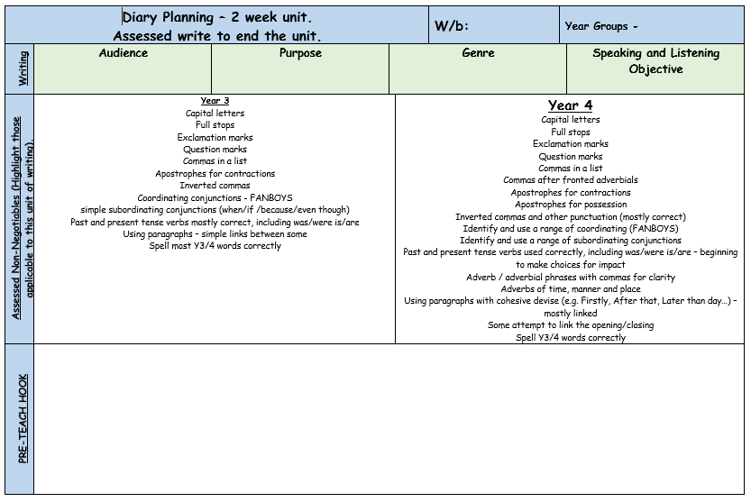

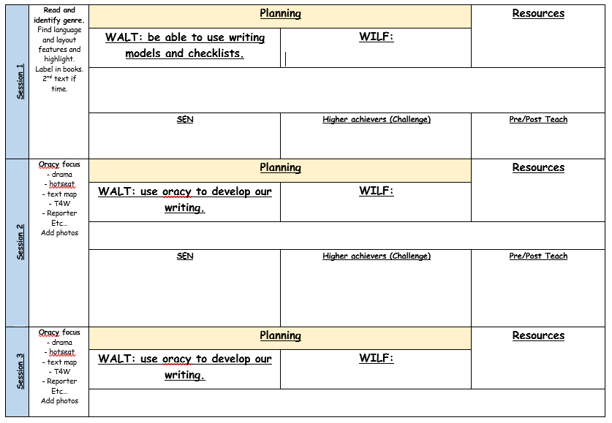

PROGRAMMES OF STUDY

Year 1 Writing
Pupils should be taught to:
- spell:
- words containing each of the 40+ phonemes already taught
- common exception words
- the days of the week

- name the letters of the alphabet:
- naming the letters of the alphabet in order
- using letter names to distinguish between alternative spellings of the same sound

- add prefixes and suffixes:
  - using the spelling rule for adding –s or –es as the plural marker for nouns and the third person singular marker for verbs
  - using the prefix un–
  - using –ing, –ed, –er and –est where no change is needed in the spelling of root words [for example, helping, helped, helper, eating, quicker, quickest]

- write from memory simple sentences dictated by the teacher that include words using the GPCs and common exception words taught so far

Writing - composition
Pupils should be taught to:
- write sentences by:
- saying out loud what they are going to write about
- composing a sentence orally before writing it
- sequencing sentences to form short narratives
- re-reading what they have written to check that it makes sense
- discuss what they have written with the teacher or other pupils
- read their writing aloud, clearly enough to be heard by their peers and the teacher

Writing - vocabulary, grammar and punctuation
Pupils should be taught to:
- develop their understanding of the concepts set out by:
  - leaving spaces between words
  - joining words and joining clauses using ‘and’
  - beginning to punctuate sentences using a capital letter and a full stop, question mark or exclamation mark
  - using a capital letter for names of people, places, the days of the week, and the personal pronoun ‘I’
  - learning the grammar for year 1
  - use the grammatical terminology in English in discussing their writing

Year 2 Writing
In writing, pupils at the beginning of year 2 should be able to compose individual sentences orally and then write them down. They should be able to spell many of the words covered in year 1 correctly. They should also be able to make phonically plausible attempts to spell words they have not yet learnt. Finally, they should be able to form individual letters correctly, establishing good handwriting habits from the beginning.
It is important to recognise that pupils begin to meet extra challenges in terms of spelling during year 2. Increasingly, they should learn that there is not always an obvious connection between the way a word is said and the way it is spelt. Variations include different ways of spelling the same sound, the use of so-called silent letters and groups of letters in some words and, sometimes, spelling that has become separated from the way that words are now pronounced, such as the ‘le’ ending in table. Pupils’ motor skills also need to be sufficiently advanced for them to write down ideas that they may be able to compose orally. In addition, writing is intrinsically harder than reading: pupils are likely to be able to read and understand more complex writing (in terms of its vocabulary and structure) than they are capable of producing themselves.
Writing - transcription

Spelling
Pupils should be taught to:
- spell by:
- segmenting spoken words into phonemes and representing these by graphemes, spelling many correctly
- learning new ways of spelling phonemes for which 1 or more spellings are already known, and learn some words with each spelling, including a few common homophones
- learning to spell common exception words
- learning to spell more words with contracted forms
- learning the possessive apostrophe (singular) [for example, the girl’s book]
- distinguishing between homophones and near-homophones
- add suffixes to spell longer words including –ment, –ness, –ful, –less, –ly
- apply spelling rules and guidance
- write from memory simple sentences dictated by the teacher that include words using the GPCs, common exception words and punctuation taught so far

Writing - composition
Pupils should be taught to:
- develop positive attitudes towards and stamina for writing by:
- writing narratives about personal experiences and those of others (real and fictional)
- writing about real events
- writing poetry
- writing for different purposes
- consider what they are going to write before beginning by:
- planning or saying out loud what they are going to write about
- writing down ideas and/or key words, including new vocabulary
- encapsulating what they want to say, sentence by sentence
- make simple additions, revisions and corrections to their own writing by:
- evaluating their writing with the teacher and other pupils
- rereading to check that their writing makes sense and that verbs to indicate time are used correctly and consistently, including verbs in the continuous form
- proofreading to check for errors in spelling, grammar and punctuation (for example, ends of sentences punctuated correctly)
- read aloud what they have written with appropriate intonation to make the meaning clear

Writing - vocabulary, grammar and punctuation
Pupils should be taught to:
- develop their understanding of the concepts set out by:
- learning how to use both familiar and new punctuation correctly
- including full stops, capital letters, exclamation marks, question marks, commas for lists and apostrophes for contracted forms and the possessive (singular)
- learn how to use:
- sentences with different forms: statement, question, exclamation, command
- expanded noun phrases to describe and specify [for example, the blue butterfly]
- the present and past tenses correctly and consistently, including the progressive form
- subordination (using when, if, that, or because) and co-ordination (using or, and, or but)
- the grammar for year 2
- some features of written Standard English
- use and understand the grammatical terminology in discussing their writing

Year 3 and 4 Writing
Pupils should be able to write down their ideas with a reasonable degree of accuracy and with good sentence punctuation. Teachers should therefore be consolidating pupils’ writing skills, their vocabulary, their grasp of sentence structure and their knowledge of linguistic terminology. Teaching them to develop as writers involves teaching them to enhance the effectiveness of what they write as well as increasing their competence. Teachers should make sure that pupils build on what they have learnt, particularly in terms of the range of their writing and the more varied grammar, vocabulary and narrative structures from which they can draw to express their ideas. Pupils should be beginning to understand how writing can be different from speech. Joined handwriting should be the norm; pupils should be able to use it fast enough to keep pace with what they want to say.
Pupils’ spelling of common words should be correct, including common exception words and other words that they have learnt. Pupils should spell words as accurately as possible using their phonic knowledge and other knowledge of spelling, such as morphology and etymology.

Writing - transcription

Spelling
Pupils should be taught to:
- use further prefixes and suffixes and understand how to add them
- spell further homophones
- spell words that are often misspelt
- place the possessive apostrophe accurately in words with regular plurals [for example, girls’, boys’] and in words with irregular plurals [for example, children’s]
- use the first 2 or 3 letters of a word to check its spelling in a dictionary
- write from memory simple sentences, dictated by the teacher, that include words and punctuation taught so far

Writing - composition
Pupils should be taught to:
- plan their writing by:
- discussing writing similar to that which they are planning to write in order to understand and learn from its structure, vocabulary and grammar
- discussing and recording ideas
- draft and write by:
- composing and rehearsing sentences orally (including dialogue), progressively building a varied and rich vocabulary and an increasing range of sentence structures
- organising paragraphs around a theme
- in narratives, creating settings, characters and plot
- in non-narrative material, using simple organisational devices [for example, headings and sub-headings]
- evaluate and edit by:
- assessing the effectiveness of their own and others’ writing and suggesting improvements
- proposing changes to grammar and vocabulary to improve consistency, including the accurate use of pronouns in sentences
- proofread for spelling and punctuation errors
- read their own writing aloud to a group or the whole class, using appropriate intonation and controlling the tone and volume so that the meaning is clear

Writing - vocabulary, grammar and punctuation
Pupils should be taught to:
- develop their understanding of the concepts by:
- extending the range of sentences with more than one clause by using a wider range of conjunctions, including: when, if, because, although
- using the present perfect form of verbs in contrast to the past tense
- choosing nouns or pronouns appropriately for clarity and cohesion and to avoid repetition
- using conjunctions, adverbs and prepositions to express time and cause
- using fronted adverbials
- learning the grammar for years 3 and 4
- indicate grammatical and other features by:
- using commas after fronted adverbials
- indicating possession by using the possessive apostrophe with plural nouns
- using and punctuating direct speech
- use and understand the grammatical terminology accurately and appropriately when discussing their writing and reading

Year 5 and 6 Writing
Pupils should be able to write down their ideas quickly. Their grammar and punctuation should be broadly accurate. Pupils’ spelling of most words taught so far should be accurate and they should be able to spell words that they have not yet been taught by using what they have learnt about how spelling works in English.
During years 5 and 6, teachers should continue to emphasise pupils’ enjoyment and understanding of language, especially vocabulary, to support their reading and writing. Pupils’ knowledge of language, gained from stories, plays, poetry, non-fiction and textbooks, will support their increasing fluency as readers, their facility as writers, and their comprehension. As in years 3 and 4, pupils should be taught to enhance the effectiveness of their writing as well as their competence.

Writing - transcription

Spelling
Pupils should be taught to:
- use further prefixes and suffixes and understand the guidance for adding them
- spell some words with ‘silent’ letters [for example, knight, psalm, solemn]
- continue to distinguish between homophones and other words which are often confused
- use knowledge of morphology and etymology in spelling and understand that the spelling of some words needs to be learnt specifically, as listed in English appendix 1
- use dictionaries to check the spelling and meaning of words
- use the first 3 or 4 letters of a word to check spelling, meaning or both of these in a dictionary
- use a thesaurus

Writing - composition
Pupils should be taught to:
- plan their writing by:
- identifying the audience for and purpose of the writing, selecting the appropriate form and using other similar writing as models for their own
- noting and developing initial ideas, drawing on reading and research where necessary
- in writing narratives, considering how authors have developed characters and settings in what pupils have read, listened to or seen performed
- draft and write by:
- selecting appropriate grammar and vocabulary, understanding how such choices can change and enhance meaning
- in narratives, describing settings, characters and atmosphere and integrating dialogue to convey character and advance the action
- précising longer passages
- using a wide range of devices to build cohesion within and across paragraphs
- using further organisational and presentational devices to structure text and to guide the reader [for example, headings, bullet points, underlining]
- evaluate and edit by:
- assessing the effectiveness of their own and others’ writing
- proposing changes to vocabulary, grammar and punctuation to enhance effects and clarify meaning
- ensuring the consistent and correct use of tense throughout a piece of writing
- ensuring correct subject and verb agreement when using singular and plural, distinguishing between the language of speech and writing and choosing the appropriate register
- proofread for spelling and punctuation errors
- perform their own compositions, using appropriate intonation, volume, and movement so that meaning is clear

Writing - vocabulary, grammar and punctuation
Pupils should be taught to:
- develop their understanding of the concepts set out in by:
- recognising vocabulary and structures that are appropriate for formal speech and writing, including subjunctive forms
- using passive verbs to affect the presentation of information in a sentence
- using the perfect form of verbs to mark relationships of time and cause
- using expanded noun phrases to convey complicated information concisely
- using modal verbs or adverbs to indicate degrees of possibility
- using relative clauses beginning with who, which, where, when, whose, that or with an implied (ie omitted) relative pronoun
- learning the grammar for years 5 and 6
- indicate grammatical and other features by:
- using commas to clarify meaning or avoid ambiguity in writing
- using hyphens to avoid ambiguity
- using brackets, dashes or commas to indicate parenthesis
- using semicolons, colons or dashes to mark boundaries between independent clauses
- using a colon to introduce a list
- punctuating bullet points consistently
- use and understand the grammatical terminology accurately and appropriately in discussing their writing and reading
Handwriting at Bentley New Village
- Handwriting is to be a key focus when the modelled, shared and paired writing is being taught and marked.
- All pupils will be taught to write with the cursive style and will be expected to display leaders and exit strokes.
- Children will write with a pencil and then when their joins are nearing perfect, they will be promoted to writing with a blue biro across all subjects on the proviso that their handwriting continues to show consistency.

Handwriting expectations at Bentley New Village

