Hello Everyone,
We hope that you have enjoyed the learning packs over the last few weeks This week would have been our final week at school and next week sees the start of the summer holidays. We hope that you all have a wonderful summer with your families……keep busy and look after yourselves.

We are all looking forward to being back at school in Spetember.

Remember to stay safe and if you want to contact us, you still can do that using the teacher e-mails that we have been using over the last few weeks.

Have a great Summer, from all in the Year 3/4 team!

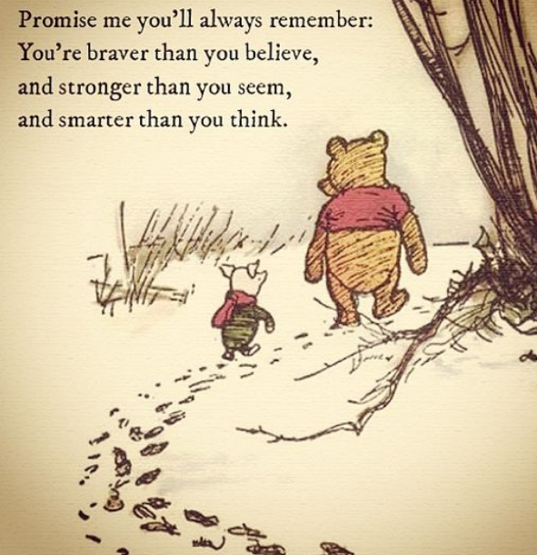

Just a few ideas for the summer!

Have a go at the picture quiz – the answers are at the very end of the pack if you get stuck.

When you are out and about, use the spotter sheets to identify sea creatures, minibeast, trees and flowers.Here’s a challenge…..can you find them all during the holidays?

Keep active using the attached ideas!

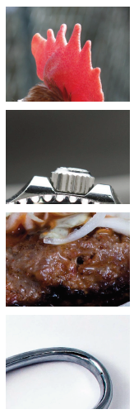
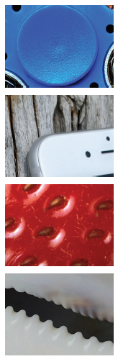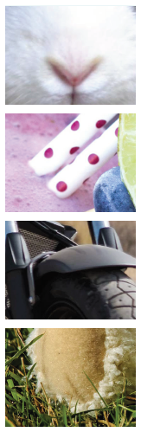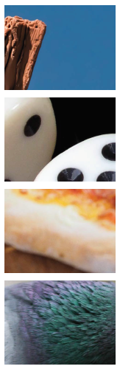
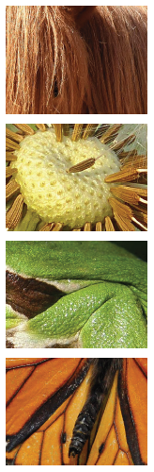
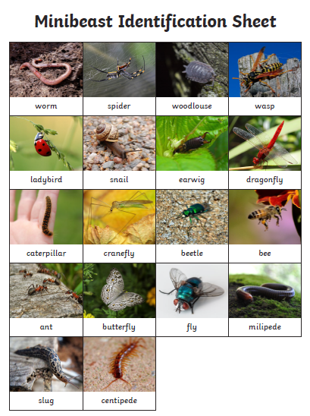
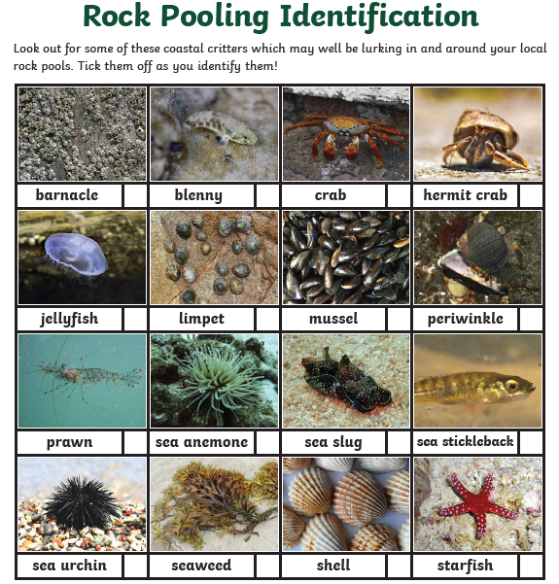
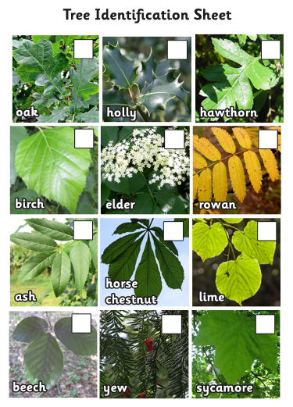
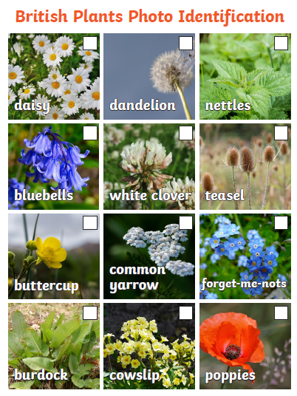

Remember to keep active.
Here are some ideas

Obstacle course:

It’s an exciting way to exercise!
If you’ve watched any television reality game shows, you know what we are talking about.
Use some furniture, and also some chalk to draw out a course ranging from the inside of your house to the garden. Add challenges to the course. You can add a puzzle to be solved, a vast area to be crossed without touching the ground, etc.

Hunt!
This can be either indoors or outdoors!
Organize a hunt that spreads across a large area, or even just inside your house.
Just place toys or treats hidden in different places and start with the first place.
Each place should have a puzzle written for the next. It works better if you make sure the places are far apart.

Gardening!
Simple activities like gardening are a great source of exercise for kids. If you don’t have your own garden, you could just plant some seeds and keep them on a sunny windowsill.

Dance
By far the simplest and the most fun-filled activity to do to get that daily cardio workout!
Just get some drinks and snacks ready, put on some music, and gather up your family!
You now have your very own dance party!

Walk:
If you have a dog, divide daily responsibilities of walking it. If you don’t, go for strolls in the park or walking to the grocery store instead of taking a vehicle. Walk as much as you can.

Hula Hooping:
Get a hoola hoop and lear how to spin it aound your waist! Once you have leaned to hool hoop you can find different ways to use it.

Skipping:
Get a skipping rope and learn how to skip. Running and skipping is the easiest way to start. Once you can skip, have a go at learning some skipping rhymes too!

