Hello Everyone,
I hope you enjoyed last week’s learning, This will be the last learning pack before we actually finish for Summer. Keep busy and look after yourselves and your family.

I am missing you all and look forward to us all being back at school.

Remember to stay safe

If you want to contact me you can do at:
MrsSmith@newvillage.doncaster.sch.uk
You can attach any documents or photographs of work you complete.

I wish you all good luck in your new classes and hope you soon settle back in once we are all back at school.

Mrs Smith x

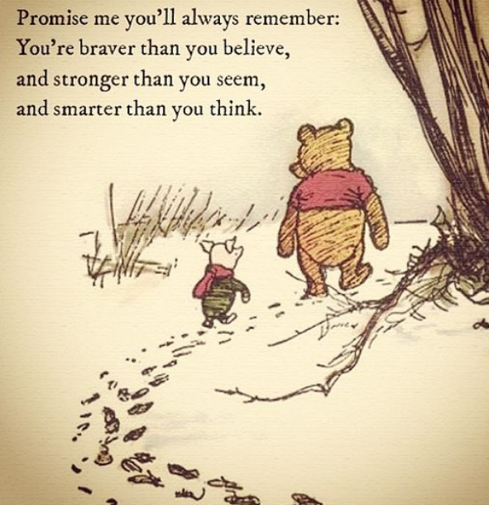

Year 3/4 /5

All the tasks for the week will be in one document. Just complete them through the week. Try to do a range of learning each day. There is no need to complete one task from every section each day, as I know lots of you are having great family times and making lovely memories to look back on.

Remember to keep active also. Here are some ideas

Obstacle course:

It’s an exciting way to exercise!
If you’ve watched any television reality game shows, you know what I’m talking about.
Use some furniture, and also some chalk to draw out a course ranging from the inside of your house to the garden or corridor outside. Add challenges to the course. You can add a puzzle to be solved, a vast area to be crossed without touching the ground, etc.

Hunt!
This can be either indoor or outdoor!
Organize a hunt that spreads across a large area, or even just inside your house.
Just place toys or treats hidden in different places and start your kid off with the first place.
Each place should have a puzzle written for the next. If you make sure the places are far apart, your kids will get a good run out of it.

Gardening:
Simple activities like gardening are a great source of exercise for kids. If you don’t have your own garden, just get some pots, some mud, and some saplings and ask your kids to fill the pots up themselves!

Dance
By far the simplest and the most fun-filled activity to do to get that daily cardio workout.
Just put on some music, get some preferably healthy snacks and gather up your child’s friends!
You now have your very own dance party. You could also just do this during family time with your children.

Walk:
If you have a dog, divide daily responsibilities of walking it. If you don’t, practise going for strolls in the park or walking to the grocery store instead of taking a vehicle. Walk as much as you can with your kids.

Hula Hooping:
For some reason, children love hula hoops!
Get your children some hula hoops and start hooping with them. Just teach them how to do it and we promise you that they won’t be able to get enough.

Mrs Smith x

SPAG ACTIVITIES FOR THE WEEK
This week we will look at some practise questions for a range of spelling, grammar and punctuation
Print off/ write on paper
- Answers are provided but try to answer questions before checking answers.
- Can you improve your score through the week?

Spelling, punctuation and grammar.
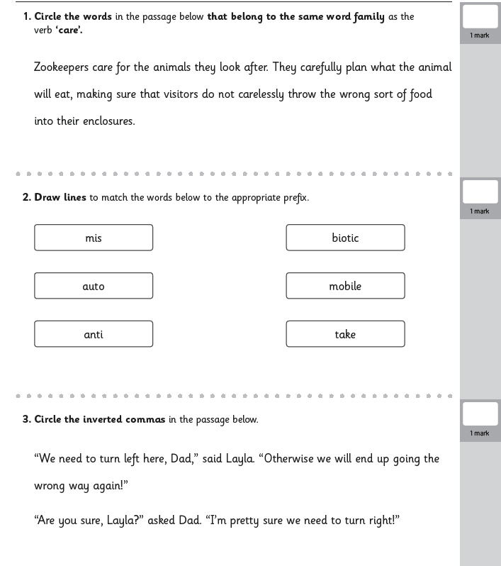
TASK 1

TASK 2 SPAG
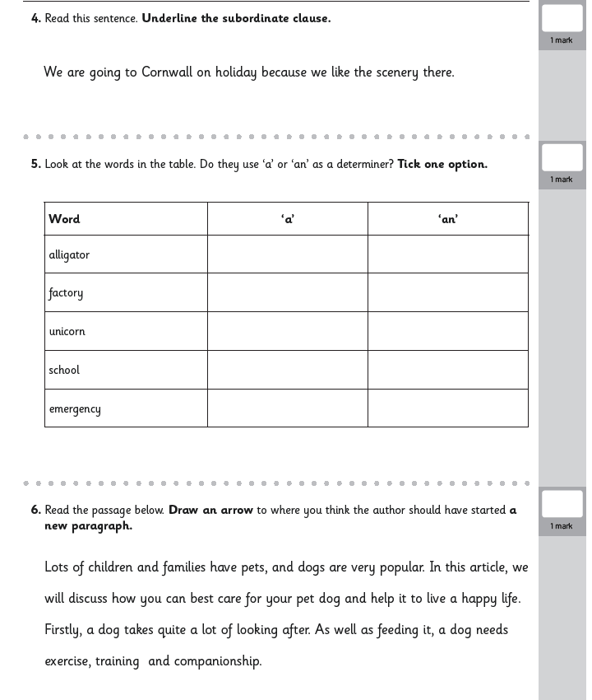

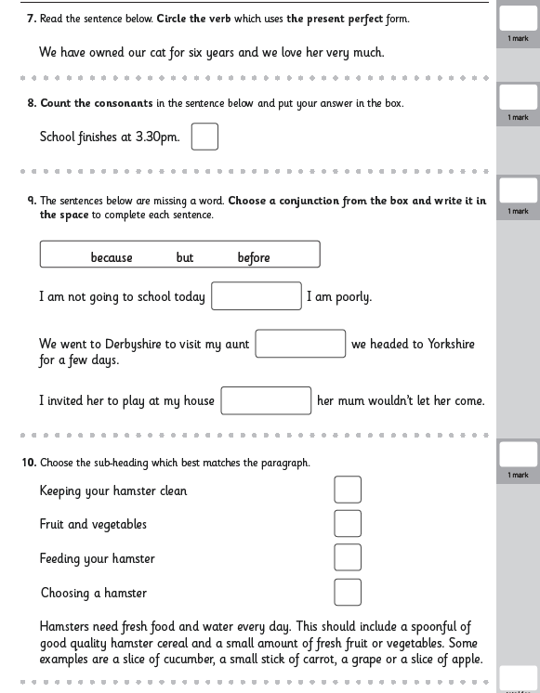
TASK 3

ANSWERS
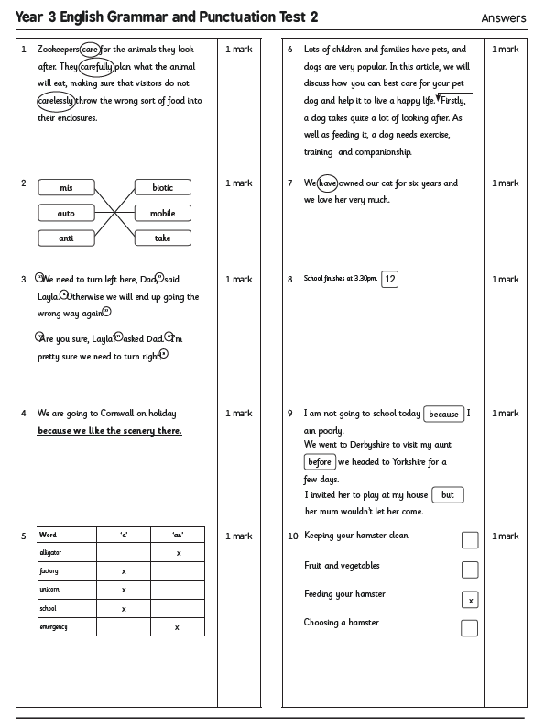
Reading this week will link to the writing project I am asking you to do.
Reading task 1 – you might need an adult to help you read the information
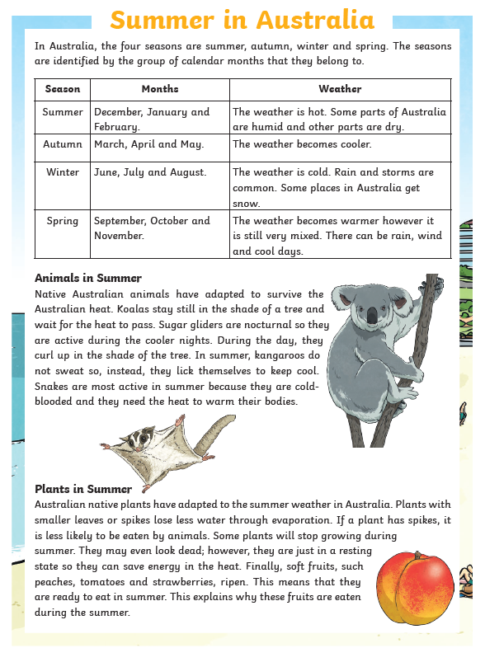

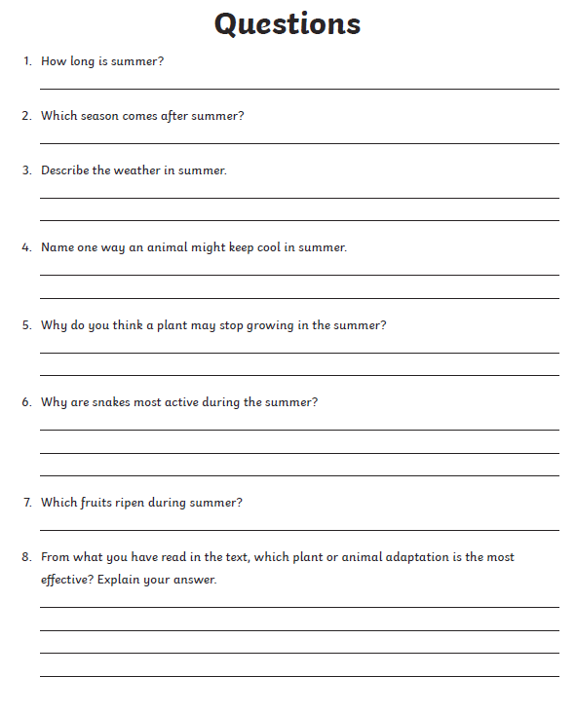

READING TASK 2
Ask an adult to help you read the facts about Indoa. Answer the questions. You could use some of the information you find in your writing if you choose India as your research country.

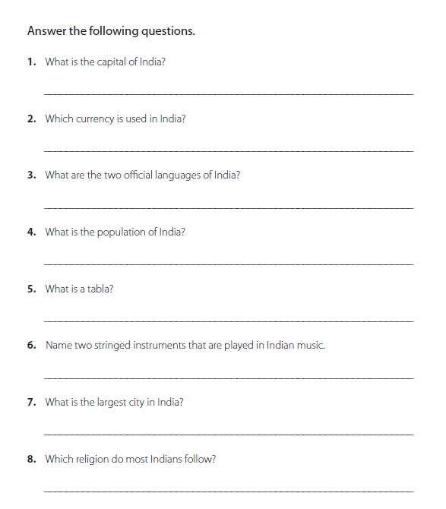
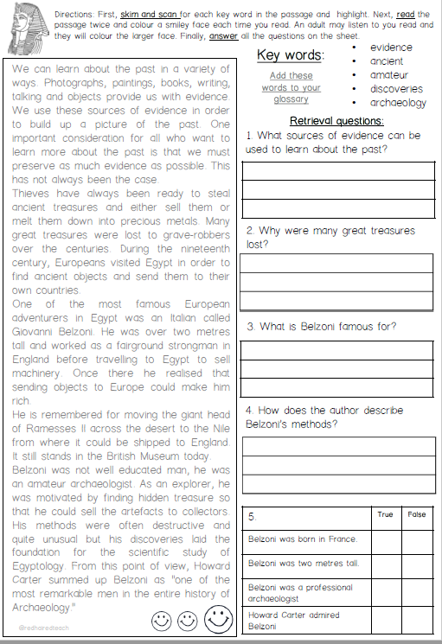
READING TASK 3 - Write the answers on another sheet as the spaces are only small.

READING TASK 4 and 5
READ FOR PLEASURE
Choose your most favourite book and share with someone in your family.
You could even ask them questions about what you read.
Stories can also be accessed through the links below.
https://www.storylineonline.net/ ( read to you )
http://www.magickeys.com/books/invis-allig/page6.html#pictop
(for you to read)
https://www.freechildrenstories.com/ ( choose from a range of ages and genre)

MATHS ACTIVITIES FOR WEEK
TASK 1
Here are some activity sheets for you to have a go at throughout the week. Print off or write calculations down. Talk about your learning with an adult.
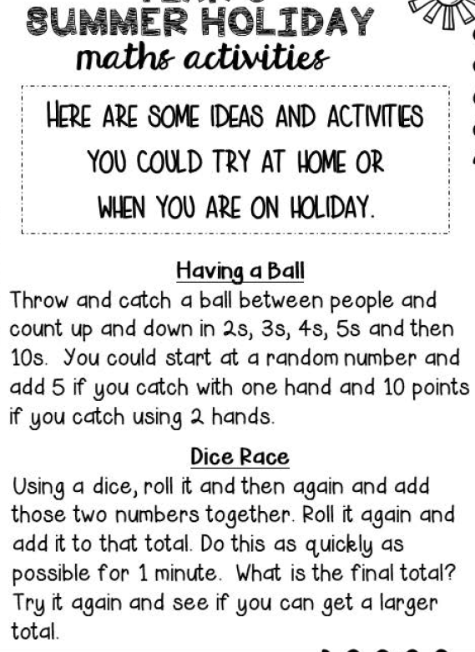

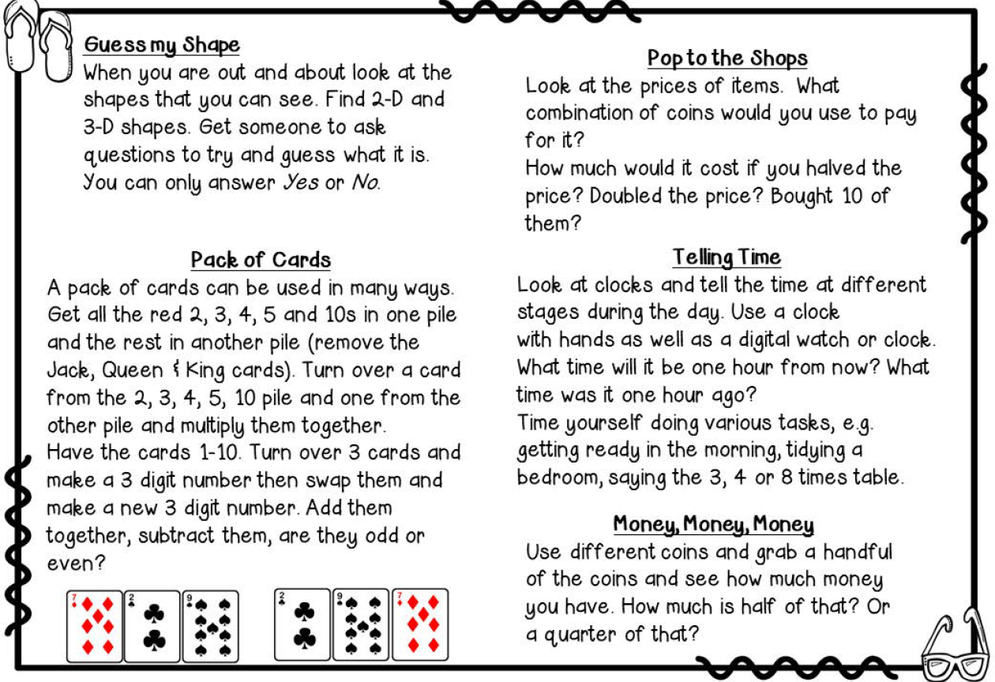
MATHS TASK 2

MATHS TASKS 3
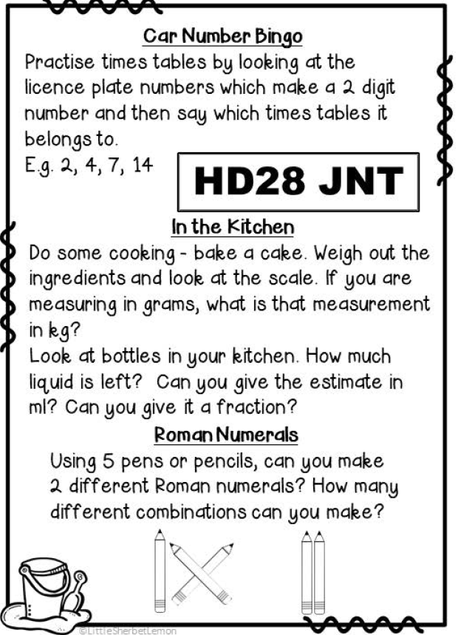
Remember to keep gping with your times tables. Use Times tables rock stars and practise writing your times tables in no order just to memorise the anwers.
Have a speed teast with someone in your family.
WRITING FOR THE WEEK
This week I am asking you to research and write about a country. The choice is yours but I have given you a starting point for three countries, if you want to choose one I have suggested.
The countries I have suggested are: Egypt, Australia or india.
All these countries have some interesting animals, landmarks and food.
In writing this week, it could continue further if you wanted it to ( there is loads of information about countries), I am asking you o research one location.
Find out and write about:
Where exactly the place is ( map work through google)
Food in the locaton
Animals that are native to the location
Any landmarks/volcanoes the location has
Religion and festivals that link to the religion of the location
Clothes for the location
The websites below is a good start to research
https://www.theschoolrun.com/
http://www.primaryhomeworkhelp.co.uk/
Type in here ( search) the country you are researching
Use the links to find lots of information and write a section or two for your booklet each day

ACTIVITIES TO LINK TO THE WRITING

Painting animals from the country | Sketching animals | Look on google maps can you locate your country. Which countries are near?
Food from the country. Have a go at making the food from your country | Create a front cover for your information booklet | Draw the country’s famous landmark
Use this website for more craft ideas lined to a specific place.
https://www.dltk-kids.com/world

________________________________________________________________________________________________________________________________________________________________________________________________________________________________________________________________________________________________________________________________________________________________________________________________________________________________________________________________________________________________________________________________________________________________________________________________________________________________________________________________________________________________________________________________________________________________________________________________________________________________________________________________________________________________________________________________________________________________________________________________________________________________________________________________________________________________________________________________________________________________________________________________________________________________________________________________________________________________________________________________________________________________________________________________________________________________________________________________________________________________________________________________________________________________________________________________________________________________________________________________________________________________________________________________________________________________________________________________________________________________________________________________________________________________________________________________________________________________________________________________________________________________________________________________________________________________ You could send me some pictures of what you create mrssmith@newvillage.doncaster.sch.uk

