Have a look at the activities on this site.

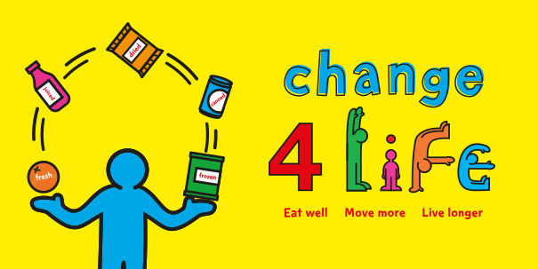

www.nhs.uk/change4life

- Click on activities. There is a list of suggested Shake Up games, sports activities and indoor activities to do.
Have a go at some of these. Have fun!

