Y3S - Home Learning
Dear Y3S, since we are not able to be together at school at the moment, I have put together some more learning activities that you can complete with your adults at home. Some activities can be printed and there are also some on-line links that may be helpful. I hope that you are all well and look forward to being back together as soon as we can. Miss Shaw
Daily Activities:
 | Activity
9.00 | PE | Take a look at the NETFLEX powerpoint, open it up and choose a link to an exercise of your choice……..superhero….frozen…….Joe Wickes…….anything you like!  You will find the instructions below.
Activity 1 | Maths  (30 mins) | Follow the link below to find daily BBC bitesize Maths activities  https://www.bbc.co.uk/bitesize/tags/zmyxxyc/year-3-and-p4-lessons/1
Activity 2 | Times tables  (15 mins) | Log in to Splat 100 square and splat your counting patterns.  https://www.primarygames.co.uk/pg2/splat/splatsq100.html  Monday 2’s  Tuesday 4’s  Wednesday 8’s  Thursday 3’s  Friday 6’s  For each daily pattern count it forwards and backwards….as a challenge, can you count them forwards then backwards with your eyes closed?  Then log into TTRS and complete 10 minutes of practice on the studio section.  Studio helps you to extend your learning as you are using all the times tables.
Activity 3 | Spelling  (10 mins) | Write the spellings for this week just like we do every day in the classroom. Remember LOOK / COVER / WRITE / CHECK  LOOK at the word carefully  COVER the word  WRITE it from memory  CHECK your spelling  Then use the words in a sentence – if you are not sure of the meaning you can ask an adult / check it in a dictionary / check using an on-line dictionary.  The words that I have selected this week all have silent letters.  island  answer  write  wrapper  knife  knock  thumb  doubt  half  calm
Activity 4 | Handwriting  (5 mins) | Use the prepared line guide or just a piece of paper to write the joins used in our selected spellings.  wr kn
Activity 5 | English  (30 mins) | Follow the link below to find daily BBC bitesize English activities  https://www.bbc.co.uk/bitesize/tags/zmyxxyc/year-3-and-p4-lessons/1
Activity 6 | (30 mins) | Look at the other learning opportunities listed below and select one to do each day!

Other learning opportunities
Choose an activity each day

As it is nearly the summer holidays, this week we have a seaside theme… from your e-mails, I know that lots of you have had a day out at the seaside.
Check out these interesting facts about starfish and dolphins…

https://www.natgeokids.com/uk/discover/animals/sea-life/starfish-facts/

https://www.natgeokids.com/uk/discover/animals/sea-life/dolphins/

Music | https://www.outoftheark.co.uk/ootam-at-home/?utm_source=homepage&utm_campaign=ootamathome2&utm_medium=banner  Log on to the above website. Here you will find lovely songs to sing, just like the ones that we use every week in singing assembly.  Choose a song  Listen to it all the way through and spot any repetition  Join in with the song the 2nd time through, following the words on screen.  Make up your own actions or even dance moves, and don’t forget to follow the links for other activities related to each song  This week, I’ve been singing “Sing together” again from the “Wellbeing” section because singing always makes me feel happy. Try it….you’ll soon see how good it makes you feel.
Geography | Grace darling lived on Longstone lighthouse (pictured below)  Can you find out how many lighthouses there are around the coast of the UK?  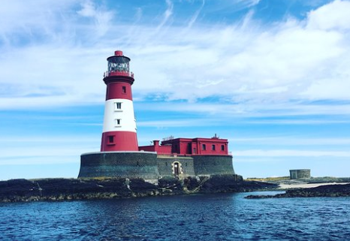  You could even find out where they are and mark them on a map of the UK.  I have copied a map of the UK below for you to use.
Art | Have you ever wanted to be able to draw a great white shark? Click on the link below…remember you can pause it at any time.  https://www.youtube.com/watch?v=jCV_MAr02xo  https://www.youtube.com/watch?v=XbmCDPn_HuM  All you need is a pen a paper and maybe some coloured pens!
ICT | Send me an email to the address below and include an emoji to let me know how you feel. Some people like to include a photograph of something that they have made or something enjoyable that they have done. It is really great to hear about what you have all been doing.  MissShaw@newvillage.doncaster.sch.uk
PSHE | The sea is amazing – full of colour and life. Click on the link below to see some amazing scenes of a coral reef. It is very relaxing…..  https://www.youtube.com/watch?v=wJIbhSYteK0
History | Do you remember reading about Grace darling? Find out more about her life by following the link below……  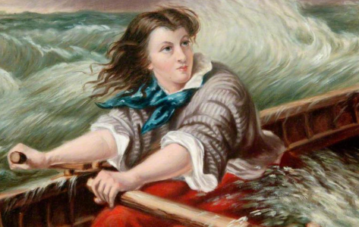  https://www.youtube.com/watch?v=xCL1x7wHQLY  https://www.youtube.com/watch?v=Yv3eS40j0N0
DT | Why not have a go at making a paper shark puppet. Just follow the link below…  https://www.youtube.com/watch?v=wy2-3BxdtYY  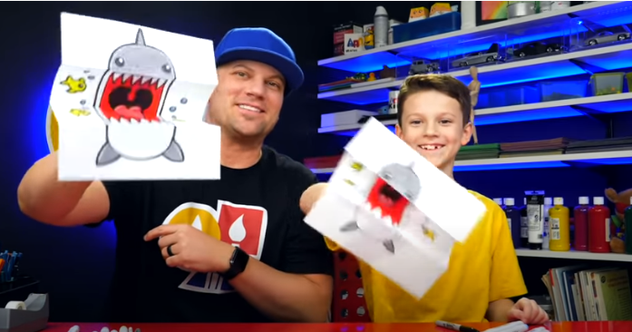
Science | Take a look at the rock pooling identification photos below. Try and find out some information about each item on the list. If you are lucky enough to go to the seaside, have a go at rock pooling and see what you can find.  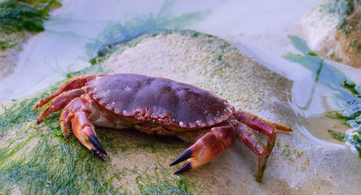
Exercise outdoors a little bit each day. Set yourself a daily challenge! |  | A zoom night in!  Connect with friends and family online.

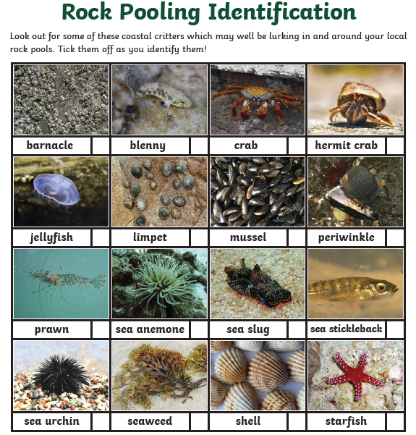

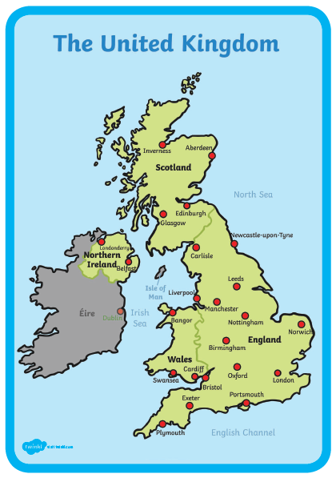

Use the lines below to write a sentence using each of these words – remember to use

your joined handwriting

