Hello to all super Year 2 class,
I hope you enjoyed he activities in the learning pack last week.
Keep going with your learning .
Well done everyone at home you are doing amazing. We do understand that sometimes it can be difficult to get children motivated to complete task. Keep up the good work.

Mrs Hemmingway says” Hello, and she misses you all”.

We hope that you are all having fun, enjoying your time and making memories with your adults.

There is a work pack here for you to have a go at. There is no need to print anything out so do not worry if you don’t have a printer, just talk through the work with your adult or write things on paper or even on the computer.

Don’t forget you can send me some pictures of your work, I would love to see it.
Mrssmith@newvillage.doncaster.sch.uk
I am sure Mrs Hemmingway would love to see how you are getting on CC her into the email.

Mrshemmingway@newvillage.doncaster.sch.uk

Spelling, Grammar and Punctuation
Write the sentences either printing out the sheet or on your paper.
Task 1 Remember Proper nouns have capital letters too. (EG: Names of days, names of people etc.)
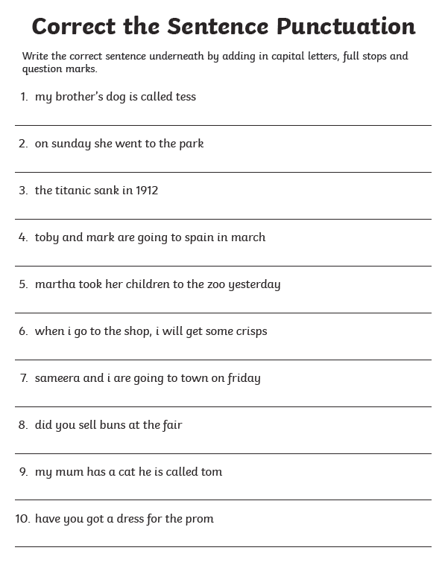
Task 2
An expanded noun phrase is used to describe something using 1 or more adjectives.
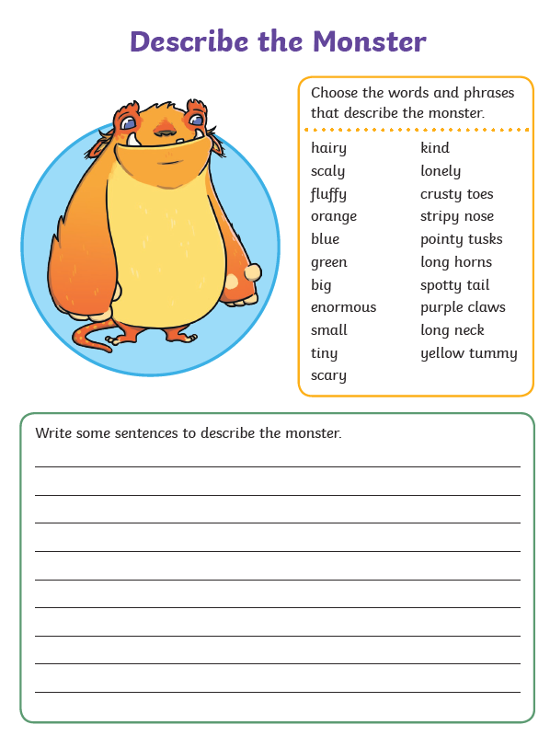
Task 3
Compound words are made by joining two other words together
Discuss the compound words that can be made using the pictures below. Can you write a sentence using some of them?
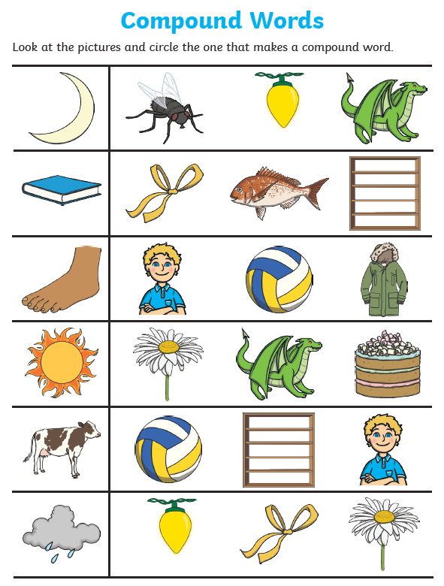

Additional writing Tasks
Use the sheet provided to develop a story idea. This can be used to develop vocabulary with an adult /child shared creation of a story.
Ask children to describe objects /characters that are used.
Question children about what the characters are doing/ where they are going/ what will the end of the story be like?
Ask children to write some sentences about the story or characters.
Why not put yourselves in the story and have an adventure.

Writing sheets have been provided for children to write ideas.
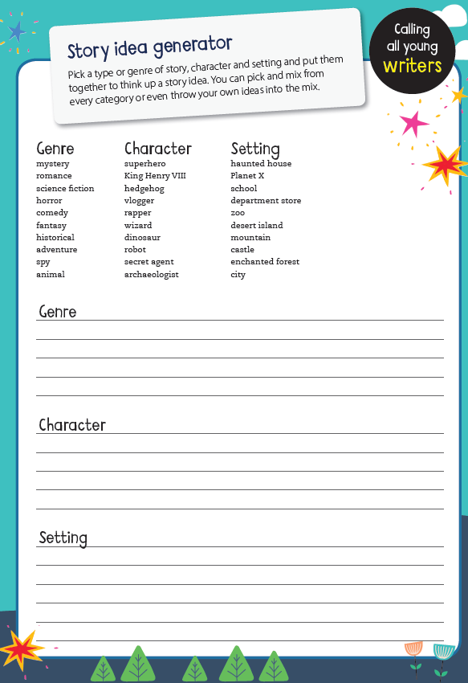
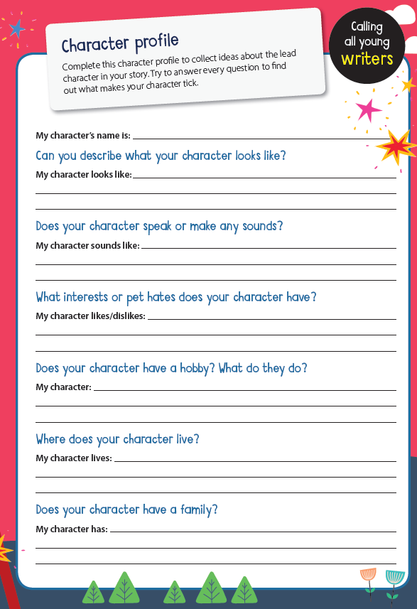
READING
I have three more stories for you to listen to this week. Look at the picture of the front cover (to get a clearer picture of front cover- follow the link and pause before story begins) and talk about what you think will happen in the story.
Answer the questions about the stories.
You could discuss these or write the answers.

Elves and the Shoemaker | Me and my cat | The tale of Peter Rabbit
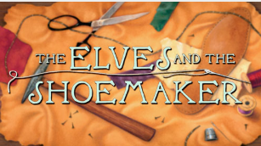 | 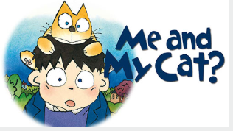 | 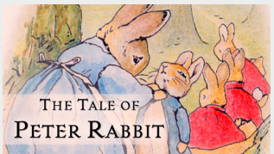
https://www.storylineonline.net/books/the-elves-and-the-shoemaker/  The link may have to be copied and pasted into the address bar.  Or can be accessed through typing Stories online into google. | https://www.storylineonline.net/books/me-and-my-cat/  The link may have to be copied and pasted into the address bar.  Or can be accessed through typing Stories online into google. | https://www.storylineonline.net/books/peter-rabbit/  The link may have to be copied and pasted into the address bar.  Or can be accessed through typing Stories online into google.
- What do you think will happen in the story?  - What did the shoemaker do for a job?  - What did the shoemaker do before he went to bed?  - What did the shoemaker and his wife see in the morning?  - Who bought the shoes?  - What did he pay?  - Do you think the man who bought the shoes liked them? What makes you think this?  - What did the shoe maker buy?  - What did the shoemaker’s wife suggest they did?  - what did they hear at midnight?  - What did they see?  - What did the elves do with the leather that the shoemaker had cut out?  - How did the elves make sure they were not heard when they left?  - What did the shoemaker and his wife make for the elves?  - What did the elves think of the clothes? | - What do you think will happen in the story?  - Who came into the window?  - Why did Mum wake up Nicolas?  - Why did the boy look at himself in the mirror?  - What had happened to the boy?  - Did the boy like being a cat? How do you know?  - What happened when the boy(cat) leapt to the other side of the room?  - Who liked him?  - What did the mean cats do and say?  - What was the scratching at the front door?  - How did the boy act?  - What did Mum do when she was really worried?  - What did the doctor suggest?  - What happened when the cat and the boy went to bed?  - What mistake had the witch made?  - How were things in the morning?  - How were things at school? | - What do you think will happen in the story?  - What were the rabbits called?  - Where did they live?  - Where were they not allowed to go?  - Where did Mrs Rabbit go?  - Where did Peter go?  - What did he eat?  - Who ran after Peter rabbit?  - Where did peter Rabbit lose his shoes/  - Who helped Peter Rabbit?  - Where did peter Rabbit hide?  - Why did Mr McGregor go back to his work?  - Why didn’t Peter Rabbit go home?  - Who was carrying the peas?  - What was next to the pond?  - What did Peter see when he stood on top of the wheelbarrow?  - Do you think Peter enjoyed it in Mr McGregor’s garden? Why?  - What did Mr McGregor do with the shoes and the jacket? Why?  - What did Peter do when he got home?  - What did Peter miss out on because he went to bed feeling ill?

Extra activities linked to reading
ART
Design an outfit for the elves
What clothes would you design for the elves? What colours would you use? Would your elves be girls or boys? Would you have a hat, a scarf, long or short socks, long or short trousers, skirt or dress, and what kinds of shoes would you give them?
- Make a drawing to show the clothes that you would make for the elves. Label your clothes.
- Make a detailed drawing of your shoes. How much would you sell them for?

Potato Printing
With an adult cut a potato into half and cut a shape into it.
Paint the potato and make prints with it on paper. How colourful can you make it?
Science
Grow a potato plant
In a container of soil /compost or in the garden plant a pototo. Water it and make a mound of soil around it.
Watch over several days to see if the potato will grow more potatoes. You will have to be patient.
Or leave an old potato in a dark cupboard. Observe what happens – the longer you leave it the longer the roots will get.
MATHS ACTIVITIES
Here are three activity sheets for you to have a go at throughout the week. Print off/discuss or write calculations down. Talk about your learning with an adult. Enlarge the page to see the measurement clearer.
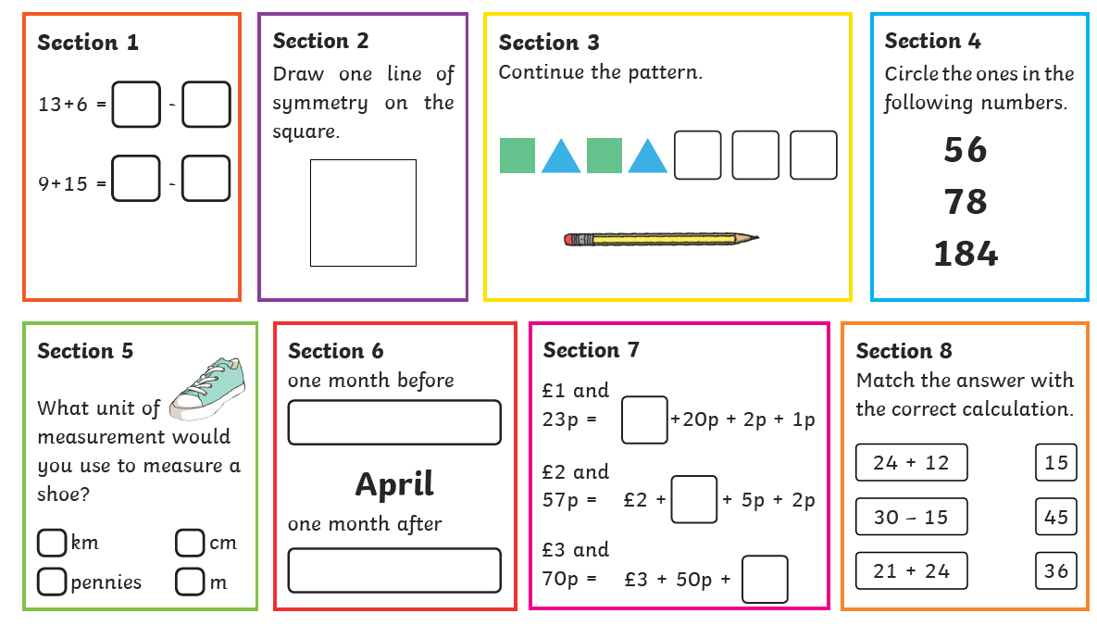
TASK 2
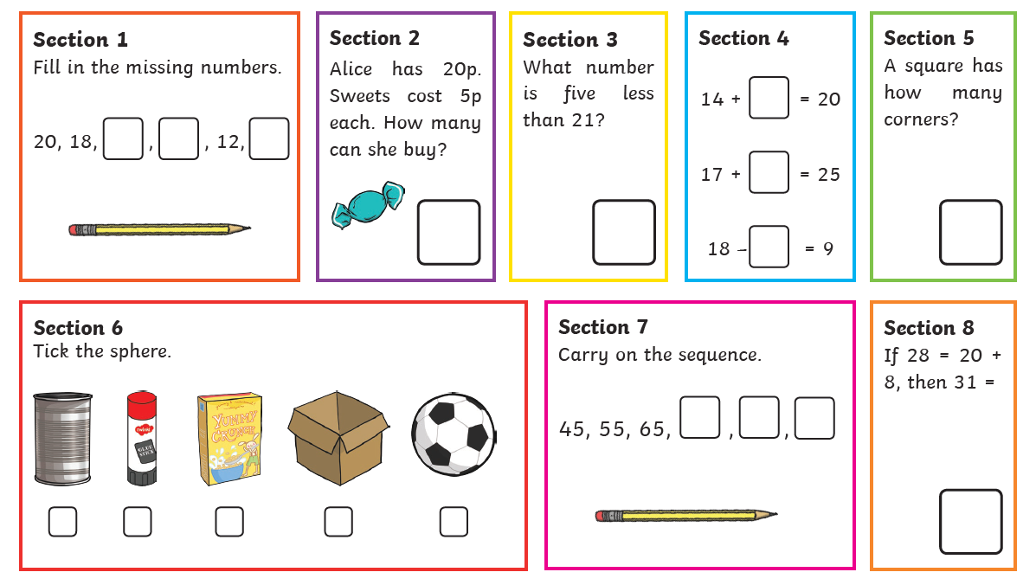

TASK 3
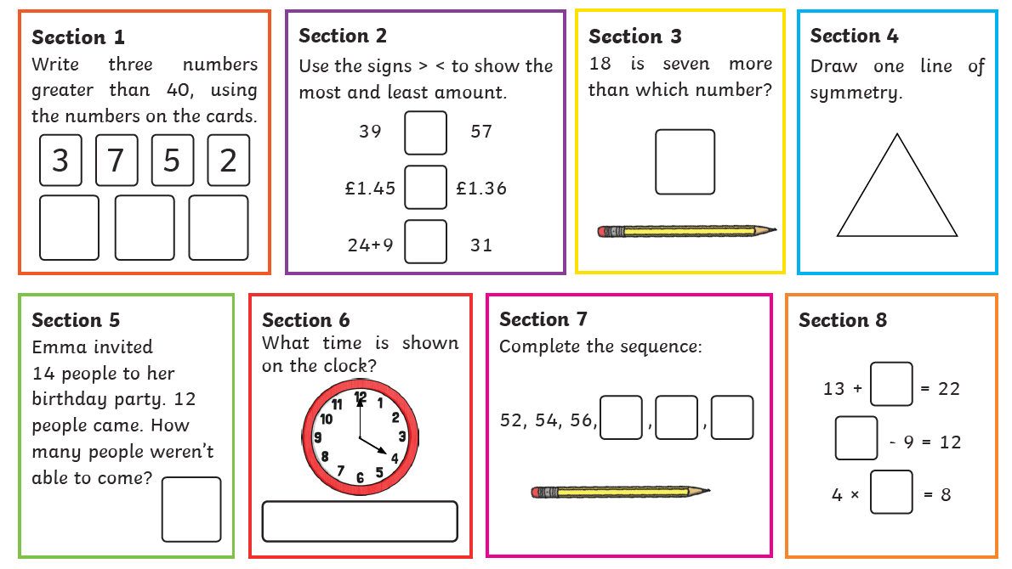

Finally, some topic activities for the week
Remember to also look at the Art and Science ideas after the reading activities.

Geography
Locate places on a map.
Open google/safari/Chrome
Search google maps
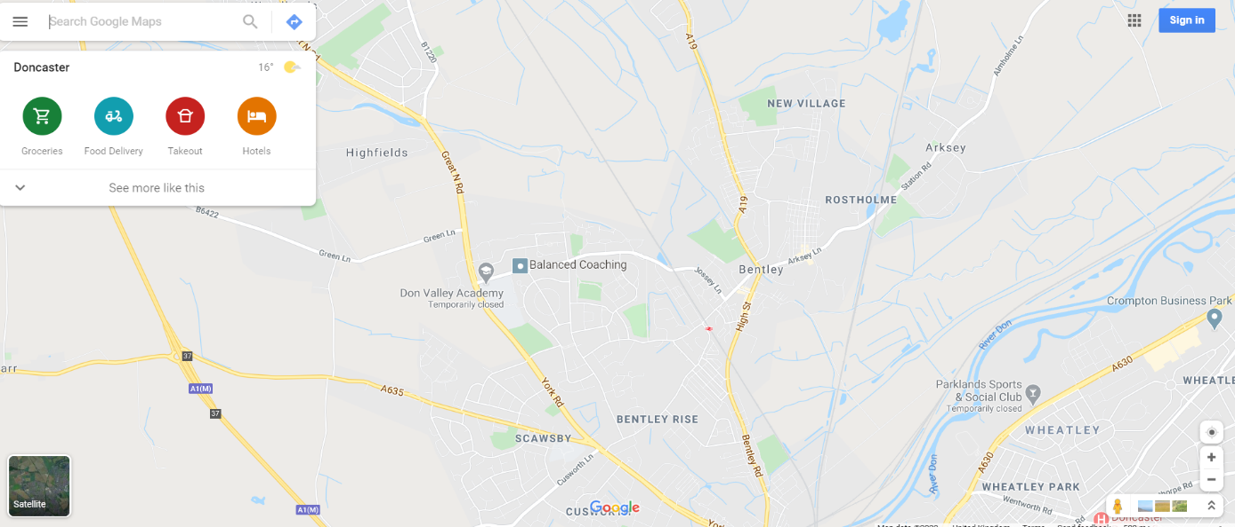
https://www.google.com/maps/@53.5479749,-1.1608891,14z

Enlarge the map and find where you live.
If you live out of Bentley search the area where you live.
What other things can you find on the map.
Discuss with an adult.
Design and Technology
Pattern
Use the link below from bbc
https://www.bbc.co.uk/bitesize/articles/z47dqp3
Discuss what patterns are and the different ways they are made.
Complete the tessellation activity ( shapes fitting together)

Complete the sheet on the next page.

Iscuss with an adult whether these shapes will fit together perfectly without any spaces. It has to be the same shape

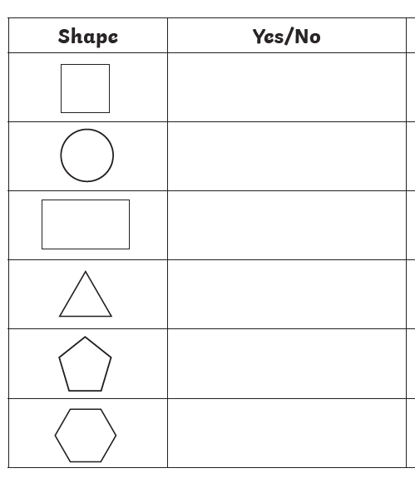

Now try out the website below and test your ideas.

https://www.nctm.org/Classroom-Resources/Illuminations/Interactives/Tessellation-Creator/

Music
Use this website to sing and make some noise
https://www.bbc.co.uk/teach/bring-the-noise/eyfs-ks1-music-play-it-bring-the-noise/z4sq92p
Choose a song – you could do a different song on different days.
Click on the option you want to do
Sing in layers/Instruments/Make some noise.

You could send me some pictures of your work
mrssmith@newvillage.doncaster.sch.uk

