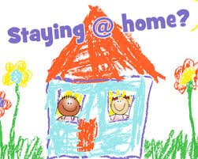
Activities to help at home.

Don’t’ forget to check your child’s personalised learning for the activities for this week.
Remember to send us photos of what you have been doing at home.
Make sure you remember the importance of PLAY this is how young children learn best.
Lots of opportunities for talk, sharing and taking turns.
Mrs Hobbs & Mrs Harrison

