Cut and Stick
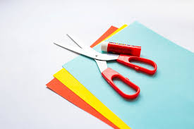

What you will need:
- A pair of scissors.
- Coloured and plain paper.
- Glue

Method:
- Use the scissors to cut out different shapes from the coloured paper. (Your grown up could draw some shapes for you to cut out)
- Once you have cut out the shapes, you can stick them to the paper to create a pattern, collage or a picture of your choice.
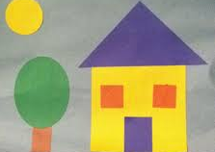
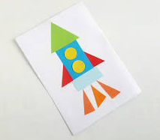

Don’t forget to take a picture of your creation. And please be careful with the scissors!

