Hello to all my lovely Year 2 class,

What has happened to the sun?
Eurgh! This lockdown is so miserable without the sunshine and being able to play in the garden. It is so disappointing!

There is a workpack here for you to have a go at. There are only 9 activities for the week and they should not take you too long. There is no need to print anything out so do not worry if you don’t have a printer, just talk through the work with your adult.
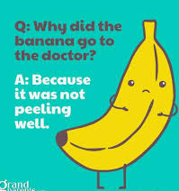
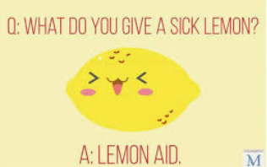

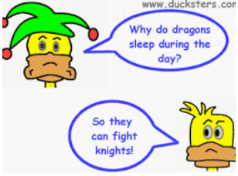
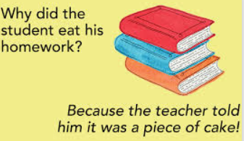

3 listening and comprehension activities…
I have three virtual tours for you to look at this week; please watch the video with an adult and have a go at answering some of the questions – you do not need to write the answers down, just talk to your adult about them.
The Lion and  the Mouse | The Ugly Duckling | Papa Please Get the moon for me
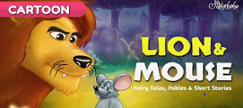 | 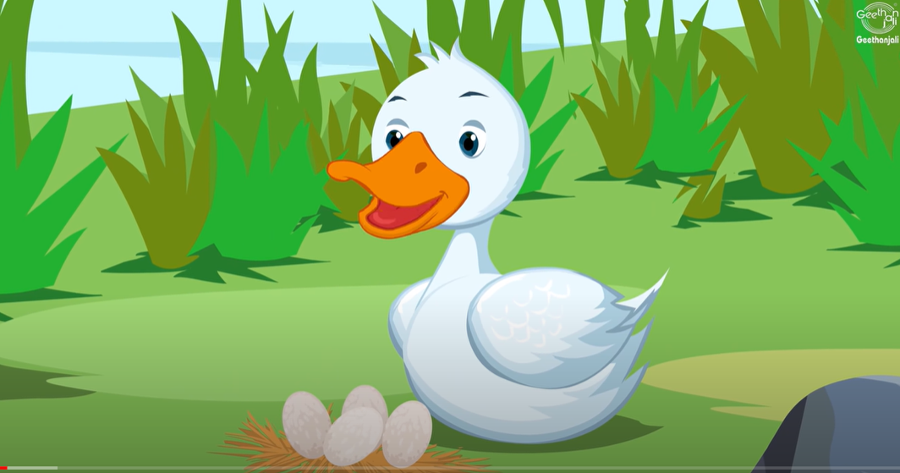 | 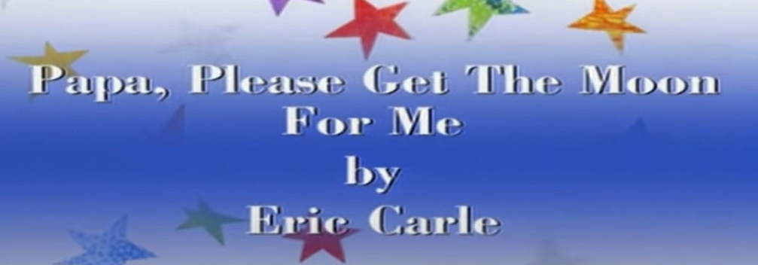
https://www.youtube.com/watch?v=DKgRHys6bfA | https://www.youtube.com/watch?v=OSWLxj4kTKA | https://www.youtube.com/watch?v=sGqAw7UM6qo
- What do we know about the mouse?  - What did all the animals do to the mouse  - How do you think the mouse felt with how they treated him?  - Who was the Lion?  - What does the word ‘curious’ mean?  - How did the animals feel when Lion and Mouse came eye to eye?  - What does the word ‘courage’ mean?  - How did the Lion respond to the Mouse?  - Why did Lion think that Mouse could not help him?  - What made Lion not eat Mouse?  - What happened to Lion?  - How do you think he felt when he was trapped?  - Who helped Lion and how?  - What does the word ‘underestimated’ mean? | - What does the word ‘unsteady’ mean?  - How many ducklings were there?  - How does mother duck make the eggs hatch?  - Where do the ducklings go to meet other ducklings?  - Why do they not want the duckling?  - What scared the little duckling?  - Who did the cottage belong to?  - How does the duckling feel?  - What does the duckling want to do?  - Did the new ducklings want to be friends with the ugly duckling.  - What happened to the leaves in autumn?  - What happened to the duckling at the end and how did he feel? | - Who is the main character in the story?  - What is it that she wants to do?  - What did the moon appear to do to the girl?  - In what ways did Papa try to get to the moon?  - Why do you think Papa could not move the moon?  - What happened to the moon?  - How did Dad get the moon to the girl?  - What did she do with the moon?  - What made Monica happy?

Hands on maths…
I have got three activities for you to do with your adult this week. Please have a go…
Time | Number Bonds | Months of the Year
Make a paper plate clock with your parents.  Can you label the numbers correctly on the clock and can you say where the hands would be for quarter past, half past, quarter to and o’clock?  Can you label the hour and minute hand?  Challenge  Can you add another layer underneath showing quarter past, half past, quarter to and o’clock?  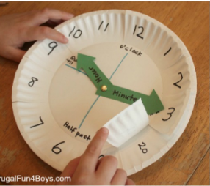 | Can you put 20 small items in a cup  Keep shaking some of the items out and keep some in.  How many different ways can you find to make 20?  When you have tipped some out, write the number, then shake the rest out and write the second number.  Challenge  Can you do it without the items?  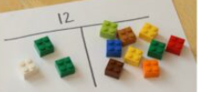 | https://www.youtube.com/watch?v=Fe9bnYRzFvk  Follow the link above to learn the months of the year song.  Try to keep practicing it and see if you can learn the months of the year without it.  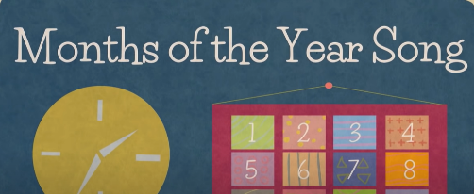
Finally, 3 topic activities for the week;
Can you complete the following as neatly as possible, send me some photos of your work too.
Art | Science | Design Technology
Can you make a beach style picture using your footprints or handprints?  You do not need paint, you could draw around them and colour them in.  Here are some examples to help  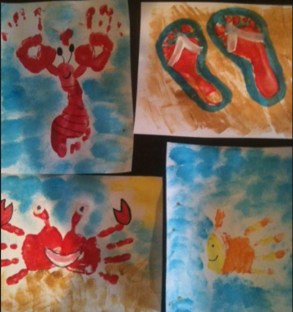 | Egg Race – Salt Water V Fresh Water  Discuss that the sea has 0ceans around it made up of salt water. Do they know what salt water is? Do they know how it is different?  Parent - Watch the youtube clip  https://www.youtube.com/watch?v=rxGCPAKrlGg  Have a go at completing the eggsperiment with your child. See how many tablespoons it takes for the eggs to float in the salt water. Discuss that the the salt water is more dense.  What does this mean on the beach do they think? | Create a photo montage by cutting, gluing, rearranging and overlapping photographs into a new image. Use either photos you have taken yourself or photos from newspapers or magazines to create either:  1. A photo montage using images of animals.  2. A photo montage to represent ‘lockdown’.
 |  | Tip: Try to use photos/pictures taken from an unusual perspective or thought-provoking viewpoint.

