Learning Pack for Year 1, - week 9
Hi Everyone,
This is Miss Shah here. I’m pleased you’re enjoying the learning packs with less printing and less writing. Remember you get a star for each one you do! Don’t forget to send in pictures of you learning ! mrsgeaney@newvillage.doncaster.sch.uk
Activity 1  Have a competition with someone in your family.  - Throw and catch the ball with a family member with a maths question eg What do you add to 17 to make 20?  - Throw and catch the ball to the 5 times table.  - Do some star jumps safely.  - Challenge a parent to an exercise you like and have a go - see who wins! | Activity 2  Create a collage of the UK. You can use different types of paper, card, sand, twigs, leaves, fabric etc. It looks like this:  Do you remember the countries of the UK? What about the capital cities of each country? | Activity 3  Science Activity –Investigate the parachute:  Create 3 different parachutes using different fabrics  - Tissue paper  - Fabric  - Newspaper/paper  With your parent’s help, see which parachute takes the longest to fall to the ground. | Activity 4  Maths Activity – Colour in a bar chart!  Ask people in your house their favourite colour from red, yellow, blue, green, pink or orange.  Jot down what they say.  Ask your grown up if you can fone a friend or grandparent, aunt etc to ask the same question. Who likes which colour? How many people like pink? Which colour is most popular?  Now make a bar chart of it using squares to help.  d colour it in. | Activity 5  Weather Check  For the next week I would like you to be the weather person. Your job is to show if it was sunny, cloudy, rainy or windy on each day. If it was sunny on Monday, draw a sun shining. If it was raining on Wednesday, draw a cloud with some raindrops falling.  Day Weather check  Monday  Tuesday  Wednesday  Thursday  Friday  Saturday  Sunday
Four In A Row – Challenge a sibling or parent - Choose an activity to do and put a counter on it when you’ve done it. Who got Four In A Row first? Send in your pics – I’d love to see them! Thanks.
Write the alphabet in lower case letters | Read to a member of your household. | Write the alphabet in upper case letters | Read to someone over the fone – get permission first!
Sponsored spell. Get your parent/grandparent to give you a reward (like smiles, high fives, extra veg for dinner) for spelling each word correctly - Words at the end. | Your choice ! | Do some gardening – water the plants, pull out the weeds (not the flowers) tidy up the yard. | Your parent’s choice !
Draw circles and then draw the time you:  - wake up,  - get dressed  - have lunch  - play  - do some learning  - do something else | Say the 10 times table – backwards ! | Help lay the table and clear the table after breakfast and lunch.  Can you even do that at dinner time? | Hide things around the house with your parent. Write clues for where your treasure is. Ask another family member to go find. How many can they find?
Measure the height of the plants or flowers. | Make a habit of tidying your bedroom without being asked. Can you do this? Do you need reminding? | Ask a family member to help you find out how tall you are. Note it down. Put the note somewhere safe. Look at the note at Christmas and see if you’ve grown. | What do you remember of school? What do you think it’ll be like when you go back?
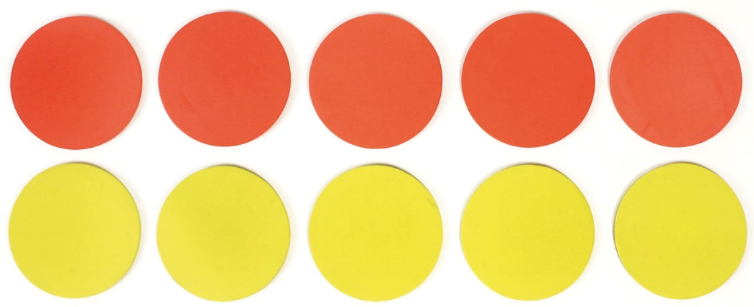

And Finally,
3 short daily (this means every day) activities to do with your family for each subject…
Reading | Writing | Maths
- Read a story with a grown up.  - Read a story over the fone to a family member or friend you can’t visit yet – like a grandparent or a friend.  - Story time: Listen to the story of The Rainbow Fish online:  https://www.youtube.com/watch?v=Z3cmddZh6t8  - Draw your favourite character  - What is she or he like?  - Why do you like them? | Handwriting - This is really important to please do this slowly for a while every day:  Do some handwriting. Practice all your letters – get a parent to check you’re doing them right. Do the lower case letters and then do the upper case letters.  Copy and complete these sentences but remember to use capital letters, finger spaces and full stops:  - My name is ….  - I am…years and...months old  - The best thing about being at home has been ….  - The things I miss about school are ….  - Write a story with a character in it.  - Now write your own sentences. | 1. The answer is 20 What is the question?  How many add questions can you do in 1 minute?  How many can your parent get?  How many take away questions can you do in a minute?  What about another family member?  Can you think of any times or divide questions that give 20 as an answer?  Also try some times tables:  1x2= 2 x 2= 3x2=  4x2= 5 x 2= 6x2=  7x2= 8 x 2 = 9 x 2 =  10 x 2 = 11 x 2 = 12 x 2 =  Now try the same for the 5 times table and then the 10 times table.
And that’s it – Smile again Let me know what you think !
If you have any spare time, there is some extra work on the next few pages. Enjoy!

Spellings
Look at the spelling words. Can you say them? Can you spell them? Can you use them in a sentence?
 | Look at the word | Say the word | Spell the word | Use the word in a sentence
the
a
do
to
today
of
said
says
uour
they
be
he
she
me
we
no
come
some
one
once
ask
friend
school
put
are
were
was
is
his
has

