Y3S - Home Learning
Dear Y3S, since we are not able to be together at school at the moment, I have put together some more learning activities that you can complete with your adults at home. Some activities can be printed and there are also some on-line links that may be helpful. I hope that you are all well and look forward to being back together as soon as we can. Miss Shaw
Daily Activities:
 | Activity
9.00 | PE | Take a look at the NETFLEX powerpoint, open it up and choose a link to an exercise of your choice……..superhero….frozen…….Joe Wickes…….anything you like!  You will find the instructions below.
Activity 1 | Maths  (30 mins) | Follow the link below to find daily BBC bitesize Maths activities  https://www.bbc.co.uk/bitesize/tags/zmyxxyc/year-3-and-p4-lessons/1
Activity 2 | Times tables  (15 mins) | Log in to Splat 100 square and splat your counting patterns.  https://www.primarygames.co.uk/pg2/splat/splatsq100.html  Monday 2’s  Tuesday 4’s  Wednesday 8’s  Thursday 3’s  Friday 6’s  For each daily pattern count it forwards and backwards….as a challenge, can you count them forwards then backwards with your eyes closed?  Then log into TTRS and complete 10 minutes of practice on the studio section.  Studio helps you to extend your learning as you are using all the times tables.
Activity 3 | Spelling  (10 mins) | Write the spellings for this week just like we do every day in the classroom. Remember LOOK / COVER / WRITE / CHECK  LOOK at the word carefully  COVER the word  WRITE it from memory  CHECK your spelling  Then use the words in a sentence – if you are not sure of the meaning you can ask an adult / check it in a dictionary / check using an on-line dictionary.  The words that I have selected this week all end with the suffix –al  closure  enclosure  composure  exposure  leisure  pressure  treasure  measure  pleasure  fissure
Activity 4 | Handwriting  (5 mins) | Use the prepared line guide or just a piece of paper to write the joins used in our selected spellings.  sure
Activity 5 | English  (30 mins) | Follow the link below to find daily BBC bitesize English activities  https://www.bbc.co.uk/bitesize/tags/zmyxxyc/year-3-and-p4-lessons/1
Activity 6 | (30 mins) | Look at the other learning opportunities listed below and select one to do each day!

Other learning opportunities
Choose an activity each day

Did you know that our Queen has 2 birthdays!!!! She has her real birthday on 21st April. This year she was 94 years old. She also has an official celebration of her birthday in June, which is known as “Trooping the colour.”
Find out more below…..

Why does the queen have 2 birthdays?
https://www.bbc.co.uk/newsround/36489213

What is trooping the colour?
https://www.bbc.co.uk/newsround/43794588

Watch part of Trooping the colour from 2016
https://www.youtube.com/watch?v=76Xub5FsPac

Music | https://www.outoftheark.co.uk/ootam-at-home/?utm_source=homepage&utm_campaign=ootamathome2&utm_medium=banner  Log on to the above website. Here you will find lovely songs to sing, just like the ones that we use every week in singing assembly.  Choose a song  Listen to it all the way through and spot any repetition  Join in with the song the 2nd time through, following the words on screen.  Make up your own actions or even dance moves, and don’t forget to follow the links for other activities related to each song  This week, I’ve been singing “Put on a smile” from the “In it together” and I noticed that it has a marching band type theme. This made me think about an event that usually takes place in June...”Trooping the colour.”
Geography | You may be wondering where the Queen lives. She has a number of homes, but the most famous is Buckingham Palace in London.  Find out more about Buckingham Palace by following the links below.  Take a virtual tour of Buckingham Palace, when you look at the rooms don’t forget to use the up and down arrow keys so that you can look at the ceilings too!  https://www.royal.uk/virtual-tours-buckingham-palace  https://www.rct.uk/visit/the-state-rooms-buckingham-palace/highlights-of-buckingham-palace#/  Changing the guard at Buckingham Palace  https://www.flickr.com/photos/britishmonarchy/sets/72157631533918524  When you have taken the virtual tour, use the writing frame below to make a postcard.
Art | 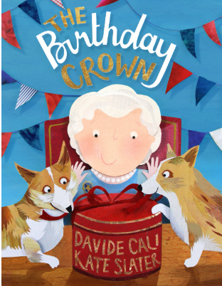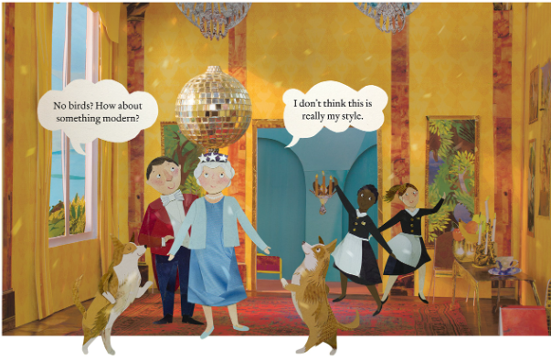  In 20016, it was the Queen’s 90th birthday and so a special picture book was written called “The birthday crown.” The artist made all the illustrations like a puppet theatre and then took photographs of them. Look at the link below.  https://www.youtube.com/watch?v=JPjLFCgQX1A  Why not use a shoe box to create a room of your own? You could cut out pictures from magazines, and use bits and bobs from around your house.
ICT | Send me an email to the address below and include an emoji to let me know how you feel. Some people like to include a photograph of something that they have made or something enjoyable that they have done. It is really great to hear about what you have all been doing.  MissShaw@newvillage.doncaster.sch.uk
PSHE | The Queen has a number of amazing coaches which are stored at the Royal Mews next to Buckingham Palace. Watch the clips below  https://www.youtube.com/watch?v=5DRYzlsf3X4  https://www.youtube.com/watch?v=rGVaJzmAOEM  If you could go for a ride in the Queen’s coach, where would you go?  Who would you take with you to share your special day and why?
History | Queen Elizabeth is the longest reigning monarch in history – this means that she has ruled longer than any other King or Queen.  Take a look at the links below to find out more about Queen Elizabeth. You could also do some research of your own and write a biography about her using the writing sheet below or just using paper and pencils.  https://www.royal.uk/her-majesty-the-queen  Queen Elizabeth comic strip  https://www.natgeokids.com/uk/primary-resource/queen-elizabeth-ii-primary-resource/  If you can’t print off the comic strip resource, I have included it below for you to read online.
DT | Why not have a go at making your model coach with wheels that move. Think about what you have a home that you could use. Try different ways of attaching the wheels…what works the best.
Science | Since we have a royal theme to our learning this week, why don’t you have a go at cleaning some coins so that you can see the Queen on the reverse?  Pennies  Materials:  - Lemon Juice  - Dirty Pennies  - A cup  - Paper Towels  - Brown sauce / vinegar (optional)  Instructions:  - Put a dirty penny in the cup and cover it with lemon juice.  - Wait about five minutes then remove the penny and wipe it off with a paper towel.  - The penny should be nice and shiny.  How it Works:  Pennies are made out of a metal called copper. The copper mixes with oxygen, the same gas that we breathe. This cause something called oxidation and makes the copper coins look dirty. Lemon juice has acid in it that removes the dirty colour or oxidation and makes the penny nice and shiny again!  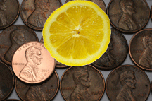  Extra Experiments:  Does vinegar work? Try rubbing the coin with brown sauce? What happens?  If you colour the penny with marker does it come off?  Does it work with other coins? Which ones?
Exercise outdoors a little bit each day. Set yourself a daily challenge! |  | A zoom night in!  Connect with friends and family online.

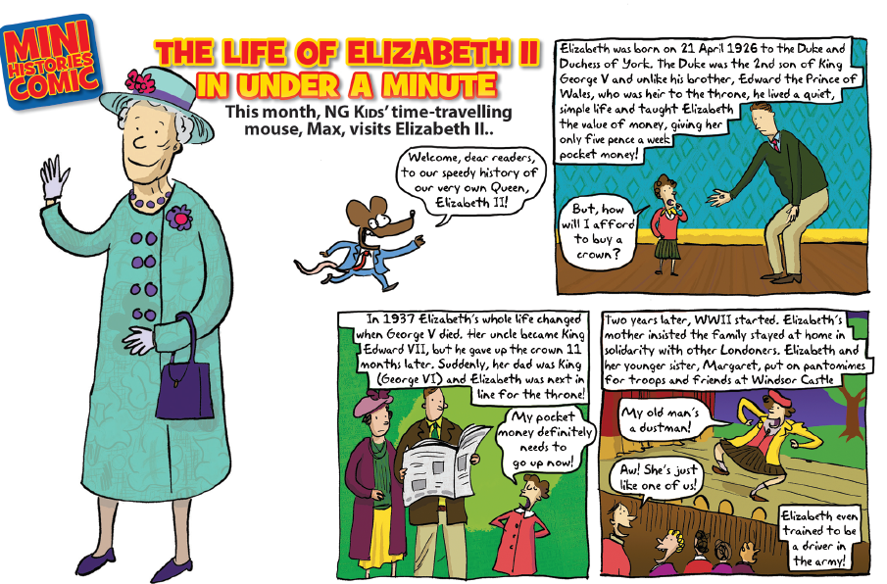
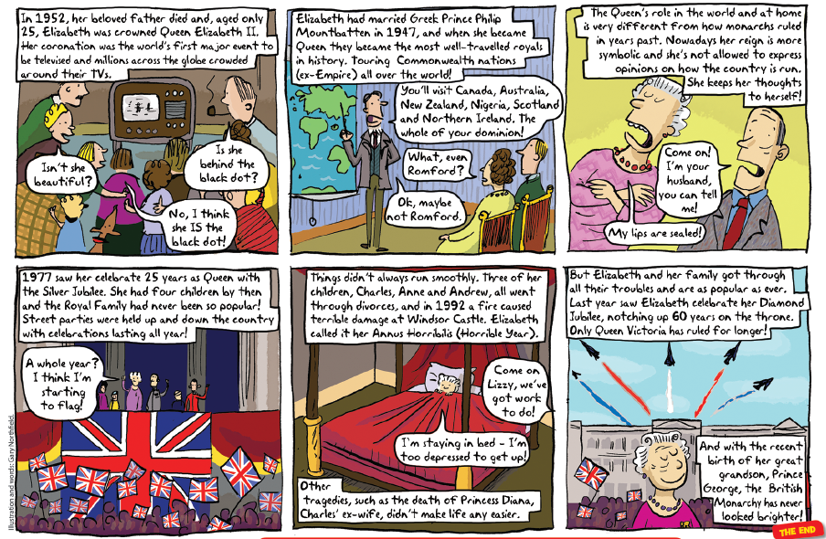

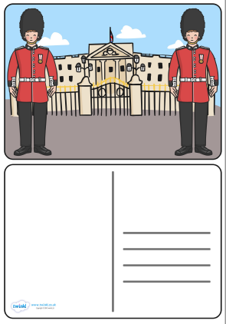

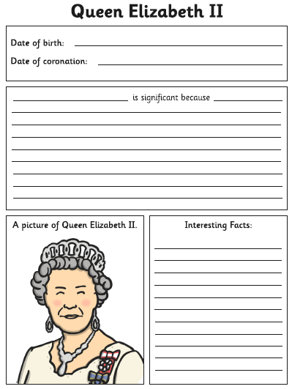

Use the lines below to write a sentence using each of these words – remember to use

your joined handwriting

