Y3S - Home Learning
Dear Y3S, since we are not able to be together at school at the moment, I have put together some more learning activities that you can complete with your adults at home. Some activities can be printed and there are also some on-line links that may be helpful. I hope that you are all well and look forward to being back together as soon as we can. Miss Shaw
Daily Activities:
 | Activity
9.00 | PE | Take a look at the NETFLEX powerpoint, open it up and choose a link to an exercise of your choice……..superhero….frozen…….Joe Wickes…….anything you like!  You will find the instructions below.
Activity 1 | Maths  (30 mins) | Follow the link below to find daily BBC bitesize Maths activities  https://www.bbc.co.uk/bitesize/tags/zmyxxyc/year-3-and-p4-lessons/1
Activity 2 | Times tables  (15 mins) | Log in to Splat 100 square and splat your counting patterns.  https://www.primarygames.co.uk/pg2/splat/splatsq100.html  Monday 2’s  Tuesday 4’s  Wednesday 8’s  Thursday 3’s  Friday 6’s  For each daily pattern count it forwards and backwards….as a challenge, can you count them forwards then backwards with your eyes closed?  Then log into TTRS and complete 10 minutes of practice on the studio section.  Studio helps you to extend your learning as you are using all the times tables.
Activity 3 | Spelling  (10 mins) | Write the spellings for this week just like we do every day in the classroom. Remember LOOK / COVER / WRITE / CHECK  LOOK at the word carefully  COVER the word  WRITE it from memory  CHECK your spelling  Then use the words in a sentence – if you are not sure of the meaning you can ask an adult / check it in a dictionary / check using an on-line dictionary.  The words that I have selected this week all end with the suffix –al  actual  medical  natural  capital  personal  national  vocal  accidental  sensational  occasional
Activity 4 | Handwriting  (5 mins) | Use the prepared line guide or just a piece of paper to write the joins used in our selected spellings.  al
Activity 5 | English  (30 mins) | Follow the link below to find daily BBC bitesize English activities  https://www.bbc.co.uk/bitesize/tags/zmyxxyc/year-3-and-p4-lessons/1
Activity 6 | (30 mins) | Look at the other learning opportunities listed below and select one to do each day!

Other learning opportunities
Choose an activity each day

Music | https://www.outoftheark.co.uk/ootam-at-home/?utm_source=homepage&utm_campaign=ootamathome2&utm_medium=banner  Log on to the above website. Here you will find lovely songs to sing, just like the ones that we use every week in singing assembly.  Choose a song  Listen to it all the way through and spot any repetition  Join in with the song the 2nd time through, following the words on screen.  Make up your own actions or even dance moves, and don’t forget to follow the links for other activities related to each song  This week, I’ve been singing “The planets” from the “Sing in every subject” pack because on Saturday 30th May 2020, a SPACE X rocket was launched in America to take 2 astronauts to the International Space Station. Once you have joined in with the song, have a look at the related activities page……just click and download.  I know that some of you may have seen the rocket launch at the weekend. Therefore, our links this week are related to outer space and space travel.
Geography | You may be wondering what the International Space Station is…follow the links below to find out more……it is fascinating!!!!!!!!!!!!!  What is the international space station?  https://www.esa.int/kids/en/learn/Life_in_Space/Space_Stations/The_International_Space_Station  Facts about the International Space Station  https://www.bbc.co.uk/newsround/34792835  Who are the team members at the international space station at the moment?  https://www.nasa.gov/specials/kidsclub/nowinspace/expedition63/index.html  Below, I have included an International Space Station colouring sheet for you to print out.
Art | I hope that you have enjoyed the previous workshops. This week follow the links below to have a go at drawing astronauts and space pictures!  https://www.youtube.com/watch?v=LWgzybrHjIA  https://www.youtube.com/watch?v=HjnRYnSEuG4  Or why not just get creative and draw space inspired pictures of your own!
ICT | Send me an email to the address below and include an emoji to let me know how you feel. Some people like to include a photograph of something that they have made or something enjoyable that they have done. It is really great to hear about what you have all been doing.  MissShaw@newvillage.doncaster.sch.uk
PSHE | The International Space Station, Astronauts have an amazing view of our earth.  Why not relax while watching these beautiful images? While you are watching, can you spot the lightning storms?  https://www.youtube.com/watch?v=h_pKuOIM4qk
History | 51 years ago. in 1969, men first travelled to the moon. Find out more by following the link below.  https://www.youtube.com/watch?v=CbTaDOuSePk  Take a look at the comic strip below to find out more about Neil Armstrong. You could do some research of your own and write a report about the moon landing, or write a biography about Neil Armstrong.  Neil Armstrong comic strip  https://www.natgeokids.com/uk/primary-resource/neil-armstrong-primary-resource/  If you can’t print off the resource, I have included it below for you to read online.
DT | Why not have a go at making your own paper rocket with paper and a drinking straw.  https://www.youtube.com/watch?v=mQblbX9YccM
Science | Find out more about space by following the links below to the NG kids website.  Top 10 facts about space / universe  https://www.natgeokids.com/uk/discover/science/space/universe-facts/  Fascinating facts about the earth  https://www.natgeokids.com/uk/discover/science/space/facts-about-the-earth/  Since we have a space theme to our learning this week, why don’t you have a go at making rocket mice!!!!!!!  Follow the link below and download “rocket mice” – all you need are things that you may already have at home  https://learning.sciencemuseumgroup.org.uk/learning-resources/  If you can’t print off the resource, I have included it below for you to read online.
Exercise outdoors a little bit each day. Set yourself a daily challenge! |  | A zoom night in!  I have just learned how to use “Zoom” to connect with other people. Why not link up via zoom with friends or relatives for a quiz night.

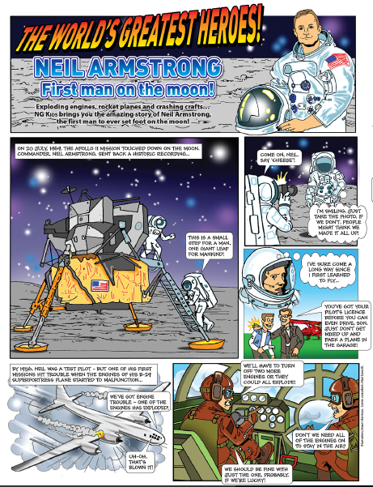

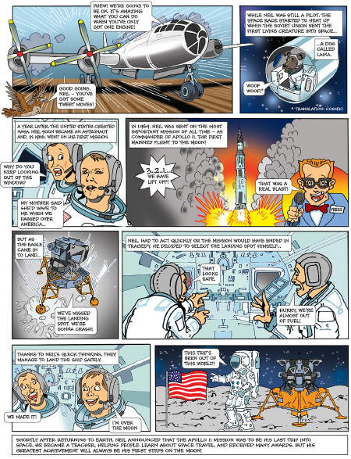
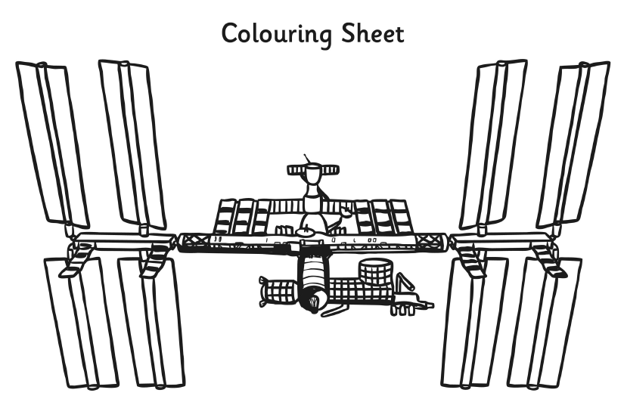

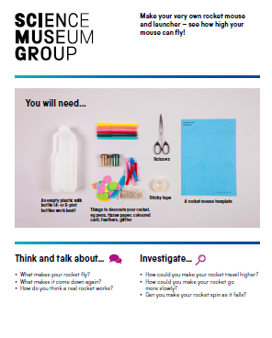

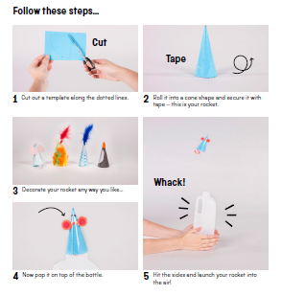

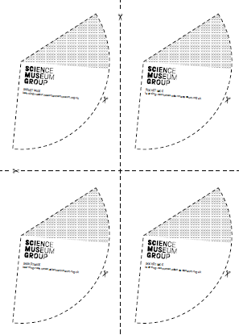
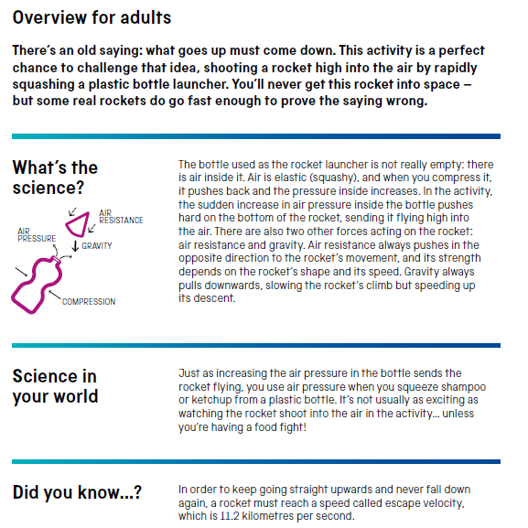

Use the lines below to write a sentence using each of these words – remember to use

your joined handwriting

