Learning Pack for Year 1, - week 8
Hi Everyone,
This is Miss Shah here. I’m pleased you’re enjoying the learning packs with less printing and less writing. Remember you get a star for each one you do! Don’t forget to send in pictures of you learning ! mrsgeaney@newvillage.doncaster.sch.uk
Activity 1  Have a competition with someone in your family.  - Throw and catch the ball with a family member. Who is going to let it drop first?  - Throw and catch the ball to the 2 times table.  - Jog on the spot for one minute.  - Challenge a parent to an exercise they like and have a go - see who wins! | Activity 2  The UK is made up of countries. Find out which ones.  Bonus – can you find the capital cities of each country in the UK?  Here’s a link to help you:  https://www.bbc.co.uk/bitesize/topics/zyhp34j/articles/z4v3jhv | Activity 3  Science Activity – or is it Art?  I used to have hours of fun making flip books. Have a go at making one of your own.  Follow the link to make a flip book – the aim is to make it look as though the object is moving.  Here’s the link:  https://www.sciencebuddies.org/stem-activities/flip-book | Activity 4  Maths Activity – We’re Going on a Minibeast Hunt!  Go into the garden and count (and tally) how many of these you find. | Activity 5  Temperature Check  For the next week I would like you to check the temperature outside at the same time each day.  A lot of fones can tell you the temperature – so ask if your parent can help you find the temperatures. Then jot it down on a table/chart like this:  Day Temperature  Monday  Tuesday  Wednesday  Thursday  Friday  Saturday  Sunday
Four In A Row – Challenge a sibling or parent - Choose an activity to do and put a counter on it when you’ve done it. Who got Four In A Row first? Send in your pics – I’d love to see them! Thanks.
Say the alphabet in lower case letters | Say your 2 times table | Say the alphabet in upper case letters | Say the 5 times table
Challenge your grown up to a spelling competition (words at the end of this pack). | Write instructions on how to make a paper plane. Read the instructions to a relative/friend you can’t see at the moment. Can they follow your instructions ? | Do some gardening – what’s growing more  - The grass  - The flowers  - The weeds ? | Challenge a parent to the 2s, 5s or 10 times table – who can say it first?.
Write down the time: when:  - You wake up  - You have lunch  - You do some exercise  - You read a book  - You have some fun  - You go to bed | Say the 10 times table | Help your parent make dinner – jot down (or draw a picture of) all the vegetables you need to make the dinner. | Make up a scavenger hunt with your parent. Hide the items. How long does it take you to find the things? Then it’s your turn to hide them – how long does it take the parent?
Water the plants – if it’s raining though you don’t need to. | Try to keep all of your bedroom tidy for a day. Can you manage it for a week? | Measure how tall your plants are. Have they grown? | If you were going to make a suitcase of memories of the last few months, what would you put into your suitcase?
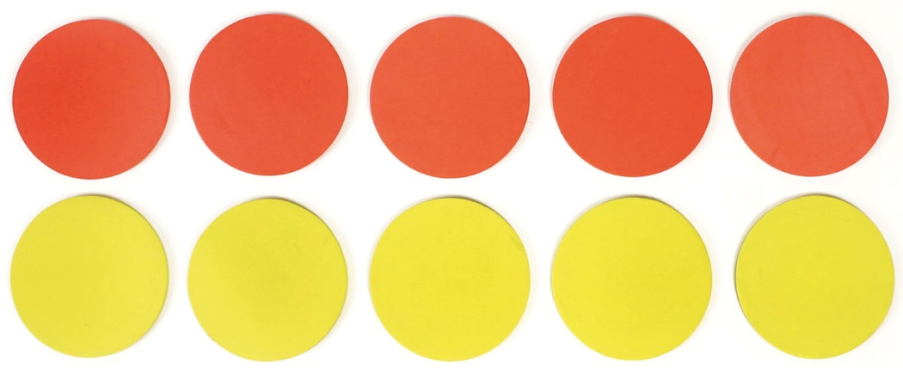

And Finally,
3 short daily (this means every day) activities to do with your family for each subject…
Reading | Writing | Maths
- Read a story with a grown up.  - Draw what happens in the story in 6 boxes.  - Create a character profile of the main character.  - What they look like  - What their personality is like  - Which bit in the story made you draw the character like that?  - Which bit in the story gave you a clue about what he character’s personality was like? | Handwriting - This is really important to please do this slowly for a while every day:  Do some handwriting. Practice all your letters – get a parent to check you’re doing them right. Can you do your numbers too?  We’ve had some lovely weather lately. Can you write an acrostic poem about sunshine? Here’s an example, just make sure each line starts with these letters in order. | 1. Number Bond Challenge:  Ask your parent to say a number between 1 and 20. Your job is to say what you add to that number to make 20.  How many can you get in 1 minute?  How many can your parent get?  Also try some times tables:  2 x 3 = 2 x 5 =  5 x 4 = 5 x 6 =  10 x 2 = 10 x 2 =  Now make up your own times table questions to answer.

And that’s it – Smile again Let me know what you think !
If you have any spare time, there is some extra work on the next few pages. Enjoy!

