To my class,
I hope that you all enjoyed the nice weather that we’ve been having and have spent lots of time outdoors! I enjoyed hearing what lots of you have been up to on the phone again last week. If you want to send me anything, you can email me at:
MrStallard@newvillage.doncaster.sch.uk

1 | PE | Youth Sport Trust Activity Bingo
2 | Reading and spellings | One for each day  Complete reading activities 1-5  Spelling activities 1-5
3 | Maths | Times Tables Rockstars logins provided and daily learning tasks. I’ll be updating the TTRS website and setting individual Times Tables for those of you who want to use Garage.
4 | English | SPaG mats
Lunch
5 | Science and Geography | Recap our learning on States of Matter:  https://www.bbc.co.uk/bitesize/articles/zvxthbk  Why do we have different time zones throughout the world?  https://www.bbc.co.uk/bitesize/articles/z4jbrj6
6 | Thrive and… Mary Poppins! | I’m attaching a list of Thrive activities – one for each day. I’ll also write the links for the websites to go to on the page!  I’m also attaching some instructions for how to build a kite – just like on Mary Poppins!
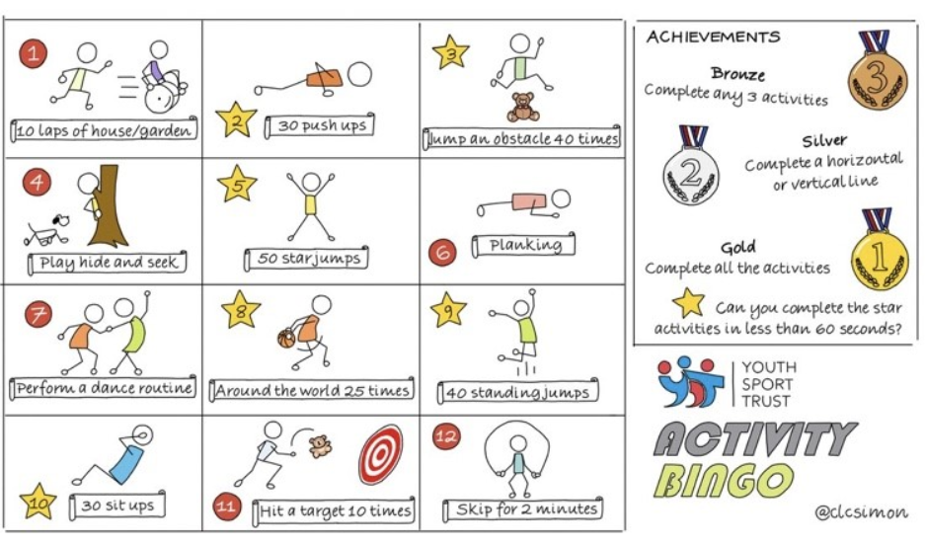

NETFLEX
If you go on our class area on the website and click on ‘Try Mr Stallard’s Exercises’, you can download NETFLEX!

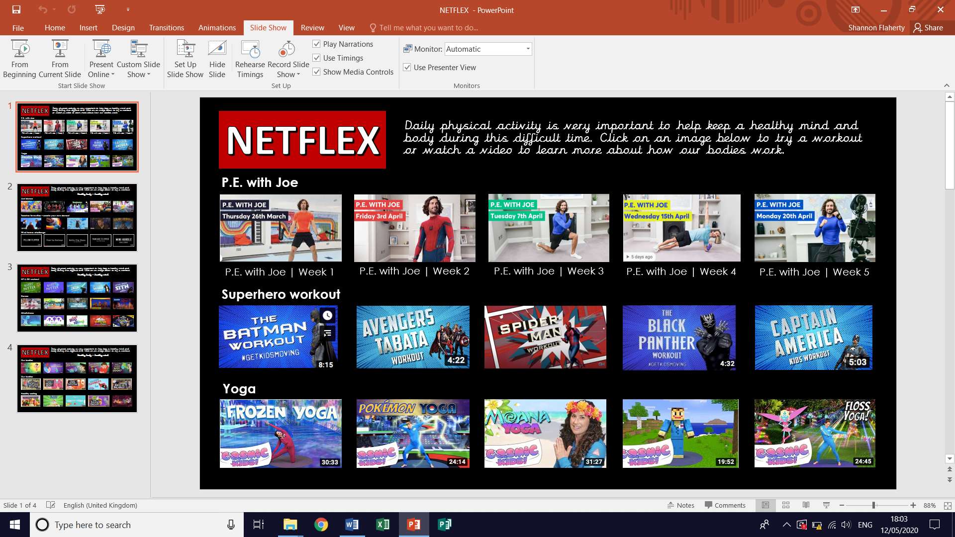
- Scroll through just like you would on Netflix and look at the different exercise activities by clicking on them after it’s gone full screen!
- Click on ‘Slide Show’
- Click on ‘From Beginning’

Reading – choose a book they want to read for Days 1-3

Day 1 | Listen to your child read and ask the questions from the Summarising with Sheba mat.  Ask your child to say some of the answers and possibly write some of them down too.
Day 2 | Listen to your child read and ask 5 questions from the Vocabulary with Victor mat.
Day 3 | Listen to your child read and ask 5 questions from the Retrieval with Rex mat
Day 4 | The Salem With Trials reading comprehension activity.
Day 5 | The Cat in the Witch’s Woods reading comprehension activity

Comprehension Activity 1 Week 8
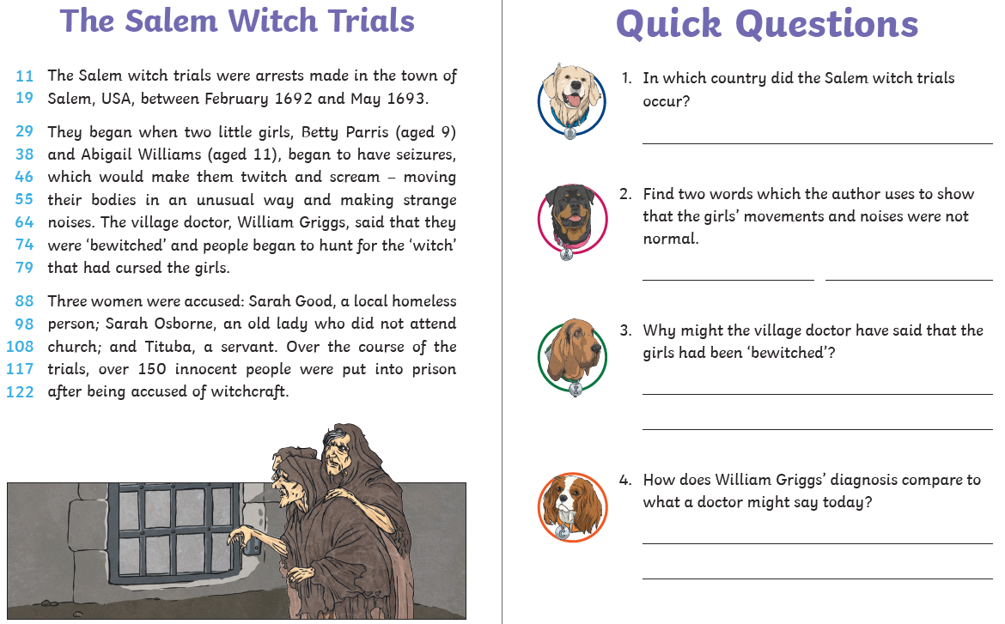
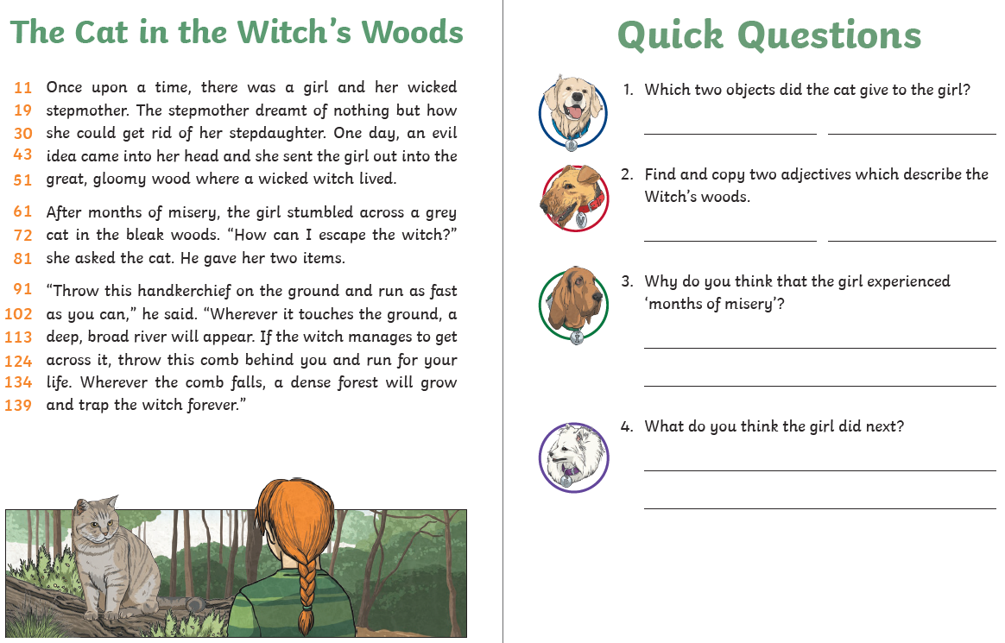
Comprehension Activity 2 Week 8
Spelling – Some of the children are in Group 1 and some are in
Group 2, your child will know which group they’re in.
 | Group 1 – Homophones/near homophones Group 2 – Suffix ‘-ous’
DAY 1 | Look, Say, Cover, Write, Check
DAY 2 | Word search
DAY 3 | Word jumble | Crossword
DAY 4 | ‘any’ word mat | ‘exercise’ word mat
DAY 5 | ‘busy’ word mat | ‘experience’ word mat

NOTE FOR PARENTS AND CHILDREN:
If you’re unable to print any of the sheets off, they can all be adapted. If you can just see the sheet on the screen, all you need is pencil and paper to practice the spellings for Day 1 and Day 3 and the same for Day 4 and Day 5. For the word searches, can you just find the words in order on the screen?
Group 1 – Day 1
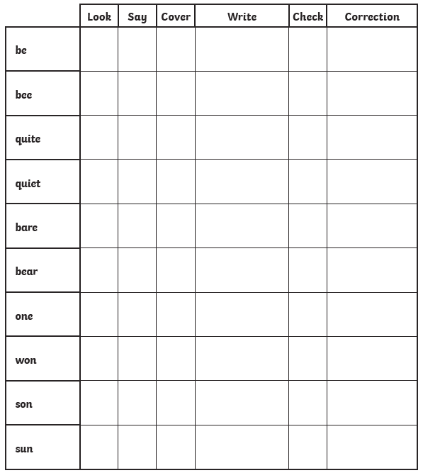

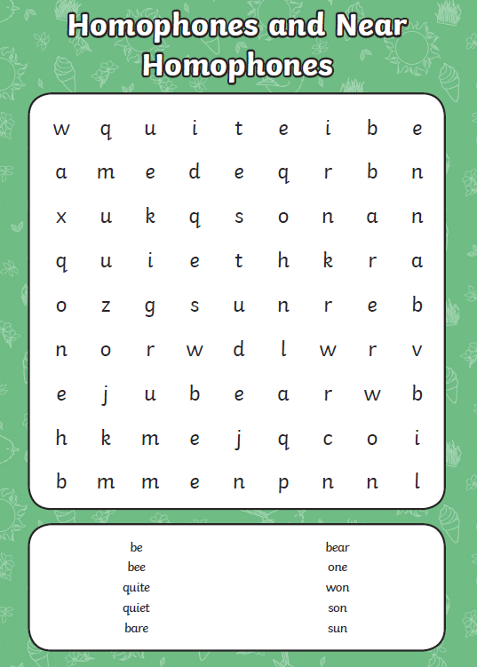
Group 1 – Day 2

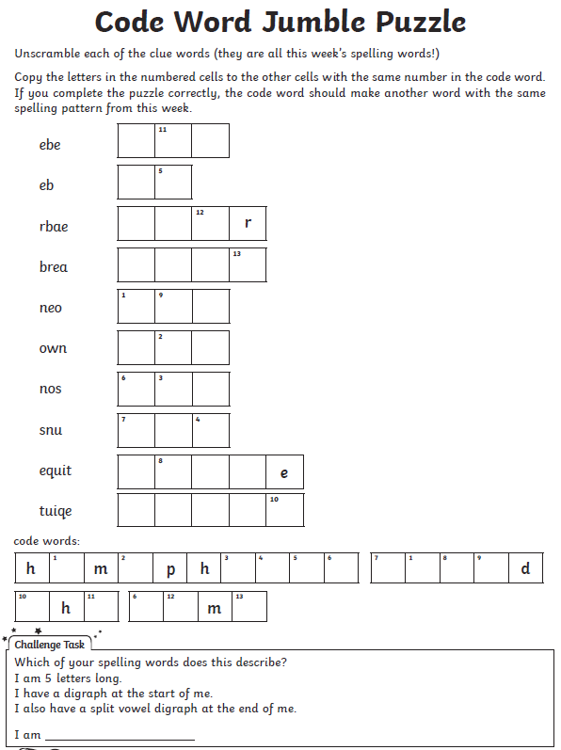
Group 1 – Day 3

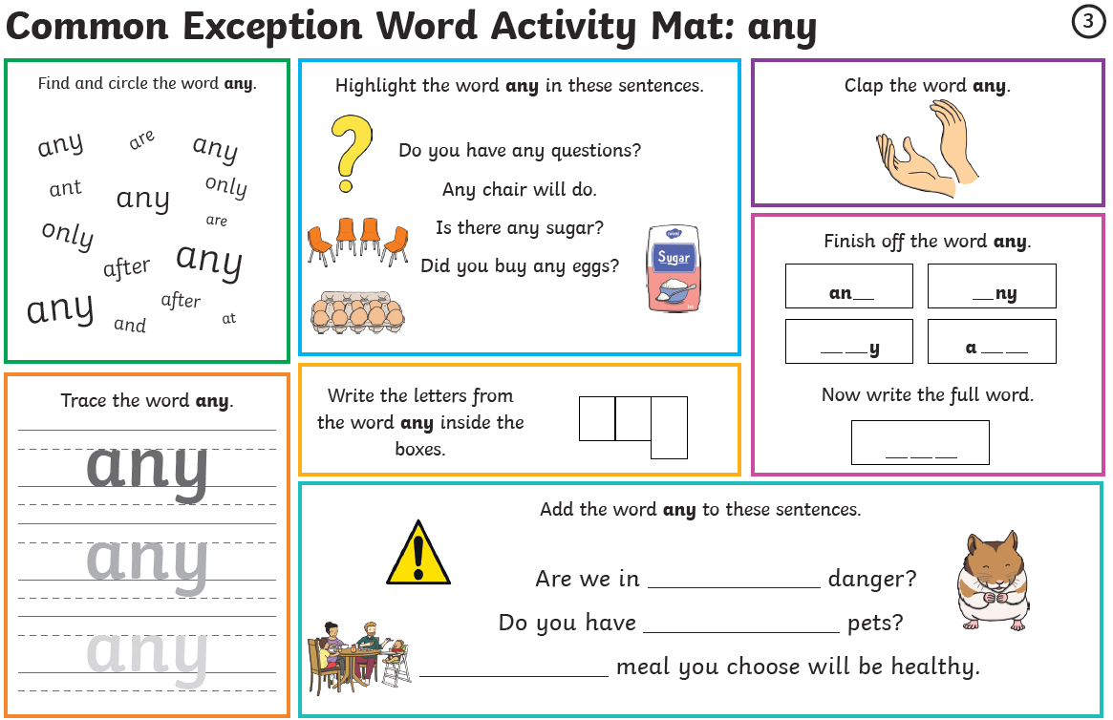
Group 1 – Day 4
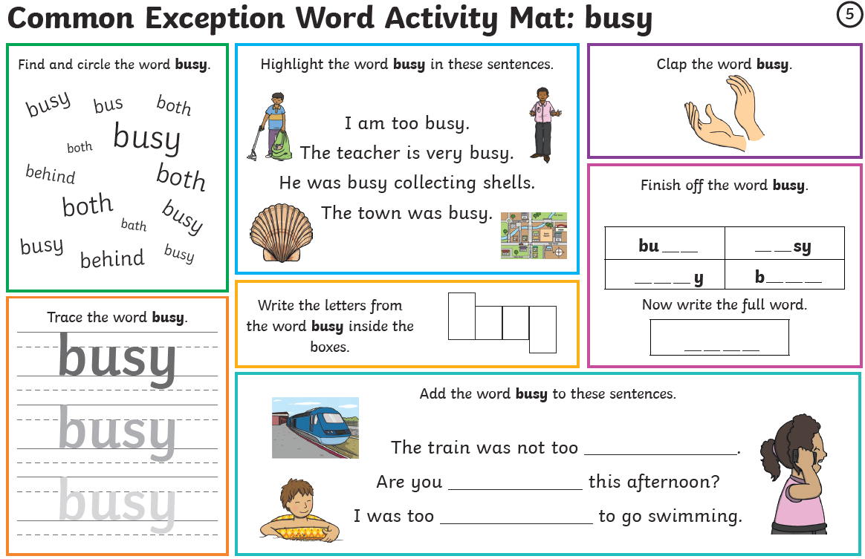
Group 1 – Day 5

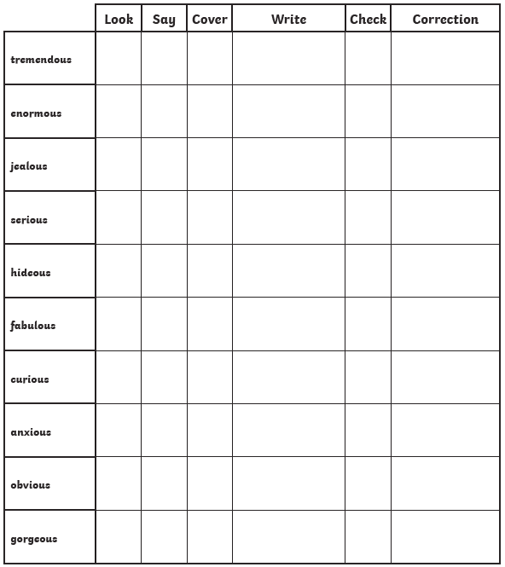
Group 2 – Day 1

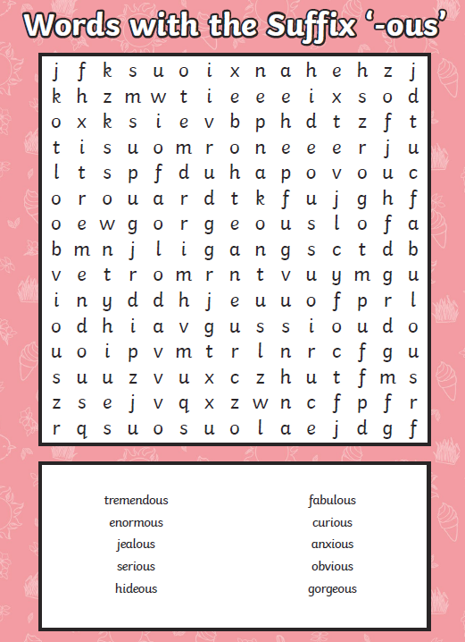
Group 2 – Day 2

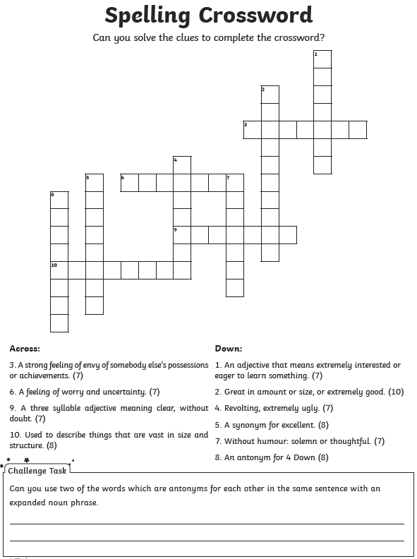
Group 2 – Day 3

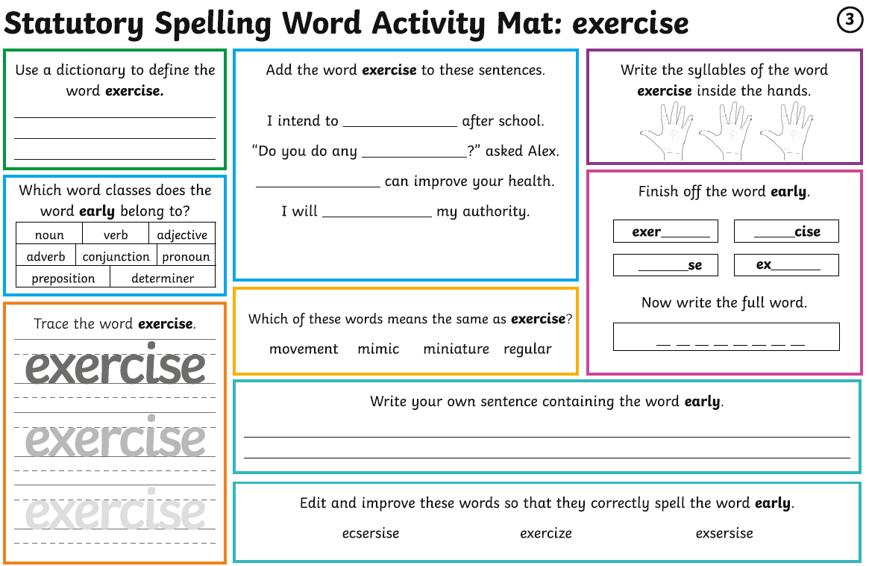
Group 2 – Day 4

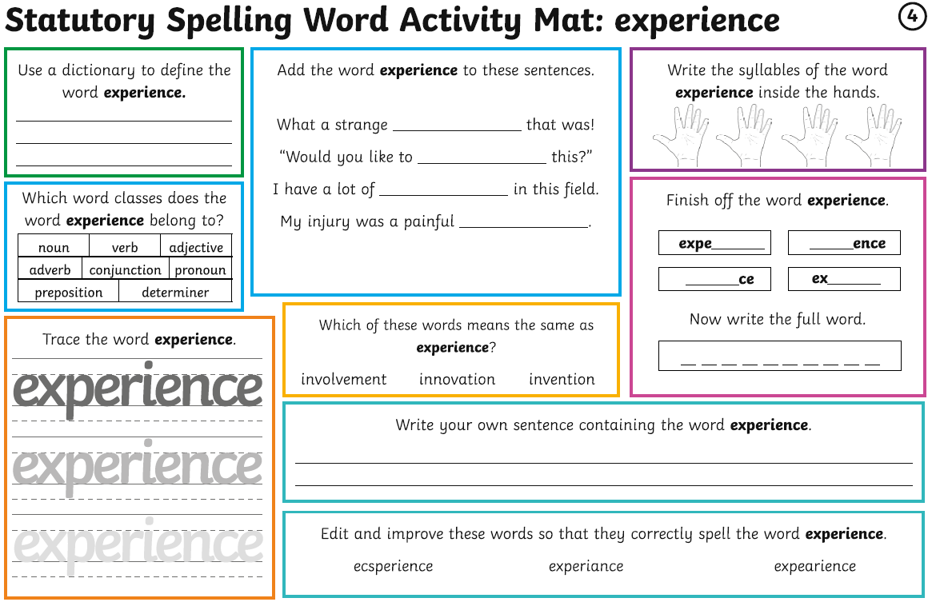
Group 2 – Day 5

Maths – Times Tables Rockstars logins – Please ensure your child is only logging in using their own login details.
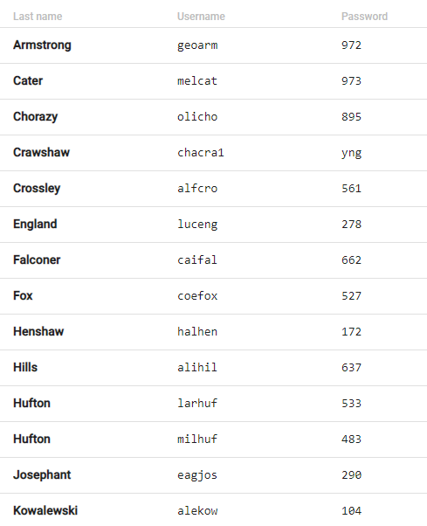
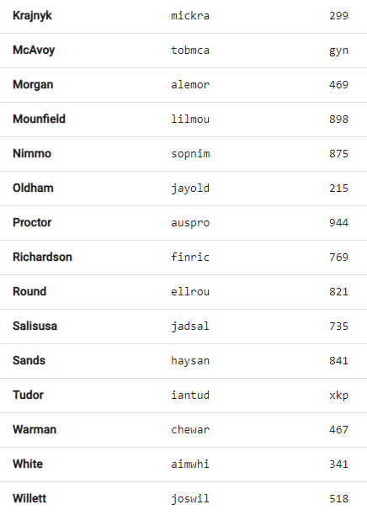
Times Tables Rockstars
WELL DONE again to Lily Mounfield and Halle Henshaw who are again the most improved people on Studio over the last month!

Maths

Monday | Tuesday | Wednesday | Thursday | Friday
Go on the BBC link.  Watch the videos and complete the activities.  Answers provided on a link at the bottom of the webpage. | Applying yesterday’s learning to reasoning problems.  Answers in the last pages. | Work on Times Tables Rockstars. | Go on the BBC link.  Watch the videos and complete the activities.  Answers provided on a link at the bottom of the webpage. | Applying yesterday’s learning to a reasoning problem.  Answers in the last pages.

Day 1 - https://www.bbc.co.uk/bitesize/articles/zjy2xyc

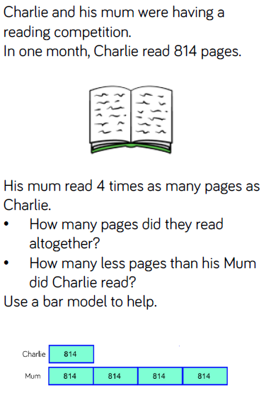
Day 2

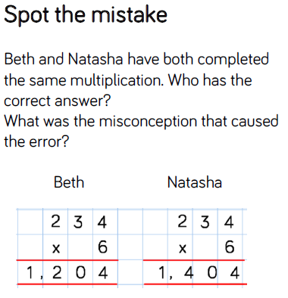

Day 4 - https://www.bbc.co.uk/bitesize/articles/znfj7nb

Day 5
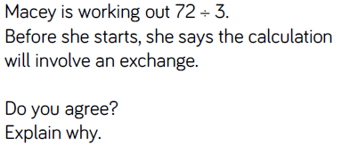
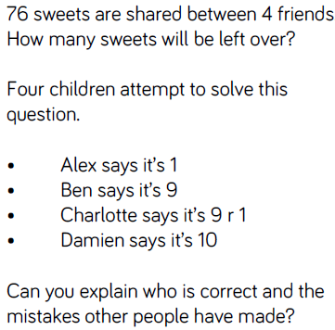
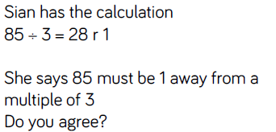
Writing – Day 1
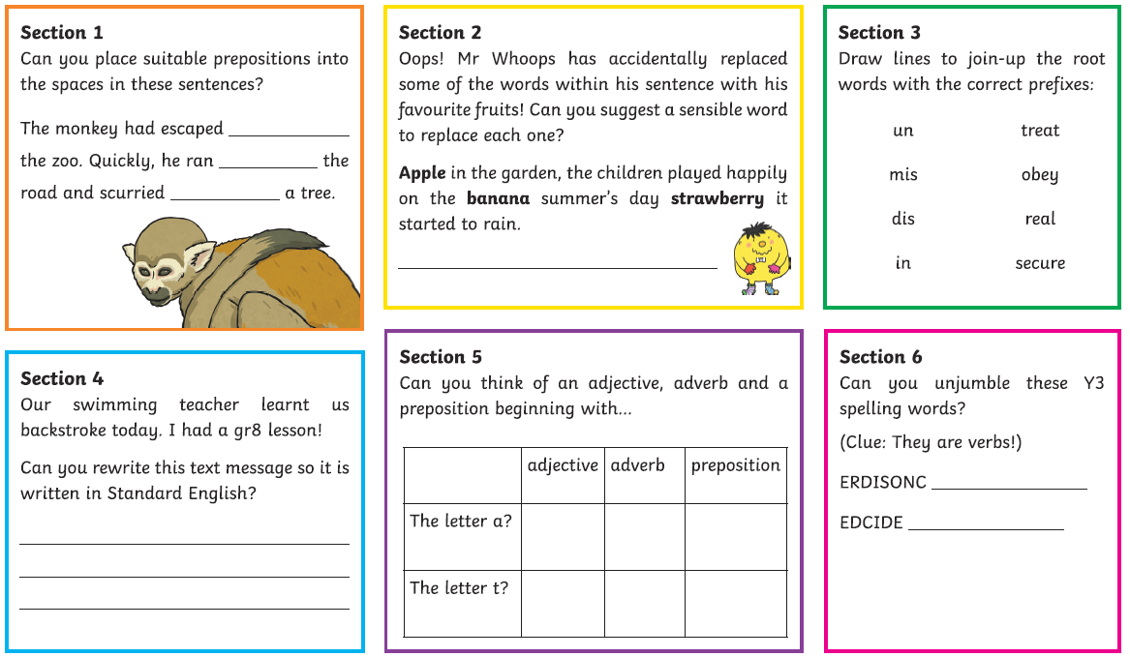

Writing – Day 2
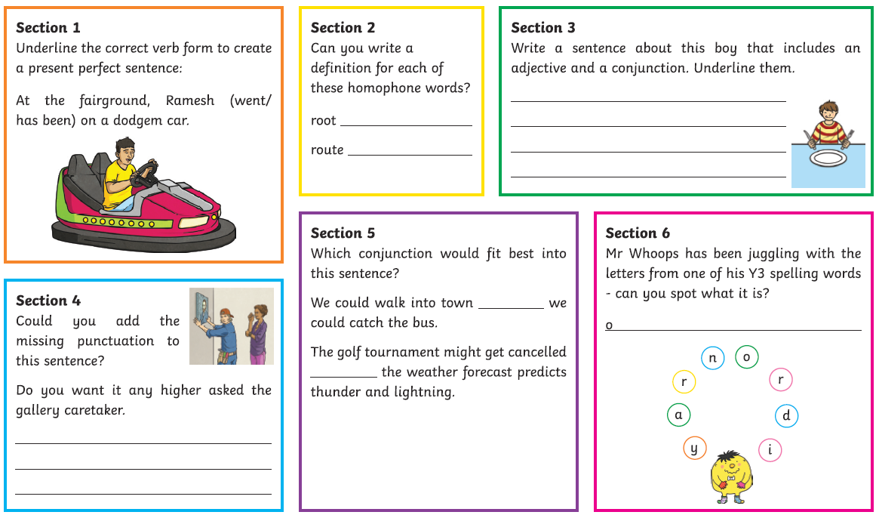
Writing – Day 3
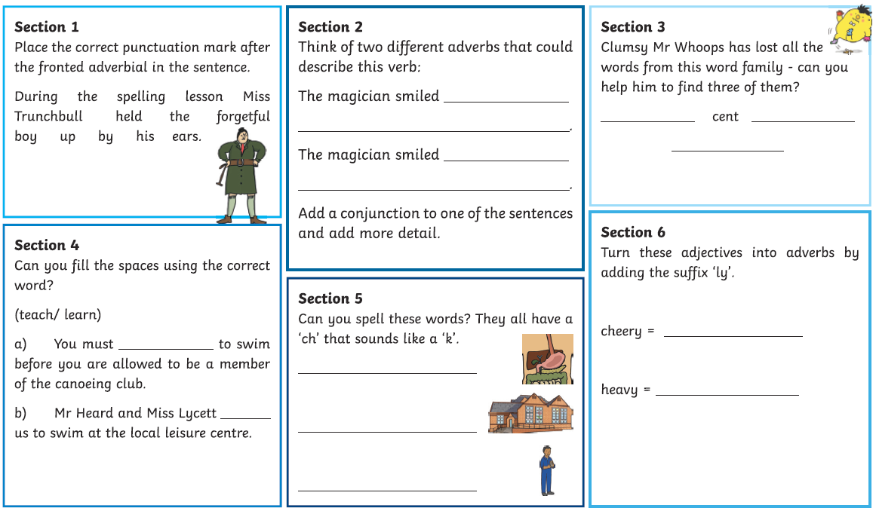
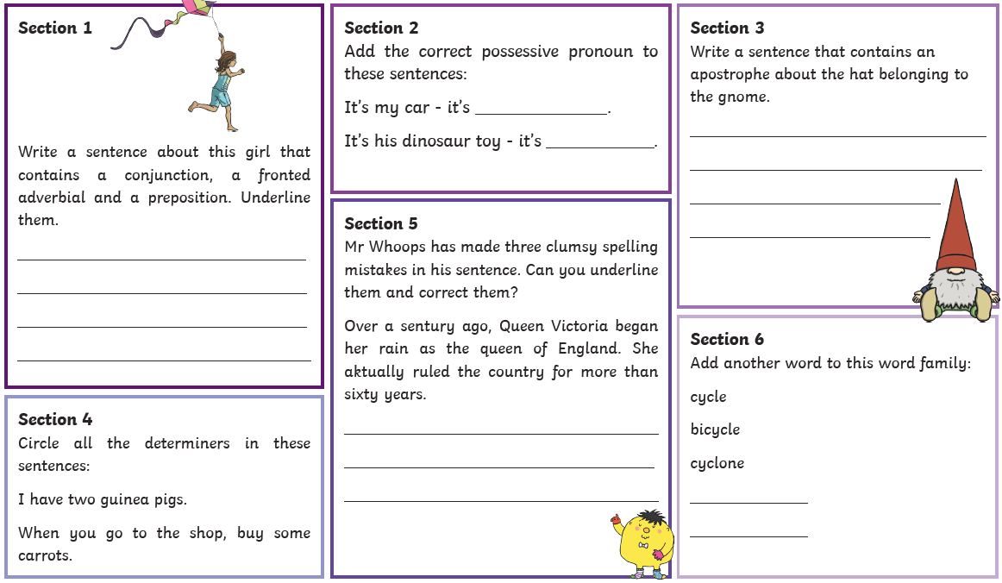
Writing – Day 4

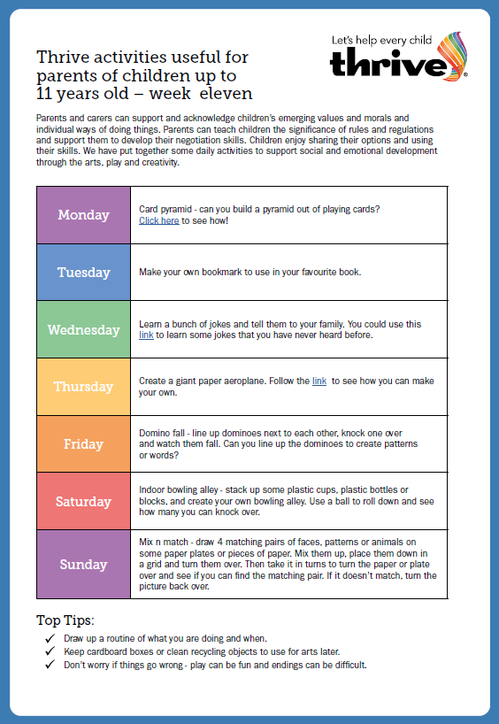

Card pyramid - https://www.youtube.com/watch?v=xWDnJt1McT4
Jokes - https://www.onmoxieandmotherhood.com/around-the-house/kids-activities/best-jokes-for-kids/
Paper aeroplane - https://www.youtube.com/watch?v=bjpYVn3ne94

MARY POPPINS
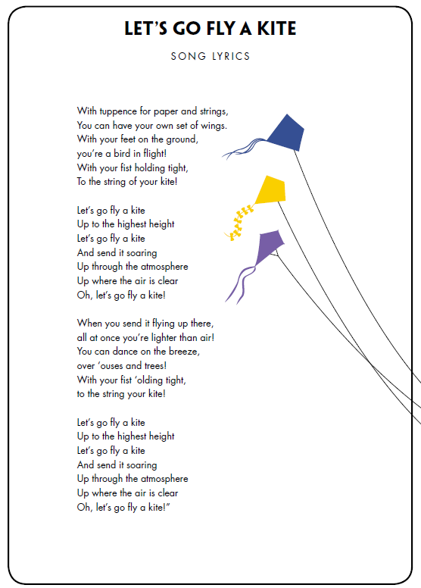
At Christmas, I went to London to see Mary Poppins at the theatre and it was amazing! This week, Disney have sent me a Mary Poppins-related activity. I’m giving you a sheet of lyrics for a song and I’d love for you to go on YouTube and listen to it! https://www.youtube.com/watch?v=zNSler7jBWs

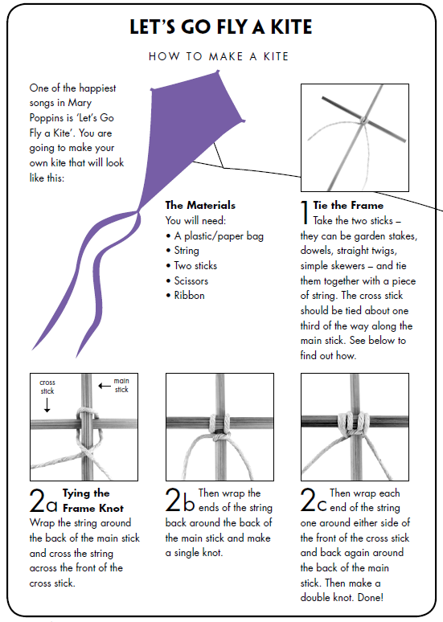
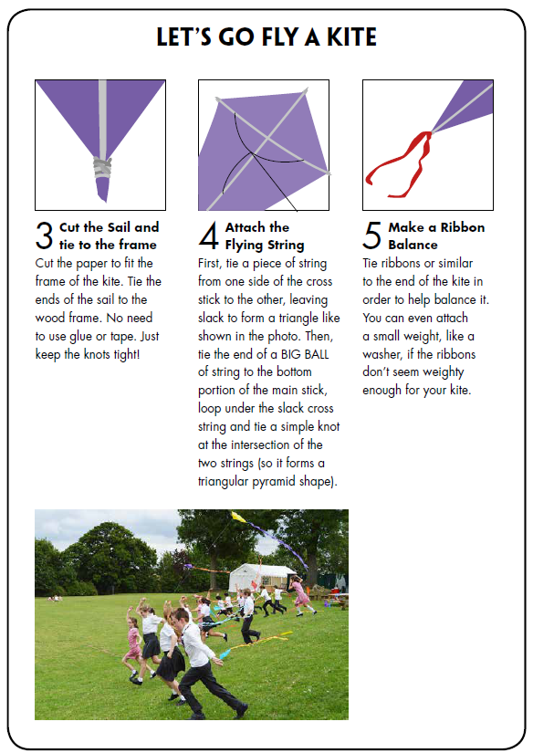

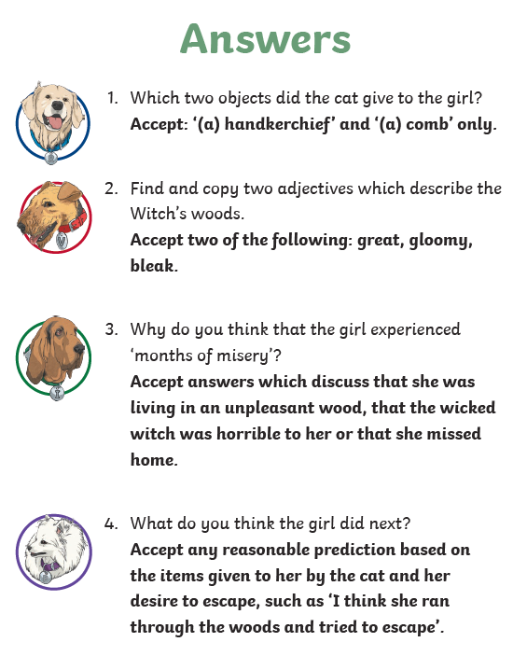
READING ANSWERS
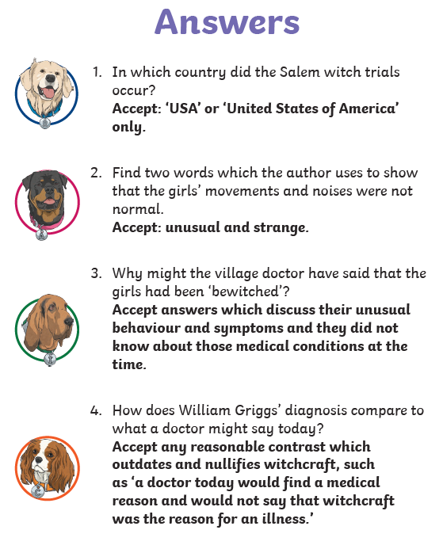

SPELLING ANSWERS
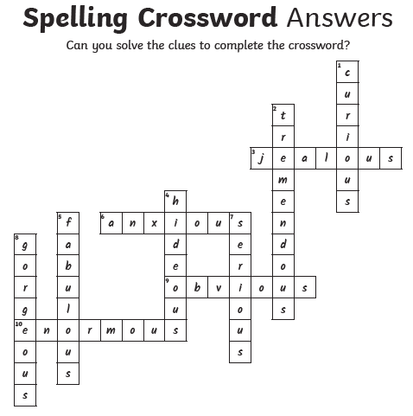
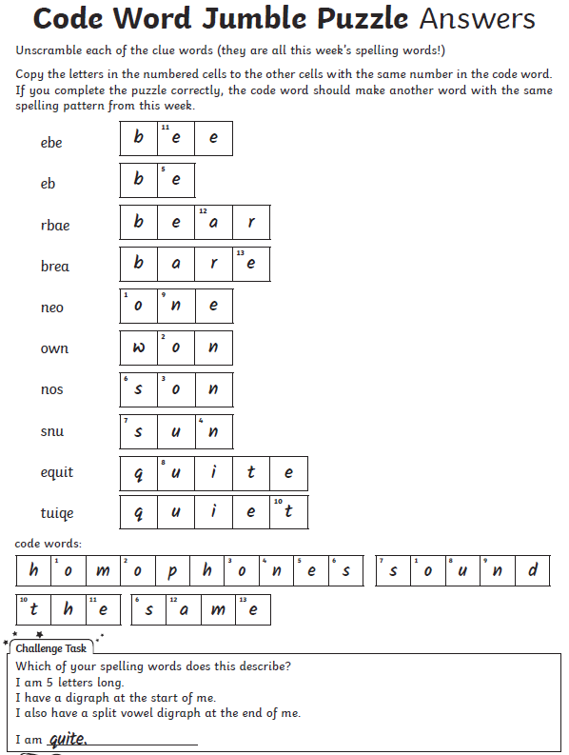

MATHS ANSWERS
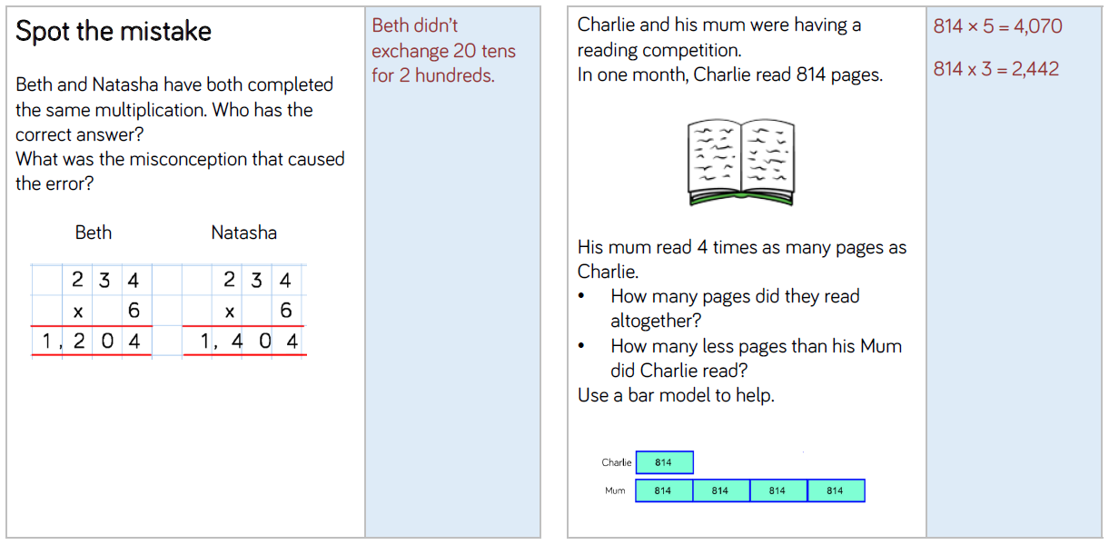

MATHS ANSWERS
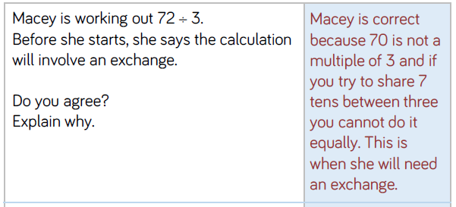
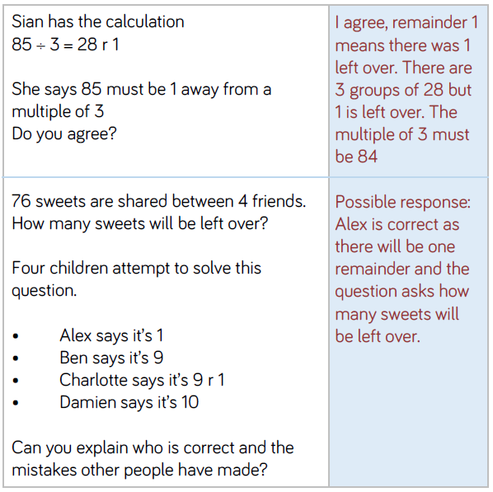

WRITING ANSWERS
Day 1
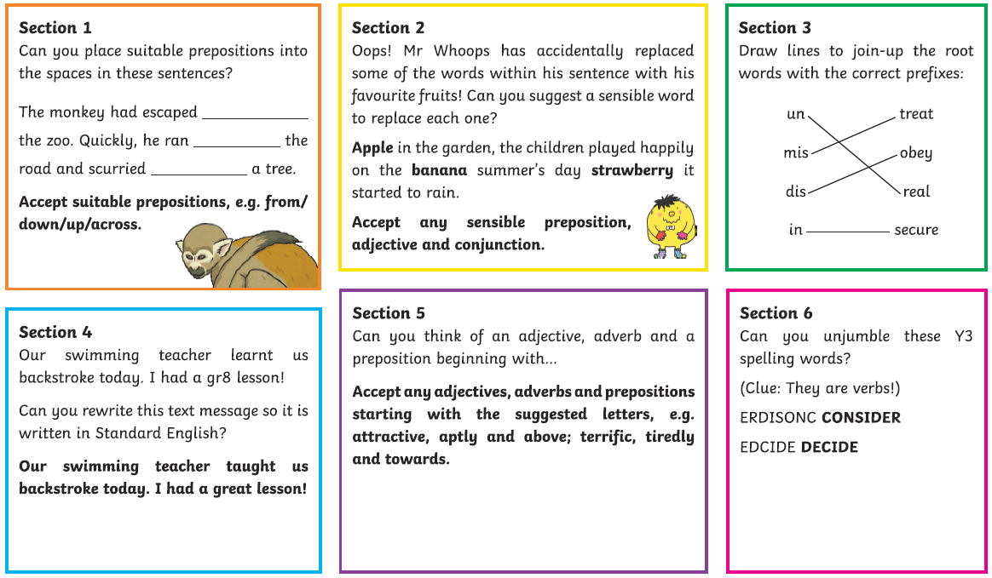
Day 2
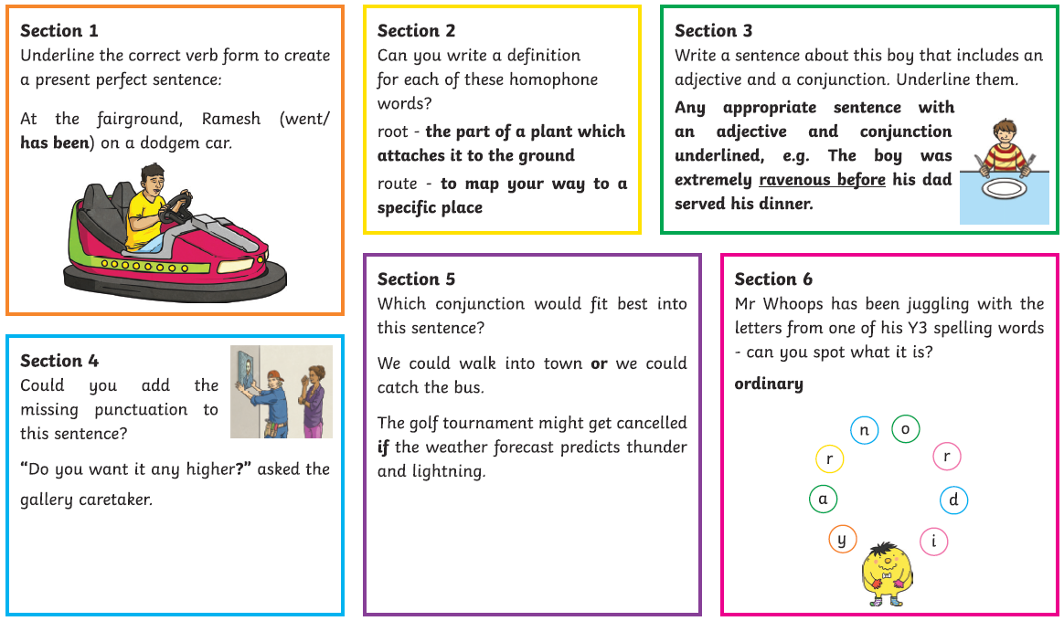
WRITING ANSWERS
Day 3
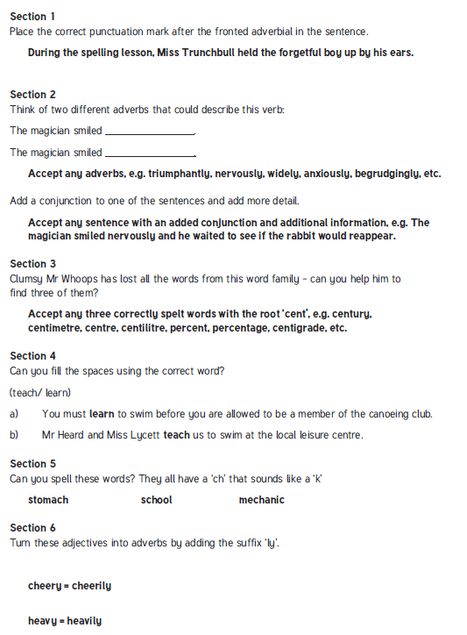

WRITING ANSWERS
Day 4
