To my class,
The weather has changed its mind a bit this week, hasn’t it! I’ve not been able to do much outside lately but I have started exercising a little bit more. Tell me all about what you’re doing by emailing me!

MrStallard@newvillage.doncaster.sch.uk

1 | PE | Youth Sport Trust Activity Bingo – new edition!
2 | Reading and spellings | One for each day  Complete reading activities 1-5  Spelling activities 1-5
3 | Maths | Times Tables Rockstars logins provided and daily learning tasks. I’ll be updating the TTRS website and setting individual Times Tables for those of you who want to use Garage.
4 | English | SPaG mats
Lunch
5 | Science, History and Computing | What do plants need to live?  https://www.bbc.co.uk/bitesize/articles/z6m4kmn  What is Stonehenge?  https://www.bbc.co.uk/bitesize/articles/zv67mfr  How do we get computers to do what we want?  https://www.bbc.co.uk/bitesize/articles/z4gsy9q
6 | Thrive | I’m attaching a list of Thrive activities – one for each day. I’ll also write the links for the websites to go to on the page!

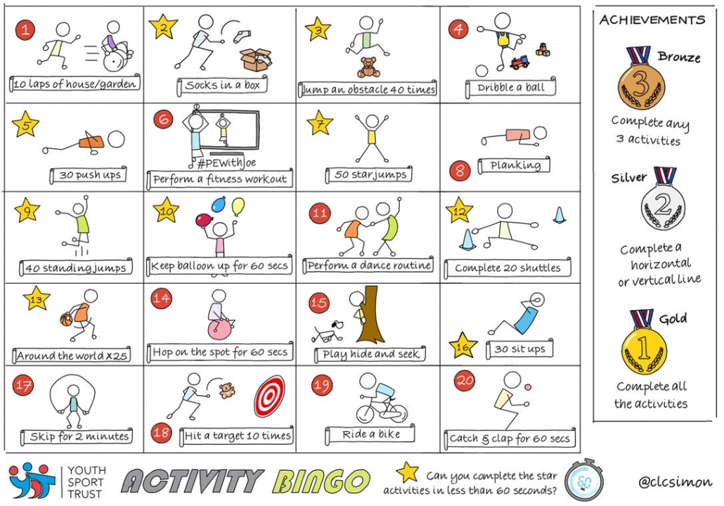

NETFLEX
If you go on our class area on the website and click on ‘Try Mr Stallard’s Exercises’, you can download NETFLEX!

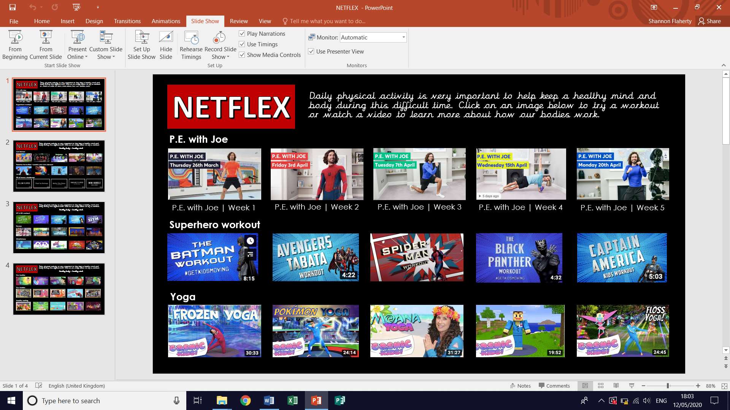
- Scroll through just like you would on Netflix and look at the different exercise activities by clicking on them after it’s gone full screen!
- Click on ‘Slide Show’
- Click on ‘From Beginning’

Reading – choose a book they want to read for Days 1-3

Day 1 | Listen to your child read and ask the questions from the Compare, Contrast and Comment with Cassie mat.  Ask your child to say some of the answers and possibly write some of them down too.
Day 2 | Listen to your child read and ask 5 questions from the Inference with Iggy mat.
Day 3 | Listen to your child read and ask 5 questions from the Prediction with Pip mat
Day 4 | Gary’s Big Adventure reading comprehension activity.
Day 5 | Layers of the Rainforest reading comprehension activity

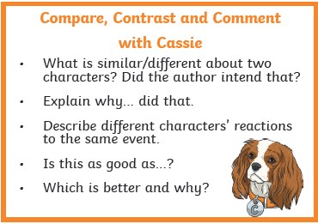

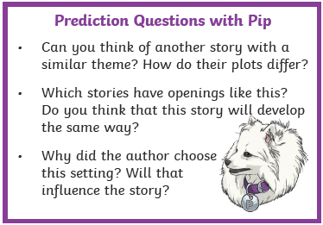
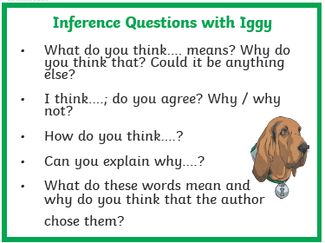

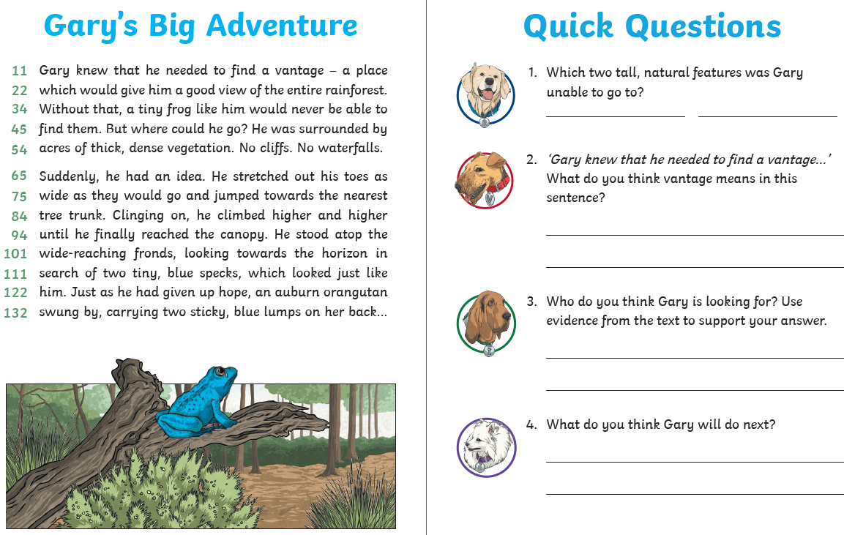
Comprehension Activity 1 Week 9
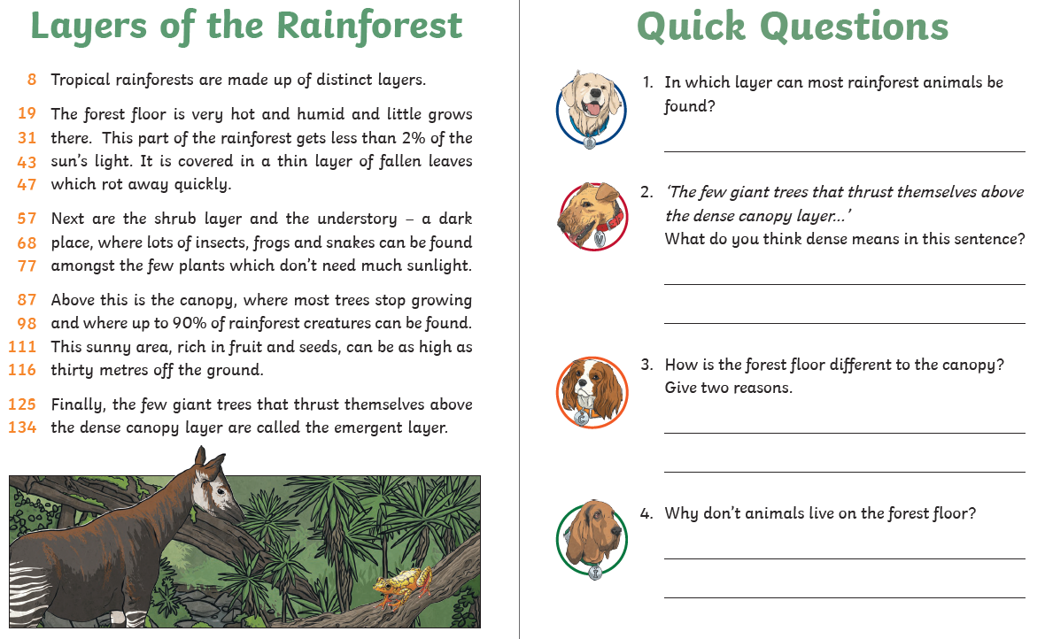
Comprehension Activity 2 Week 9
Spelling – Some of the children are in Group 1 and some are in
Group 2, your child will know which group they’re in.
 | Group 1 – Homophones and conjunctions Group 2 – Suffix ‘-ous’
DAY 1 | Look, Say, Cover, Write, Check
DAY 2 | Word search
DAY 3 | Riddles | Which Word Where?
DAY 4 | ‘move’ word mat | ‘exercise’ word mat
DAY 5 | ‘every’ word mat | ‘experience’ word mat

NOTE FOR PARENTS AND CHILDREN:
If you’re unable to print any of the sheets off, they can all be adapted. If you can just see the sheet on the screen, all you need is pencil and paper to practice the spellings for Day 1 and Day 3 and the same for Day 4 and Day 5. For the word searches, can you just find the words in order on the screen?
Group 1 – Day 1
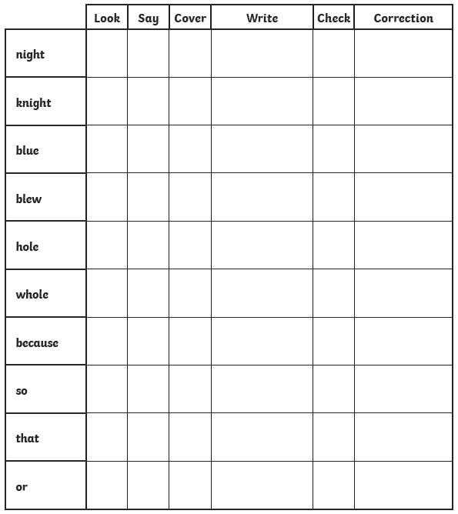

Group 1 – Day 2

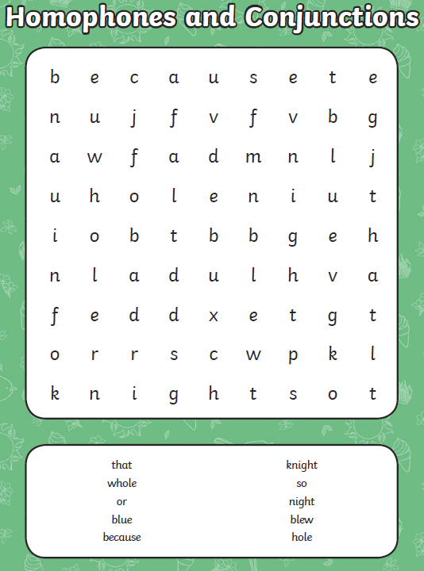

Group 1 – Day 3
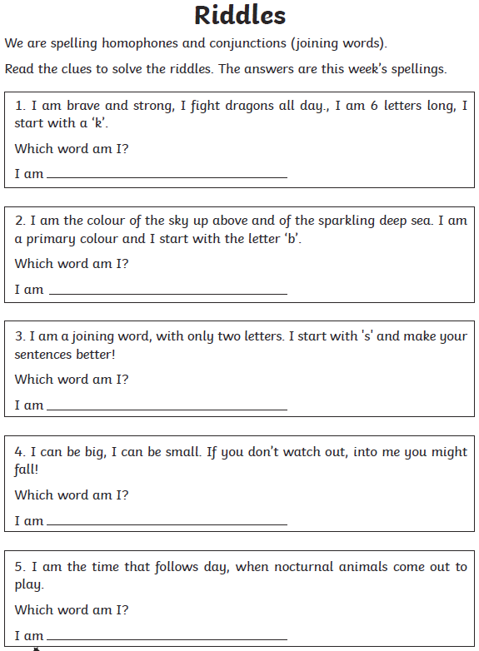
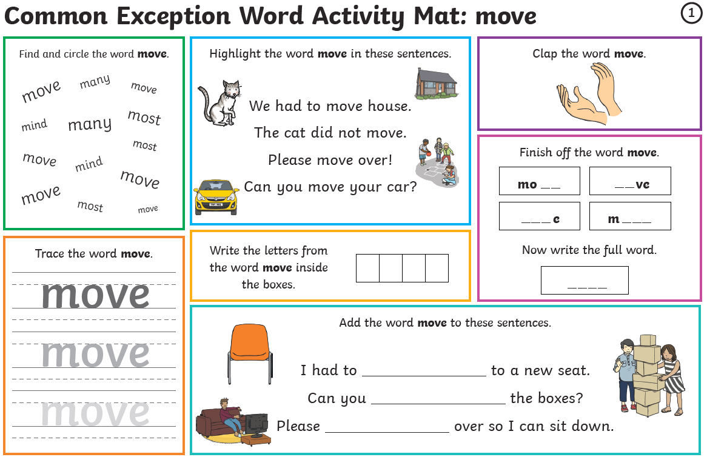
Group 1 – Day 4
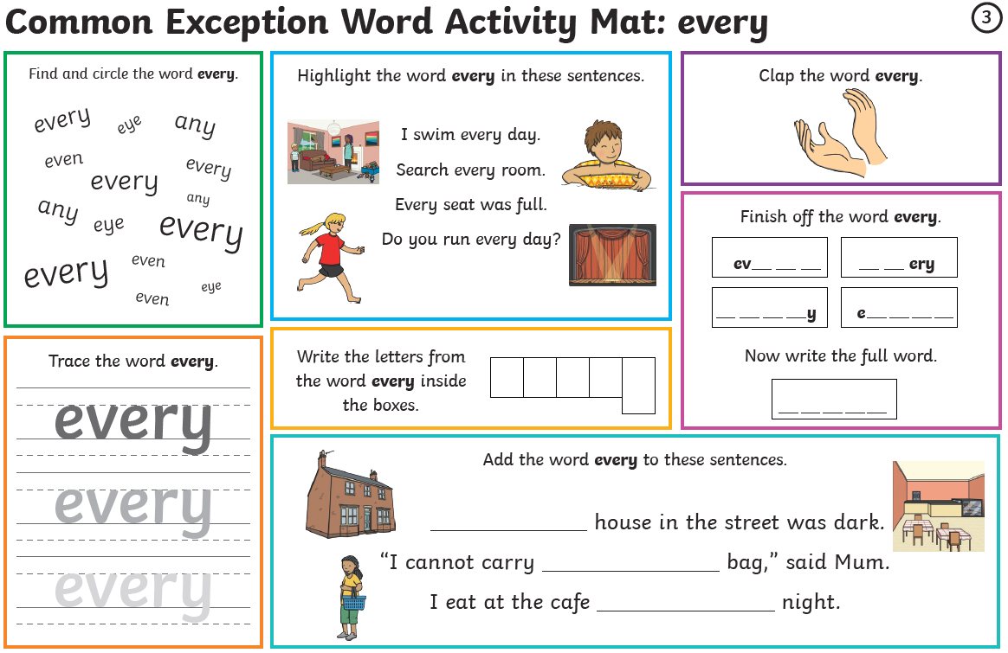
Group 1 – Day 5

Group 2 – Day 1

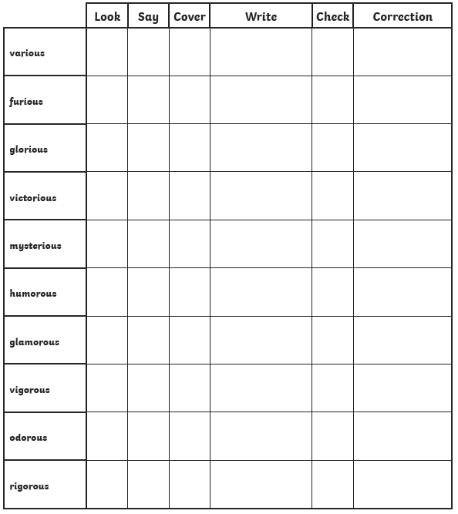
Group 2 – Day 2
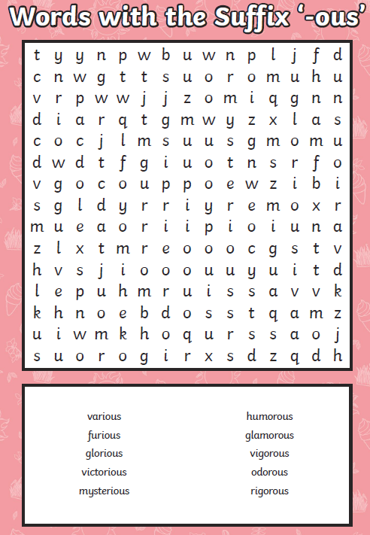

Group 2 – Day 3
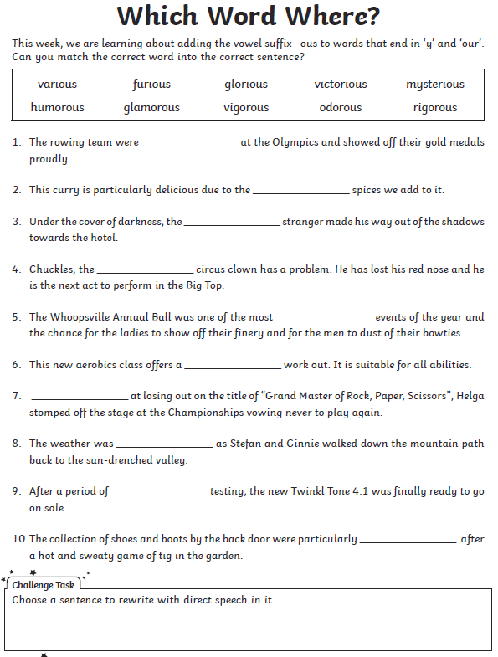
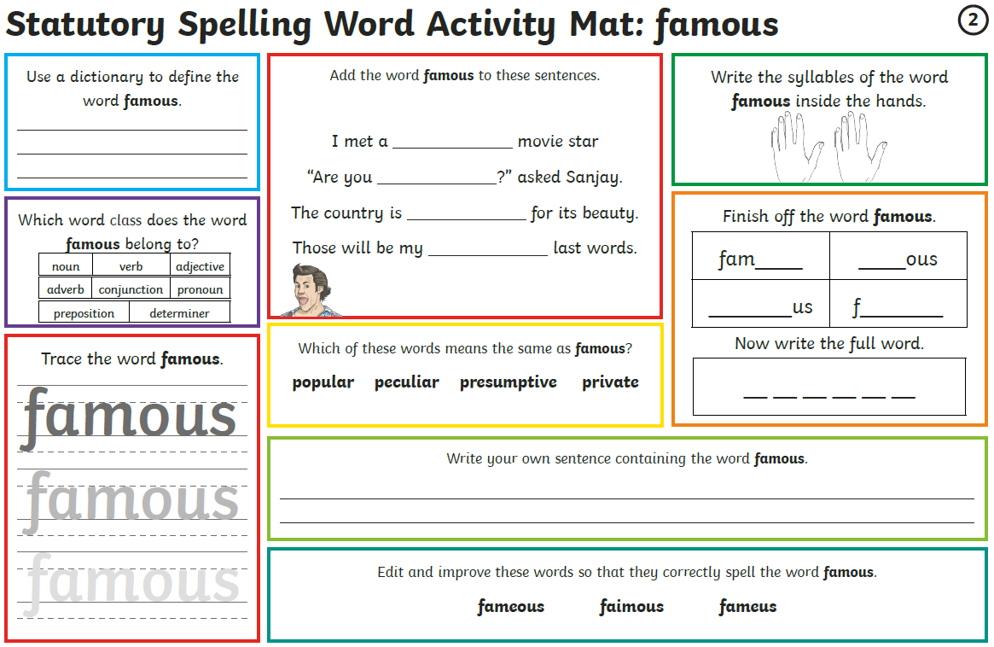
Group 2 – Day 4

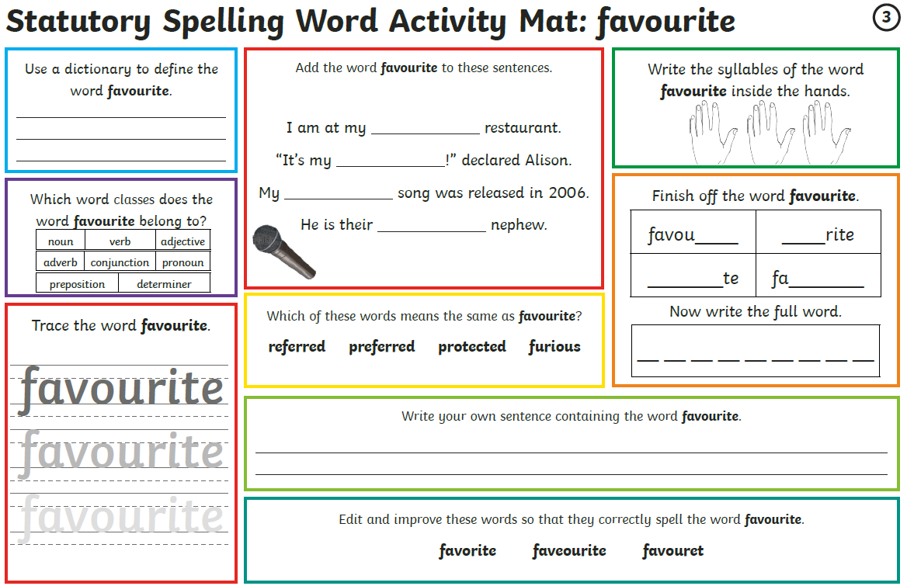
Group 2 – Day 5

Maths – Times Tables Rockstars logins – Please ensure your child is only logging in using their own login details.
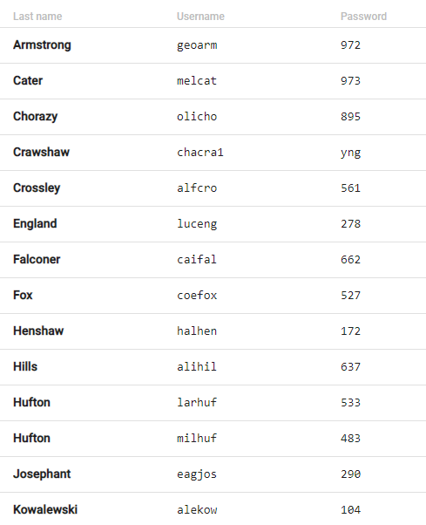
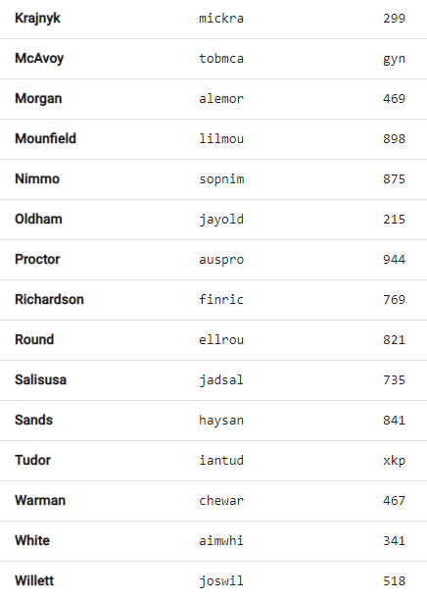
Times Tables Rockstars
A BIG thank you to Melissa, Halle, Alisha, Lily and Sophie for playing last week.
Well done in particular to Halle, who earned 6,760 coins last week!

Maths

Monday | Tuesday | Wednesday | Thursday | Friday
Go on the BBC link.  Watch the videos and complete the activities.  Answers provided on a link at the bottom of the webpage. | Applying yesterday’s learning to reasoning problems.  Answers in the last pages. | Work on Times Tables Rockstars. | Go on the BBC link.  Watch the videos and complete the activities.  Answers provided on a link at the bottom of the webpage. | Applying yesterday’s learning to a reasoning problem.  Answers in the last pages.

Day 1 - https://www.bbc.co.uk/bitesize/articles/zbcnf4j

Day 2
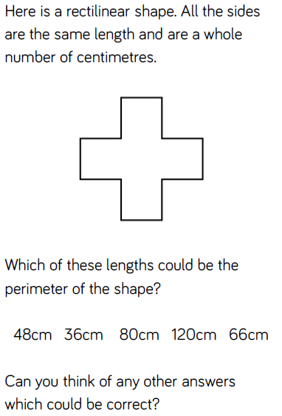
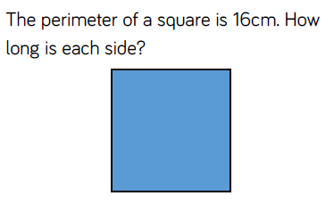
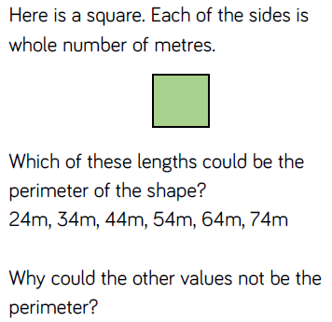

Day 4 - https://www.bbc.co.uk/bitesize/articles/zjf2xyc

Day 5
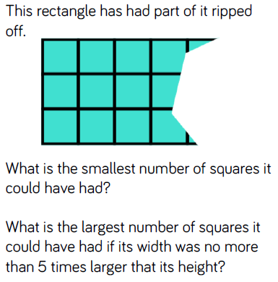
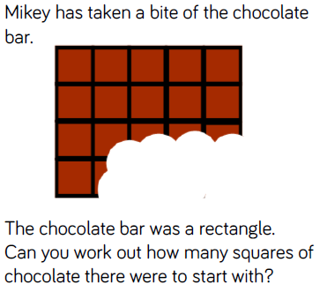

Writing – Day 1
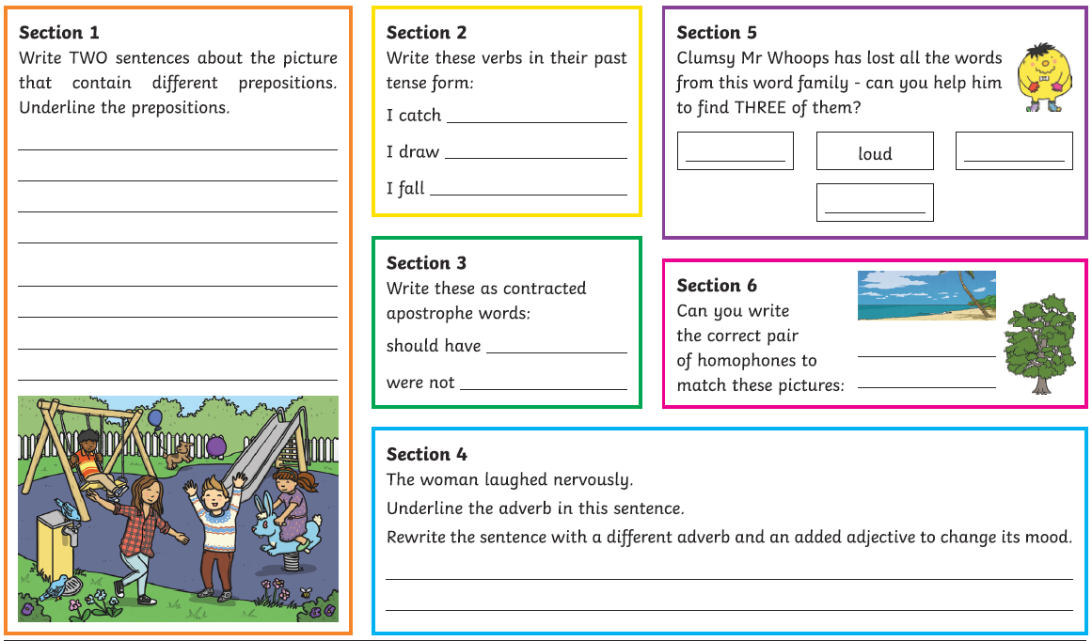

Writing – Day 2
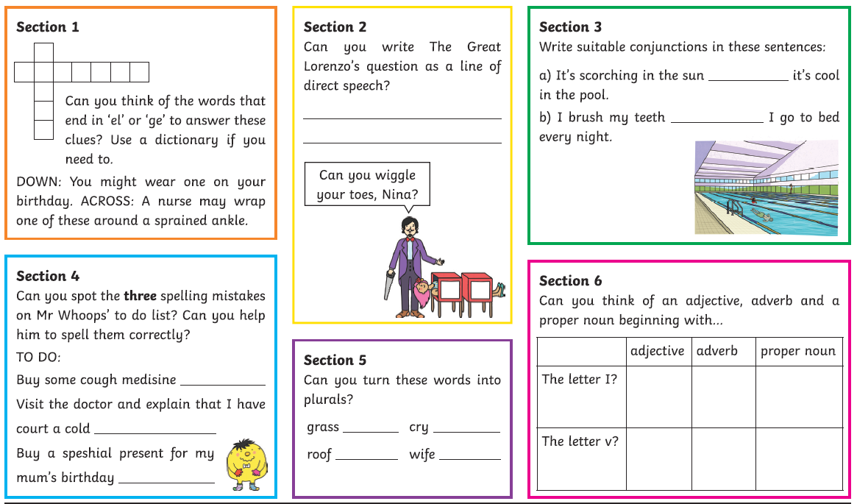
Writing – Day 3
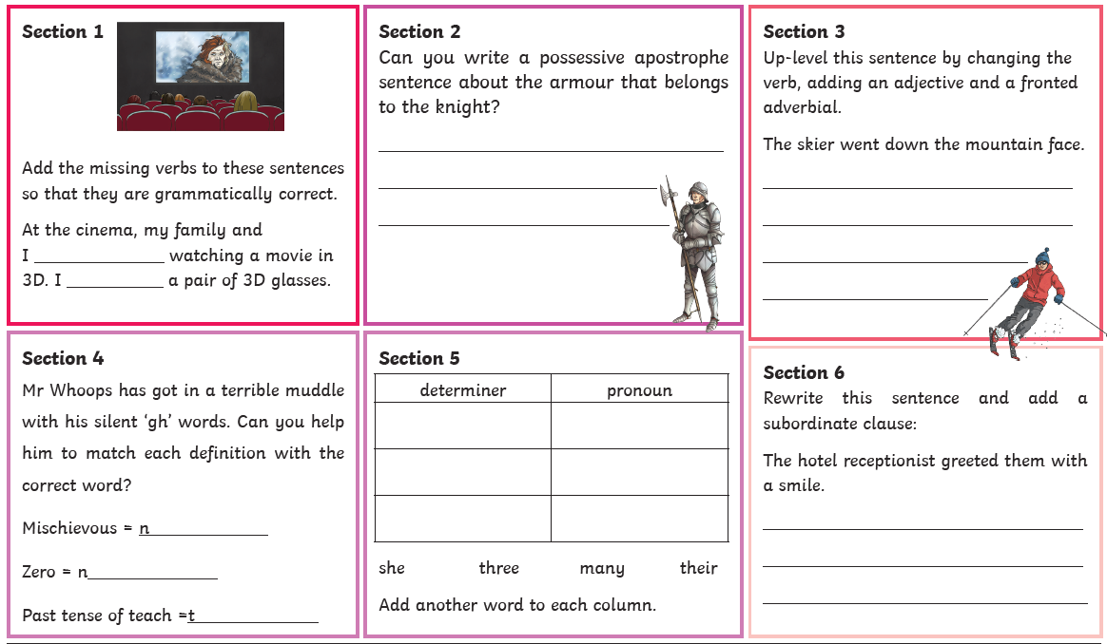

Writing – Day 4
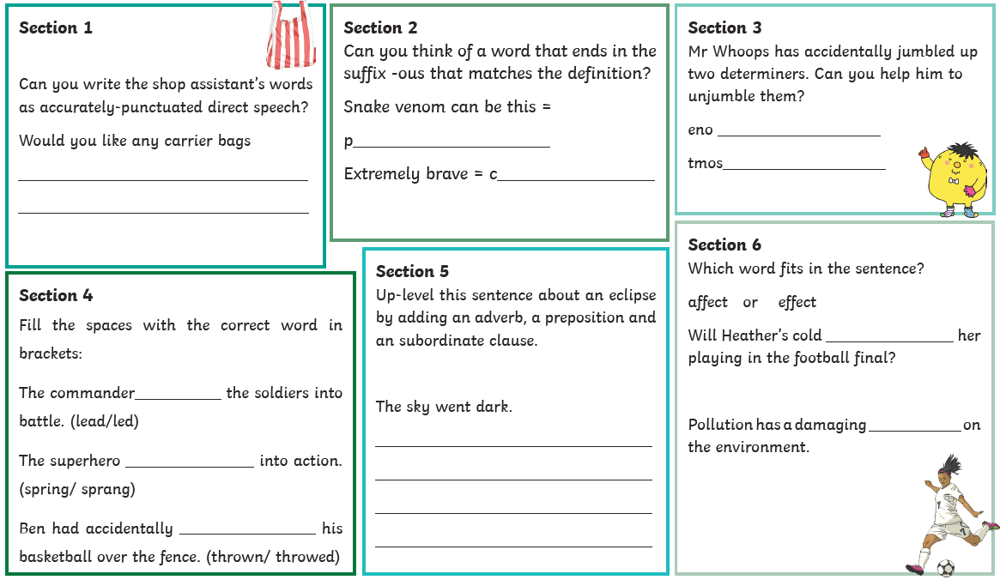
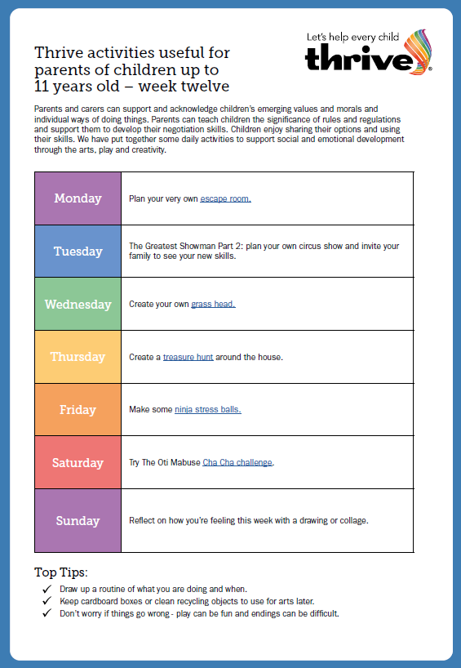

Escape room - https://thefamilybackpack.com/how-to-plan-a-diy-escape-room-adventure-for-kids/
Grass head - https://www.youtube.com/watch?v=HQhLGX0MmpQ
Treasure hunt - https://www.pinterest.co.uk/pin/413134965799129559/
Ninja stress balls - https://frugalfun4boys.com/ninja-stress-balls/
Cha Cha Challenge - https://www.youtube.com/watch?v=TqvLba3ERpA

READING ANSWERS
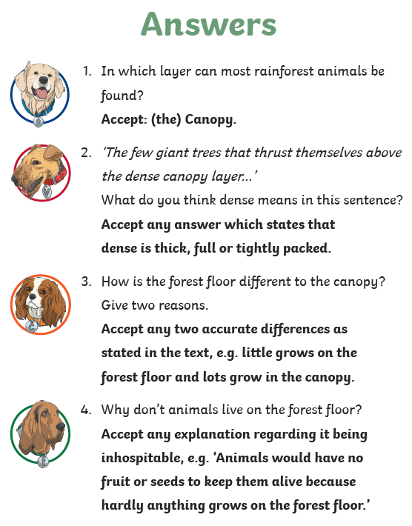
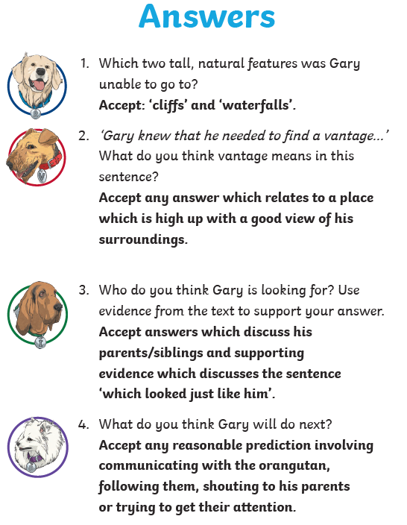

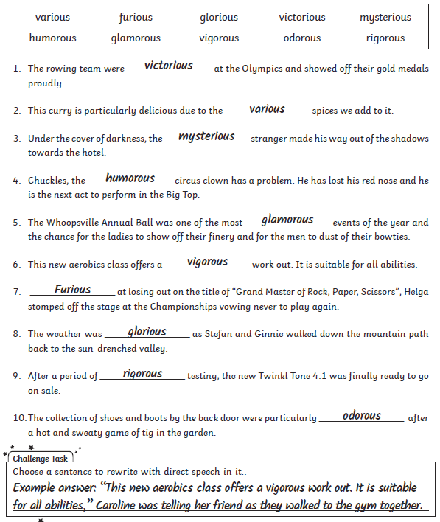
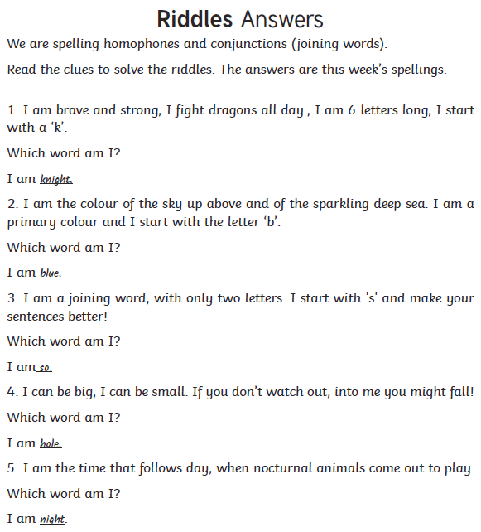
SPELLING ANSWERS

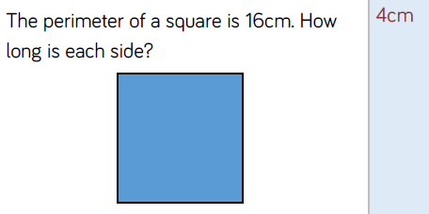
MATHS ANSWERS
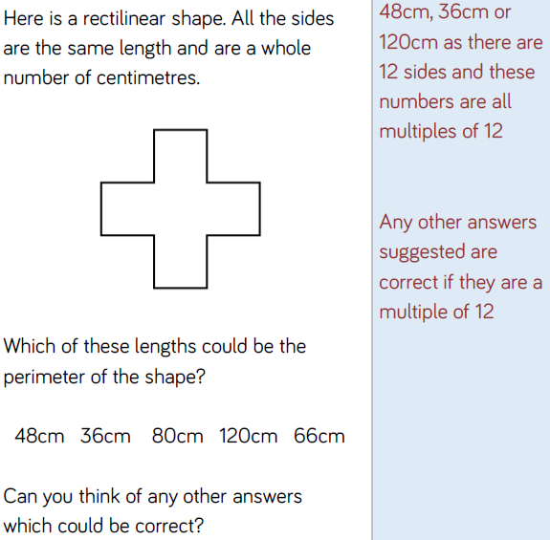

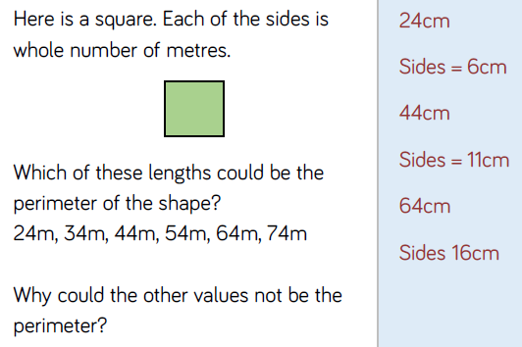

MATHS ANSWERS
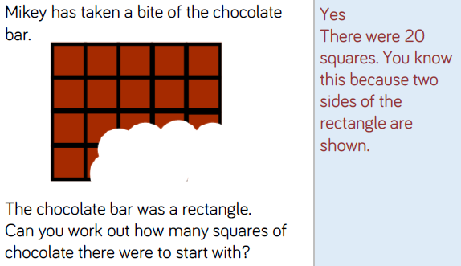
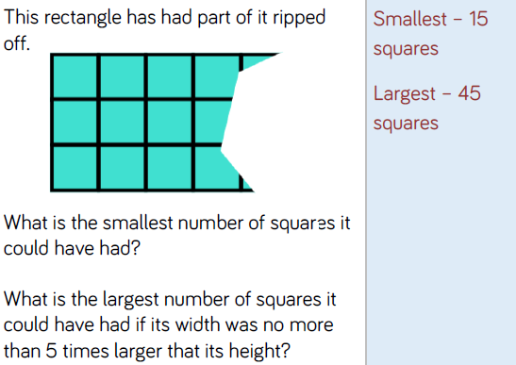
WRITING ANSWERS
Day 1
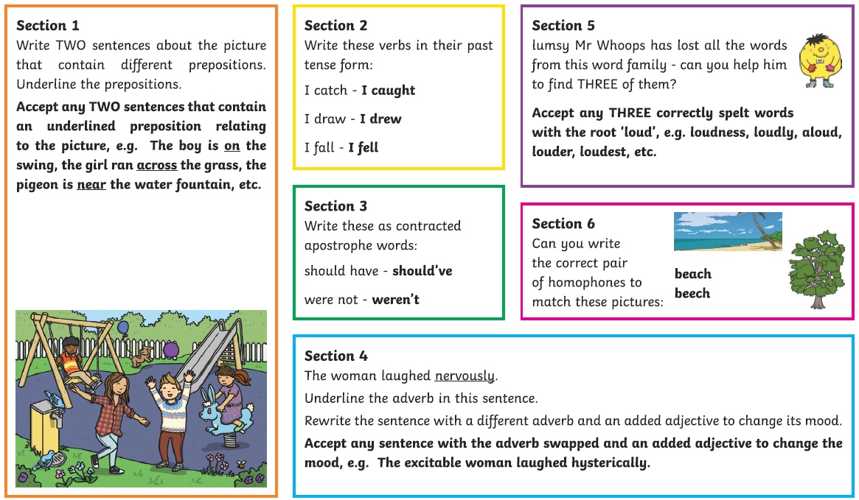
Day 2
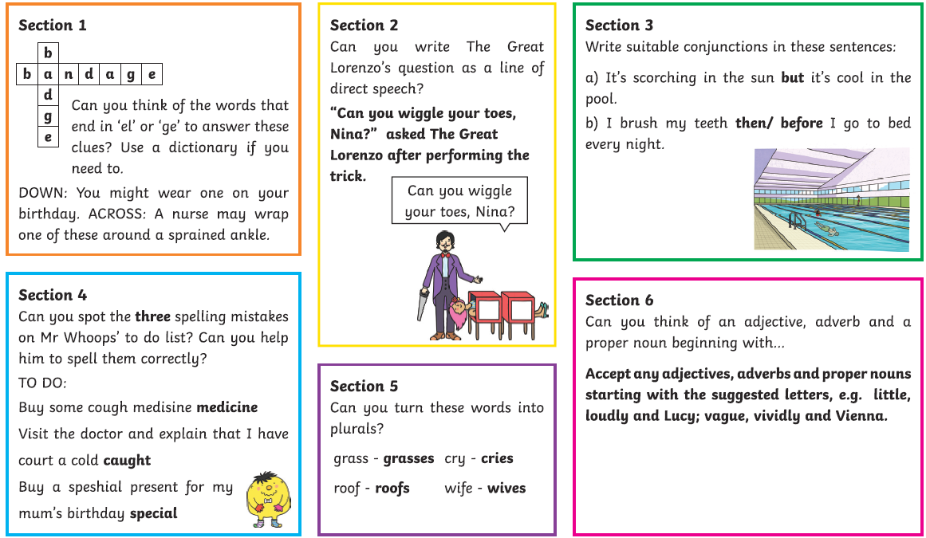
WRITING ANSWERS
Day 3
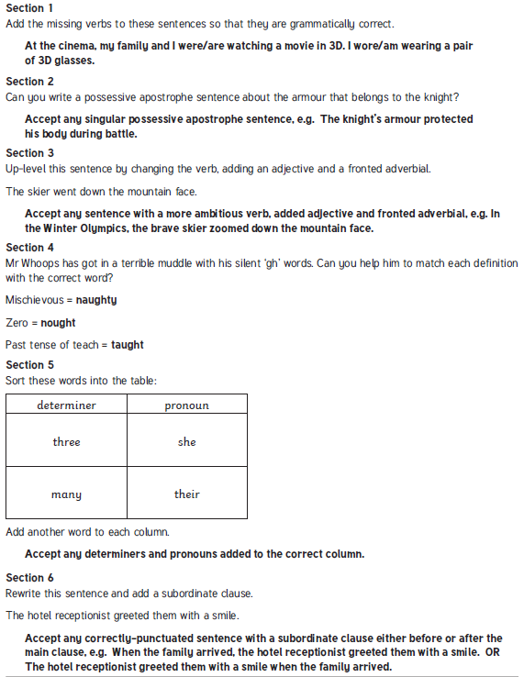

WRITING ANSWERS
Day 4
