Hello Everyone,
I hope you enjoyed last week’s learning.

I am missing you all.

Remember to stay safe I can’t wait to see you back at school.

If you want to contact me you can do at:
MrsSmith@newvillage.doncaster.sch.uk
You can attach any documents or photographs of work you complete.

Year 3

All the tasks for the week will be in one document. Just complete them through the week. Try to do a range of learning each day. There is no need to complete one task from every section each day, as I know lots of you are having great family times and making lovely memories to look back on.

Mrs Smith x

SPAG ACTIVITIES FOR THE WEEK
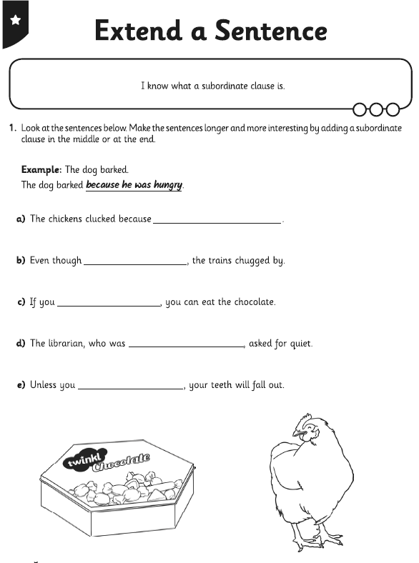

TASK 2
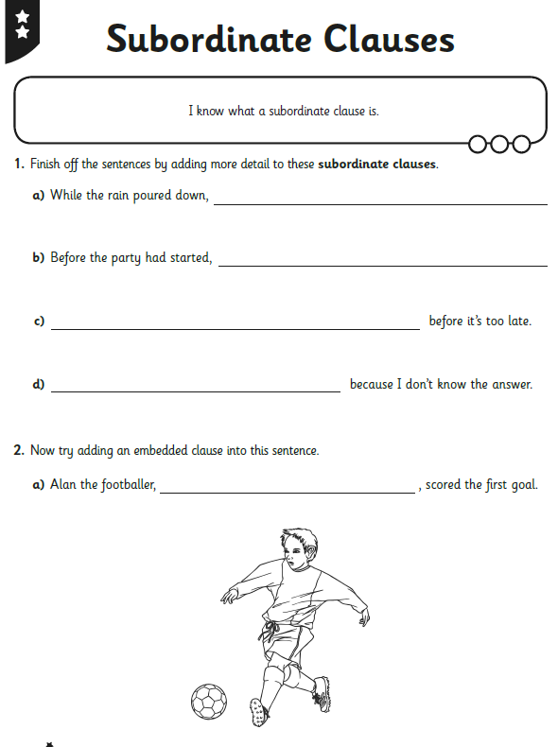

TASK 3
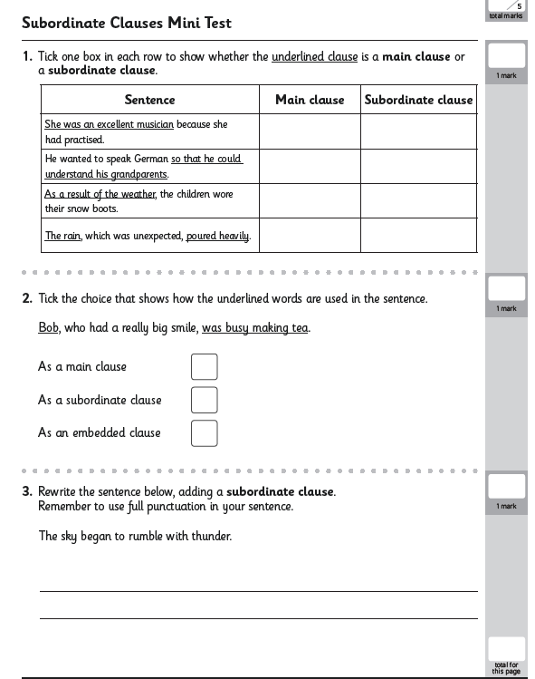

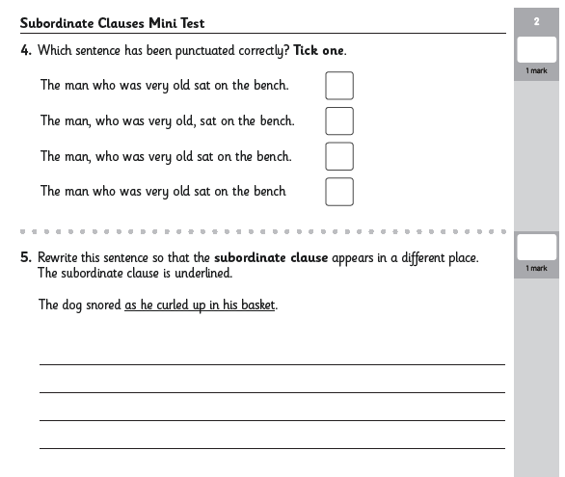

Reading tasks

Use BBc reading from 15 June 25, 2020

https://www.bbc.co.uk/bitesize/articles/zfjxdp3
Follow the videos and answer the questions on screen.
The activities have been downloaded into this pack .
There are three activities for you to complete. Complete one a day.

Two activities are on screen
One is a book review. ( see below) Happy reading.

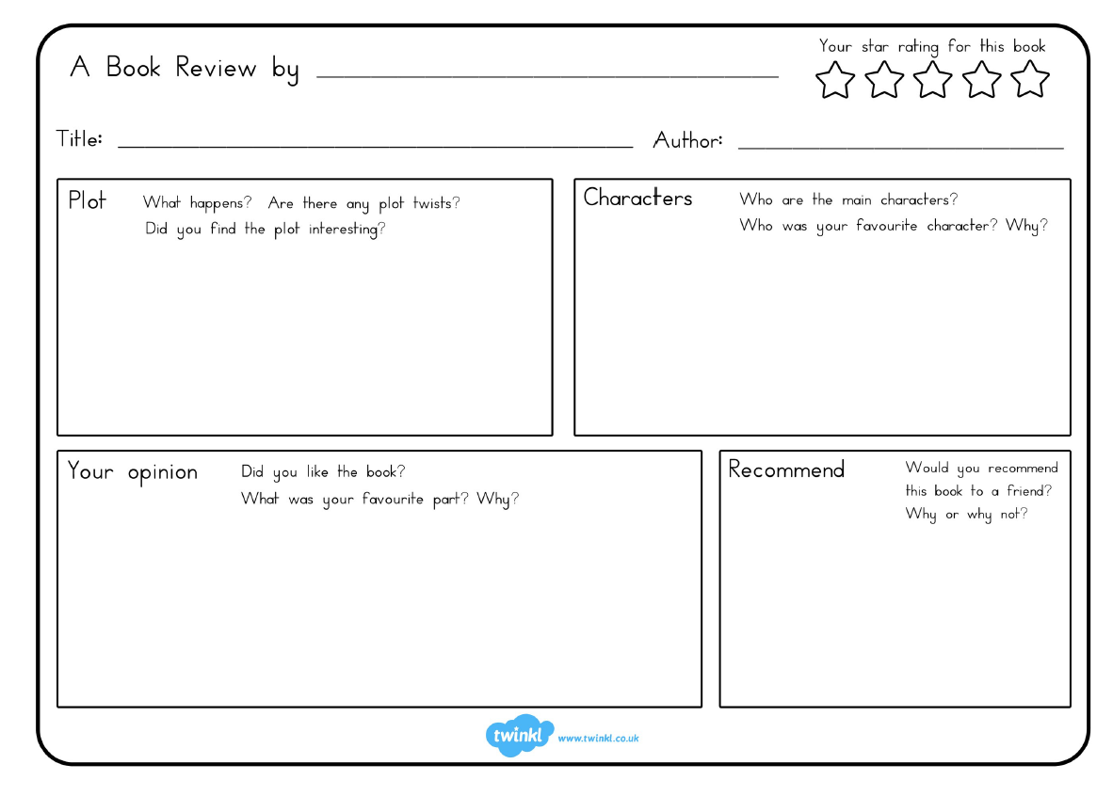

READ FOR PLEASURE
Choose your most favourite book and share with someone in your family.
You could even ask them questions about what you read.
Stories can also be accessed through the links below.
https://www.storylineonline.net/ ( read to you )
http://www.magickeys.com/books/invis-allig/page6.html#pictop
(for you to read)
https://www.freechildrenstories.com/ ( choose from a range of ages and genre)

MATHS ACTIVITIES FOR WEEK
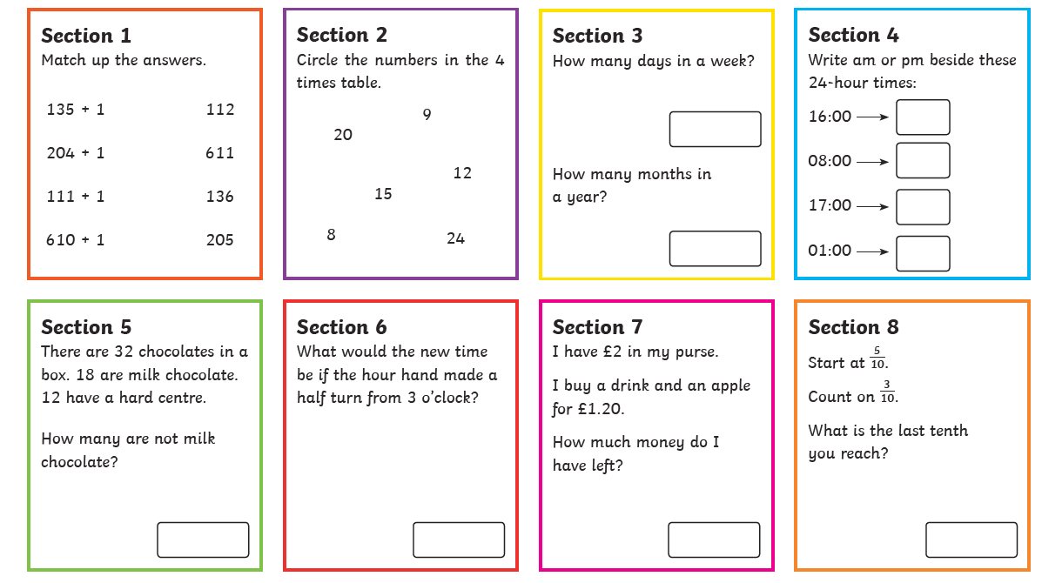
Here are some activity sheets for you to have a go at throughout the week. Print off or write calculations down. Talk about your learning with an adult. TASK 1
TASK 2 – remember to draw a picture to help work out the answers
Divide by the bottom ( denominator) when finding a fraction of a number.
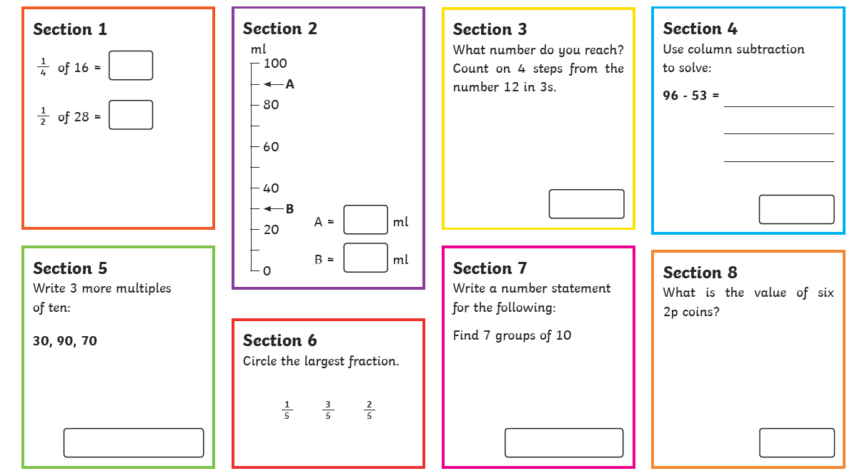
TASK 3
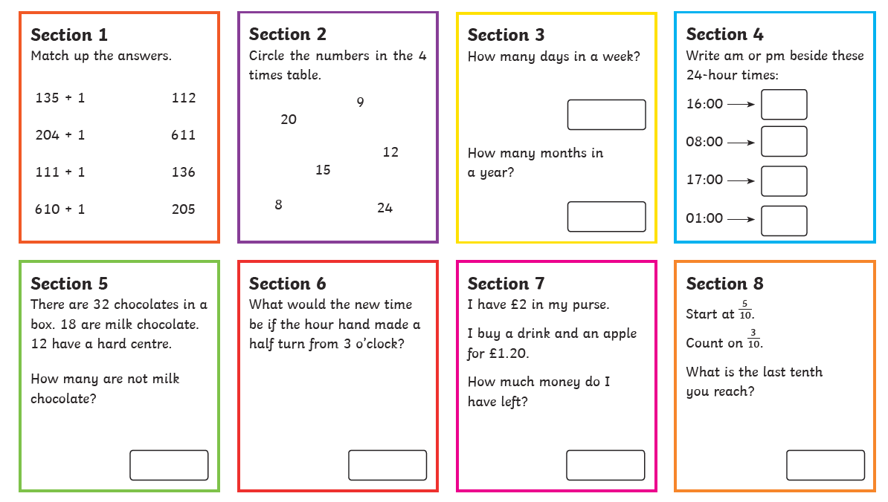

MATHEMATCIS FOR THE NEXT 2 DAYS IS MULTIPLICATION PRACTISE.
Give yourself about 2 or 3 minutes to complete as many of the times tables as you can on a sheet. Set yourself a personal target -
Can you improve over the two days.
Try doing 2 sheets a day.
Or you could complete them over more days and challenge yourself to improve your score.

REMEMBER TO USE TIMES TABLE ROCK STARS TOO.
COMPLETE STUDIO PRACTISES.

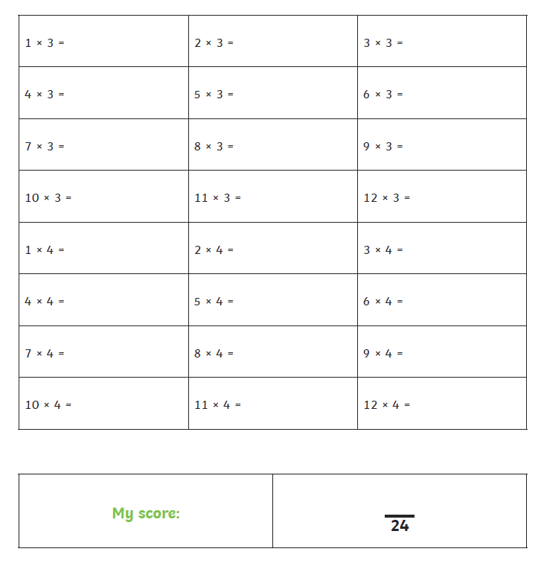

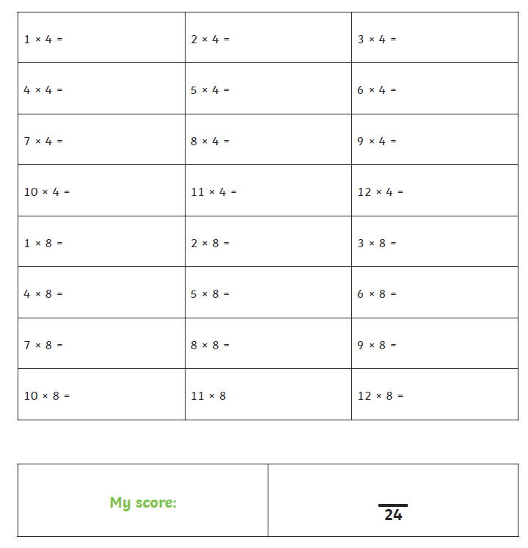

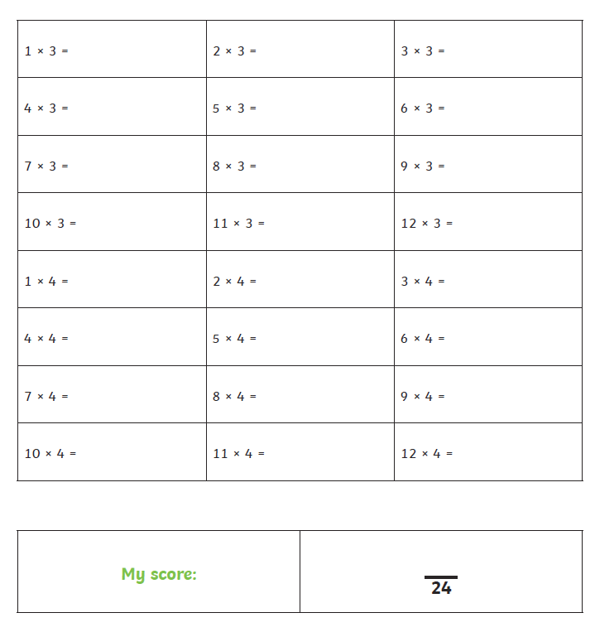
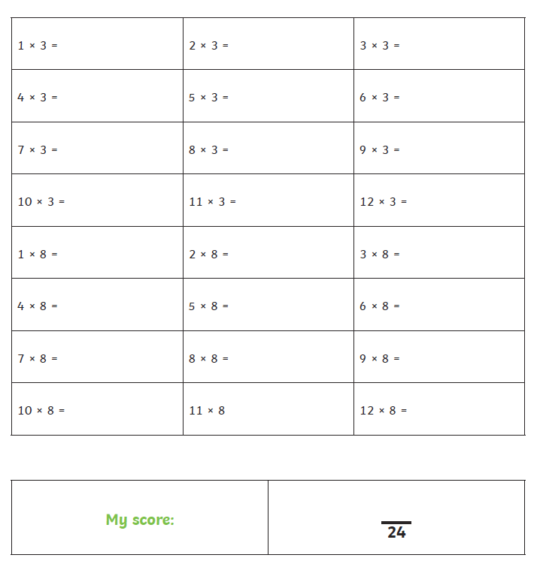
WRITING FOR THE WEEK
This week I am asking you to research and write about caterpillars, butterflies and moths.
I will be providing a picture of a butterfly or a moth each day I would like you to research the insect and write a paragraph about it. Think about:
Description of the insect, include a description and detail about the caterpillar too. (you could do this from observations).
What they eat
Where they live.
What time of year they are abundant?
Interesting facts (camouflage, warning signs/patterns)

I have provided a writing frame for you to use for your information, if you want to.
Art this week will focus on colourful drawings/paintings.
Science will focus on Life cycle
Use the links below for a start to your research.
You could write more than one page if you find lots of information .
Make your own sentences with the information you find.

Check non- negotiables (shown on page 20 as you are writing).
Remember to use complete sentences.

Research 1 - https://www.wildlifetrusts.org/wildlife/how-identify/identify-caterpillars
Research 2 - https://www.woodlandtrust.org.uk/blog/2019/04/british-caterpillars/
Research 3 - https://butterfly-conservation.org/moths/cinnabar
https://www.woodlandtrust.org.uk/blog/2019/04/british-caterpillars/
Research 4 - https://www.woodlandtrust.org.uk/blog/2019/04/british-caterpillars/
https://www.woodlandtrust.org.uk/trees-woods-and-wildlife/animals/butterflies/peacock/
If the links do not work- copy and paste them into address bar.

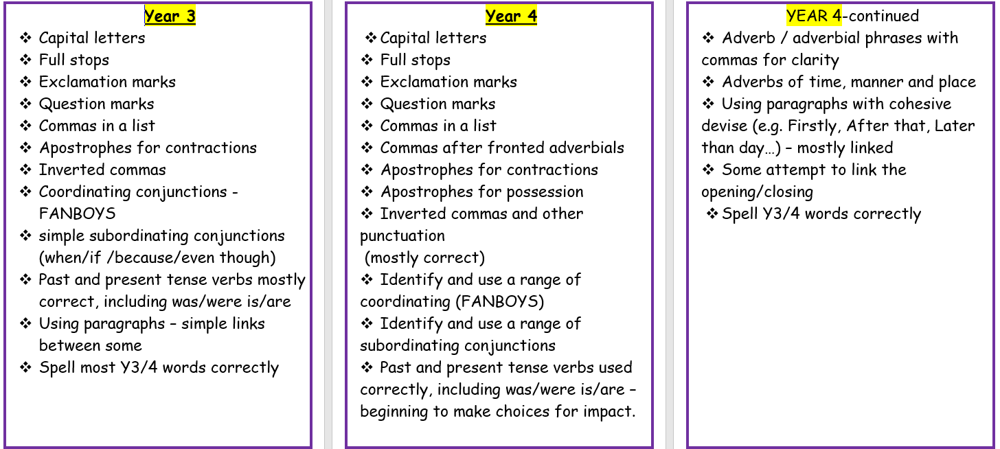

RESEARCH 1 DINKER MOTH

Introduction: (A few sentences about what you are writing about)

Information

information

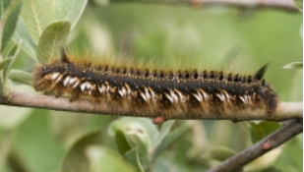

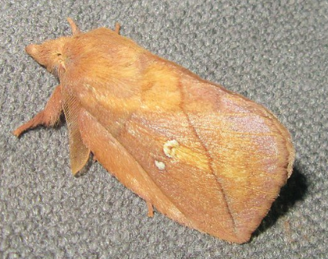

Interesting Facts

RESEARCH 2
LARGE WHITE ( CABBAGE WHITE)
Information

Introduction: (A few sentences about what you are writing about)

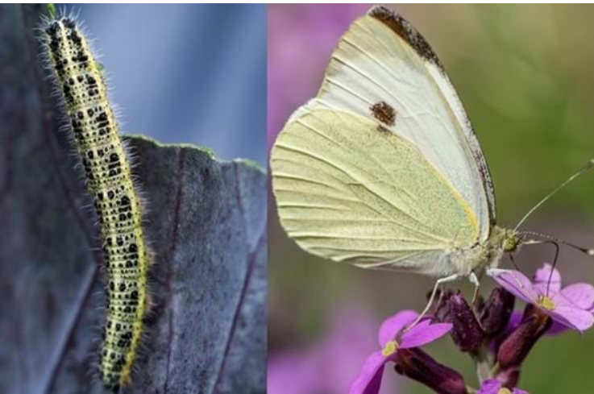
information

Interesting Facts

RESEARCH 3
Introduction: (A few sentences about what you are writing about)

CINNABAR MOTH/CATERPILLAR

Information

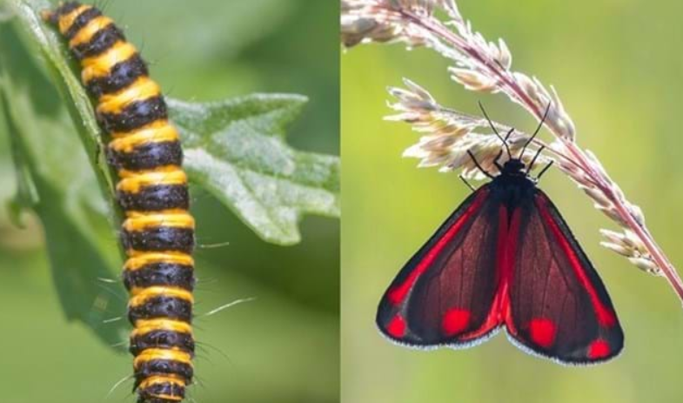
information

Interesting Facts

Research 4
Peacock butterfly
Introduction: (A few sentences about what you are writing about)

Information

information

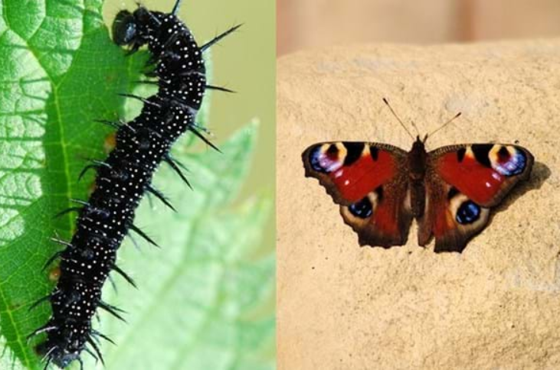

Interesting Facts

Day 5 – Writing
Using all the information sheets you have written create a booklet.
ART- Draw a front cover for your booklet- Remember a title
Add a back cover- remember to write a little paragraph about what is in your booklet.
Check non – negotiables given at beginning of writing.
How many did you manage to include ?
Finally, some topic activities for the week

Topic activities will focus on Butterflies/Moths and caterpillars.
WHY NOT GET OUTDOORS AND SEE HOW MANY DIFFERENT TYPES OF MOTH OR BUTTERFLIES AND CATERPILLARS YOU CAN SPOT?
I would love to see some photographs - I love butterflies.
I spotted some on my dog walk.
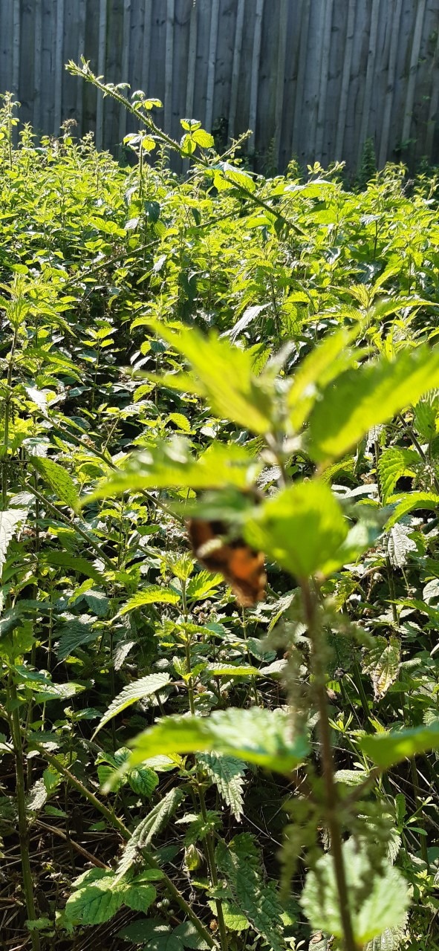
Found on the nettles drying out

Found between brambles and other wild plants.

SCIENCE
Life cycle of a butterfly
https://www.bbc.co.uk/teach/class-clips-video/how-caterpillars-change-into-butterflies-no-narration/zn4rkmn
Watch the clip above, carefully and draw the story to see how a caterpillar changes into a butterfly.

This website shows the process of change more detailed
https://www.youtube.com/watch?v=mQOFh1exp3A

Use the information from the websites and create a presentation that explains the life cycle.
It could be a drawing/ poster/collage/written information with pictures./ a poem or anything you can come up with – be as creative as you can. – Remember send me your ideas.
Here are some ideas
https://www.youtube.com/watch?v=FtKPBj7pgEM
https://www.youtube.com/watch?v=yfstwh00LIA
https://www.youtube.com/watch?v=v3t0f3kcCas

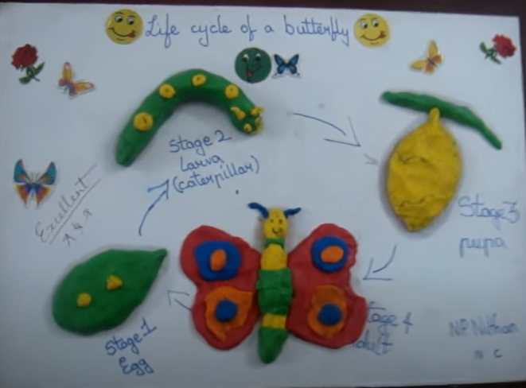
To Make Salt dough (playdough)

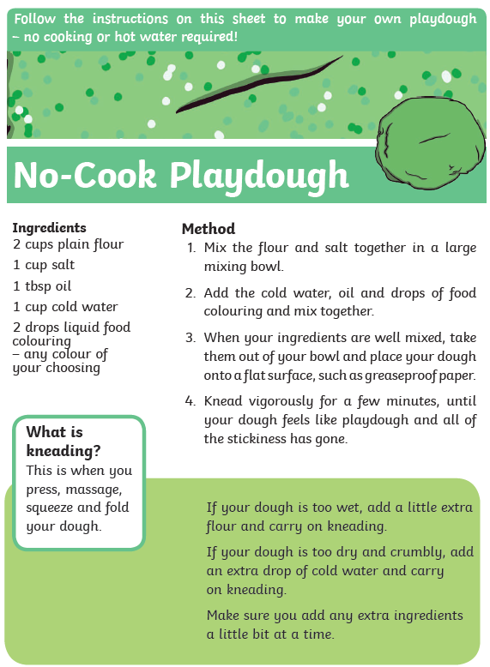

JUST ADD FOOD COLOURING TO A LITTLE DOUGH FOR DIFFERENT COLOURS
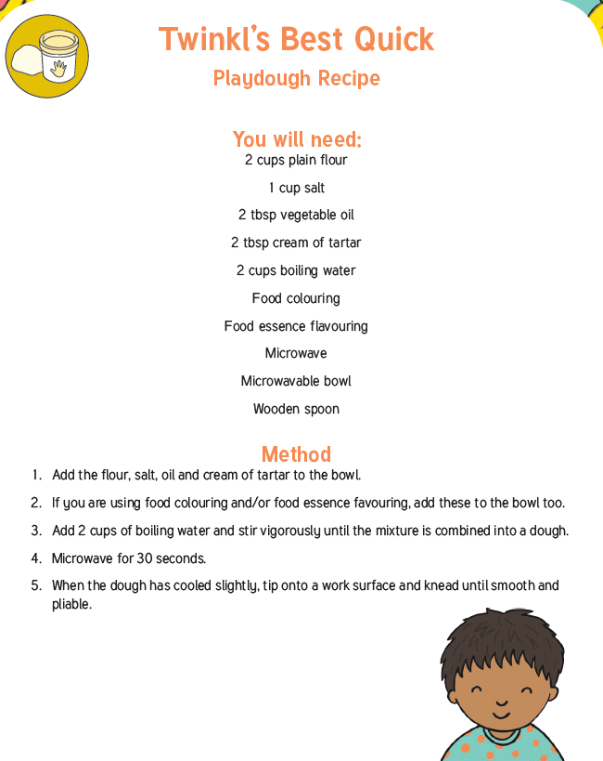

ART

First draw lines on the paper using a dark pen or pencil.
Then colour or paint the sections. As shown below:

Then with help from a grown up draw butterfly wing using the whole paper and cut them out. Then make the body for the butterfly either from black paper or coloured black.
Attach as shown below.
Voila a beautiful butterfly.
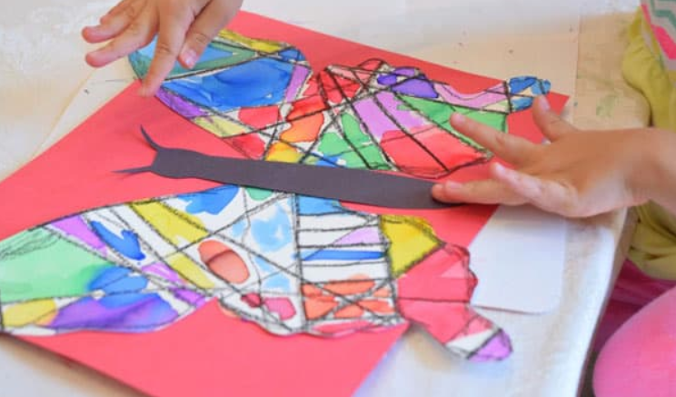

TASK 2 – ART
Here are some images of moths and butterflies.
Use your drawing and colouring skills to copy them
Remember to send me your pictures.
Make sure you look for position and proportion of what you are drawing.
Use different pressure with the same colour to get lighter or deeper lines..
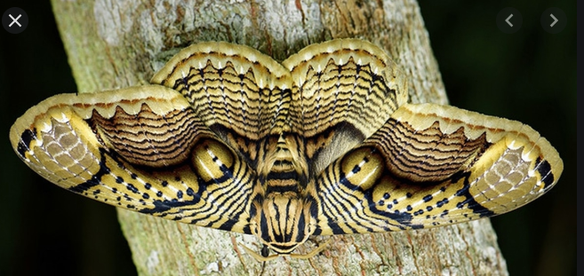

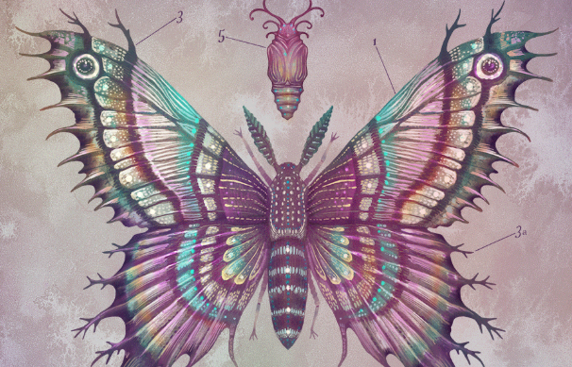

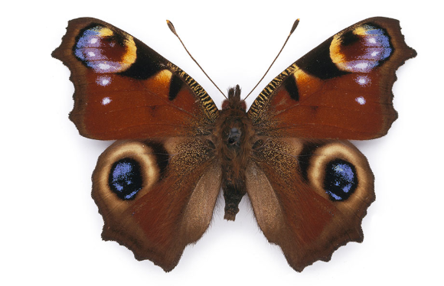

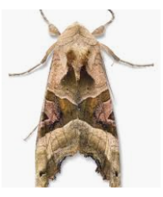

DESIGN AND TECHNOLOGY
Create a play dough caterpillar.
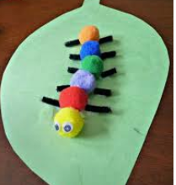
Could you make a caterpillar like this from cake or buns?

MUSIC
See if you can name all the instruments.
( answers are given ..But don’t cheat!! )
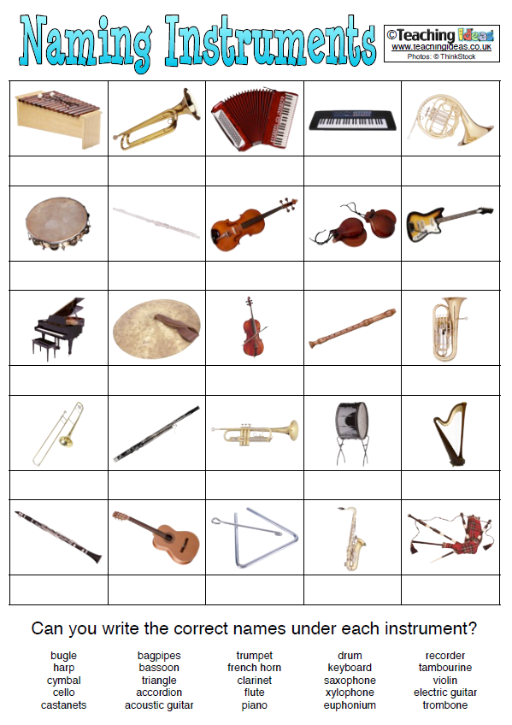

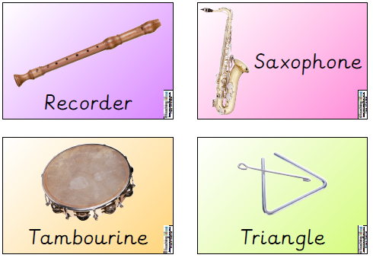
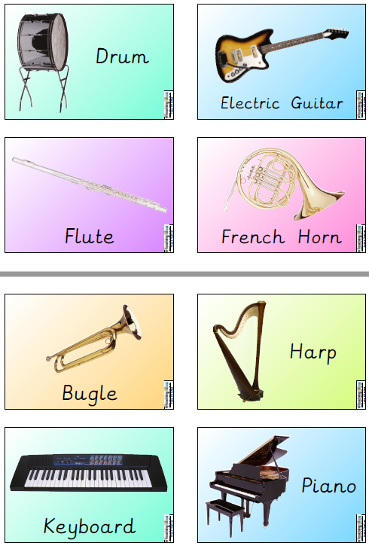
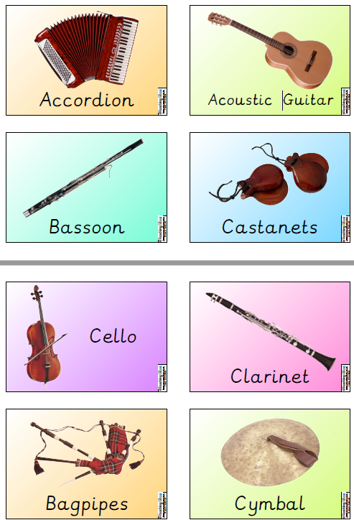
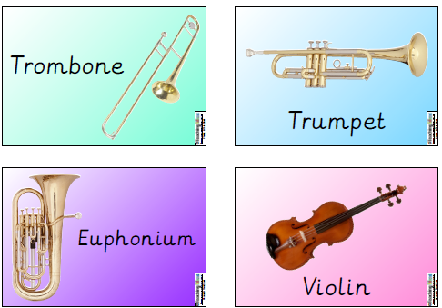

COMPUTERS
ACCESS SCRTACH AND BUILD A BUTTERFLY/MOTH/CATERPILLAR GARDEN

https://scratch.mit.edu/
COPY AND PASTE LINK INTO THE ADDRESS BAR IF IT DOESN’T WORK

CHOOSE CREATE FROM TOP OPTIONS

https://scratch.mit.edu/ideas ---- some tutorials
You do not have to join to use but work cannot be saved.

Other interesting websites
What is the difference between a butterfly or moth
https://www.youtube.com/watch?v=iblveeTDkXQ

AMAZING Creatures – just to watch
https://www.youtube.com/watch?v=QMJxEDPLPfY

Virtual butterfly house ( America)
https://www.youtube.com/watch?v=-8BVOzLSYXQ
------------------------------------------------------------------------------------------------------------------------------------------------------------------------------------------------------------------------------------------------------------------------------------------------------------------------------------------------------------------------------------------------------------------------------------------------------------------------------------------------------------------------------------------------------------------------------------------------------------------------------------------------------------------------------------------------------------------------------------------------------------------------------------------------------------------------------------------------------------------------------------------------------------------------------------------------------------------------------------------------------------------------------------------------------------------------------------------------------------------------------------------------------------------------------------------------------------------------------------------------------------------------------------------------------------------------------------------------------------------------------------------------------------------------------------------------------------------------------------------------------------------------------------------------------------------------------------------------------------------------------------------------------------------------------------------------------------------------------------------------------------------------------------------------------------------------------------------------------------------------------------------------------------------------------------------------------------------------------------------------------------------------------------------------------------------------------------------------------------------------------------------------------------------------------------------------------------

You could send me some pictures of your work mrssmith@newvillage.doncaster.sch.uk
Mrs Smith x

