See if you can still use your writing skills on this description of

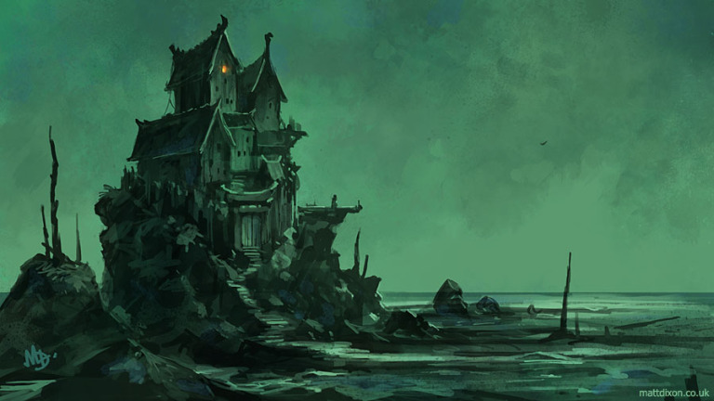
The Witch House.

Describe this setting. Can you use any of the words below?
  - rickety
  - ramshackle
  - decayed
  - rotting
  - derelict
  - crumbling
  - clogged
  - weather-beaten
    - Challenge: Select the three most suitable words and justify your choices.

- Does anyone live here? Who? How do you know?
- Why do they choose to live here? Explain your answer.
- Describe the home owner’s personality. What is important to them/what do they value?
- What are the wooden spikes around the house?
- Why is there only one light source?
- Does this person get many visitors?
- Why is the sky an eerie, green colour? What is the effect of this?
- How could you use this setting in a story? Challenge: Analyse and discuss how appropriate this setting is for a fairy tale.

