Hello everyone! It’s Miss Shaw here, I have put together some learning activities that you can do at home. I hope that you are all safe and well, and that you are enjoying the time with your family.
There is no need to print anything out, so do not worry if you don’t have a printer, just talk through the work with someone at home.

Start your day with a song and get moving!

https://www.outoftheark.co.uk/ootam-at-home/?utm_source=homepage&utm_campaign=ootamathome2&utm_medium=banner
Log on to the above website. Here you will find lovely songs to sing, just like the ones that we use at school.

Choose a song
Listen to it all the way through and spot any repetition
Join in with the song the 2nd time through, following the words on screen.
Make up your own actions or even dance moves, and don’t forget to follow the links for other activities related to each song

This week, I’ve been singing “Join the song” from the “Get moving” section…..there are some great challenges to try!

How do you stop a baby astronaut from crying?
You rock-it!

3 listening and comprehension activities…When I was a little girl, I used to love the Mr. Benn stories because he always had such brilliant adventures. Here are 3 of the stories for you to enjoy. I think the way that he walks along the road will make you smile!
Mr. Benn | Mr. Benn – the  space man | Mr. Benn the cook
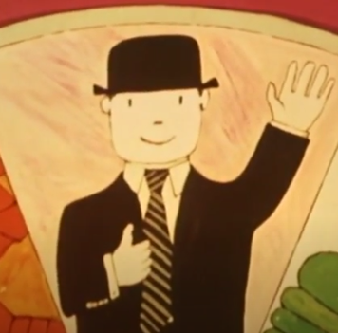 | 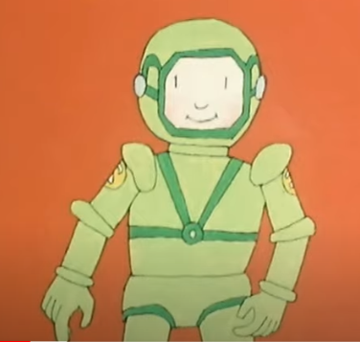 | 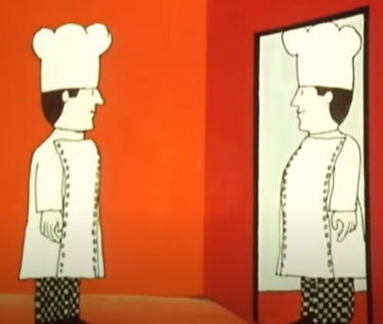
https://www.youtube.com/watch?v=KJuj_ZT8pjU | https://www.youtube.com/watch?v=m7EmQuBAD2k | https://www.youtube.com/watch?v=bhltueITGuU
- Why does Mr. Benn go to the costume shop?  - Which costume does he try on?  - When Mr. Benn goes through the door and sees the dragon, what does he think?  - Why is the dragon so unhappy?  - What has the matchmaker done to make everyone cross with the dragon?  - What does Mr. Benn do to help?  - What is the matchmaker’s punishment?  - How does Mr. Benn get back to the shop?  - At the end of the story, what does he find in his pocket? | - What made Mr. Benn think about going to the costume shop?  - When Mr. Benn goes through the door, where does he find himself?  - What is the problem on the first planet?  - What would have happened to Mr. Benn if he had stayed on the second planet?  - The third planet looked amazing, but what was the problem?  - The astronaut flew back to a place that was “not perfect, but not too bad either.” Where do you think this was?  - At the end of the story, what does Mr. Benn keep to help him remember his adventure? | - What number is Mr. Benn’s house?  - Which costume does he try on today?  - When Mr. Benn goes through the door, where does he find himself?  - Why were the king and queen worried about the princess?  - Why do you think that Mr. Benn invited all the children to the palace?  - What do you think made the princess want to eat the lovely food?  - What did the king promise the princess?  - At the end of the story, what does Mr. Benn keep to help him remember his adventure?
Could you make up your own adventure for Mr. Benn or even dress up and have an adventure of your own!
Hands on maths…Here are three activities for you to do with your adult this week. Please have a go…
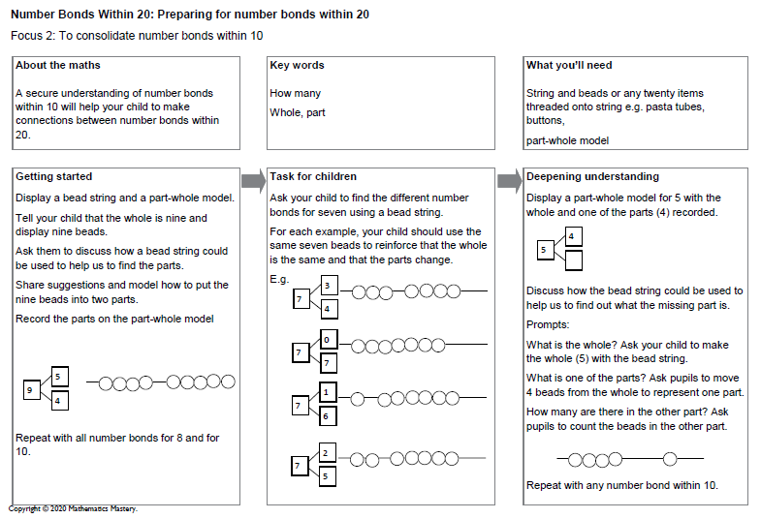
Finally, as Mr Benn went into space for one of his adventures, here are 3 “space” themed activities for the week……
Take a look at the following activities and give them a go!
Design Technology | Science |  | Art
Why not have a go at making your own paper rocket with paper and a drinking straw.  https://www.youtube.com/watch?v=mQblbX9YccM  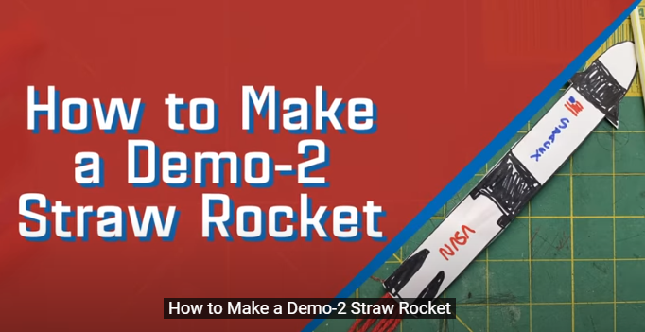  When you have watched the clip, collect the materials that you need and follow the instructions. Remember that you can pause the clip at any time….. you don’t have to rush. |  | Since we have a space theme to our learning this week, why don’t you have a go at making rocket mice!!!!!!!  Follow the link below and download “rocket mice” – all you need are things that you may already have at home  https://learning.sciencemuseumgroup.org.uk/learning-resources/  If you can’t print off the resource, I have included it below for you to read online.  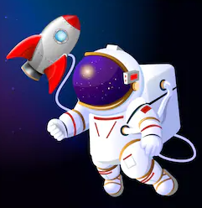 |  | https://www.youtube.com/watch?v=HjnRYnSEuG4  Follow the link above to see how to draw an astronaut. Remember that you can pause the clip at any time….. you don’t have to rush. All you need is a pencil and some paper. You may want to colour it when you have finished.  Try drawing a space scene….just follow the link below.  https://www.youtube.com/watch?v=LWgzybrHjIA
