Hi everyone, Mrs Wainer here again. How fast did that week go? I hope you’re all safe and well and enjoying the lovely weather. I’m wondering if anyone has managed to learn new skills during lockdown. I’ve been baking much more than I ever have done. I’ve made quite a few cheesecakes using Mrs Walkden’s recipe.
Mr Stallard is still checking his emails to see what you have been doing. You can still contact him on:
MrStallard@newvillage.doncaster.sch.uk

To parents, carers and family,

I’m now attaching answers to these learning packs so that the children can mark their work too. If they make mistakes or get different answers, encourage them to work to try and understand where their mistake was or why the correct answer is correct.
The most important thing for the children isn’t necessarily to have help with their work, but to feel encouraged by the adults around them.

From Mr Stallard, Mrs Wainer and Mrs Shakespeare

 |  | Week 11
1 | PE | Youth Sport Trust Activity
2 | Reading and spellings | One for each day  Complete reading activities 1-5  Spelling activities 1-5
3 | Maths | Times Tables Rockstars logins provided and daily learning tasks.
4 | English | SPaG mats
Lunch
5 | History and Geography | Look at this website and watch the video clip on the human body and teeth and answer the quiz questions at the bottom of the page.  https://www.bbc.co.uk/bitesize/articles/z3nhjsg  On a different day, visit this website  https://www.bbc.co.uk/bitesize/articles/zs9csk7  and watch the video clips on poetry. The video of Spike Milligan is quite funny.
6 | Art | I have added some art ideas for you to try. It’s important to learn about the elements of art. The seven most common elements include line, shape, texture, form, space, colour and value. This week I have made the focus about PATTERN. I’d like you to work on skill building before you attempt the drawing activity. I have attached a practise sheet for you to try first. I wonder if you’ll be able to make a Mandala ? Hope you enjoy it.

NETFLEX
If you go on our class area on the website and click on ‘Try Mr Stallard’s Exercises’, you can download NETFLEX!
1. Scroll through just like you would on Netflix and look at the different exercise activities by clicking on them after it’s gone full screen!
2. Click on ‘Slide Show’
3.Click on ‘From Beginning’

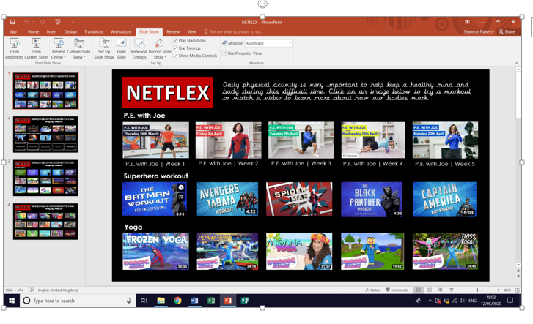

Get Active

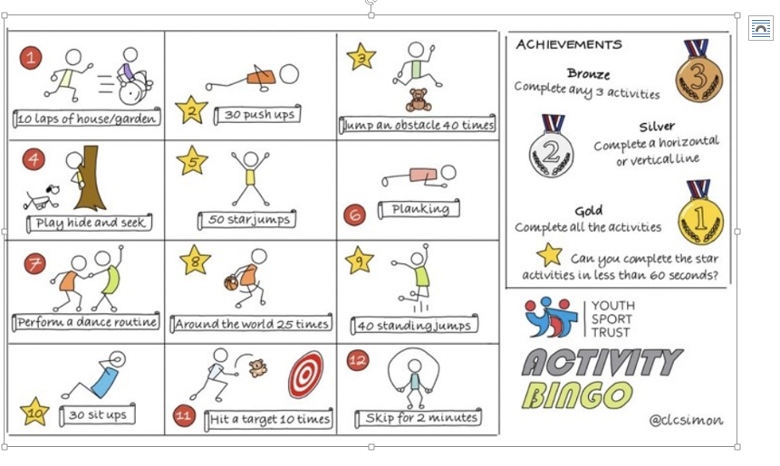

Reading – choose a book they want to read for Days 1-3

Day 1 | Listen to your child read and ask 5 questions from the Retrieval with Rex mat
Day 2 | Listen to your child read and ask the questions from the Compare, Contrast and Comment with Cassie mat.  Ask your child to say some of the answers and possibly write some of them down too.
Day 3 | Listen to your child read and ask 5 questions from the Inference with Iggy mat.
Day 4 | Friendly Felines – reading comprehension activity
Day 5 | Get Ready With Cleopatra – reading comprehension activity

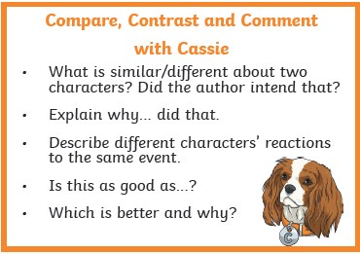
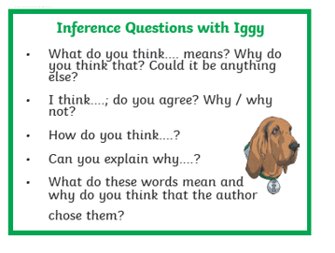

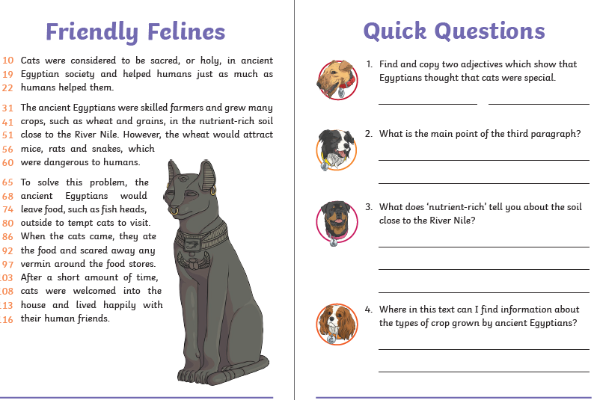

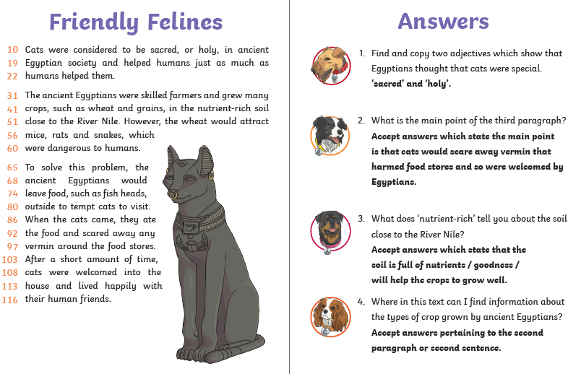

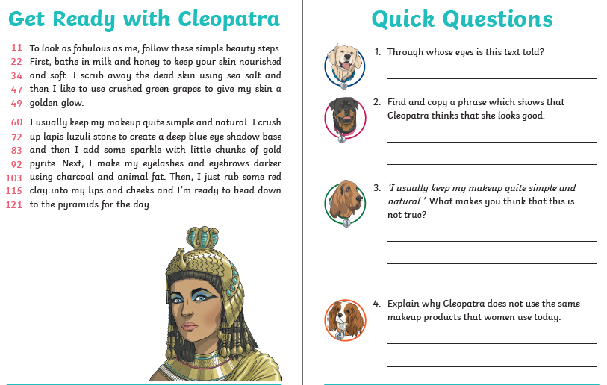

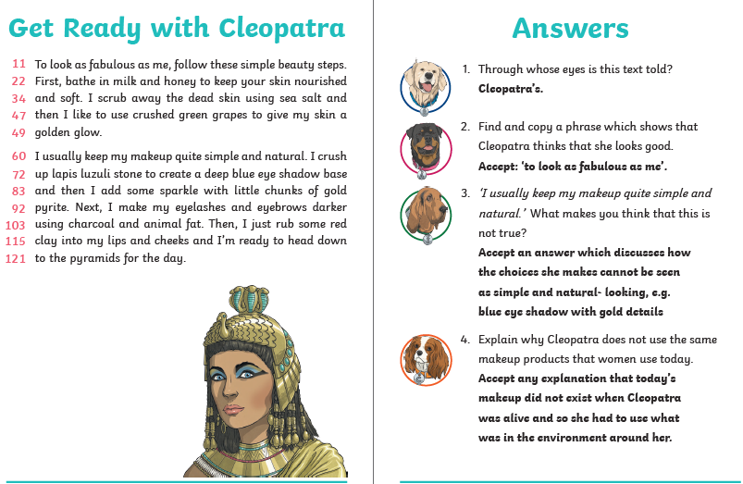

Spellings – Some of the children are in Group 1 and some are in Group 2, your child will know which group they’re in.
 | Group 1 – Months of the year and time. Group 2 – Adverbials of Frequency and Possibility
DAY 1 | Look, Say, Cover, Write, Check
DAY 2 | Word search
DAY 3 | Handwriting Practise | Hanwriting Practise
DAY 4 | word mat - hour | word mat
DAY 5 | word mat – pretty | word mat
NOTE FOR PARENTS AND CHILDREN:
If you’re unable to print any of the sheets off, they can all be adapted. If you can just see the sheet on the screen, all you need is pencil and paper to practice the spellings for Day 1 and Day 3 and the same for Day 4 and Day 5. For the word searches, can you just find the words in order on the screen

Spellings Group 1 Day 1

 | look | say | cover | write | check | correction
November
December
after
past
hour
half
minute
quarter
month
second

Word search Group 1 Day 2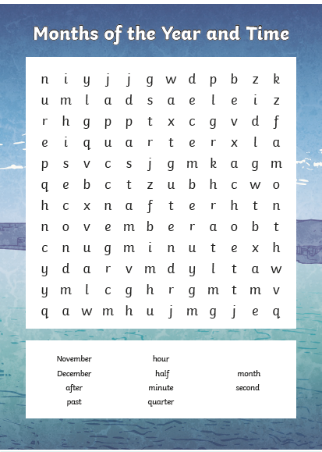
Group 1 Day 3
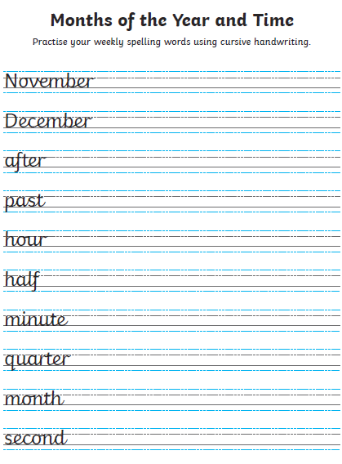
Group 1 Day 4
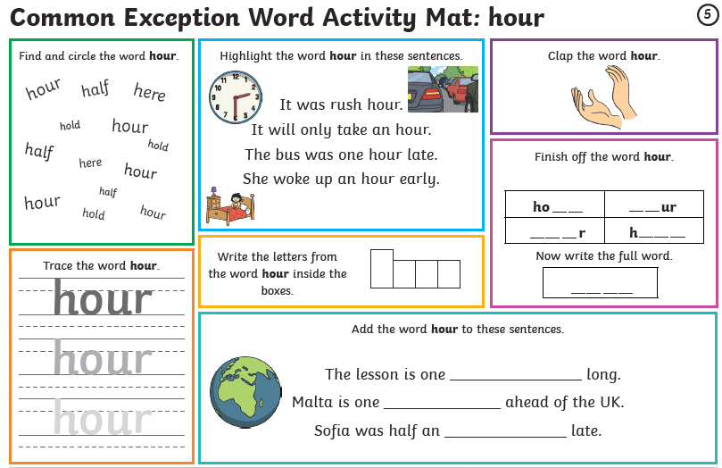

Group 1 Day 5

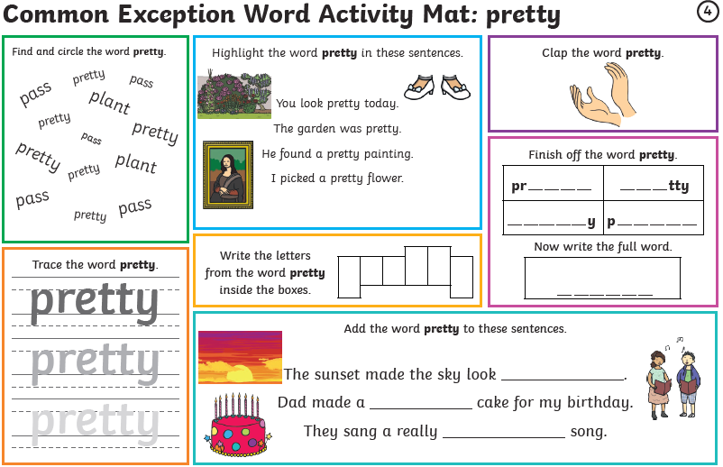

Group 2 Day 1

 | look | say | cover | write | check | correction
regularly
occasionally
frequently
usually
rarely
perhaps
maybe
certainly
possibly
probably

Group 2 Day 2
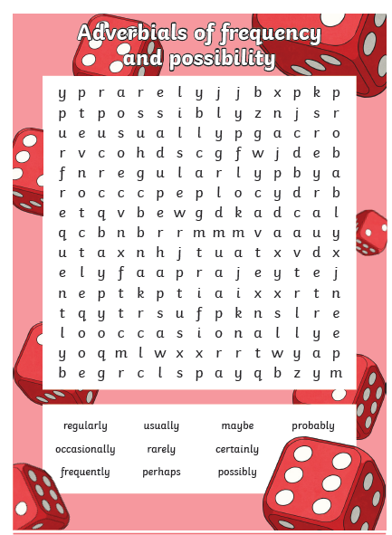
Group 2 Day 3
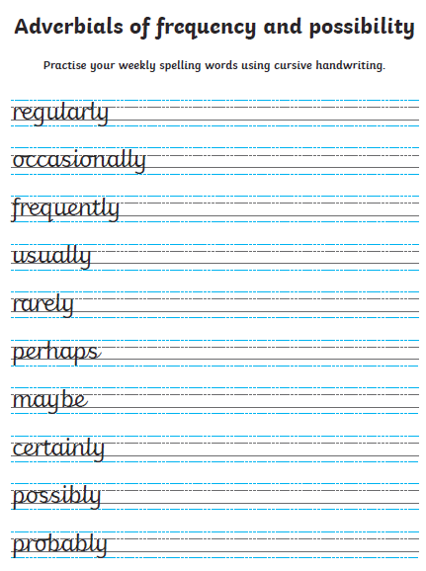
Group 2 Day 4
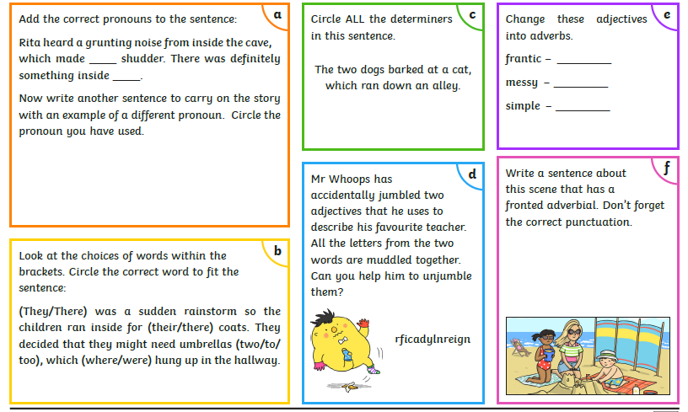

Group 2 Day 5

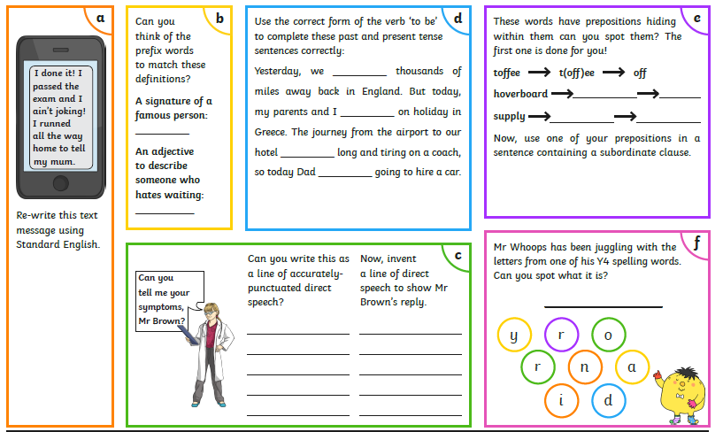

Maths – Times Tables Rockstars logins – Please ensure your child is only logging in using their own login details
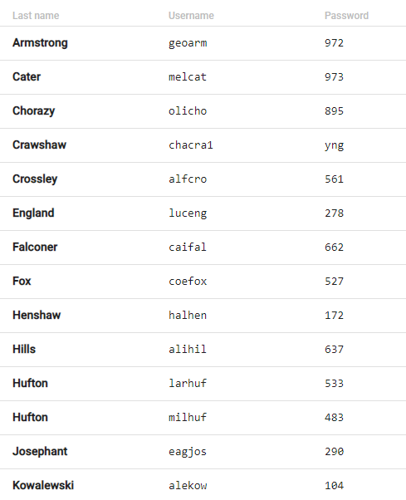

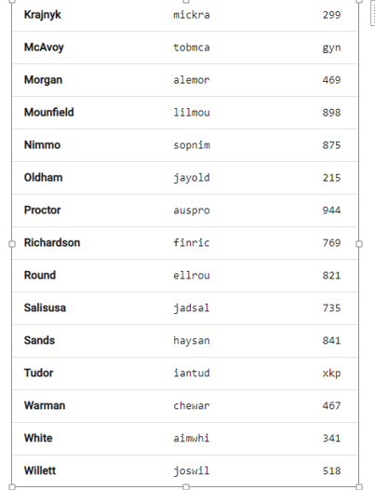

Maths
Reasoning Questions Days 1,2,4 and 5
Times Table Rock Stars Day 3

Day 1

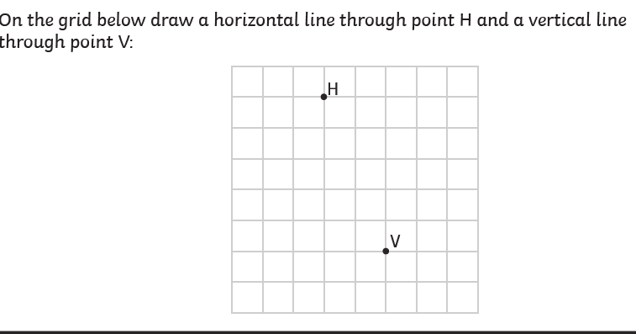

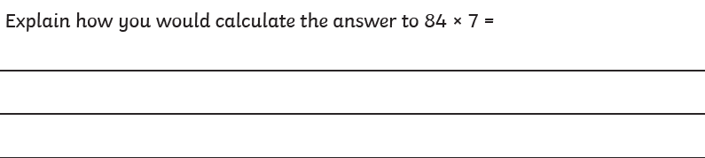

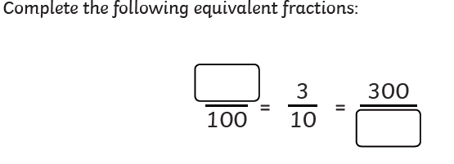

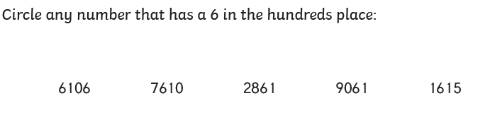

Answers Day 1
1.
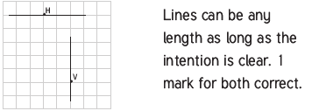

2.
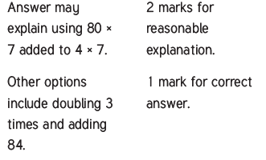
3.
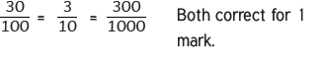
4.
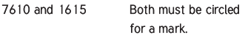

Maths Day 2

1.

2.
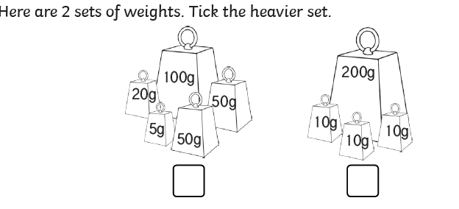

3.
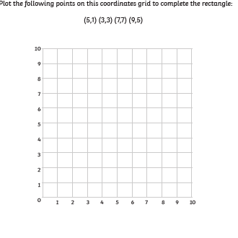

Answers Day 2
- 3 years

2.
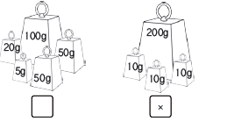

3.
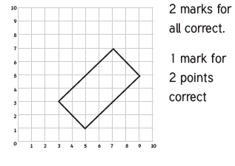
Maths Day 4

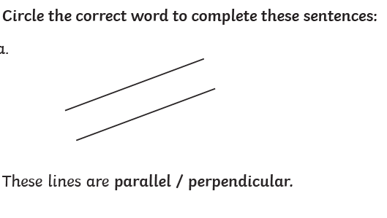
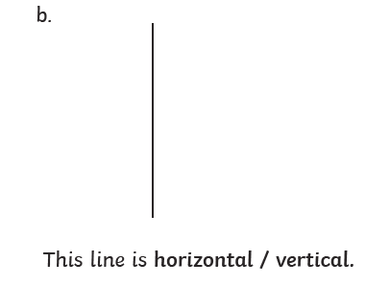

2.
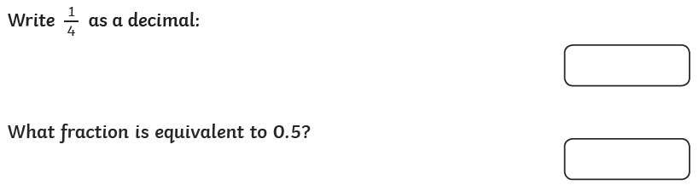

3.
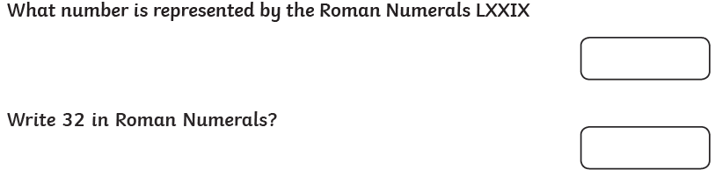

Answers Day 4
1.
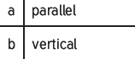

2.
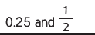

3.

Maths Day 5
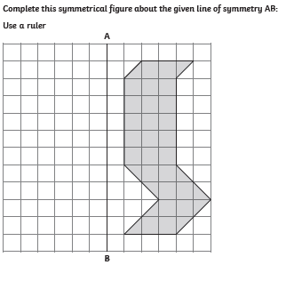
2.
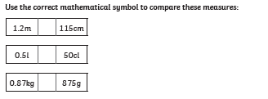

3.
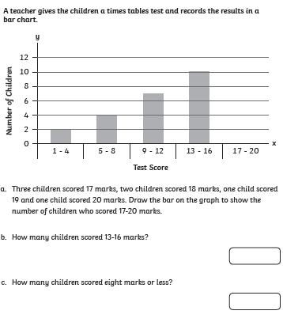

Answers Day 5
1.
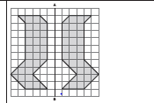

2.
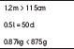
3.
. 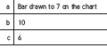
Writing Day 1

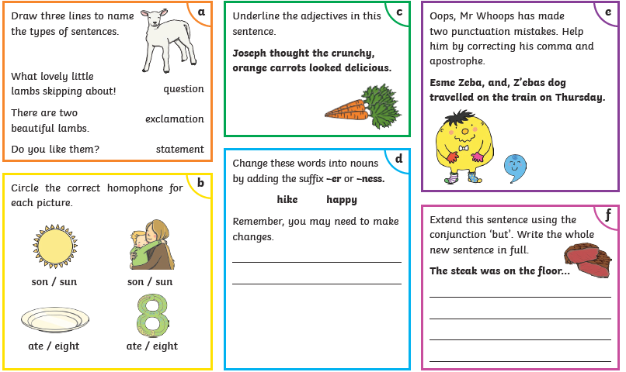

Writing Answers Day 1
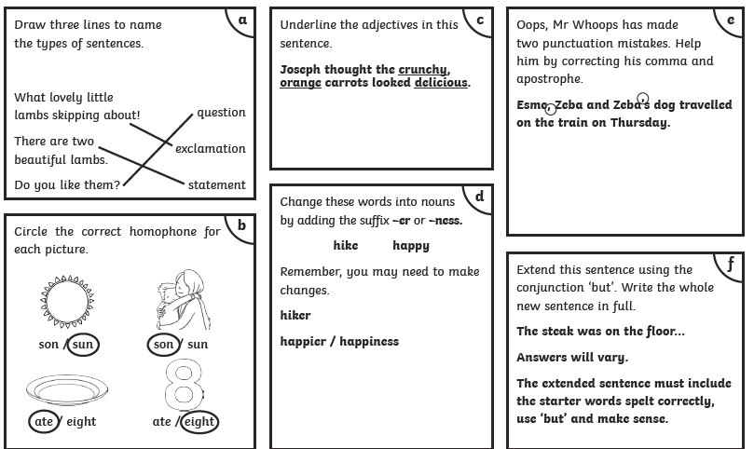

Writing Day 2
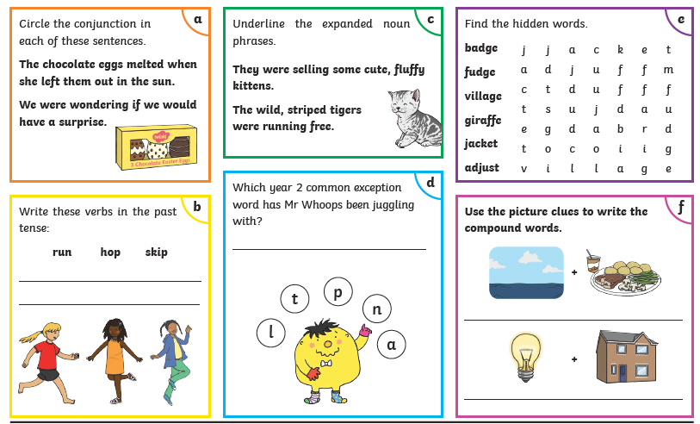

Writing Answers Day 2
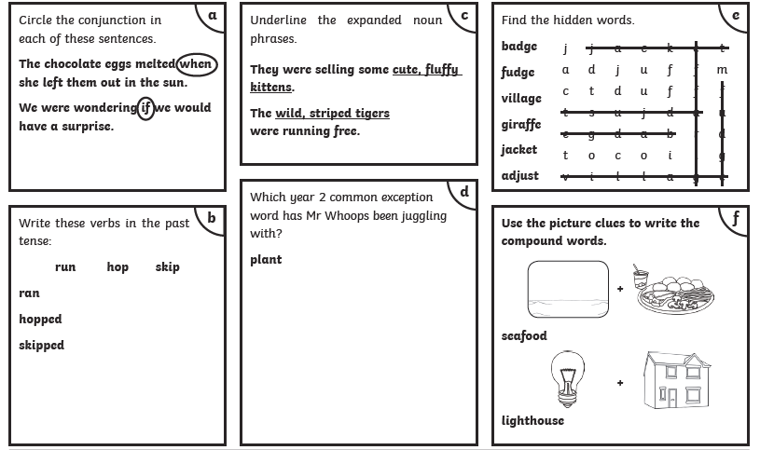

Writing Day 3
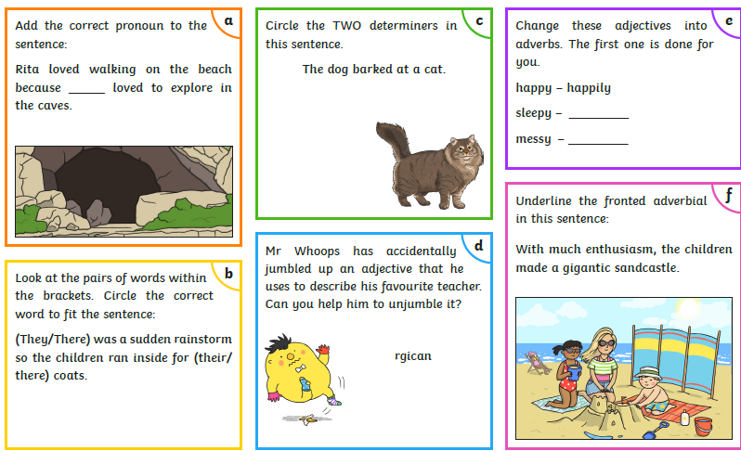

Answers Writing Day 3
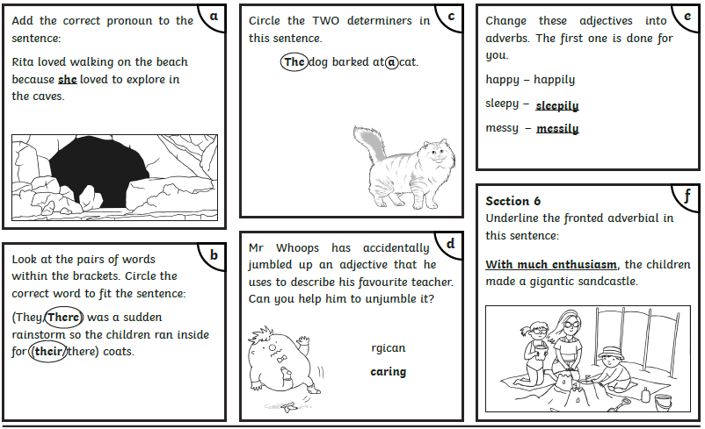

Writing Day 4
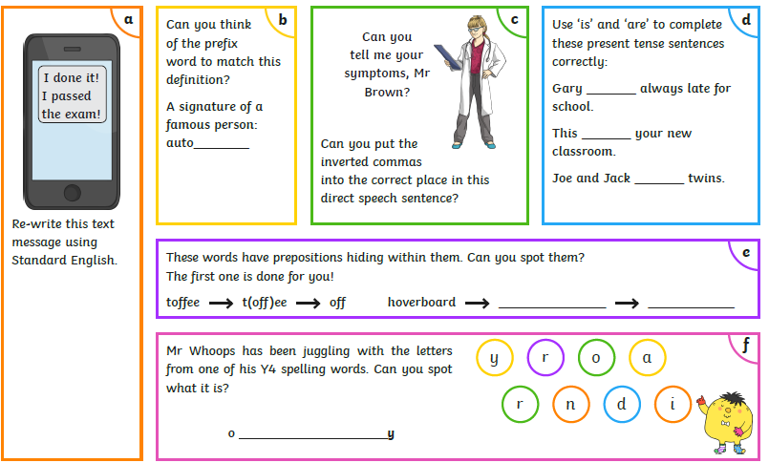

Answers Writing Day 4
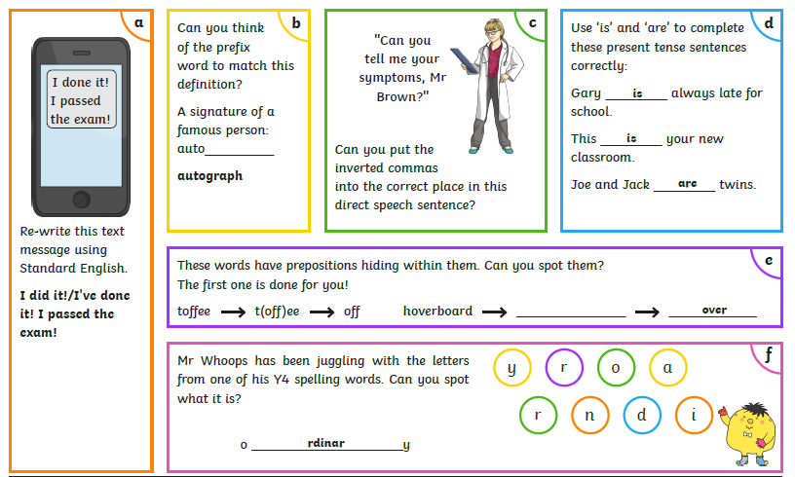

Art Activities
This week I thought that we could look at another element of art. Pattern. I have included some practise sheets for you develop your own ideas. I have also included a couple of websites for you to look at.You might even make a Mandala. If you get chance, maybe you could send a picture of your artwork to Mr Stallard. Have fun!
https://www.art-is-fun.com/how-to-make-a-pattern

https://artprojectsforkids.org/klimt-and-patterns/

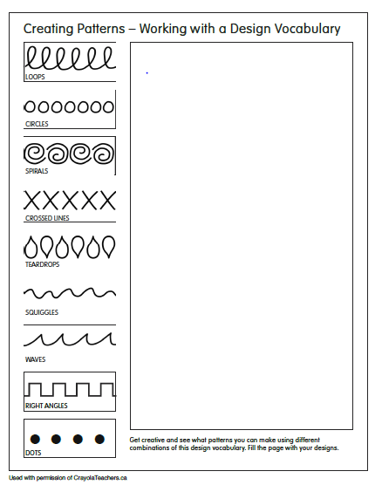

Mandalas

