Hello Everyone,
I hope you enjoyed last week’s learning.

I am missing you all.

Remember to stay safe I can’t wait to see you back at school.

If you want to contact me you can do at:
MrsSmith@newvillage.doncaster.sch.uk
You can attach any documents or photographs of work you complete.

Year 3
Reading Comprehension
I had planned to have a week investigating and writing about Caterpillars and butterflies. However, on my travels I have not noticed many of either so this week we will look at Science investigations and French.

Remember I changed the layout of the learning pack.
All the tasks for the week will be in one document. Just complete them through the week. Try to do a range of learning each day. There is no need to complete one task from every section each day, as I know lots of you are having great family times and making lovely memories to look back on.

Mrs Smith x

SPAG ACTIVITIES FOR THE WEEK
TASK 1 SPAG
USE SPELLING FRAME TO PRACTISE SOME WORDS WITH A SUFFIX ENDING.
USE YEAR 3/4 Spelling rule 20
https://spellingframe.co.uk/spelling-rule/23/20-Possessive-apostrophe-with-plural-words
Choose a game to play from spelling tiles.

You could play a different game each day to really practise the words.
Why not test yourself to see how well you have learnt the words?

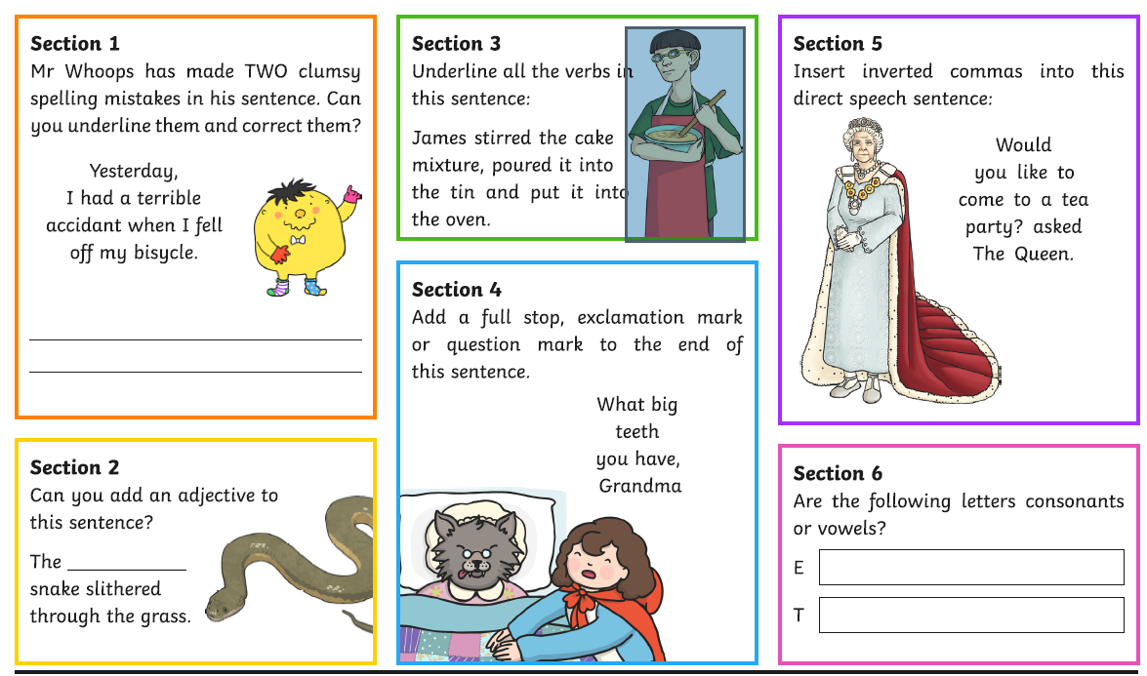
Print off or write out/discuss answers. SPAG TASK 2
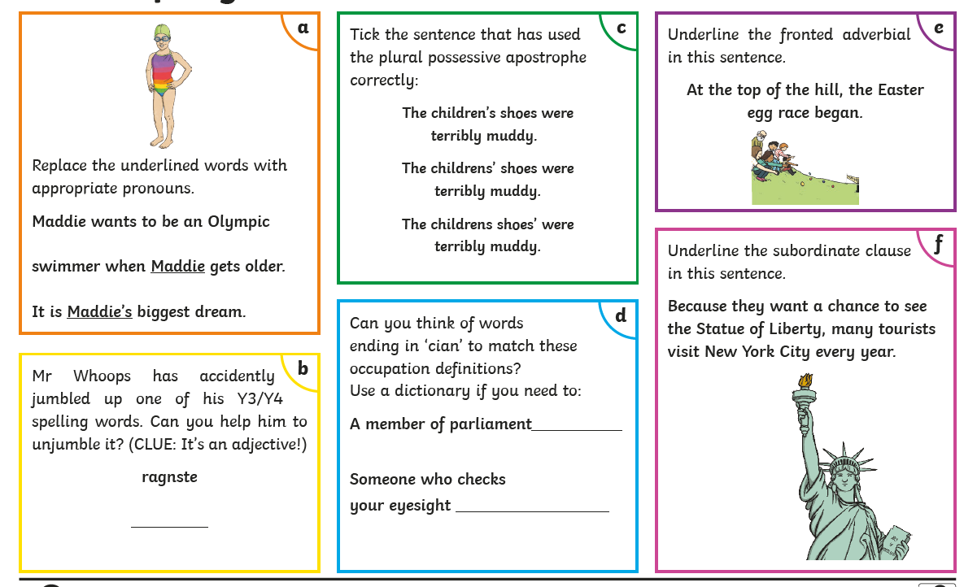
SPAG TASK 3 PRINT?WRITE?DISCUSS
TASK 4
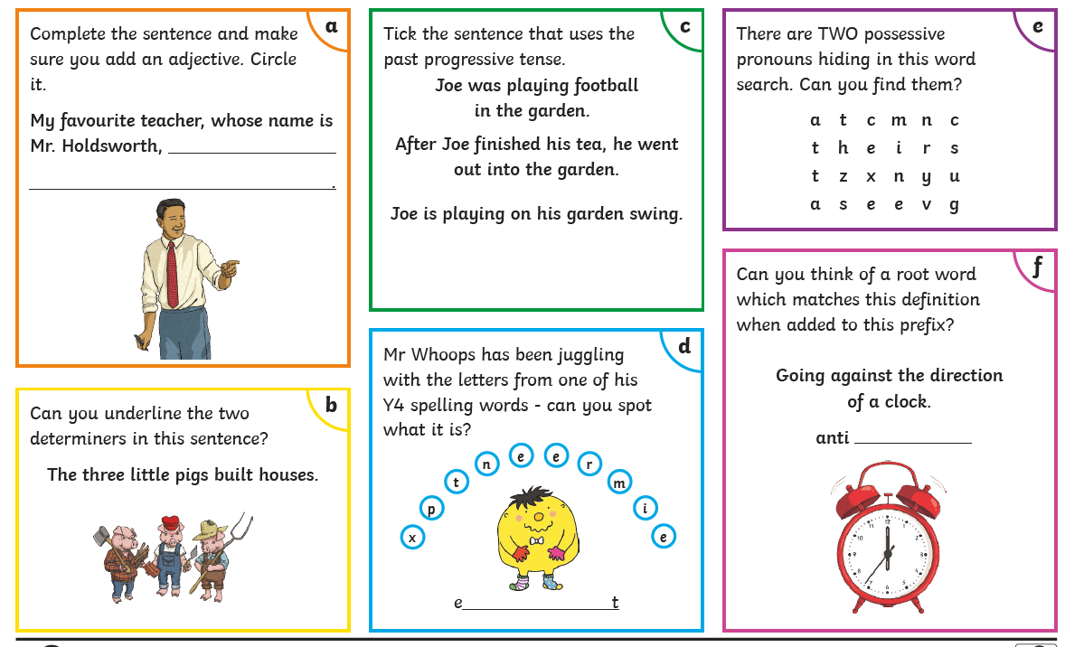
Print/WRITE/DISCUSS

Reading task 1
Complete each reading task on different days
Task 1
Link to bbc website
https://www.bbc.co.uk/bitesize/articles/z9jhqfr ( not todays date)
Learn about poetry by reading with an adult through the teaching points.
Complete activity I quiz to develop knowledge of vocabulary used in poems and the features.
Complete activity 2 – Read the text and answer the questions.
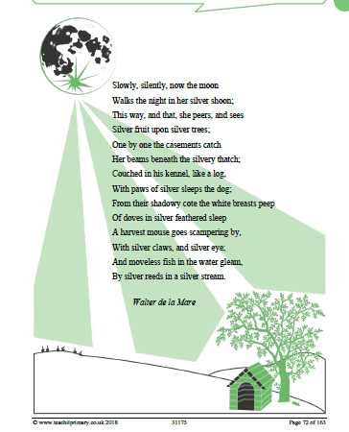

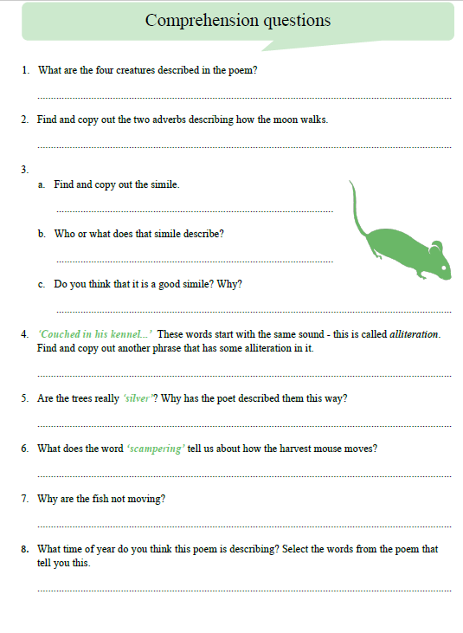

READING TASK 2
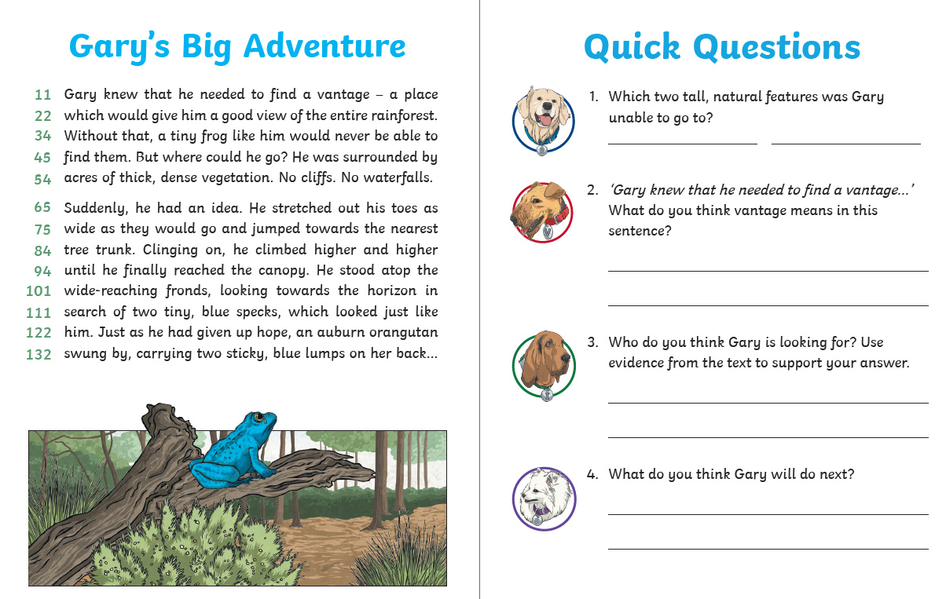
READING TASK 3 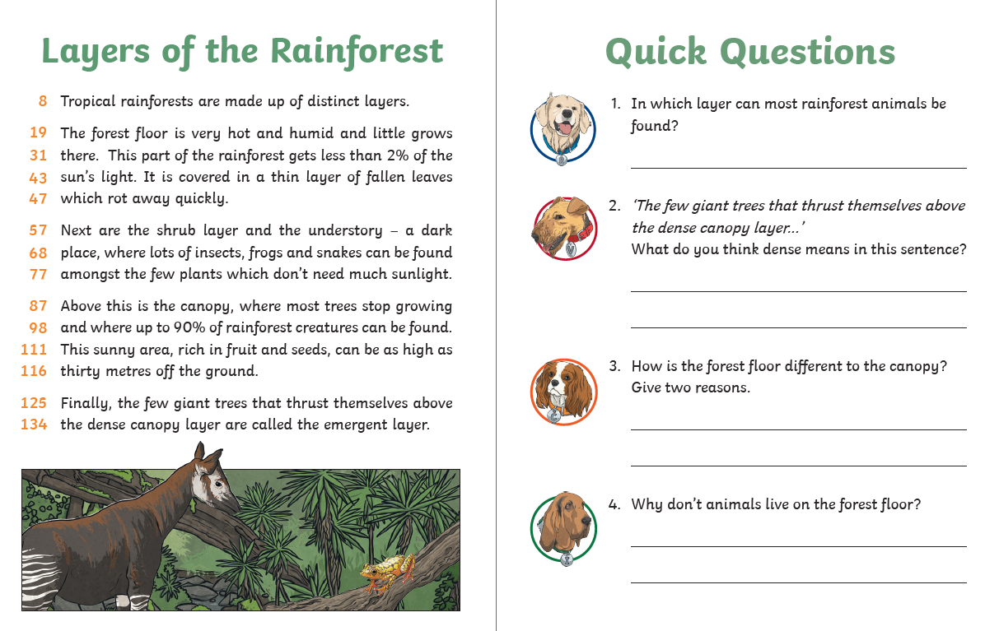

READING TASK 4 and 5
READ FOR PLEASURE
Choose your most favourite book and share with someone in your family.
You could even ask them questions about what you read.
Stories can also be accessed through the links below.

https://www.storylineonline.net/ ( read to you )

http://www.magickeys.com/books/invis-allig/page6.html#pictop
( for you to read)

https://www.freechildrenstories.com/ ( choose from a range of ages and genre)

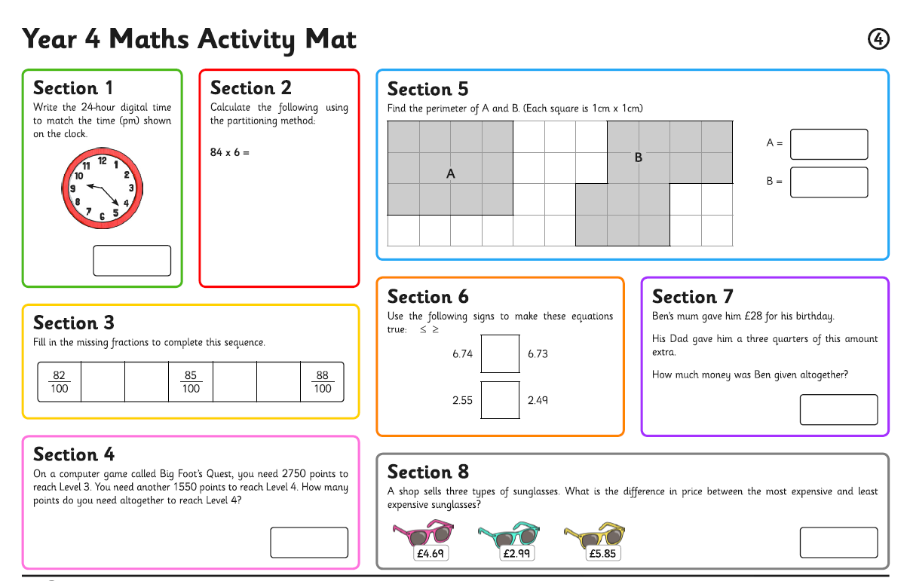
MATHS ACTIVITIES FOR THE WEEK MATHS TASK 1 Here are some activity sheets for you to have a go at throughout the week. Print off or write calculations down. Talk about your learning with an adult.
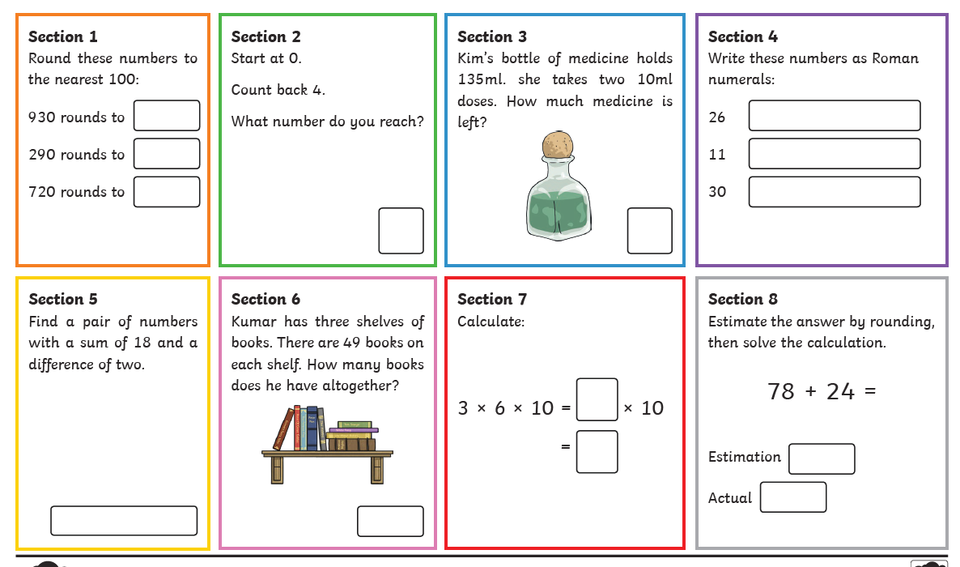
MATHS TASK 2
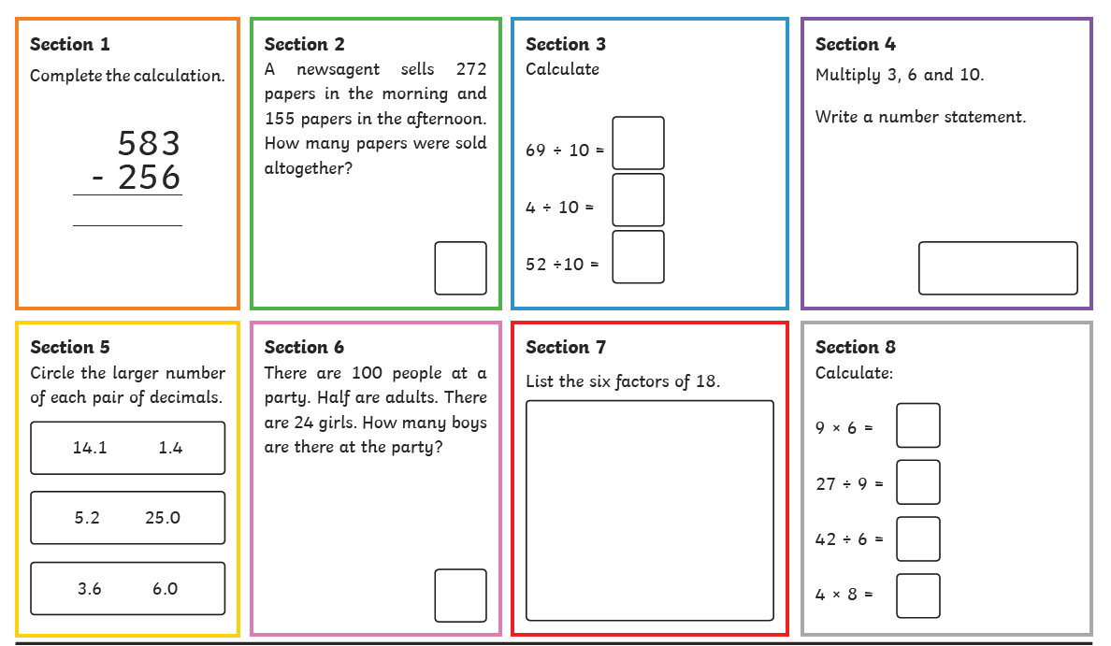
MATHS TASKS 3
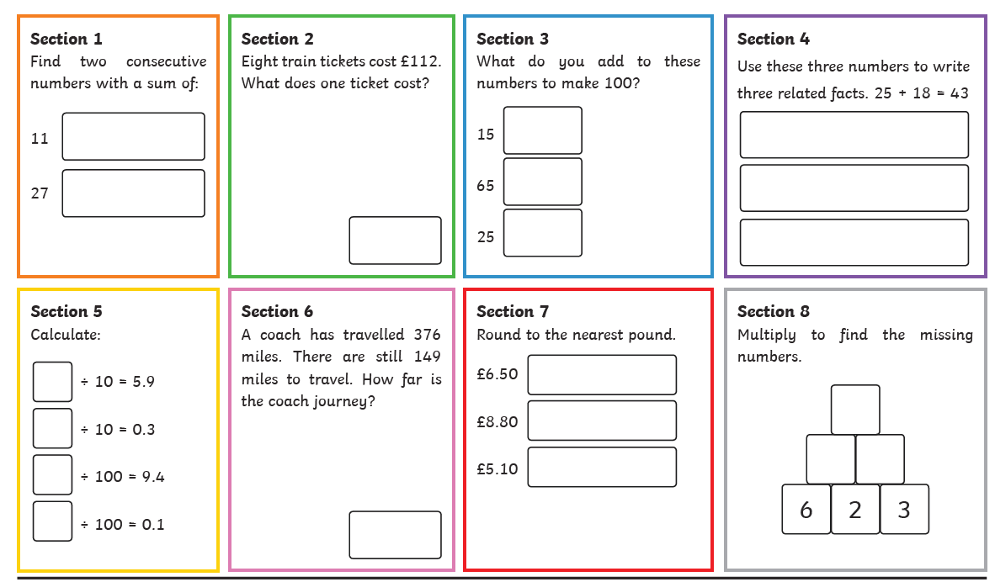
TASK 4

Rest of week
Remember to log onto Times tables Rock stars
Play 5 games of Studio
Have a go at some tournaments
Can you link with anyone you know?

Have a speed test with someone in your house.
One person asks the questions and other have to get answer.

Make some snap cards
Some with the questions on, some with the answers. Turn upside down and play snap. Play find doubles turning all the cards upside down and taking in turns with people in your house to find two cards that link…..no cheating though!!

WRITING FOR THE WEEK
TASK 1
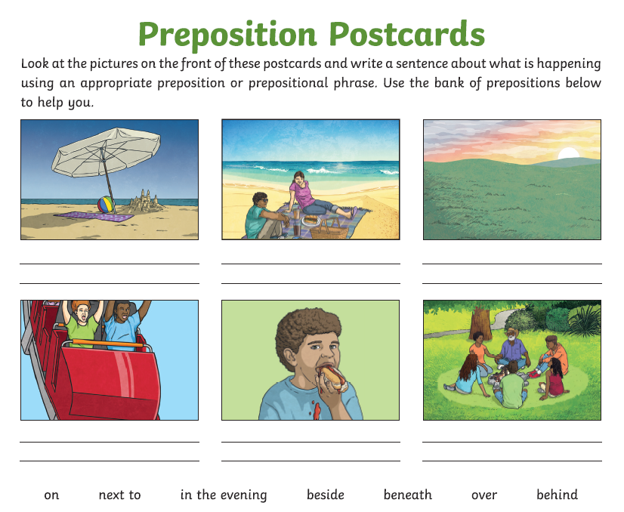
Write a postcard of your own to tell your teacher about your dream holiday.
Where would you be?
What would be there?
What would you do?
Why would you take with you?

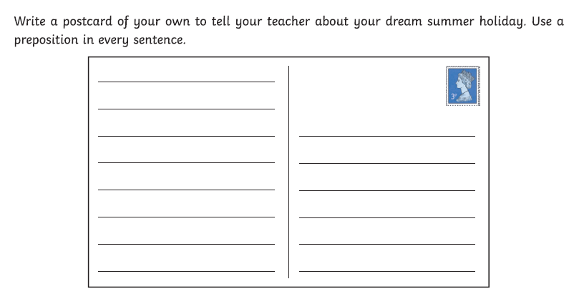
WRITING TASK 2
Think back to when we created our mythical creatures and wrote to Yorkshire Wildlife.
This week I am asking you to invent an animal and write about it.
Think about:
Where the animal was found
What the animal looks like
Where the animal likes to live
How does it move
What does your animal eat and how does it catch its prey?
Can you name your animal?
You could choose an animal that you like and give a feature of another animal, perhaps change it food and how it moves.
For instance:
You could have a fish that eats grass and has claws with a bushy tail instead of a fin. Strange and unusual.
Remember to use complete sentences and include all the non-negotiables such as conjunctions, different punctuation, adverbial phrases, prepositions ( explain where).
The choice is yours:
Write a description , a story or a poem about your animal.

________________________________________________________________________________________________________________________________________________________________________________________________________________________________________________________________________________________________________________________________________________________________________________________________________________________________________________________________________________________________________________________________________________________________________________________________________________________________________________________________________________________________________________________________________________________________________________________________________________________________________________________________________________________________________________________________________________________________________________________________________________________________________________________________________________________________________________________________________________________________________________________________________________________________________________________________________________________________________________________________________________________________________________________________________________________________________________________________________________________________________________________________________________________________________________________________________________________________________________________________________________________________________________________________________________________________________________________________________________________________________________________________________________________________________________________________________________________________________________________________________________________________________________________________________________________________________________________________________________________________________________________________________________________________________________________________________________________________________________________

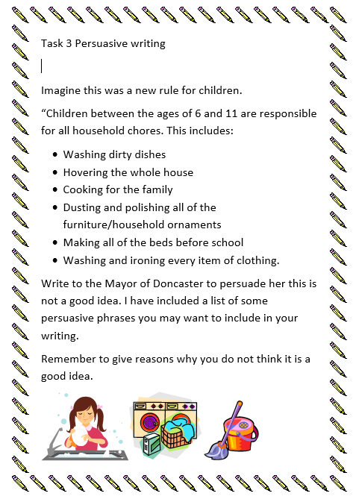
Finally, some topic activities for the week
SCIENCE
Link to the websites and try out he Science investigations
They use things that you may have in the kitchen cupboards.

Invisible ink.
It uses things like vinegar or lemon juice to write a secret message on paper that when it dries it cannot be seen.
When ink /paint is placed over it the message it reappears. You could write secret codes. Have a go https://www.thoughtco.com/make-your-own-invisible-ink-605973

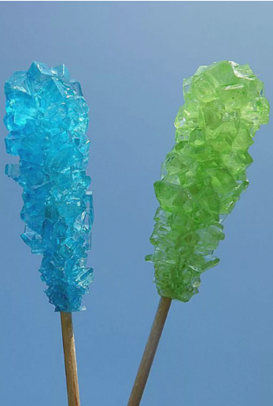
ROCK CANDY CRYSTALS
You will need a grown up to help with this and you will need to be patient to wait for it to work.
It is making a syrup solution, cooling it and then putting the solution in a jar, dangling some string into the sugar solution and the solution will form crystals on the string. If you can remember it is like the salt crystals we made in class.
https://www.thoughtco.com/how-to-make-rock-candy-607414

SLIME – watch the video also and test out your material you made with the corn flour and water.
Is it a solid or is it a liquid?
This investigation is making a type of slime that sometimes is runny and then other times seems hard.
It’s made with corn flour and water
https://www.thoughtco.com/easy-recipe-to-make-oobleck-605996

Bouncing egg
Make a hard-boiled egg bounce
Investigate how acid such as vinegar changes the consistency of an egg.
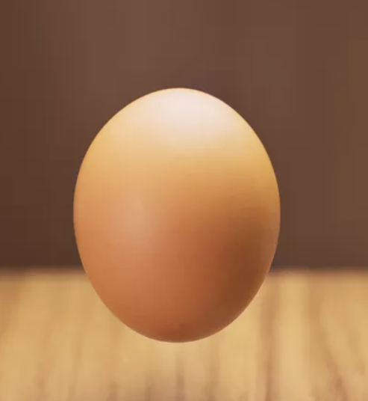
Does a hard-boiled egg bounce?
What about after the investigation?

https://www.thoughtco.com/rubber-egg-and-chicken-bones-608246

Write about one of your investigations using the sheet below.

Title – what is your investigation finding out?
Equipment ( drawings with labels or a list)

Method ( what did you have to do?)

Results - what happened

Conclusion - Do you know why this happened?

FRENCH
Read through and learn about the names of food. You should recognise names of numbers from learning about these in school and earlier Learning Pack. I have included a poster just in case you have forgotten the numbers.
Write the sentences in French to say
If you can print out, you could stick the pictures next to your sentences or draw a picture.
‘I would like ---------------------------- please.
Je voudrais _____________________________s’il vous plait.

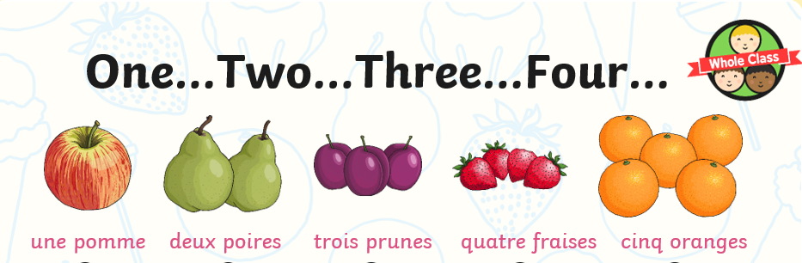

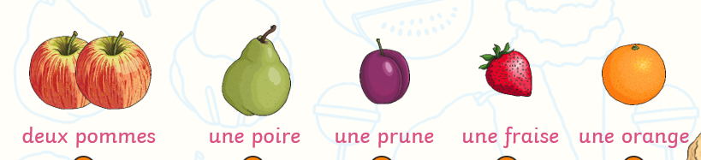

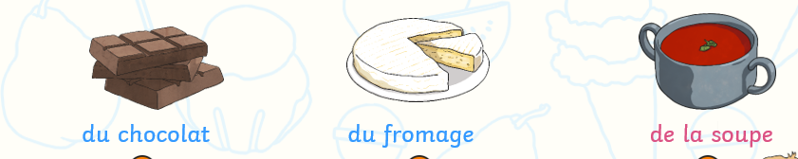
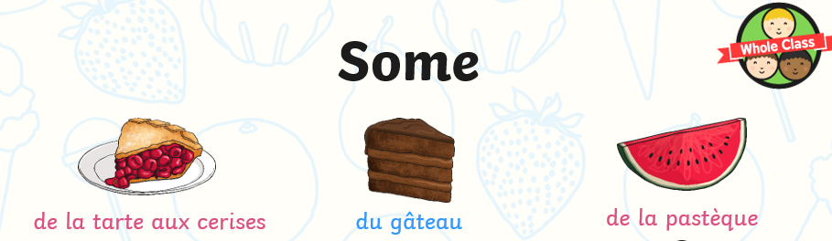
some cherry pie ( tart) some gateaux ( cake) some watermelon
some chocolate some cheese some soup

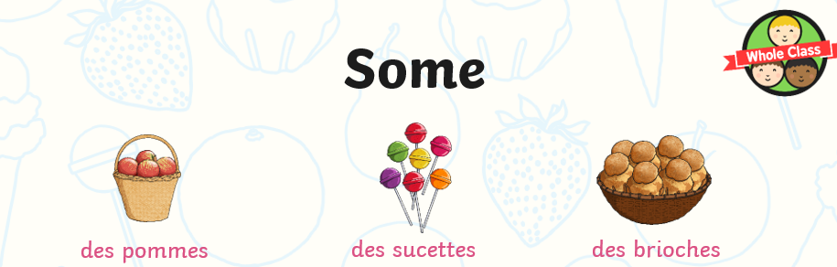
some apples some lolly pops some sweet bun
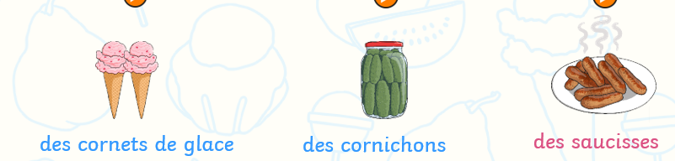
some ice-cream cornets some gerkins some sausages
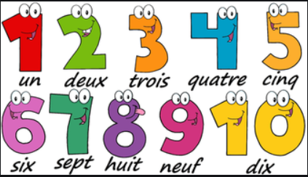

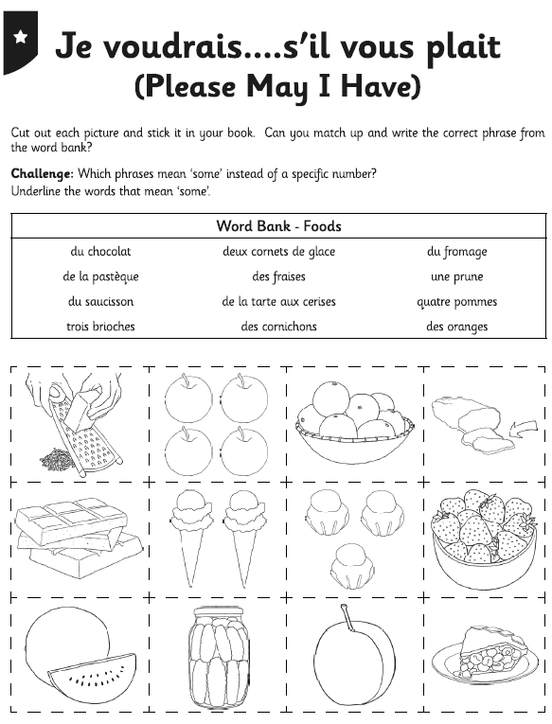

------------------------------------------------------------------------------------------------------------------------------------------------------------------------------------------------------------------------------------------------------------------------------------------------------------------------------------------------------------------------------------------------------------------------------------------------------------------------------------------------------------------------------------------------------------------------------------------------------------------------------------------------------------------------------------------------------------------------------------------------------------------------------------------------------------------------------------------------------------------------------------------------------------------------------------------------------------------------------------------------------------------------------------------------------------------------------------------------------------------------------------------------------------------------------------------------------------------------------------------------------------------------------------------------------------------------------------------------------------------------------------------------------------------------------------------------------------------------------------------------------------------------------------------------------------------------------------------------------------------------------------------------------------------------------------------------------------------------------------------------------------------------------------------------------------------------------------------------------------------------------------------------------------------------------------------------------------------------------------------------------------------------------------------------------------------------------------------------------------------------------------------------------------------------------------------------------------------------------------------------------------------------------------------------------------------------------------------------------------------------------------
DT

Use this recipe from your reading task to make a wonderful fruit salad.
You can use any fruit.
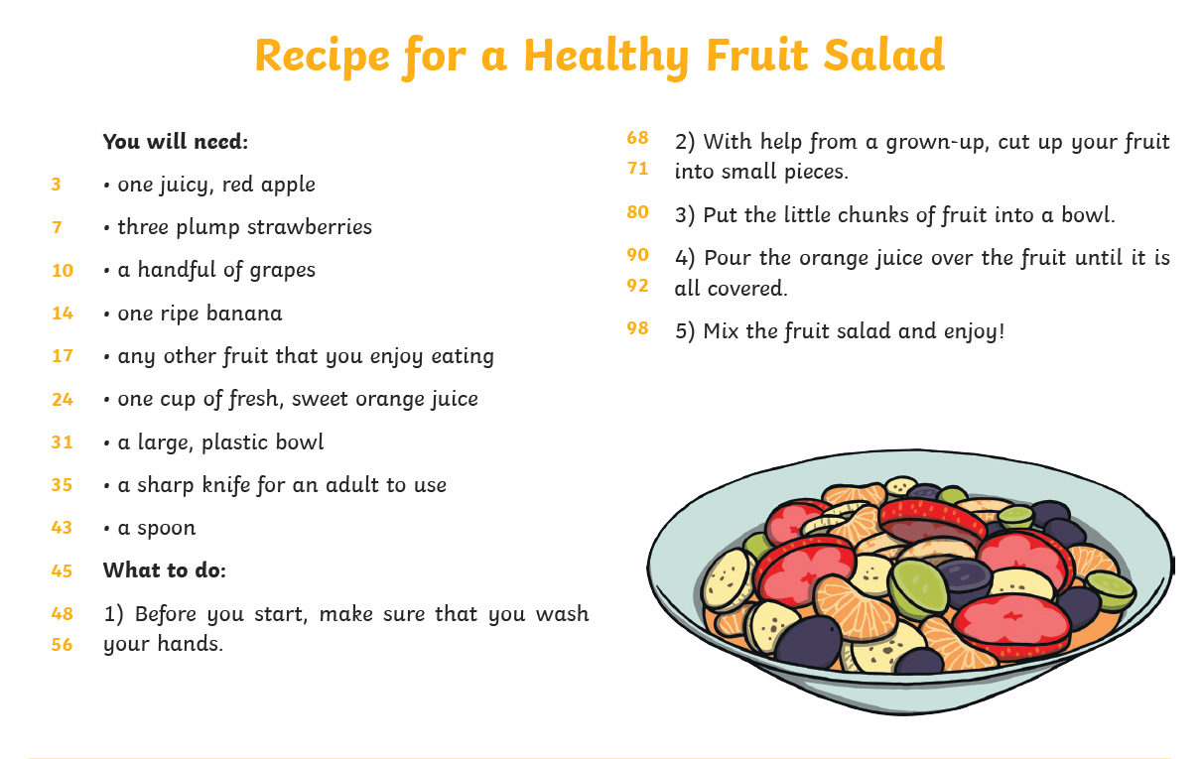

You could send me some pictures of what you create mrssmith@newvillage.doncaster.sch.uk

