Hello Everyone,
I hope you enjoyed last week’s learning.

I am missing you all.

Remember to stay safe I can’t wait to see you back at school.

If you want to contact me you can do at:
MrsSmith@newvillage.doncaster.sch.uk
You can attach any documents or photographs of work you complete.

Year 3
I had planned to have a week investigating and writing about Caterpillars and butterflies. However, on my travels I have not noticed many of either so this week we will look at Science investigations and French and DT/healthy eating.

Remember I changed the layout of the learning pack.
All the tasks for the week will be in one document. Just complete them through the week. Try to do a range of learning each day. There is no need to complete one task from every section each day, as I know lots of you are having great family times and making lovely memories to look back on.

Mrs Smith x

SPAG ACTIVITIES FOR THE WEEK
TASK 1 SPAG
USE SPELLING FRAME TO PRACTISE SOME WORDS WITH A SUFFIX ENDING.
USE YEAR 2 Spelling rule 17
https://spellingframe.co.uk/spelling-rule/94/17-The-sound-spelt-a-before-l-and-ll
Choose a game to play from spelling tiles.

You could play a different game each day to really practise the words.
Why not test yourself to see how well you have learnt the words?
Print off or write out/discuss answers.

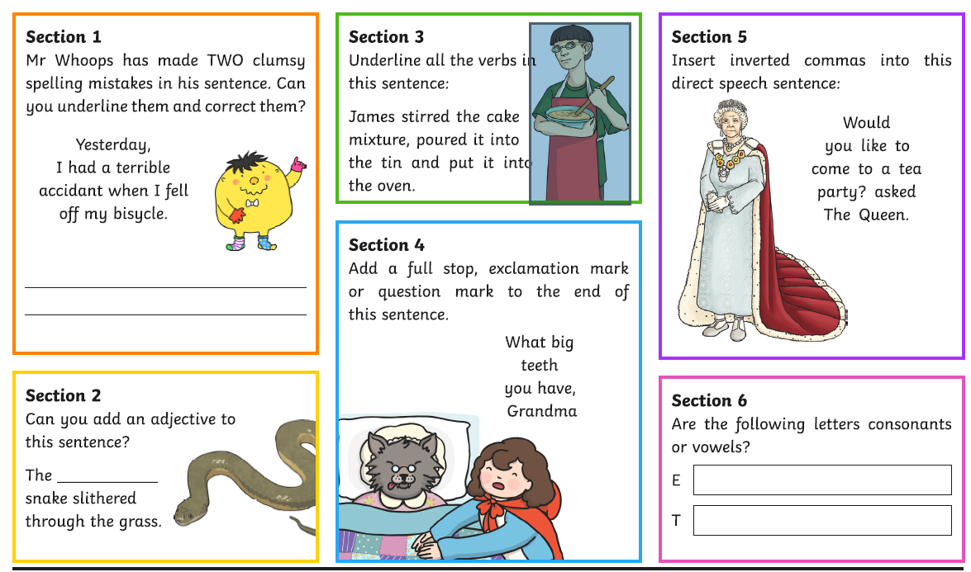
TASK 2
TASK 3
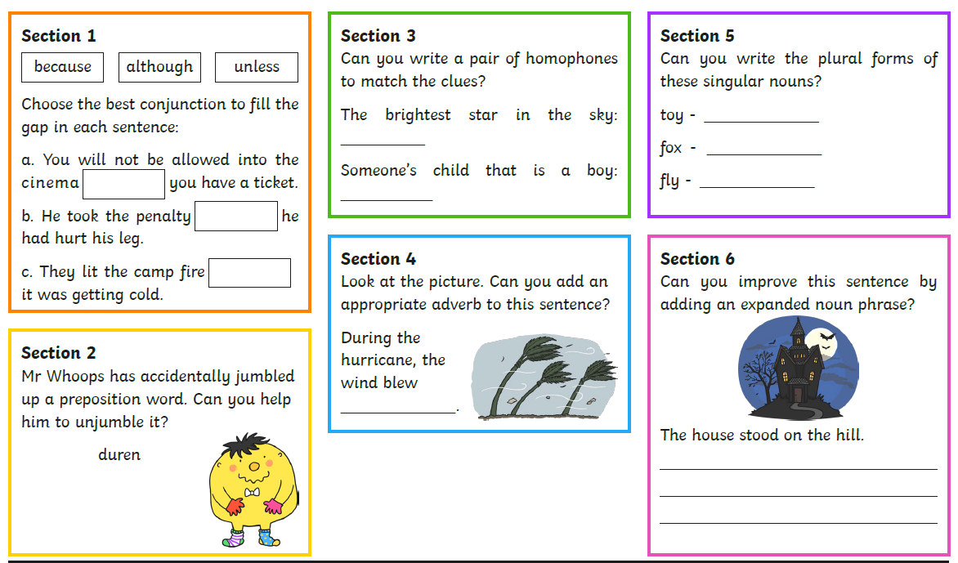

TASK 4
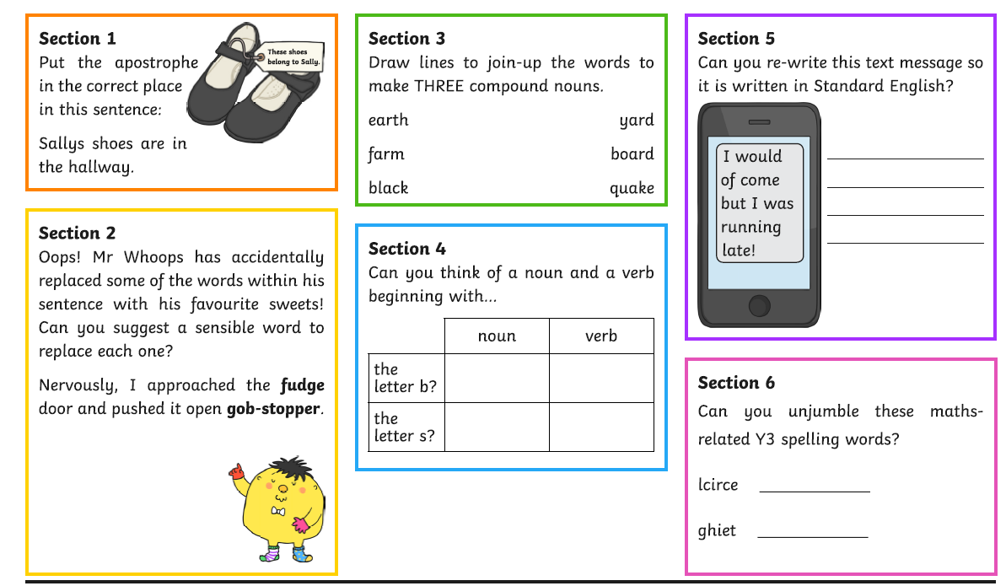

Reading task 1
Use the bbc resources to listen to two extracts ( part of the story) from
‘The Attack of the Demon Dinner ladies.’
https://www.bbc.co.uk/bitesize/articles/zncc92p
Discuss the questioning with your adult as the extracts are read.
Extract 1
- Do you know what Shepherd’s Pie is?
- Why did the children sit at the Packed Lunch table that day?
- What does the word ‘weird’ mean?
- Do you think Mrs Kidd is evil?
Extract 2
- Do you know what a cockroach is?
- Why is Maisie screaming at the beginning of this extract?
- Why does Izzy give Jodie a look?
- What type of a girl is Maisie?
Complete activity one
Read the extract

Extract 1
It all started on a Friday when we were on our way to school dinners.
We were walking down the stairs and that’s when Maisie said, 'That’s weird. I still can’t smell it.'
And it WAS weird because Maisie meant that she couldn’t smell the SHEPHERD’S PIE and Maisie ALWAYS smells the shepherd’s pie before we get to the dining hall when it’s Shepherd’s Pie Day. And we all knew that it was definitely Shepherd’s Pie Day because it was Friday, and the dinner ladies hadn’t served it yet this week, and they ALWAYS serve it at LEAST once a week, even though it’s stinking.
When we got to the dining hall me, Jodi, Zach and Maisie sat down at the Packed Lunch Table because we had packed lunches that day because we all hate the shepherd’s pie and Maisie is actually terrified of it.
One time, Mrs Kidd (the evil dinner monitor), tried to make Maisie eat the shepherd’s pie and Maisie fainted head first into it because Maisie faints most of the time when she’s scared.

Record information about Maisie
Find evidence in the text
What I Think About Maisie | How I Know (Evidence From The Extract)
Maisie –

READING TASK 2
Continuing from yesterday
https://www.bbc.co.uk/bitesize/articles/zncc92p

Extract 2
Maisie wouldn’t stop screaming about the EYEBALL WATER being on her sleeve so I had to take her jumper off and give her mine to wear so she wouldn’t faint, even though my jumper was FAR too big for her.
That’s when Jodi said, 'Do you think they were real eyes?' And I gave Jodi a LOOK because I had just managed to calm Maisie down and didn’t want her to go all wobbly again.
But then Maisie said it was OK to talk about the eyes, because she wanted to know what was going on so she could decide if she needed her mum to write her a note to say she wasn’t allowed to go to the dining hall ever again.
Zach said that the eyes had looked like tiny black, beady animal eyes and we all agreed that they had.
And Jodi said that they were probably COCKROACH EYES. And then Maisie had to put her head between her knees for ages until she started breathing normally again.
Nobody was sure what to do next so we decided to wait until lunch the next day to see if the eyes were in our water jug again.
- Read the second extract and think about what happens.
- Number the events 1-5 in the order that they happened.
Event | Number
Maisie put her head between her knees
Maisie began to scream
Zach said the eyes looked tiny and beady
Izzy gave her jumper to Maisie
Jodie asked if the eyes were real

READING TASK 3
Read and answer questions
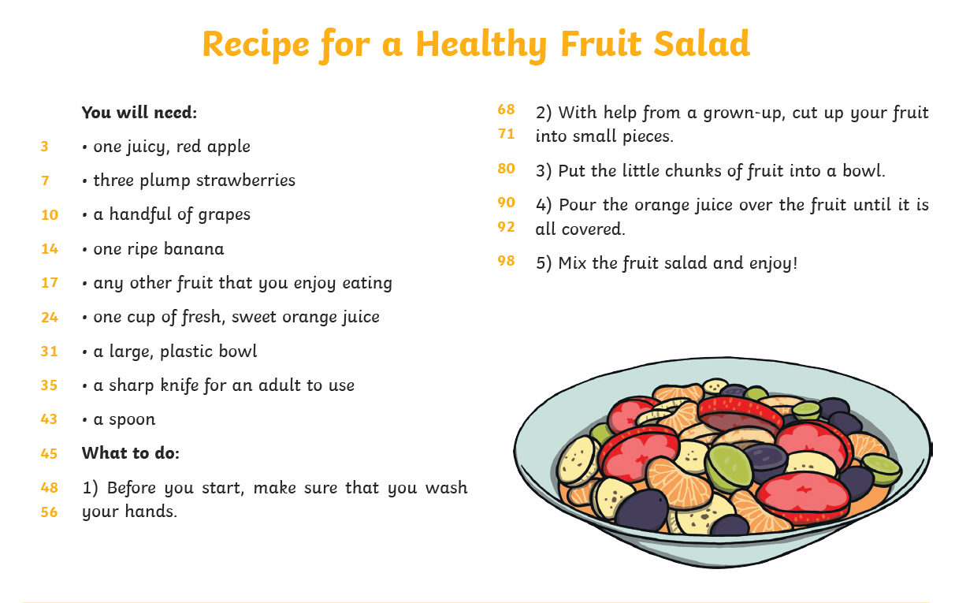

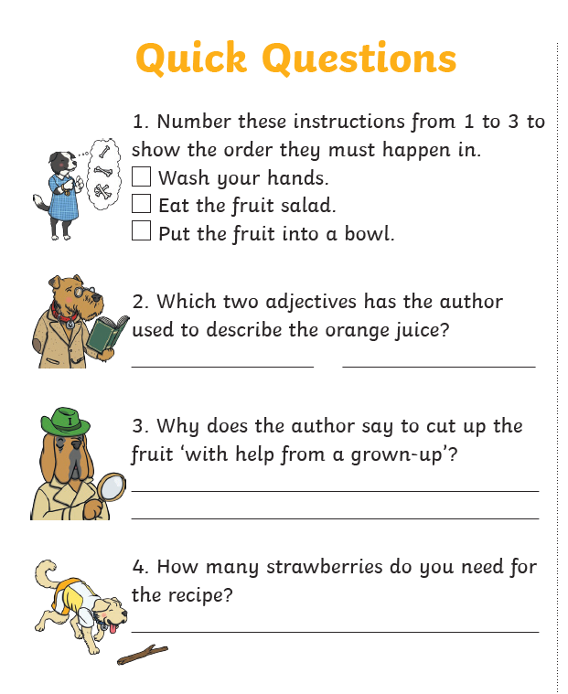

READING TASK 4 and 5
READ FOR PLEASURE
Choose your most favourite book and share with someone in your family.
You could even ask them questions about what you read.
Stories can also be accessed through the links below.
https://www.storylineonline.net/ ( read to you )
http://www.magickeys.com/books/invis-allig/page6.html#pictop
(for you to read)
https://www.freechildrenstories.com/ ( choose from a range of ages and genre)

MATHS ACTIVITIES FOR WEEK
TASK 1
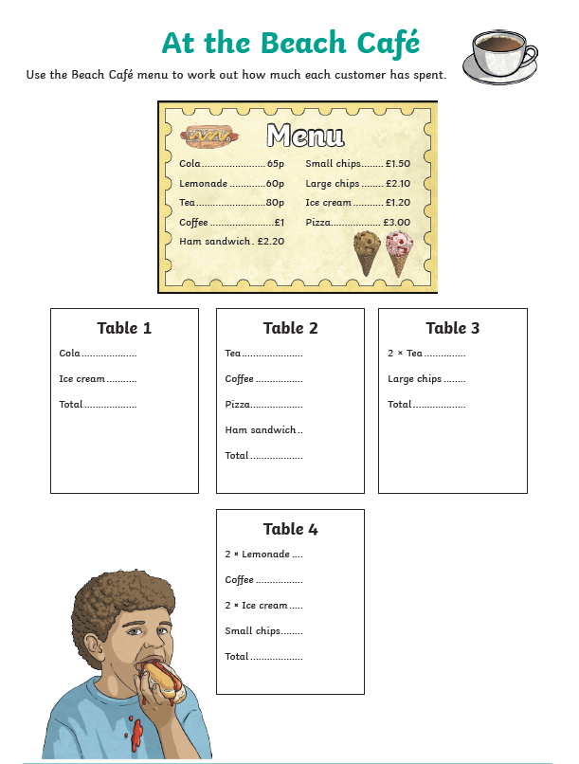
Here are some activity sheets for you to have a go at throughout the week. Print off or write calculations down. Talk about your learning with an adult.
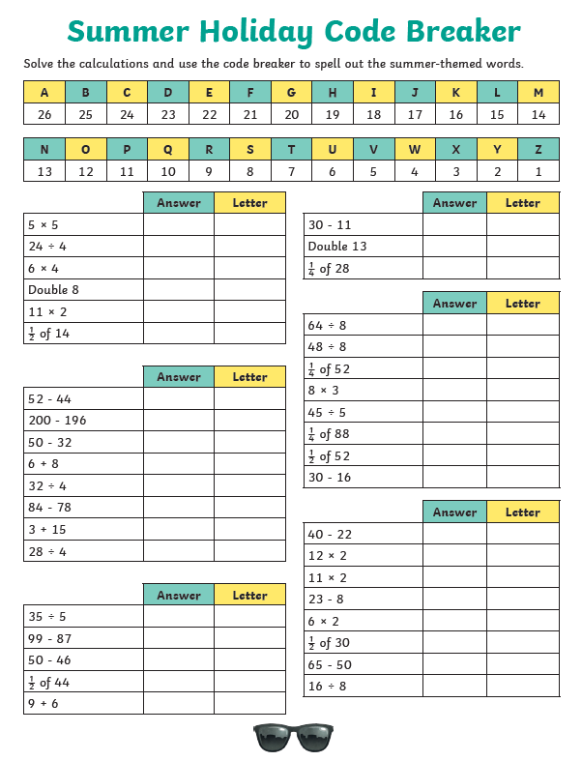
MATHS TASK 2

--------------------------------------------------------------------------------------------------------------------------------------------------------------------------------------------------------------------------------------------------------------
MATHS TASKS 3
Use the pictures to practise fractions discuss/write out answers.
How many circled out of how many altogether. Remember the whole number of things is the denominator (bottom of the fraction). The part is the numerator (top of the fraction).
A fraction sentence is shown in the first picture.
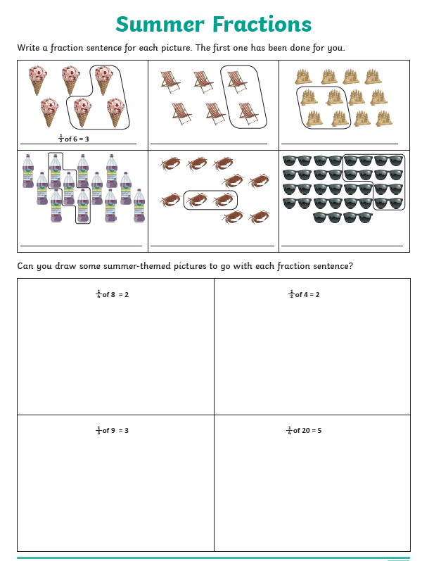

Rest of week
Remember to log onto Times tables Rock stars
Play 5 games of Studio
Have a go at some tournaments
Can you link with anyone you know?

Have a speed test with someone in your house. One person asks the questions and other have to get answer.

Make some snap cards
Some with the questions on, some with the answers. Turn upside down and play snap. Play find doubles turning all the cards upside down and taking in turns with people in your house to find two cards that link…..no cheating though!!

WRITING FOR THE WEEK
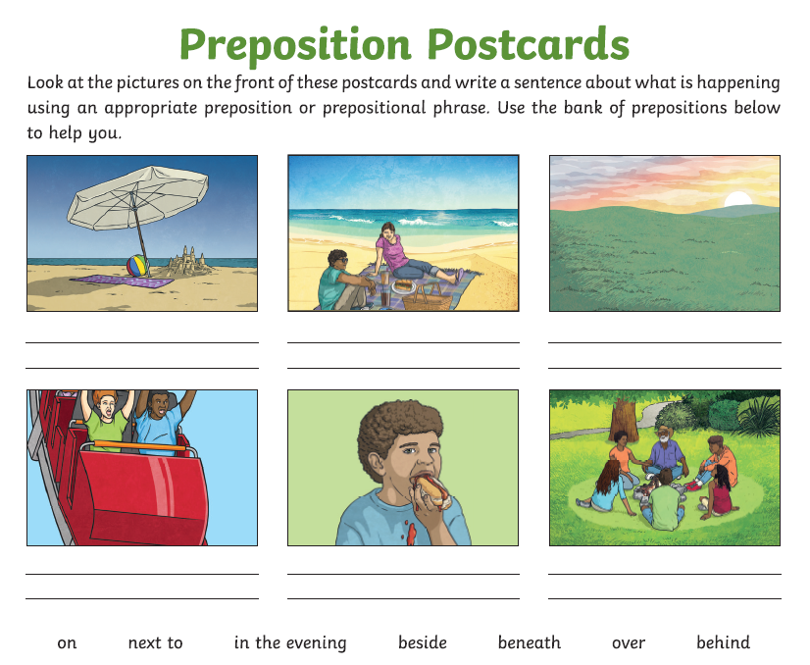
Write a postcard of your own to tell your teacher about your dream holiday.
Where would you be?
What would be there?
What would you do?
Why would you take with you?

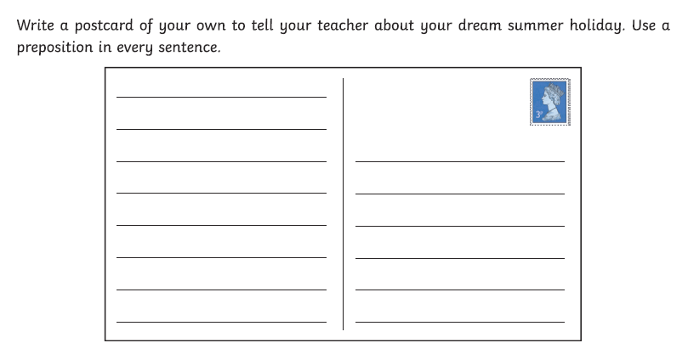
TASK 2
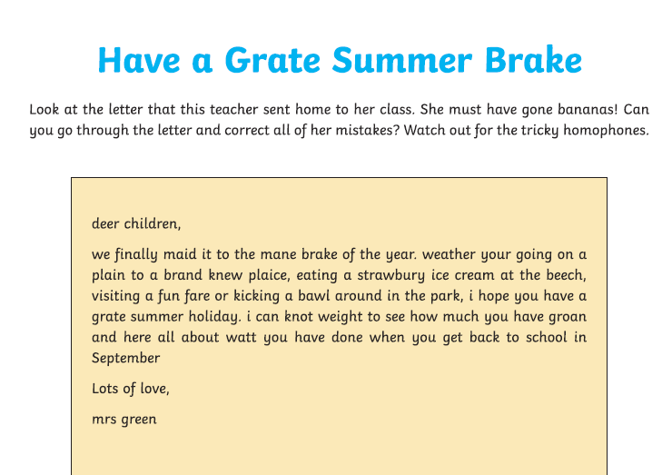

__________________________________________________________________________________________________________________________________________________________________________________________________________________________________________________________________________________________________________________________________________________________________________________________________________________________________________________________________________________________________________________________________________________________________________________________________________________________________________________________________________________________________________________________________________________________________________________________________________________________________________________________________________________________________________________________________________________________________________________________________________________________________________________________________________________________________________________________________________________________________________________________________________________________________________________________________________________________________________________________________________________________________________________________________________________________________________________________________________________________________________________________________________________________________________________________________________________________________________________________________________________________________________________________________________________________________________________________________________________________________________________________________________________________________________________________________________________________________________________________________________________________________________________________________________________________________________________________________________________________________________________________________________________________________________________________________________________________________________________

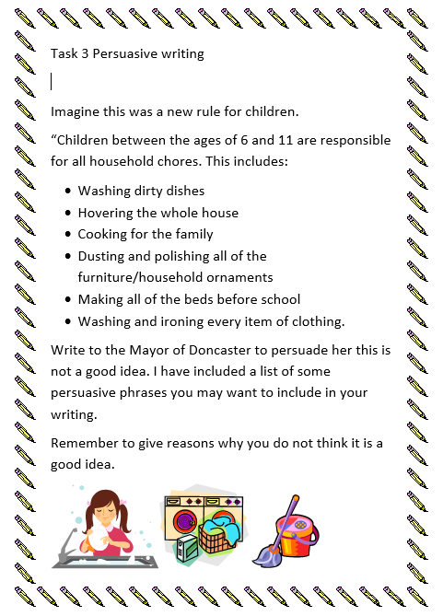
Task 3

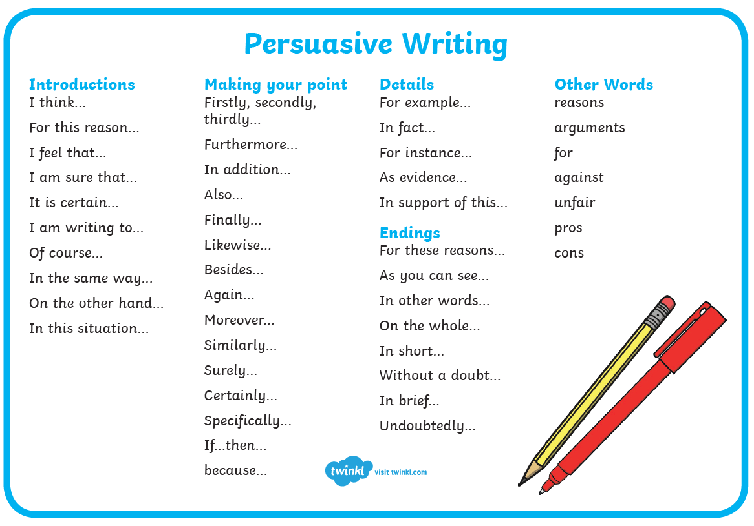

Task 4

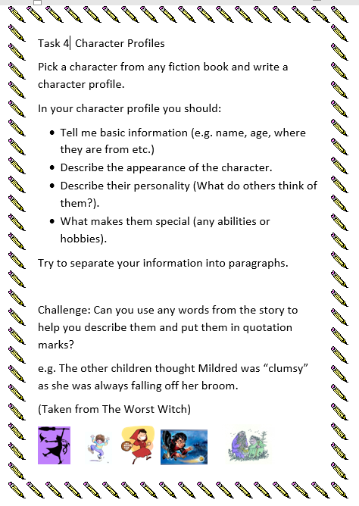
Finally, some topic activities for the week
SCIENCE
Link to the websites and try out he Science investigations
They use things that you may have in the kitchen cupboards.

Invisible ink.
It uses things like vinegar or lemon juice to write a secret message on paper that when it dries it cannot be seen.
When ink /paint is placed over it the message it reappears. You could write secret codes. Have a go https://www.thoughtco.com/make-your-own-invisible-ink-605973

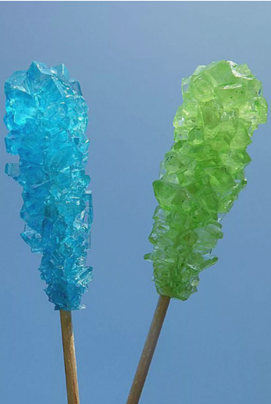
ROCK CANDY CRYSTALS
You will need a grown up to help with this and you will need to be patient to wait for it to work.
It is making a syrup solution, cooling it and then putting the solution in a jar, dangling some string into the sugar solution and the solution will form crystals on the string. If you can remember it is like the salt crystals we made in class.
https://www.thoughtco.com/how-to-make-rock-candy-607414

GLOOP – watch the video also and test out your material you made with the corn flour and water.
Is it a solid or is it a liquid?
This investigation is making a type of goo that sometimes is runny and then other times seems hard.
It’s made with corn flour and water
https://www.thoughtco.com/easy-recipe-to-make-oobleck-605996

Bouncing egg
Make a hard-boiled egg bounce
Investigate how acid such as vinegar changes the consistency of an egg.
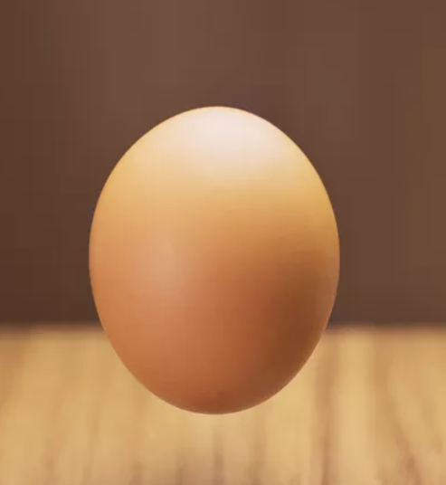
Does a hard-boiled egg bounce?
What about after the investigation?

https://www.thoughtco.com/rubber-egg-and-chicken-bones-608246

Write about one of your investigations using the sheet below.

Title – what is your investigation finding out?
Equipment ( drawings with labels or a list)

Method ( what did you have to do?)

Results - what happened

Conclusion - Do you know why this happened?

FRENCH
Read through and learn about the names of food. You should recognise names of numbers from learning about these in school and earlier Learning Pack. I have included a poster just in case you have forgotten the numbers.
Write the sentences in French to say
If you can print out, you could stick the pictures next to your sentences or draw a picture.
‘I would like ---------------------------- please.
Je voudrais _____________________________s’il vous plait.

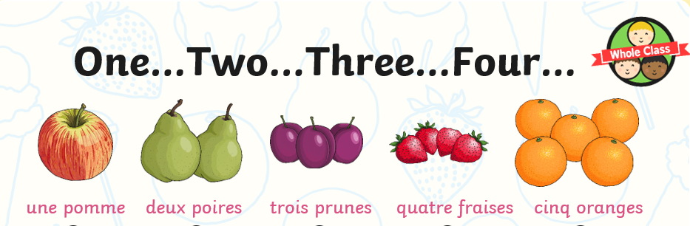

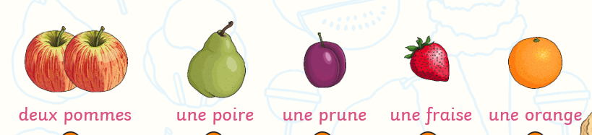

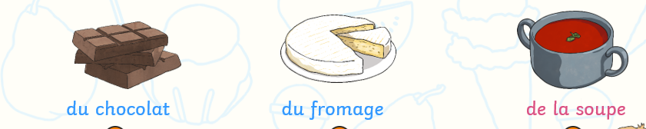
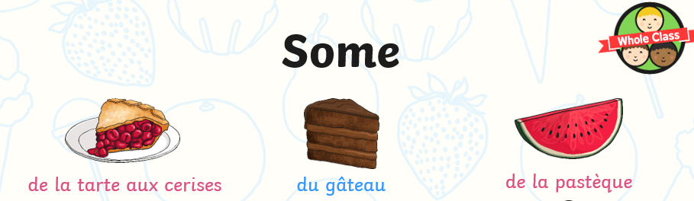
some cherry pie ( tart) some gateaux ( cake) some watermelon
some chocolate some cheese some soup

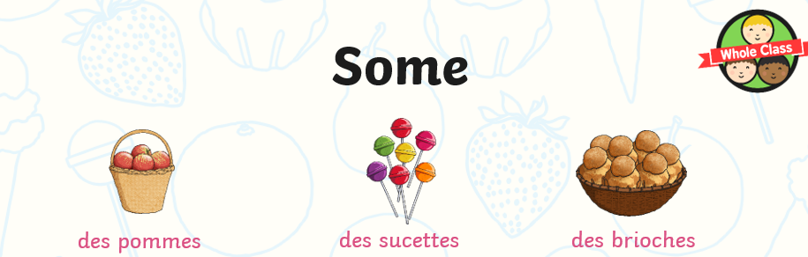
some apples some lolly pops some sweet bun
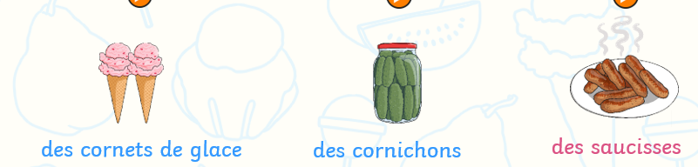
some ice-cream cornets some gerkins some sausages
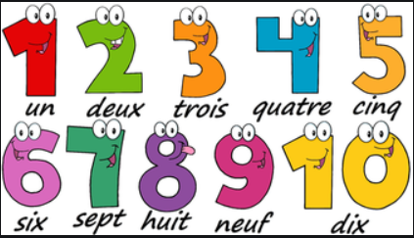

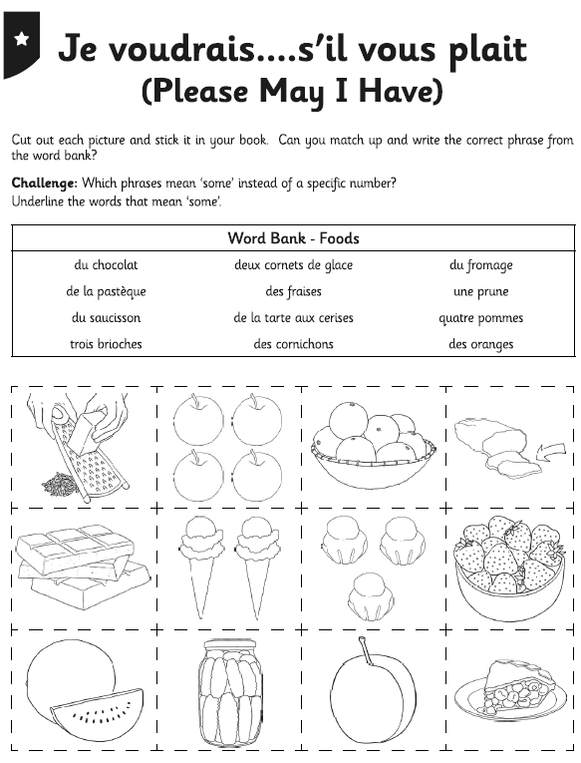

------------------------------------------------------------------------------------------------------------------------------------------------------------------------------------------------------------------------------------------------------------------------------------------------------------------------------------------------------------------------------------------------------------------------------------------------------------------------------------------------------------------------------------------------------------------------------------------------------------------------------------------------------------------------------------------------------------------------------------------------------------------------------------------------------------------------------------------------------------------------------------------------------------------------------------------------------------------------------------------------------------------------------------------------------------------------------------------------------------------------------------------------------------------------------------------------------------------------------------------------------------------------------------------------------------------------------------------------------------------------------------------------------------------------------------------------------------------------------------------------------------------------------------------------------------------------------------------------------------------------------------------------------------------------------------------------------------------------------------------------------------------------------------------------------------------------------------------------------------------------------------------------------------------------------------------------------------------------------------------------------------------------------------------------------------------------------------------------------------------------------------------------------------------------------------------------------------------------------------------------------------------------------------------------------------------------------------------------------------------------------------

Use this recipe from your reading task to make a wonderful fruit salad.
You can use any fruit.

You could send me some pictures of what you create mrssmith@newvillage.doncaster.sch.uk

