Hello everyone! It’s Miss Shaw here, I have put together some learning activities that you can do at home. I hope that you are all safe and well, and that you are enjoying the time with your family.
There is no need to print anything out, so do not worry if you don’t have a printer, just talk through the work with someone at home.

Start your day with a song and get moving!

https://www.outoftheark.co.uk/ootam-at-home/?utm_source=homepage&utm_campaign=ootamathome2&utm_medium=banner
Log on to the above website. Here you will find lovely songs to sing, just like the ones that we use at school.

Choose a song
Listen to it all the way through and spot any repetition
Join in with the song the 2nd time through, following the words on screen.
Make up your own actions or even dance moves, and don’t forget to follow the links for other activities related to each song

This week, I’ve been singing “Clap hands, stamp feet!” from the “Get moving” section, it is a great way to star your day!

What do bees say in the summer?

“Swarm, isn’t it?!!”

3 listening and comprehension activities…
Nadia Shireen is one of my favourite authors. Why not listen to her reading her stories and talking about her books. Then have a go at answering some of the questions – you do not need to write the answers down, just talk to your adult about them.
The Bumblebear | Nadia Shireen talks about being an author | Billy and the beast
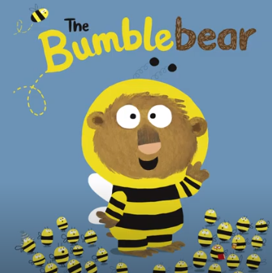 | 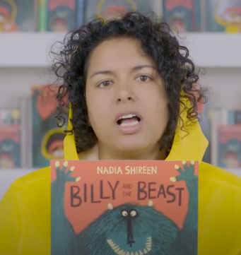 | 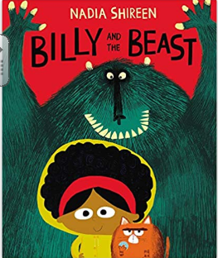
https://www.youtube.com/watch?v=o6ZaSM6sNGw | https://www.youtube.com/watch?v=jqVZHXSgk1I | https://www.youtube.com/watch?v=jMUHqVyJ5yk  Here is the whole story………………  https://www.youtube.com/watch?v=EAtuoQr5x8M
- What did Norman want to be and why?  - Where did Norman tell the bees that he came from?  - Can you remember 3 things that Norman did at bee school?  - Can you remember 3 things that the bees learned to chase away?  - Why do you think that Amelia took Norman to the secret honey store?  - At the end of the story, how did Norman save the day?  - Do you think it was windy that day? | - What is Billy and the beast all about?  - Who is Billy based on?  - What is Nadia’s favourite moment in the book?  - Why do you think that Nadia won’t tell you more about her favourite part of the story? | - Who did Billy and fat cat say hello to?  - What was making the rumbling noise?  - What did Billy take out of her hair for fat cat?  - Who had taken fox, hedgehog, the mice and the bunny rabbits?  - When everything went black, what had happened to Billy and fat cat?  - What was the beast hoping to make using his recipe?  - Why did Billy draw spots on the mice?
Hands on maths…Here are three activities for you to do with your adult this week. Please have a go…
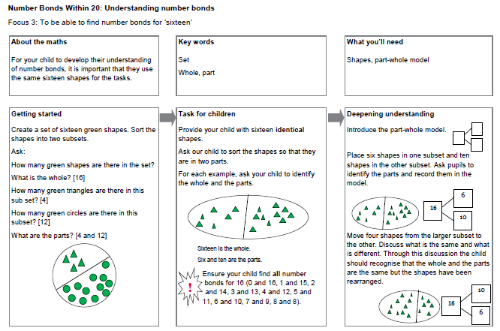
Finally, 3 “bee” themed activities for the week……
Take a look at the following activities and give them a go!
Design Technology | Science | Art
For inspiration, watch the clip below about how to make a bee hotel for solitary bees in your garden.  https://www.youtube.com/watch?v=LS_5rntNexo  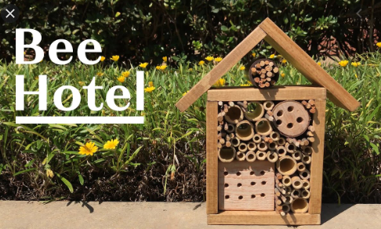  When you have watched the clip, see what natural materials you have in your garden that might be useful and design your very own bee hotel. You don’t need special tools, just imagination.  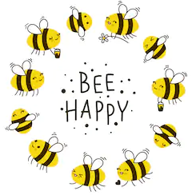 | 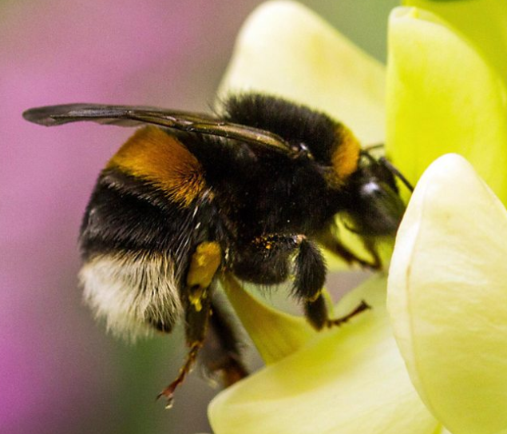  Watch the Blue Peter clip all about bees by following the link below.  https://www.bbc.co.uk/cbbc/watch/bp-all-about-bees  What else can you find out about bees?  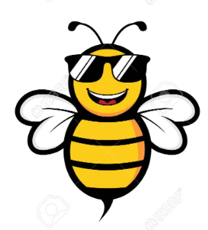 | https://www.youtube.com/watch?v=Ho4aUHY6fss  Follow the link above to see how to draw a realistic bee. Remember that you can pause the clip at any time….. you don’t have to rush. All you need is a pencil and some paper. You may want to colour it when you have finished.

