Y3S - Home Learning
Dear Y3S, since we are not able to be together at school at the moment, I have put together some more learning activities that you can complete with your adults at home. Some activities can be printed and there are also some on-line links that may be helpful. I hope that you are all well and look forward to being back together as soon as we can. Miss Shaw
Daily Activities:
 | Activity
9.00 | PE | Take a look at the NETFLEX powerpoint, open it up and choose a link to an exercise of your choice……..superhero….frozen…….Joe Wickes…….anything you like!  You will find the instructions below.
Activity 1 | Maths  (30 mins) | Follow the link below to find daily BBC bitesize Maths activities  https://www.bbc.co.uk/bitesize/tags/zmyxxyc/year-3-and-p4-lessons/1
Activity 2 | Times tables  (15 mins) | Log in to Splat 100 square and splat your counting patterns.  https://www.primarygames.co.uk/pg2/splat/splatsq100.html  Monday 2’s  Tuesday 4’s  Wednesday 8’s  Thursday 3’s  Friday 6’s  For each daily pattern count it forwards and backwards….as a challenge, can you count them forwards then backwards with your eyes closed?  Then log into TTRS and complete 10 minutes of practice on the studio section.  Studio helps you to extend your learning as you are using all the times tables.
Activity 3 | Spelling  (10 mins) | Write the spellings for this week just like we do every day in the classroom. Remember LOOK / COVER / WRITE / CHECK  LOOK at the word carefully  COVER the word  WRITE it from memory  CHECK your spelling  Then use the words in a sentence – if you are not sure of the meaning you can ask an adult / check it in a dictionary / check using an on-line dictionary.  The words that I have selected this week all end with the suffix –al  lecture  literature  mature  miniature  mixture  moisture  sculpture  signature  temperature  texture
Activity 4 | Handwriting  (5 mins) | Use the prepared line guide or just a piece of paper to write the joins used in our selected spellings.  ture
Activity 5 | English  (30 mins) | Follow the link below to find daily BBC bitesize English activities  https://www.bbc.co.uk/bitesize/tags/zmyxxyc/year-3-and-p4-lessons/1
Activity 6 | (30 mins) | Look at the other learning opportunities listed below and select one to do each day!

Other learning opportunities
Choose an activity each day

Last week there was a great deal to learn about animals from around the worlds.
So, this week our learning pack continues to be all about wonderful animals. Check out these amazing animal facts below……

https://www.natgeokids.com/uk/discover/animals/general-animals/ten-facts-about-orang-utans/

https://www.natgeokids.com/uk/discover/animals/general-animals/spotted-hyena-facts/

https://www.natgeokids.com/uk/discover/animals/general-animals/ten-hippo-facts/

Music | https://www.outoftheark.co.uk/ootam-at-home/?utm_source=homepage&utm_campaign=ootamathome2&utm_medium=banner  Log on to the above website. Here you will find lovely songs to sing, just like the ones that we use every week in singing assembly.  Choose a song  Listen to it all the way through and spot any repetition  Join in with the song the 2nd time through, following the words on screen.  Make up your own actions or even dance moves, and don’t forget to follow the links for other activities related to each song  This week, I’ve been singing “Living and learning” again from the “Sing in every subject” and I noticed that it has an African musical beat. This song made me think about all the wonderful animals around the world and how nature continues, whatever is happening in our lives.
Geography | Check out the links below to find out amazing facts about koalas, elephants and pandas  https://www.natgeokids.com/uk/discover/animals/general-animals/meerkat-facts/  https://www.natgeokids.com/uk/discover/animals/general-animals/zebra-facts/  https://www.natgeokids.com/uk/discover/animals/general-animals/black-bear-facts/  Where in the world would you find these creatures and what type of habitat do they need?
Art | Have you ever wanted to be able to draw a cheetah or a rattlesnake? Click on the links below…remember you can pause it at any time.  https://www.youtube.com/watch?v=6f2ZldW1sOI  https://www.youtube.com/watch?v=MBzd0piFzR4  All you need is a pen a paper and maybe some coloured pens!
ICT | Send me an email to the address below and include an emoji to let me know how you feel. Some people like to include a photograph of something that they have made or something enjoyable that they have done. It is really great to hear about what you have all been doing.  MissShaw@newvillage.doncaster.sch.uk
PSHE | London zoo is a very famous zoo in our capital city. Take a virtual tour of the zoo by clicking the link below and see some of the animals being fed. Why not click on the 2nd link and plan a visit with your family and think about all the wonderful things that you could see there.  https://www.zsl.org/zsl-london-zoo/virtual-london-zoo  https://www.zsl.org/london
History | Did you know that Jumbo the elephant was the first international animal superstar. Click on the links below to find out more….  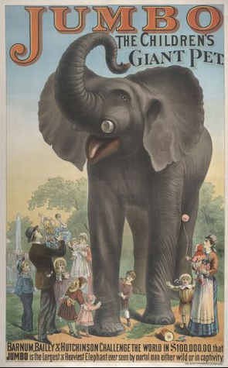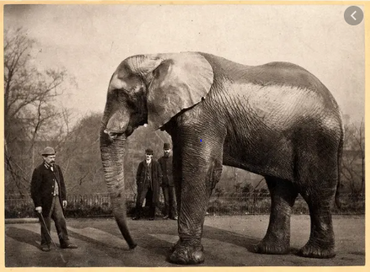  https://www.museumoflondon.org.uk/discover/meet-beast-jumbo-elephant#/  https://kids.kiddle.co/Jumbo
DT | Why not have a go at designing your very own model zoo. You can use everyday materials that you can find around your home. Don’t forget the different types of enclosures that you would need to make the animals feel safe and comfortable. You could even use some model animals to put in it once you have finished.  You can then design posters for your zoo, tickets and leaflets……the opportunities are endless!  If you had a go at this activity last week, you could add to what you made. You could even photograph your toy animals in their enclosures and design a leaflet to advertise your zoo. Make sure to tell people how you would care for the animals and what food they like to eat.
Science | https://www.youtube.com/watch?v=GfCRaUXlfiw  Click on the link from last week to find out about animal classifications. Can you think of two creatures that belongs to each group? Use the diagram below to record your ideas or make your own diagram on a piece of paper.  Click on the link below to see human and animal skeletons in action!  https://www.bbc.co.uk/bitesize/clips/ztfnvcw
Exercise outdoors a little bit each day. Set yourself a daily challenge! |  | A zoom night in!  Connect with friends and family online.

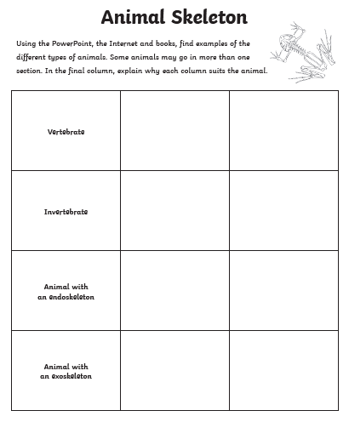

Use the lines below to write a sentence using each of these words – remember to use

your joined handwriting

