Hello to all super Year 1 class,
I hope you enjoyed he activities in the learning pack last week.
Here are some more for you to work through for this week.
Mrs Hemmingway says” Hello, and she misses you all”.

We hope that you are all having fun, enjoying your time and making memories with your adults.
We are hoping for the sunshine to return.
There is a work pack here for you to have a go at. There is no need to print anything out so do not worry if you don’t have a printer, just talk through the work with your adult or write things on paper or even on the computer.

Don’t forget you can send me some pictures of your work
Mrssmith@newvillage.doncaster.sch.uk
I am sure Mrs Hemmingway would love to see how you are getting on CC her into the email.
Mrshemmingway@newvillage.doncaster.sch.uk

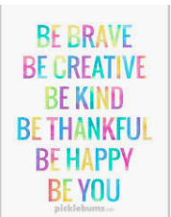

Spelling, Grammar and Punctuation
Use the link below for spelling frame
There is no need to log in or to register.
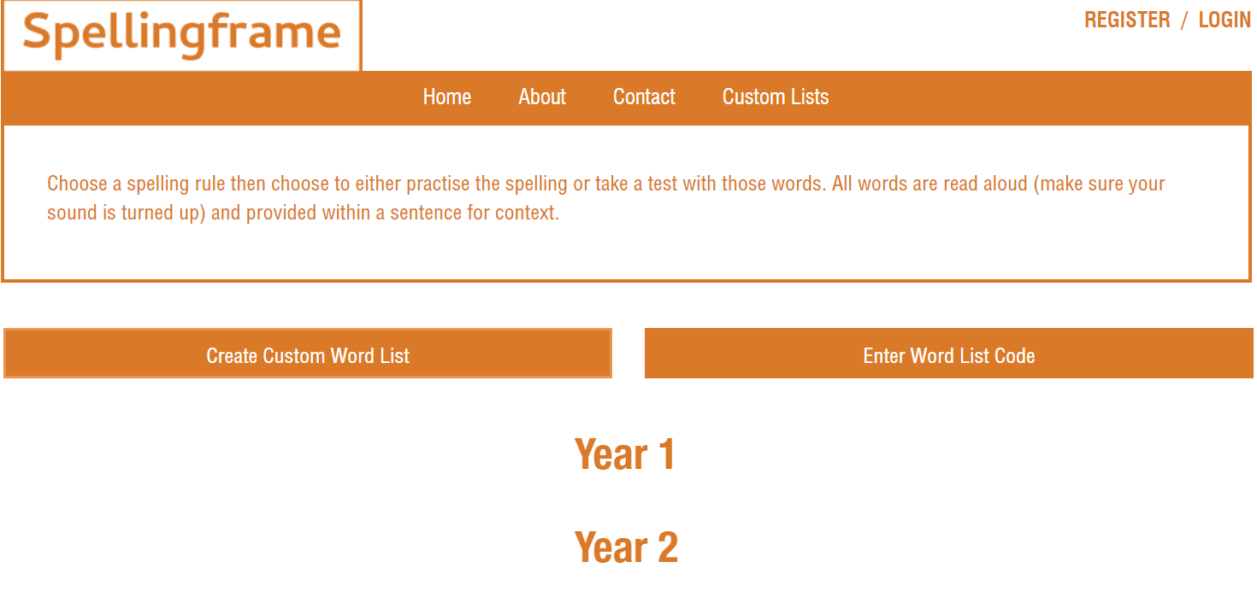
Click into Year 1
Task 1/ Task 2 - Choose spelling list 33 common exception words.
Task 3 /Task 4 – Choose spelling list 34 Common exception words
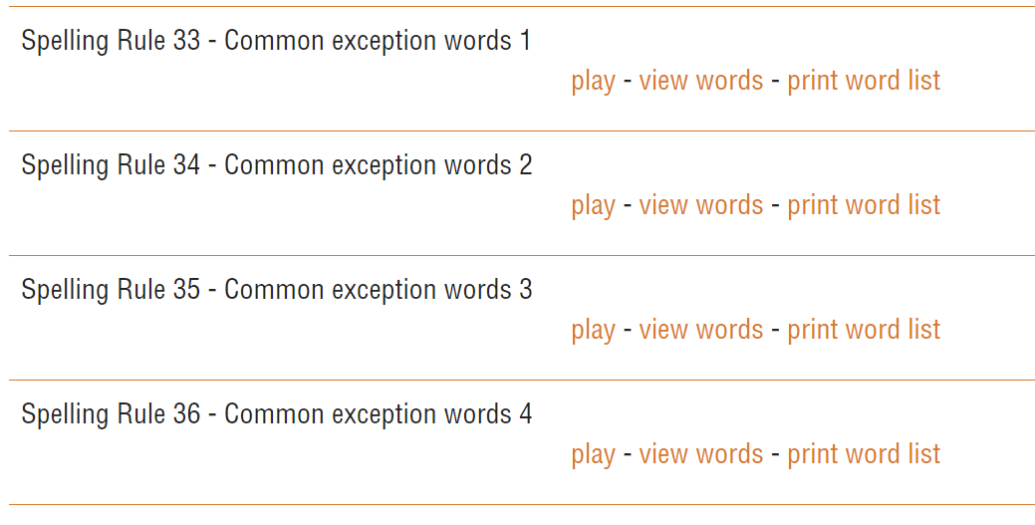
View and read words with an adult
Choose spelling times and a game to practise the words.
Reading /Retrieval/prediction and some inference
3 watching/listening and comprehension activities…
I have three more stories for you to listen to this week. Look at the picture of the front cover (to get a clearer picture of front cover- follow the link and pause before story begins) and talk about what you think will happen in the story.
Then ask your adult to ask questions about the story. Some are given as a start below.
If you prefer you could read story books that you have at home.
Clark the Shark | Harry the dirty dog | No more noisy nights
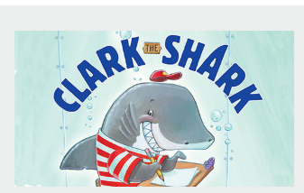 | 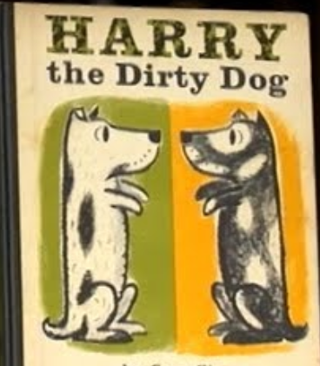 | 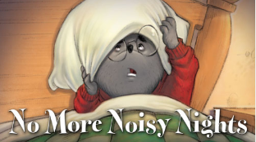
https://www.storylineonline.net/books/clark-the-shark/  The link may have to be copied and pasted into the address bar.  Or can be accessed through typing Stories online into google. | https://www.storylineonline.net/books/harry-the-dirty-dog/  The link may have to be copied and pasted into the address bar.  Or can be accessed through typing Stories online into google. | https://www.storylineonline.net/books/no-more-noisy-nights/  The link may have to be copied and pasted into the address bar.  Or can be accessed through typing Stories online into google.
- What do you think will happen in the story?  - What did Clark the shark love to do?  - What did Clark the Shark think to school?  - What did the other kids say to Clark the Shark?  - Why did the other children not like to play with Clark?  - What did the teacher say the rule was?  - What did Clark tell himself ‘when teacher’s talking don’t go ______________?  - Who was the new ‘kid’ in school?  - What was the new game Clark made up with Sid the squid? | - What do you think will happen in the story?  - What did Harry not like?  - What did Harry do with the scrubbing brush?  - Why do you think he ran away?  - Why did Harry go back home?  - Why do you think the family did not recognise him?  - How did Harry get the family to realise it was Harry?  - What did Harry find in the garden?  - How did the little girl know the dog wanted a bath?  - How did the children know Harry was happy?  - What did Harry do after dinner? | - What do you think will happen in the story?  - What had Jackson been doing all day?  - What time did he go to bed?  - What noise did he hear?  - What did Jackson do because he was so tired?  - What was making the noise?  - What did Jackson put on the attic floor?  - What did Jackson do after breakfast?  - What was in the piano?  - What did Jackson wash his face with when he was too tired?  - How did Jackson keep his friends busy so he could go to sleep?

Extra activities linked to reading
Make Arnie the doughnut

MATERIALS —
Small white paper plates
Scissors
Paint, markers, or crayons
Confetti
Pipe cleaners (two per student)
Googly eyes
Black construction paper for mouth (for smaller children, pre-cut mouths
PROCEDURE —
Step 1: Cut out middle of paper plate to make Arnie

Step 2: Ice Arnie – use paints, crayons or markers to colour the paper plate
Sprinkles – add confetti ( small pieces of paper)

Step 3: Apply googly eyes and mouth using glue
Step 4: Cut one pipe cleaner in half – bend each piece to form feet. Glue to paper plate.
Cut the other pipe cleaner in half. Glue to paper plate for arms.

.

Make Harry the dirty dog.
Use him to retell the story
Harry 1
Use a cardboard tube and cover with white paper
Add small round dots of white or colour spots on
Cut out some ears and stick them to the sides.
Add googly eyes or stick some black paper ones on, add a mouth and nose.

Harry 2
(dirty Harry) Use a cardboard tube and colour black
Add small round dots of white
Cut out some ears and stick them to the sides.
Add googly eyes or stick some paper ones on, add a mouth and nose ( these will have to be red or pink to show up on black)
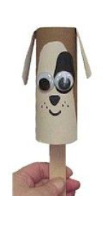

MATHS ACTIVITIES
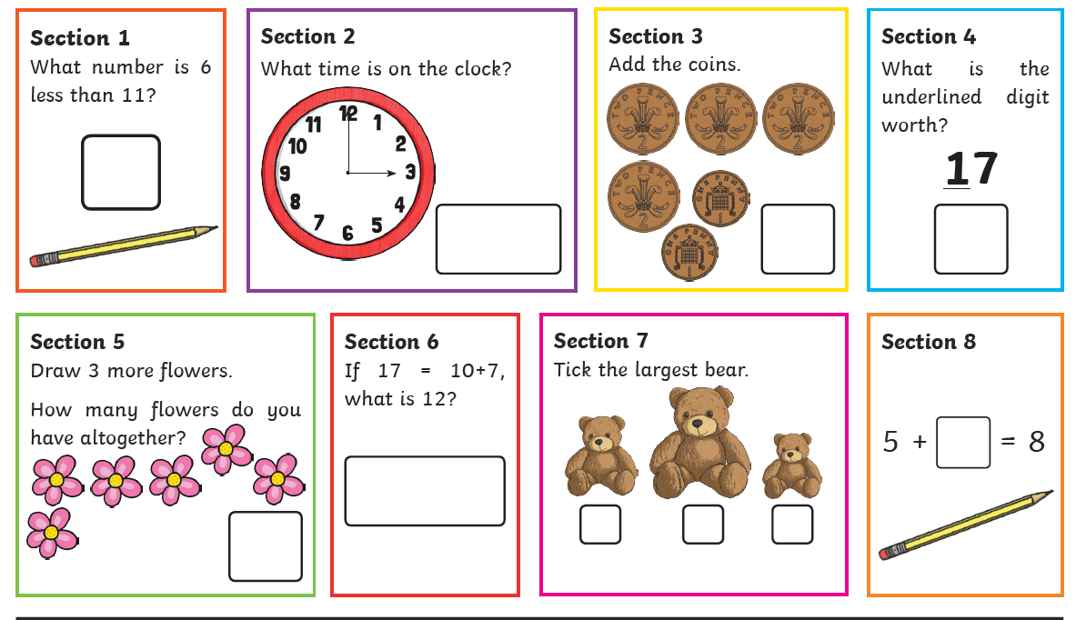
Here are three activity sheets for you to have a go at throughout the week. Print off or write calculations down. Talk about your learning with an adult.
TASK 2
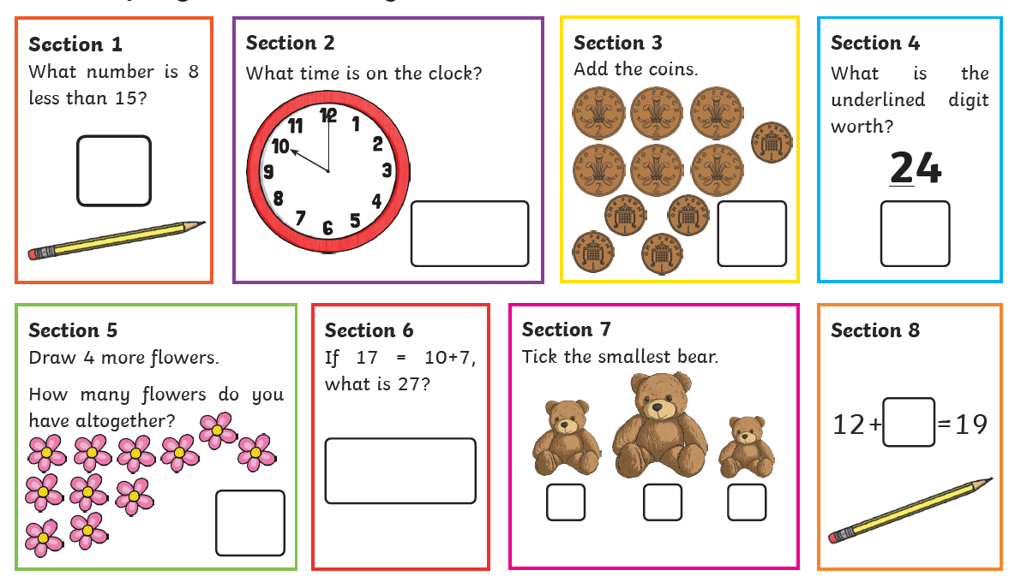

TASK 3
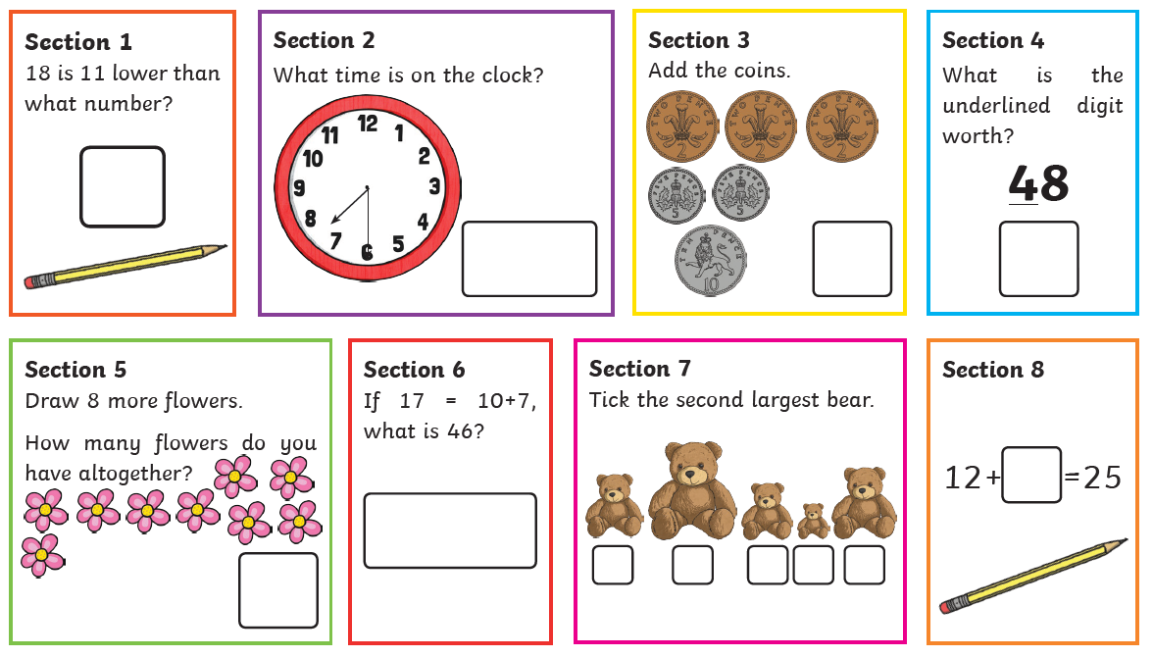

WRITING
This week to continue with Practising spellings.
Write a sentence using some of the spelling words you have practised.
Your sentences could be about:
Your most favourite part of the day ( like a diary to look back on)
What you are planning to do tomorrow.
Or you could write a longer piece of writing doing a little everyday such as:
a letter to a relative, friend or neighbour.
A story about a magical penny.
ASK AN ADULT TO HELP YOU WITHYOUR SENTENCES.
the
a
do
to
today

of
said
says
are
were

Finally, some topic activities for the week
Remember to look at the art ideas after the reading activities.

Music – sing out loud sing out strong
https://youtu.be/iGUABWgeA1Q
Sing a song about kindness

https://youtu.be/ut5_ZaEAS3s
A song just to sing

A blast from the past ( a cheery singing song )
https://www.youtube.com/watch?v=t2VZkk7wbVg
DT
Collect some junk and make a musical instrument.
Be as creative as you can.
You could use some of the links below for ideas.
Does your instrument make music, give it a go and sing along.

https://www.youtube.com/watch?v=JvPF6yZFfJE

https://www.youtube.com/watch?v=C6mGpHbh89Q

https://artsycraftsymom.com/diy-musical-instruments-for-kids-to-make-and-play/

https://kinderart.com/art-lessons/music/easy-make-musical-instruments/

https://www.cbc.ca/parents/play/view/activity_musical_instruments

You could send me some pictures of what you create
mrssmith@newvillage.doncaster.sch.uk

