Hello everyone! My name is Miss Shaw and, for the next few weeks, I will be e-mailing you and sending you some learning activities that you can do at home. I hope that you are all safe and well, and that you are enjoying the time with your family.
There is no need to print anything out, so do not worry if you don’t have a printer, just talk through the work with someone at home.

Start your day with a song and get moving!

https://www.outoftheark.co.uk/ootam-at-home/?utm_source=homepage&utm_campaign=ootamathome2&utm_medium=banner
Log on to the above website. Here you will find lovely songs to sing, just like the ones that we use at school.

Choose a song
Listen to it all the way through and spot any repetition
Join in with the song the 2nd time through, following the words on screen.
Make up your own actions or even dance moves, and don’t forget to follow the links for other activities related to each song

This week, I’ve been singing “Wake up!” from the “Get moving” section, it is a great way to star your day!

What do sheep do in the summer?

They have a baa-baa-que!

3 listening and comprehension activities…
I have three virtual tours for you to look at this week; please watch the video with an adult and have a go at answering some of the questions – you do not need to write the answers down, just talk to your adult about them.
Milo Goes to the Beach | Milo - the sandcastle | Milo - Sea shells and sea creatures
 | 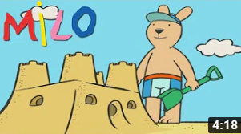 | 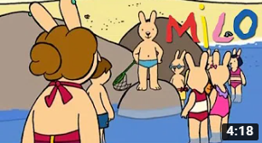
https://www.youtube.com/watch?v=UTF2E-eQZOc | https://www.youtube.com/watch?v=o1PnZToegxc | https://www.youtube.com/watch?v=I5uqgnQDqeg
- Why does Milo not like the sunshine?  - What are the worries about the sun?  - What happens when Milo puts on the glasses?  - What helps to stop sunburn?  - What colour were Milo’s glasses?  - What did Milo see flying in the air?  - What did Milo do wrong?  - How did Milo feel when he stopped following the kite?  - What are water wings and what do they do?  - Do you think it was windy that day? | - Who was at the beach with Milo?  - What is a pale?  - What happened to Milo’s sandcastle? Do you know why?  - How did Milo feel when he went back to his Dad?  - What did Dad do?  - What colour spade does Milo have?  - What does Milo help Luke to do?  - What tool does he use to do this?  - What do you need to add to the sand to make it more solid?  - What did the boys build between the castle?  - What lesson did they learn? | - What do you know about the sea?  - What do they want to hunt for?  - What couldn’t they find?  - What is the house?  - What should you always check before you go swimming?  - When is swimming dangerous?  - Why should you not go walking alone when the tide is low?  - Why are the flags important?  - What makes them think the crab is not happy?

Hands on maths…
Here are three activities for you to do with your adult this week. Please have a go…

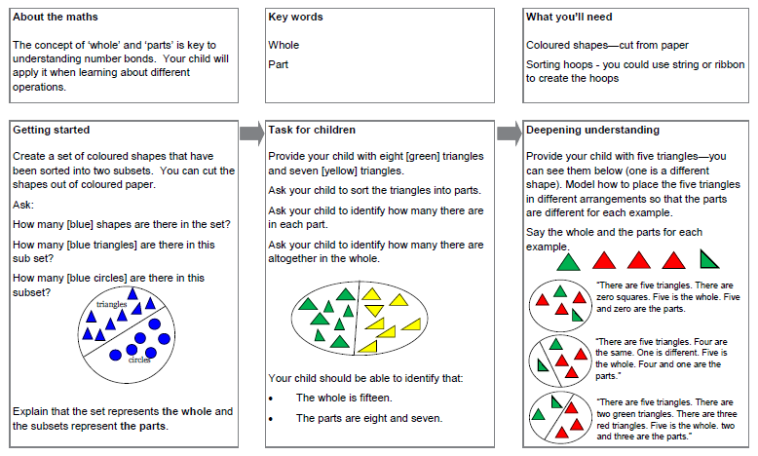
Finally, 3 topic activities for the week;
Can you complete the following as neatly as possible, send me some photos of your work too.
Art | Science | Design Technology
Can you make a beach style picture using your footprints or handprints?  You do not need paint, you could draw around them and colour them in.  Here are some examples to help  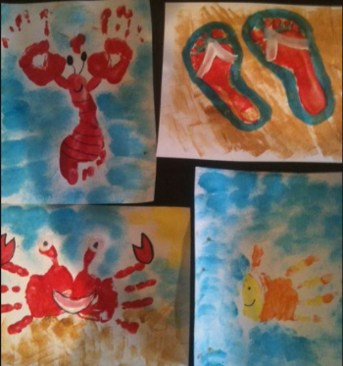 | Egg Race – Salt Water V Fresh Water  Discuss that the sea has 0ceans around it made up of salt water. Do they know what salt water is? Do they know how it is different?  Parent - Watch the youtube clip  https://www.youtube.com/watch?v=rxGCPAKrlGg  Have a go at completing the eggsperiment with your child. See how many tablespoons it takes for the eggs to float in the salt water. Discuss that the the salt water is more dense.  What does this mean on the beach do they think? | Create a photo montage by cutting, gluing, rearranging and overlapping photographs into a new image. Use either photos you have taken yourself or photos from newspapers or magazines to create either:  1. A photo montage using images of the seaside.  2. A photo montage to represent your time at home over the last few weeks.

