Mr Stallard’s class
Hi, this is Mrs Wainer here. Mr Stallard is very busy preparing work for when we return to school. I am helping out with the home learning packs. I hope that you are all keeping safe and well. Mr Stallard is still checking his emails and looks forward to hearing about all the things that you are doing. If you need to contact him, you can reach him through his email address.
MrStallard@newvillage.doncaster.sch.uk

To parents, carers and family,

I’m now attaching answers to these learning packs so that the children can mark their work too. If they make mistakes or get different answers, encourage them to work to try and understand where their mistake was or why the correct answer is correct.
The most important thing for the children isn’t necessarily to have help with their work, but to feel encouraged by the adults around them.

From Mr Stallard, Mrs Wainer and Mrs Shakespeare

 |  | Week 10
1 | PE | Youth Sport Trust Activity
2 | Reading and spellings | One for each day  Complete reading activities 1-5  Spelling activities 1-5
3 | Maths | Times Tables Rockstars logins provided and daily learning tasks.
4 | English | SPaG mats
Lunch
5 | History and Geography | What Weather?  Look at this website and watch the video clip on the weather and answer the quiz questions at the bottom of the page.  https://www.bbc.co.uk/bitesize/topics/z849q6f/articles/z7dkhbk  How much do you know about Mary Anning?  On a different day, visit this website and watch the video clip and answer the quiz questions at the bottom of the page.  https://www.bbc.co.uk/bitesize/topics/zd8fv9q/articles/zf6vb82
6 | Art | I have added some art ideas for you to try. It’s important to learn about the elements of art. The seven most common elements include line, shape, texture, form, space, colour and value. This week I have made the focus about ‘LINE’. I’d like you to work on skill building before you attempt the drawing activity. I have attached some practise sheets for you to try first. Hope you enjoy it.

NETFLEX
If you go on our class area on the website and click on ‘Try Mr Stallard’s Exercises’, you can download NETFLEX!
1. Scroll through just like you would on Netflix and look at the different exercise activities by clicking on them after it’s gone full screen!
2. Click on ‘Slide Show’
3.Click on ‘From Beginning’

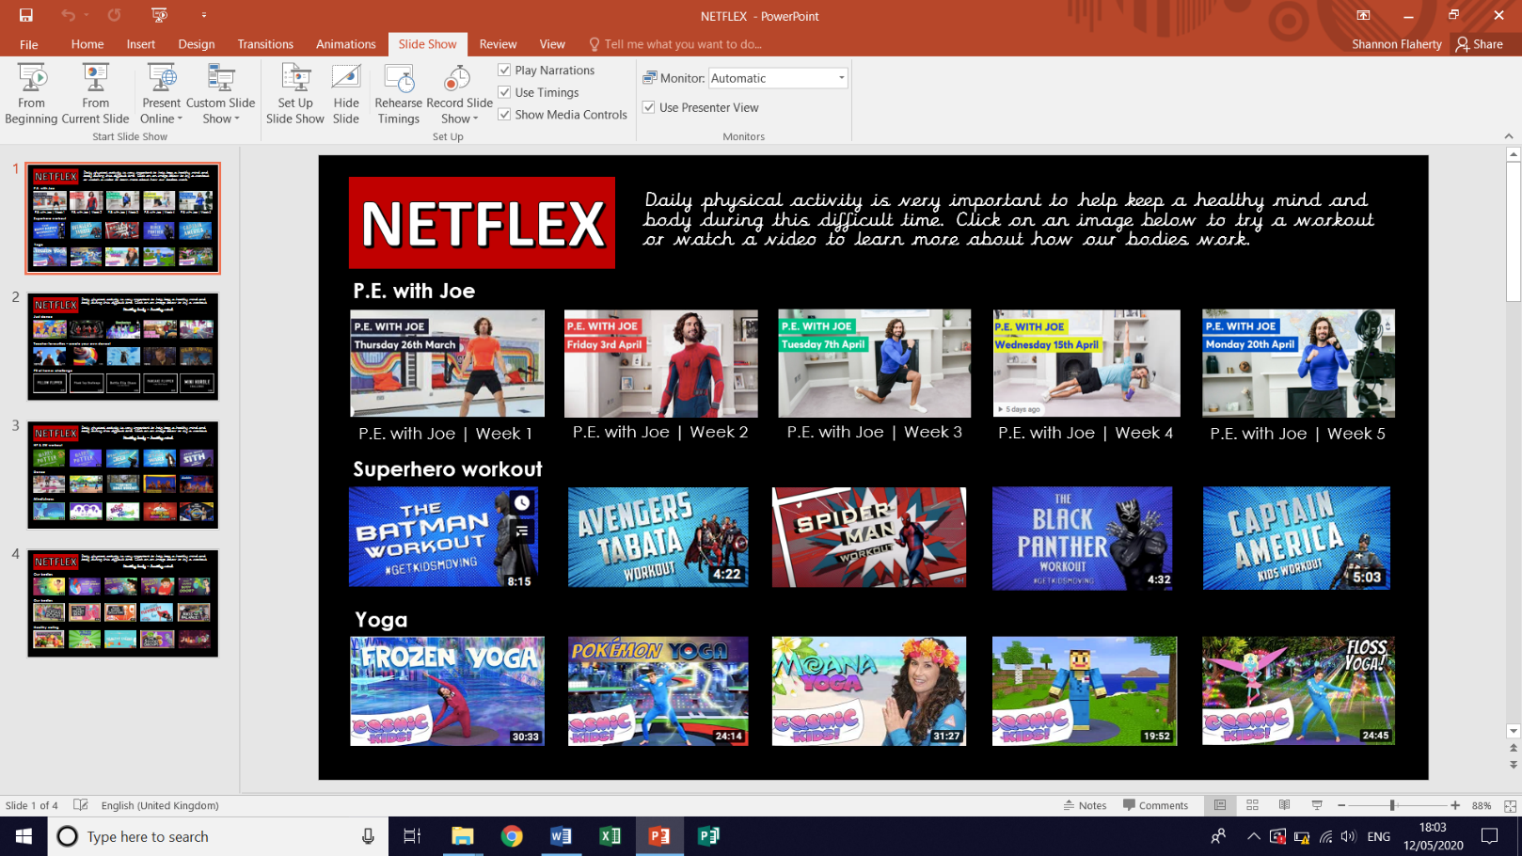
GET ACTIVE

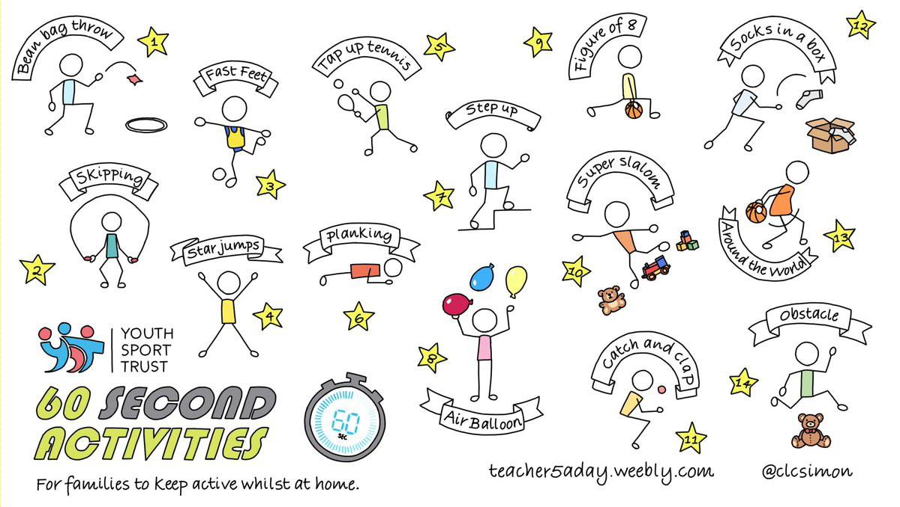

Reading – choose a book they want to read for Days 1-3

Day 1 | Listen to your child read and ask the questions from the Vocabulary Questions with Victor mat.  Ask your child to say some of the answers and possibly write some of them down too.
Day 2 | Listen to your child read and ask the questions from the Summarising with Sheba mat.  Ask your child to say some of the answers and possibly write some of them down too.
Day 3 | Listen to your child read and ask 5 questions from the Be an Author with Arlo mat
Day 4 | Emma’s Puppy Problem – reading comprehension activity
Day 5 | Amazing Facts About The Human Body – reading comprehension activity
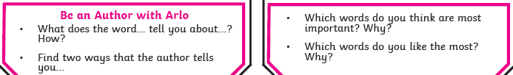
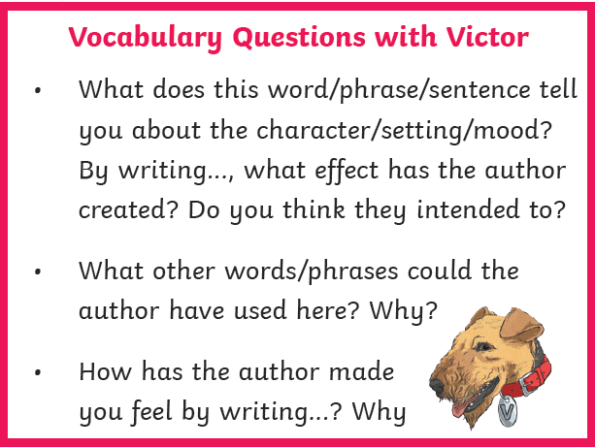
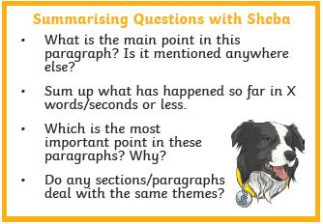
Spellings – Some of the children are in Group 1 and some are in
Group 2, your child will know which group they’re in.
 | Group 1 – Months of the year. Group 2 – Suffix – ‘ous’
DAY 1 | Look, Say, Cover, Write, Check
DAY 2 | Word search
DAY 3 | Handwriting Practise | Hanwriting Practise
DAY 4 | word mat - door | word mat - through
DAY 5 | word mat – floor | word mat - surprise
NOTE FOR PARENTS AND CHILDREN:
If you’re unable to print any of the sheets off, they can all be adapted. If you can just see the sheet on the screen, all you need is pencil and paper to practice the spellings for Day 1 and Day 3 and the same for Day 4 and Day 5. For the word searches, can you just find the words in order on the screen

Group 1 Day 1

 | look | say | cover | write | check | correction
January
February
March
April
May
June
July
August
September
October

Group 1 Day 2

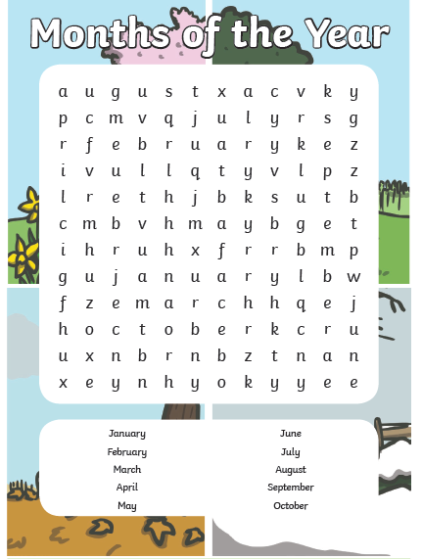
Group 1 Day 3
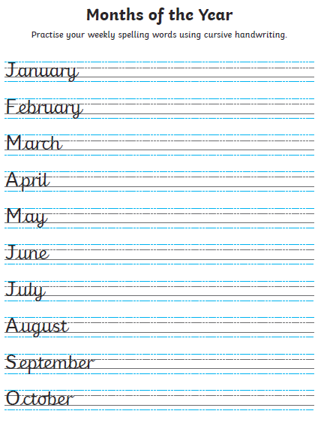
Group 1 Day4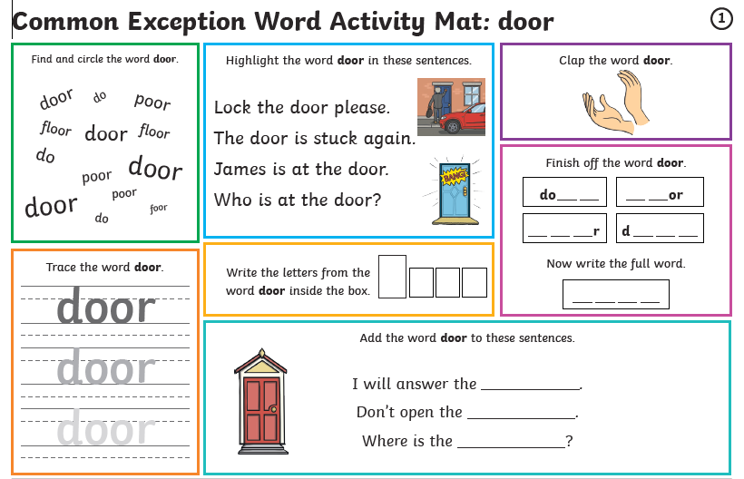

Group 1 Day 5
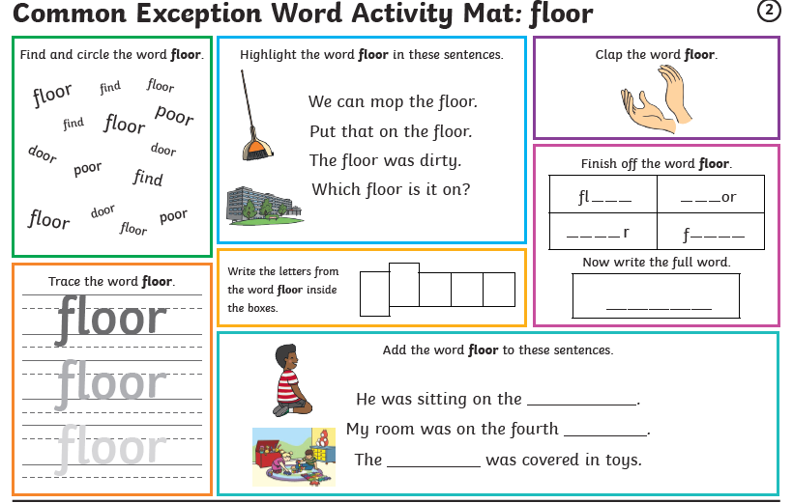

Group 2 Day 1
 | look | say | cover | write | check | correction
famous
nervous
ridiculous
carnivorous
herbivorous
porous
adventurous
courageous
outrageous
advantageous

Group 2 Day 2
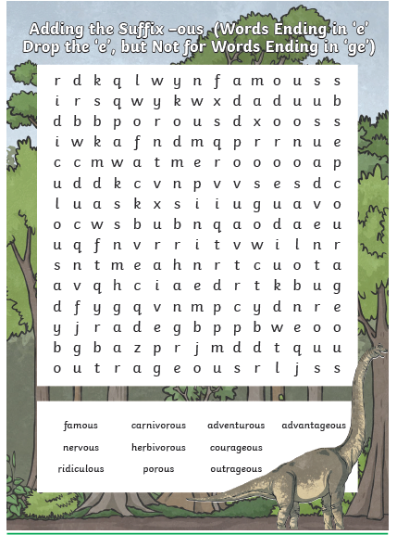

Group 2 Day 3
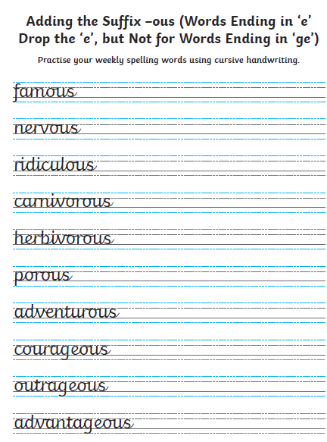
Group 2 Day 4

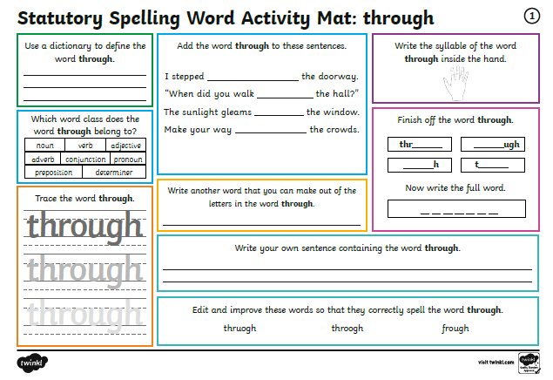

Group 2 Day 5

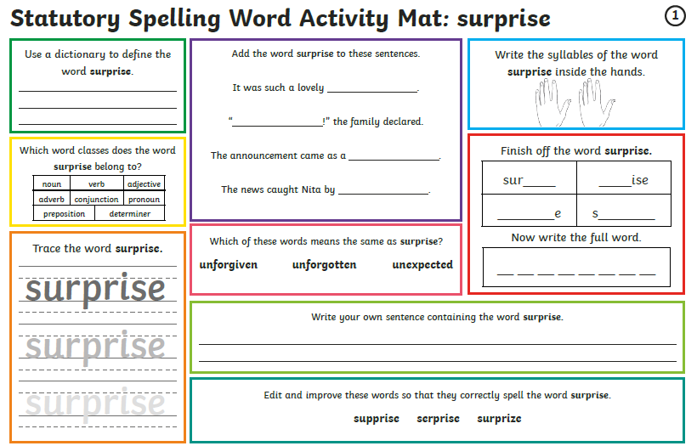

Writing Day 1

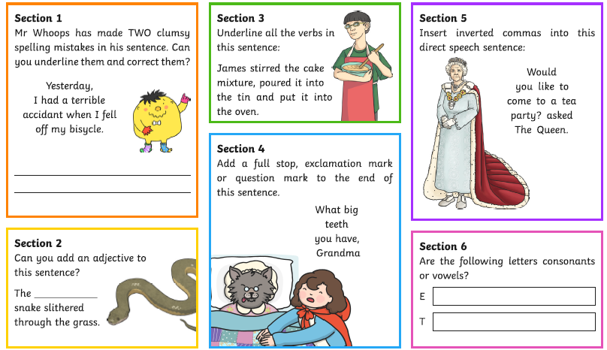

Writing Day 2
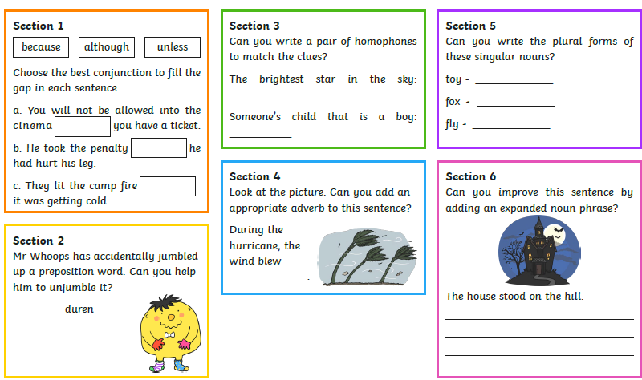

Writing Day 3

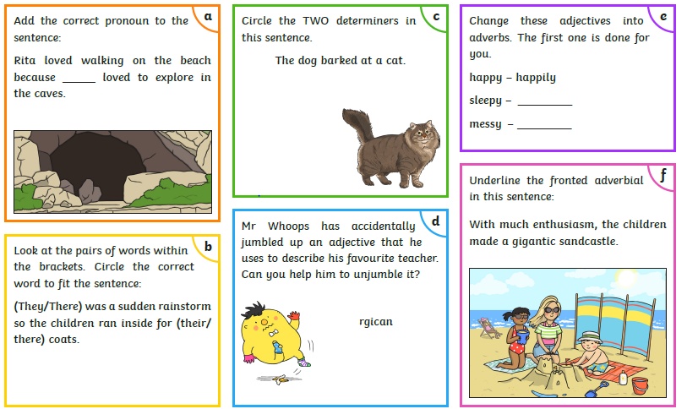

Writing Day 4

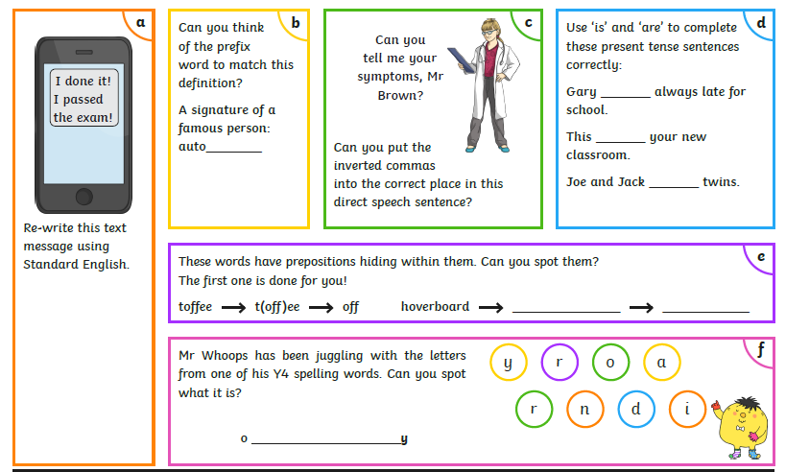

Art Activities
Lines – Try and draw the different types of lines listed in the boxes.
Straight
Curvy
Wavy
Thick
Thin
Loopy
Scalloped
Dotted
Dashed

Zigzag
Castle

Spiral

Now that you’ve investigated making different types of lines, can you use these skills to make a picture?
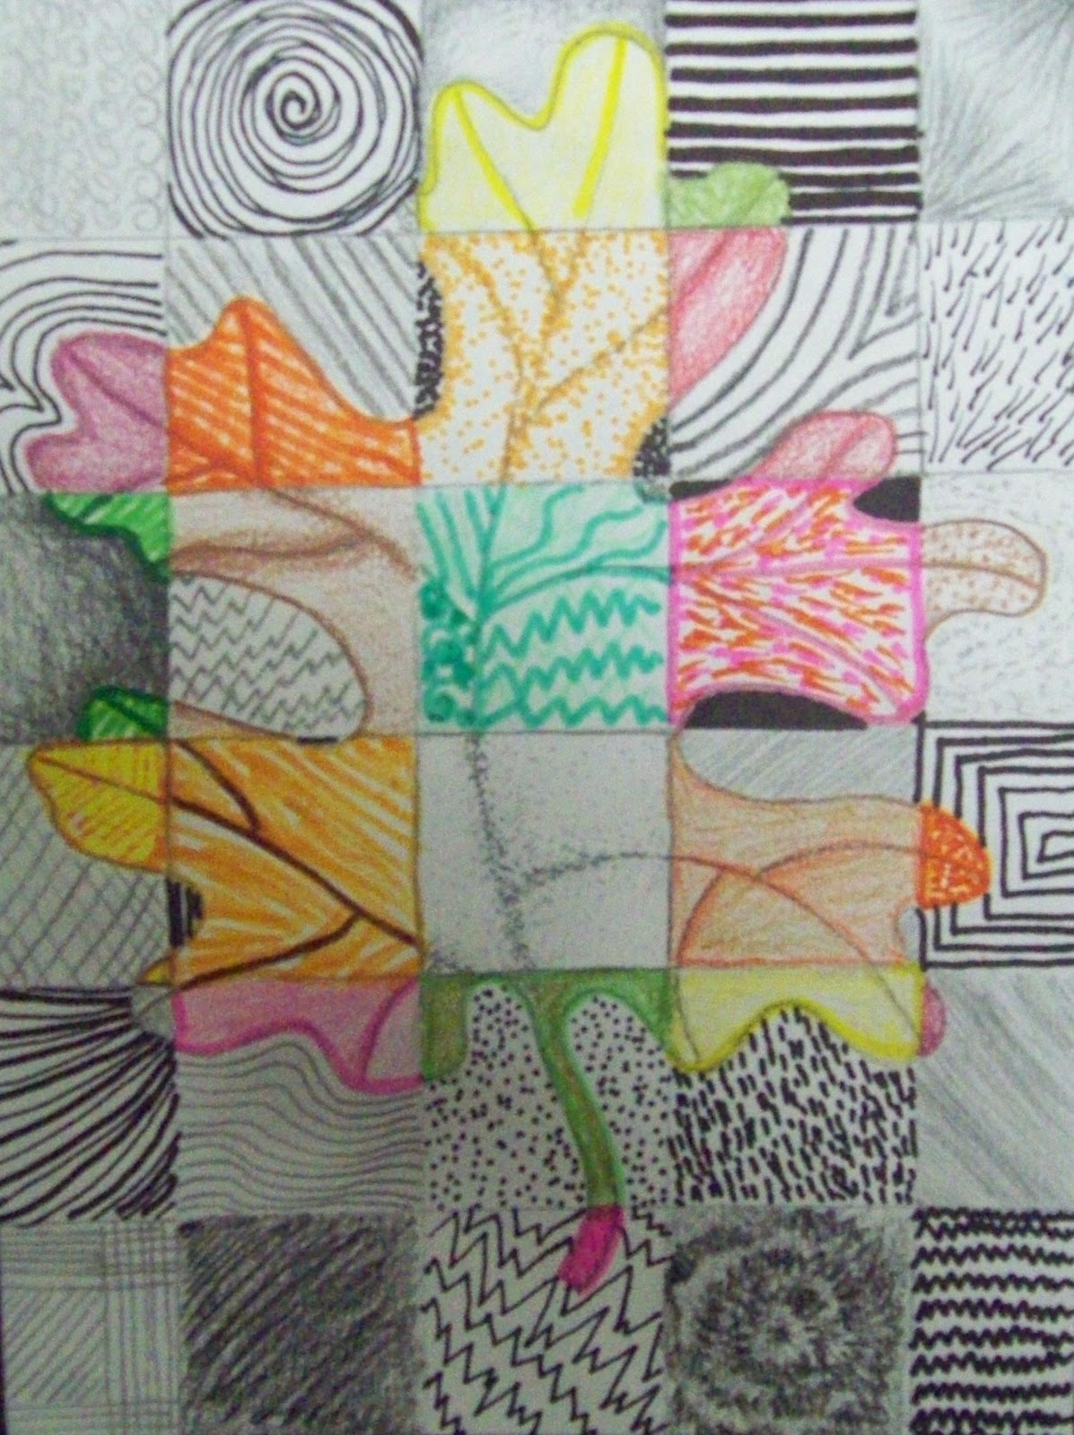
I’ve included one as an example.

Perhaps you could send Mr Stallard some pictures of your finished work. Have fun!

