Hello Everyone,
I hope you enjoyed last week’s learning.

I am missing you all.

Remember to stay safe I can’t wait to see you back at school.

If you want to contact me you can do at:
MrsSmith@newvillage.doncaster.sch.uk
You can attach any documents or photographs of work you complete.

Year 3
Reading Comprehension
This weeks learning will focus on Mini beasts.
I have changed the format slightly. I hope you find this layout good.
All the tasks for the week will be in one document. Just complete them through the week. Try to do a range of learning each day. There is no need to complete one task from every section each day, as I know lots of you are having great family times and making lovely memories to look back on.
Hope the sunshine returns soon.

SPAG ACTIVITIES FOR THE WEEK
Print off or write out/discuss answers. TASK 1
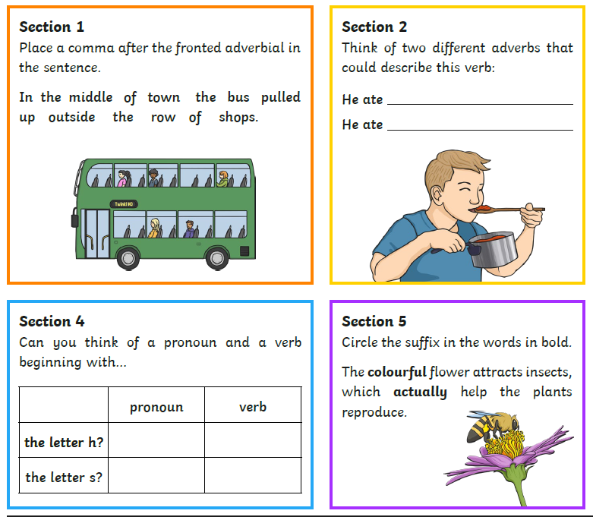

TASK 2 SPAG
USE SPELLING FRAME TO PRACTISE SOME WORDS FROM THE STATUATORY YEAR 3 AND 4 LIST
https://spellingframe.co.uk/spelling-rule/3/Year-3-and-4
USE YEAR 3/4 Spelling rule 36
Choose a game to play from spelling tiles.

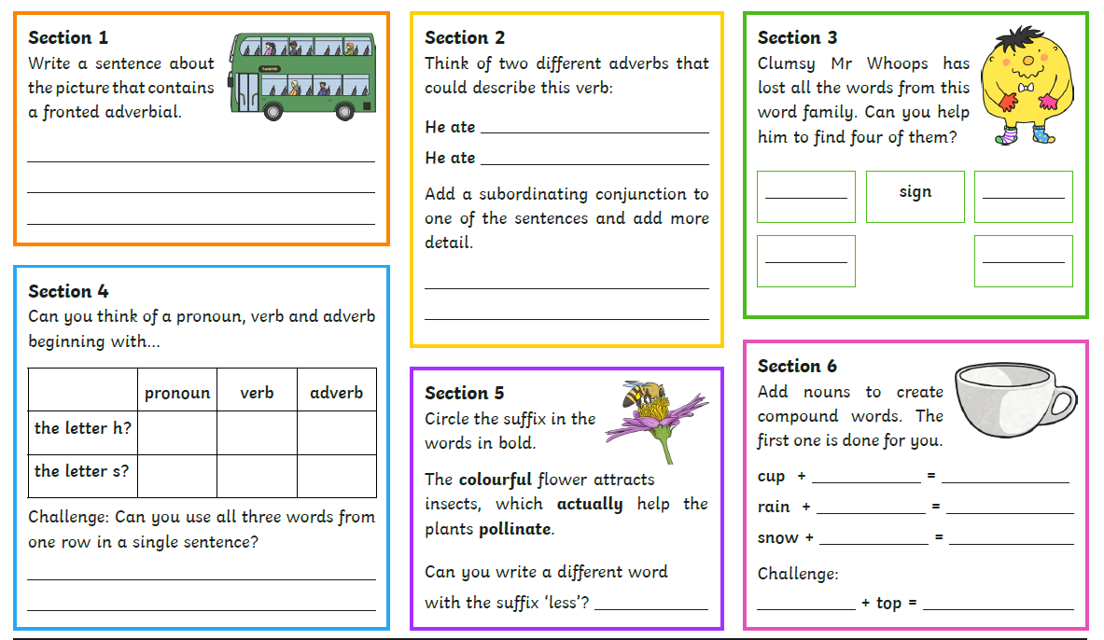
TASK 3 SPAG

Read the text and answer the questions that follow. You can print the sheet or write answers using complete sentences on paper/into a word document. One task per day.
Reading task 1

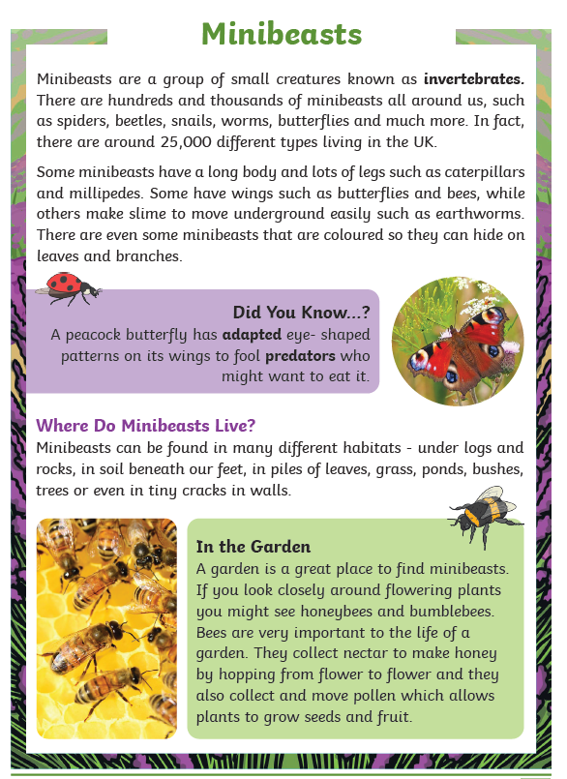

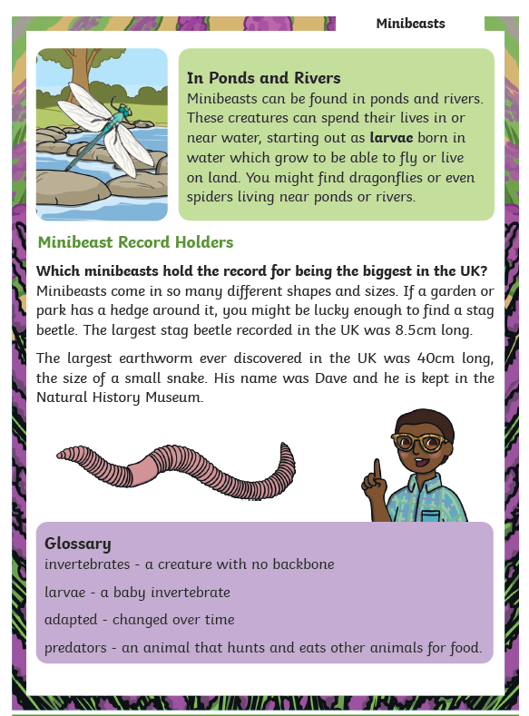
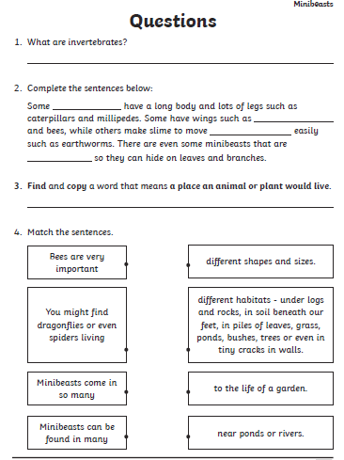

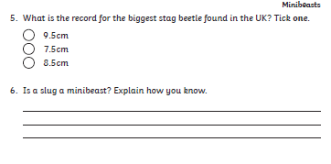

READING TASK 2
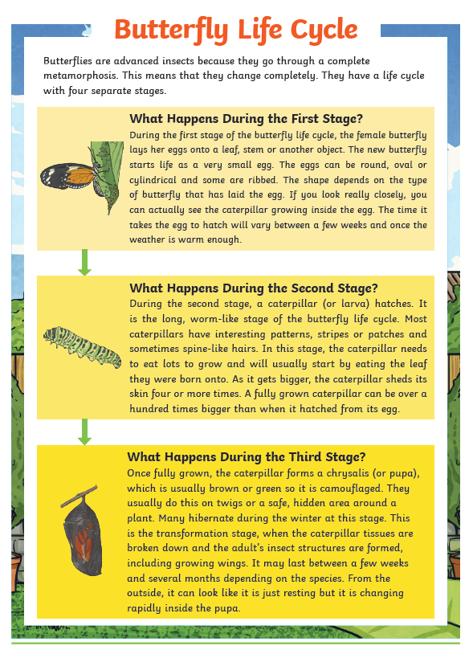

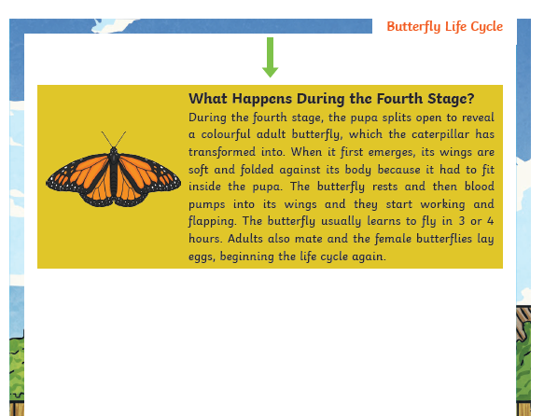
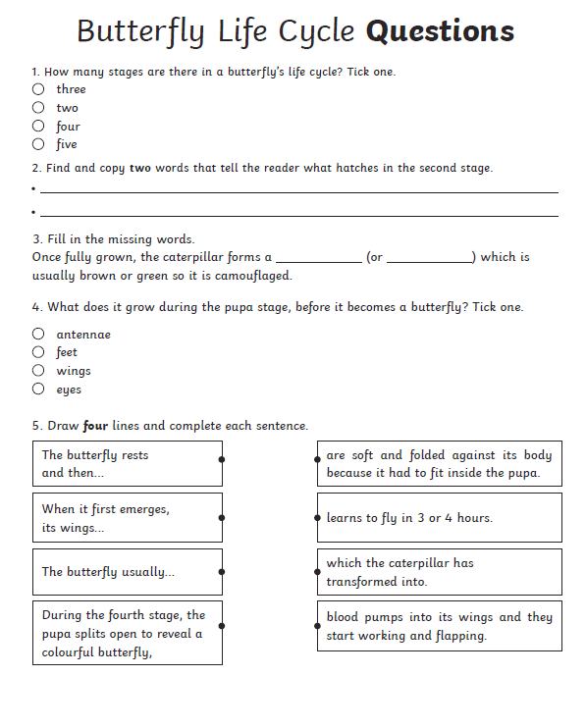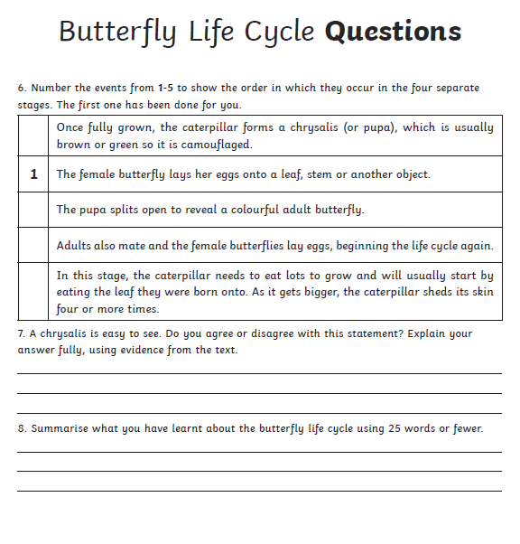

READING TASK 3
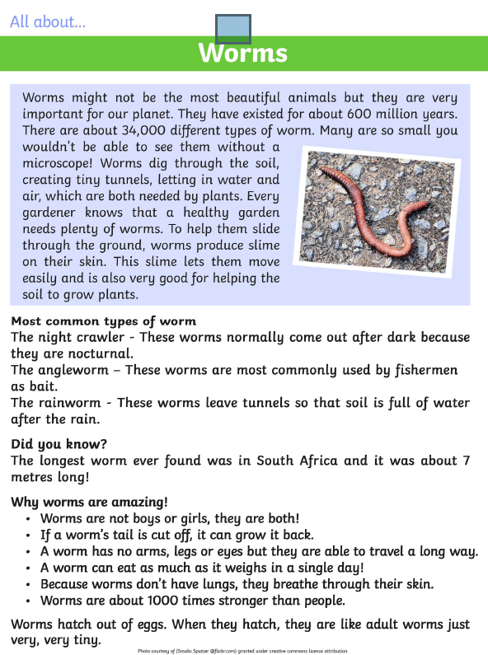
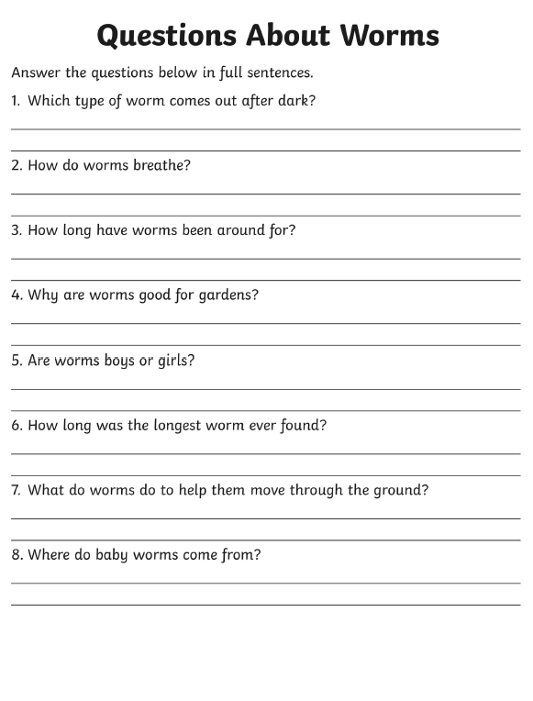

READING TASK 4 and 5
READ FOR PLEASURE
Choose your most favourite book and share with someone in your family.
You could even ask them questions about what you read.
Stories can also be accessed through the links below.

https://www.storylineonline.net/ ( read to you )

http://www.magickeys.com/books/invis-allig/page6.html#pictop
( for you to read)

https://www.freechildrenstories.com/ ( choose from a range of ages and genre)

MaTHS ACTIVITIES FOR THE WEEK
Here are some activity sheets for you to have a go at throughout the week. Print off or write calculations down. Talk about your learning with an adult.
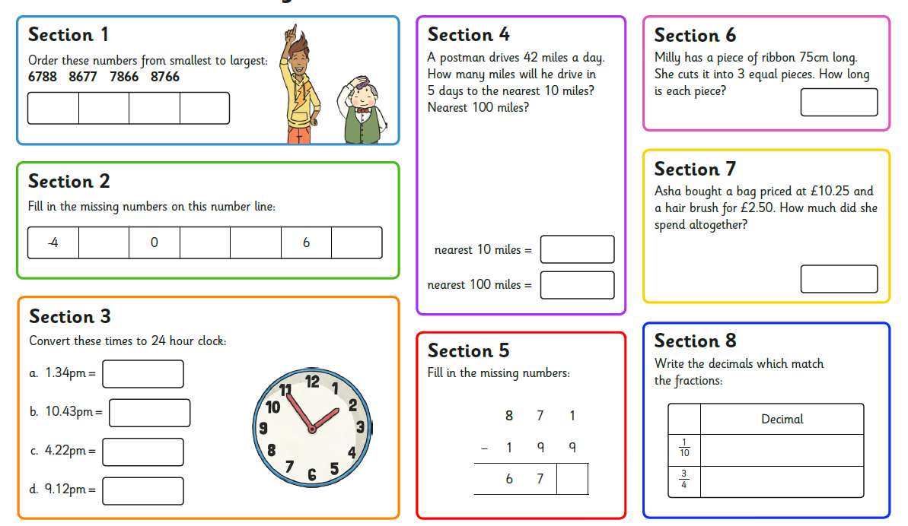

MATHS TASK 2

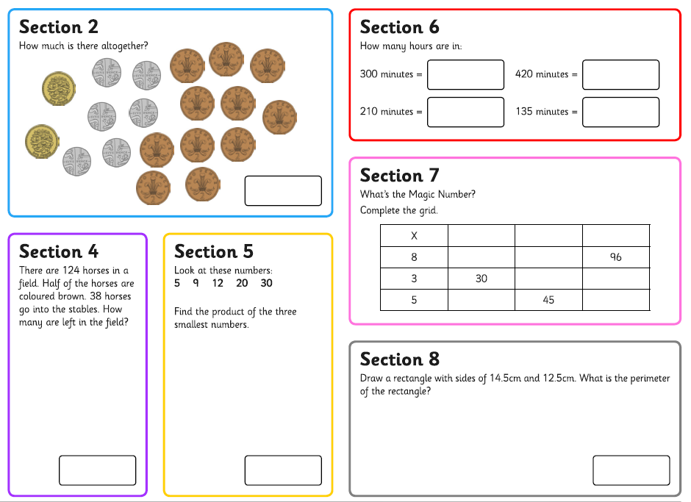

MATHS TASKS 3
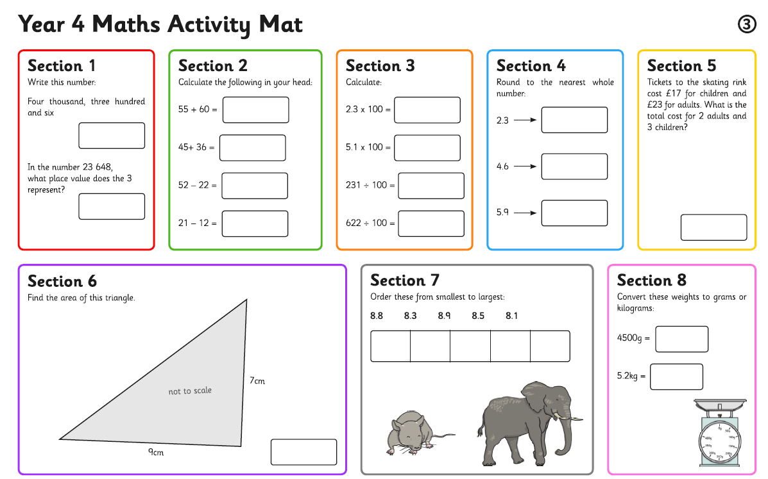

Practical Mathematics.
For other learning of Mathematics.
Pay for shopping trying to work out what it will cost before you get to the counter.
How much change will you get if you paid in money?
How many items could you buy: for instance if bread was 80p , how many loaves could you buy for £5?

Use sharing as developing your fraction knowledge.
If you had 5o sweets and 10 people. How many sweets would they each get?
This is a tenth 1/10 because you shared by 10.
Can you make up any more money stories for fractions and sharing?

Remember to log onto Times tables Rock stars every week and practise times tables.

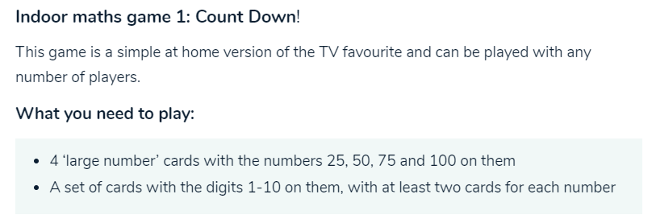
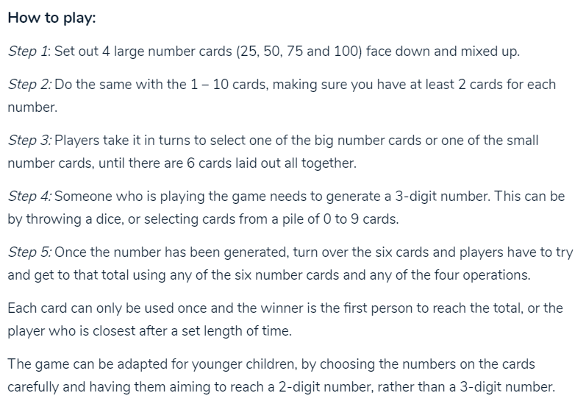
WRITING FOR THE WEEK
EACH DAY CHOOSE AN MINI- BEAST THAT YOU MIGHT HAVE FOUND IN YOUR GARDEN OR ON A WALK OR DO SOME RESEARCH FOLLOWING THE LINKS BELOW

Here are some links online to develop your learning about mini-beasts.
https://www.youtube.com/watch?v=LSp_meUwug4
https://www.youtube.com/watch?v=rKQfJFAHW8Q
https://www.youtube.com/watch?v=TZ1r6R-UwwU
Create a fact sheet like the one shown on the next page about the mini- beast.
You could use small pieces of paper to write your sentences on and build up a collage fact file as shown, giving a range of information on each section. Don’t forget pictures too.
THINK ABOUT:
Where do you think it lives?
Why do you think it lives in a place like this?
What does the mini- beast look like?
How is it different to another min- beast: For instance, beetles have six legs and spiders have eight.
What do you think it eats?
What do you think eats the mini- beast?
Does it live s alone or are there lots that live together?

REMEMBER TO USE COMPLETE SENTENCES

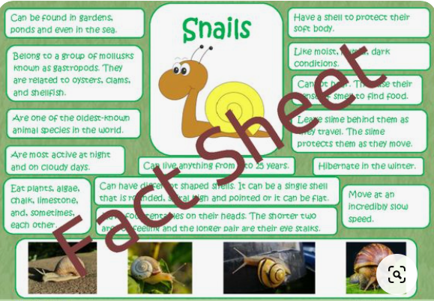

Finally, some topic activities for the week
- Hunt for mini- beasts in the garden/outside.
https://www.youtube.com/watch?v=xzr2au_WRQs

- Sketch/paint the mini-beasts you have written about or seen.
Remember to include detail and look carefully at the mini-beast.
I have given some pictures below.

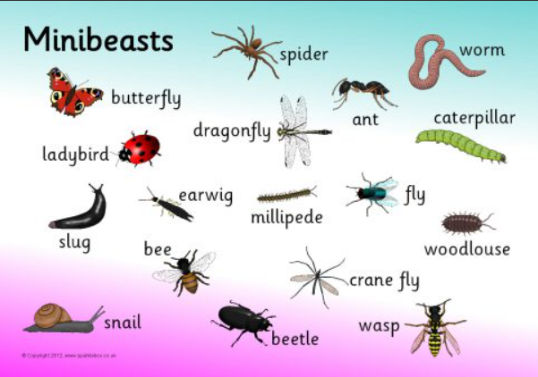
Try out some of these ideas linked to mini- beasts.

Spiderweb craft
Collect some small sticks from the garden or from a walk. You canuse string, wool or twine to fix them together and weave a spider’s web
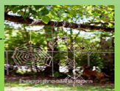

Worm painting
Simply cook some spaghetti, drain and wait for it to cool. Dip it into paint and drag it across the paper. You can twirl and twist the spaghetti to develop pattern.
Spider tag
This is similar to tig. The person who is on is the spider and they have to tig the flies every time a fly is caught in the spiders web, they hold hands and catch more flies.
You could send me some pictures of what you create mrssmith@newvillage.doncaster.sch.uk
- As a final art project crea te a mini- beast habitat using craft materials. Why not Use playdough or plasticine/salt dough to make parts.

You could send me some pictures of what you create
mrssmith@newvillage.doncaster.sch.uk

