Hello to all super Year 2 class,

My name is Mrs Smith, you will know me from teaching in Year 3 and 4 class. Mrs Hemminway is now back in school with year 6 children so I will be putting together some work for you to complete at home. Mrs Hemmingway says” Hello, and she misses you all”.

We hope that you are all having fun, enjoying your time ne and making memories with your adults.
We are hoping for the sunshine to return.

There is a work pack here for you to have a go at. There is no need to print anything out so do not worry if you don’t have a printer, just talk through the work with your adult.

Reading and Retrieval
3 watching/listening and comprehension activities…
I have three stories for you to listen to this week. Look at the picture of the front cover (to get a clearer picture of front cover- follow the link and pause before story begins) and talk about what you think will happen in the story.
Then ask your adult to ask questions about the story. Some are given as a start below.
Just follow the links or if you prefer you could read story books that you have at home.
When a Dragon moves in | Carla’s Sandwich
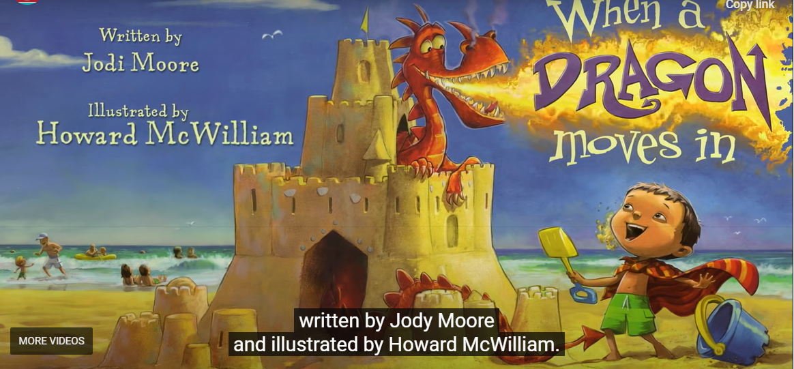 | 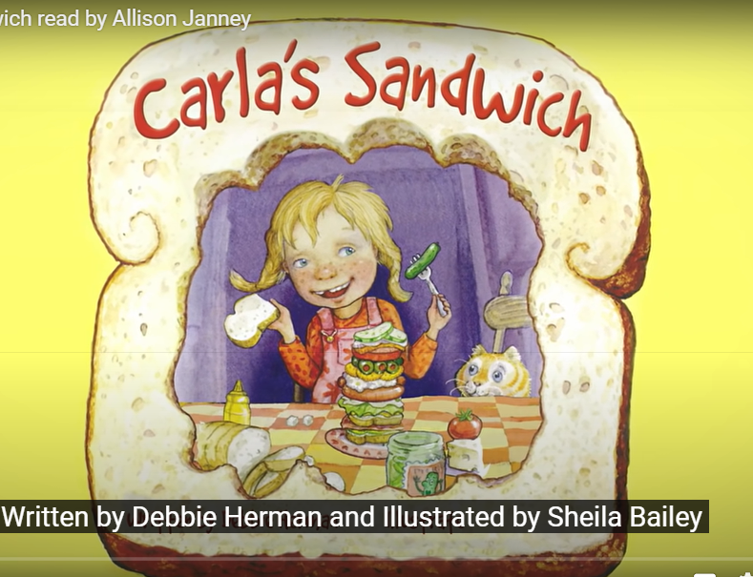 | 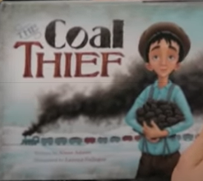
https://www.storylineonline.net/books/when-a-dragon-moves-in/ | https://www.storylineonline.net/books/carlas-sandwich/ | https://www.storylineonline.net/books/the-coal-thief/
- What do you think will happen in the story?  - What kind of castle would a dragon move in?  - What things would you have if a dragon moved into your castle?  - What would be the best thing about having a dragon in your castle?  - What kinds of things would you have to do so the lifeguard didn’t find out about the dragon?  - What sound does the dragon make?  - Where did Dad say the feather was from?  - What sound did the dragon make in the lemonade? Who got the blame?  - Do you think it was a good idea to have a dragon in the sand castle? Why? | - What do you think will happen in the story?  - What did Carla take to school?  - Who noticed Carla’s sandwich first?  - What was in the first sandwich?  - Why do you think the other children acted the way they did?  - What kind of sandwich did Carla take on Wednesday?  - Where did the teacher say the children were going?  - What sandwich did Buster have for the picnic?  - Do you think the other children were kind to Carla?  - What problem did Buster have at the picnic? How do you think he felt?  - Who let Buster have some of their sandwich?  - What did Buster think to the sandwich?  - Why did the other children want some of Carla’s sandwich?  In Art you are asked to draw your own creative sandwich. | - What do you think will happen in the story?  - Why was the little boy called?  - Why was he cold?  - What were Georgie’s shoes like?  - What was on the train  (locomotive)?  - How do you think Georgie felt when he was getting the coal off the train?  - What did Georgie and his Papa do with the coal? Why do you think they did this?  - What did Georgie give the boy as well as coal?  - What kind of boy do you think Georgie was?  - What was Georgie like when he got home?  - Who was the last piece of coal for?  - How do you think Georgie felt when he was giving out the coal?

MATHS ACTIVITIES
Here are three activity sheets for you to have a go at throughout the week. Print off or write calculations down. Talk about your learning with an adult.

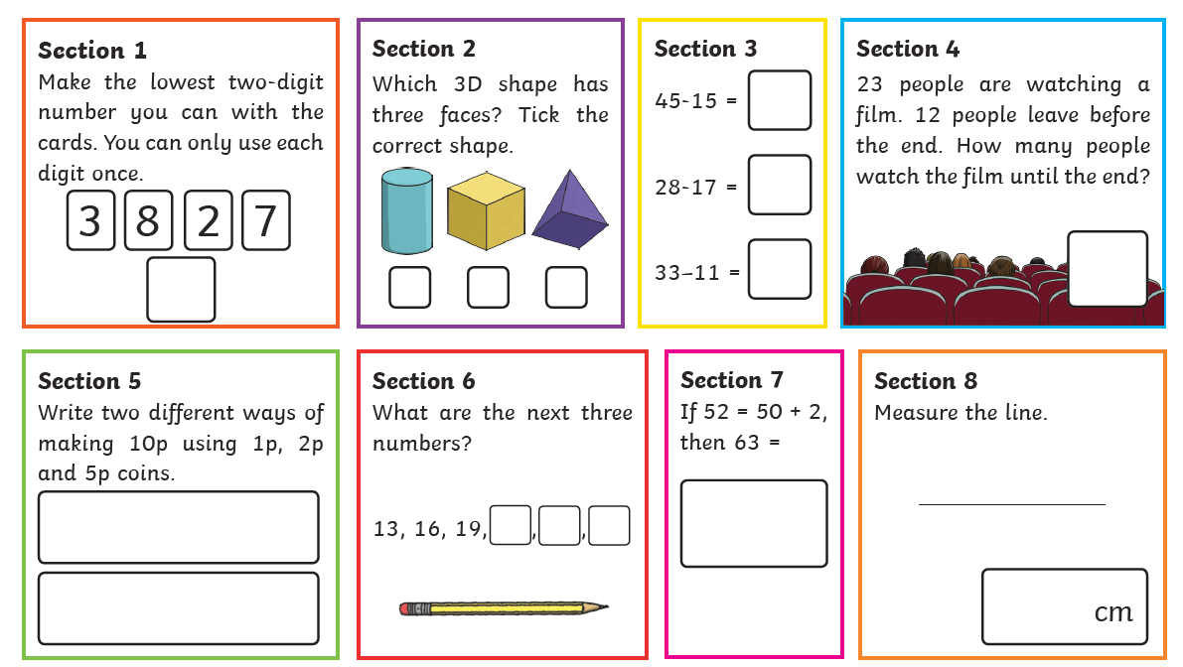

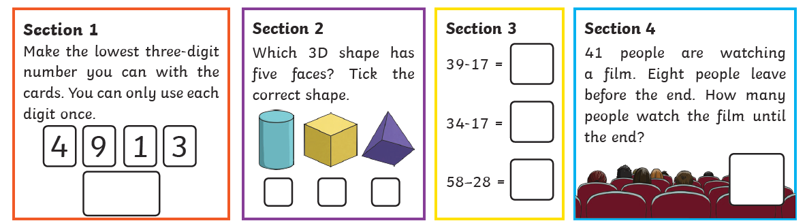

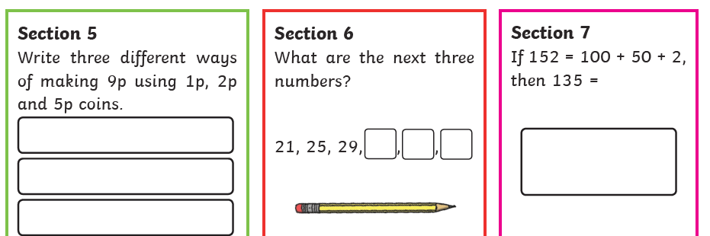

WRITING
Have a go at writing some sentences about the pictures. Remember a sentence starts with a Capital letter and ends in a full stop.
You cacould even make a little story about what the picture is showing.
Think about characters.
Where are they?
Why are they there?
What are they doing?
What behaviours do they have?
Does anyone else come into the story?
What problem might they have?
How might this problem be sorted?

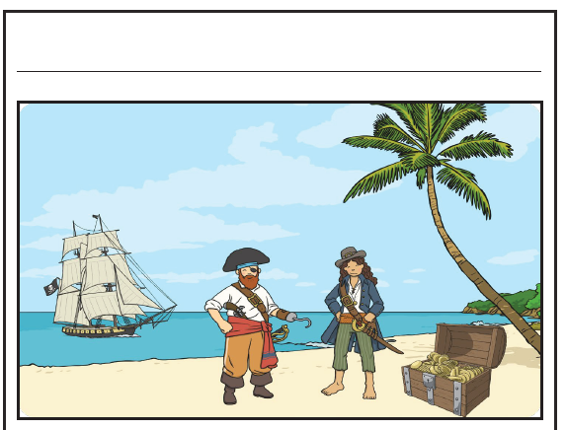

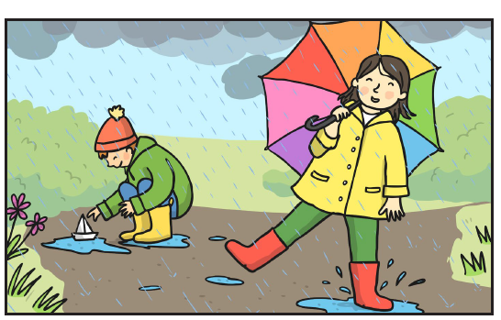

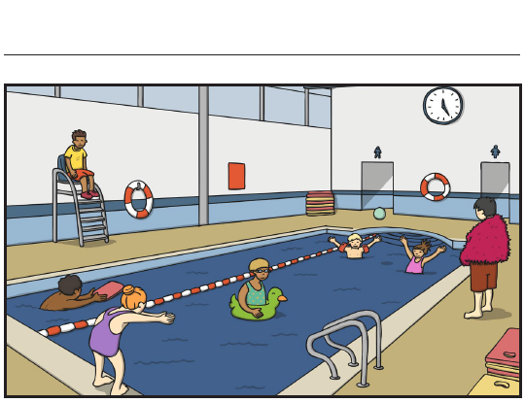

Finally, 3 topic activities for the week and 1 additional one
Can you complete the following as neatly as possible, why not send me some photos of your work, I would love to see it.
mrs.smith@newvillage.doncaster.sch.uk

Art/Writing
After listening to the story Carla’s sandwich.
https://www.storylineonline.net/books/carlas-sandwich/
Draw your most creative sandwich.

What would you put inside?

What name would you give to your sandwich?

Can you use description to write a few sentences about your sandwich?
Geography /Science
The weather has definitely been unsettled over the last few weeks. First really sunny and warm ( even hot enough for bikinis and trunks) then it’s raining it’s pouring.
Use the weather diary to record the weather of the next 3 days. Use symbols to draw the weather. As shown below.
Can you write a description of the weather?
Think about the temperature.
Think about the brightness of the day.
Think about how clear the sky is.
Think about the colour of the clouds.
Watch the YouTube video about weather
https://www.youtube.com/watch?v=Uo8lbeVVb4M
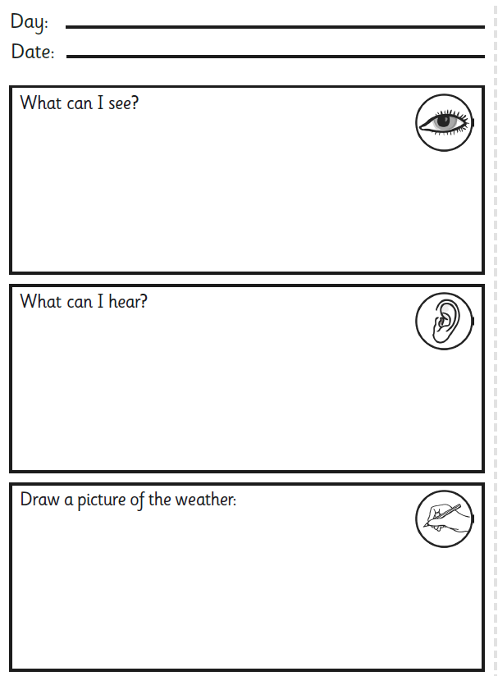

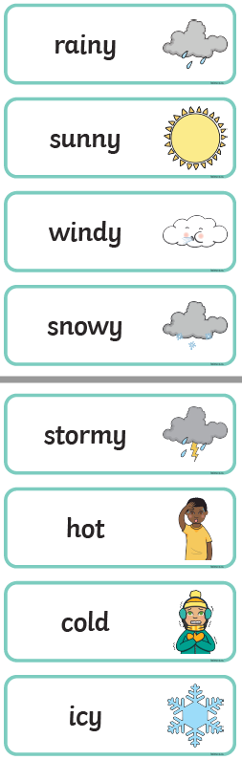
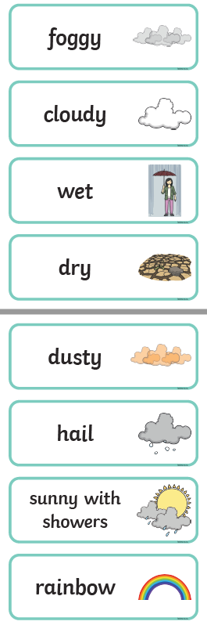

SCIENCE
Scientists believe weather is changing due to global warming
( that means the earth is getting warmer). People believe that using too much energy to produce materials for use in everyday life is partly to blame for Global warming.

Listen to the song to learn about materials
https://www.youtube.com/watch?v=xOKr462HLc0
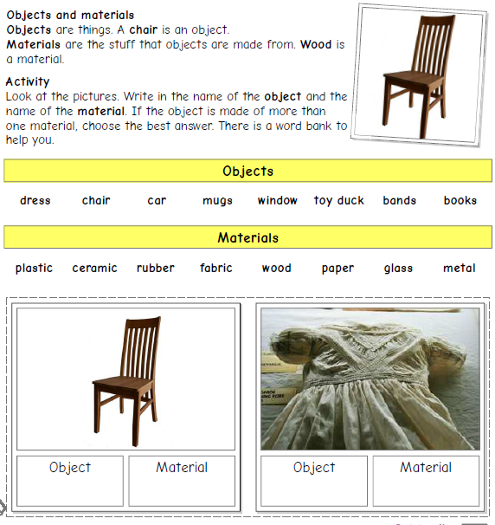
Look at the things below and discuss/complete the sheet to show what they are and what they are made from..

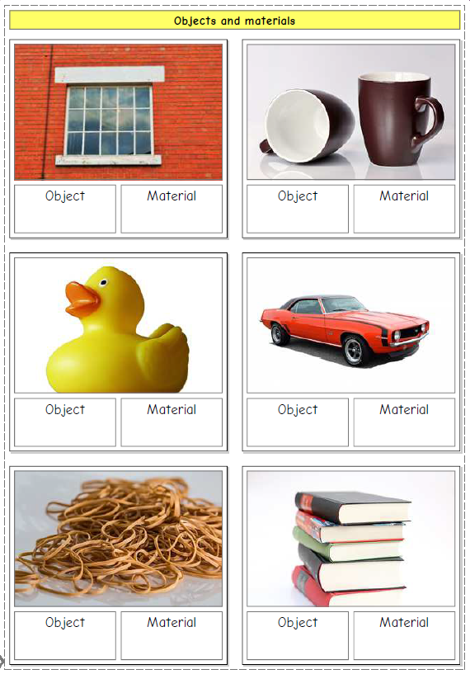

As an additional activity
Can you find any other things that are made out of some of the materials you have found out about?
What about things we throw away.
Could you make a model out of some of the things we throw away?
What about a pop bottle?
A cereal box?
A pizza box?
A milk carton?
A cardboard tube?
Make a junk model- a rocket, a plane, a bus, a robot be creative as you can.

You could send me some pictures of what you create
mrssmith@newvillage.doncaster.sch.uk

Next week I will give you some songs to sing for music and some ideas for making musical instruments. – Remember to save boxes, tubes, bottles.

