To all our wonderful Y1 Children

I hope you are being good for your grown-ups!

Please stay safe, try to do a little bit of work but most of all stay healthy and happy.

If you want to contact us you can
contact your teacher for when you return - Mrs Shah –

mrsgeaney@newvillage.doncaster.sch.uk

Year 1 (Mrs Geaney’s)
Home Learning

 | Activity | Week 1
Activity 1  9.00am | PE with Joe Wickes | Each day: Login to you tube and search for Joe Wickes PE – it will be live that morning. This is good for all children to take part in.
Break
Activity 2 | Reading and spellings | Each day: Complete reading and comprehension.  Spelling Activity 1-5
Break
Activity 3 | Maths | Log in to - https://play.prodigygame.com
Break
Activity 4 | English | Writing tasks 1-5
Lunch
Activity 5 | Topic project | Make a solar system.  Include at least one of the planets, the moon and sun. You may do this however you choose.  Or create a Birthday Card for Captain Tom Moore.
Break
Activity 6 | Craft / Life skills | Art/making/jobs around the house/cooking/baking/board games/nature pictures/singing/making music/make videos/play outdoors etc.

Reading – choose a book they want to read.
Day 1 | Listen to your child read and ask 5 questions from the Rex Retriever mat. Ask your child to say some of the answers and possibly write some of them down too.
Day 2 | Listen to your child read and ask 5 questions from the Rex Retriever mat. Ask your child to say some of the answers and possibly write some of them down too.
Day 3 | Listen to your child read and ask 5 questions from the Inference Iggy mat. Ask your child to say some of the answers and possibly write some of them down too.
Day 4 | Week 1 Complete Comprehension 1 activity
Day 5 | Week 1 Complete Comprehension 2 activity

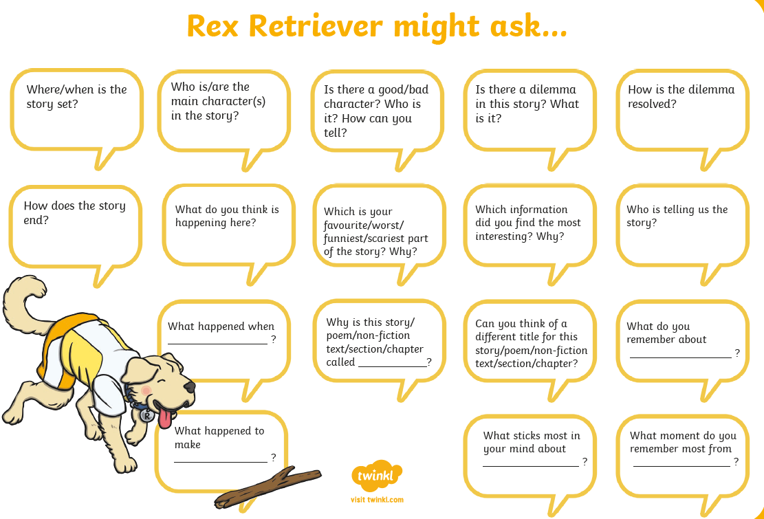
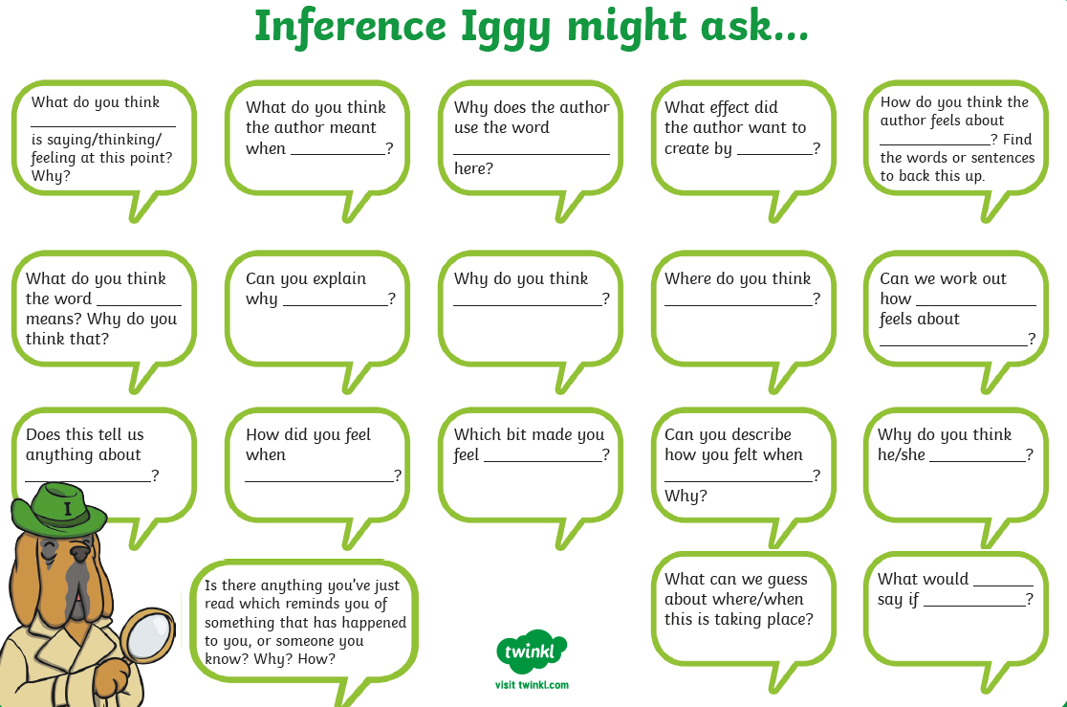

Comprehension Activity 1 Week 2
Comprehension Activity 2 Week 2

Spelling
 | Week 2
DAY 1 | Common exception word mat - of
DAY 2 | Common exception word mat – said
DAY 3 | Common exception word mat – do
DAY 4 | Common exception word mat – to
DAY 5 | Common exception word mat - you

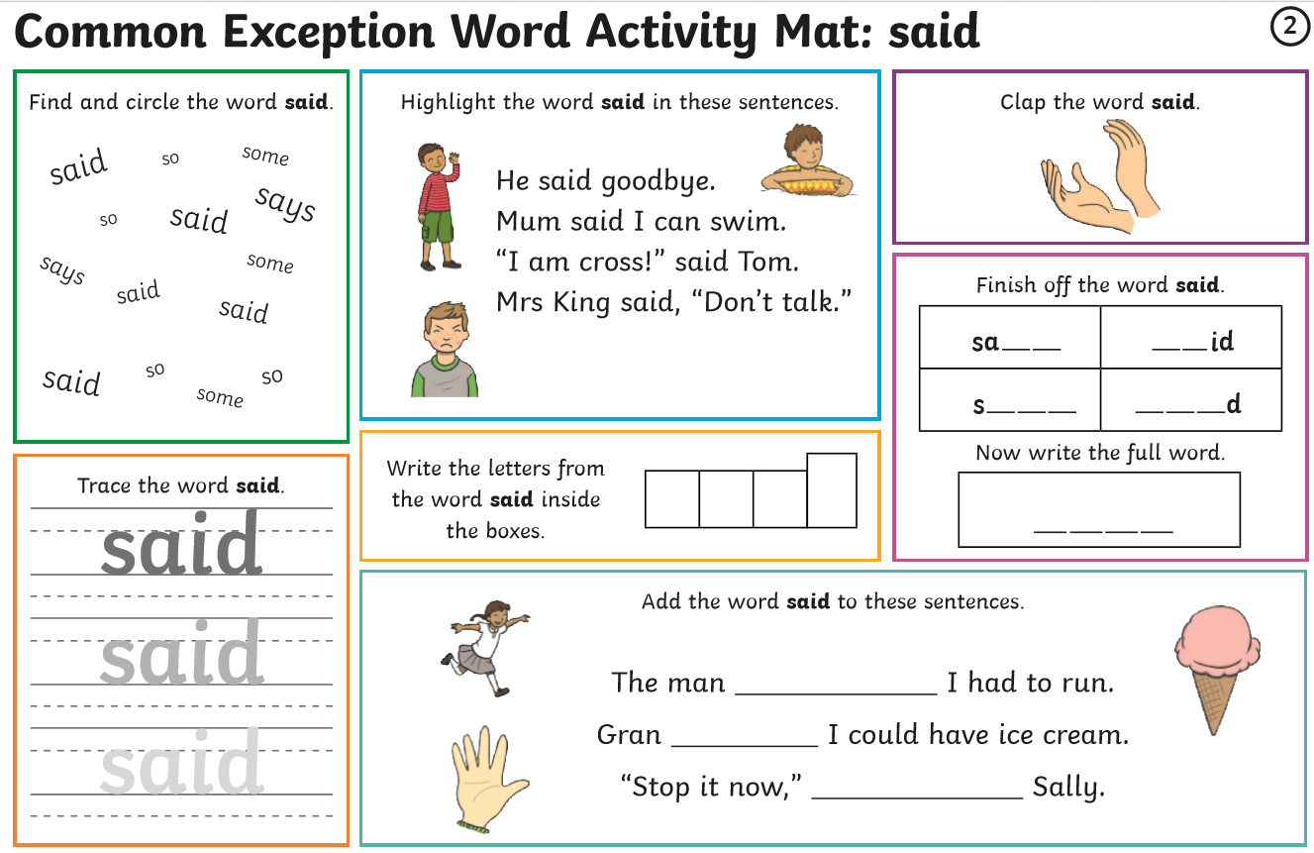
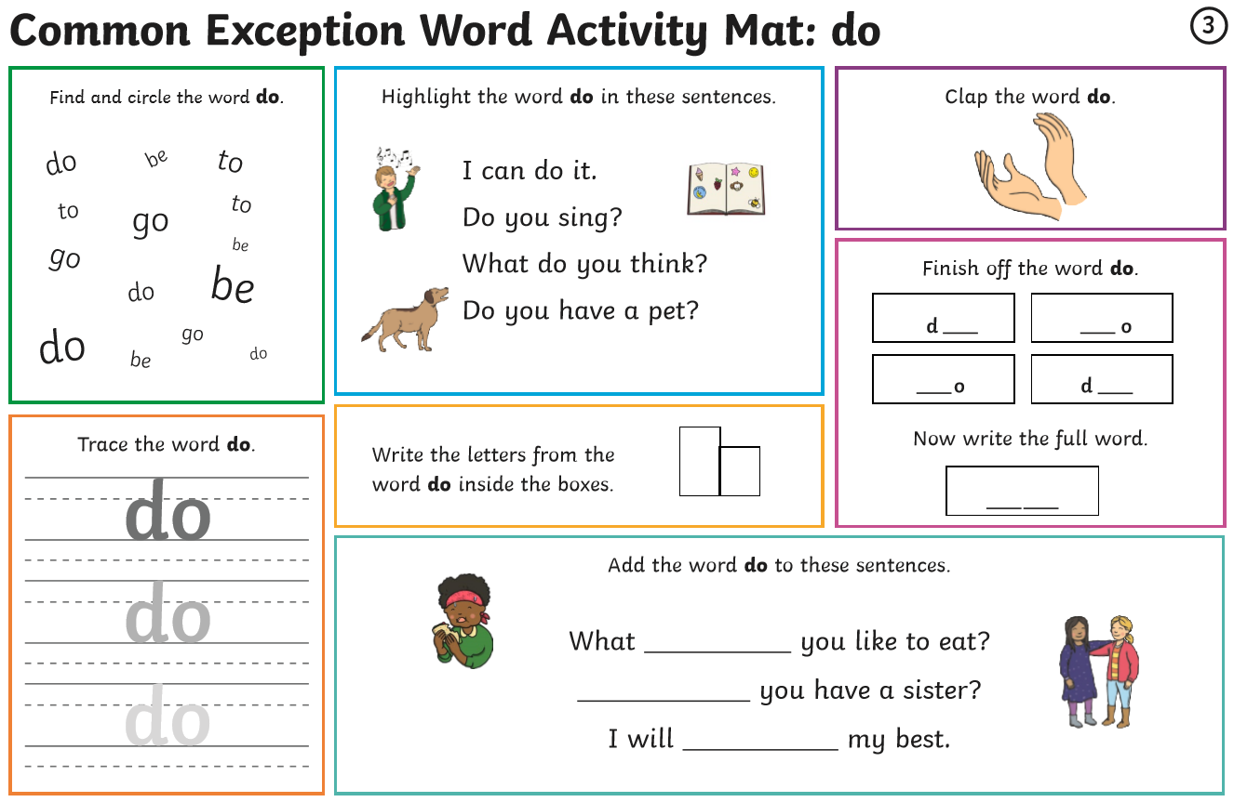

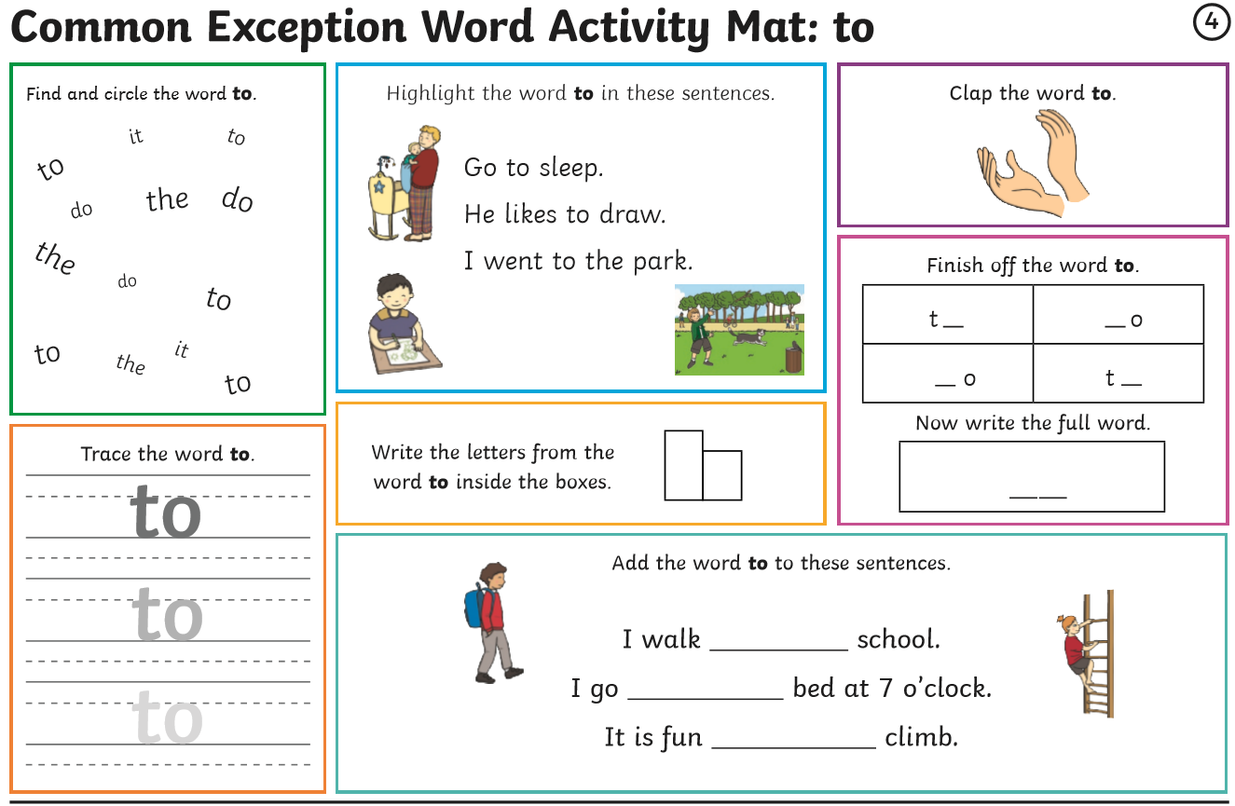
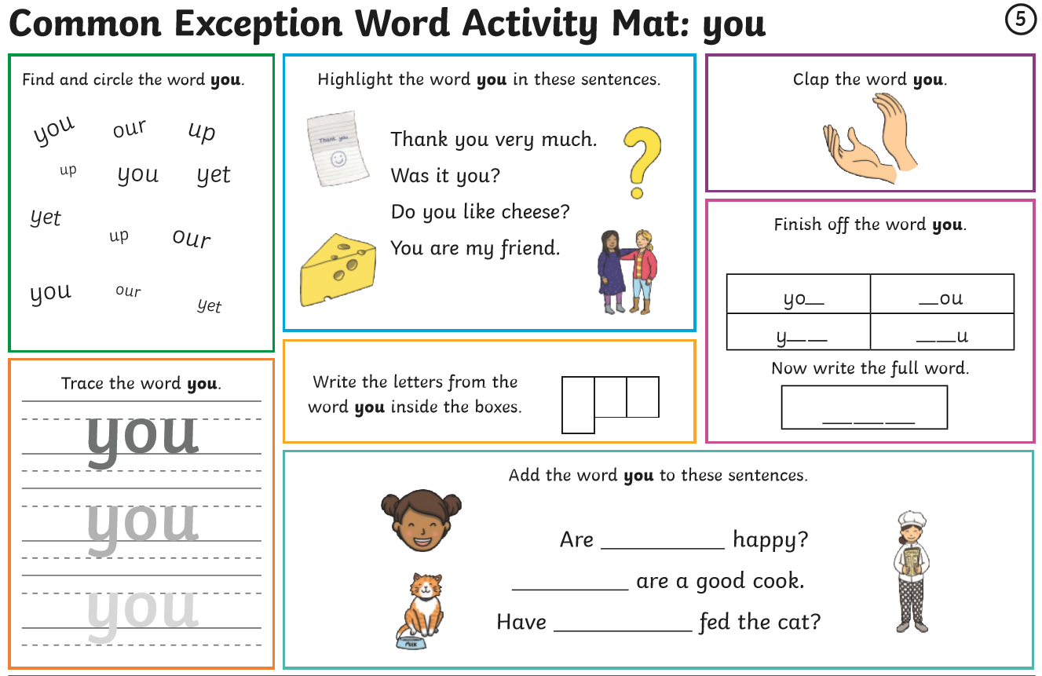

Multiplication – Week 2
Monday | Tuesday | Wednesday | Thursday | Friday
Worksheet for week 2 day 1.  Counting in tens. Can your child count in tens with you?  Can your child group things into tens? You might want to group items you have at home into tens eg socks, peas, sweets etc. | Worksheet for week 2 day 2.  Can your child count in tens?  Shading in all the numbers that Jemima will say. | Complete a picture of your child’s choice made up from a range of different items grouped in tens eg, grapes, sweetcorn, birds, trees etc. | Can your child recognise equal groups? Complete the drawing. | Make a picture to go with the picture.  You might want to make mini cookies and group them in tens

Week 2 – Day 1 Counting in tens

Week 2 – Day 2 Counting in tens

Week 2 – Day 4 Making Equal Groups

Week 2 – Day 5 Making Equal Groups
Writing: Write some super sentences using these prompts.
Monday: do number 1a and 1b. Wednesday: do number 1.
Tuesday: do number 2a and 2b. Thursday: do number 2a and 2b.
Friday Check back through all your writing for the features
Remember I am looking for your –

- Capital Letters
- Full Stops
- Finger Spaces
- Handwriting
- Spelling

