Spelling, Punctuation and Grammar

- Revise different types of conjunctions, do the activities orally If you aren’t able to print
- Complete the spellings using the spelling pattern, ‘Spelling Rule 44 - Use of the hyphen’

Subordinating conjunctions
Sort these conjunctions into coordinating and subordinating conjunctions

But
Because
And
Until
Before
When
Or
So
If

Subordinating | Coordinating

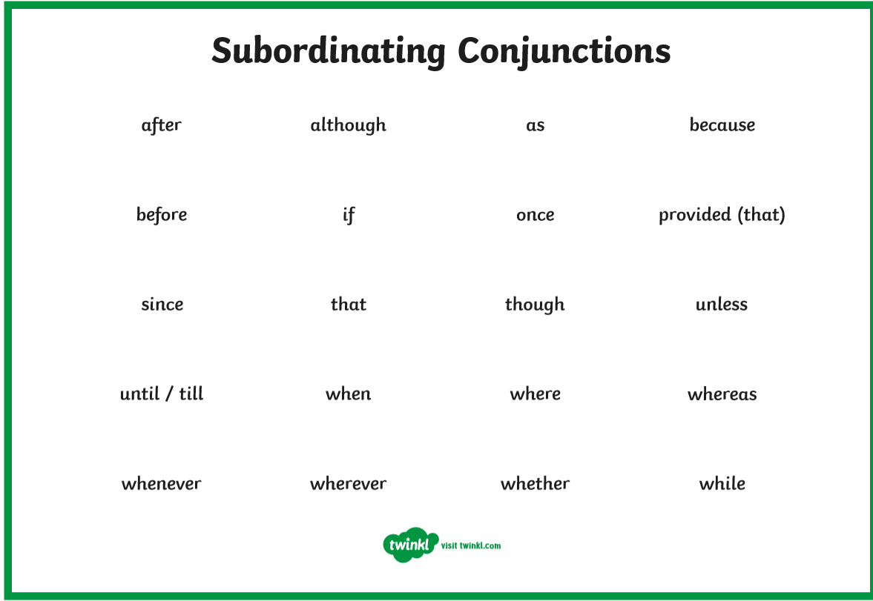

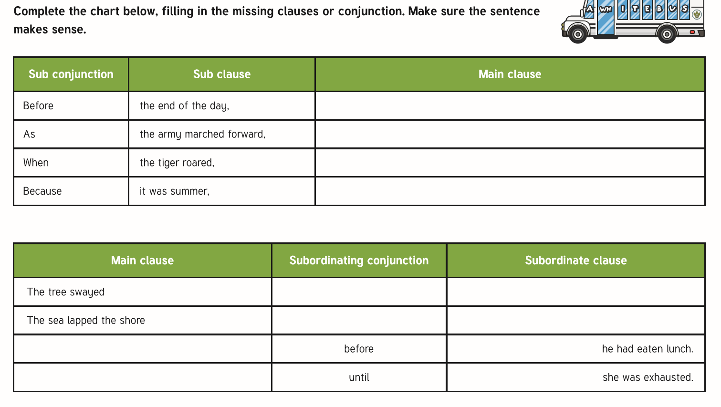

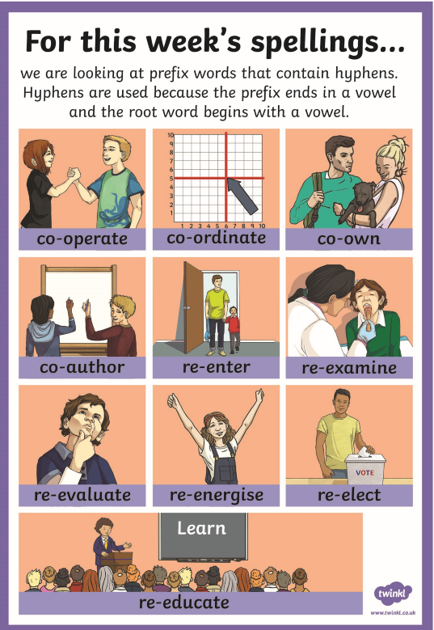
Spelling Rule 44 - Use of the hyphen
Match the hyphenated word to its definition
