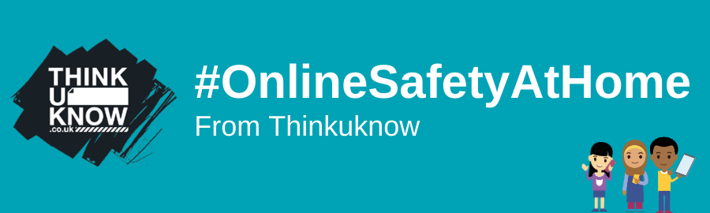

Access your fifth #OnlineSafetyAtHome pack with new activities for parents and carers to use at home:
- 4-5s
- 5-7s
- 8-10s
- 11-13s
- 14+
Share our new video for parents and carers
Our short video provides parents and carers with:
- An introduction to NCA-CEOP, the Thinkuknow education programme and its resources
- Advice on how they can keep their child safe online, including a helpful tool to support them in having the right conversations about online safety.
- An introduction to NCA-CEOP, the Thinkuknow education programme and its resources
- Advice on how they can keep their child safe online, including a helpful tool to support them in having the right conversations about online safety.

The hidden benefits of playing video games in lockdown
Many children are likely to be spending more time playing video games during lockdown. While some parents may be worried about this, it's important to recognise the positive experiences video games can bring.
Our new Parent Info article explores the hidden benefits of playing video games, and how parents and carers can help create a safe and enjoyable gaming experience for their children.
Thanks to you and the rest of our network we've had over 250,000 downloads of our activity packs, and more and more families around the UK are now using them to help keep children safe online.
If you have any feedback or questions about our packs, get in touch with us at ceopeducation@nca.gov.uk. Remember, you can still share your ideas on how we can further support you by taking our short survey too.

Best wishes,
CEOP Education Team
