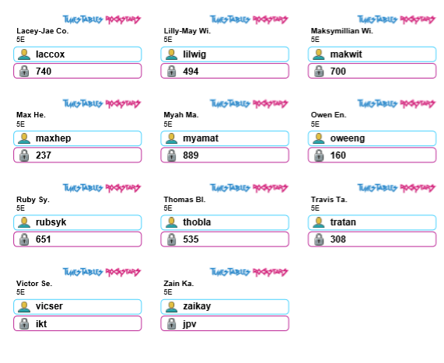
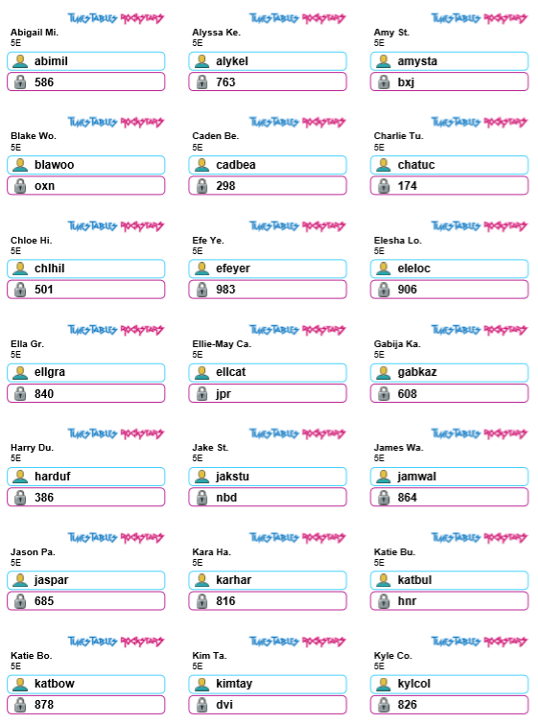
TTR logins:
TTR logins- Please ensure your child is only logging in using their own login details.

WALT: read, write, order and compare numbers to at least 1,000,000 and determine the value of each digit

If you are not able to print the resources or do not have paper and a pen handy use household items/sweets or things from the garden to represent thousands, hundreds, tens and ones

WILF:
Remember:
1-9 = digits
0= holds place value
- Determine the value of the digit
- Know the numbers worth by determining the value
- Compare numbers using the language ‘greater/smaller’

After you have completed the work, you might like to play:
http://www.math-play.com/Place-Value-Millionaire/place-value-millionaire-game_html5.html

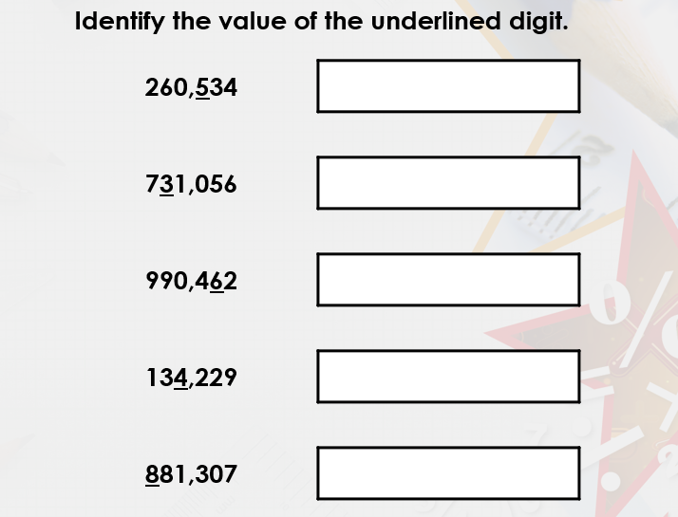
Recap

Hundred thousand | Ten thousand | Thousands | Hundreds | Tens | Ones
2 | 6 | 0 | 5 | 3 | 4

- The digit 5 is worth five hundreds (500)

Task Two: Bar models
Example:
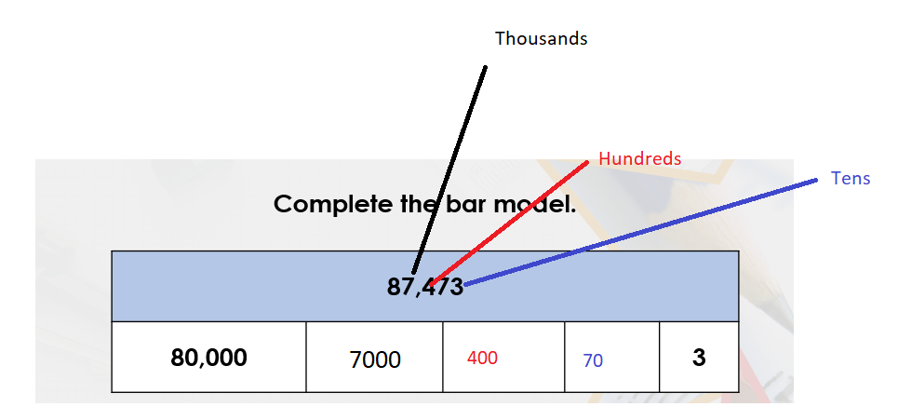
Your turn:
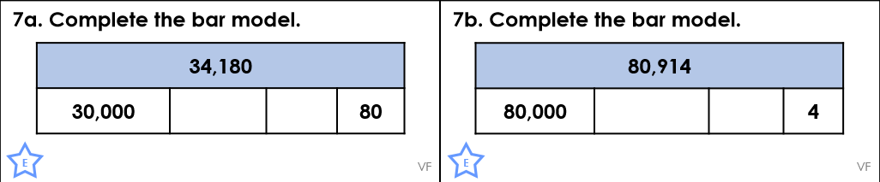
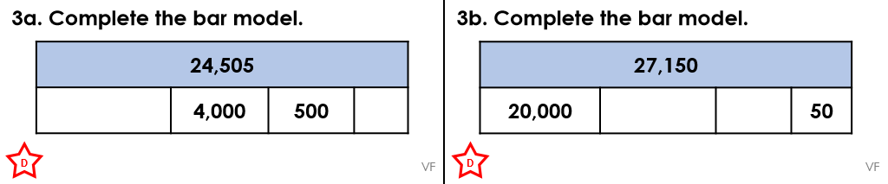

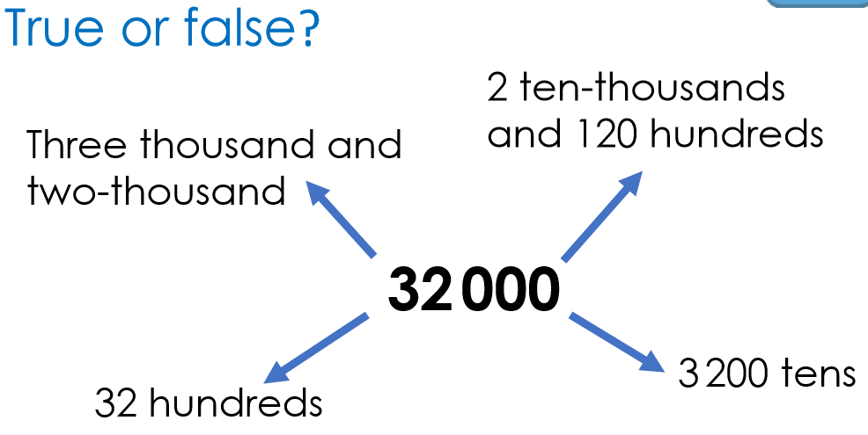
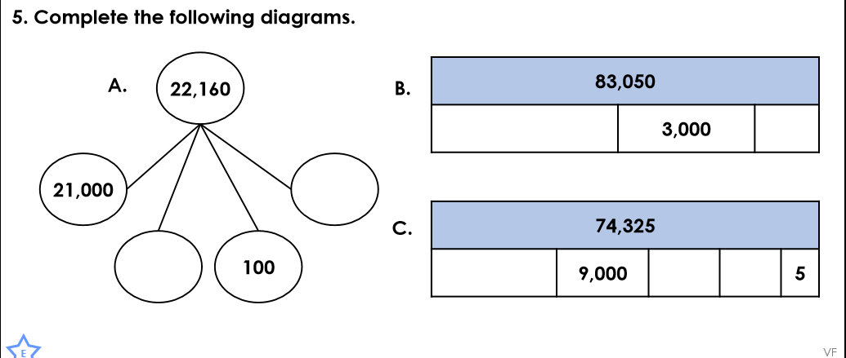

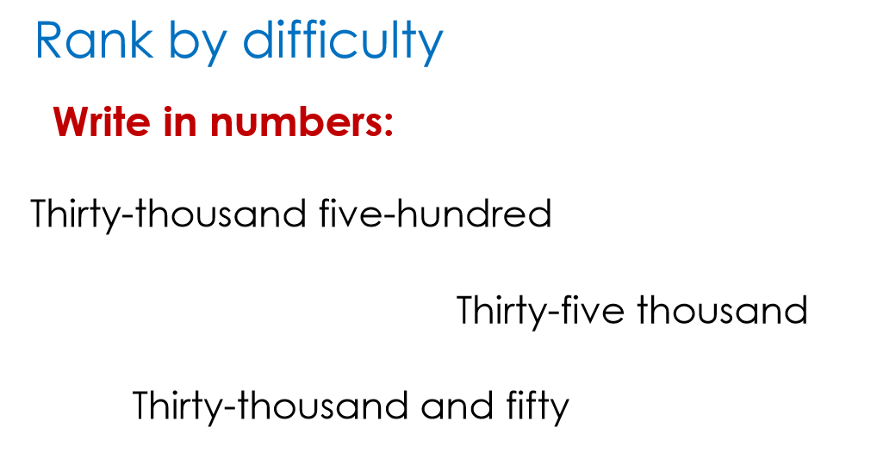
Write in numbers

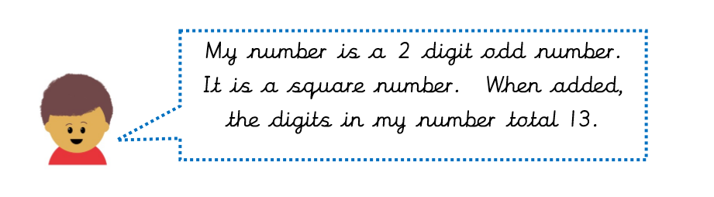
Challenge- Work out their number
