Geography-
Think back to our last topic lesson when we explored the arctic and Antarctic looking at globes.
This week’s focus is on The Antarctic
Watch these clips to help you
- https://www.bbc.co.uk/teach/class-clips-video/what-adaptations-do-penguins-have-to-survive-in-antarctica/z6rtscw
- https://www.bbc.co.uk/teach/class-clips-video/science--geography-ks2-how-climate-change-is-affecting-penguins-and-their-habitats/zb2rkmn
Challenge:
Design your own animal which has adapted to live in Bentley. What adaptations has it made to successfully survive? Please send your completed animal to missemery@newvillage.doncaster.sch.uk

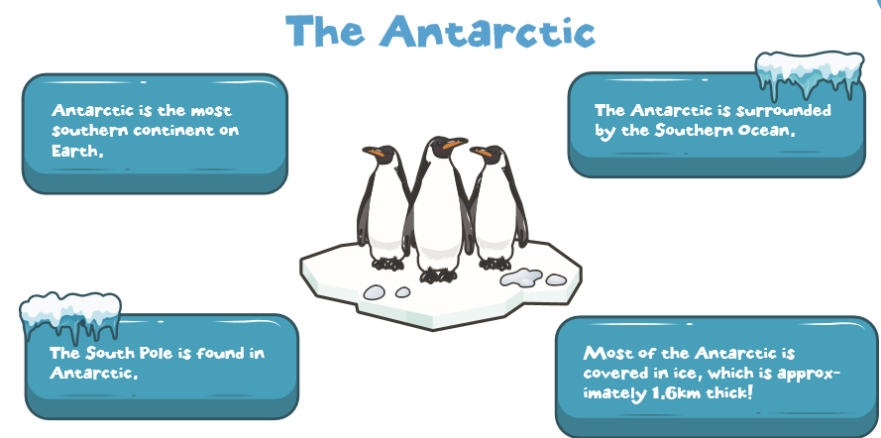
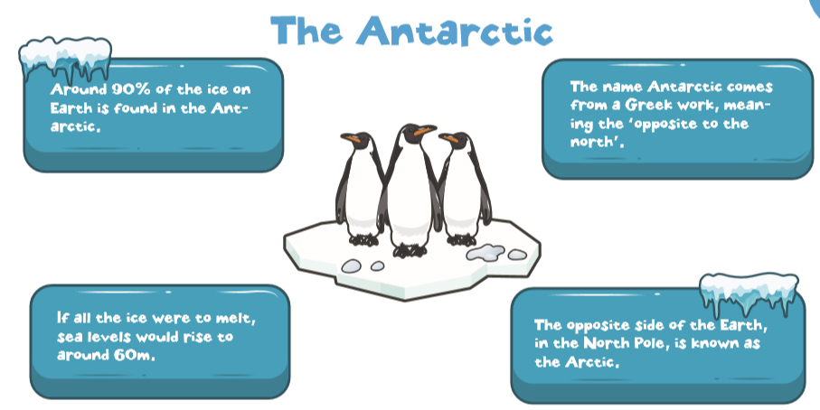

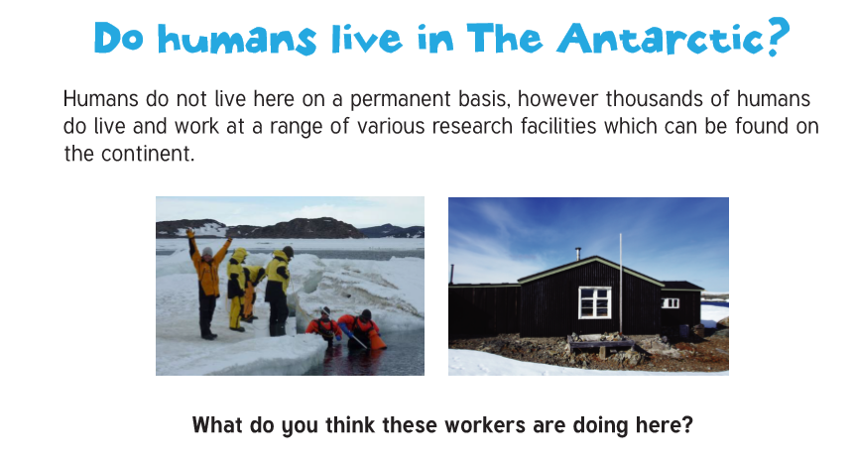
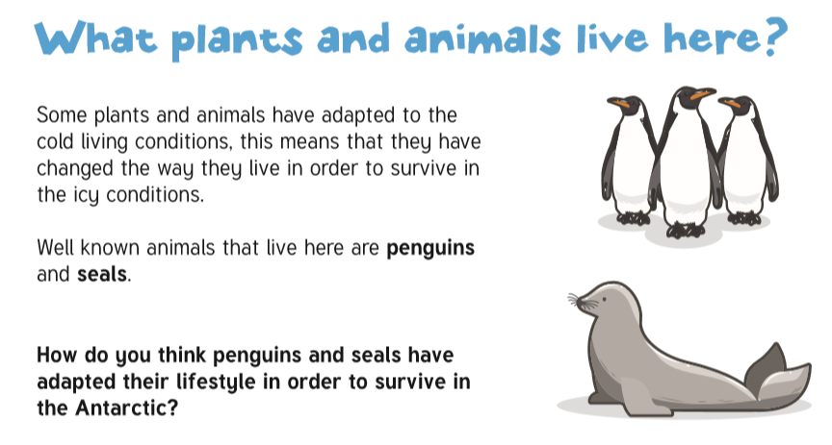

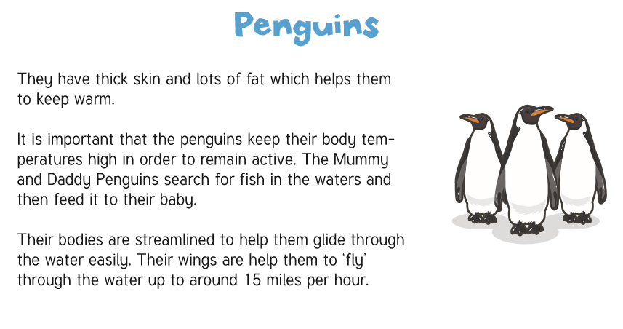
Task:
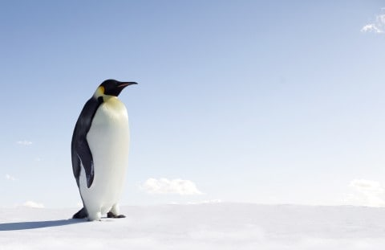
Create a spider diagram about a penguin and label its adaptations which help it to successfully live in the Antarctic, use the videos to help you.

Task two: can you design and label a creature which would survive in Bentley? What adaptations does it have to successfully survive?
Send to Missemery@newvillage.doncaster.sch.uk

Have a go at drawing your own penguin:
