Y3S - Home Learning
Dear Y3S, since we are not able to be together at school at the moment, I have put together some more learning activities that you can complete with your adults at home. Some activities can be printed and there are also some on-line links that may be helpful. I hope that you are all well and look forward to being back together as soon as we can. Miss Shaw
Daily Activities:
 | Activity
9.00 | PE | Take a look at the NETFLEX powerpoint, open it up and choose a link to an exercise of your choice……..superhero….frozen…….Joe Wickes…….anything you like!  You will find the instructions below.
Activity 1 | Maths  (30 mins) | Follow the link below to find daily BBC bitesize Maths activities  https://www.bbc.co.uk/bitesize/tags/zmyxxyc/year-3-and-p4-lessons/1
Activity 2 | Times tables  (15 mins) | Log in to Splat 100 square and splat your counting patterns.  https://www.primarygames.co.uk/pg2/splat/splatsq100.html  Monday 2’s  Tuesday 4’s  Wednesday 8’s  Thursday 3’s  Friday 6’s  For each daily pattern count it forwards and backwards….as a challenge, can you count them forwards then backwards with your eyes closed?  Then log into TTRS and complete 10 minutes of practice on the studio section.  Studio helps you to extend your learning as you are using all the times tables.
Activity 3 | Spelling  (10 mins) | Write the spellings for this week just like we do every day in the classroom. Remember LOOK / COVER / WRITE / CHECK  LOOK at the word carefully  COVER the word  WRITE it from memory  CHECK your spelling  Then use the words in a sentence – if you are not sure of the meaning you can ask an adult / check it in a dictionary / check using an on-line dictionary.  The words that I have selected this week all belong to word families.  press  suppress  express  compress  impress  event  eventful  invent  prevent  venture  adventure
Activity 4 | Handwriting  (5 mins) | Use the prepared line guide or just a piece of paper to write the joins used in our selected spellings.  press vent
Activity 5 | English  (30 mins) | Follow the link below to find daily BBC bitesize English activities  https://www.bbc.co.uk/bitesize/tags/zmyxxyc/year-3-and-p4-lessons/1
Activity 6 | (30 mins) | Look at the other learning opportunities listed below and select one to do each day!

Other learning opportunities
Choose an activity each day

Music | https://www.outoftheark.co.uk/ootam-at-home/?utm_source=homepage&utm_campaign=ootamathome2&utm_medium=banner  Log on to the above website. Here you will find lovely songs to sing, just like the ones that we use every week in singing assembly.  Choose a song  Listen to it all the way through and spot any repetition  Join in with the song the 2nd time through, following the words on screen.  Make up your own actions or even dance moves, and don’t forget to follow the links for other activities related to each song  This week, I’ve been singing “Living and learning” from the “Sing in every subject” pack because whatever problems we have in our lives at the moment, the seasons continue and there is such a lot for us to enjoy. Once you have joined in with the song, have a look at the related activities page……just click and download.  I know that some of you are enjoying growing things at home at the moment. Some of you are even growing sunflowers. All our links this week are related to sunflowers and an artist called Vincent Van Gogh
Geography | Vincent Van Gogh was born in the Netherlands. Can you find out some key facts about the Netherlands?
Art | I hope that you enjoyed the workshops last week, provided by local Sheffield Artist Pete McKee.This week follow the links below to have a go at drawing sunflowers in the style of Vincent Van Gogh.  https://www.youtube.com/watch?v=rU_-LTH2Qts  https://www.youtube.com/watch?v=krfRYdNgJUU  Or why not just go out into your garden with a pencil and some paper and draw some of your own flowers.
ICT | Send me an email to the address below and include an emoji to let me know how you feel. Some people like to include a photograph of something that they have made or something enjoyable that they have done. It is really great to hear about what you have all been doing.  MissShaw@newvillage.doncaster.sch.uk
PSHE | In parts of France, whole fields of sunflowers are grown. In the summer they look very beautiful. Take a minute to watch this film clip of sunflowers growing in France. It is very relaxing and it might even inspire you to grow your own sunflowers.  https://www.youtube.com/watch?v=K3CZKLhI5HM
History | Vincent Van Gogh was an artist famous for painting sunflowers. Click on the link below and take a look at the story “Camille and the sunflowers” to find out more about his life.  https://www.youtube.com/watch?v=JqK6Iwwg96U
DT | The Netherlands, where Vincent Van Gogh was born, is famous for windmills. Make your own paper windmill after watching the clip below.  https://www.youtube.com/watch?v=xUpCuwf3JEg
Science | Since we have a summer theme to our learning this week, why don’t you have a go at making instant ice cream!!!!!!!  Follow the link below and download “instant ice cream” – all you need are things that you may already have at home  https://learning.sciencemuseumgroup.org.uk/learning-resources/  If you can’t print off the resource, I have included it below for you to read online.
Exercise outdoors a little bit each day. Set yourself a daily challenge! |  | A zoom night in!  I have just learned how to use “Zoom” to connect with other people. Why not link up via zoom with friends or relatives for a quiz night.
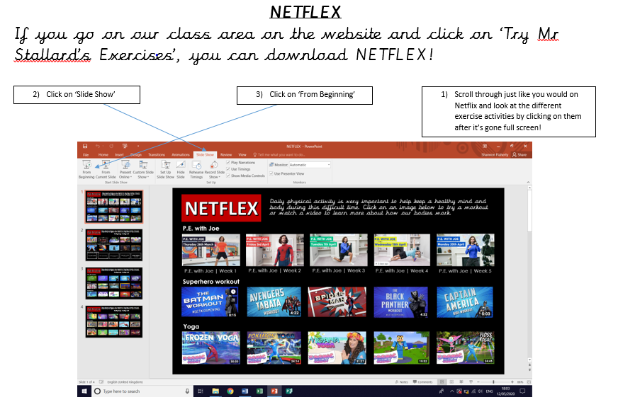

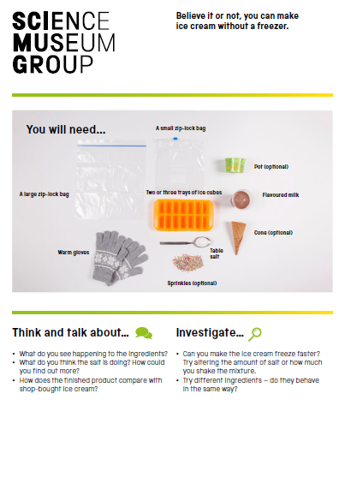

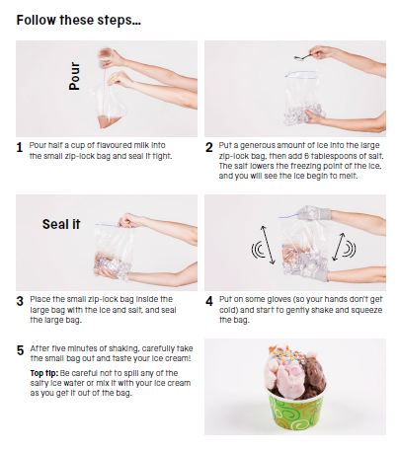

Use the lines below to write a sentence using each of these words – remember to use

your joined handwriting

