Learning Pack for Year 1, - week 7
Hi Everyone,
This is Miss Shah here. I hope you’re all keeping safe and keeping healthy. I’m glad you’re enjoying the learning packs with less printing and less writing. So here are this week’s little activities for you to have a go at. How many can you do? You get a star for each one you do! I’ve loved looking at the photos of your activities from last week. Take some selfies of yourself doing the activities and send them to –mrsgeaney@newvillage.doncaster.sch.uk
Activity 1  Have a competition with someone in your family.  a) Do 10 underarm throws to each other – who drops it first!  b) Have a go at skipping! Can you do 3 skips in a row? Can you do more? Who can do the most in your family?  e) Jog from on the spot for 1 minute then count your breaths. | Activity 2  Learn your full home address and telephone number. Can you say it all with the post code?  Can you remember your telephone number? | Activity 3  Complete this science activity  Make a kite and fly it safely with a parent –  - On a sunny day  - On a breezy day  - On a rainy day  Which day was the best day to fly the kite?  Why do you think this was? | Activity 4  Maths Activity  Collect some twigs and little stones. Make a square, a triangle and a rectangle.  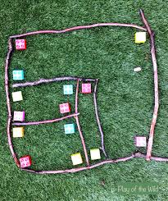  Put a little stone where 2 twigs meet. These are the corners (the posh word is vertex).  Make a house using shapes and label it. | Activity 5  Cloud Hunt  Go outside and look at the sky every day.  Can you see any clouds? What do they look like?  Draw the clouds you can see every day.  Are they the same on a warm day and on a breezy or cold day?
Four In A Row – Challenge a sibling or parent - Choose an activity to do and put a counter on it when you’ve done it. Who got Four In A Row first? Send in your pics – I’d love to see them! Thanks.
Pay someone a complement – this means say something nice about them. | Help separate the washing into different colours. | What? Where? How? Why? Write some questions about a story you know. Read the story to a grown up then ask them the questions – can they get any right? | Read, read, read – read to the goldfish or the cat, read to the radiator, read to a person
Practice Master Chef – help create a sandwich. | Remember Master Chef – once you’ve created the sandwich, jot down what you did in the right order so you remember. | Do some gardening – this week I want you to notice what’s different in the garden this week | Do an activity that you are allowed to do at home but do it silently for more than 10 minutes.
Make a card for a neighbour to make them smile during this time – post it through the letterbox | Practice how to tie shoelaces | Do some baking with a parent – send a pic of it to a friend or family member with a text or WhatsApp message telling them all about it. | Play guess the book – mime the title of a book you know to family members – if they get it, it’s their go
Pull some weeds out with a family member – pull the weeds not the plants! | Make your bed – then offer to make a family member’s bed | Water the plants - then draw yourself watering the plants | Write an email to me about your week and how you’re feeling – get a parent to help if you need
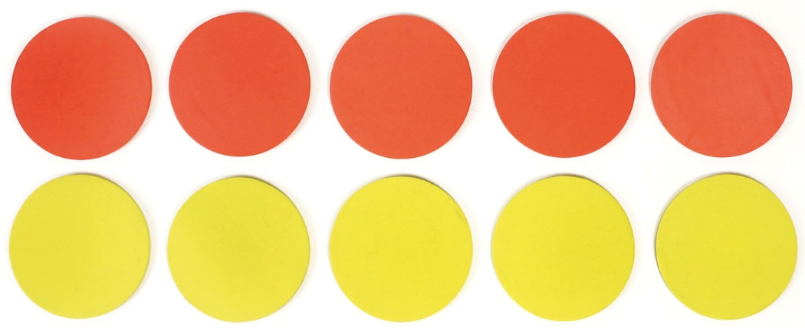

And Finally,
3 short daily (this means every day) activities to do with your family for each subject…
Reading | Writing | Maths
1. Read for 5 minutes to your parent or brother or sister and then tell them what happens in the story.  2. Story time at Five to Five -  Can you read to someone at Five to Five every day – you could read to a parent, sibling, neighbour or phone a friend or grandparent or other family member.  3. Draw a picture of the setting (where the story takes place). Now draw a picture of the main character (who it’s about). | 1. Do some handwriting. Practice all your letters – get a parent to check you’re doing them right. Can you do your numbers too?  2. TOY STORY – choose two or three toys. Imagine they go on an adventure. Write the story of what happens in the adventure.  3. Write down things that begin with capital letters – this could be your name, a day in the week, the month, a town, city or country you’ve visited. How many things can you think of? Did you make sure you started with a capital? | 1. Make sure you know your times tables really well. Here are some songs to help:  https://www.bbc.co.uk/bitesize/topics/zqbg87h/articles/zc7ygdm  https://www.bbc.co.uk/bitesize/topics/zqbg87h/articles/zw8qxfr  https://www.bbc.co.uk/bitesize/topics/zqbg87h/articles/zq3rk2p  https://www.bbc.co.uk/bitesize/topics/zjkphbk/articles/zd4b382  Practice singing the times tables to a tune or song you or your family member likes.  2. What time is it Mr Fox? This is a game your parents or grandparents might know. Ask how to play it and then play it with them. Draw the time on a clock. Grown ups please include o’clock, half past and quarter to or quarter past in your game. Thanks.  3. Number bonds to 10 and 20.  Make me 20. What numbers do you need to add to these to make 20?  17 18 19  15 13 11  10 7 4

And that’s it – Smile again Let me know what you think !

