Colour the box when you have completed the challenge!
LIFE SKILLS BINGO
Make a sandwich | Decorate a cake with a rainbow | Make your bed | Lay the table for dinner | Practice wrapping up gifts in paper
Help with the washing up/ stack the dishwasher | Clear the table | Get dressed independently | Tidy a cupboard/drawer | Price comparison searching for groceries online
Peel vegetables | Help with the dusting | Help pull the weeds in the garden | Vacuuming | Learn how to tie shoelaces
Tidy up your toys | Help to feed your pets | Help to wash the car | Fold the laundry | Help your grown up with a task

GENERAL LEARNING SKILLS BINGO
Create a pattern from nature | Make a paper aeroplane – can you make it go really fast? | Write an email to the class | Write instructions on how to play a game you have made up | Listen carefully to the sounds in nature can you copy them
Tell a toy your favourite story | Create a maths game | Learn a song off by heart | Create a shop where you buy/get change | Create a pattern where not touching parts are the same.

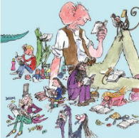
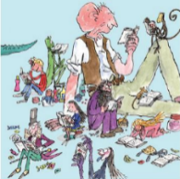
Home Learning Menu
Choose a minimum of three learning challenges to complete.
Reading challenge
Read a book every day/night for one week!
Maths
Write down all number bonds to 100
eg. 1 + 99

Art
Create an imaginary creature and draw/paint/create it using your own choice of paper, paint, pencils, crayons, charcoal, pastels or felt tip pens.
Maths
Carry out the money Maths Investigation in this pack

DT
Create a seaside in a jar
Reading/Geography/History
Complete the reading comprehension about Seaside Holidays

Science Investigation
Carry out the Science Investigation in this pack

Physical Challenge
Use https://www.jumpstartjonny.co.uk/ and learn the three dances.

Science / Gardening
Create a bug hotel using twigs and things you have found on a nature walk:

Book Review
Choose a book.
Write a short book review…what is the book about?, Is it funny or sad? Do you like it? Why?

Reading activity
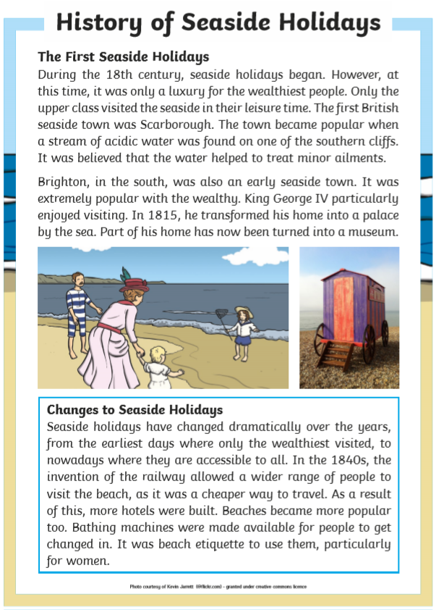

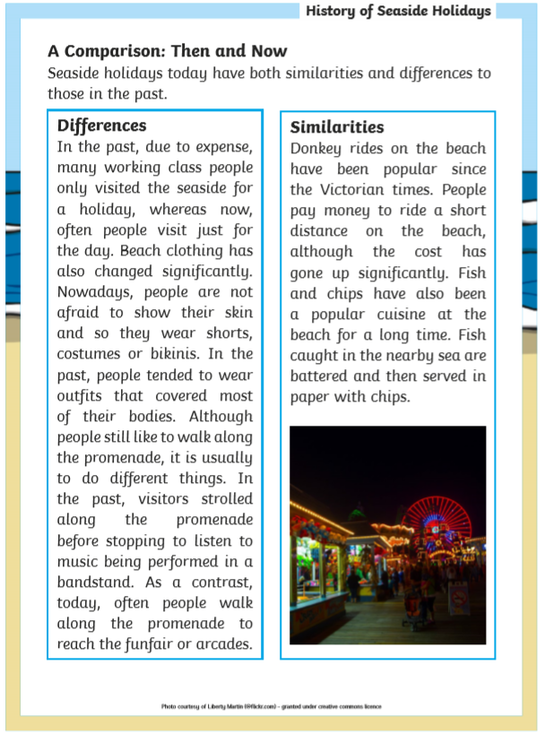

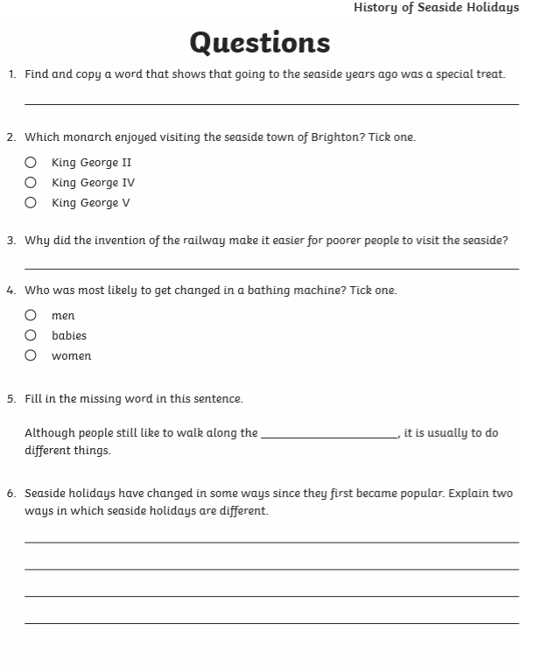

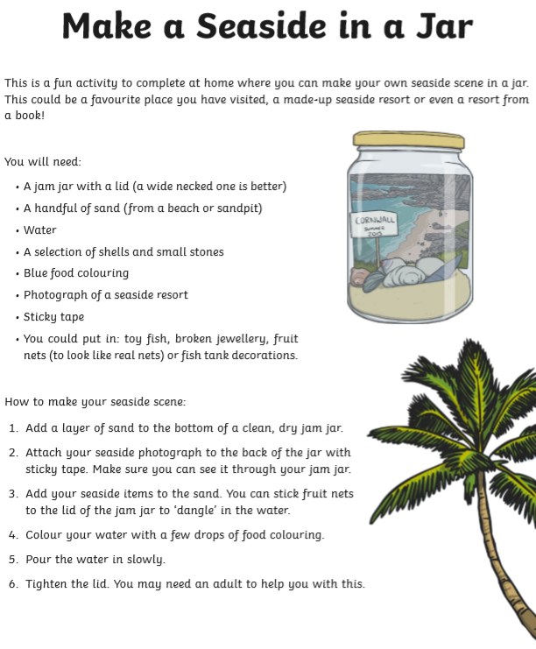

Arithmetic practice
It would be beneficial for your child if they practised simple arithmetic daily.
Calculation | Types of numbers | Examples
Addition | Add 2-digit numbers where the total equals less than 100. | 63 + 25 = | 49 + 32 = | 12 + 10 + 18 =
Subtraction | Subtract 2-digit numbers less than 100. | 90 – 37 = | 75 – 12 = | 94 – 30 =
Multiplication | Multiply two numbers less than 12, where one of the numbers is 0, 1, 2, 3, 5 or 10. | 7 x 5 = | 11 x 3 = | 12 x 10 =
Division | Divide two numbers where the divisor is either 0, 1, 2, 3, 5 or 10.  The answer should not include remainders. | 21 ÷ 3 = | 80 ÷ 10 = | 65 ÷ 5 =

Answer these questions over a few days and then ask an adult write out new number sentences for you to do.
42 + 15 =  43 + 49 =  74 – 25 =  11 x 3 =  6 x 10 =  49 + 48 =  21 ÷ 3 =  20 ÷ 2 =  65 – 25 = | 58 + 23 =  41 + 39 =  40 – 22 =  6 x 5 =  4 x 5 =  47 - 28 =  18 ÷ 3 =  16 ÷ 2 =  16 – 12 = | 61 + 18 =  87 + 11 =  89 – 7 =  8 x 5 =  3 x 10 =  61 - 20 =  15 ÷ 3 =  40 ÷ 10 =  68 – 27 = | 19 + 75 =  5 + 9 + 7 =  51 – 28 =  4 x 5 =  7 x 10 =  58 - 40 =  25 ÷ 5 =  60 ÷ 2 =  64 – 38 = | 49 + 79 =  12 + 13 + 7 =  75 – 28 =  12 x 5 =  6 x 10 =  37 - 29 =  40 ÷ 5 =  18 ÷ 2 =  76 – 27 =

Maths investigation
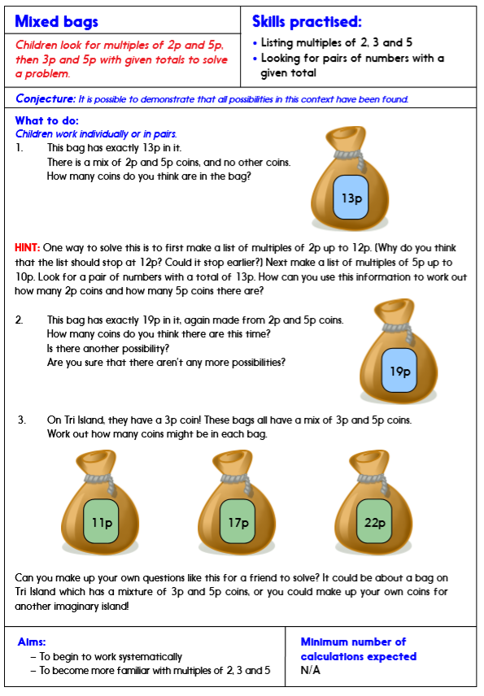

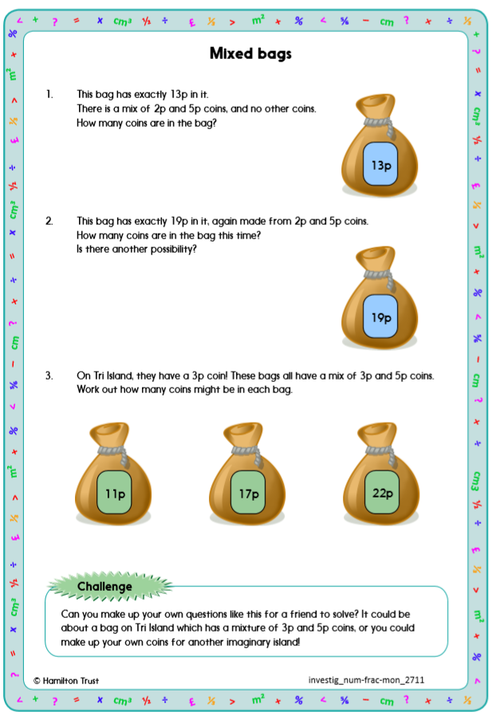

Science Investigation

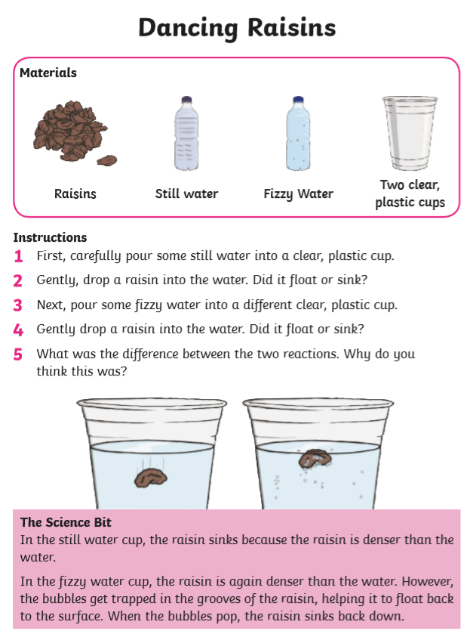

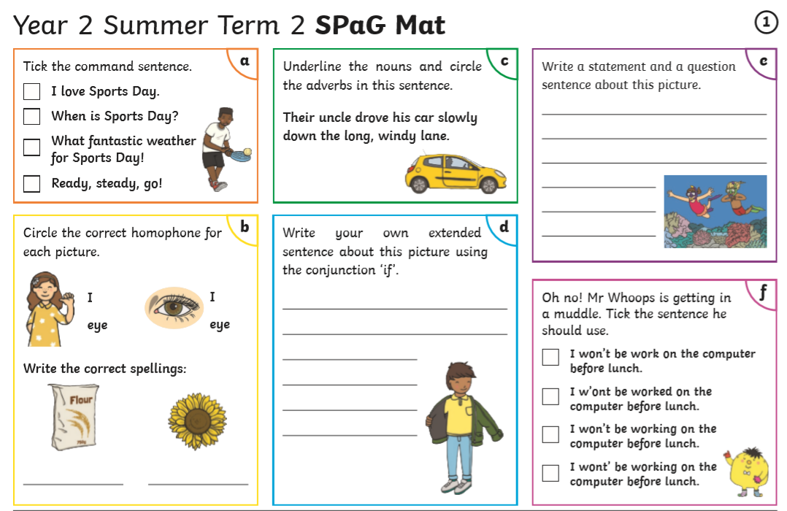

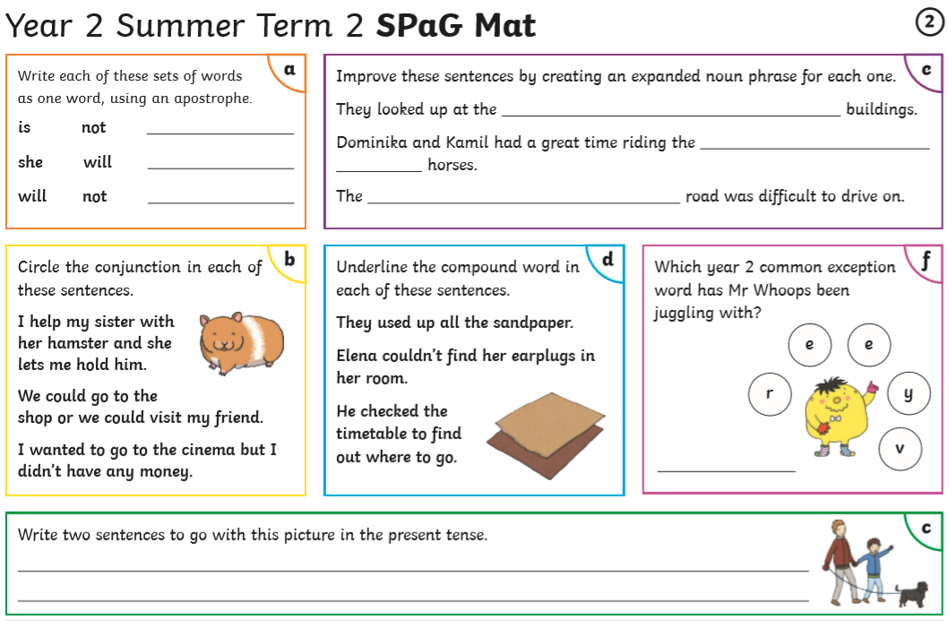

Writing Activity
Write an acrostic poem about the seaside. Each line should start with a letter from the word seaside. Every line should contain an adjective and a verb e.g. Squawking, naughty seagull stealing chips.
