Writing – Please have a go at a short piece of writing each day. Remember your capital letters, full stops and finger spaces! Challenge – Can you include lots of adjectives? (Describing words).
Monday | Tuesday | Wednesday | Thursday | Friday
 |  | 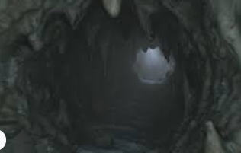 |  | 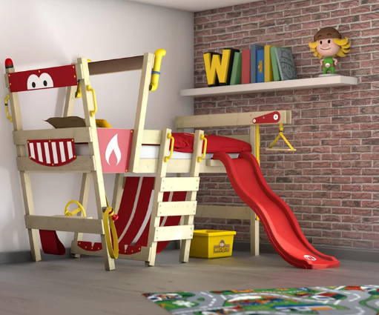
We want to see your creative writing skills today. We all know how naughty seagulls can sometimes be, especially at the seaside. Can you come up with an idea about what you think will happen next…  Will the seagull fly away or will the little boy save his ice cream?  Maybe he will steal the ice cream but a superhero will come and save the day.  We can’t wait to hear your ideas and see some creative writing. | Today we would like you to write about A spy. You could do a story or write a description but it must include a spy. | Today I would like you to write about a deep, dark cave. It could be that you write a description, a poem, a story, a set of instructions.  Make sure you really explain what it is like in the deep, dark cave.  What can you see, hear, feel, smell? | You go in a rocket ship and you go to space. Tell your adult about the take off. How was it?  How did you feel? What could you hear? What did it feel like? | Describe your bedroom.  What colour is it?  What do you have in it?  What is on your walls?  Maybe you could draw a picture too to go with it.

