Reading (Monday)
Spellings
Grown-ups read the common exception words and children you write them down (remember they are tricky words)

- The
- They
- One
- Your
- Some

Here are 5 more ‘sh’ and ‘ch’ words

- Fish
- Shop
- Chip
- Chicken
- Hatch

- Spell them out, mark them and correct them!

Reading (Tuesday)
Spellings
Use your phonics skills to blend and spell the words.
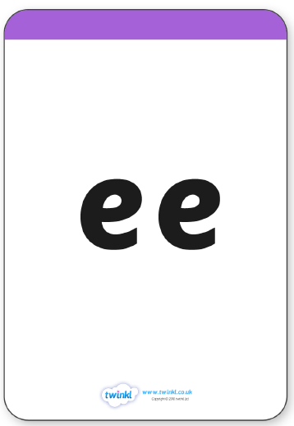
c d s
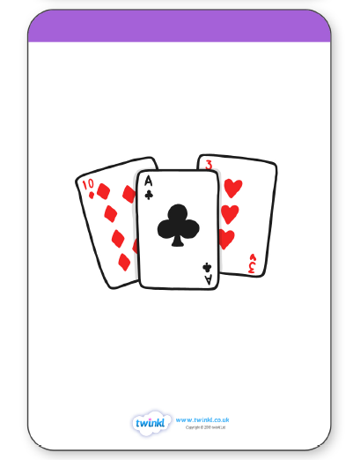

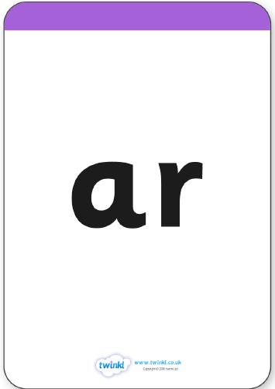

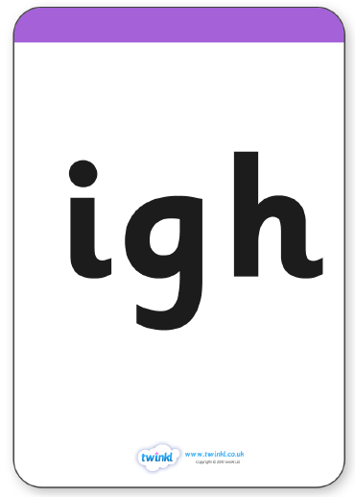

5 common exception words
- once
- a
- he
- ask
- here

r i ng
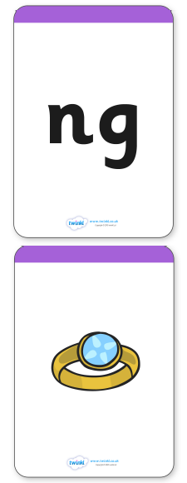

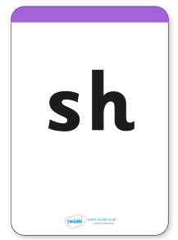

Reading (Wednesday)
Spellings
Grown-ups read the common exception words and children you write them down (remember they are tricky words)

- come
- to
- school
- do
- you

Here are 5 more words which include digraphs

- thin
- May
- Sleep
- Zoo
- sharp

- Spell them out, mark them and correct them!

Reading (Thursday)
Spellings
We would like you to go on https://www.phonicsbloom.com/uk/game/list/phonics-games-phase-5 and play the ‘Phonics Frog’ game.
Choose the different digraphs- click the mouse to make the frog jump- but only jump on to real words with that digraph… don’t get confused by the nonsense words.

5 common exception words
- Of
- We
- Put
- Said
- No

Reading (Friday)

Read for pleasure: choose your favourite book- put your feet up- find a comfy, relaxing place (maybe even a cup of hot chocolate) and read to your grown-ups. Then let your grown-ups read a story to you.
https://www.youtube.com/watch?v=L_LUpnjgPso this is a virtual fire place to make it nice and peaceful whilst you have story time!

Spellings common exception words

Be
kind
Children
You
Are
All
Stars
Who
Shine
Bright

