Creatures of the Rainforest
Watch these you-tube clips to remind you.
https://www.youtube.com/watch?v=3vijLre760w
https://www.youtube.com/watch?v=JEsV5rqbVNQ
Complete the activities:
complete the quiz
-layers of the rainforest
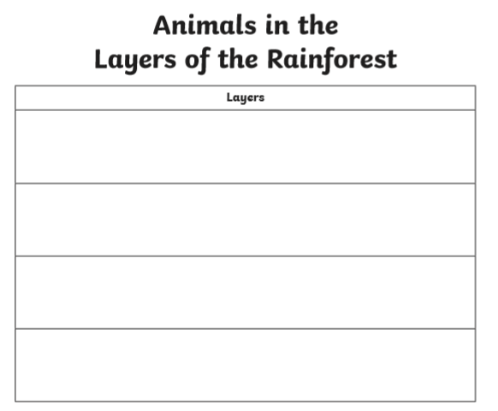
-animals of the rainforest
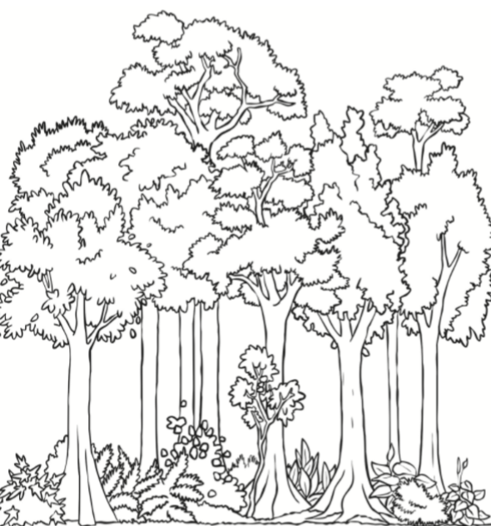

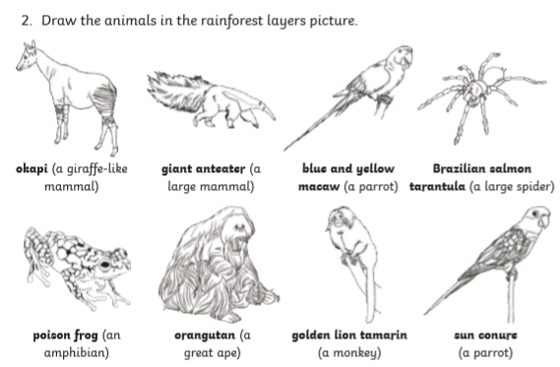
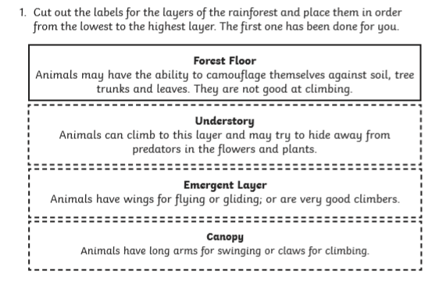
Complete these two quizzes and test your knowledge!
http://news.bbc.co.uk/cbbcnews/hi/newsid_3540000/newsid_3544400/3544401.stm
http://www.srl.caltech.edu/personnel/krubal/rainforest/Edit560s6/www/quiz.html

