WALT: To continue to distinguish between homophones and other words which are often confused

Remember homophones:
- Sound the same (or very similar)
- Have a different spelling
- Have a different meaning
Use the online dictionary to help you:
https://www.collinsdictionary.com/dictionary/english
Play these games once you have finished this pack of work-
https://www.learninggamesforkids.com/vocabulary-games/homophones-games.html https://www.bbc.co.uk/teach/class-clips-video/english-ks2-wonderful-words-homophones/z732t39
https://www.vocabulary.co.il/homophones/

Task one:
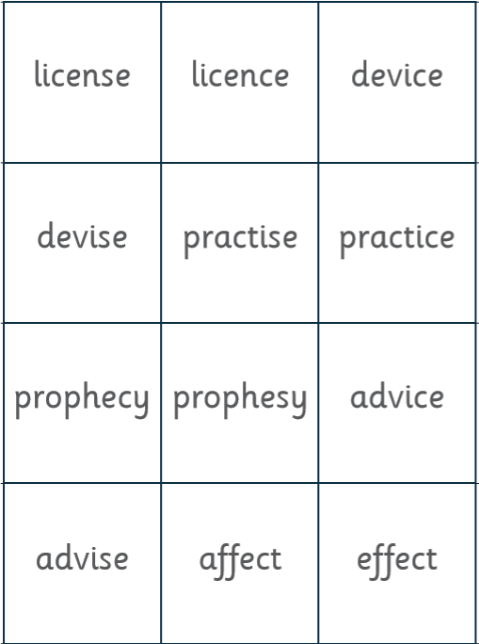
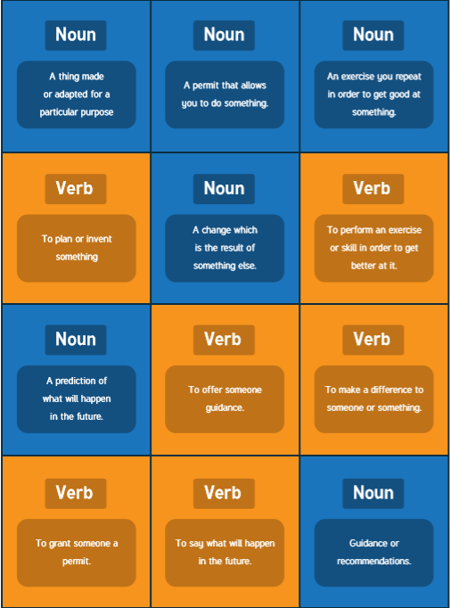
Match the word to the definition

Task two:
Match the corresponding homophone
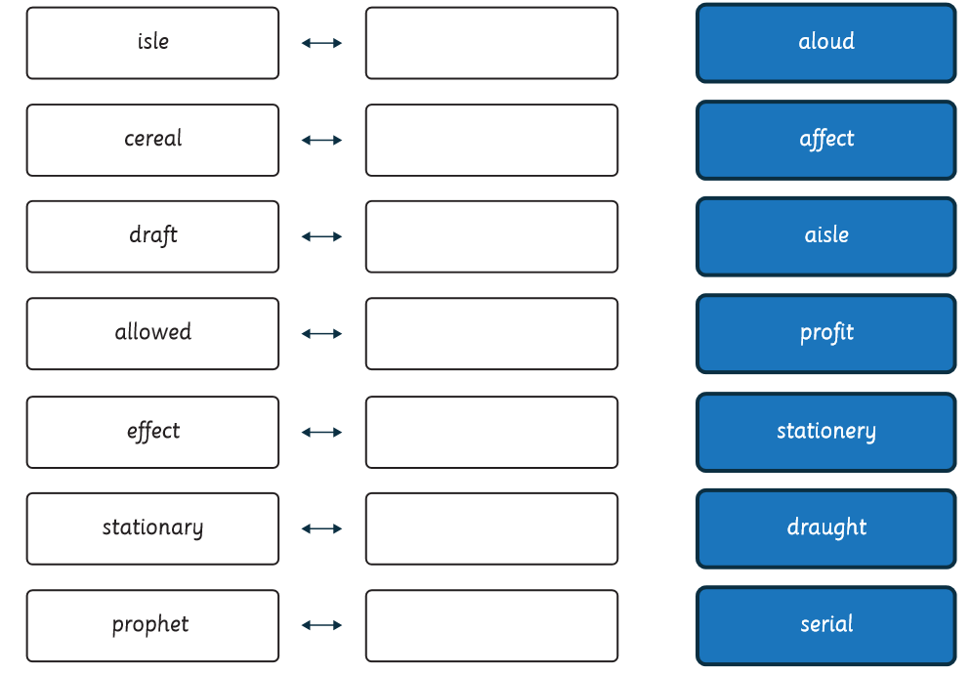

Task three:
Match to the definition
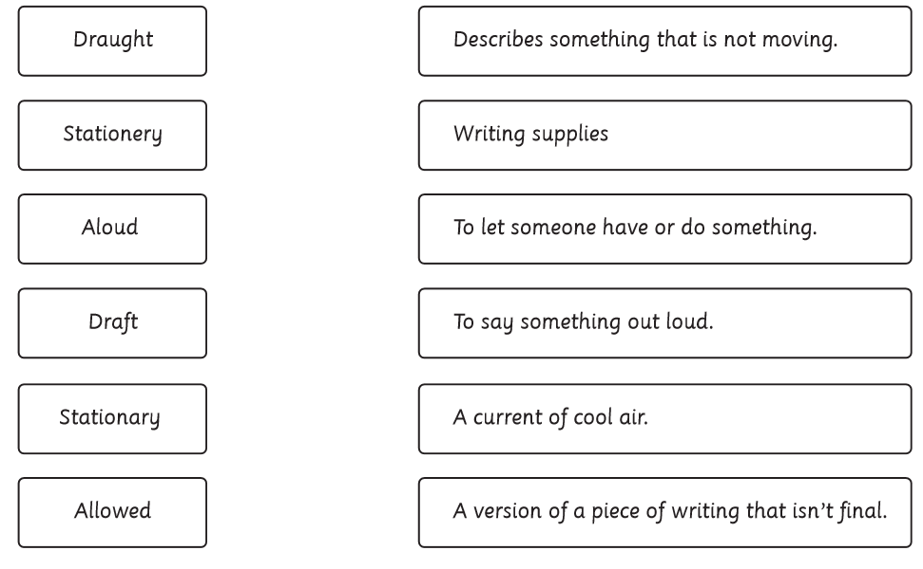

Task four:
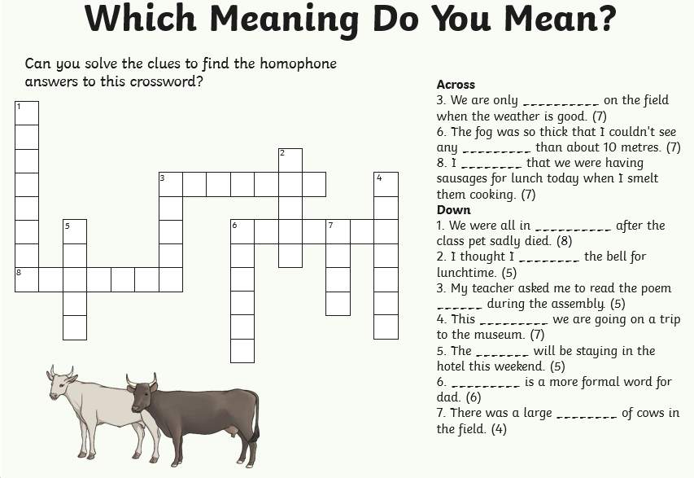
Cross word, write the correct homophone

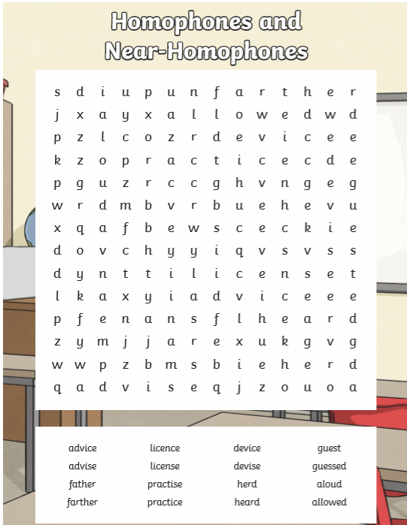
Task five: Wordsearch

